A Reproducible Workflow exercise

inSileco Inc., David Beauchesne, Kevin Cazelles, Steve Vissault

2021-03-01

Table of Contents

# Section 1 title

## Subsection 1 title

*Lorem* **ipsum** ***dolor*** ~~sit~~ amet, consectetur adipiscing elit. Nulla eget ipsum a nulla maximus ornare. Nunc ut nibh orci. Phasellus lacinia velit sed tincidunt euismod. Morbi euismod, lectus et consectetur tristique, urna eros facilisis magna, faucibus condimentum leo dui a enim. Praesent massa velit, egestas et eros eget, ornare tincidunt nisl. Vestibulum mattis enim a enim mattis iaculis. Etiam ipsum tortor, vehicula pretium consequat at, pharetra non mauris. Nam ac facilisis libero. Donec ut arcu gravida, pellentesque eros in, tempor mi.

Numbered list of numbers

1. one
2. two
3. three

A man who dares to waste one hour of time has not discovered the value of life.

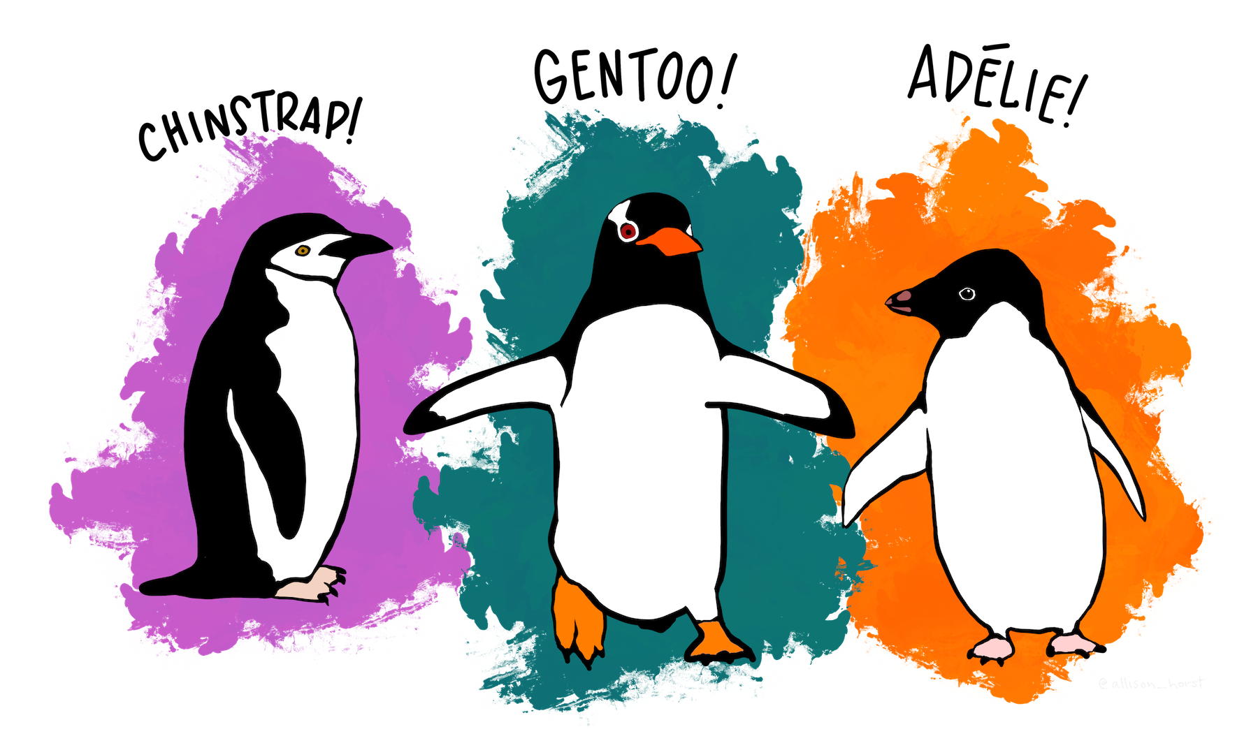

Artistic drawing of palmer penguins.[1]

library(palmerpenguins)  
data(penguins)  
knitr::kable(penguins[1:20, ])

|  |  |  |  |  |  |  |  |
| --- | --- | --- | --- | --- | --- | --- | --- |
| species | island | bill_length_mm | bill_depth_mm | flipper_length_mm | body_mass_g | sex | year |
| Adelie | Torgersen | 39.1 | 18.7 | 181 | 3750 | male | 2007 |
| Adelie | Torgersen | 39.5 | 17.4 | 186 | 3800 | female | 2007 |
| Adelie | Torgersen | 40.3 | 18.0 | 195 | 3250 | female | 2007 |
| Adelie | Torgersen | NA | NA | NA | NA | NA | 2007 |
| Adelie | Torgersen | 36.7 | 19.3 | 193 | 3450 | female | 2007 |
| Adelie | Torgersen | 39.3 | 20.6 | 190 | 3650 | male | 2007 |
| Adelie | Torgersen | 38.9 | 17.8 | 181 | 3625 | female | 2007 |
| Adelie | Torgersen | 39.2 | 19.6 | 195 | 4675 | male | 2007 |
| Adelie | Torgersen | 34.1 | 18.1 | 193 | 3475 | NA | 2007 |
| Adelie | Torgersen | 42.0 | 20.2 | 190 | 4250 | NA | 2007 |
| Adelie | Torgersen | 37.8 | 17.1 | 186 | 3300 | NA | 2007 |
| Adelie | Torgersen | 37.8 | 17.3 | 180 | 3700 | NA | 2007 |
| Adelie | Torgersen | 41.1 | 17.6 | 182 | 3200 | female | 2007 |
| Adelie | Torgersen | 38.6 | 21.2 | 191 | 3800 | male | 2007 |
| Adelie | Torgersen | 34.6 | 21.1 | 198 | 4400 | male | 2007 |
| Adelie | Torgersen | 36.6 | 17.8 | 185 | 3700 | female | 2007 |
| Adelie | Torgersen | 38.7 | 19.0 | 195 | 3450 | female | 2007 |
| Adelie | Torgersen | 42.5 | 20.7 | 197 | 4500 | male | 2007 |
| Adelie | Torgersen | 34.4 | 18.4 | 184 | 3325 | female | 2007 |
| Adelie | Torgersen | 46.0 | 21.5 | 194 | 4200 | male | 2007 |

## Subsection 2 title

The [penguins dataset](https://github.com/allisonhorst/palmerpenguins) contains data on 344 individuals, 3 species, and from 3 islands. Across individuals, the mean flipper length is NA.

plot(x = penguins$flipper_length_mm, y = penguins$body_mass_g, pch = 20, col = '#32c4c4',  
 main = 'Penguin body mass as a function of flipper length',  
 xlab = 'Flipper length (mm)', ylab = 'Body mass (g)')

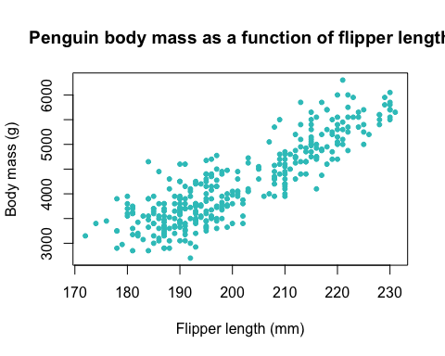

1. Artwork by @allison_horst