# Aim of testing

The purpose of us testing our system is to discover as many faults that are present in our system so that ultimately, we are able to create a much more robust and well-rounded system.

# Test objectives

- To discover stress and overload faults within our system. (I.e. Flooding of the system’s databases)

- To determine boundary and capacity faults of our system when it is run in different environments. (I.e. Different web browsers and/or hardware specifications)

- To detect algorithmic faults within our system. (I.e. Mismatch of variables with incorrect datatypes)

- To identify computation and precision faults within our system. (I.e. System fails to run in the correct sequence)

- To determine performance faults within our system. (I.e. Page load times)

# Test plan

**Unit test (6 Hours)**

-White Box testing will be utilized, to analyse and test the inner workings of our system’s source code. In order to verify the functionality of our source code, a series of experiments(test cases) with varying input data, will be carried out on our source code.

**Integration test (2 Hours)**

- Big-Bang Integration testing will be utilized, to test our system as a whole, once we have completely integrated all modules within our system simultaneously.

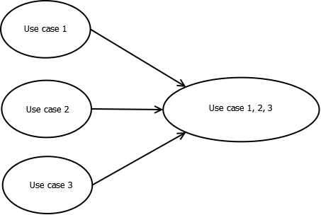

The diagram depicts the process of our system's integration test

**System test (1.5 Hours per requirement)**

- In this iteration, for the functional requirements, we will be developing 3 use cases, which are, Maintain Hospital Information, Register Account, and View Hospital Information.

- As for the non-functional requirements, we will be working on 4 aspects, which are, Technical, Performance, Usability, and Security.