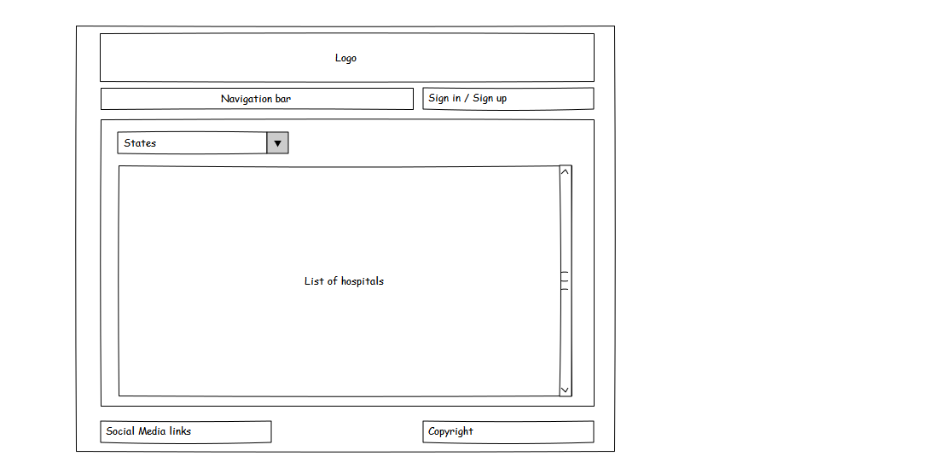The Navigation bar comprises of multiple clickable elements, such as Home, About us, Purchase medication, as well as Hospitals.

The Sign in/Sign up bar will change to View profile and Sign out after the user has logged into their account.

The List of hospitals will refresh whenever a user selects a state from the dropdown box of states (By default, the List of hospitals will show a list of all government hospitals that are present in KL).

The layout of all the elements shown is maintained throughout every other page.