Key features:
- 3.3V/5V adjustable Output Voltage
- Breaks out the ADC6 and ADC7 pins
- Adds footprints for optional I2C pull-up resistors
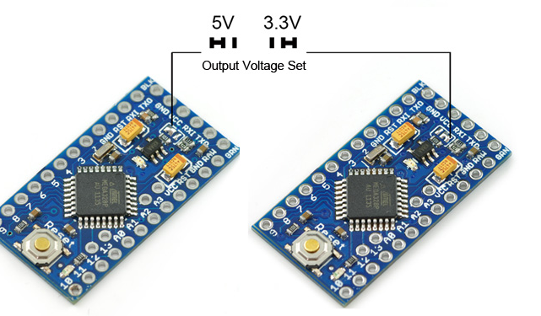
It's the Enhancement V2 Pro Mini! It's thin (0.8mm)!This Mini board with a adjustable voltage regulator(you can setting the output voltage by yourself) running the 8MHz bootloader .This Pro Mini V2 does not come with connectors populated so that you can solder in any connector or wire with any orientation you need.
The Enhancement V2 Pro Mini ,we used all SMD components, made it two layer, etc. This board connects directly to the FTDI Basic Breakout board and supports auto-reset. The Enhancement V2 Pro Mini also works with the FTDI cable but the FTDI cable does not bring out the DTR pin so the auto-reset feature will not work.
Features:
- ATmega328 running at 8MHz with adjustable voltage regulator(3.3V/5V)
- USB connection off board
- Supports auto-reset
- Max 150mA output
- Over current protected
- Reverse polarity protected
- DC input 5V up to 12V
- On board Power and Status LEDs

