**Assignment 1 Social Media Analytics CS G519**

**Keval Kulkarni 2020H1030136P**

**Brijgopal Dixit 2020H1030129P**

**GitHub Repository : https://github.com/KevalKulkarni98/Community-Detection---Empirical-Study**

**Q2.**

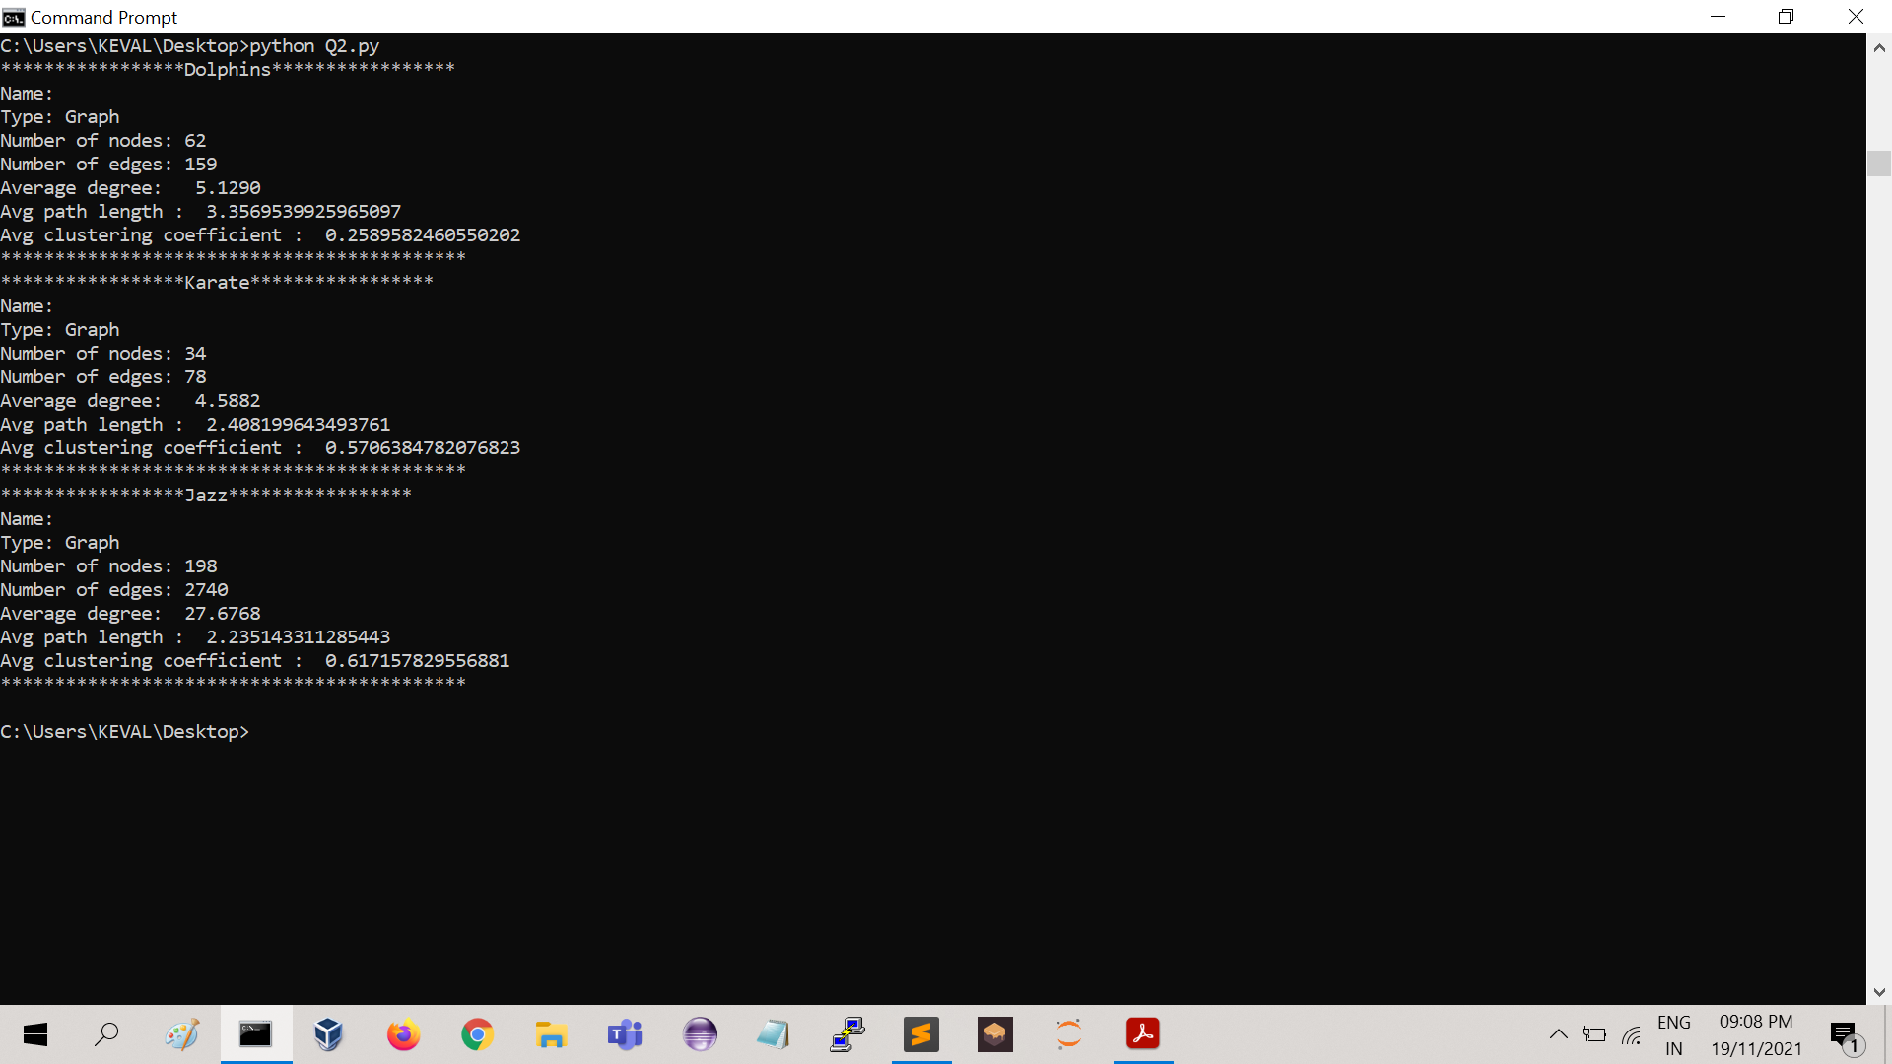

**Q3.**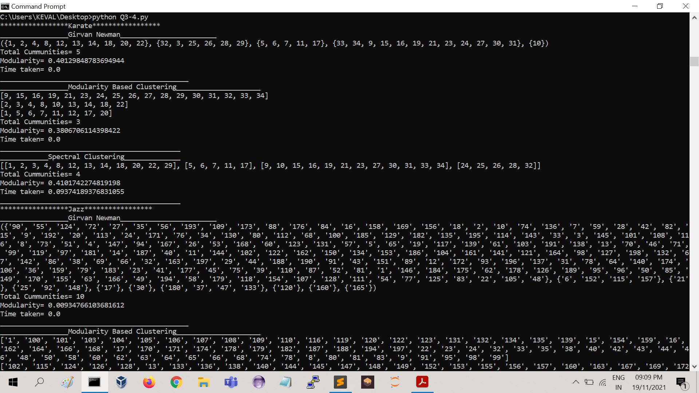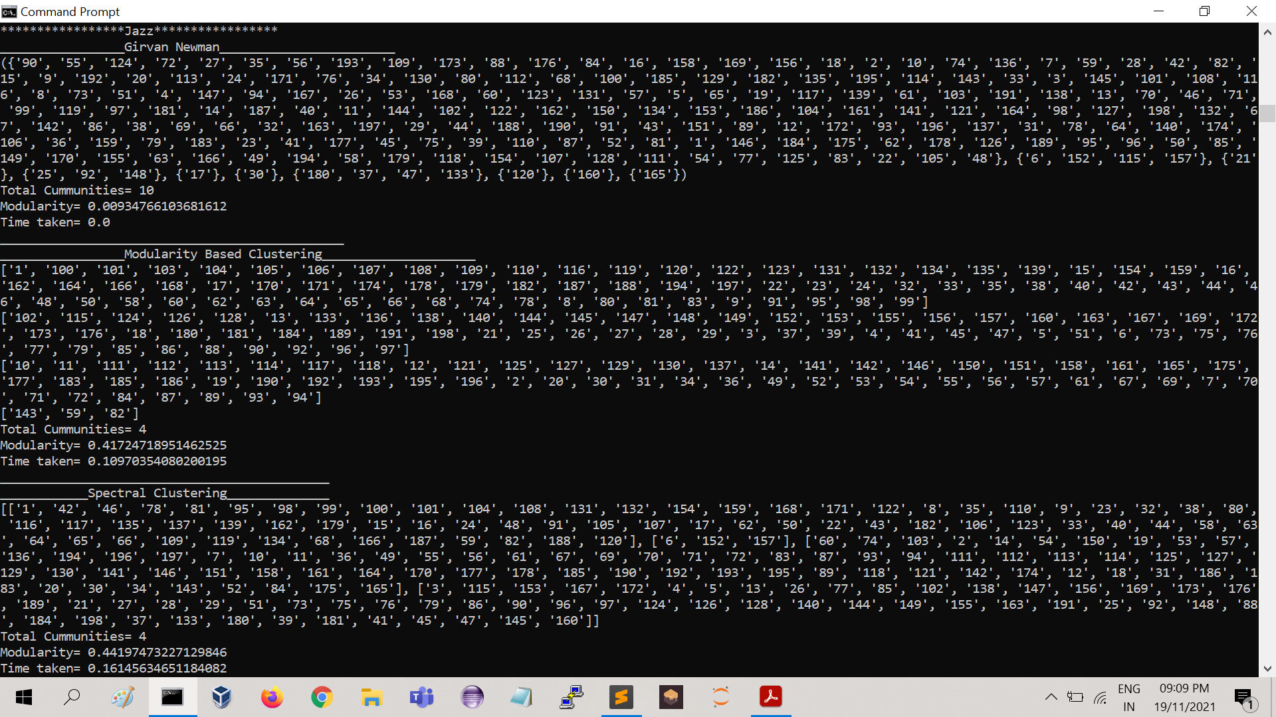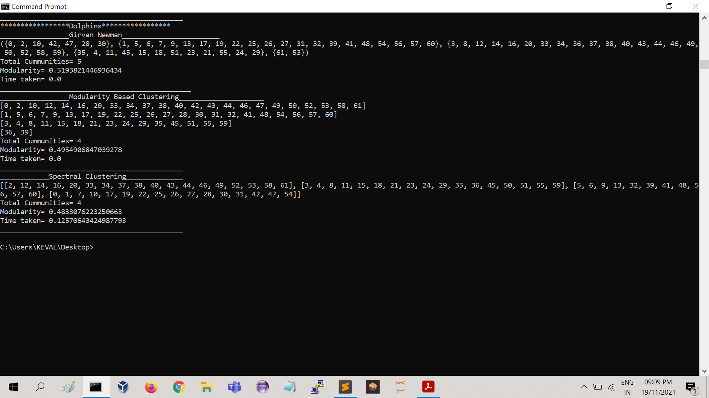

**Q4.**

**Number of Clusters**

|  |  |  |  |
| --- | --- | --- | --- |
|  | **Girvan-Newman** | **Modularity-based clustering** | **Spectral clustering** |
| **Karate** | **5** | **3** | **4** |
| **Dolphins** | **5** | **4** | **4** |
| **Jazz** | **4** | **4** | **4** |

**Modularity Score**

|  |  |  |  |
| --- | --- | --- | --- |
|  | **Girvan-Newman** | **Modularity-based clustering** | **Spectral clustering** |
| **Karate** | **0.40** | **0.38** | **0.41** |
| **Dolphins** | **0.57** | **0.49** | **0.48** |
| **Jazz** | **0.39** | **0.41** | **0.44** |

**Run Time(secs)**

|  |  |  |  |
| --- | --- | --- | --- |
|  | **Girvan-Newman** | **Modularity-based clustering** | **Spectral clustering** |
| **Karate** | **0** | **0** | **0.09** |
| **Dolphins** | **0** | **0** | **0.12** |
| **Jazz** | **0** | **0.10** | **0.16** |

**Observations :**

**From the above results it can be seen that Run time of Spectral Clustering is higher than Modularity based clustering and Girvan-Newman algorithm.**

**But Spectral Clustering is more efficient and accurate in finding the number of clusters or communities in the network as compared to Girvan-Newman.**

**Modularity based clustering shows average results between above both methods.**

**Gephi Visualizations :**

1. **Karate Dataset**

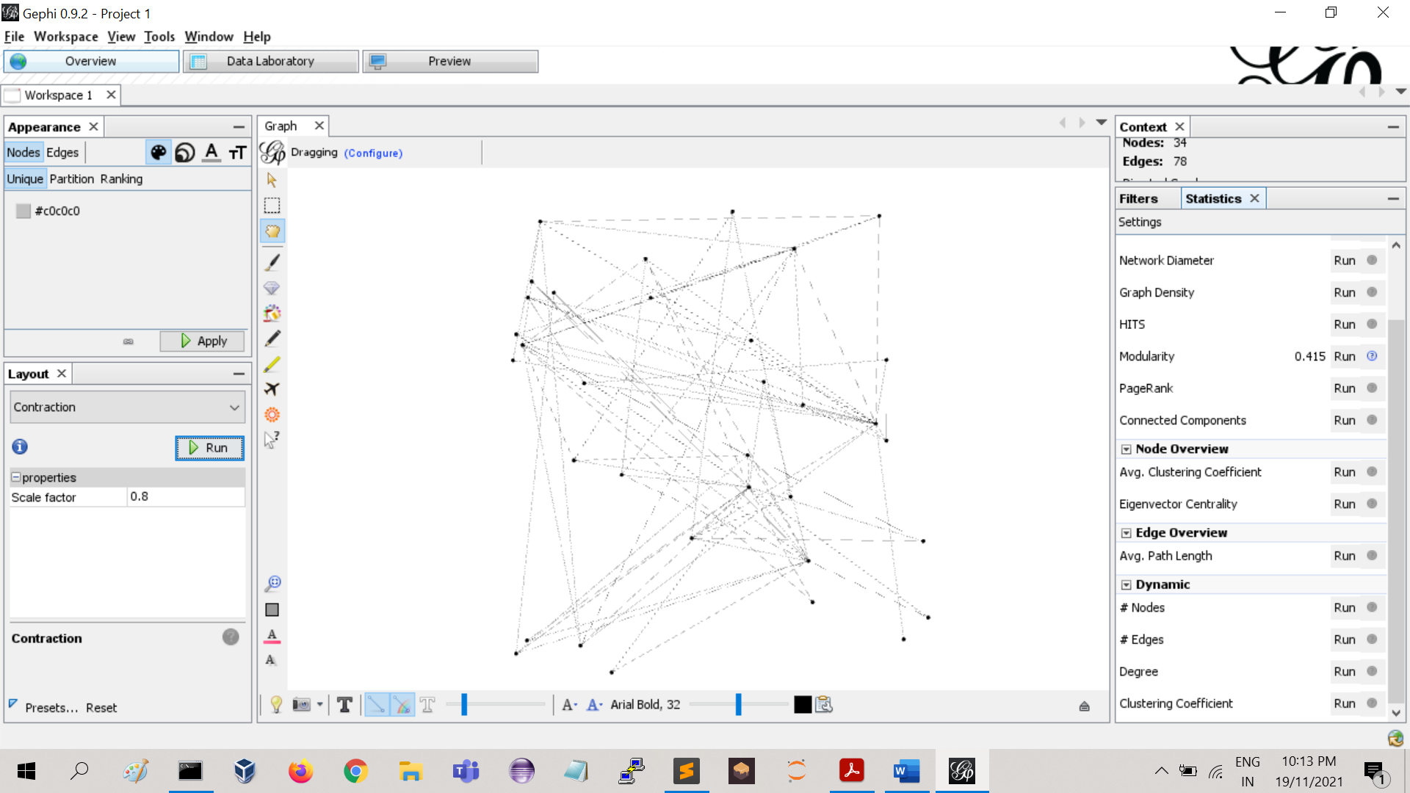

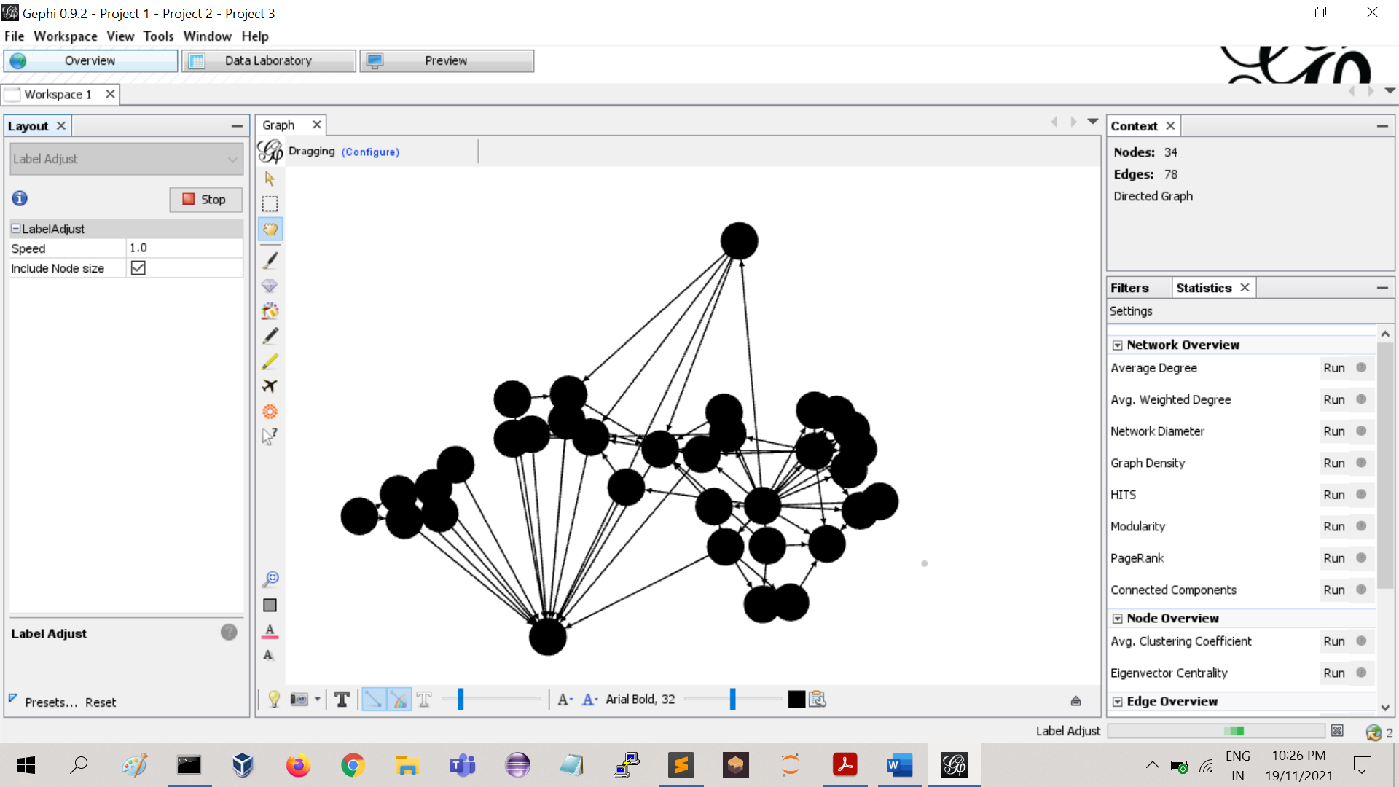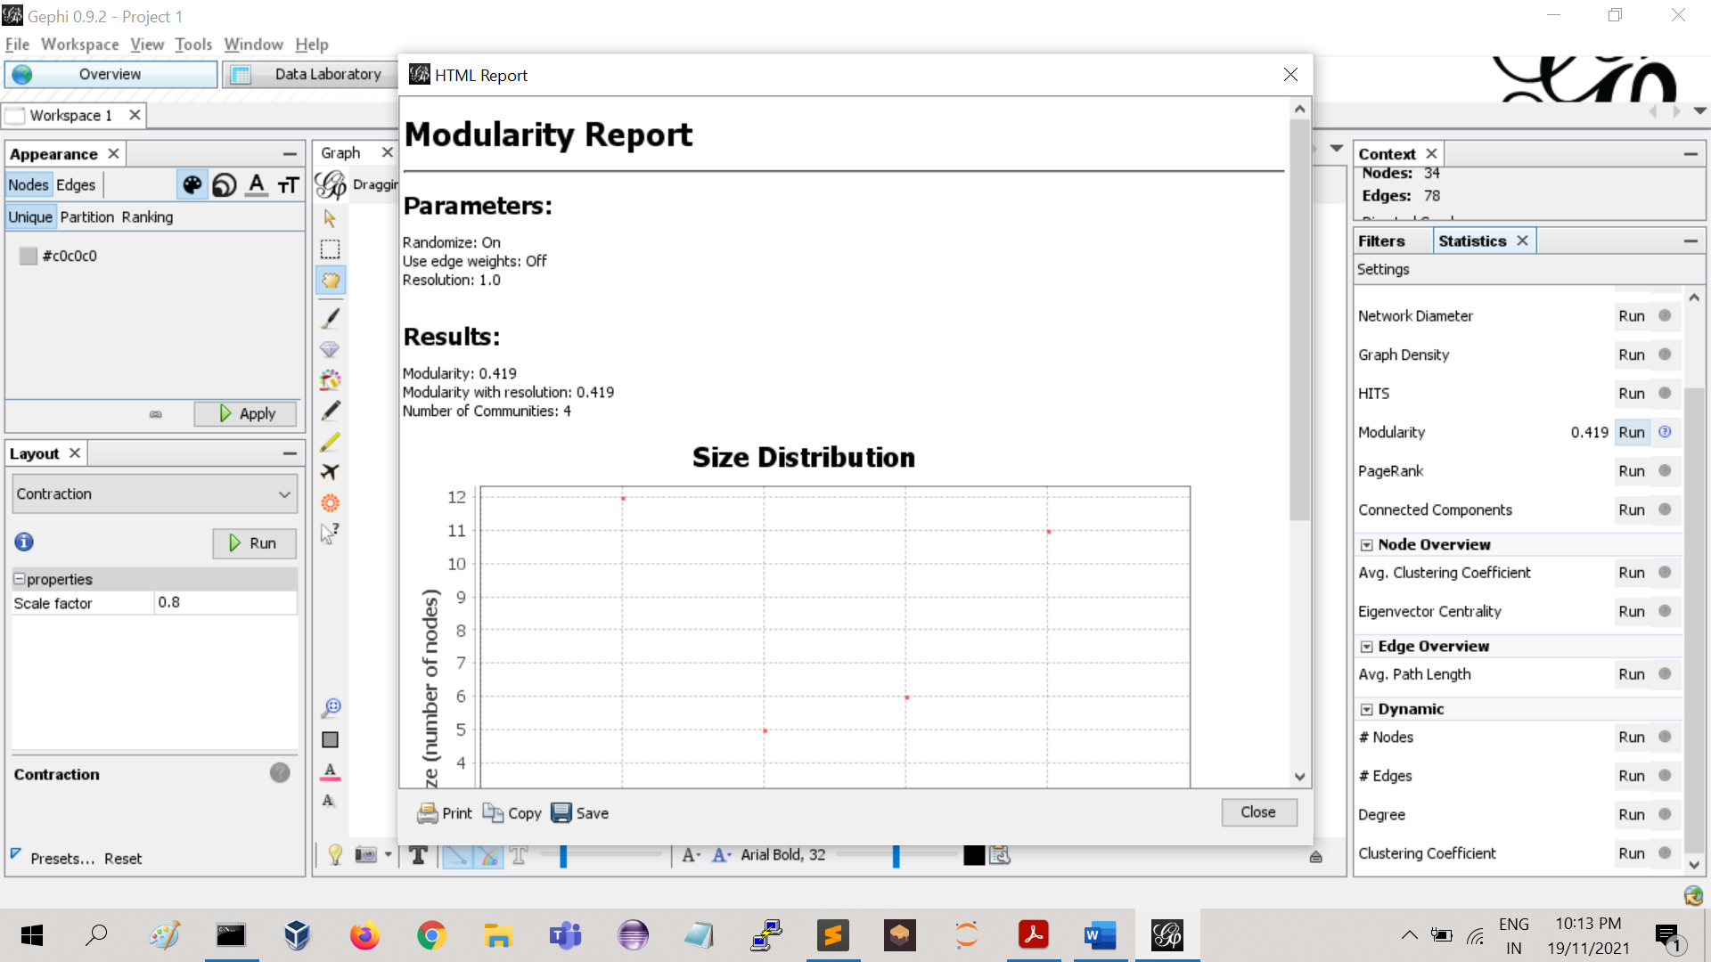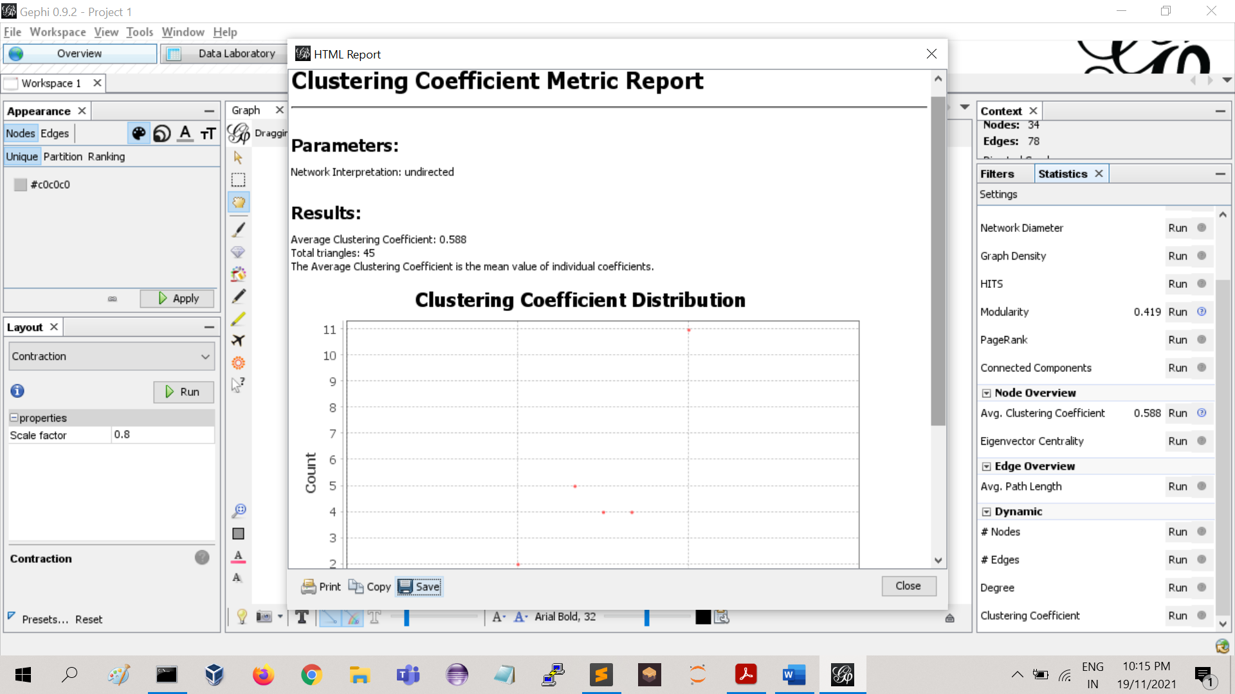

1. **Dolphins Dataset**

