# **Marketa Analytics**

**Objective**:

As an Algorithmic marketing analyst, we need to build an analytical dashboard to illustrate the value of data driven analytics. The themes to be considered include:

• Pricing

• Promotion

• Search

• Recommendations

**Our POC:**

Our dataset has the following relationships:

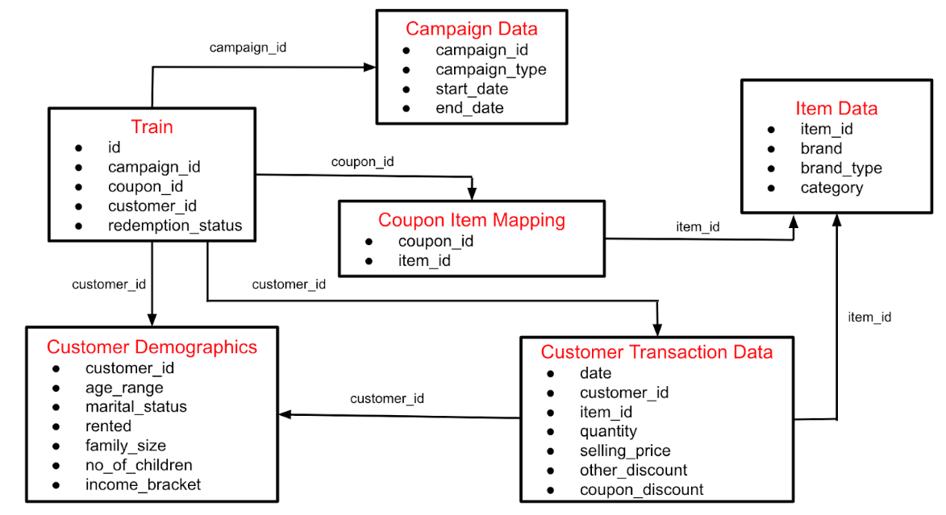

**Data Pre-processing and Data Wrangling**

To remove any kind of anomalies in the dataset (remove null values, duplicate values and fill missing values)

We have used pandas, xsv and trifacta in the event of pre-processing our data for the purpose of building the dashboard.

**What is Search**

For an inventory management system, a search query is defined as the matching user search with the best possible recommendation. Hence, to match this search query, the system uses the concept of collaborative filtering, wherein items are searched and recommended based on an item’s movement in any inventory. For example, a customer A has searched and bought items 1,2,3 and customer B has bought items 1,2,3,4. So the system recommends item 4 to customer A based on the matching search patterns of both customers.

**Recommendation System**

We are using collaborative filtering for building the recommendation system.is a process of making a recommendation or predictions about the interest of a user based on the preferences and tastes of many other users. The predictions made using the collaborative technique are specific to a user but use information obtained from many different users.

**Word Cloud for making recommendation**

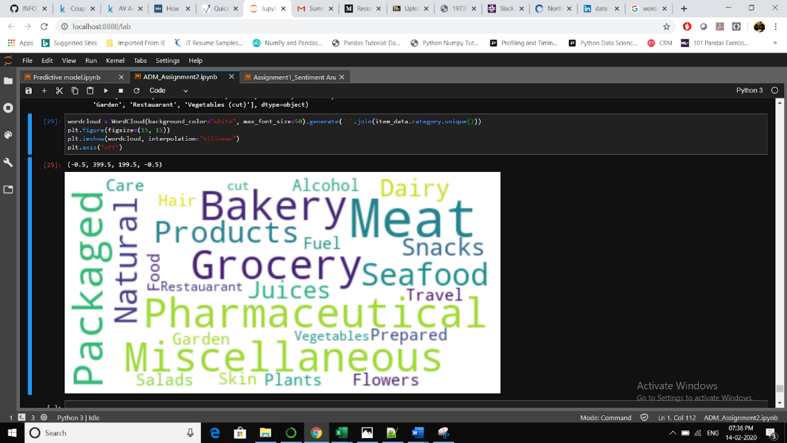

**Dashboards**

We are using Salesforce Einstein Analytics for building different dashboards for the client.

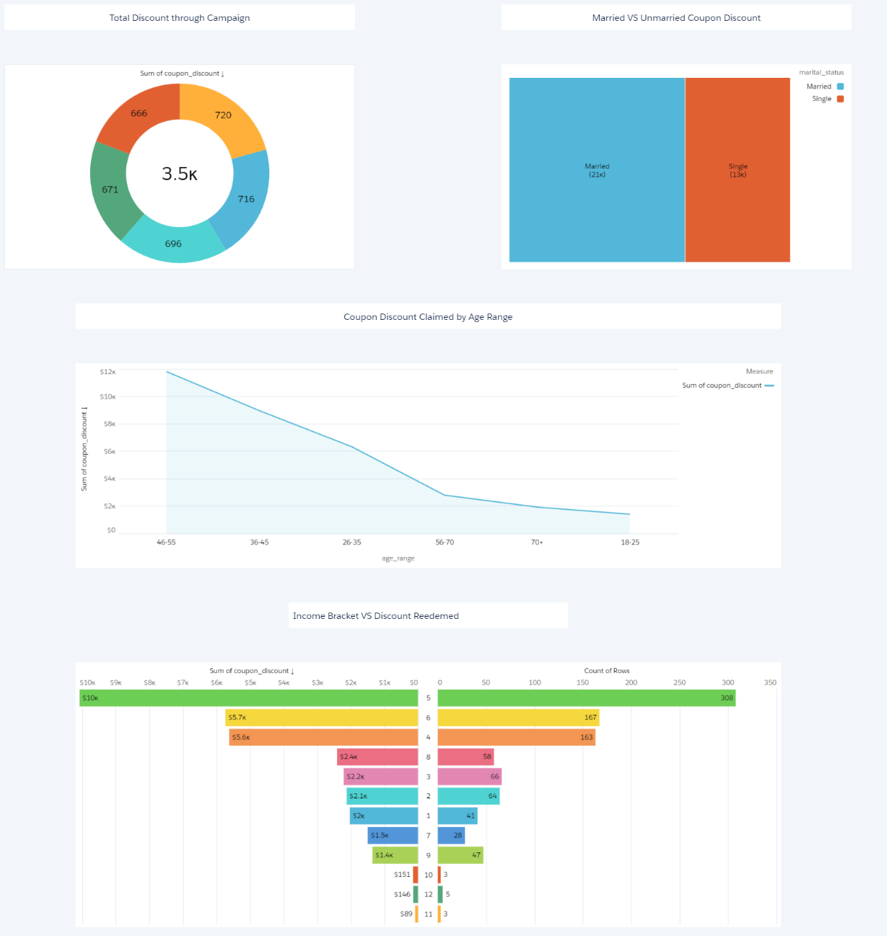

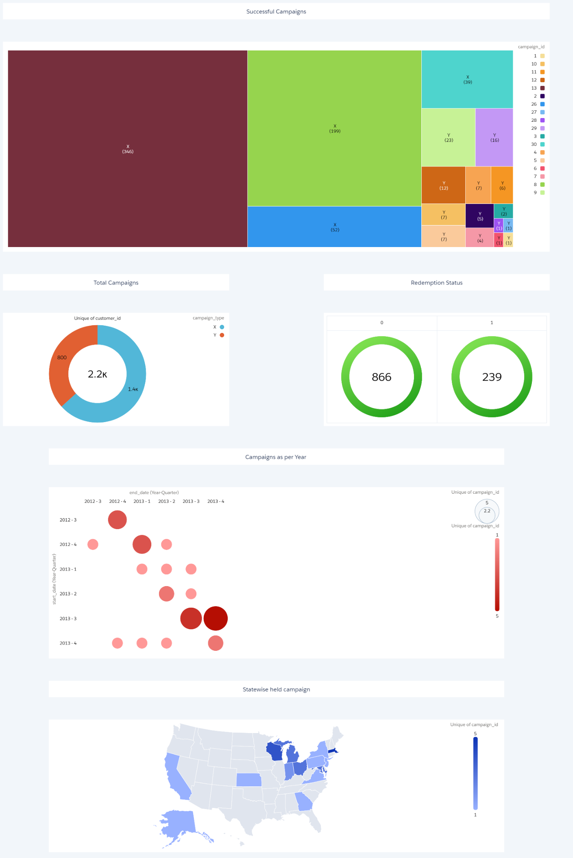

**Stories – We explored stories that are also provided by Einstien Analytics Studio.**

