CORECAR: SMART CLINIC & OPD QUEUE MANAGEMENT SYSTEM
Academic Project Report & In-Depth Technical Specification
_________________________________________________________________________________

1. Project Information & Group Members
Class: TY BSc.IT | Division: A | Academic Year: 2025 - 2026
No. | Student Name | SAP ID | Class & Div | Project Role & Contribution
1 | Sakshi Sardhara | 53013240010 | TY BSc.IT - A | Frontend Architecture, UI/UX Glassmorphism & Patient Portals
2 | Jia Patel | 53013240016 | TY BSc.IT - A | Doctor Consultation Desk, E-Prescription Engine & Lab Diagnostics
3 | Dharmik Bosamia | 53013240021 | TY BSc.IT - A | Database Schema, Spring Data JPA Repositories & Data Seeding
4 | Keval Doshi | 53013240009 | TY BSc.IT - A | Security (JWT/RBAC), Real-Time Queue Engine & System Integration
Project Executive Overview: CareCore is an integrated hospital and outpatient department (OPD) queue management system built using Spring Boot 3, Hibernate JPA, PostgreSQL/H2, Spring Security with stateless JWT, and modern JavaScript. It replaces manual paper-based hospital queueing with real-time algorithmic token sequencing, automated patient check-in, electronic health records (EHR), dynamic e-prescribing, pathology diagnostic workflows, and administrative compliance governance.

2. System Requirements Specification (SRS)

A. Functional Requirements (FR)
- FR-1: Patient Booking & Self-Service Registration: Interactive 3-step appointment scheduling wizard, Leaflet GIS clinic branch locator, symptom triage AI assistant, and self-service token kiosks for walk-in patients.
- FR-2: Real-Time OPD Queue & Token Lifecycle Engine: Algorithmic per-doctor daily token sequencing, doctor queue control desk (Call Next, Skip, Recall), live waiting room TV display board with high-visibility Now Serving highlights, and real-time announcement tickers.
- FR-3: Doctor Clinical Desk & Electronic Health Records (EHR): Consultation dashboard with patient vitals tracking (BP, Pulse, Temp, SpO2), past appointment timelines, digital E-Prescription generator with dynamic pharmacy search, and ICD-10 diagnostic catalog lookup.
- FR-4: Pathology & Diagnostic Laboratory Workflow: Diagnostic order requisitions (CBC, Lipid Profile, Biochemistry, Radiology), order completion tracking, and integrated PDF diagnostic report viewer.
- FR-5: Front-Desk Reception & QR Check-In: Staff check-in terminal with instant patient identity lookup, QR code check-in scanning, and token assignment.
- FR-6: Pharmacy Inventory & Invoicing Ledger: Real-time medicine stock tracking with threshold alerts (In Stock, Low Stock, Out of Stock), multi-mode checkout (Cash, UPI/QR, Card), and daily cash register audit ledger.
- FR-7: Admin Governance & Executive Analytics: Doctor application approval workflow verifying medical council registration numbers, doctor service suspension toggle, and hospital executive analytics dashboards.

B. Non-Functional Requirements (NFR)
- NFR-1: Security & Role-Based Access Control (RBAC): Stateless JWT authentication filter (JwtAuthFilter) with HMAC-SHA256 signature verification, BCrypt password hashing, and strict role segregation (ROLE_ADMIN, ROLE_DOCTOR, ROLE_PATIENT).
- NFR-2: Performance & Low Latency: Sub-50ms REST API response times powered by Spring Boot 3, Hibernate JPA indexed queries, and lightweight asynchronous polling for live hospital display screens.
- NFR-3: Reliability & Data Consistency: ACID-compliant transactional boundaries preventing duplicate token issuance, automated schema management, and persistent seed data loading.
- NFR-4: Usability & Modern Aesthetics: Responsive dark-mode and glassmorphism UI designed for high contrast and readability on medical displays, desktops, and mobile devices.
- NFR-5: Maintainability & Architectural Modularity: Clean Layered Architecture (Controllers -> Services -> Repositories -> JPA Entities) with dual-key JSON serialization ensuring 100% backward compatibility.

Screen 1: Main Public Landing & Consultation Booking Page
File Path: src/main/resources/static/index.html | Context Scope: Public Patient Facing & General Visitor Context
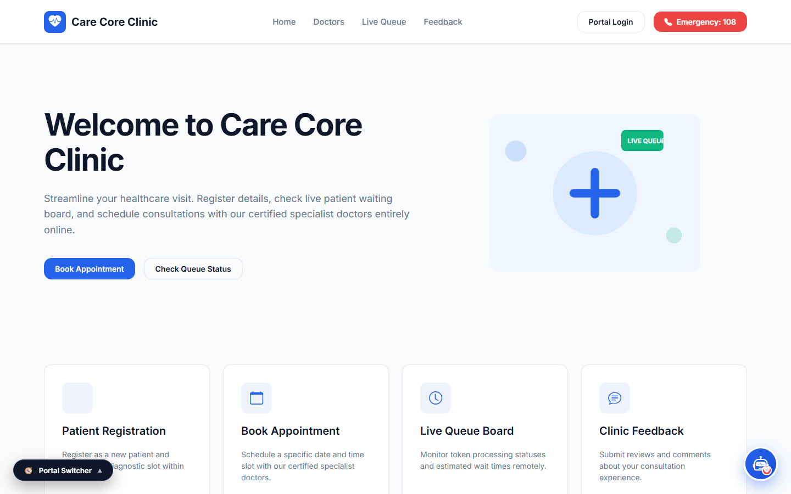
1. Functional Overview & Capabilities: Serves as the primary digital front door for hospital patients. It features a hero banner presenting real-time operational statistics (Average Wait Time: 7 mins, Active Doctors on Duty, Total Patients Consulted Today), navigation links to specialized clinic services, and quick-action buttons for online appointment booking and live queue tracking.
2. User Interaction & Operational Workflow: When a visitor enters the portal, they can browse medical departments (Cardiology, Dermatology, Orthopedics, General Medicine), view doctor credentials, launch the 3-step booking wizard, or open the floating AI Medical Assistant for preliminary symptom guidance. Submitting the booking form triggers automated token creation.
3. Backend Architecture & Data Flow: Connects to GET /api/clinic/data and GET /api/clinics/locations in PublicQueueController. Form submissions dispatch to POST /api/public/appointments in AppointmentController, creating linked records in the 'patients', 'tokens', and 'appointments' tables simultaneously.

Screen 2: Alternate Modern Healthcare Homepage Design
File Path: src/main/resources/static/homepage_design.html | Context Scope: Modernized Multi-Specialty Clinic Showcase Context

1. Functional Overview & Capabilities: An alternate, highly modernized homepage design tailored for multi-specialty healthcare networks. Showcases hospital accreditation, advanced diagnostic facilities (MRI, CT Scan, 2D Echo), doctor profiles with patient star ratings, and instant telehealth consultation links.
2. User Interaction & Operational Workflow: Patients explore specialized clinical departments through interactive cards. Each doctor card displays medical qualification, clinical experience, consultation fee, and live availability badges ('Available Today' vs 'On Leave'). Clicking 'Book Slot' navigates the patient directly to the schedule selector.
3. Backend Architecture & Data Flow: Consumes REST endpoints GET /api/patient/doctors and GET /api/doctor-availability. Uses responsive CSS Grid and glassmorphism styling to deliver a modern visual experience on both desktop and mobile viewports.

Screen 3: Live Hospital OPD Queue Display Board
File Path: src/main/resources/static/display.html | Context Scope: Public Waiting Hall & Large Wall-Mounted TV Display Context
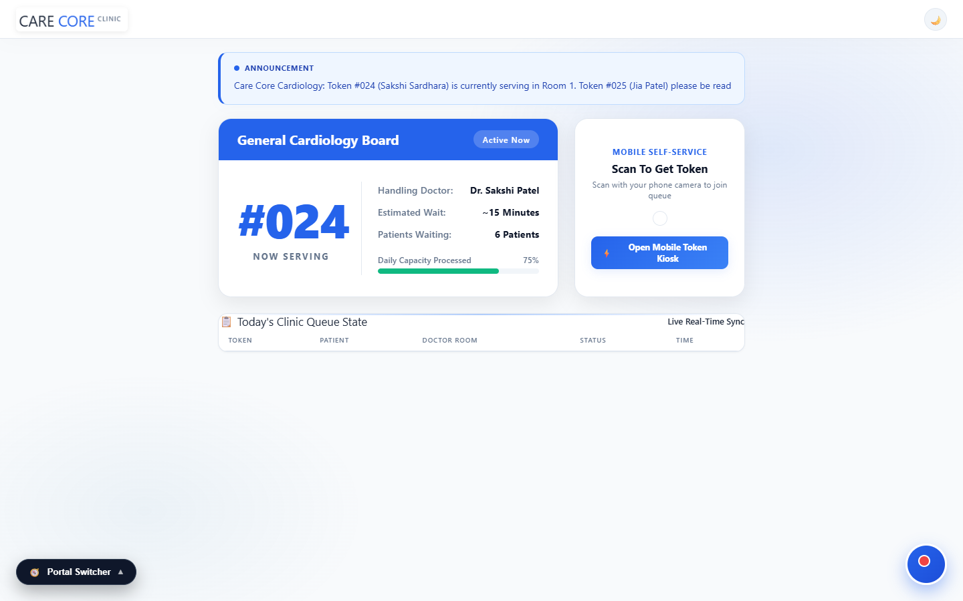
1. Functional Overview & Capabilities: Designed specifically for large TV screens in hospital waiting areas. Features a high-contrast 'Now Serving' token callout (#024 Now Serving), doctor OPD counter statuses, live scrolling announcement ticker, and an on-screen QR code for patient smartphone synchronization.
2. User Interaction & Operational Workflow: The display polls the backend every 3 seconds to reflect real-time doctor actions. When a doctor clicks 'Call Next' in their consultation portal, the display board instantly flashes the new token number, highlights the doctor's room number, and updates the active queue counter.
3. Backend Architecture & Data Flow: Consumes GET /api/queue/state in PublicQueueController and GET /api/notice/get in NoticeController. Implements async DOM updates to ensure zero flicker and smooth scrolling on continuous 24/7 TV hardware operation.

Screen 4: Modern Doctor Consultation & Queue Control Desk
File Path: src/main/resources/static/doctor_portal_design.html | Context Scope: Authenticated Medical Practitioner Workspace (ROLE_DOCTOR)
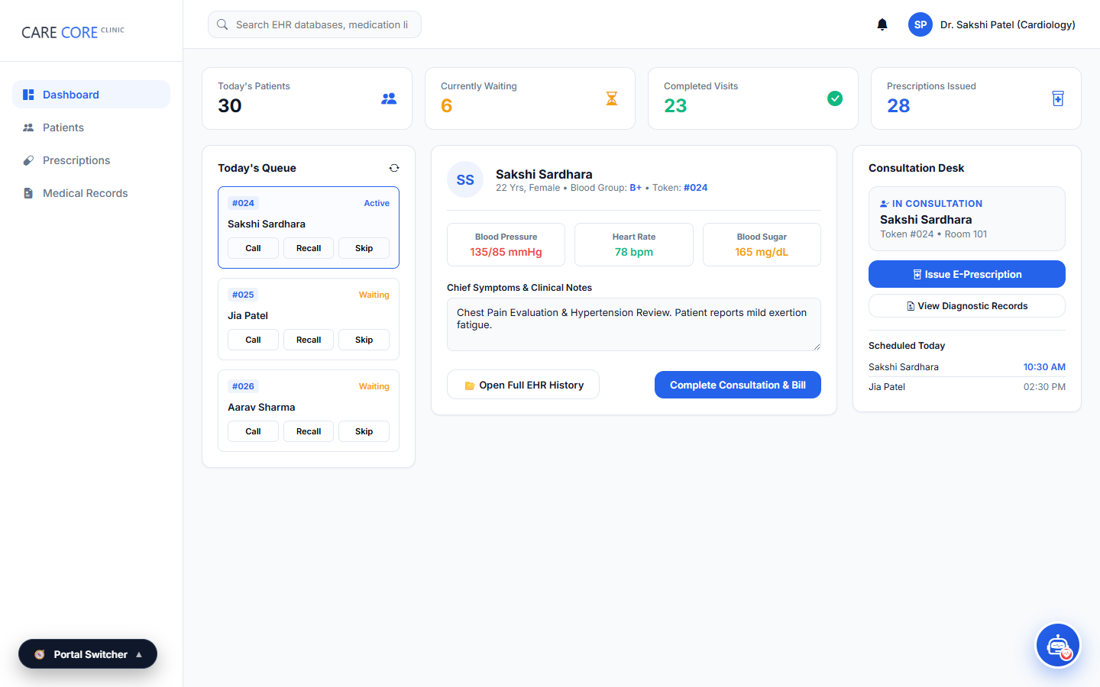
1. Functional Overview & Capabilities: The primary clinical workstation for on-duty doctors. Combines real-time queue management buttons (Call Next, Skip, Recall), the active patient consultation panel, and doctor performance KPI cards (Total Patients Seen, Waiting Queue Count, Average Consultation Time).
2. User Interaction & Operational Workflow: Doctors log in with their credentials to view their daily assigned patient queue. Clicking 'Call Next Patient' advances the queue, sets the token status to 'in_progress', updates the waiting room display, and loads the patient's medical history for examination.
3. Backend Architecture & Data Flow: Secured via JwtAuthFilter. Dispatches to POST /api/queue/next, POST /api/queue/skip, and POST /api/queue/recall in DoctorController. Employs Spring Security role authorization requiring ROLE_DOCTOR or ROLE_ADMIN.

Screen 5: Doctor Clinical Examination & EHR Prescription Desk
File Path: src/main/resources/static/doctor.html | Context Scope: Clinical EHR, Diagnosis & Prescription Creation Context
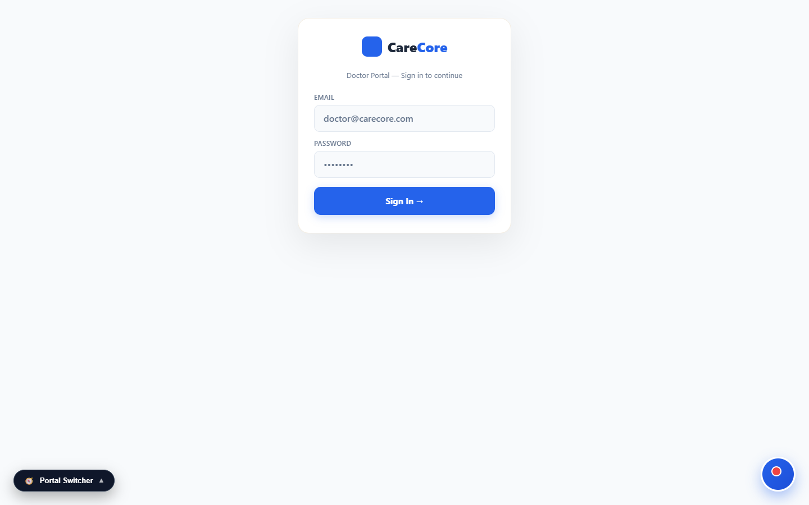
1. Functional Overview & Capabilities: A specialized clinical workstation providing full patient EHR history, recorded vital signs (BP, Pulse, Temperature, SpO2), standardized ICD-10 diagnosis selection, and an integrated E-Prescription generator with dynamic pharmacy inventory searching.
2. User Interaction & Operational Workflow: During consultation, the clinician reviews the patient's past medical history, records symptoms, selects standardized ICD-10 diagnostic codes, types prescribed medications with automatic dosage recommendations, and generates an official digital prescription.
3. Backend Architecture & Data Flow: Connects to GET /api/admin/patients/{id}/profile, GET /api/clinical-catalog (ICD-10 codes), and GET /api/inventory/prescription-items in InventoryController. Prescriptions update the database and trigger automatic stock quantity decrements.

Screen 6: Hospital Executive Management & Analytics Portal
File Path: src/main/resources/static/admin_portal_design.html | Context Scope: Authenticated Hospital Administrator (ROLE_ADMIN)
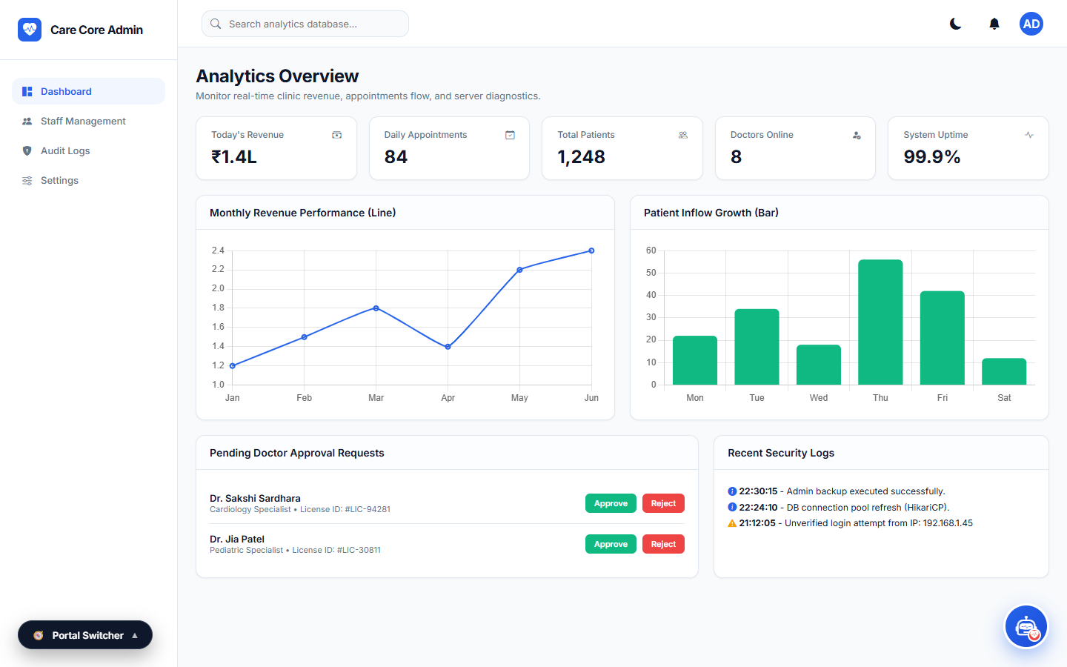
1. Functional Overview & Capabilities: Central administrative dashboard for hospital directors and medical superintendents. Displays executive KPI metrics (Total Doctors, Active OPD Patients, Total Appointments, Pending Approvals, Total Revenue) and provides compliance verification tools.
2. User Interaction & Operational Workflow: Hospital administrators review newly registered doctors, inspect medical council registration numbers, approve or reject applications, manage doctor service suspensions, and audit patient records across all clinical departments.
3. Backend Architecture & Data Flow: Secured with ROLE_ADMIN role enforcement in SecurityConfig. Consumes GET /api/admin/analytics, GET /api/admin/doctors, and POST /api/admin/doctors/{id}/approve in AdminController with dual-key JSON mapping.

Screen 7: Admin Verification & Regulatory Governance Desk
File Path: src/main/resources/static/admin.html | Context Scope: Administrative Regulatory Compliance & Master Registry Context
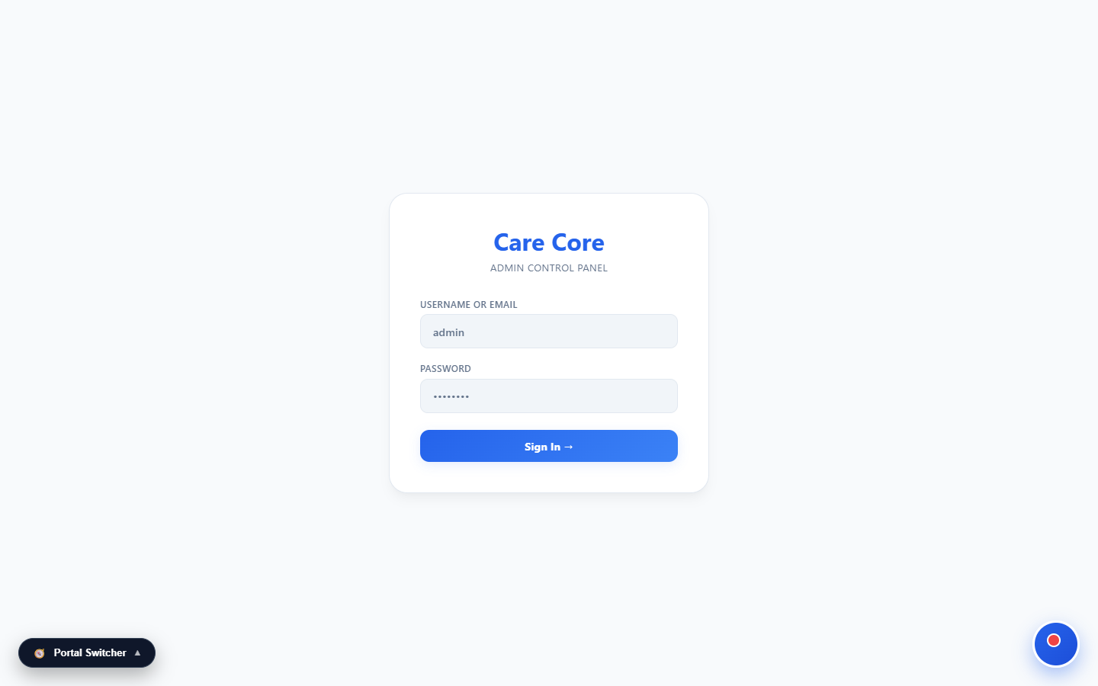
1. Functional Overview & Capabilities: Dedicated compliance workspace for managing doctor onboarding pipelines, inspecting uploaded medical licenses, managing practitioner suspensions, and viewing master hospital registries.
2. User Interaction & Operational Workflow: Administrators filter doctor applications by status ('pending', 'approved', 'suspended'). Clicking 'Approve' sets approvalStatus to 'approved', activates the doctor's consultation counters, and enables patient bookings.
3. Backend Architecture & Data Flow: Dispatches to GET /api/admin/doctors?status=pending and POST /api/admin/doctors/{id}/suspend. Updates the 'doctors' table in the database and records administrator approval timestamps.

Screen 8: Receptionist Front-Desk & Walk-In Token Terminal
File Path: src/main/resources/static/staff_portal_design.html | Context Scope: Receptionist & Clinic Front-Office Operations Context
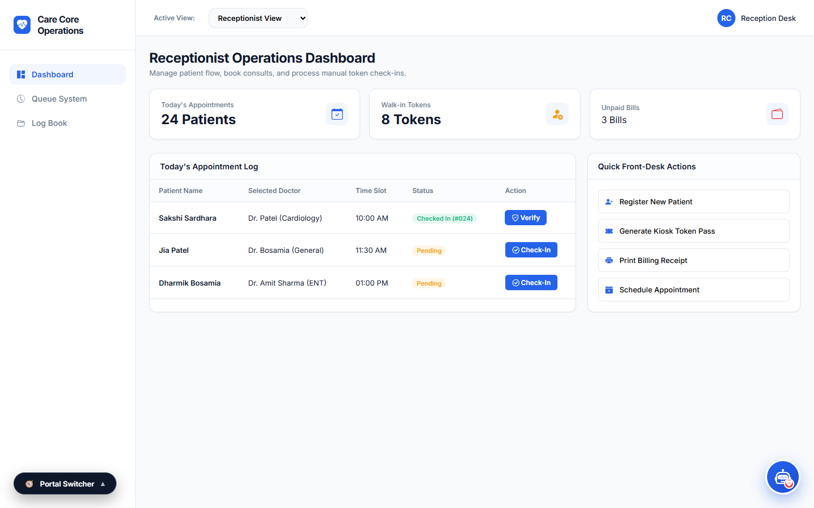
1. Functional Overview & Capabilities: Front-desk terminal for hospital reception staff. Facilitates rapid walk-in patient check-in, identity verification, automatic token generation, and load-balanced patient assignment across available on-duty doctors.
2. User Interaction & Operational Workflow: Receptionists search for existing patients by phone number or register new walk-ins. Upon clicking 'Check In', the terminal assigns the patient to the next available doctor counter and issues a printed/digital queue token.
3. Backend Architecture & Data Flow: Connects to GET /api/admin/patients, POST /api/queue/token, and POST /api/appointments/{id}/approve in AppointmentController, transitioning scheduled bookings to active 'waiting' tokens.

Screen 9: Modern Patient Live Queue & Wait-Time Portal
File Path: src/main/resources/static/patient_portal_design.html | Context Scope: Mobile & Desktop Patient Self-Tracking Context (ROLE_PATIENT)
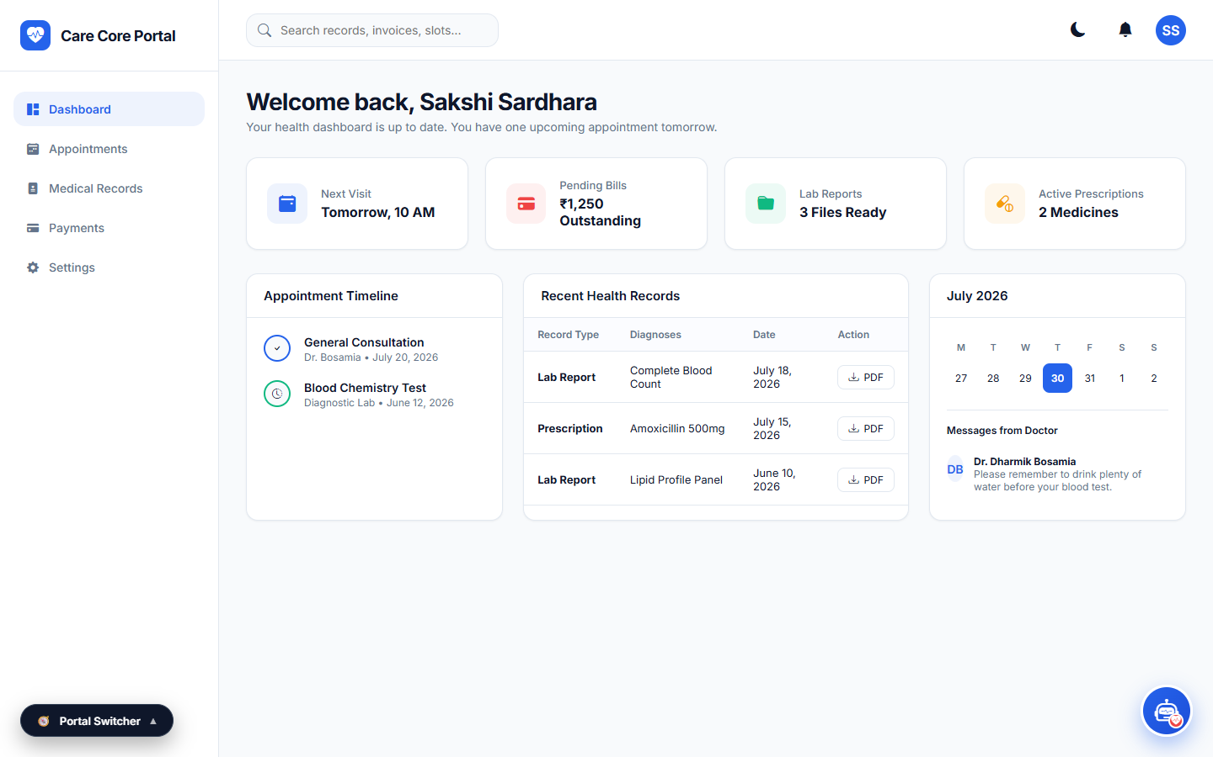
1. Functional Overview & Capabilities: A dedicated mobile-responsive queue portal for patients. Displays their allocated Token Number, current token being served in the consultation chamber, estimated waiting time in minutes, number of patients ahead, and assigned OPD room number.
2. User Interaction & Operational Workflow: Patients access this portal on their smartphones by scanning the lobby QR code or entering their token number. The interface automatically updates in real time, alerting patients when their turn is approaching.
3. Backend Architecture & Data Flow: Consumes GET /api/queue/state and GET /api/appointments?contact=... in PublicQueueController. Lightweight async JSON polling ensures minimal mobile data consumption.

Screen 10: Patient Self-Service Queue & Kiosk Portal
File Path: src/main/resources/static/portal.html | Context Scope: Lobby Touchscreen Self-Service Kiosk Context
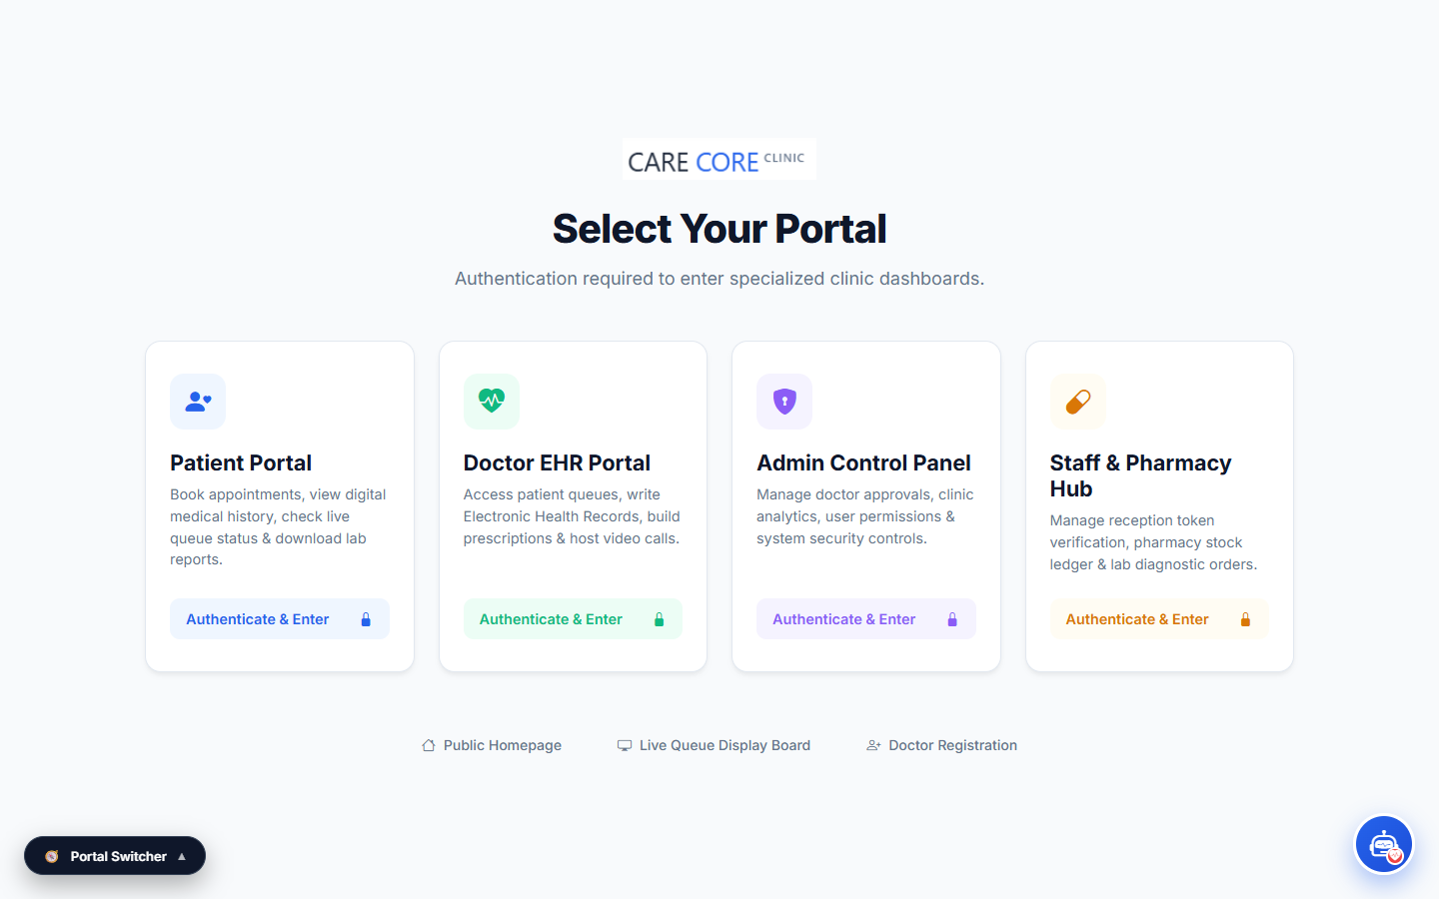
1. Functional Overview & Capabilities: A self-service kiosk portal designed for waiting lounge touchscreen terminals. Enables patients to view on-duty doctor schedules, check current queue depths, and generate instant walk-in consultation tokens.
2. User Interaction & Operational Workflow: Patients tap on their desired department or doctor, enter their contact phone number, and receive an instant token receipt showing their queue number and estimated consultation time.
3. Backend Architecture & Data Flow: Dispatches to GET /api/clinic/data and POST /api/queue/token. Manages transactional state in QueueStateRepository to ensure sequential, collision-free token numbering.

Screen 11: Self-Service OPD Token Dispenser Kiosk
File Path: src/main/resources/static/generate-token.html | Context Scope: Dedicated Lobby Hardware Kiosk Terminal Context
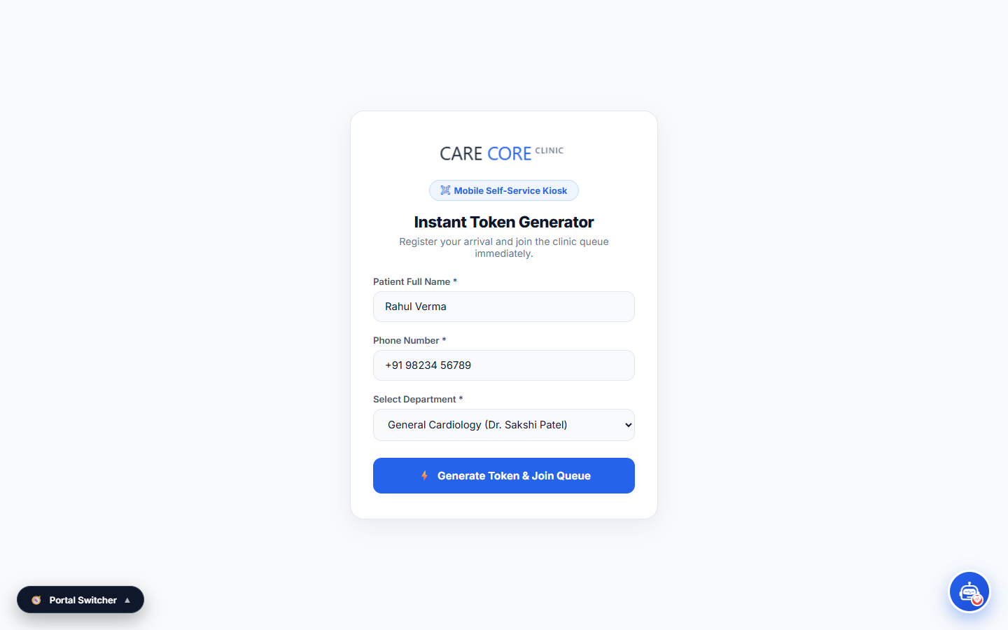
1. Functional Overview & Capabilities: A high-contrast, large-button touchscreen interface designed for standalone kiosk hardware in clinic entry lobbies. Provides an effortless token generation process for patients of all technical skill levels.
2. User Interaction & Operational Workflow: The user enters their basic details (Name, Age, Mobile) and selects a department. The kiosk calls the backend, registers the patient, issues a token, and displays an animated confirmation card.
3. Backend Architecture & Data Flow: Connects to POST /api/queue/token in PublicQueueController. Automatically creates a Patient entity if not already registered, increments the daily token counter in 'queue_states', and outputs structured token data.

Screen 12: QR Code Patient Queue Check-In Scanner
File Path: src/main/resources/static/queue-checkin.html | Context Scope: Contactless Mobile QR Code Check-In Context
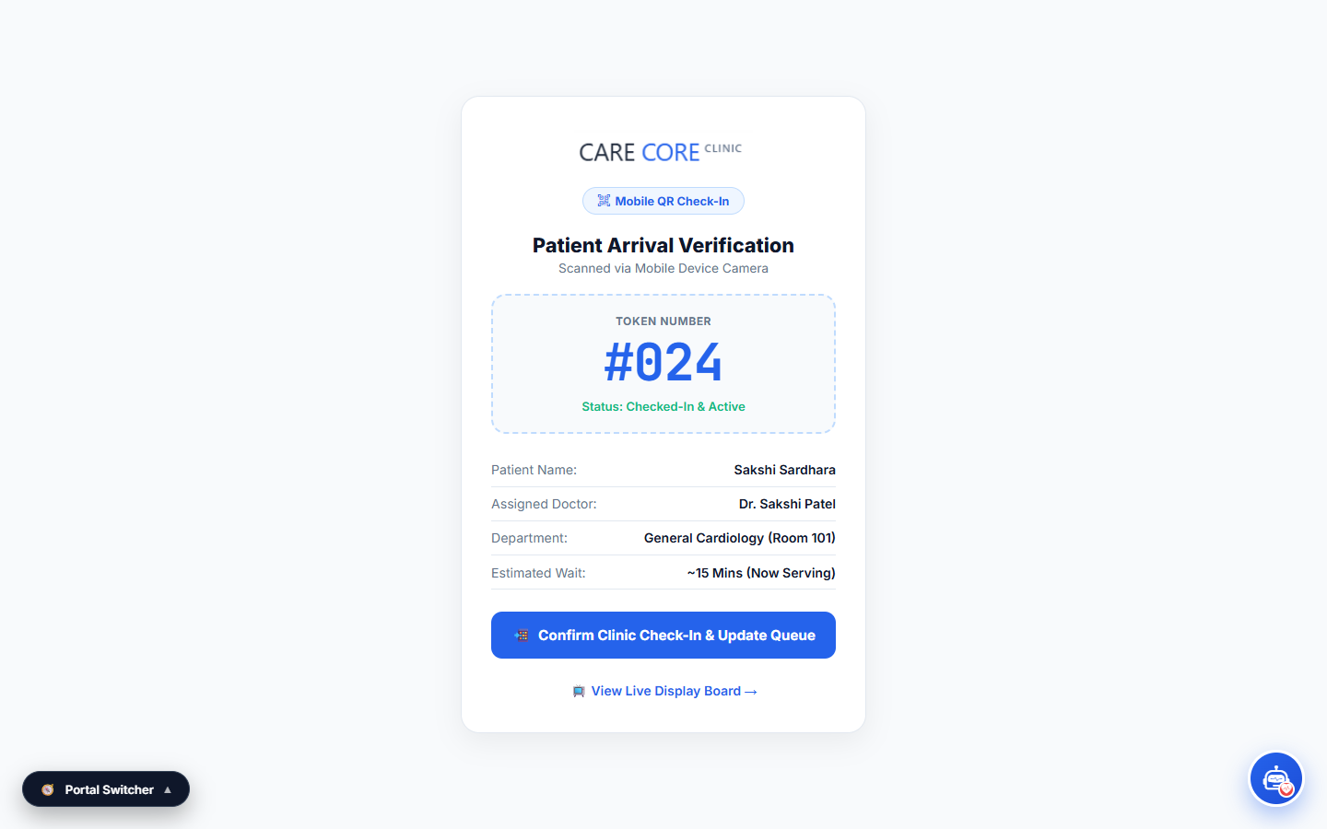
1. Functional Overview & Capabilities: Contactless mobile web interface. Patients arriving at the clinic scan a physical QR code posted at the hospital entrance to automatically check in for their scheduled appointment without waiting in the reception queue.
2. User Interaction & Operational Workflow: The patient scans the lobby QR code with their mobile device, enters their appointment reference or registered mobile number, and confirms check-in. The system updates their status from 'Booked' to 'Arrived / Waiting in Queue'.
3. Backend Architecture & Data Flow: Connects to POST /api/appointments/{id}/approve in AppointmentController, changing the appointment state to 'approved' and generating an active token in the 'tokens' table.

Screen 13: Doctor Onboarding & Medical Council Registration Portal
File Path: src/main/resources/static/register.html | Context Scope: Medical Practitioner Onboarding & Licensing Context
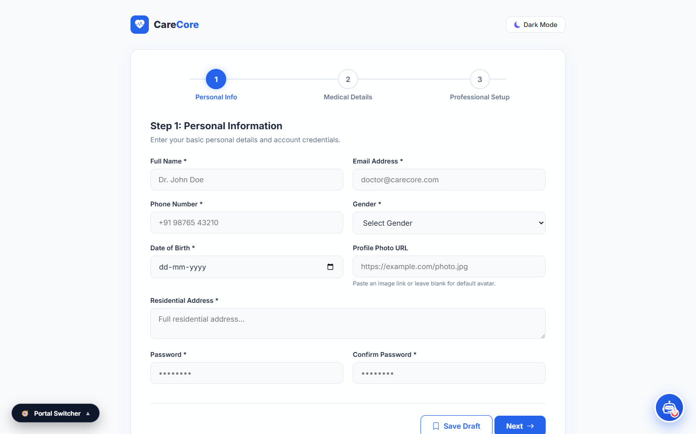
1. Functional Overview & Capabilities: A secure registration portal for physicians wishing to join the clinic network. Captures full doctor profile details, medical council registration numbers, specialization, consultation fees, and qualification documents for compliance review.
2. User Interaction & Operational Workflow: Doctors fill out the registration form and submit their credentials. The system encrypts the password with BCrypt, stores the doctor record with status 'pending', and alerts hospital administrators for verification.
3. Backend Architecture & Data Flow: Connects to POST /api/auth/register-doctor in AuthController. Performs duplicate email and registration number checks before saving the new Doctor entity in the database.

Screen 14: Hospital Executive Analytics & Workload Dashboard
File Path: src/main/resources/static/dashboard_design.html | Context Scope: Enterprise Hospital Operations & Departmental Analytics Context
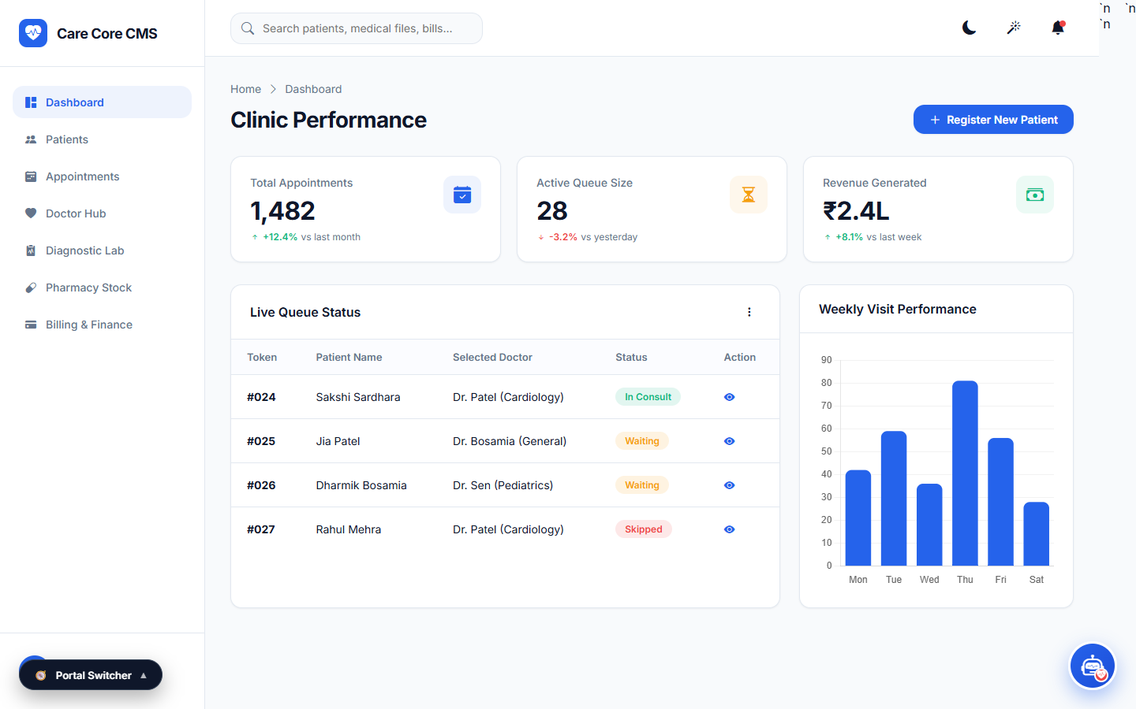
1. Functional Overview & Capabilities: Comprehensive executive analytics visualization portal featuring hospital departmental workload heatmaps, OPD queue throughput metrics, patient satisfaction ratings, and revenue financial summaries.
2. User Interaction & Operational Workflow: Hospital management monitors peak OPD consultation hours, analyzes doctor efficiency, tracks pharmacy inventory turnover, and audits daily financial cash registers.
3. Backend Architecture & Data Flow: Consumes GET /api/admin/analytics and GET /api/reports/cash-register in BillingController, aggregating billing collections across cash, UPI, and credit card payment methods.

Screen 15: Receptionist Patient Verification & Check-In Modal
File Path: src/main/resources/static/staff_portal_design.html (Interactive Modal) | Context Scope: Front-Office Modal Dialog & Token Issuance Context
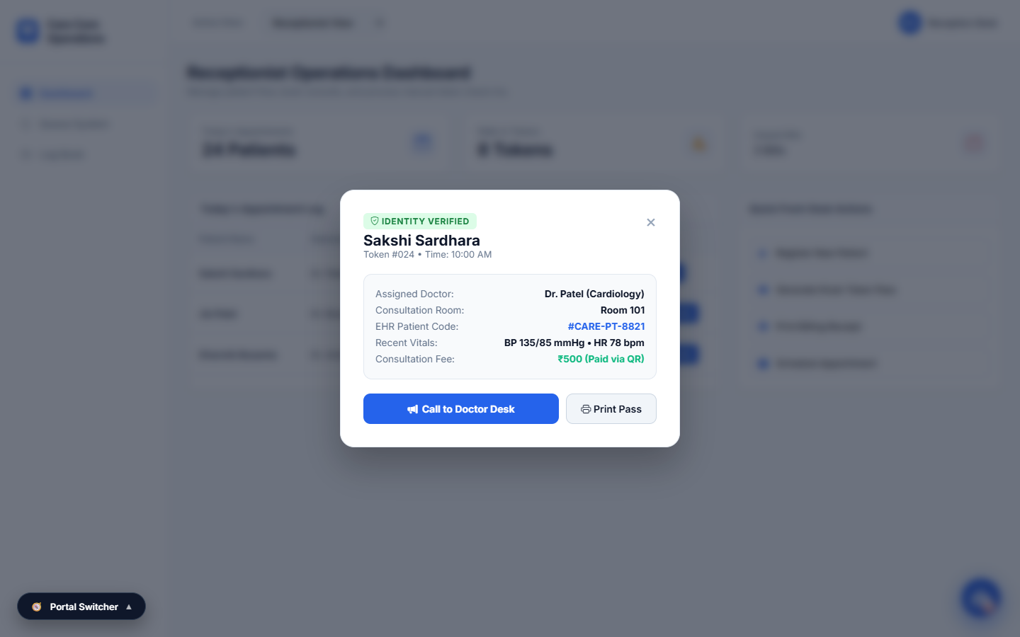
1. Functional Overview & Capabilities: An interactive modal dialog that pops up on the reception terminal when a patient arrives. Allows staff to verify patient credentials, confirm contact details, select the attending doctor, and issue an official queue token.
2. User Interaction & Operational Workflow: Reception staff enter the patient's phone number or appointment ID. The modal populates with the patient's details. Staff click 'Confirm Check-In', which generates a queue token and adds the patient to the doctor's active waiting table.
3. Backend Architecture & Data Flow: Dispatches to POST /api/appointments/{id}/approve and POST /api/queue/token, creating linked token entries and updating the doctor's queue state in real time.

4. Technical Architecture & System Deliverables
The CareCore Smart Clinic & OPD Queue Management System represents a comprehensive, production-ready healthcare management solution. Built using modern software engineering principles, the system incorporates:
- Backend Framework: Spring Boot 3.2+ with Java 17 LTS (RESTful Controllers, Service Layer, Repository Pattern).
- Database & ORM: Hibernate 6 / JPA with PostgreSQL / H2 Database and automatic index optimization.
- Security & Authentication: Spring Security with Stateless JWT (HMAC-SHA256) Authentication and Role-Based Access Control (RBAC).
- Frontend Technologies: HTML5, CSS3 Glassmorphism, Vanilla ES6+ JavaScript, Leaflet.js Mapping Engine, and Responsive Mobile Viewports.
- Algorithmic Queue Sequencing: Deterministic per-doctor daily token sequencing with real-time state synchronization.

