*T1*

CREATE TABLE CLIENT_MASTER1

(

CLIENT_NO VARCHAR2 (6),

NAME VARCHAR2 (20),

ADDRESS_1 VARCHAR2 (30),

ADDRESS_2 VARCHAR2 (30),

CITY VARCHAR2 (15),

PINCODE NUMBER (8),

STATE VARCHAR2 (15),

BALDUE NUMBER (10,2)

)

*T2*

CREATE TABLE PRODUCT_MASTER1

(

PRODUCT_NO VARCHAR2 (6),

DESCRIPTION VARCHAR2 (15),

PROFITPERCENT NUMBER (4,2),

UNITMEASURE VARCHAR2 (10),

QTYONHAND Number (8),

REORDERLVL Number (8),

SELLPRICE Number (8,2),

COSTPRICE Number (8,2)

)

*T3*

CREATE TABLE SALESMAN_MASTER1

(

SALESMANNO Varchar2 (6),

SALESMANNAME Varchar2 (20),

ADDRESS1 Varchar2 (30),

ADDRESS2 Varchar2 (30),

CITY Varchar2 (20),

PINCODE Number (8),

STATE Varchar2 (20),

SALAMT Number (8,2)

)

#TABLE 1#

INSERT INTO CLIENT_MASTER1 VALUES ('C00001','Ivan Bayross', '', '','Mumbai',400054,'Maharshtra',15000);

INSERT INTO CLIENT_MASTER1 VALUES ('C00002','Mamta Muzumder', '', '','Madras ',780001 ,'Tamil Nadu',0);

INSERT INTO CLIENT_MASTER1 VALUES ('C00003','Chhaya Bankar', '', '','Mumbai',400057,'Maharshtra',5000);

INSERT INTO CLIENT_MASTER1 VALUES ('C00004','Ashwini Joshi', '', '','Bangalore',560001,'Karnataka',0);

INSERT INTO CLIENT_MASTER1 VALUES ('C00005','Hansel Colaco', '', '','Mumbai',400060,'Maharshtra',2000);

INSERT INTO CLIENT_MASTER1 VALUES ('C00006','Deepak Sharma', '', '','Mangalore',560050,'Karnataka',0);

#TABLE 2#

INSERT INTO PRODUCT_MASTER1 VALUES('P00001','T-Shirts',5,'Piece',200,50,350,250)

INSERT INTO PRODUCT_MASTER1 VALUES('P0345','Shirts',6,'Piece',150,50,500,350)

INSERT INTO PRODUCT_MASTER1 VALUES('P06734','Cotton Jeans',5,'Piece',100,20,600,450)

INSERT INTO PRODUCT_MASTER1 VALUES('P07865','Jeans',5,'Piece',100,20,750,500)

INSERT INTO PRODUCT_MASTER1 VALUES('P07868','Trousers',2,'Piece',150,50,850,550)

INSERT INTO PRODUCT_MASTER1 VALUES('P07885','Pull Overs',2.5,'Piece',80,30,700,450)

INSERT INTO PRODUCT_MASTER1 VALUES('P07965','Denim Shirts',4,'Piece',100,40,350,250)

INSERT INTO PRODUCT_MASTER1 VALUES('P07975','Lycra Tops',5,'Piece',70,30,300,175)

INSERT INTO PRODUCT_MASTER1 VALUES('P08865','T-Shirts',5,'Piece',75,30,450,300)

#TABLE 3#

INSERT INTO SALESMAN_MASTER1 VALUES('S00001','AMAN','A/14','WORLI','MUMBAI','400002','MAHARASHTRA','3500')

INSERT INTO SALESMAN_MASTER1 VALUES('S00002','OMKAR','65','NARIMAN','MUMBAI',400001,'MAHARASTRA',4000)

INSERT INTO SALESMAN_MASTER1 VALUES('S00003','RAJ','P-7','BANDRA','MUMBAI',400032,'MAHARASTRA',5000)

INSERT INTO SALESMAN_MASTER1 VALUES('S00004','ASHISH','A/5','JUHU','MUMBAI',400044,'MAHARASTRA',3500)

INSERT INTO SALESMAN_MASTER1 VALUES('S00005','HARSH','H/14','ANDHERI','MUMBAI',400045,'MAHARASTRA',4500)

QUERYS

4:SELECT NAME FROM CLIENT_MASTER1

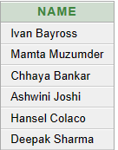

5:SELECT DISTINCT NAME FROM CLIENT_MASTER1

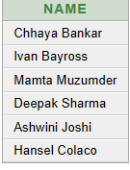

6:SELECT *FROM CLIENT_MASTER1 ORDER BY NAME DESC

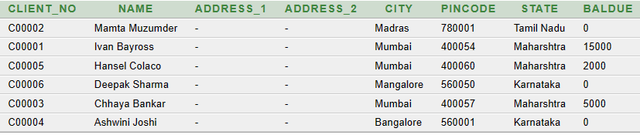

7:SELECT *FROM CLIENT_MASTER1 ORDER BY BALDUE ASC

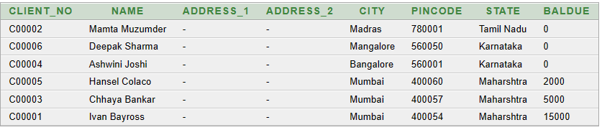

8:SELECT NAME,CITY FROM CLIENT_MASTER1

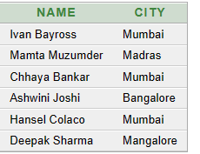

9:SELECT *FROM CLIENT_MASTER1

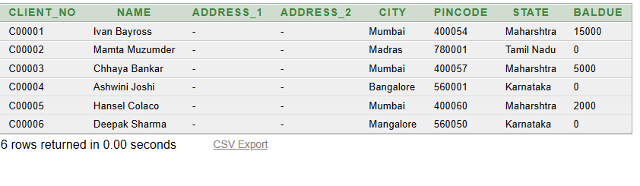

10:SELECT CLIENT_NO,NAME,ADDRESS_1,ADDRESS_2,CITY,PINCODE,STATE,BALDUE FROM CLIENT_MASTER1



11:SELECT * FROM CLIENT_MASTER1 WHERE NAME='KRISHNA'



12:SELECT CITY,PINCODE FROM CLIENT_MASTER1 WHERE NAME='Krishna'



13:SELECT PINCODE FROM CLIENT_MASTER1 WHERE NAME='Krishna' AND City='Mumbai'



14:SELECT CITY,PINCODE FROM CLIENT_MASTER1 WHERE NAME='Krishna' AND City='Mumbai'



15:SELECT CITY,PINCODE FROM CLIENT_MASTER1 WHERE NAME='Krishna' AND NOT City='Mumbai'



16:SELECT CITY,PINCODE FROM CLIENT_MASTER1 WHERE NAME='Krishna' AND City='Delhi' AND BALDUE=5000



17:SELECT DISTINCT DESCRIPTION FROM PRODUCT_MASTER1

