**Self Driving Car**

This is a project in which we are autonomously driving car.

**Problem Statement and Problem Definition**

* Build a Deep Learning model that would let a car drive by itself around the track in a driving simulator.
* It is supervised regression problem between the car steering angles and the road images in real-time from the camera of a car.

**Models**

**Dataset:**

* Udacity Self Driving Car Simulator
* Recording
* After recording we have two files.
* Images
* .csv file

**How to Run?**

To run our project follow the below steps:

1) open anaconda go into our file section where all these files are.

2) type: “conda activate myenviron” (without quotes) to activate the environment.

3) type: python drive.py

4) open udacity self driving car simulator.

5) after drive.py run on simulator choose display dimension and click on autonomous mode.

6) car running automatically.

**Google Colab**

#importing modules

#importing datasets

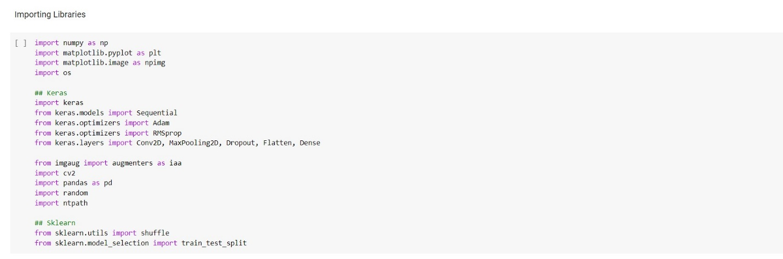

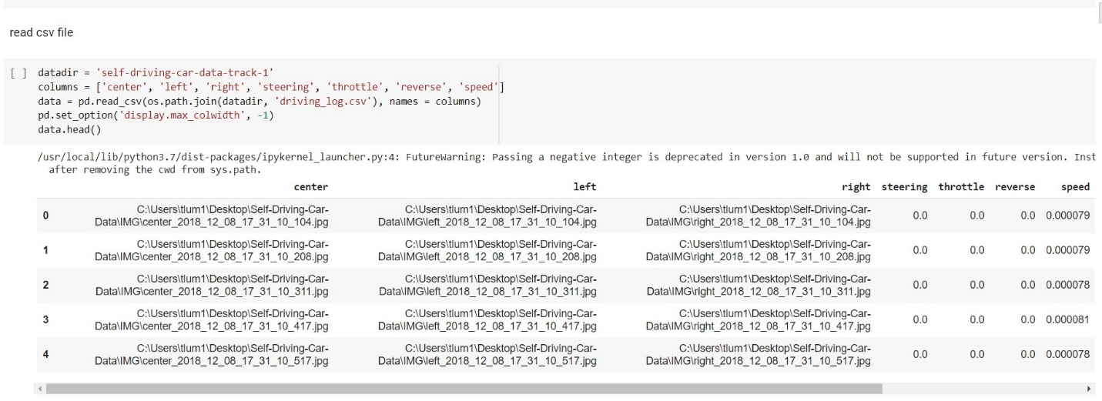

#We are retrieving the contents of CSV file using the above command

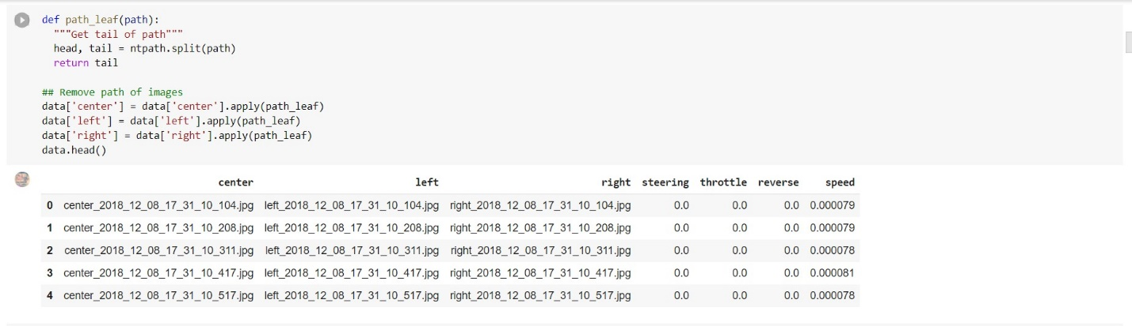

#We need to remove the initial name of image so that it becomes easy to train the model. It is done using the above command.

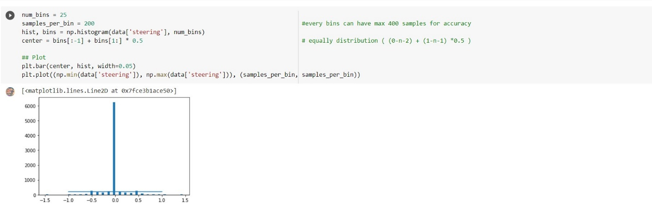

#From this bar plot clearly see that we need max 200 samples for each steering angle. Here we see around 6000 steering angle's value is '0'. which means our car go straight which leads inaccuracy in our model so we iterate through all steering angle and append index of steering angle in list which lies between two bins then => for example: Here around 6000 data values are '0'. So, we add all index of those data in list and shuffle it then remove some random indexes.

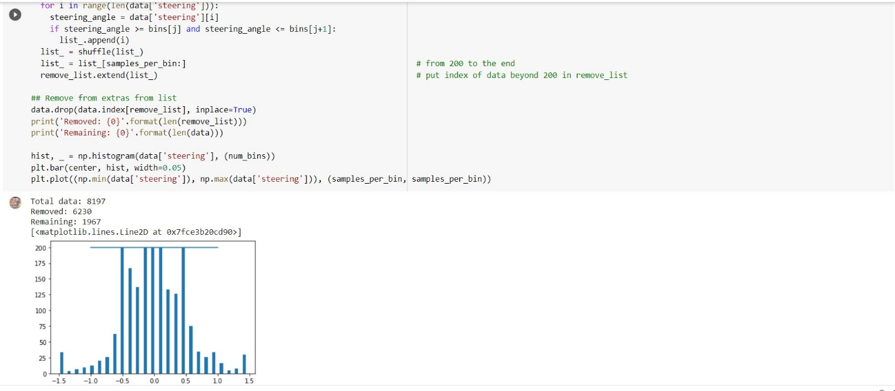

#Total data: 8197

#Removed: 6230

#Remaining: 1967

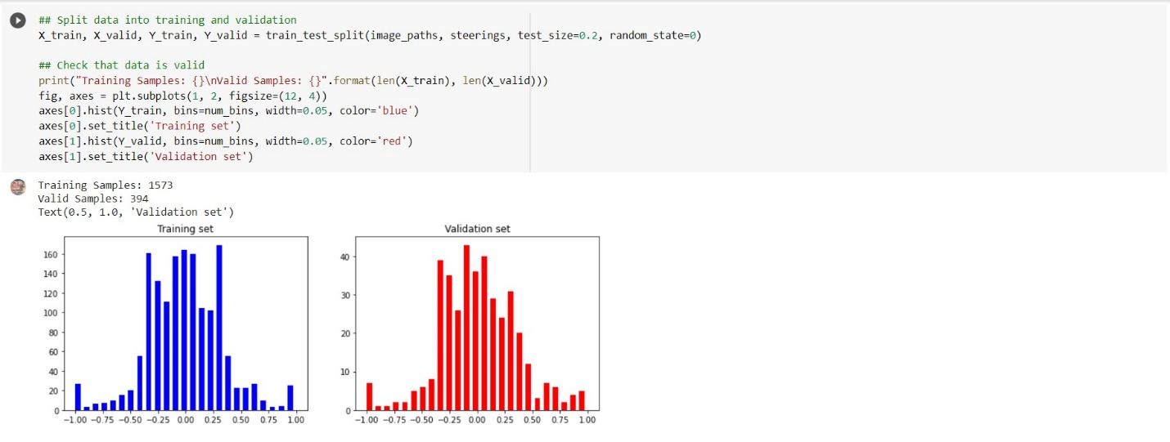

# Done image augmentation

**Live Demo**

We have made a live demo of autonomously Self driving car using Udacity simulator. Below are the images which are taken from camera of autonomous self driving car showing different type of image taken from camera.

**Self Driving Car**

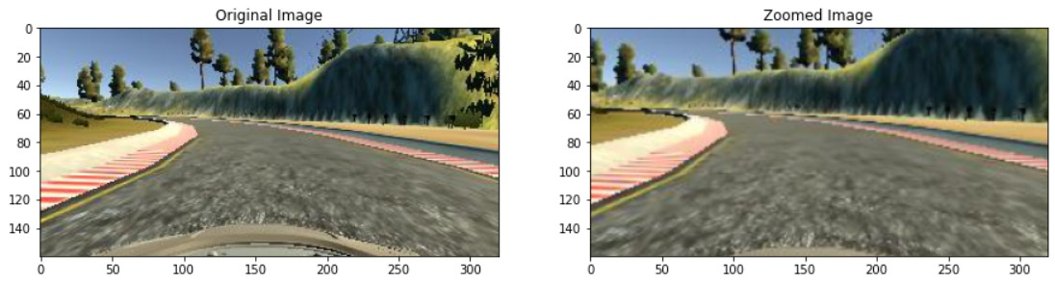

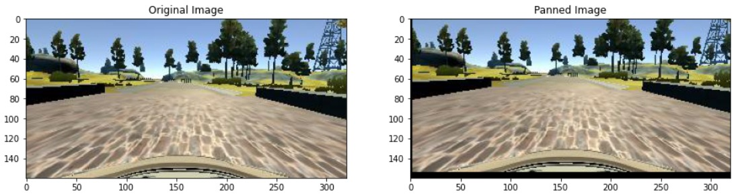

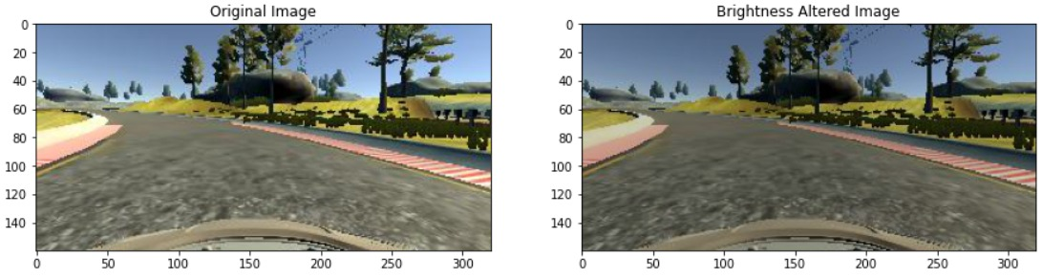

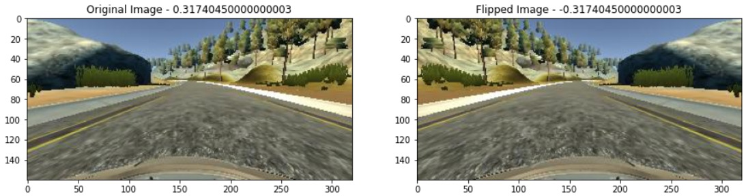

**References**

Dataset and Features:

* https://github.com/udacity/self-driving-car-sim

Research Papers:

* For Self Driving Car:
* <https://images.nvidia.com/content/tegra/automotive/images/2016/solutions/pdf/end-to-end-dl-using-px.pdf>

**Future Scope**

* As our project gives 90% accuracy while driving, it can be further used for lane detection when different vehicles are also there.
* The project can further be modified and developed for further large scale projects.