VISVESVARAYA TECHNOLOGICAL UNIVERSITY
“JnanaSangama”, Belgaum -590014, Karnataka.


LAB REPORT

On

ANALYSIS AND DESIGN OF ALGORITHMS (23CS4PCADA)

Submitted by

Kevan Patira (1BF24CS136)

in partial fulfillment for the award of the degree of
BACHELOR OF ENGINEERING
in
COMPUTER SCIENCE AND ENGINEERING



B.M.S. COLLEGE OF ENGINEERING
(Autonomous Institution under VTU)
BENGALURU-560019
February to June 2026

CERTIFICATE

B. M. S. College of Engineering,
Bull Temple Road, Bangalore 560019
(Affiliated To Visvesvaraya Technological University, Belgaum)
Department of Computer Science and Engineering



This is to certify that the Lab work entitled “ANALYSIS AND DESIGN OF ALGORITHMS” carried out by Kevan Patira(1BF24CS136), who is a bonafide student of B. M. S. College of Engineering. It is in partial fulfillment for the award of Bachelor of Engineering in Computer Science and Engineering of the Visvesvaraya Technological University, Belgaum during the year 2025-26. The Lab report has been approved as it satisfies the academic requirements in respect of Analysis and Design of Algorithms Lab - (23CS4PCADA) work prescribed for the said degree.

Dr. Manjula S Dr. Kavitha Sooda
Assistant Professor Professor and Head
Department of CSE Department of CSE
BMSCE, Bengaluru BMSCE, Bengaluru

Index Sheet
Sl.  No. | Experiment Title | Page No.
1 | Write a program to obtain the Topological ordering of vertices in a given digraph.
2 | Implement Johnson Trotter algorithm to generate permutations.
3 | Sort a given set of N integer elements using Merge Sort technique and compute its time taken. Run the program for different values of N and record the time taken to sort.
4 | Sort a given set of N integer elements using Quick Sort technique and compute its time taken.
5 | Sort a given set of N integer elements using Heap Sort technique and compute its time taken.
6 | Implement 0/1 Knapsack problem using dynamic programming. (5 Marks)
7 | Implement All Pair Shortest paths problem using Floyd’s algorithm.
8 | - Find Minimum Cost Spanning Tree of a given undirected graph using Prim’s algorithm.  - Find Minimum Cost Spanning Tree of a given undirected graph using Kruskal’s algorithm.
9 | Implement Fractional Knapsack using Greedy technique.
10 | From a given vertex in a weighted connected graph, find shortest paths to other vertices using Dijkstra’s algorithm.
11 | Implement “N-Queens Problem” using Backtracking.

Course outcomes:
CO1 | Analyze time complexity of algorithms using asymptotic notations.
CO2 | Apply various algorithm design techniques for the given problem.
CO3 | Evaluate the appropriate algorithm/design technique for solving a given problem.
CO4 | Conduct practical experiments by applying appropriate algorithm design a technique to solve problems.

Lab program 1:
CODE:

#include <stdio.h>
#define MAX 10
int graph[MAX][MAX], indegree[MAX], queue[MAX];
int n;

void topologicalSort() {
int front = 0, rear = 0;
int count = 0, i, j;

for (i = 0; i < n; i++) {
indegree[i] = 0;
for (j = 0; j < n; j++)
indegree[i] += graph[j][i];
}

for (i = 0; i < n; i++)
if (indegree[i] == 0)
queue[rear++] = i;
printf("Topological Ordering: ");
while (front < rear) {
int v = queue[front++];
printf("%d ", v);
count++;
for (i = 0; i < n; i++)
if (graph[v][i] == 1) {
indegree[i]--;
if (indegree[i] == 0)
queue[rear++] = i;
}
}
if (count != n) {
printf("\nGraph contains a cycle. Topological sort not possible.\n");
}
}

int main() {
int i, j;

printf("Enter number of vertices: ");
scanf("%d", &n);

printf("Enter adjacency matrix:\n");
for (i = 0; i < n; i++) {
for (j = 0; j < n; j++) {
scanf("%d", &graph[i][j]);
}
}
topologicalSort();

return 0;
}

OUTPUT:

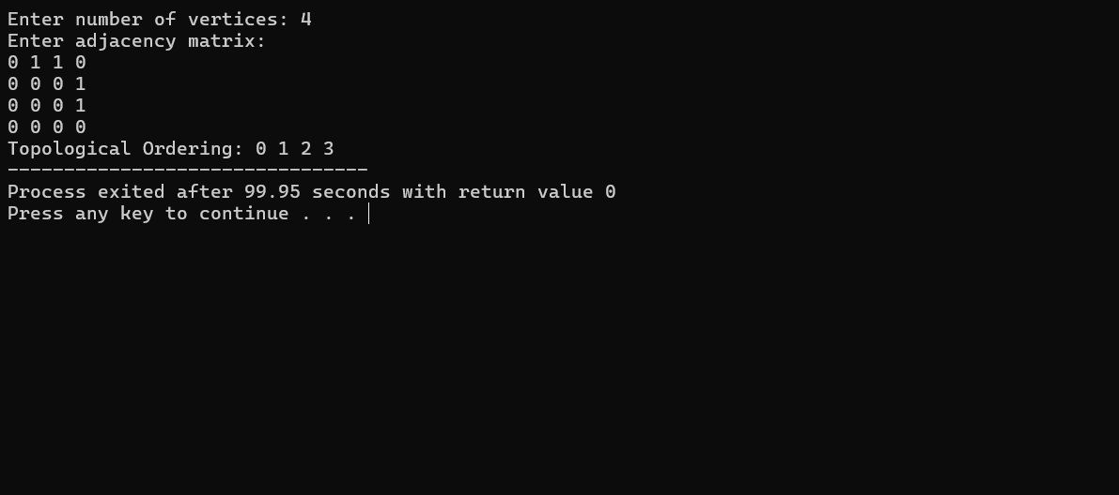

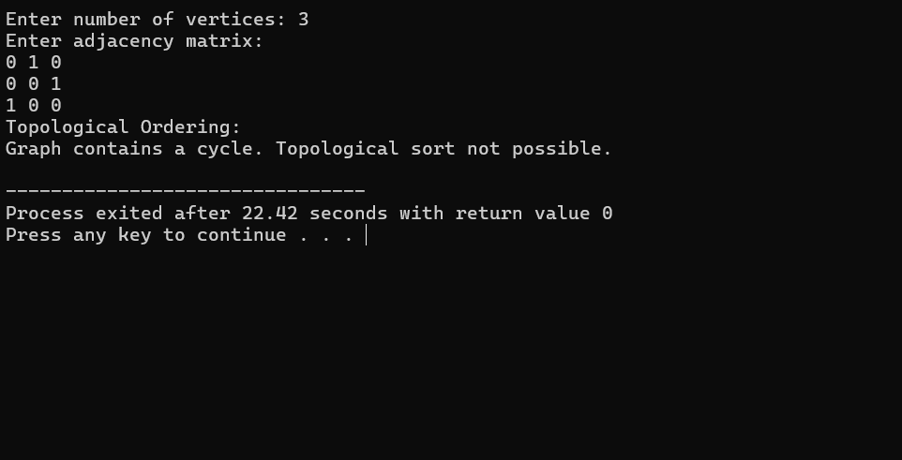

GRAPH:
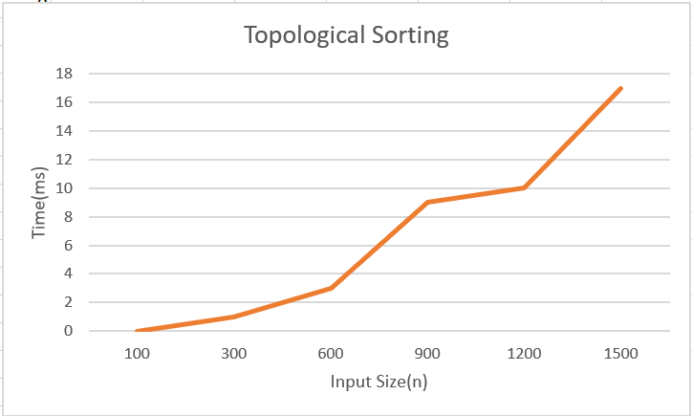

LEETCODE 207.Course Schedule

CODE:
#include <stdbool.h>
bool canFinish(int numCourses, int** prerequisites, int prerequisitesSize, int* prerequisitesColSize){
int graph[2000][2000] = {0};
int indegree[2000] = {0};
int queue[2000];
int front = 0, rear = 0;
int count = 0;
for(int i = 0; i < prerequisitesSize; i++){
int a = prerequisites[i][0];
int b = prerequisites[i][1];
graph[b][a] = 1;
indegree[a]++;
}
for(int i = 0; i < numCourses; i++){
if(indegree[i] == 0){
queue[rear++] = i;
}
}
while(front < rear){
int node = queue[front++];
count++;
for(int i = 0; i < numCourses; i++){
if(graph[node][i] == 1){
indegree[i]--;
if(indegree[i] == 0){
queue[rear++] = i;
}
}
}
}
return (count == numCourses);
}

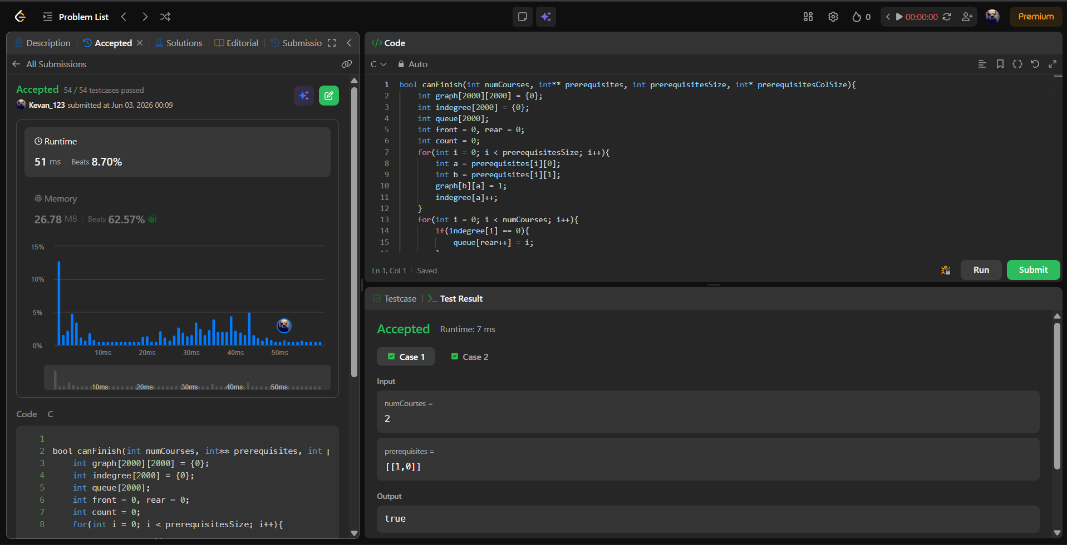
OUTPUT:
Lab program 2:
CODE:
#include <stdio.h>

#define LEFT -1
#define RIGHT 1

int mobile(int p[], int d[], int n) {
int maxMobile = 0,i;

for ( i = 0; i < n; i++) {

if (d[i] == LEFT &&
i > 0 &&
p[i] > p[i - 1] &&
p[i] > maxMobile) {

maxMobile = p[i];
}
if (d[i] == RIGHT &&
i < n - 1 &&
p[i] > p[i + 1] &&
p[i] > maxMobile) {
maxMobile = p[i];
}
}
return maxMobile;
}

int main() {

int i,n;
printf("Enter value of n: ");
scanf("%d", &n);

int p[10], d[10];

for (i = 0; i < n; i++) {
p[i] = i + 1;
d[i] = LEFT;
}

while (1) {

for ( i = 0; i < n; i++) {
printf("%d ", p[i]);
}
printf("\n");

int m = mobile(p, d, n);

if (m == 0)
break;

int pos = -1;

for ( i = 0; i < n; i++) {
if (p[i] == m) {
pos = i;
break;
}
}
int next = pos + d[pos];
int temp = p[pos];
p[pos] = p[next];
p[next] = temp;
temp = d[pos];
d[pos] = d[next];
d[next] = temp;
for (i = 0; i < n; i++) {
if (p[i] > m) {
d[i] = -d[i];
}
}
}
return 0;
}
OUTPUT:

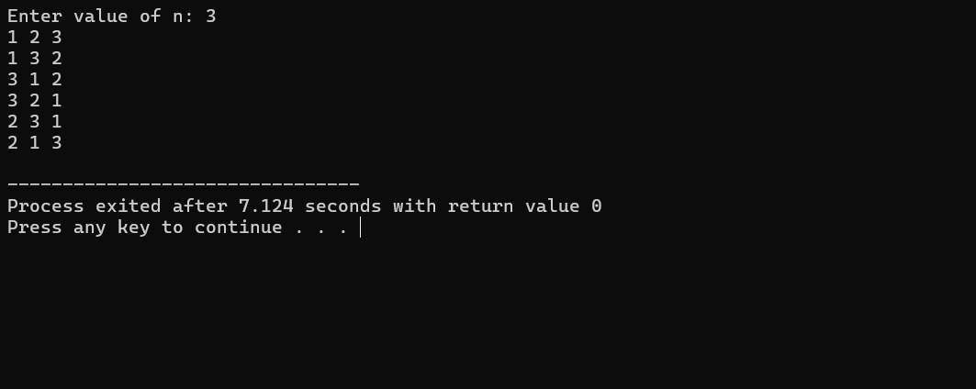

Lab program 3:
CODE:

#include <stdlib.h>
#include <stdio.h>
#include <time.h>

void merge(int low, int mid, int high, int *a) {

int i = low;
int j = mid + 1;
int k = low;

int temp[high + 1];

while (i <= mid && j <= high) {

if (a[i] < a[j])
temp[k++] = a[i++];
else
temp[k++] = a[j++];
}

while (i <= mid)
temp[k++] = a[i++];

while (j <= high)
temp[k++] = a[j++];

// Copy back
for (i = low; i <= high; i++)
a[i] = temp[i];
}

void mergeSort(int low, int high, int *a) {
if (low >= high)
return;

int mid = (low + high) / 2;

mergeSort(low, mid, a);
mergeSort(mid + 1, high, a);

merge(low, mid, high, a);
}

int main() {
int n;
printf("Enter size: ");
scanf("%d", &n);

int a[n];
for (int i = 0; i < n; i++)
a[i] = rand() % 1000;

clock_t stTime = clock();
mergeSort(0, n - 1, a);
clock_t endTime = clock();
double t =
((double)(endTime - stTime))
/ CLOCKS_PER_SEC;

printf("\nSorted Array:\n");
for (int i = 0; i < n; i++)
printf("%d ", a[i]);

printf("\n\nTime Taken: %.4f ms\n", t * 1000);

return 0;
}

OUTPUT:

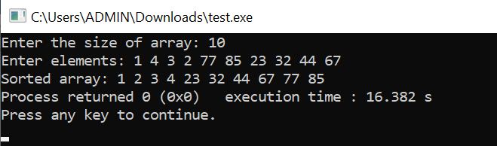

GRAPH:

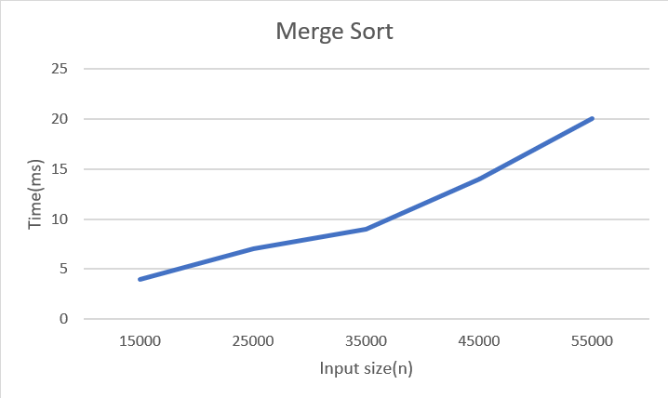

LEETCODE 912.Sort an Array

CODE:

void merge(int arr[], int low, int mid, int high) {
int i = low, j = mid + 1, k = low;
int temp[high + 1];
while (i <= mid && j <= high) {
if (arr[i] <= arr[j])
temp[k++] = arr[i++];
else
temp[k++] = arr[j++];
}
while (i <= mid)
temp[k++] = arr[i++];
while (j <= high)
temp[k++] = arr[j++];
for (int p = low; p <= high; p++)
arr[p] = temp[p];
}
void mergeSort(int arr[], int low, int high) {
if (low < high) {
int mid = (low + high) / 2;
mergeSort(arr, low, mid);
mergeSort(arr, mid + 1, high);
merge(arr, low, mid, high);
}
}
int* sortArray(int* nums, int numsSize, int* returnSize) {
mergeSort(nums, 0, numsSize - 1);
*returnSize = numsSize;
return nums;
}

OUTPUT:

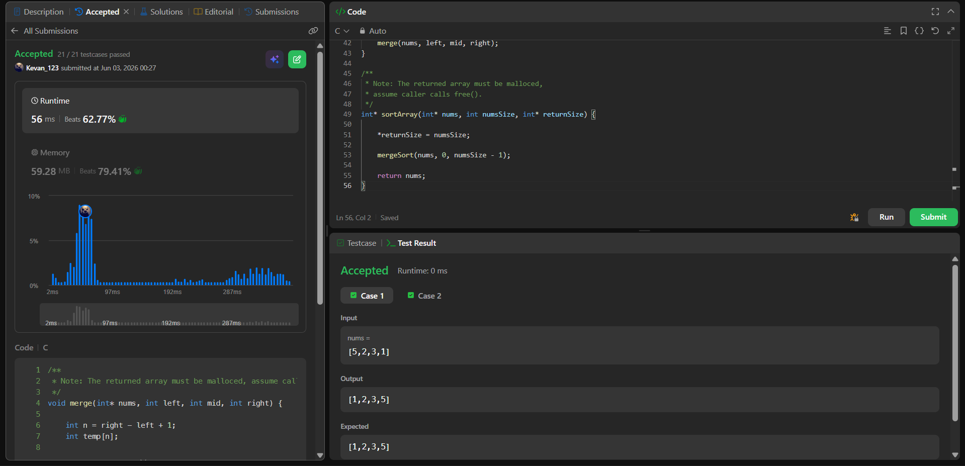

Lab program 4:
CODE:

#include<stdio.h>
#include<time.h>
#include<stdlib.h>
void quicksort(int low,int high,int arr[]);
int partition(int low,int high,int arr[]);
void quicksort(int low,int high,int arr[]){
if(low<high){
int p=partition(low,high,arr);
quicksort(low,p-1,arr);
quicksort(p+1,high,arr);
}
}
int partition(int low,int high,int arr[]){
int i=low;
int j=high+1;
int pivot=arr[low];
int temp;
while(i<j){
do{
i++;
}while(i<=high && arr[i]<=pivot);
do{
j--;
}while(arr[j]>pivot);
if(i<j){
temp=arr[i];
arr[i]=arr[j];
arr[j]=temp;
}
}
temp=arr[j];
arr[j]=pivot;
arr[low]=temp;
return j;
}
void main()
{
clock_t start,end;
double cpu_time_used;
int n;
printf("Enter number of elements:");
scanf("%d",&n);
int arr[n];
printf("Enter elements:");
for(int i=0;i<n;i++){
scanf("%d",&arr[i]);
}
start=clock();
quicksort(0,n-1,arr);
end=clock();

cpu_time_used=(((double)(end-start))/CLOCKS_PER_SEC)*1000.0;
printf("Sorted array:");
for(int i=0;i<n;i++){
printf("%d ",arr[i]);
}
printf("\nExecution time:%.5f ms",cpu_time_used);
}

OUTPUT:

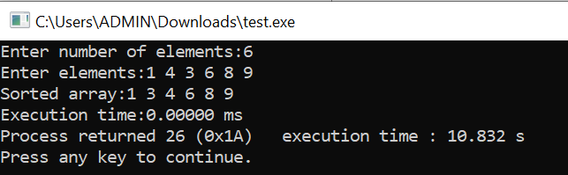

GRAPH:

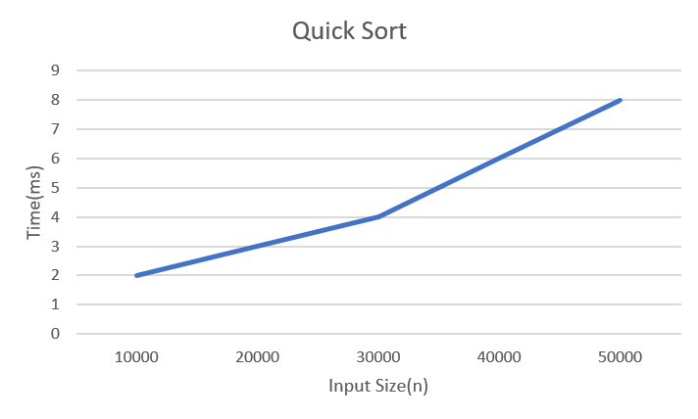

LEETCODE 977.Squares of sorted array

CODE:
int* sortedSquares(int* nums, int numsSize, int* returnSize) {
int *arr = (int*)malloc(numsSize * sizeof(int));
int left = 0;
int right = numsSize - 1;
int idx = numsSize - 1;
while(left <= right) {

int leftSq = nums[left] * nums[left];
int rightSq = nums[right] * nums[right];

if(leftSq > rightSq) {
arr[idx--] = leftSq;
left++;
}
else {
arr[idx--] = rightSq;
right--;
}
}
*returnSize = numsSize;
return arr;
}

OUTPUT:
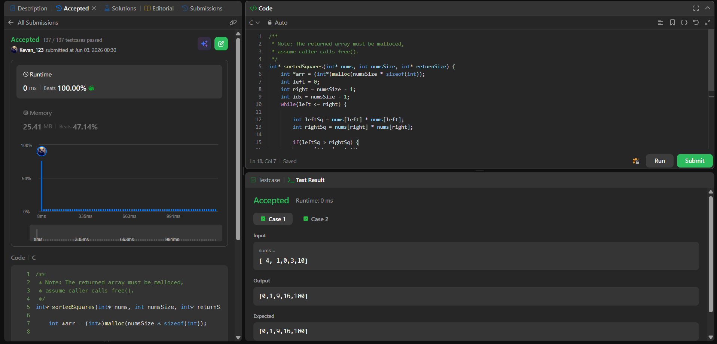

Lab program 5:
CODE:

#include <stdio.h>
#include <time.h>

void heapify(int arr[], int n, int i) {
int largest = i;
int left = 2 * i + 1;
int right = 2 * i + 2;

if (left < n && arr[left] > arr[largest])
largest = left;

if (right < n && arr[right] > arr[largest])
largest = right;

if (largest != i) {
int temp = arr[i];
arr[i] = arr[largest];
arr[largest] = temp;

heapify(arr, n, largest);
}
}

void heapSort(int arr[], int n) {
int i;
for (i = n / 2 - 1; i >= 0; i--)
heapify(arr, n, i);

for (i = n - 1; i > 0; i--) {

int temp = arr[0];
arr[0] = arr[i];
arr[i] = temp;

heapify(arr, i, 0);
}
}

int main() {
int n,i;
printf("Enter number of elements: ");
scanf("%d", &n);
int arr[n];
printf("Enter %d integer elements:\n", n);

for ( i = 0; i < n; i++) {
scanf("%d", &arr[i]);
}
clock_t start = clock();
heapSort(arr, n);
clock_t end = clock();
double time_taken = ((double)(end - start)) / CLOCKS_PER_SEC;
printf("\nSorted elements:\n");
for (int i = 0; i < n; i++) {
printf("%d ", arr[i]);
}
printf("\n");
printf("\nTime taken: %.8f seconds\n", time_taken);
return 0;
}

OUTPUT:

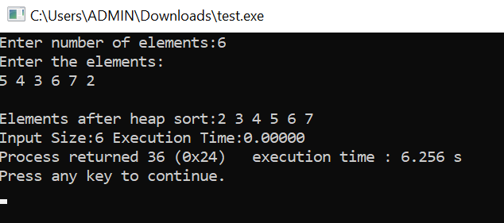

GRAPH:

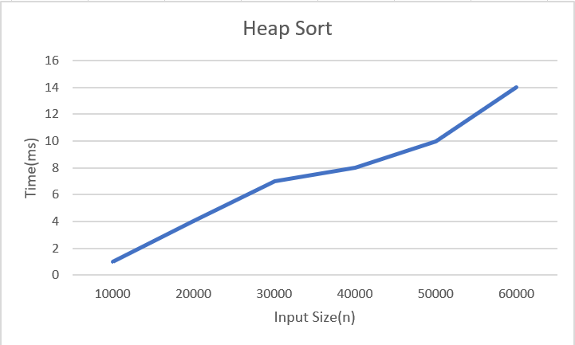

Lab program 6:
CODE:

#include <stdio.h>
int max(int a , int b){
return (a>b)?a:b;
}
int knapsack(int W, int wt[], int val[], int n){
int dp[n+1][W+1], i,w;
for( i=0;i<=n;i++)
for( w=0;w<=W;w++)
if(i==0 || w==0) dp[i][w]=0;
else if(wt[i-1]<=w) dp[i][w]=max(val[i-1]+dp[i-1][w-wt[i-1]], dp[i-1][w]);
else dp[i][w]= dp[i-1][w];
for( i=0;i<=n;i++){
for( w=0;w<=W;w++)
printf("%d\t",dp[i][w]);
printf("\n");
}
return dp[n][W];
}

void main(){
int n, W,i;
printf("Enter number of items:");
scanf("%d",&n);
printf("Enter max capacity:");
scanf("%d",&W);
int val[n];
int wt[n];
printf("Enter wt and value for %d items:\n",n);
for(i=0;i<n;i++)
scanf("%d %d",&wt[i], &val[i]);
printf("Result = %d", knapsack(W, wt, val ,n));
}

OUTPUT:

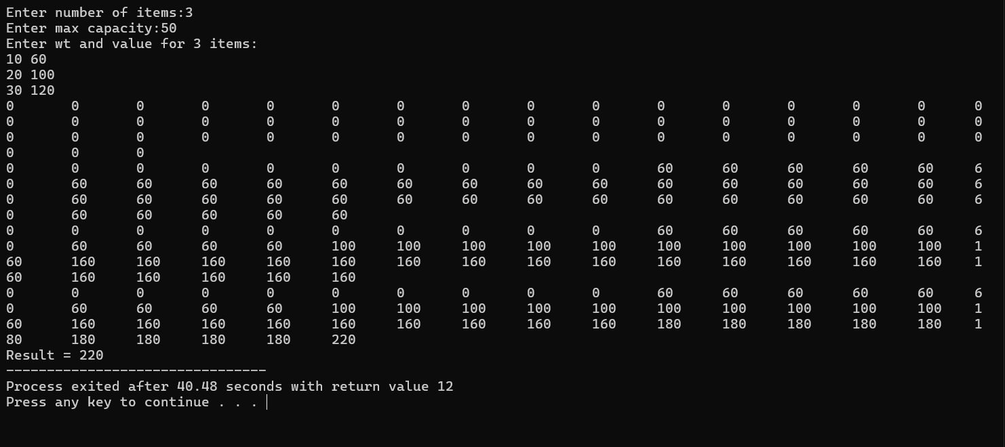

LEETCODE 518.Coin Change II

CODE:

int change(int amount, int* coins, int coinSize) {
unsigned long long dp[amount + 1];
for (int i = 0; i <= amount; i++)
dp[i] = 0;
dp[0] = 1;
for (int i = 0; i < coinSize; i++) {
for (int j = coins[i]; j <= amount; j++) {
dp[j] += dp[j - coins[i]];
}
}
return (int)dp[amount];
}

OUTPUT:

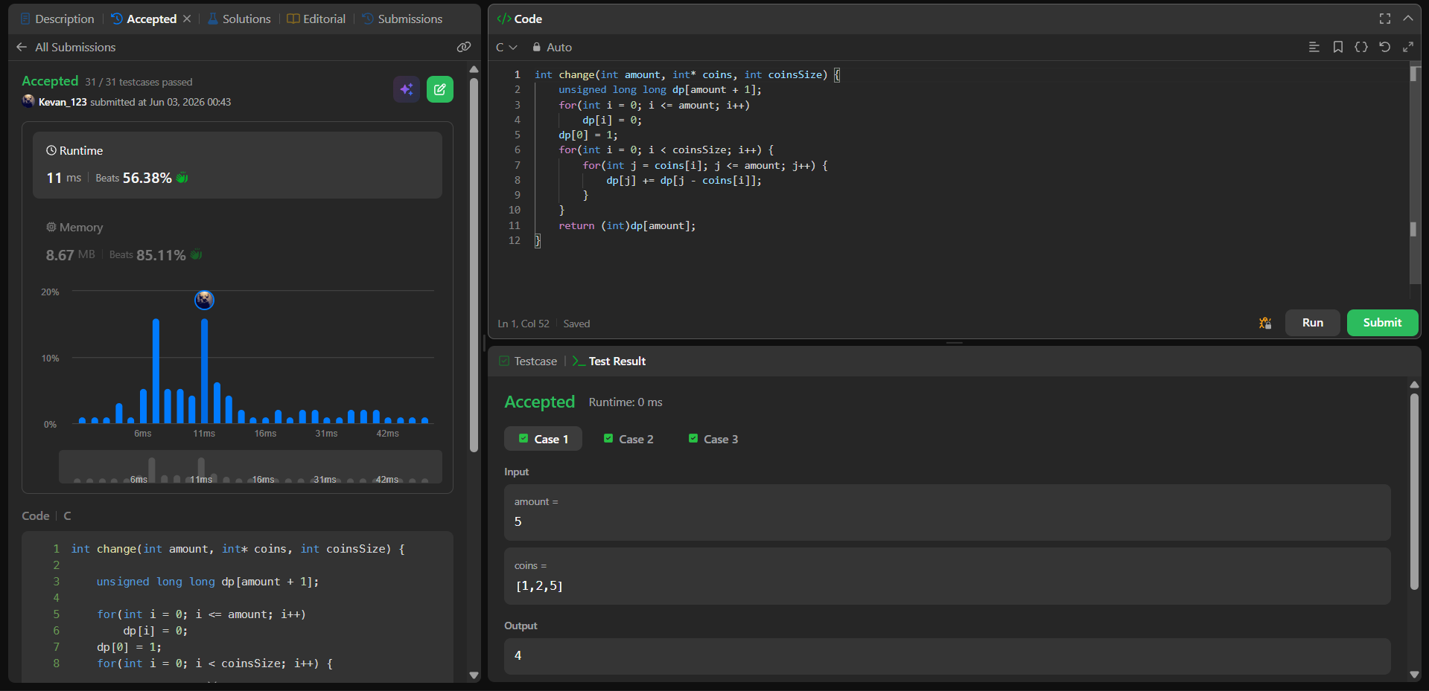

Lab program 7:
CODE:

#include <stdio.h>
#define N 10
#define INFI 99999
int min(int a, int b){
return (a<b)? a: b;
}
void floyd(int d[N][N], int n){
for (int k=0;k<n;k++)
for(int i=0;i<n;i++)
for(int j=0;j<n;j++)
d[i][j] = min(d[i][j], d[i][k] + d[k][j]);

printf("\nUpdated Path :\n");
for (int i = 0; i < n; i++){
for(int j = 0; j < n; j++)
if (d[i][j] == INFI) printf("INF\t");
else printf("%d\t", d[i][j]);
printf("\n");
}
}

void main(){
int path[N][N];
int n;
printf("Enter number of nodes:");
scanf("%d",&n);
printf("Enter distance matrix\n(enter -1 for infinity):\n");
for (int i=0;i<n;i++)
for(int j=0;j<n;j++){
int a;
scanf("%d",&a);
if(a==-1) path[i][j] = INFI;
else path[i][j]= a;
}
floyd(path, n);
}

OUTPUT:
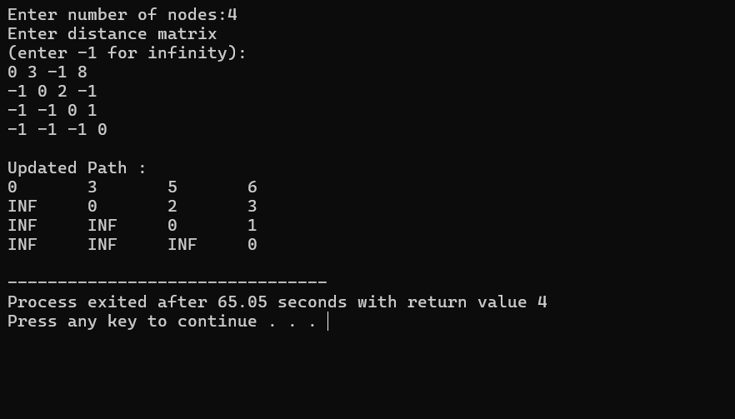

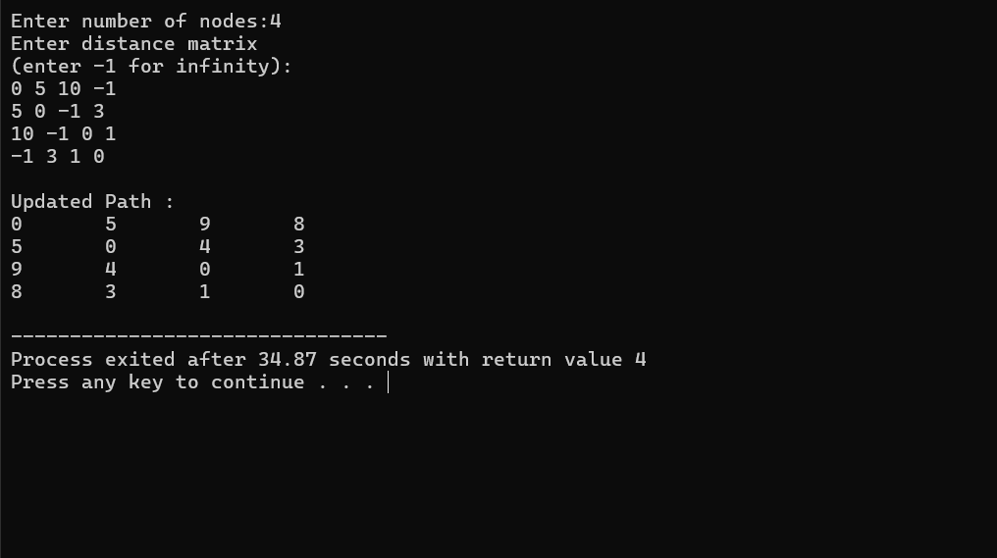

LEETCODE 783.Minimum Distance Between BST Nodes

CODE:

/**
* Definition for a binary tree node.
* struct TreeNode {
* int val;
* struct TreeNode *left;
* struct TreeNode *right;
* };
*/
int minDiff = 100000;
struct TreeNode* prev = NULL;
void inorder(struct TreeNode* root) {
if(root == NULL)
return;
inorder(root->left);
if(prev != NULL) {
int diff = root->val - prev->val;

if(diff < minDiff)
minDiff = diff;
}
prev = root;
inorder(root->right);
}
int minDiffInBST(struct TreeNode* root) {
minDiff = 100000;
prev = NULL;
inorder(root);
return minDiff;
}

OUTPUT:

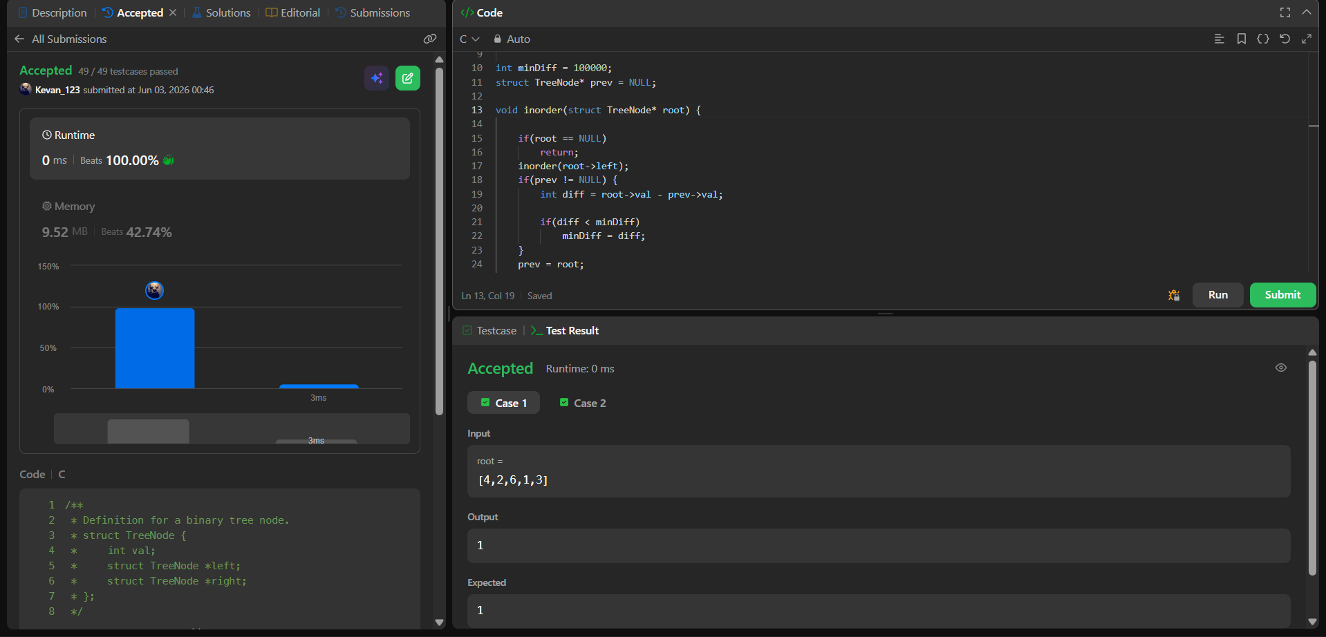
Lab program 8:
8(a)
CODE:

#include <stdio.h>
#define MAX 10
#define INF 999
int main(){
int cost[MAX][MAX];
int visited[MAX] = {0};
int n, i, j;
int min, a, b;
int edges = 0, minCost = 0;
printf("Enter number of vertices: ");
scanf("%d", &n);
printf("Enter adjacency matrix:\n");
for(i = 0; i < n; i++){
for(j = 0; j < n; j++){
scanf("%d", &cost[i][j]);
if(cost[i][j] == 0)
cost[i][j] = INF;
}
}
visited[0] = 1;
printf("Edges in MST:\n");
while(edges < n - 1){
min = INF;
for(i = 0; i < n; i++){
if(visited[i]){
for(j = 0; j < n; j++){
if(!visited[j] && cost[i][j] < min){
min = cost[i][j];
a = i;
b = j;
}
}
}
}
printf("%d - %d = %d\n", a, b, min);
minCost += min;
visited[b] = 1;
edges++;
}
printf("Minimum Cost = %d\n", minCost);
return 0;
}

OUTPUT:

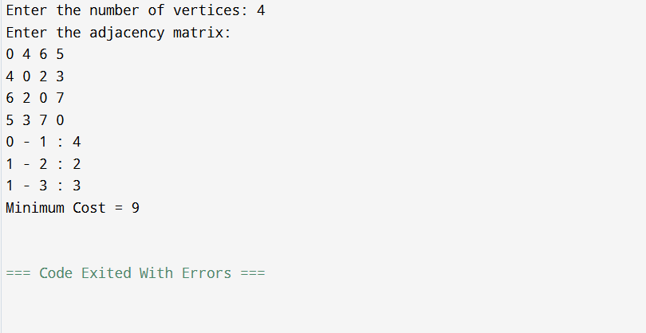

8(b)
CODE:

#include <stdio.h>
#define MAX 10
#define INF 999
int parent[MAX];
int find(int x){
while(parent[x] != x)
x = parent[x];
return x;
}
void unionSet(int a, int b){
parent[find(a)] = find(b);
}
int main(){
int cost[MAX][MAX];
int n, i, j;
int min, a, b;
int edges = 0, minCost = 0;
printf("Enter number of vertices: ");
scanf("%d", &n);
printf("Enter adjacency matrix:\n");
for(i = 0; i < n; i++){
for(j = 0; j < n; j++){
scanf("%d", &cost[i][j]);
if(cost[i][j] == 0)
cost[i][j] = INF;
}
}
for(i = 0; i < n; i++){
parent[i] = i;
}
printf("Edges in MST:\n");
while(edges < n - 1){
min = INF;
for(i = 0; i < n; i++){
for(j = i + 1; j < n; j++){
if(cost[i][j] < min){
min = cost[i][j];
a = i;
b = j;
}
}
}
if(find(a) != find(b)){
printf("%d - %d = %d\n", a, b, min);
minCost += min;
unionSet(a, b);
edges++;
}
cost[a][b] = cost[b][a] = INF;
}
printf("Minimum Cost = %d\n", minCost);
return 0;
}

OUTPUT:

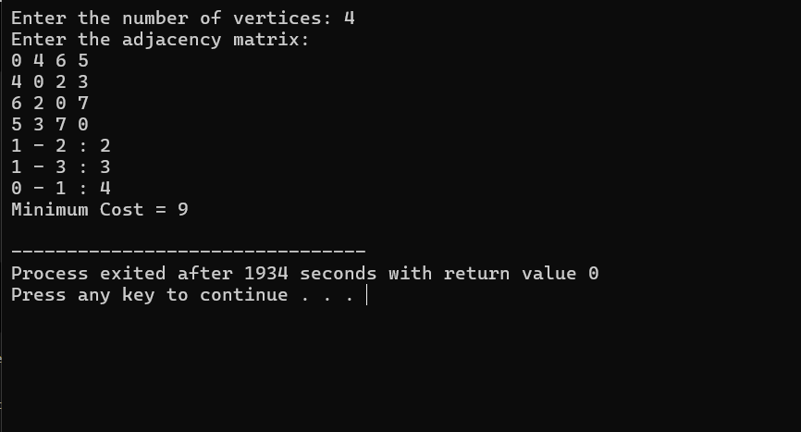

Lab program 9:
CODE:

#include<stdio.h>
struct object{
float profit;
float weight;
float pw;
};
void sort(struct object o[],int n){
struct object temp;
for(int i=0;i<n-1;i++) {
for(int j=0;j<n-i-1;j++){
if(o[j].pw<o[j+1].pw){
temp=o[j];
o[j]=o[j+1];
o[j+1]=temp;
}
}
}
}
int main(){
int n;
printf("Enter number of objects:");
scanf("%d",&n);
struct object o[n];
printf("Enter the profit and weight for:\n");
for(int i=0;i<n;i++){
printf("Object %d:",i);
scanf("%f %f",&o[i].profit,&o[i].weight);
o[i].pw=o[i].profit/o[i].weight;
}
sort(o,n);
int size;
printf("Enter the size of the knapsack:");
scanf("%d",&size);
float total_profit=0;
int rm=size;
int i=0;
while(rm!=0){
if(o[i].weight<rm){
total_profit+=o[i].profit;
rm-=o[i].weight;
}
else{
total_profit+=((o[i].profit*rm)/o[i].weight);
rm=0;
}
i++;
}
printf("%-12s %-12s %-12s %-12s\n", "Object", "Profit", "Weight", "Ratio");
for(int i = 0; i < n; i++){
printf("%-12d %-12.2f %-12.2f %-12.2f\n",
i, o[i].profit, o[i].weight, o[i].pw);
}
printf("\nMaximum profit: %.2f\n", total_profit);
return 0;
}

OUTPUT:

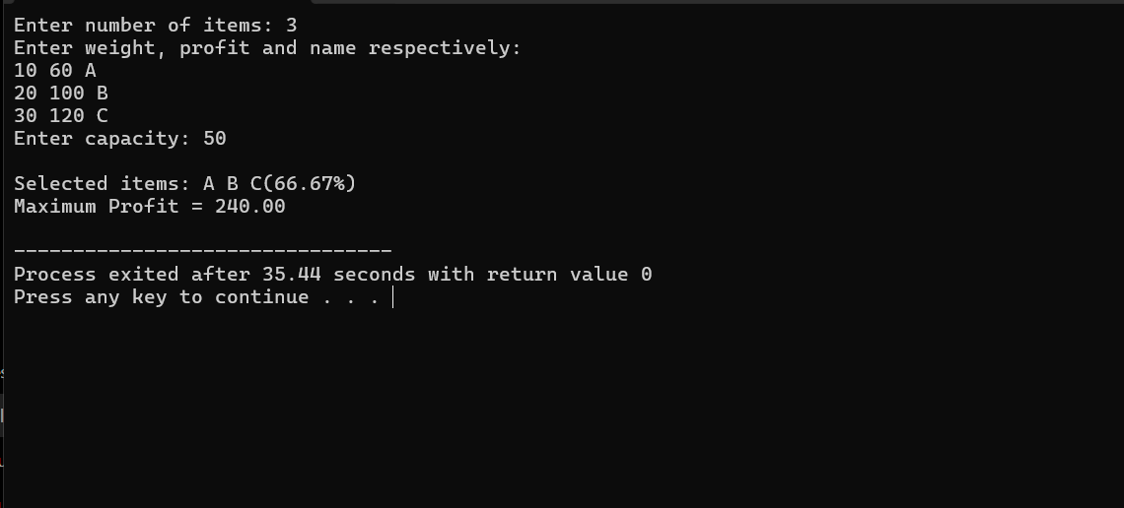

LEETCODE 455.Assign Cookies

CODE:

int cmp(const void* a,const void*b)
{
return (*(int*)a)-(*(int*)b);
}
int findContentChildren(int* g, int gSize, int* s, int sSize) {
int count=0;
qsort(g,gSize,sizeof(int),cmp);
qsort(s,sSize,sizeof(int),cmp);
int i=0,j=0;
while(i<gSize && j<sSize){
if(g[i]<=s[j]){
count++;
i++;
}
j++;
}
return count;
}

OUTPUT:

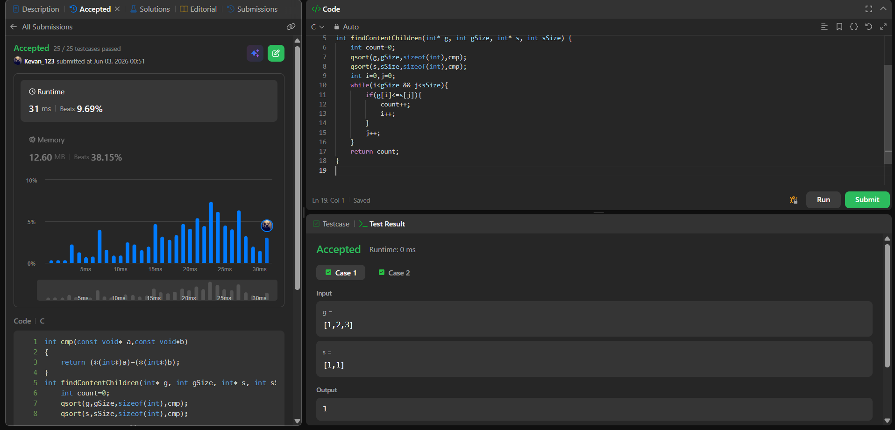

Lab program 10:
CODE:

#include<stdio.h>
#include<limits.h>
void p(int parent[],int j){
if(parent[j]==j){
printf(" Path:%d ",j);
return;
}
p(parent,parent[j]);
printf("%d ",j);
}
void main(){
int n;
printf("Enter the number of vertices:");
scanf("%d",&n);
int a[n][n];
printf("Enter the weights and enter 0 for no edges:\n");
for(int i=0;i<n;i++){
for(int j=0;j<n;j++){
scanf("%d",&a[i][j]);
}
}
int distance[n];
int visited[n];
int parent[n];
int source;
printf("Enter the source vertex:");
scanf("%d",&source);
for(int i=0;i<n;i++){
distance[i]=(i!=source && a[source][i]==0)?INT_MAX:a[source][i];
parent[i]=source;
visited[i]=0;
}
distance[source]=0;
visited[source]=1;
for(int i=1;i<n;i++){
int min=INT_MAX;
int u=-1;
for(int j=0;j<n;j++){
if(!visited[j] && distance[j]<min){
min=distance[j];
u=j;
}
}
if(u==-1) break;
visited[u]=1;
for(int v=0;v<n;v++){
if(a[u][v]!=0 && !visited[v]){
if(distance[u]+a[u][v]<distance[v]){
distance[v]=distance[u]+a[u][v];
parent[v]=u;
}
}

}
}
printf("The distances are:\n");
for(int i=0;i<n;i++){
printf("%d to %d",source,i);
if(distance[i]==INT_MAX) printf(":No path");
else{
p(parent,i);
printf(":%d",distance[i]);
}
printf("\n");
}
}

OUTPUT:
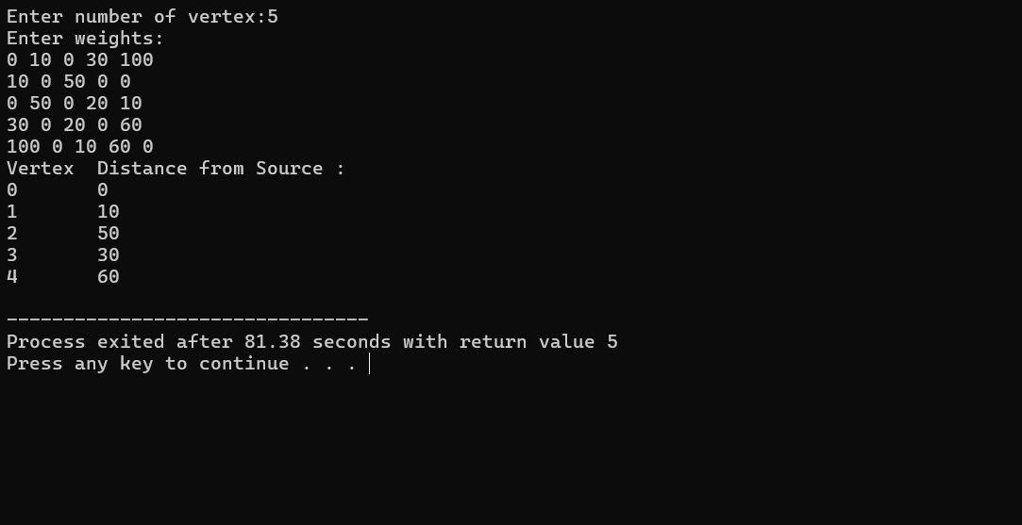
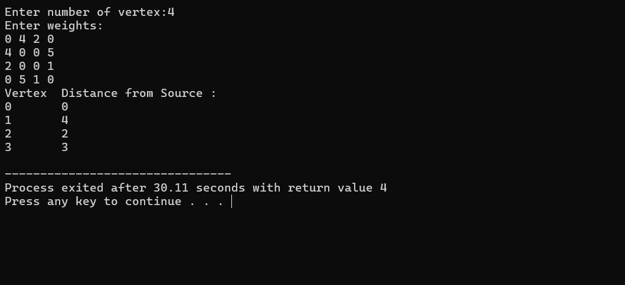

Lab program 11:
CODE:
#include <stdio.h>
#include <stdlib.h>

int x[20];

int place(int k, int i) {
for (int j = 1; j < k; j++) {
if (x[j] == i || abs(j - k) == abs(x[j] - i))
return 0;
}
return 1;
}

void NQueens(int k, int n) {
for (int i = 1; i <= n; i++) {
if (place(k, i)) {
x[k] = i;

if (k == n) {
// Print solution as a binary matrix
for (int row = 1; row <= n; row++) {
for (int col = 1; col <= n; col++) {
if (x[row] == col)
printf("1 ");
else
printf("0 ");
}
printf("\n");
}
printf("\n");
}
else {
NQueens(k + 1, n);
}
}
}
}
int main() {
int n;
printf("Enter number of queens: ");
scanf("%d", &n);
NQueens(1, n);
return 0;
}

OUTPUT:

