Cruz, Kevin Bryan B.

2ECE-C

PROBLEM 1

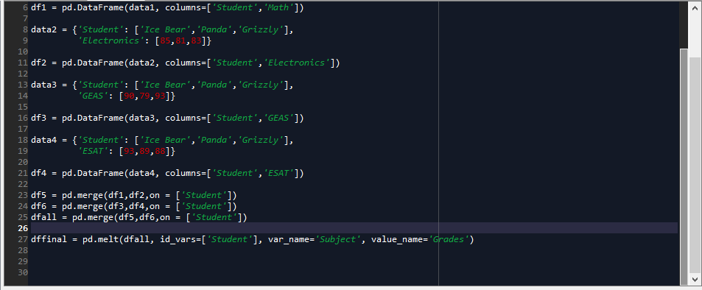

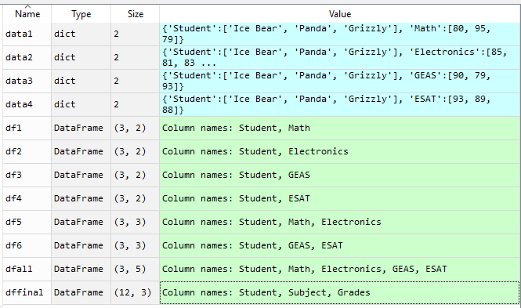

Using pd.merge the data frame results to this:

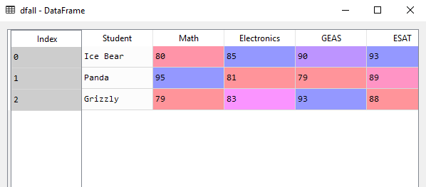

Converting it to long format, the previous data frame looks like this:

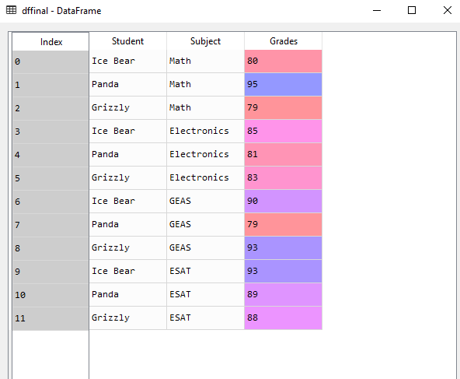

PROBLEM 2

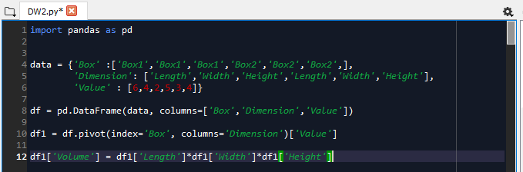

Messy Data

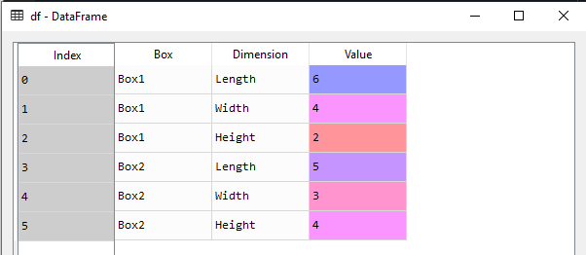

Converted to Tidy Data

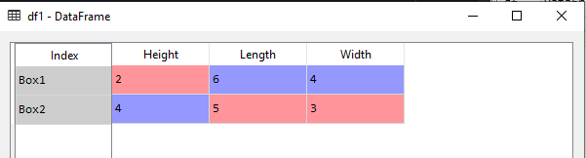

Adding a new column “Volume”

