Cruz, Kevin Bryan B.

2ECE-C

Problem 1:

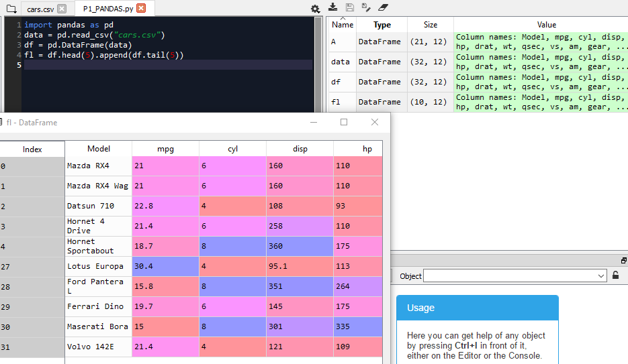

Problem 2:

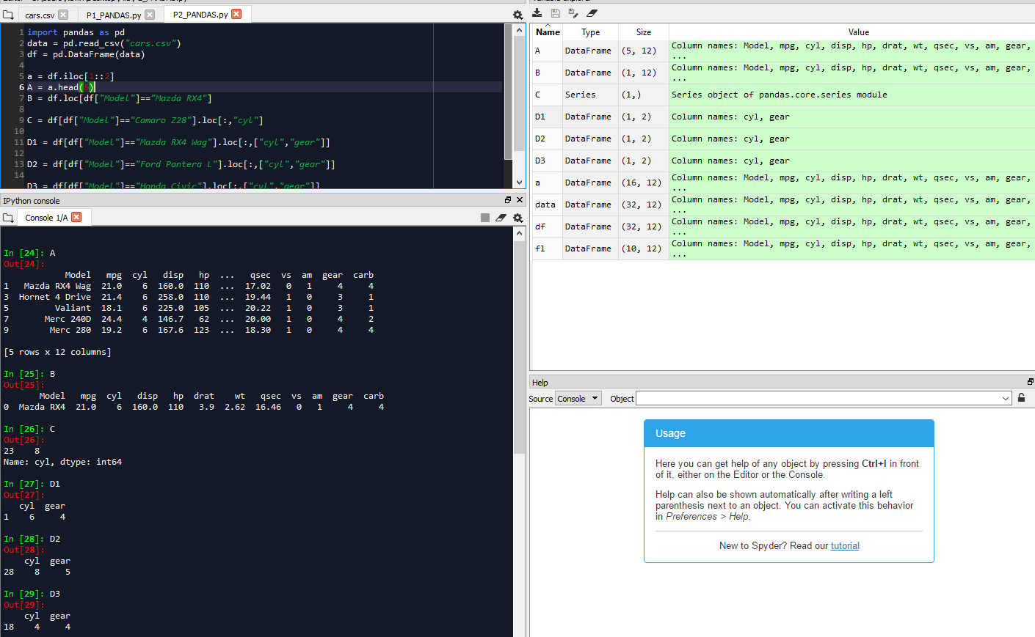

A

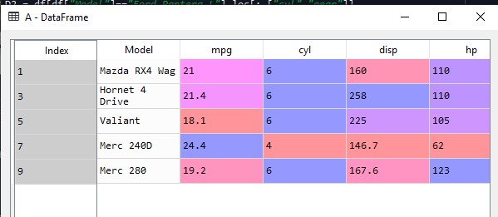

B



C

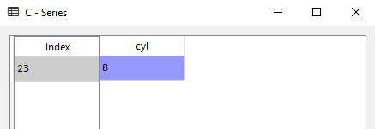

The model Mazda RX4 has 8 cylinders.

D

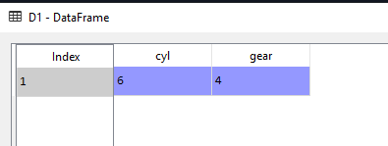

The model Mazda RX4 Wag has 6 cylinders and 4 gears.

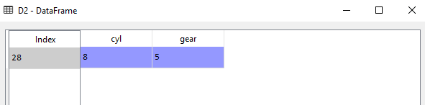

The model Ford Pantera L has 8 cylinders and 5 gears.

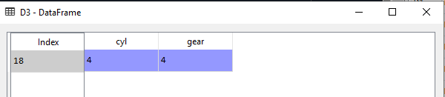

The model Honda Civiv has 4 cyliners and 4 gears.