APEX
Architecture Document
Agentic-AI Platform — Cloud-Neutral Core, Cloud Profiles, Industry Packs, Service Envelopes
Document type | Architecture document (consolidated)
Version | v1.0
Status | Draft — pending ConCon Architecture Integration conformance review
Author | Keven Markham, VP — Deloitte Microsoft Technology & Services Practice
Date | May 2026
Audience | ConCon Architecture Integration · APEX core team · cloud-profile teams · pack-author teams
Classification | Deloitte Internal Use Only
Distribution | Dhingra, Himanshu (ConCon); Dow, Eli (ConCon); Nichols, Tom; APEX core

Document Control

Change Log
Version | Date | Author | Change Summary
v0.5 | March 2026 | Markham | Initial design narrative consolidated as APEX-Design.md
v0.9 | April 2026 | Markham | Teaching deck published (APEX-Design.pptx, 28 slides)
v1.0 | May 2026 | Markham | Architecture document consolidated for ConCon conformance review

Related Documents
- APEX-Design.md — design narrative (source content for this architecture document)
- APEX-Design.pptx — 28-slide teaching deck (visual model · executive walkthrough)
- APEX-M-GSSC-Lab-Infrastructure-Deployment.docx — 135-page Day-0 lab build guide
- APEX_ConCon_Positioning.pptx — ConCon-specific positioning deck
- APEX_Family_Positioning_9.pptx — broader-audience positioning
- apex-m-gssc-backlog.json + apex-m-gssc-tasks.json — ADO work-item definitions (20 Epics / 60 Features / 238 Stories / 714 Tasks)

Reviewers & Approvers
Role | Name | Decision Required
ConCon Architecture Integration | Dhingra, Himanshu | Conforms / Conforms with conditions / Does not conform
ConCon Architecture Integration | Dow, Eli | Conforms / Conforms with conditions / Does not conform
Engagement Sponsor | Nichols, Tom | Acknowledge gap list (if any)
APEX Core (Author) | Markham, Keven | Author — provides walkthrough and remediation plan

Executive Summary
Purpose
This document is the consolidated architecture description of APEX — Deloitte's agentic-AI delivery framework. It is the artifact submitted for ConCon Architecture Integration conformance review, supporting the action item from the Agentic Merch x ConCon Connect call.
What APEX Is
APEX is a cloud-neutral framework with three cloud profiles — APEX-M (Microsoft), APEX-G (Google), APEX-A (AWS) — that runs on top of cloud-native agent runtimes (Foundry · Vertex AI · Bedrock) and adds a Margin Spine of Virtual Views, Industry Solution Packs, Service Envelopes, and a WORM LEDGER that makes agent work sellable, auditable, and repeatable. APEX is the engagement layer cloud vendors do not ship.
Architectural Pillars
- Cloud-Neutral Core — the IP, written once, calls cloud-specific services only through a 12-interface contract.
- Cloud Profiles (M / G / A) — concrete implementations of the 12-interface contract; behaviourally equivalent for all in-scope workloads.
- Virtual Views — declarative, manifest-defined federated sensing surfaces with thresholds and resolution routes.
- 6-Agent Fleet — Assess / Classify / Quantify / Approve / Act / Evidence-Write; sequential orchestration with HITL gate at step 4.
- WORM LEDGER — 14-field row store with SHA-256 hash chain; cryptographic audit substrate.
- Industry Solution Packs — 10-asset bundles (Manufacturing, Merchandising, Finance, Risk, CX, ESG); cloud-agnostic.
- Service Envelopes — five sellable tiers (Foundation → Operate); pack sub-tiers (Lite / Standard / Enterprise).
- Scenario Chains — named end-to-end business outcomes composed from Virtual Views, agents, and personas.
- View Studio — visual SPA design surface for VV authoring; hosted in each cloud's native notebook environment.
Decision Requested
ConCon to review the six conformance items in Chapter 14 (Conformance Matrix) and issue one of: conforms / conforms with conditions / does not conform. Any gap list is welcome — the APEX team will propose remediation and a timeline.
Independence note: Deloitte does not receive ECIF directly from Microsoft (Deloitte is Microsoft's auditor). All funding paths in this architecture honour the Independence constraint — BVA (client-funded), DCIF (Deloitte co-invest), ISV Marketplace burndown, SI teaming POC, T&M, or client direct.

Table of Contents
If the table below shows 'Right-click to update field', open in Word and press F9 (or right-click → Update Field). LibreOffice updates automatically on open.
Right-click to update field.

Chapter 1 — Introduction

1.1 Problem Statement
Cloud vendors ship agent runtimes — Microsoft Foundry, Google Vertex AI Agent Builder, AWS Bedrock Agents. They do not ship the engagement layer that turns an agent runtime into a billable, regulator-defensible Deloitte engagement:
- Canonical schemas and audit-defensible decision attribution
- Industry verticalization (Manufacturing, Retail, Finance, Risk, CX, ESG)
- Commercial structure (Service Envelopes) Deloitte can price and sell
- Methodology that account teams can replicate across clients
- WORM evidence substrate with cryptographic integrity
APEX is that engagement layer.

1.2 One-Sentence Definition
APEX is Deloitte's agentic-AI delivery framework: a Cloud-Neutral Core that runs on top of cloud-native agent runtimes (Foundry · Vertex · Bedrock) and adds a Margin Spine — Virtual Views, Industry Solution Packs, Service Envelopes, and a WORM LEDGER — that makes agent work sellable, auditable, and repeatable.

1.3 Scope
In-Scope (framework)
- Data substrate (Bronze · Silver · Gold · LEDGER)
- Virtual Views layer (declarative sensing surfaces)
- 6-Agent Fleet (Assess / Classify / Quantify / Approve / Act / Evidence-Write)
- Industry Solution Packs (Manufacturing first; six on roadmap)
- Service Envelopes (5 tiers; pack sub-tiers)
- Cloud Profile contract (12 interfaces M/G/A implement)
- Operations (multi-tenancy · FinOps · DataOps · DR · SLA)
- Account-team enablement and GTM playbook
Out-of-Scope (delegated to cloud vendors)
- Agent runtime orchestration primitives (Foundry threads · Vertex sessions · Bedrock traces)
- LLM hosting, model selection, fine-tuning infrastructure
- Underlying lakehouse storage primitives (OneLake · GCS · S3)
- Identity provider infrastructure (Entra · Cloud Identity · IAM Identity Center)

1.4 Stakeholder Map
Stakeholder | Interest | Decision Rights
ConCon Architecture Integration | Conformance of APEX to reference architecture and integration patterns | Conformance verdict + gap list
APEX Core team | Cloud-neutral runtime, LEDGER, MCP contracts, threshold engine | Design authority on Core IP
Cloud-profile teams (M/G/A) | 12-interface concrete implementations + marketplace SKUs | Cloud-native binding decisions
Industry pack teams (×6) | 10-asset pack bundle authorship and certification | Pack content + threshold defaults
Delivery / Account teams | Sellability, BVA workshops, envelope configuration | Client commercial structure
Clients | Outcomes, audit defensibility, multi-tenant isolation | Overlay-level customization only

Chapter 2 — Architectural Principles
P1. Cloud-Neutral Core
All shared IP is written once. The Core never imports cloud-specific modules; it calls through the 12-interface Cloud Profile contract. New clouds are added by implementing the contract, not by modifying Core.
P2. Declarative over Imperative
Virtual Views, Scenarios, Personas, and Overlays are declarative YAML manifests. Gap analysis (orphan views, hungry scenarios), lineage, and validation fall out for free. Imperative code is reserved for the runtime, federator, and adapters.
P3. WORM Audit Substrate
Every action — agent recommendation, threshold breach, persona decision, virtual-query result, action dispatch — emits a LedgerRow on a SHA-256 hash chain. The LEDGER never splits: one cloud is the audit source of truth across the estate.
P4. HITL by Design
Step 4 of the agent fleet (Approve) is a non-bypassable human-in-the-loop gate. Persona binding, SLA, and escalation chain are pack-defined and ledger-recorded.
P5. Industry Verticalization
All client-facing value lives in Industry Solution Packs. Packs are cloud-agnostic. The Core has no industry semantics; the Cloud Profile has no industry semantics. Verticalization is isolated to one ownership boundary — the pack team.
P6. Independence-Safe Commercial Structure
Service Envelopes accommodate the Microsoft auditor constraint: Deloitte never receives ECIF directly. BVA / DCIF / ISV Marketplace burndown / SI teaming / T&M / client-direct are the supported funding vehicles.
P7. Behavioural Equivalence Across Profiles
APEX-M, APEX-G, and APEX-A are behaviourally equivalent for all in-scope workloads. Differences are limited to native bindings (Teams vs Chat vs Slack for HITL; OneLake vs GCS vs S3 for storage; etc.). The pack code is identical.
P8. Overlay over Fork
Clients customize through delta-only overlays that extend a base pack. Pack updates flow through to the client without merge conflicts. Forking a pack is not supported.
P9. Source-Health is a First-Class Event
Upstream source freshness, schema drift, and credential expiry emit Exceptions through the same resolution-router plumbing as everything else. There are no out-of-band incidents.
P10. Replay is Mandatory
Every LedgerRow is reproducible. The apex-replay CLI re-executes the federated query against the historical Bronze snapshot; the hash must match. Forensic audit is built in.

Chapter 3 — Reference Architecture

3.1 Layered View
APEX is structured as six horizontal layers. The top three are commercial / methodology constructs sold and run by Deloitte. The middle two are technology constructs delivered as products. The bottom layer is the cloud platform.
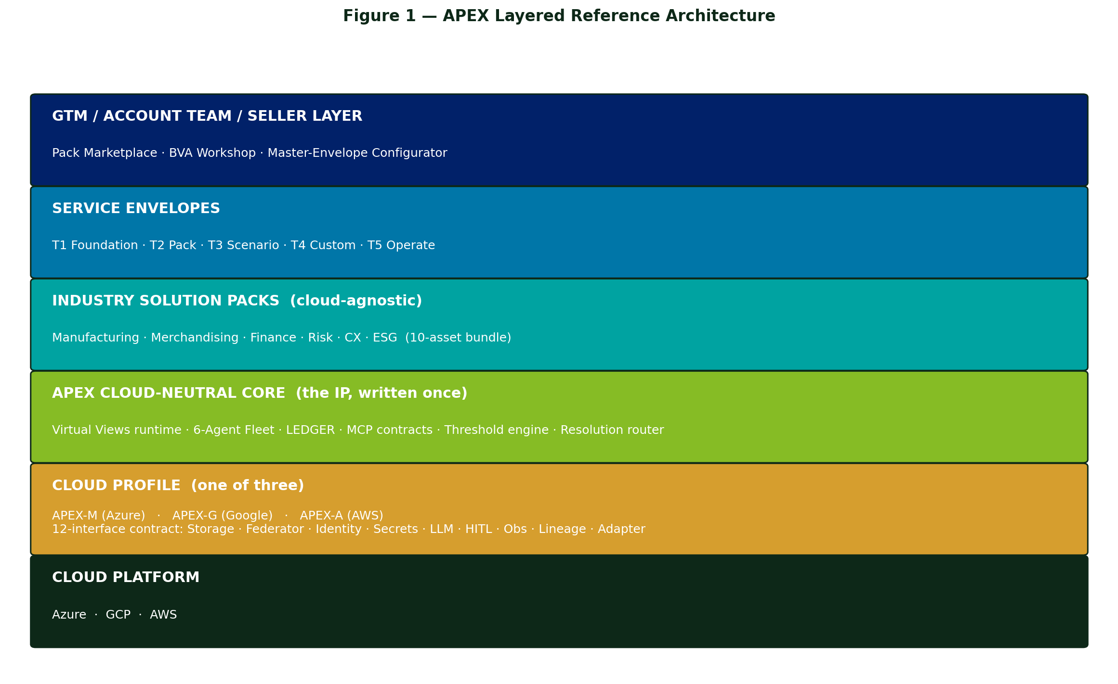
Figure 1 — APEX Layered Reference Architecture

3.2 The Three Composition Layers
Within the technology stack, APEX composes from three discrete units. Each higher layer composes the layer below. Each unit is a manifest (declarative YAML), not code.
Layer | Unit | Role | Example
3 | Scenario Chain | Named end-to-end business outcome — composes views + agents + personas + briefs | rc-risk-01 SOX PMO test cycle
2 | Virtual View | Active sensing surface — manifest-defined federated view with thresholds + resolution route | mfgml.oee_by_line
1 | Schema entity | Canonical data atom in the medallion (Bronze / Silver / Gold) | ForwardSignal · LedgerRow · Exception

3.3 Logical Architecture Boundaries
The three boundaries that matter for ConCon conformance:
- Core ↔ Profile boundary — defined by the 12-interface contract (Chapter 5). Core never imports a cloud-specific module.
- Pack ↔ Core boundary — defined by the VV / Scenario / Persona manifest schemas. Packs never call into runtime internals.
- Profile ↔ Cloud boundary — defined by the profile's adapter implementations. Profiles never bypass the cloud's IAM, KMS, or audit subsystem.

3.4 Composition vs Inheritance
APEX favours composition. Industry packs do not inherit from a base pack — they ship the 10 standard assets and compose Core primitives. Overlays do not subclass packs — they patch via delta YAML. There is no class hierarchy to navigate; everything is data.

Chapter 4 — Cloud-Neutral Core

4.1 Core Components (Logical View)
The Core is a single deployable unit composed of seven services:
Component | Responsibility | Implementation
VV Runtime | Loads VV manifests; resolves queries; dispatches to federator | Python service · Pydantic-validated manifests
Federation Engine | Cost-model dispatcher · in-lake vs live vs composition | DuckDB / Trino + adapter library
Threshold Engine | Band evaluation · sustain-window debounce · emits Exception | Polling + event-stream listener
Resolution Router | Role resolution · Adaptive Card build · SLA timer · escalation | Async task runner with state machine
LEDGER Writer | WORM append · SHA-256 hash chain · retention enforcement | Delta-on-storage with retention policy
Agent Orchestrator | Drives the 6-agent fleet sequence · invokes LLM via interface #8 | Foundry/Vertex/Bedrock-agnostic state machine
MCP Server | Auto-registers every VV as a tool · schema from projection | MCP protocol implementation

4.2 Component Dependency Graph
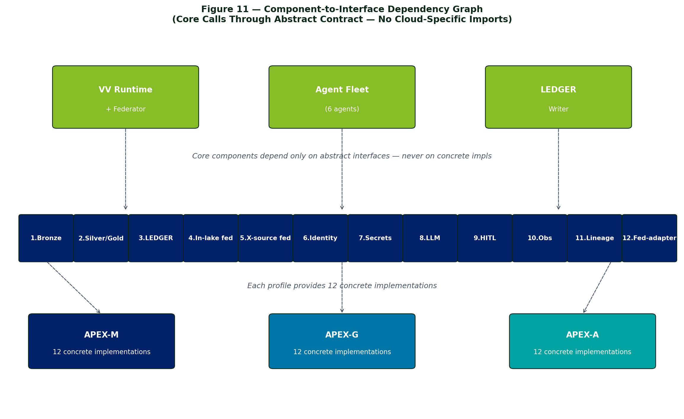
Figure 11 — Core components depend only on the 12 abstract interfaces

4.3 Detailed Component Architecture — VV Runtime
The VV Runtime is the entry point for every federated query. Internally it composes eight sub-components arranged as a pipeline: manifests in, resolved query results out.
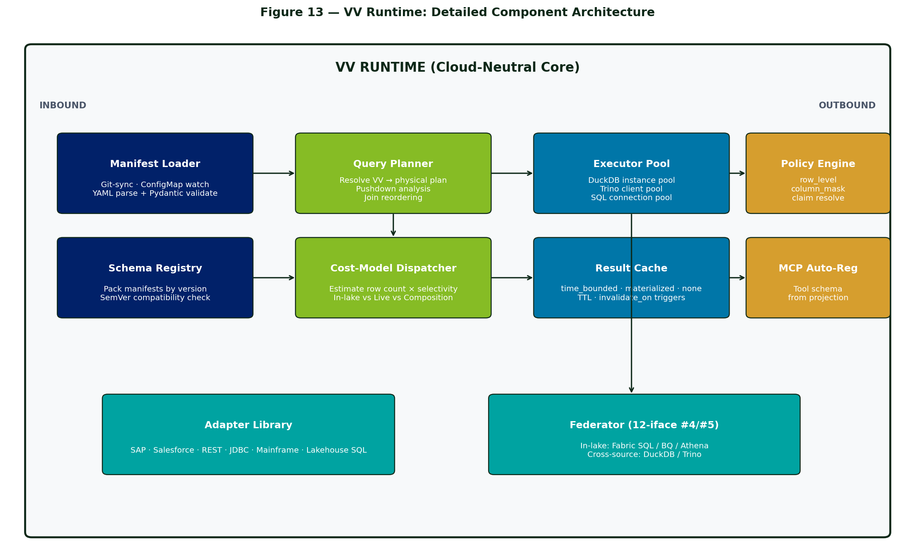
Figure 13 — VV Runtime: Detailed Component Architecture
Sub-component | Responsibility
Manifest Loader | Watches Git / ConfigMap for VV YAML; parses + Pydantic-validates; refuses malformed manifests
Schema Registry | Indexes pack manifests by version; runs SemVer compatibility check before load
Query Planner | Resolves a VV reference into a physical plan: projection, predicate, joins, pushdown analysis
Cost-Model Dispatcher | Estimates row count × selectivity per source; chooses in-lake vs live vs composition path
Executor Pool | Pool of DuckDB instances, Trino clients, lakehouse SQL connections; sized per workload
Result Cache | Honours cache.mode (time_bounded / materialized / none); invalidate_on triggers
Policy Engine | Applies row_level predicate and column_mask transforms using resolved @user.* claims
MCP Auto-Reg | Builds an MCP tool schema from each VV projection at boot; no Python glue

4.4 Detailed Component Architecture — Agent Orchestrator
The Agent Orchestrator drives the six-agent sequence through a persistent state machine. It is the only Core component that calls the LLM service (interface #8) and the HITL surface (interface #9).
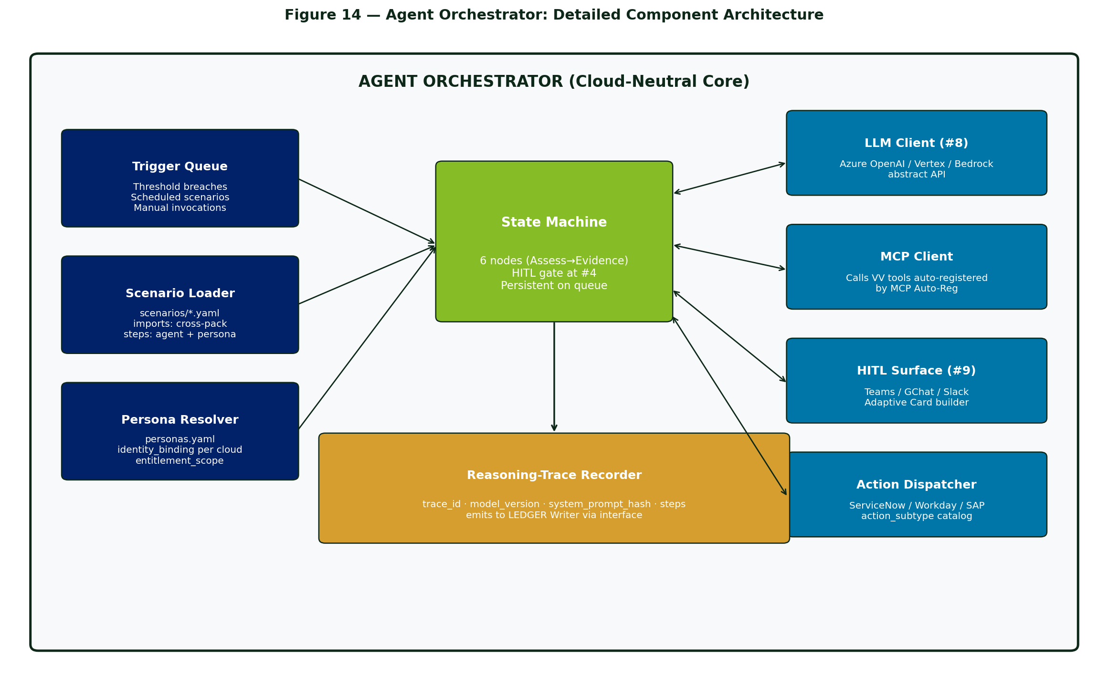
Figure 14 — Agent Orchestrator: Detailed Component Architecture
Sub-component | Responsibility
Trigger Queue | Inbound triggers: threshold breaches, scheduled scenarios, manual invocations
Scenario Loader | Reads scenarios/*.yaml + cross-pack imports; resolves the sequence of agent steps
Persona Resolver | Looks up personas.yaml per pack; resolves to cloud-specific identity group + channel
State Machine | Persistent 6-node FSM (Assess → Evidence-Write); HITL gate non-bypassable at step 4
LLM Client (#8) | Abstract client; per-profile adapter for Azure OpenAI / Vertex / Bedrock
MCP Client | Calls VV tools that the MCP Auto-Reg auto-registered; cross-pack tool calls allowed
HITL Surface (#9) | Builds Adaptive Card + posts via per-profile channel (Teams / GChat / Slack)
Action Dispatcher | Per-pack action_subtype catalog; idempotency key required; calls SOR system
Trace Recorder | Emits reasoning-trace.v1.json hash to LEDGER Writer per agent call

4.5 Detailed Component Architecture — LEDGER Writer
The LEDGER Writer is the only path by which data enters the audit substrate. All Core components publish events to its queue; the writer validates, hashes, and appends to the WORM storage interface (#3).
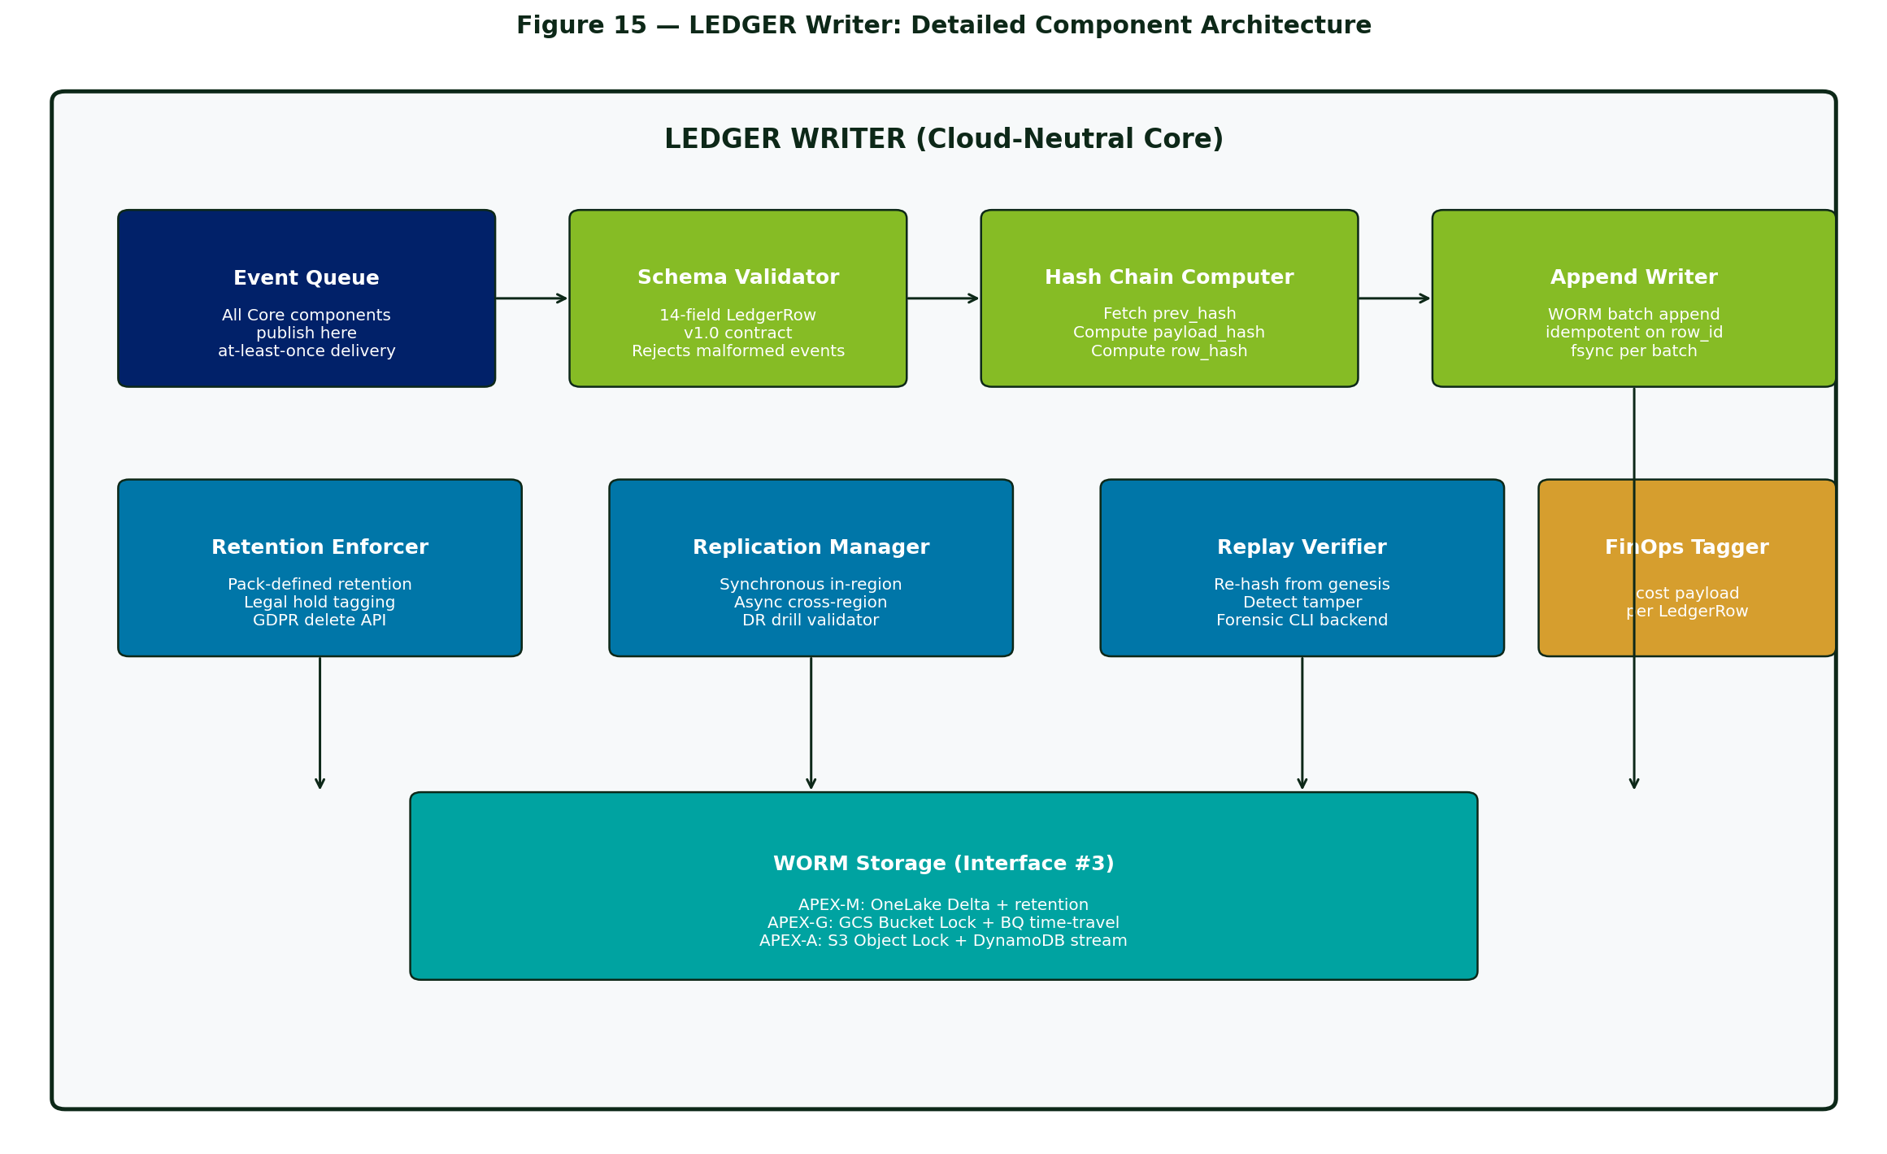
Figure 15 — LEDGER Writer: Detailed Component Architecture
Sub-component | Responsibility
Event Queue | At-least-once event ingest from every Core component; idempotent on row_id
Schema Validator | Enforces 14-field LedgerRow contract; rejects malformed events
Hash Chain Computer | Fetches prev_hash from last row; computes payload_hash and row_hash
Append Writer | WORM batch append; fsync per batch; backed by interface #3
Retention Enforcer | Per-pack retention policy; legal hold tagging; GDPR-class delete API
Replication Manager | Synchronous in-region + async cross-region; DR drill validator
Replay Verifier | Re-hashes from genesis to detect tamper; backs the apex-replay CLI
FinOps Tagger | Attaches cost payload to every LedgerRow for Operate tier billing

4.6 Detailed Component Architecture — Resolution Router
The Resolution Router converts a band breach into a notified persona, an SLA timer, an escalation chain, and ultimately a dispatched action — recording every step to the LEDGER.
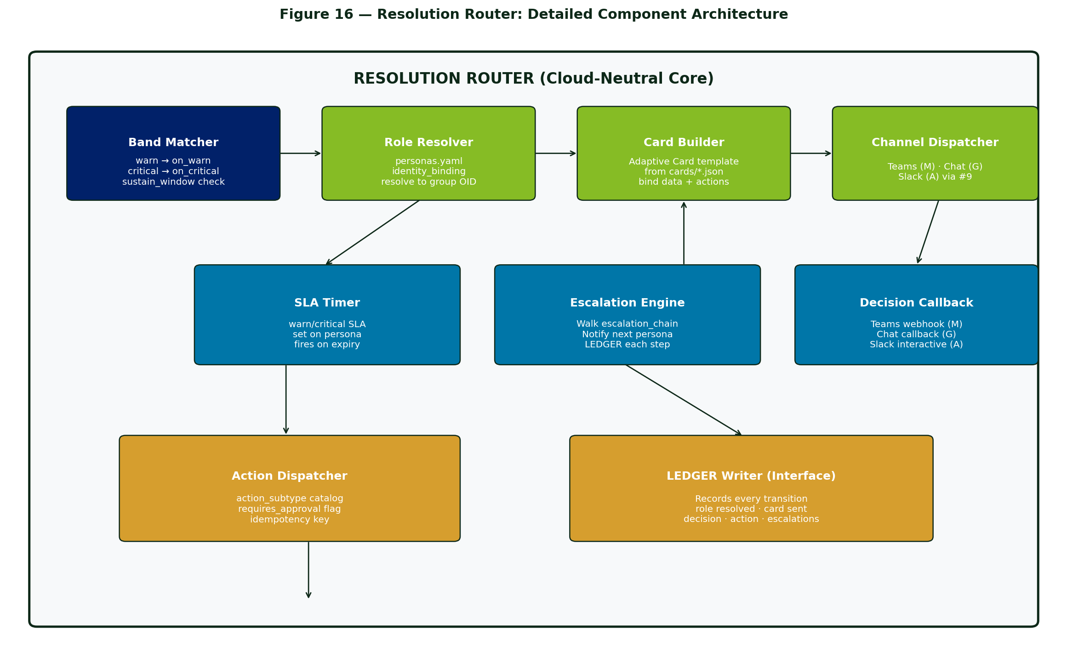
Figure 16 — Resolution Router: Detailed Component Architecture
Sub-component | Responsibility
Band Matcher | Maps the fired band to the on_warn / on_critical block in the VV manifest
Role Resolver | Resolves role: to the persona's identity group via the Cloud Profile claim_provider
Card Builder | Renders the Adaptive Card template from cards/*.json, binding the breach data
Channel Dispatcher | Posts to the persona's per-profile channel via interface #9
SLA Timer | Starts a warn/critical SLA timer per persona; fires on expiry
Escalation Engine | Walks escalation_chain on SLA breach; notifies next persona; LedgerRow each step
Decision Callback | Receives persona decision via webhook / interactive callback
Action Dispatcher | Looks up action_subtype; checks requires_approval flag; dispatches via SOR

4.7 Core Does NOT Contain
- Any cloud-specific SDK or client library (no boto3, no Azure SDK, no Google Cloud SDK in Core)
- Industry-specific schemas (those live in the pack)
- LLM provider configuration (that's a profile concern)
- Identity provider integration (that's interface #6)
- Storage primitives (those are interfaces #1, #2, #3)

4.8 Deployment Footprint
The Core runs as a set of containers in the cloud-native Kubernetes flavour (AKS for APEX-M, GKE for APEX-G, EKS for APEX-A). Helm chart is identical across profiles; only the values file differs.
- VV Runtime: stateless deployment, horizontally scalable
- Federation Engine: stateless deployment; DuckDB/Trino as sidecar or stateful set
- Threshold Engine: stateless deployment; subscribes to event streams
- Resolution Router: stateful (SLA timers); uses cloud-native queue
- LEDGER Writer: stateless; writes to interface #3 storage
- Agent Orchestrator: stateless; LLM calls via interface #8
- MCP Server: stateless; manifests loaded from configmap or git sync

Chapter 5 — Cloud Profile Contract

5.1 The 12-Interface Contract
Every Cloud Profile (APEX-M / APEX-G / APEX-A) must implement these twelve interfaces. Each implementation is a concrete adapter that binds the abstract API to cloud-native services. The Core calls only through these interfaces.
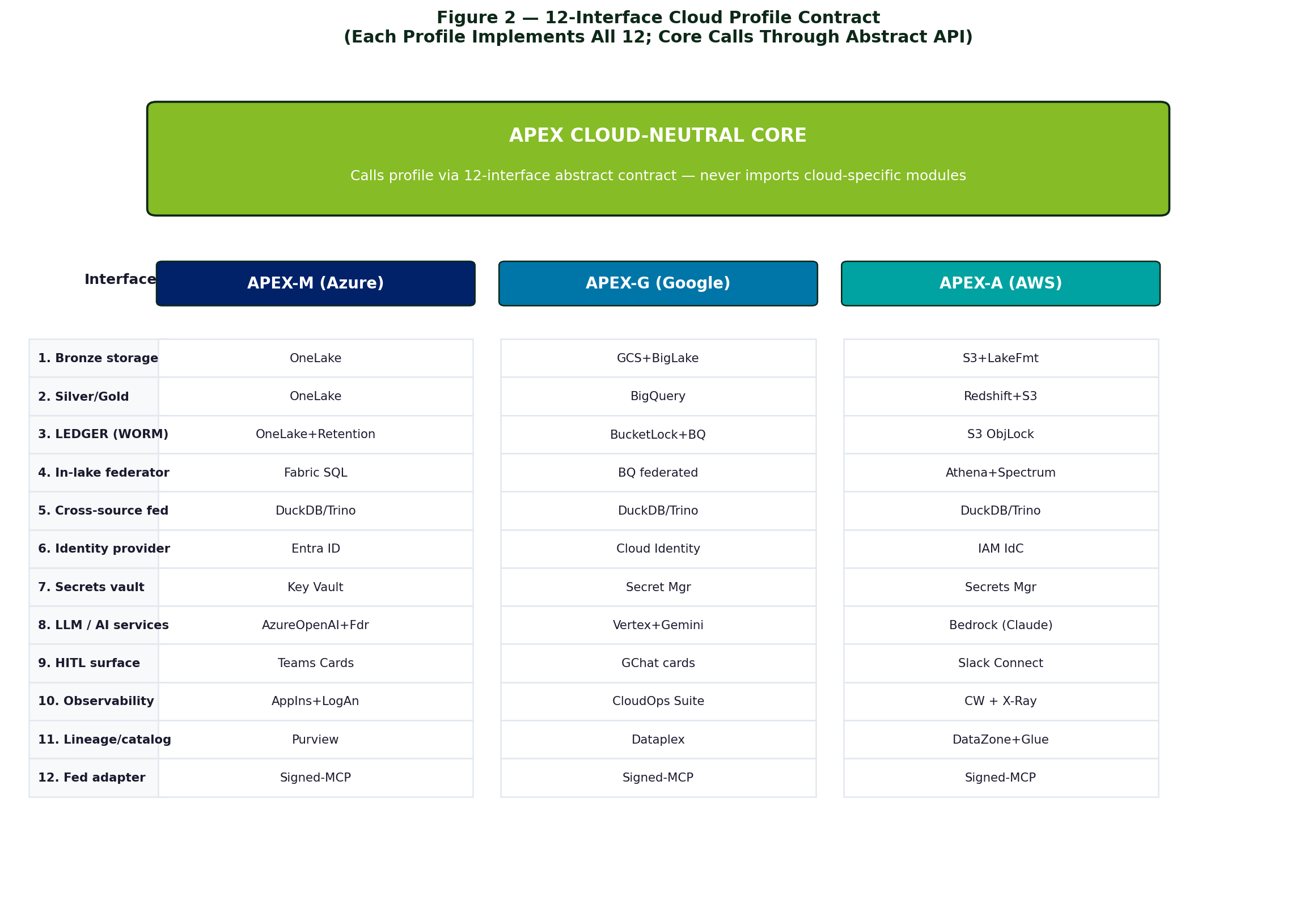
Figure 2 — 12-Interface Cloud Profile Contract

5.2 Interface Specifications
# | Interface | APEX-M | APEX-G | APEX-A
1 | Bronze storage | OneLake (Delta) | GCS + BigLake | S3 + Lake Formation
2 | Silver/Gold storage | OneLake (Delta) | BigQuery + GCS | Redshift + S3
3 | LEDGER (WORM) | OneLake Delta + retention | GCS Bucket Lock + BQ time-travel | S3 Object Lock + DynamoDB stream
4 | In-lake federator | Fabric SQL endpoint | BigQuery federated queries | Athena + Redshift Spectrum
5 | Cross-source fed. | DuckDB / Trino on AKS | DuckDB / Trino on GKE | DuckDB / Trino on EKS
6 | Identity provider | Entra ID | Cloud Identity / Workspace | IAM Identity Center
7 | Secrets vault | Key Vault | Secret Manager | Secrets Manager
8 | LLM / AI services | Azure OpenAI + Foundry | Vertex AI + Gemini | Bedrock (Claude / Nova)
9 | HITL surface | Teams Adaptive Cards | Google Chat cards / GWS | Slack Connect / Workmail
10 | Observability | App Insights + Log Analytics | Cloud Operations Suite | CloudWatch + X-Ray
11 | Lineage / catalog | Purview | Dataplex | DataZone + Glue Lineage
12 | Federation adapter | Signed-MCP to primary | Signed-MCP to primary | Signed-MCP to primary

5.3 Multi-Cloud Pattern (Primary + Satellite)
When a client estate spans multiple clouds, APEX uses a Primary + Satellite topology. One cloud is designated primary: it owns the LEDGER, the agent fleet, and the resolution router. Other clouds participate via interface #12 (federation adapter) — a signed-MCP endpoint that exposes Bronze data to the primary. The LEDGER never splits.
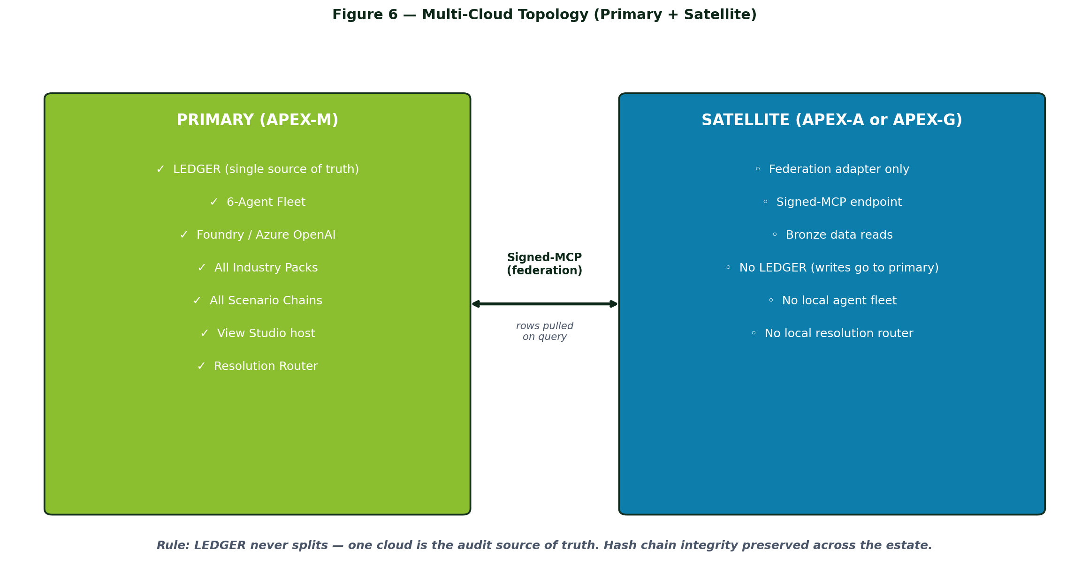
Figure 6 — Multi-Cloud Topology (Primary + Satellite)

5.4 Cross-Cloud Federation Sequence
A query that joins in-lake primary data with a satellite cloud's Bronze source runs through interface #12 as a signed-MCP roundtrip. The LedgerRow records the federation event with the satellite's signature, preserving cross-cloud audit attribution.
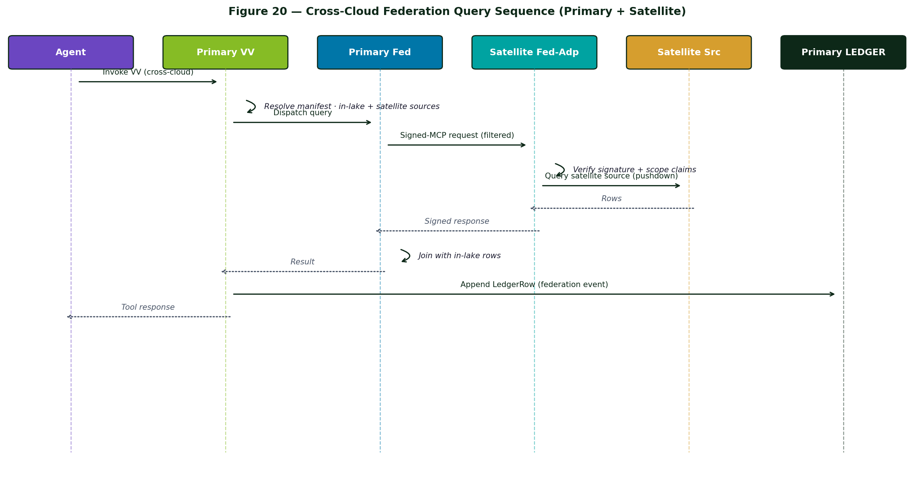
Figure 20 — Cross-Cloud Federation Query Sequence

5.5 Marketplace Strategy
Cloud | Marketplace SKU | Burndown Vehicle
Azure | APEX-M Foundation (Transactable SaaS) + per-pack SKUs | MACC
GCP | APEX-G Foundation (K8s App) + per-pack SKUs | GCP commit
AWS | APEX-A Foundation (Container product) + per-pack SKUs | EDP

Chapter 6 — Data Layer Architecture

6.1 Medallion (Bronze / Silver / Gold)
- Bronze — physical raw landing in the cloud lakehouse. Replay source of truth.
- Silver — physical canonical, namespace-aligned. May be partially virtualized as Virtual Views in v1.
- Gold — physical curated, business-friendly KPI surfaces. Materializations of Virtual Views or hand-curated.

6.2 LEDGER — The Audit Substrate
A 14-field write-once-read-many (WORM) row store with SHA-256 hash chain. Every agent action, threshold breach, persona decision, and virtual-query result emits a LedgerRow.
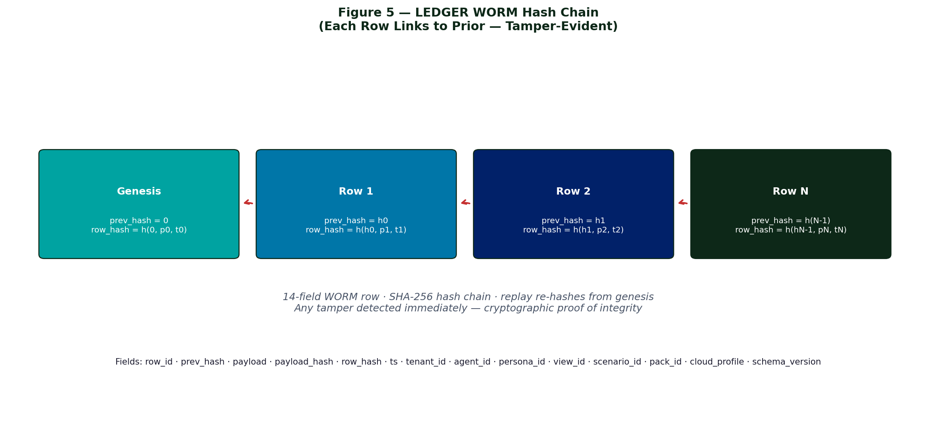
Figure 5 — LEDGER WORM Hash Chain

6.3 LEDGER Schema
Field | Type | Purpose
row_id | UUID | Primary key
prev_hash | sha256 | Links to previous row (chain)
payload | JSON | The actual event content
payload_hash | sha256 | Hash of payload
row_hash | sha256 | sha256(prev_hash + payload_hash + ts)
ts | timestamp | UTC ISO-8601
tenant_id | string | Client tenant
agent_id | string | Author of the action (or 'system')
persona_id | string | Human approver (if HITL)
view_id | string | Source view (if triggered from VV)
scenario_id | string | Scenario chain (if from a chain)
pack_id | string | Industry pack
cloud_profile | enum | apex-m / apex-g / apex-a
schema_version | string | LEDGER schema version
Hash chain replay: re-hash from the genesis row forward and compare every row_hash. Any drift detected immediately. Cryptographic proof of integrity.

6.4 Virtual Views — The Data-Virtualization Framework
A Virtual View is a manifest-defined, federated sensing surface. It is APEX's native answer to data virtualization — declarative views over heterogeneous physical sources, with built-in thresholds and resolution routes.
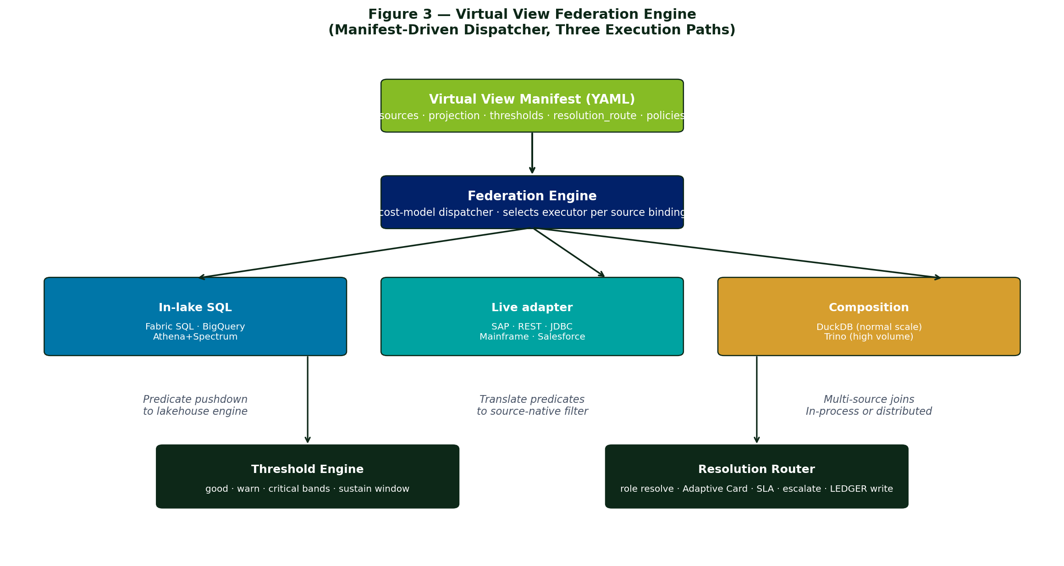
Figure 3 — Virtual View Federation Engine

6.5 VV Manifest Deployment Sequence
A new VV manifest enters the runtime through a deterministic deployment sequence: authored visually in View Studio, validated against the pack acceptance pack, PR'd to the pack repo, CI-tested, published to the Schema Registry, and hot-reloaded by the running VV Runtime. The Studio and the runtime see exactly the same canonical YAML.
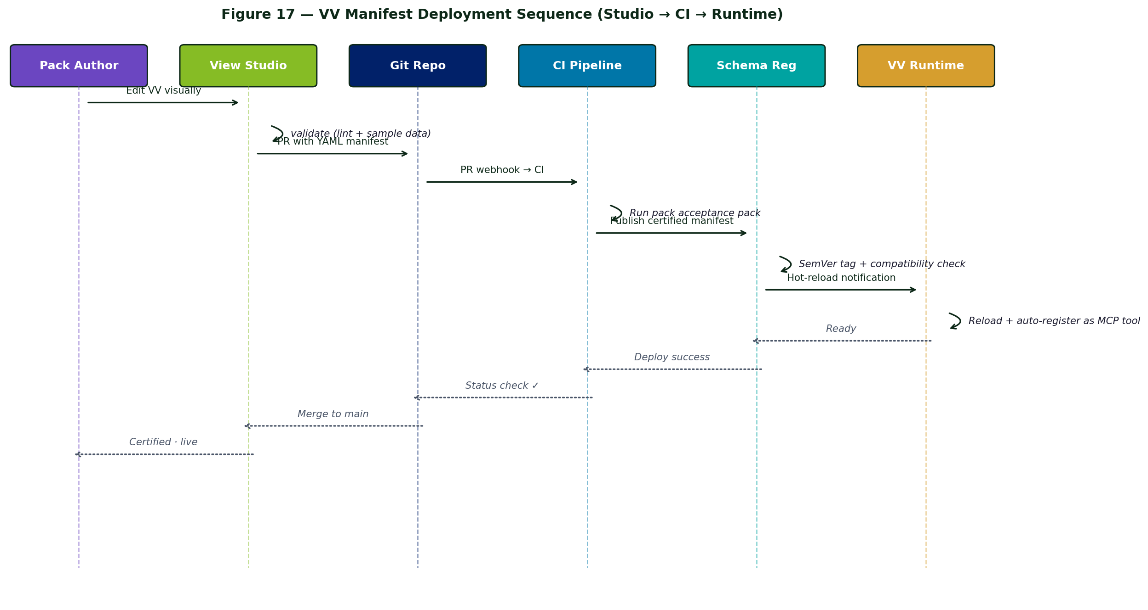
Figure 17 — VV Manifest Deployment Sequence

6.6 Federation Execution Paths
- In-lake — cloud SQL endpoint (Fabric SQL · BigQuery · Athena) with predicate pushdown
- Live — adapter library translates view predicates into source-native filters (SAP · REST · JDBC · mainframe)
- Composition / joins — DuckDB (in-process, normal scale) or Trino (high-volume, distributed)
Decision is made at view-resolve time using a cost-model heuristic: estimated row count per source × predicate selectivity → pick executor.

6.7 Query Execution Sequence
The end-to-end sequence from an agent's tool call through the federation engine to the underlying source and back, including policy enforcement and LEDGER write.
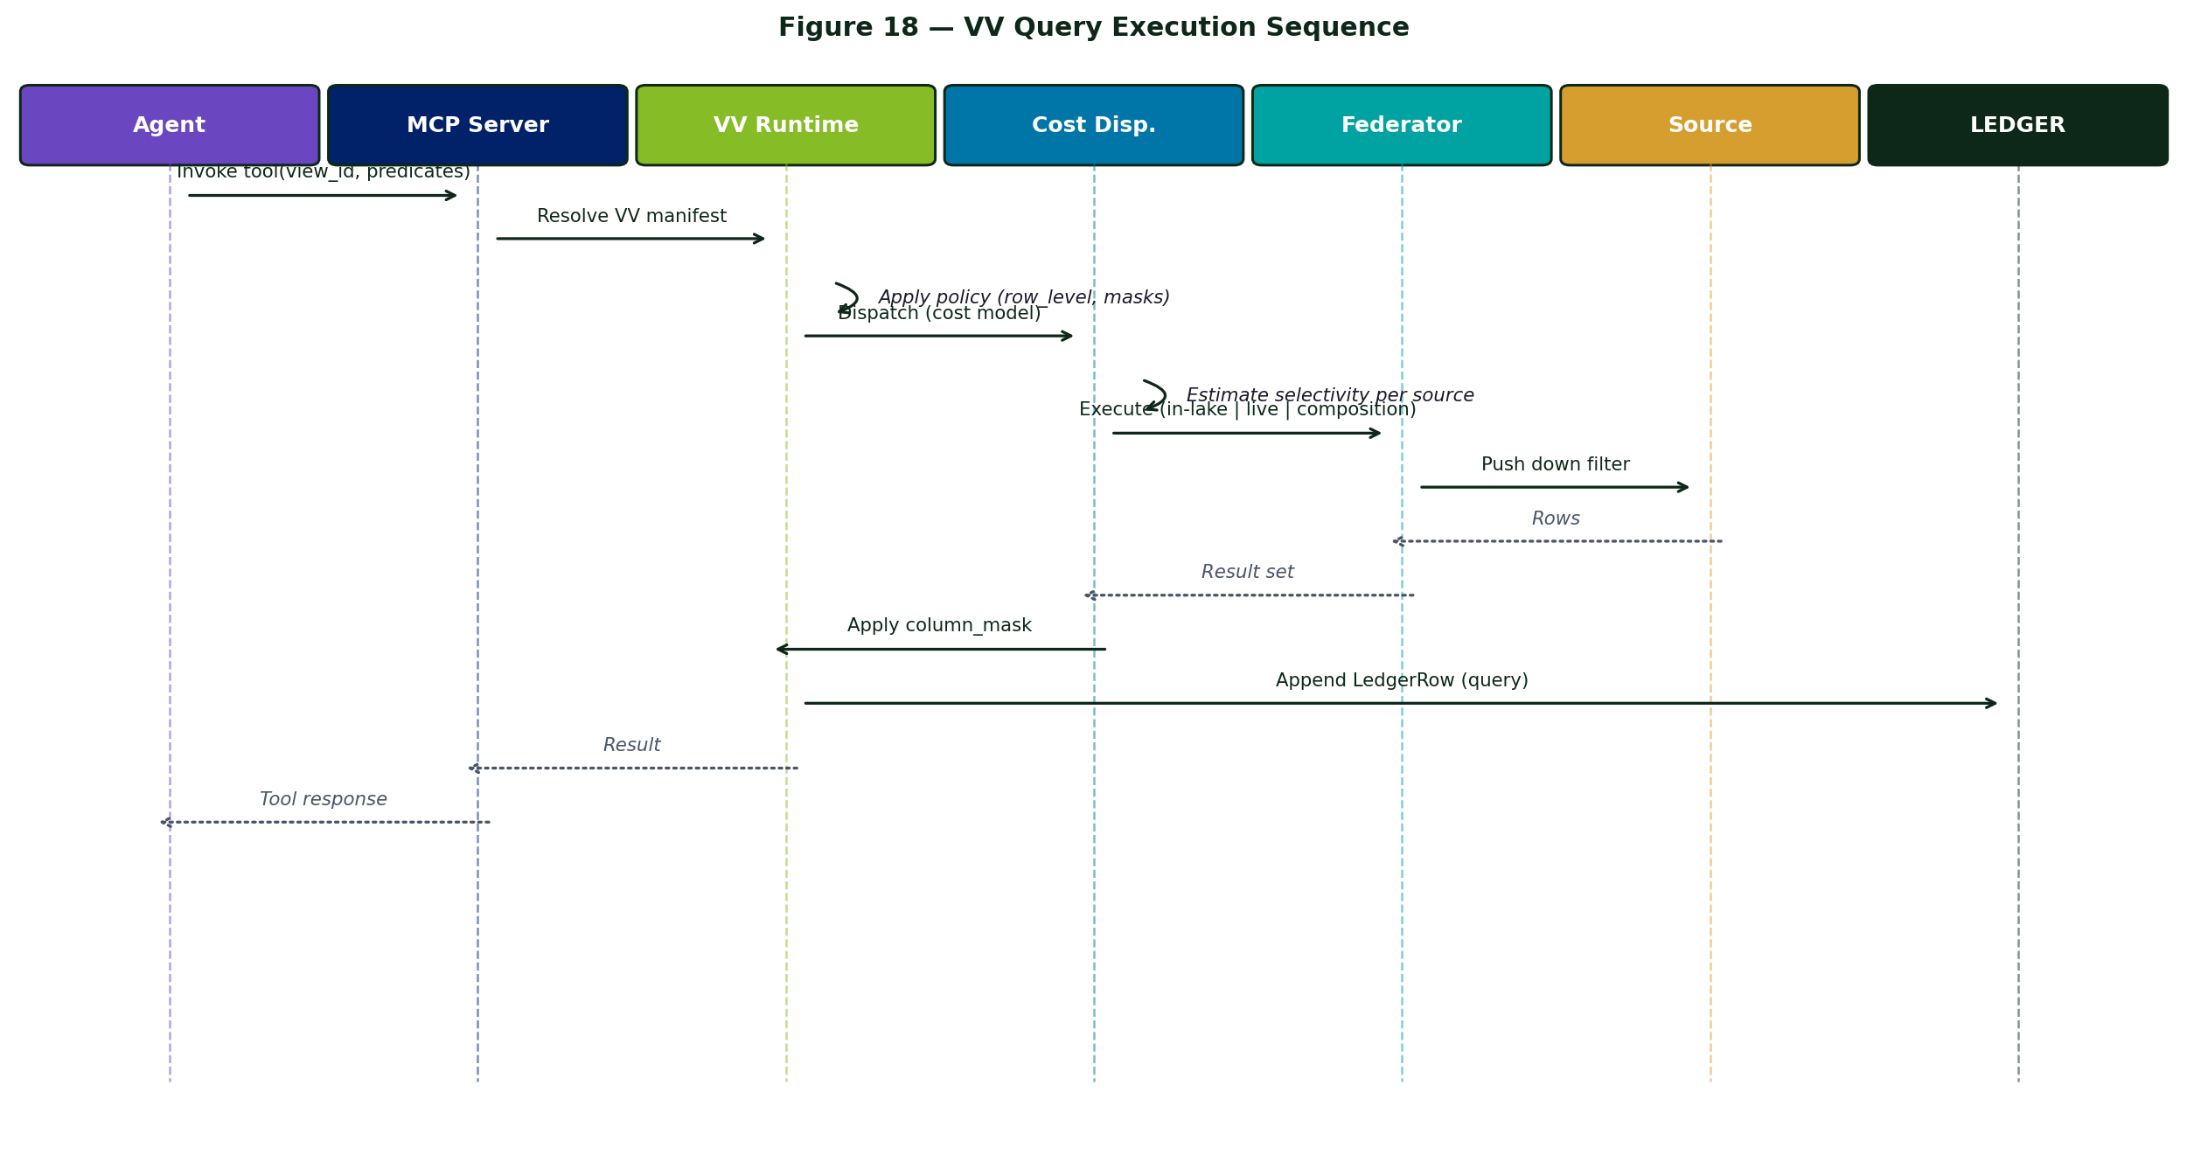
Figure 18 — VV Query Execution Sequence

6.8 Threshold Engine
Threshold bands evaluated either on a schedule (poll) or live (event stream). Result is one of good · warn · critical, plus sustain_window debounce to prevent flapping. Breach emits an Exception row in the LEDGER; the resolution router takes over from there.

6.9 Resolution Router
When a band fires, the router:
- Looks up the matching on_<band> block in the manifest
- Resolves the role: to actual identity group via the Persona model (Chapter 7)
- Builds the Adaptive Card from the named template
- Posts to the persona's channel (Teams / Chat / Slack per Cloud Profile)
- Awaits decision within SLA; escalates if expired
- Dispatches the chosen action subtype (with HITL approval if requires_approval: true)
- Writes a LEDGER row capturing the entire chain

6.10 MCP Auto-Registration
Every VV manifest becomes an MCP tool at MCP-server boot. Projection columns become the output schema; pushable predicates become the tool parameters. No Python glue.

6.11 Replay & Forensics Tooling
- apex-replay <view_id> <ts> — re-runs the federated query against the historical Bronze snapshot and compares result hash against the LEDGER row
- apex-replay-trace <trace_id> — re-runs the entire scenario chain from a starting trace
- Jupyter notebook template per pack — auditor-friendly walkthrough
- Built into every pack runbook

Chapter 7 — Agent Layer

7.1 The 6-Agent Fleet
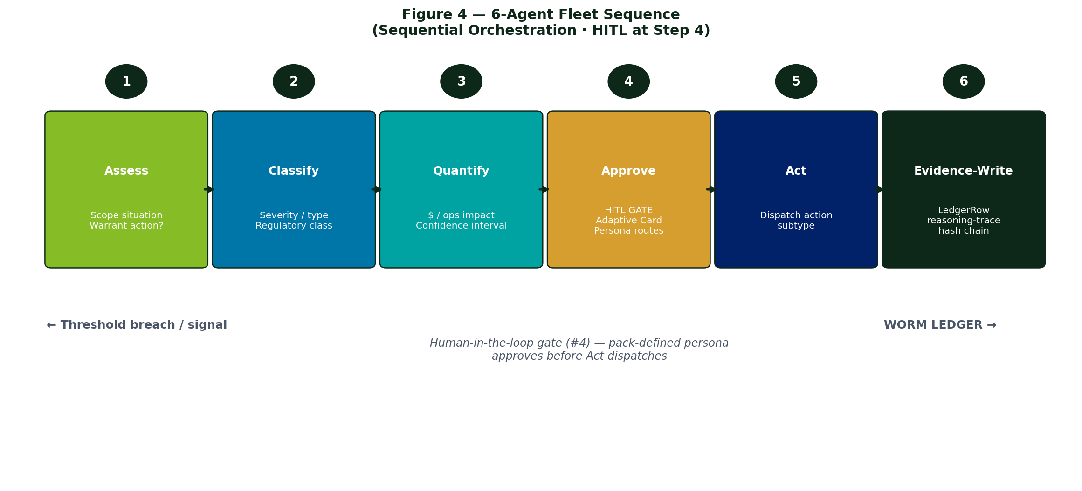
Figure 4 — 6-Agent Fleet Sequence
# | Agent | Job
1 | Assess | Receives signal, scopes the situation, determines if action is warranted
2 | Classify | Categorizes by severity / type / regulatory class (material / non-material)
3 | Quantify | Calculates financial / operational impact + confidence interval
4 | Approve | Builds Adaptive Card and routes to the persona — HITL gate
5 | Act | Dispatches the chosen action subtype
6 | Evidence-Write | Lands the LedgerRow with reasoning-trace + hash chain
Sequential orchestration with HITL gate at step 4. Same fleet across every pack — only the manifests differ.

7.2 Persona / RBAC Model
Each pack ships a personas.yaml binding role IDs to identity providers, SLAs, escalation chains, and HITL channels — per cloud profile.
Example persona definition (excerpt):
personas:
- id: plant_manager
display_name: Plant Manager
identity_binding:
apex-m: { source: entra, group_oid: <oid template> }
apex-g: { source: cloud_identity, group_email: <pattern> }
apex-a: { source: iam_identity_center, group_arn: <pattern> }
entitlement_scope:
- plant_id IN @user.plants
sla: { warn: 4h, critical: 30m }
escalation_chain: [ ops_director, plant_president ]
channel:
apex-m: teams_channel: <id pattern>
apex-g: chat_space: <id pattern>
apex-a: slack_channel: <id pattern>

7.3 Reasoning-Trace Standard
All agent calls emit a canonical reasoning trace recording model version, input/output hashes, every tool call, and token counts. Per-profile adapters map cloud-native trace formats (Foundry threads · Vertex sessions · Bedrock traces) into this canonical form. Stored once per agent call; referenced by hash from the LedgerRow.
reasoning-trace.v1.json schema:
{ "trace_id": uuid, "agent_id": str, "model_version": str,
"system_prompt_hash": sha256, "input_hash": sha256,
"steps": [ { type: tool_call | reasoning, ... } ],
"output_hash": sha256, "total_tokens": int, "completed_ts": iso8601 }

7.4 End-to-End Resolution Sequence (Swim-lane View)
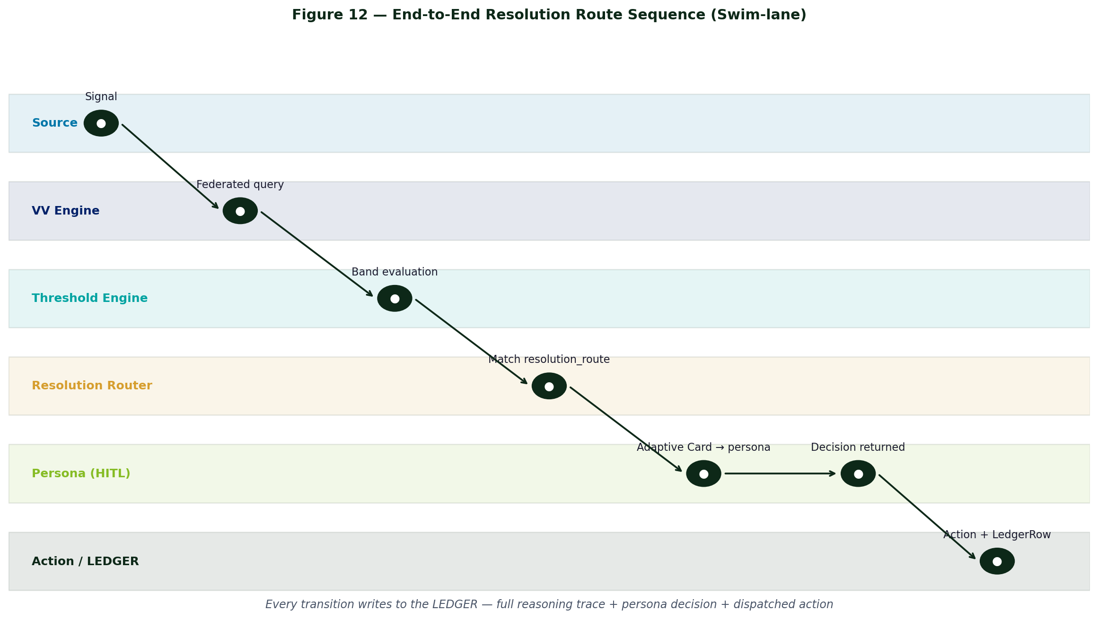
Figure 12 — End-to-End Resolution Route (Swim-lane)

7.5 Threshold Breach Sequence (Detailed UML)
The detailed sequence — from source event through agent fleet, HITL approval, action dispatch, and LEDGER write. Every transition emits a LedgerRow.
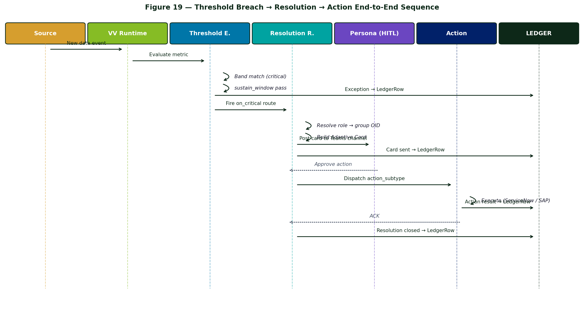
Figure 19 — Threshold Breach → Resolution → Action End-to-End

Chapter 8 — View Studio (Design Surface)

8.1 Concept
Pack authors and client analysts do not write Virtual View YAML by hand. APEX View Studio is the web-based visual editor that produces the canonical VV manifest. The Studio canvas binds drag-drop sources, joins, projections, thresholds, resolution routes, policies, and cache modes into a graphical authoring surface — and emits the same YAML the runtime executes. Round-tripping with source control is bidirectional.
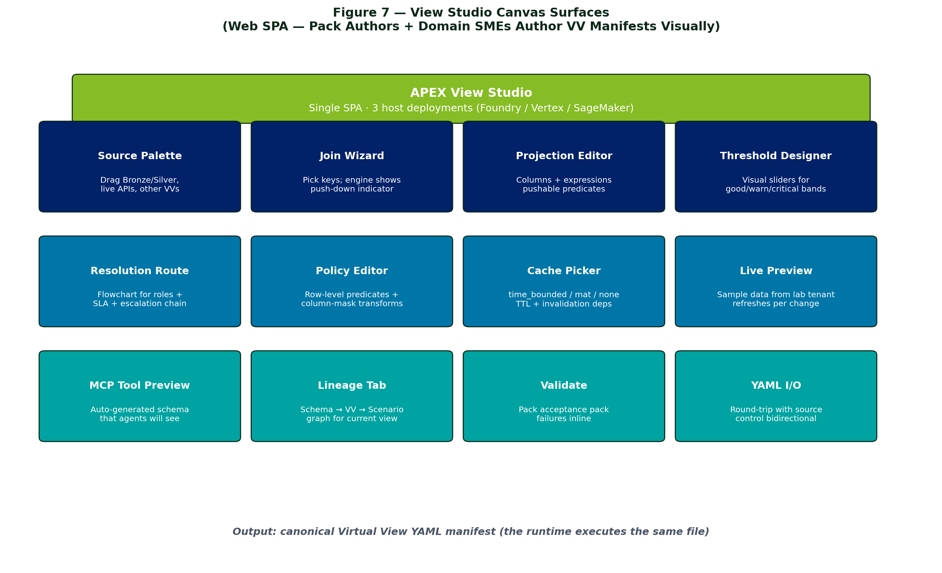
Figure 7 — View Studio Canvas Surfaces

8.2 Deployment per Cloud Profile
Cloud | Host | Identity | Lab Tenant
APEX-M | Foundry Workspace (Fabric notebook surface) | Entra ID | Fabric workspace with synthetic data
APEX-G | Vertex AI Workbench | Cloud Identity | BigQuery sandbox dataset
APEX-A | SageMaker Studio | IAM Identity Center | Athena workgroup with synthetic data
The front-end SPA is identical; only the hosting surface, identity binding, and lab tenant differ. Driven by the Cloud Profile contract.

8.3 Authoring Lifecycle
draft → validate → peer review → approve → certified
↑ │
└──────────── publish to source control ◄──────────┘
- Draft — author working in Studio, not yet committed
- Validate — runs the pack's acceptance test pack against the draft
- Peer review — pack maintainer reviews via standard PR workflow on the YAML
- Approve — pack maintainer accepts; CI runs full pack test suite
- Certified — manifest lands in the pack's views/ directory · tagged with SemVer

Chapter 9 — Industry Solution Packs

9.1 The 10-Asset Bundle
Every pack ships the same 10 assets, in the same file layout. This is the contract a pack team commits to.
# | Asset | Pack Path
1 | VV manifest set | views/
2 | Scenario chain manifest set | scenarios/
3 | Source adapter library | adapters/
4 | Adaptive Card templates | cards/
5 | Role / persona map | personas.yaml
6 | Demo data + lab tenant | demo-data/
7 | BVA worksheet (industry-tuned) | bva/<industry>-roi.xlsx
8 | Sample SOW + statement-of-IP | envelopes/
9 | Acceptance test pack | tests/
10 | Runbook + training kit | runbooks/

9.2 Pack Catalog
Pack | Namespace | Persona Anchor | Views | Release
Manufacturing | MFGML | Plant Manager | ~25 | v1 Q2 FY27
Retail Merchandising | MERML | Planning Lead, DMM, Chief Merchant | 20 | v1 Q2 FY27
Finance / Controllership | FINML | Controller, CFO | ~20 | v1 Q3 FY27
Risk & Compliance | RISKML | SOX PMO Lead, CRO | ~15 | v1 Q3 FY27
Customer Experience | CXML | Care Ops Lead | ~15 | v1 Q4 FY27
ESG / Sustainability | ESGML | Chief Sustainability Officer | ~12 | v1 Q1 FY28

9.3 Pack Lifecycle & Versioning
- SemVer per pack (e.g., manufacturing@1.7.0)
- Major version directory: packs/manufacturing/v1/, v2/
- Migration manifests: packs/manufacturing/migrations/v1-to-v2.yaml declares deltas
- Breaking deltas only at major bump; new views and thresholds at minor; doc-only at patch
- Compatibility matrix: each pack declares supported core versions; runtime refuses incompatible loads
- Sunset policy: n−2 major versions supported in parallel; n−3 enters end-of-life

9.4 Pack-Overlay Model
Clients customize via overlays, not forks. An overlay is a delta-only YAML that declaratively patches the base pack. Pack updates flow through; client deltas remain isolated and reviewable.
overlay: at-t-risk-overlay
extends: risk@1.7
overrides:
- view: riskml.sox_test_cycle
thresholds.bands.critical: "cycle_time_hours > 96"
resolution_route.on_critical.notify.role: at_t_sox_pmo_lead
adds:
- view: riskml.firstnet_control_audit

9.5 Manufacturing Pack v1 (Reference Example)
Sub-domain | Views | Persona
Production | oee_by_line · throughput_by_line · cycle_time_variance · changeover_efficiency · schedule_attainment | Plant Manager · Shift Sup
Quality | defect_rate_by_line · first_pass_yield · scrap_cost · customer_complaint_rollup · capa_open_aging | Quality Manager
Maintenance | downtime_by_cause · mtbf_by_asset · mttr_by_asset · pm_compliance · spare_part_stockout_risk | Maintenance Lead
Supply / inventory | wip_aging · raw_material_coverage_days · supplier_otd_rollup · inbound_risk_score · inventory_variance_by_sku | Materials Manager
Safety / ESG | safety_incident_rate · near_miss_trend · permit_compliance_status · energy_kwh_per_unit · emissions_intensity | EHS Lead
Source adapter coverage: GE Proficy · Rockwell PlantPAx · SAP PM/QM · AVEVA · Aspen · IBM Maximo.

9.6 Retail Merchandising Pack v1 (Reference Example)
Sub-domain | Views (4 each = 20 total) | Persona
Planning & Assortment | assortment_plan_attainment · sku_count_compliance · exit_strategy_aging · vendor_assortment_share | Planning Lead, Category DMM
Pricing & Markdown | markdown_block_eligibility · competitor_price_signal · margin_variance_by_sku · promo_lift_attribution | Category DMM, Pricing Mgr
Forecasting & Allocation | forward_demand_signal · allocation_variance · store_cluster_performance · in_stock_attainment | Demand Planner, Allocation Mgr
Inventory Health | inventory_aging_curve · weeks_of_supply · dead_stock_by_dc · shrink_variance | VP Supply Chain, Ops Lead
Vendor & OTB | open_to_buy_position · vendor_otd_rollup · vendor_lead_time_drift · po_compliance | Chief Merchant, Buyer Lead

Chapter 10 — Scenario Chains

10.1 Concept
A Scenario Chain is a named end-to-end business outcome composed from Virtual Views, agents, personas, and adaptive cards. Scenarios are the unit of value that account teams sell — Service Envelope T3 activates one scenario chain on client sources.

10.2 Manifest
scenario: rc-risk-01
name: SOX PMO control test automation
namespace: RISKML
industry_pack: risk
services: [Agent_4, Agent_8]
personas: [SOX_PMO_Lead, Controller]
uses_views:
- riskml.sox_test_cycle
- riskml.control_inventory
- finml.gl_journal_with_classification
triggered_by:
- view: riskml.sox_test_cycle
band: critical
sustain_window: 1_cycle
imports: # cross-pack composability
- pack: finance@1.x
views: [finml.gl_journal_with_classification]
steps:
- { agent: Agent_4, action: diagnose, inputs: [riskml.sox_test_cycle] }
- { agent: Agent_8, action: quantify, inputs: [finml.gl_journal_with_classification] }
- { persona: SOX_PMO_Lead, decision: approve_evidence }

10.3 Cross-Pack Composability
A scenario in pack A may consume views from pack B via an imports: block. Cross-pack reference linter enforces version compatibility. Cross-pack BVA worksheets allocate value attribution per pack so revenue can be split for internal accounting.

10.4 Catalog Viewer
The HTML catalog viewer renders every scenario as a card with: views chip row, 5-tab VV-detail modal (Manifest · Sources · Thresholds · Resolution Route · Used By), triggered_by badge on auto-triggered scenarios, Coverage Matrix tab per industry pack (orphan views / hungry scenarios), and a Pack Index landing page.

Chapter 11 — Service Envelopes

11.1 Five-Tier Stack
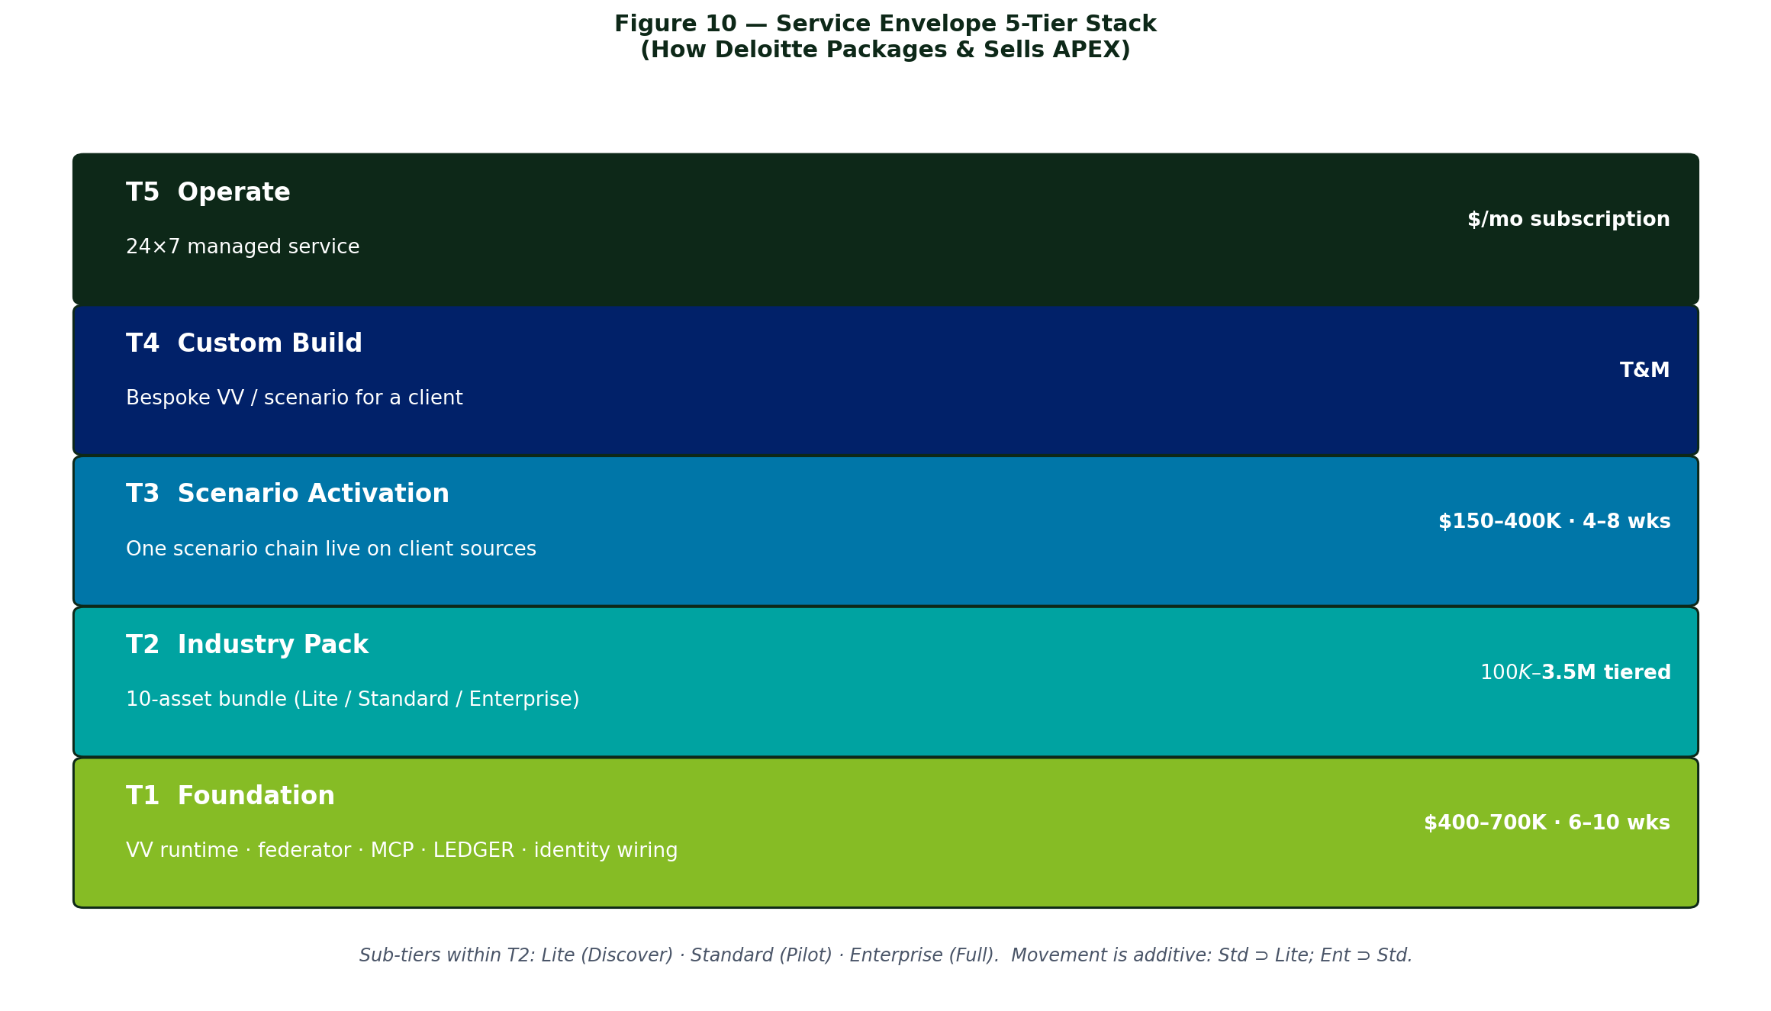
Figure 10 — Service Envelope 5-Tier Stack
Tier | Name | Envelope Contents | Pricing | Funding
T1 | Foundation | VV runtime · federator · MCP · LEDGER · Entra/Purview wiring | $400–700K fixed · 6–10 wks | BVA + DCIF
T2 | Industry Pack | 10-asset bundle — Lite / Standard / Enterprise sub-tiers | $100K–$3.5M tiered | DCIF · T&M · ISV
T3 | Scenario Activation | One scenario chain live on client sources | $150–400K fixed · 4–8 wks | DCIF · T&M · ISV
T4 | Custom Build | Bespoke VV / scenario for a client | T&M | T&M
T5 | Operate | 24×7 managed service — monitoring · tuning · pack uptake | $/mo subscription | Client direct

11.2 Pack Sub-Tiers (within T2)
Sub-tier | Scope | Timeline | Price Band
Pack Lite (Discover) | BVA + scenario shortlist + 1 demo VV on client data | 4–6 wks | $100–250K
Pack Standard (Pilot) | 1 sub-domain live + 3–5 scenarios in production | 12–16 wks | $500K–$1.5M
Pack Enterprise (Full) | All views + all scenarios + Operate-ready | 6–9 mo | $1.5–3.5M
Movement between sub-tiers is additive: Standard ⊃ Lite, Enterprise ⊃ Standard.

11.3 Funding & Independence
Independence rule: Deloitte never receives ECIF directly from Microsoft (Deloitte is Microsoft's auditor). APEX-G uses Google Industry Accelerator (GIA); APEX-A uses AWS MAP. No independence wrinkle on G/A — Deloitte does not audit Google or AWS.
Funding Vehicle | T1 | T2 | T3 | T4 | T5
BVA (client-funded) | ✓ | ✓ | ✓
DCIF (Deloitte co-invest) | ✓ | ✓ | ✓
ISV Marketplace burndown | ✓ | ✓ | ✓
SI Teaming POC |  | ✓ | ✓
Client direct | ✓ | ✓ | ✓ | ✓ | ✓
T&M |  | ✓ | ✓ | ✓

Chapter 12 — Security & Identity Architecture

12.1 Identity Foundation
Each Cloud Profile binds to the cloud-native identity provider (interface #6). APEX-M uses Entra ID; APEX-G uses Cloud Identity / Workspace; APEX-A uses IAM Identity Center. No APEX-managed user directory. SSO is the only supported interactive login path.

12.2 Persona-Bound Authorization
Authorization is persona-bound (Chapter 7.2). The Virtual View manifest's policies.row_level predicate consumes @user.* claims resolved at query-plan time by the claim_provider (Cloud Profile component). Column masks are applied during projection. Every policy decision is recorded as a LedgerRow policy_decision.

12.3 Secrets Management
- All credentials live in the cloud-native vault (interface #7): Key Vault · Secret Manager · Secrets Manager
- No secrets in environment variables or container images
- Credentials accessed via managed-identity / workload-identity / IRSA — never long-lived keys
- Secret rotation evented through DataOps source-health VVs (credential_expiry_warn)

12.4 Data Classification & Lineage
Interface #11 binds to the cloud-native lineage / catalog: Purview · Dataplex · DataZone + Glue. Every VV manifest declares the schema it produces; lineage is captured Schema → VV → Scenario automatically. Sensitive-data tags from the catalog drive column-mask policies in the VV manifest.

12.5 Audit Defensibility
The LEDGER is the audit substrate (Chapter 6.2). The hash chain is reproducible from genesis. The apex-replay CLI re-executes any historic query against the Bronze snapshot and compares the hash — proving the recorded result is the result that was returned. This satisfies regulator-defensibility requirements for SOX, GDPR, HIPAA, and PCI-class engagements.

12.6 Tenancy Boundaries
- Default: dedicated runtime per client (own VV runtime pods · own LEDGER · own agent fleet · shared adapter library + pack catalog)
- Variant: shared runtime, tenant-scoped data — only for small / sandbox tenants
- Tenant boundary enforced at identity layer; LEDGER per-tenant; cross-tenant lineage forbidden

Chapter 13 — Operations Architecture

13.1 Multi-Tenancy
Default model: dedicated runtime per client. Hard isolation, simpler Independence stance, predictable performance. Variant model (shared runtime, tenant-scoped data) used only for small clients or sandbox tenants.

13.2 FinOps & Metering
Every VV query, every agent invocation, every scenario run emits a cost payload to LEDGER with fields: cloud_unit_cost · tokens_in · tokens_out · model_unit_cost · elapsed_ms. Monthly rollup per pack / scenario / tenant drives the Operate dashboard. Expensive views surface for caching review (threshold tuning).

13.3 Threshold-Tuning Loop
Each pack ships threshold-telemetry VVs that observe band-distribution over time. When warn fires < 1% or > 30% of sampled cycles for two consecutive months, the runbook surfaces a tuning recommendation. Pack maintainer reviews and ships a minor-version update; the migration manifest captures the threshold delta.

13.4 DataOps for Upstream Sources
Every pack ships source-health VVs: source_freshness · schema_drift_detector · credential_expiry_warn. They emit Exceptions and route to the Operate team via the same resolution-router plumbing as everything else. Source breakage is a first-class APEX event.

13.5 Pack Acceptance Test Pack
Each pack ships 60+ tests across:
- Manifest validity — all VVs lint; all scenarios lint; all imports resolve
- Source reachability — every source binding produces > 0 rows in lab tenant
- Threshold sanity — band predicates well-formed; sustain windows valid
- Role resolution — every role: resolves to a non-empty identity group in lab tenant
- End-to-end fire-drill — synthetic breach triggers the full resolution route through to LEDGER write
- Performance — p95 latency per VV under SLA target
Tests run in CI per pack release. A Certified Pack badge attaches on green.

13.6 Platform SLA
Service | Availability | Latency (p95)
VV federation engine (in-lake) | 99.9% uptime | < 800ms
MCP call | 99.9% uptime | < 250ms
LEDGER append | 99.99% durability | < 100ms
Resolution route notification | 99.9% delivery | < 5s

13.7 Disaster Recovery
Component | RPO | RTO
LEDGER | 0 (synchronous replication in-region) + cross-region async replica | 15 min
Bronze | 1 hour (snapshot cadence) | 4 hours
VV runtime | 0 (stateless) | 5 min via autoscale
Resolution router | 5 min (stateful — SLA timers) | 15 min
DR drill quarterly; hash chain re-verified post-DR.

13.8 Observability
Each Cloud Profile maps platform SLOs to its native observability stack (interface #10) and emits a unified apex.platform.* metric namespace. Logs, metrics, and traces use OpenTelemetry where the cloud allows.

Chapter 14 — Deployment View per Cloud Profile
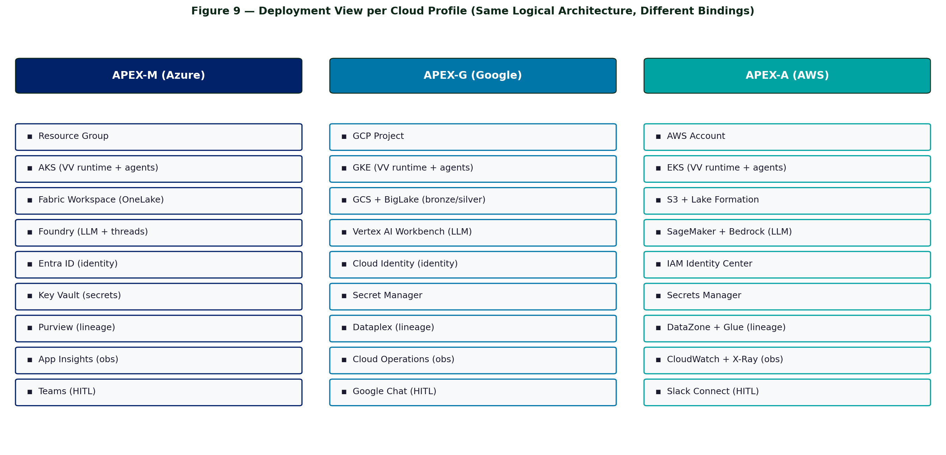
Figure 9 — Deployment View per Cloud Profile

14.1 Same Logical Architecture, Different Bindings
APEX-M, APEX-G, and APEX-A deploy the same Core components with cloud-native bindings for each of the 12 interfaces. The Helm chart is identical; only the values file differs.

14.2 APEX-M Deployment (GSSC Lab Reference)
- Subscription: sub-apex-m-gssc-lab under mg-apex-m-lab management group
- Regions: eastus2 (primary), eastus (secondary)
- AKS cluster for Core runtime (VV runtime · agents · MCP server · resolution router)
- Fabric Workspace (OneLake) for medallion (Bronze · Silver · Gold)
- Foundry workspace hosts the Agent fleet and View Studio SPA
- Azure OpenAI for LLM (interface #8)
- Entra ID groups for persona binding (interface #6)
- Key Vault for secrets (interface #7)
- Purview for lineage (interface #11)
- App Insights + Log Analytics for observability (interface #10)
- Teams channels for HITL (interface #9)
Full step-by-step build: see APEX-M-GSSC-Lab-Infrastructure-Deployment.docx (135-page Day-0 guide).

14.3 APEX-G and APEX-A (Reference Deployments)
APEX-G and APEX-A deploy with parallel structure — GKE / EKS for compute, GCS+BigLake / S3+Lake Formation for storage, Vertex / Bedrock for LLM, Cloud Identity / IAM Identity Center for identity, Cloud Operations / CloudWatch+X-Ray for observability, Google Chat / Slack Connect for HITL. The Core Helm chart and pack content are identical to APEX-M.

Chapter 15 — Operating Profiles (Cost / Latency / Audit Scalability)
Cost, latency, and audit-depth form a trilemma. APEX must not impose fixed trade-offs on clients. Operating Profiles let each tenant pick where they sit on each axis at runtime, with per-pack and per-VV override and a regulatory floor below which no profile can drop.
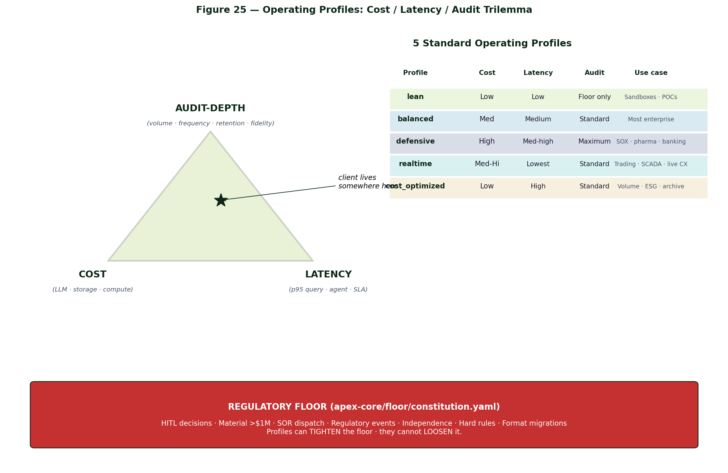
Figure 25 — Operating Profiles: Cost / Latency / Audit Trilemma

15.1 Five Standard Profiles
Profile | Cost | Latency | Audit Depth | Use Case
lean | Low | Low | Minimum legal floor | Sandboxes · POCs · dev tenants
balanced | Medium | Medium | Standard | Most enterprise (default)
defensive | High | Med-high | Maximum | SOX · pharma · banking
realtime | Med-Hi | Lowest | Standard | Trading · SCADA · live customer
cost_optimized | Low | High | Standard | Volume · ESG · archive-heavy

15.2 Regulatory Floor — What Cannot Be Sampled
Lives in apex-core/floor/constitution.yaml. ConCon ARB + Architecture Council + OGC own changes. Mandatory captures regardless of profile:
- Persona HITL decisions — 100% · full fidelity · cannot be sampled or summarized
- Material financial decisions (>$1M impact) — full reasoning trace
- Action dispatched to SOR — with idempotency key
- Regulatory-class events (SOX · GDPR · HIPAA · OSHA reportable) — full chain · longest retention
- Independence-relevant decisions — full reasoning
- Constitution hard-rule fires — rule_id · pass/fail explicit
- Cross-tenant federation events — signed-MCP envelope retained
- Schema · format migration · custody records — perpetual retention
- Profile changes — meta-audit
Profiles can tighten the floor; they cannot loosen it.

15.3 ~30 Tunable Knobs
Each profile sets ranges for 8 subsystems:
Subsystem | Example Knobs
Agent reasoning | Plan pass · self-critique · consensus samples · multimodal fetch · specialist routing · memory top-k
VV runtime | Cache mode + TTL · federation path · concurrency ceiling
Snapshot Layer | Tick cadence floor · burst pre-buffer · aggregation depth · archive tier
LEDGER capture | Per-event-class capture mode · sample rate · reasoning fidelity
Simulation | Branch count · sim LEDGER promotion
Vector / cache | Embedding policy · model size · Redis footprint
Archive | Retention class · cross-cloud replication · format migration
Featurization | Real-time vs batch · confidence floor · PII redaction

15.4 Four LEDGER Capture Modes
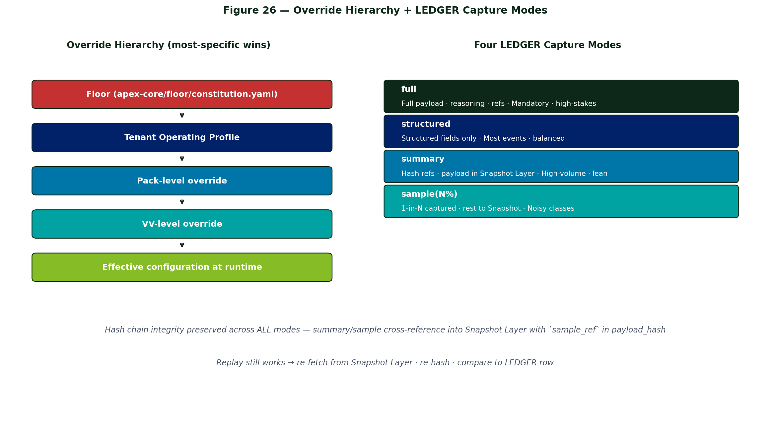
Figure 26 — Override Hierarchy + LEDGER Capture Modes
Mode | What's written | Hash chain | Use
full | Full payload + reasoning + refs | Yes | Mandatory · high-stakes
structured | Structured fields only | Yes | Most events · balanced
summary | Hash references only · payload in Snapshot Layer | Yes (xref) | High-volume · lean
sample(N%) | 1-in-N captured · rest to Snapshot Layer | Yes (sampled) | Noisy classes
summary and sample modes preserve hash-chain integrity by cross-referencing into the Snapshot Layer. Replay still works.

15.5 Override Hierarchy
Floor (apex-core/floor/constitution.yaml)
↓
Tenant Operating Profile
↓
Pack-level override (e.g., Safety VVs auto-elevate)
↓
VV-level override
↓
Effective configuration at runtime

15.6 Profile Engine — New Core Component
Resolves effective configuration per event and per query:
- Profile registry — all profiles loaded · versioned · per-tenant binding
- Override resolver — walks Floor → Profile → Pack → VV hierarchy
- Capture decision — per LedgerRow candidate · applies event-class capture policy
- Knob evaluation — provides effective values to all other Core components
- Floor enforcer — refuses to load any profile/override that violates the floor
- Change auditor — profile changes themselves emit LedgerRow events
Redis-cached for < 5ms p95 overhead. Cache invalidates on profile change.

15.7 Decoupling from Service Envelopes
Service Envelope = what Deloitte sells (T1-T5). Operating Profile = how the platform behaves. Decoupled. A T2 Pack Standard client can run lean or defensive. Same platform serves a sandbox at $50/month and a global bank at $50K/month — audit floor holds for both.

Chapter 16 — VV Temporal Semantics (Snapshot Layer · Simulation)
VV today is synchronous — 'what's the value now?' Real workloads need multi-cadence sampling (1s → 1 decade), threshold-triggered burst capture, decision-support snapshots, backward replay, and forward simulation.

16.1 Snapshot Layer — New Architectural Tier
LEDGER stays lean — only decisions, breaches, and simulation bookends land in WORM. Snapshot Layer handles the high-cadence tick volume:
- Captures high-cadence ticks into ephemeral Bronze rows (cheap object storage)
- Aggregates automatically up the cadence pyramid (1s → 1m → 1h → 1d → 1w → 1mo → 1q → 1y → 10y)
- Promotes significant snapshots (around breaches · decisions · simulation bookends) to WORM LEDGER
- Tiers storage: hot (≤7d) · warm (7-90d) · cold (90d-2y) · archive (>2y)
- Cross-references LEDGER rows to lower-tier samples by sample_ref
- sample_ref included in payload_hash — cryptographically tamper-evident
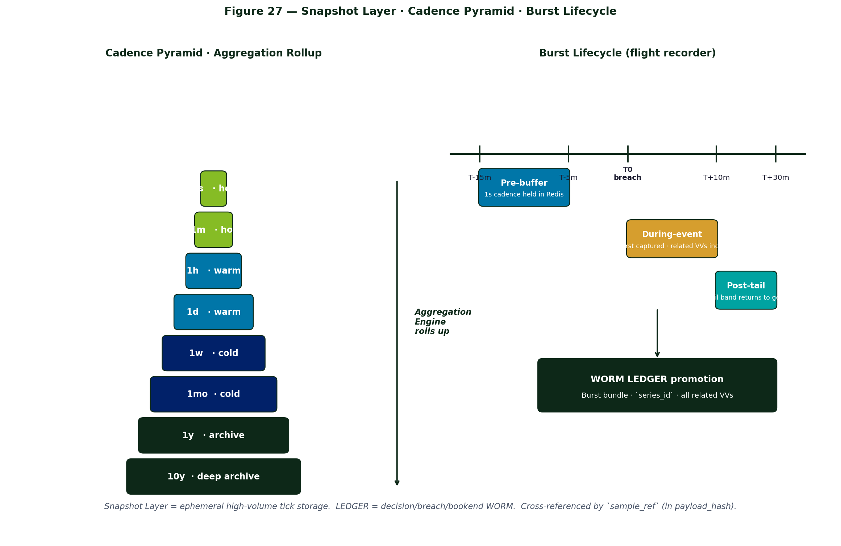
Figure 27 — Snapshot Layer · Cadence Pyramid · Burst Lifecycle

16.2 Three New Manifest Sections
snapshots:
ticks: [ cadence + retention + promotion + aggregator ]
bursts: [ trigger + pre_buffer + cadence + max_duration + post_tail + related_views ]
decisions:[ what to freeze at decision moments ]
aggregation:
pyramid: [ 1s → 1m → 1h → 1d → 1w → 1mo → 1q → 1y → 10y ]
archive_decimation: [ keep_full / decimate_to / further_decimate_to ]
simulation:
forward: [ generator + step + horizon + branches + seed ]
backward: [ extra_substitutions_allowed ]
All three optional — VVs without them behave exactly as today.

16.3 Three New Core Components
Component | Responsibility
Snapshot Scheduler | Emits tick events at every configured cadence; manages burst state on threshold breach
Aggregation Engine | Walks the pyramid; decimates at archive tier per archive_decimation policy
Simulation Engine | Backward replay (extended) + forward projection (Monte Carlo branching)

16.4 LEDGER v2 Schema Additions
Field | Purpose
snapshot_type | tick · burst · decision · sim_forward · sim_backward · breach · resolution
cadence | 200ms · 1s · 1m · 1h · 1d · 1w · 1mo · 1q · 1y · 10y
series_id | Groups related rows (one burst · one sim branch)
sequence | Ordering within the series
sample_ref | Pointer into Snapshot Layer when not promoted (cryptographically chained)

16.5 Forward Simulation Pattern
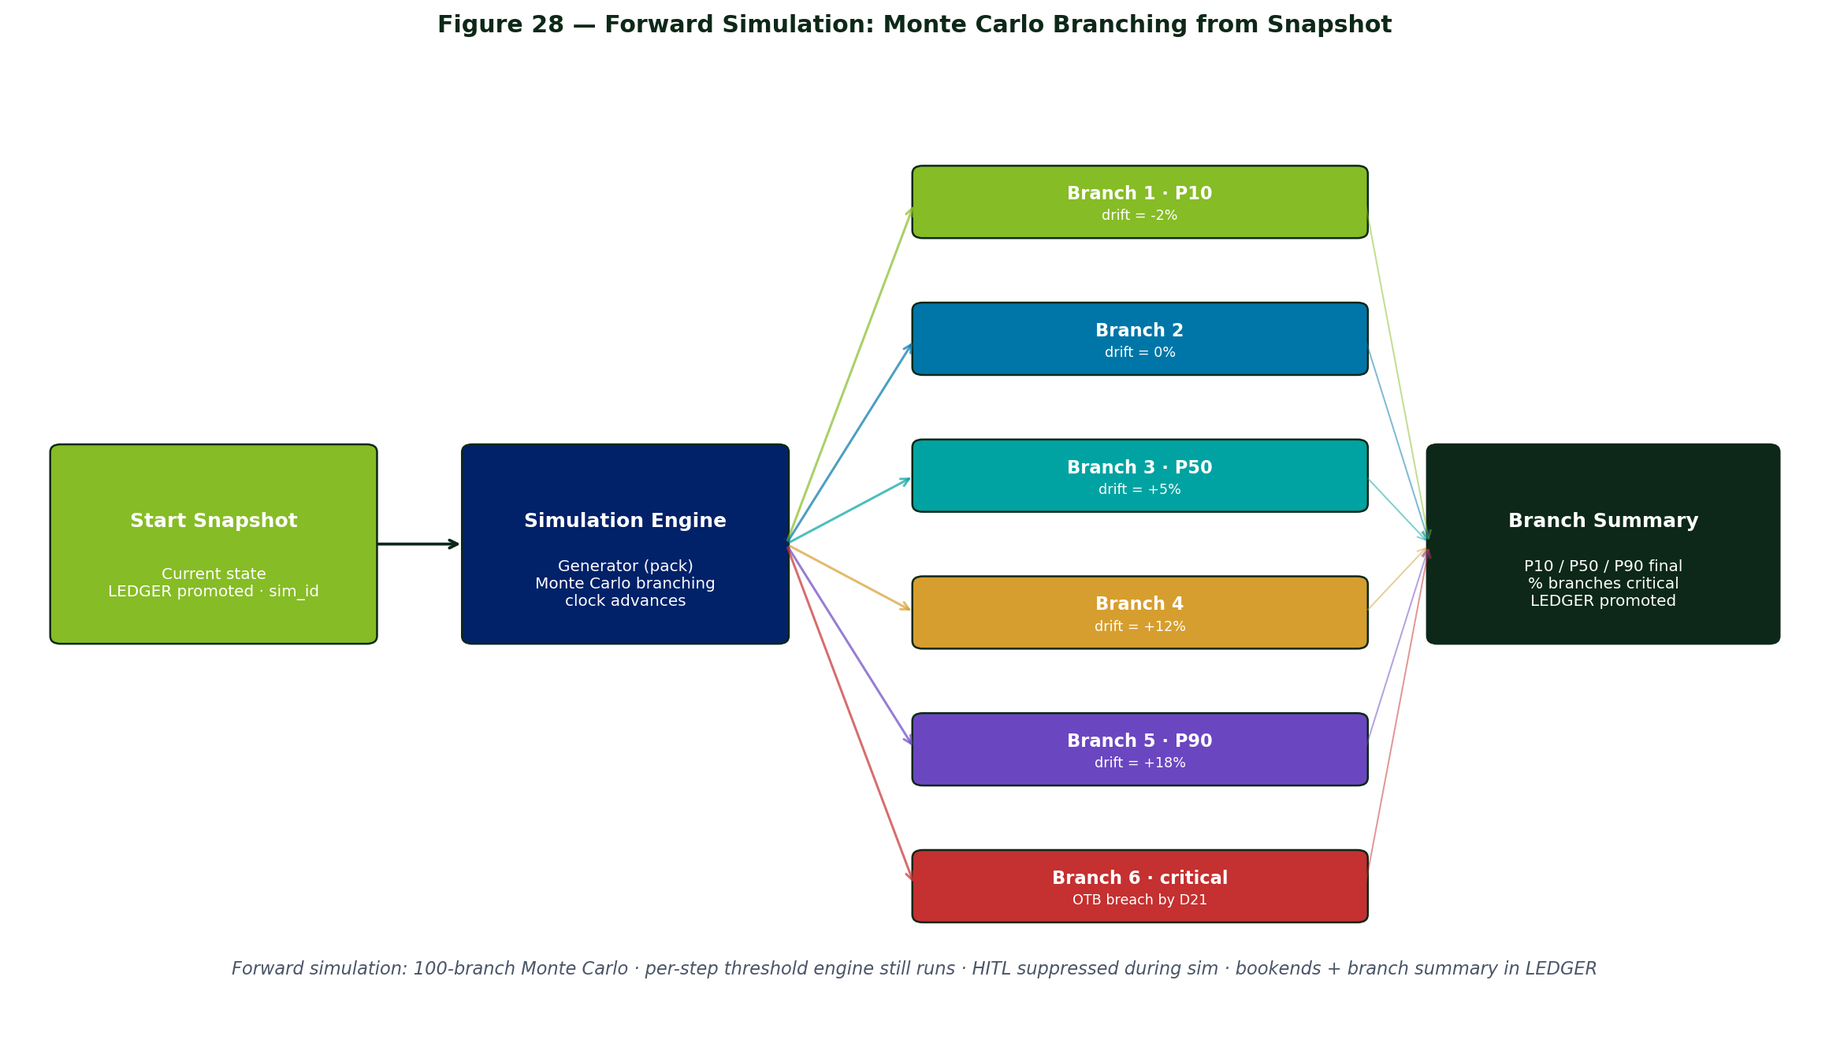
Figure 28 — Forward Simulation: Monte Carlo Branching from Snapshot

16.6 Two Worked Examples
Manufacturing OEE flight recorder
Critical OEE band fires on Line 7 at 02:00. The Snapshot Layer captures a 49-minute burst at 1-second cadence (5m pre-buffer · 42m during-event · 2m post-tail) across three views simultaneously (oee_by_line · downtime_by_cause · defect_rate_by_line). Plant Manager opens the LEDGER trace, clicks the series_id, and gets back the full scrubbable timeline — cryptographically verified.
Retail Merchandising OTB simulation
Chief Merchant asks 'what's OTB 30 days out if we don't act?' Simulation Engine forks 100 Monte Carlo branches from the current state · advances each 1 day at a time · runs threshold engine on synthetic data · promotes branch summary to LEDGER. Returns 'do nothing → 87% chance of critical OTB by day 21; rebalance now → 12%.'

Chapter 17 — Agent Intelligence Layer
Today's 6-Agent Fleet is structurally sound but cognitively shallow: stateless, monolithic, no outcome learning, no self-critique, no calibration. The Intelligence Layer is additive — the backbone is unchanged, the seven new components plug in via abstract APIs, and packs opt in per-pack.
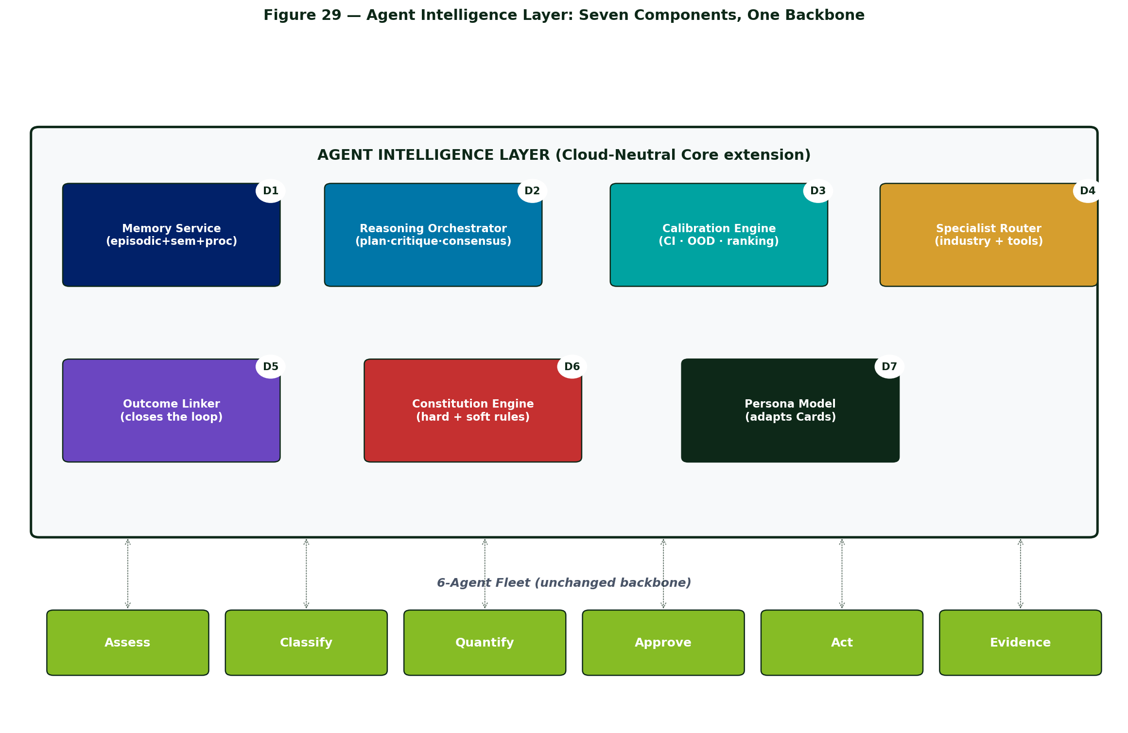
Figure 29 — Agent Intelligence Layer: Seven Components, One Backbone

17.1 Seven Dimensions of Smarter
# | Dimension | What It Unlocks
D1 | Memory | Episodic (past decisions) + Semantic (vocabulary) + Procedural (playbooks)
D2 | Reasoning depth | Plan → Self-critique → Consensus voting
D3 | Calibration | Confidence intervals · OOD score · probabilistic action ranking
D4 | Specialist sub-agents | Industry specialists (pricing · cycle-time · GL · controls) + tool specialists (SAP · Salesforce · Workday)
D5 | Outcome learning | Closed loop: outcome → effectiveness aggregation → re-rank → tune thresholds
D6 | Policy constitution | Per-pack constitution.yaml · agents self-check
D7 | Persona model | Pre-compute likely decision · adapt language · flag divergence

17.2 Seven New Core Components
Component | Responsibility
Memory Service | Vector store per tenant per pack · episodic + semantic + procedural memory types
Reasoning Orchestrator | Wraps every agent call with Plan · Self-critique · Consensus passes
Calibration Engine | Adds confidence intervals · OOD scores · conformal predictions · action ranking
Specialist Sub-Agent Router | Routes to industry + tool specialist sub-agents based on manifest
Outcome Linker | Watches LEDGER for actions · waits outcome_window · connects outcome back
Constitution Engine | Evaluates hard + soft rules · Independence checks · routes to escalation persona
Persona Model | Per-persona behavioural model · Card adaptation · divergence flagging

17.3 Constitution Flow + Outcome Learning Loop
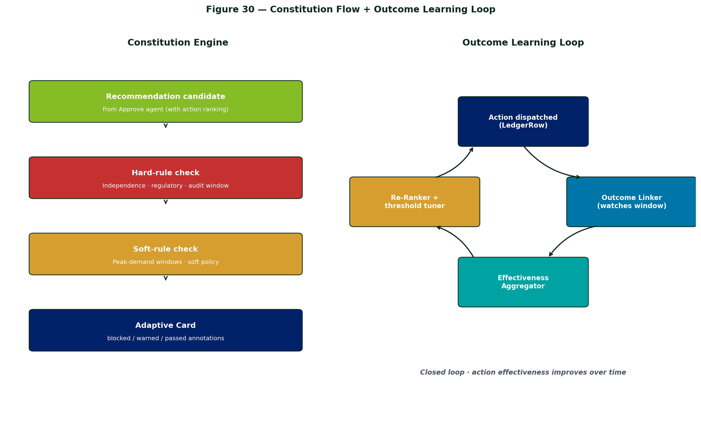
Figure 30 — Constitution Flow + Outcome Learning Loop

17.4 Constitution.yaml Example
constitution:
pack: manufacturing
hard_rules: # block + escalate on violation
- id: H1
rule: "Action cannot dispatch a production change during a regulatory audit window."
- id: H2
rule: "Material financial impact (>$1M) requires CFO approval."
soft_rules: # warn in Card, don't block
- id: S1
rule: "Avoid changeover halts during peak demand (Friday 14:00-18:00 local)."
independence:
- id: I1
rule: "Cannot include financial forecast for SEC-registered clients."

17.5 LEDGER v2.1 Schema Additions
Field | Purpose
precedent_refs | Up to 5 episodic memory hits that informed this decision
confidence | Calibrated confidence in the Quantify output
ood_score | Out-of-distribution score (0 = familiar · 1 = novel)
action_ranking | Probabilistic ranking of candidate actions
constitution_check | { hard: [pass/fail per rule], soft: [pass/warn per rule] }

17.6 Worked Example — OEE Breach with Intelligence On
Compare today's flow vs Intelligence-on flow.
Today: 'OEE 62% Line 7 · dispatch maintenance? [Approve] [Reject]'
With Intelligence Layer:
- Episodic memory pulls 4 similar Line 7 precedents
- OOD score 0.08 — familiar pattern
- Specialist mfg.cycle_time_specialist quantifies $12K ± $3K (90% CI)
- Constitution H1 passes; soft S1 warns peak-demand window
- Action ranking: maintenance dispatch (P=0.60) · upstream material check (P=0.25)
- Persona model knows Plant Manager Smith requests upstream check 30% of the time on Line 7
- Consensus voting 3/3 agrees on maintenance dispatch · disagreement = 0.0
- Card shows: 'Recommended: dispatch maintenance · Also consider: upstream material check'
- 6 hours later: Outcome Linker connects to 'OEE recovered to 84%' → effectiveness updated

Chapter 18 — Vector + Cache Substrate (Interface #13)
Memory and calibration require vector storage. Coordination and caching require Redis. Both are first-class enough to deserve dedicated treatment — Redis is promoted to Interface #13 of the Cloud Profile contract, bumping the contract from 12 to 13.
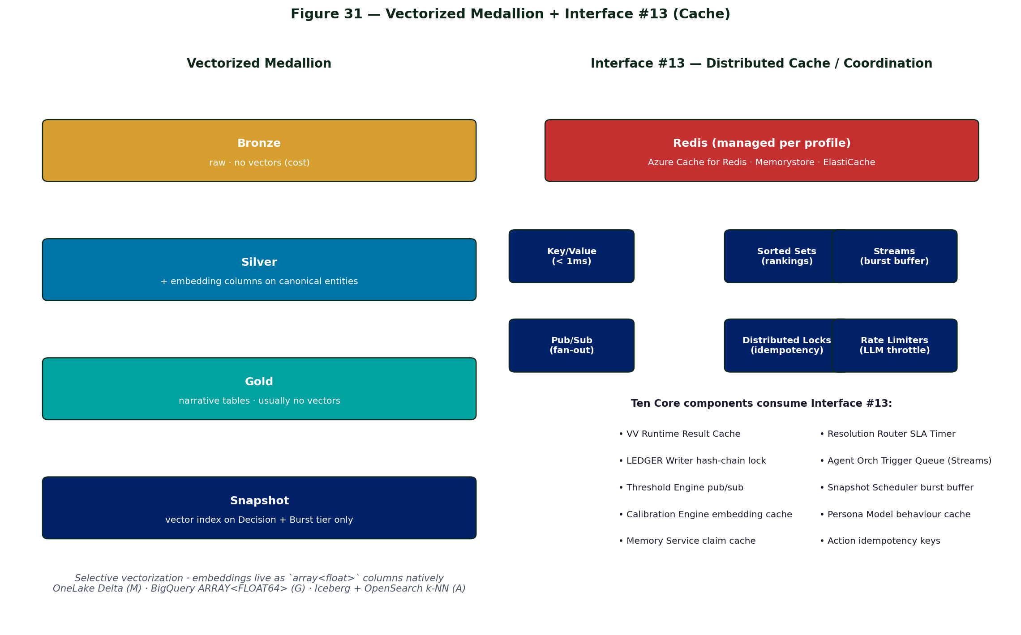
Figure 31 — Vectorized Medallion + Interface #13 (Cache)

18.1 Vectorized Columns in Storage
Five concrete use sites, all using the lakehouse-native vector column (OneLake Delta · BigQuery ARRAY · Iceberg + OpenSearch). No standalone vector database needed.
Use Site | What Gets Vectorized
Episodic Memory | Past LedgerRows — 'find 5 nearest precedents'
Semantic Memory | Pack glossary · client vocabulary mapping
Snapshot Layer index | Burst-snapshot summaries · 'find similar critical bursts'
LEDGER semantic search | Auditor forensic search by description
VV catalog discovery | 'Auto-recommend related views when authoring a new scenario'

18.2 Per-Cloud Vector Storage
Cloud | Native Vector Storage | Vector Index
APEX-M | OneLake Delta · array<float> column | Fabric Vector Search or pgvector on Azure Postgres Flexible Server
APEX-G | BigQuery · ARRAY<FLOAT64> column | BigQuery vector index or AlloyDB pgvector
APEX-A | Iceberg · array<float> on S3 | OpenSearch k-NN or RDS pgvector

18.3 Interface #13 — Distributed Cache / Coordination
Vanilla key-value cache is not sufficient. Redis is promoted to a full interface because APEX needs seven different Redis semantics:
- Sub-millisecond key/value — VV result cache · persona model lookup · claim cache
- Sorted sets — action ranking lists · SLA timer expiry ordering
- Pub/Sub — event bus between Threshold Engine ↔ Resolution Router ↔ Snapshot Scheduler
- Streams (XADD/XREAD) — burst-mode tick buffer · agent trigger queue
- Distributed locks (Redlock) — LEDGER hash-chain write coordination · action idempotency
- Rate limiters — LLM call throttling per tenant · ISV-call rate caps
- TTL eviction — manifest cache · time_bounded VV cache invalidation

18.4 Per-Cloud Redis Implementation
Cloud | Managed Redis
APEX-M | Azure Cache for Redis Enterprise (VNet · persistence · geo-replication)
APEX-G | Memorystore for Redis (HA · IAM auth)
APEX-A | ElastiCache for Redis (Multi-AZ · encryption · IAM auth)

18.5 Ten Core Components Use Interface #13
Component | Use
VV Runtime · Result Cache | Hot result cache for cross-pod sharing
Resolution Router · SLA Timer | TTL keys for SLA expiry · EXPIRE triggers escalation
Resolution Router · Decision | Idempotency key — prevent duplicate-action dispatch on retry
LEDGER Writer · Hash Chain | Distributed lock to serialize prev_hash reads under heavy multi-pod write
Agent Orchestrator · Trigger Queue | Streams (XADD/XREAD) — replaces ad-hoc cloud queue for sub-second triggers
Threshold Engine | Pub/Sub fan-out of breach events to Resolution Router + Burst Manager
Snapshot Scheduler · Burst Manager | Streams · pre-buffer holds 5-15 min of tick events before WORM promotion
Calibration Engine · OOD Score | Embedding distance cache · avoid re-embedding identical strings
Persona Model · Behaviour Cache | Hot lookup of 'what does Plant Manager Smith usually approve?'
Memory Service · Claim Cache | Resolved @user.* claims with TTL

18.6 ConCon ARB Impact
12 → 13 interfaces is a boundary change. Mandatory ConCon ARB submission (per §15.4 of v3 architecture doc · 12-interface change requires ARB). Grouped with temporal/sim · agent intelligence · multimodal/archival · operating profiles in a single ARB ticket.

Chapter 19 — Multimodal Sources & Featurization
Video · audio · documents · images · binary telemetry are first-class business signals. VV manifest contract is unchanged — raw media lands in Bronze unchanged · a new Featurization Layer runs ML pipelines per source type to emit canonical event rows + multimodal embeddings · VVs read events SQL-style · agents fetch raw clips when context demands it.
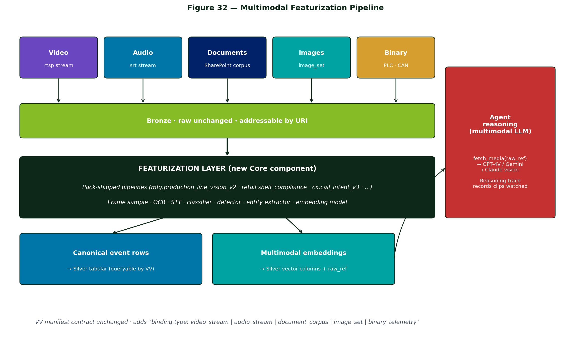
Figure 32 — Multimodal Featurization Pipeline

19.1 Featurization Layer — New Core Component
Raw media → canonical events + multimodal embeddings. Raw stays addressable via raw_ref. Featurizers are pack-shipped, containerized model endpoints.

19.2 Five Source-Type Pipelines
Source Type | Featurizer Pipeline | Emits
Video stream | Frame sample (1-10 fps) → object detection + activity recognition + safety/defect classifiers → CLIP embedding | Event rows · bounding boxes · clip_ref · CLIP embedding
Audio stream | VAD → STT (Whisper) → speaker diarization → sentiment/intent → audio embedding | Transcript rows · speaker turns · sentiment · audio_ref · audio embedding
Documents | OCR → chunk → entity extraction → clause classification → text embedding | Chunk rows · extracted entities · classification labels · page_ref · text embedding
Images | Classification + object detection + caption (BLIP / Florence) → CLIP embedding | Event row · labels · caption · img_ref · CLIP embedding
Binary telemetry | Schema inference · protocol decoder · tagging · optional event detection | Structured rows · raw_blob_ref

19.3 VV Manifest Extensions
sources:
- id: line7_camera
binding:
type: video_stream # NEW
uri: rtsp://plant.local/line7
featurizer: mfg.production_line_vision_v2
sample_rate: 5fps
retention_raw: 30d
embedding_model: clip_v3
projection:
- { col: event_type, from: line7_camera.classifier_label }
- { col: confidence, from: line7_camera.classifier_confidence }
- { col: clip_ref, from: line7_camera.raw_ref } # back-pointer
- { col: visual_embedding, from: line7_camera.embedding }

19.4 Multimodal Agent Context
Every agent gets fetch_media(media_ref, start, duration, modality) as an MCP tool. The Agent Orchestrator routes the call to a multimodal LLM (GPT-4V · Gemini Pro Vision · Claude with vision). The reasoning trace records the media watched.
Adaptive Cards embed media:
- Video clip player — persona watches 30s before approving
- Audio waveform + transcript with click-to-play
- Document excerpt with relevant clause highlighted
- Image gallery of similar past events from Episodic Memory

19.5 Worked Example — Safety Incident from Video
Featurizer emits safety_incident event (confidence 0.91). Agent calls fetch_media(line7_clip, -10s, 30s) → multimodal LLM watches the actual clip → reasons: 'Worker reached into active zone without lockout · standard procedure violated' → Constitution H1 (OSHA reportable) fires → escalates to Plant President + Safety Lead with embedded clip + 2 prior incident summaries → both approve with evidence in hand. The agent didn't just see a row; it watched the incident.

19.6 Featurizer Observability
Featurization Layer emits its own VVs:
- featurizer_throughput_by_source — frames-per-second / files-per-hour
- featurizer_confidence_distribution — alerts on model drift
- featurizer_oov_rate — unknown-class detection rate
- featurizer_cost_per_event — FinOps metering of the layer
Featurization failures route to Operate via the same resolution-route plumbing.

Chapter 20 — Archival & Legal Hold
The Snapshot Layer (Chapter 16) has hot/warm/cold/archive tiers. This chapter adds the constructs needed for multi-decade retention, legal hold, format migration, eDiscovery, and cross-cloud archive redundancy.
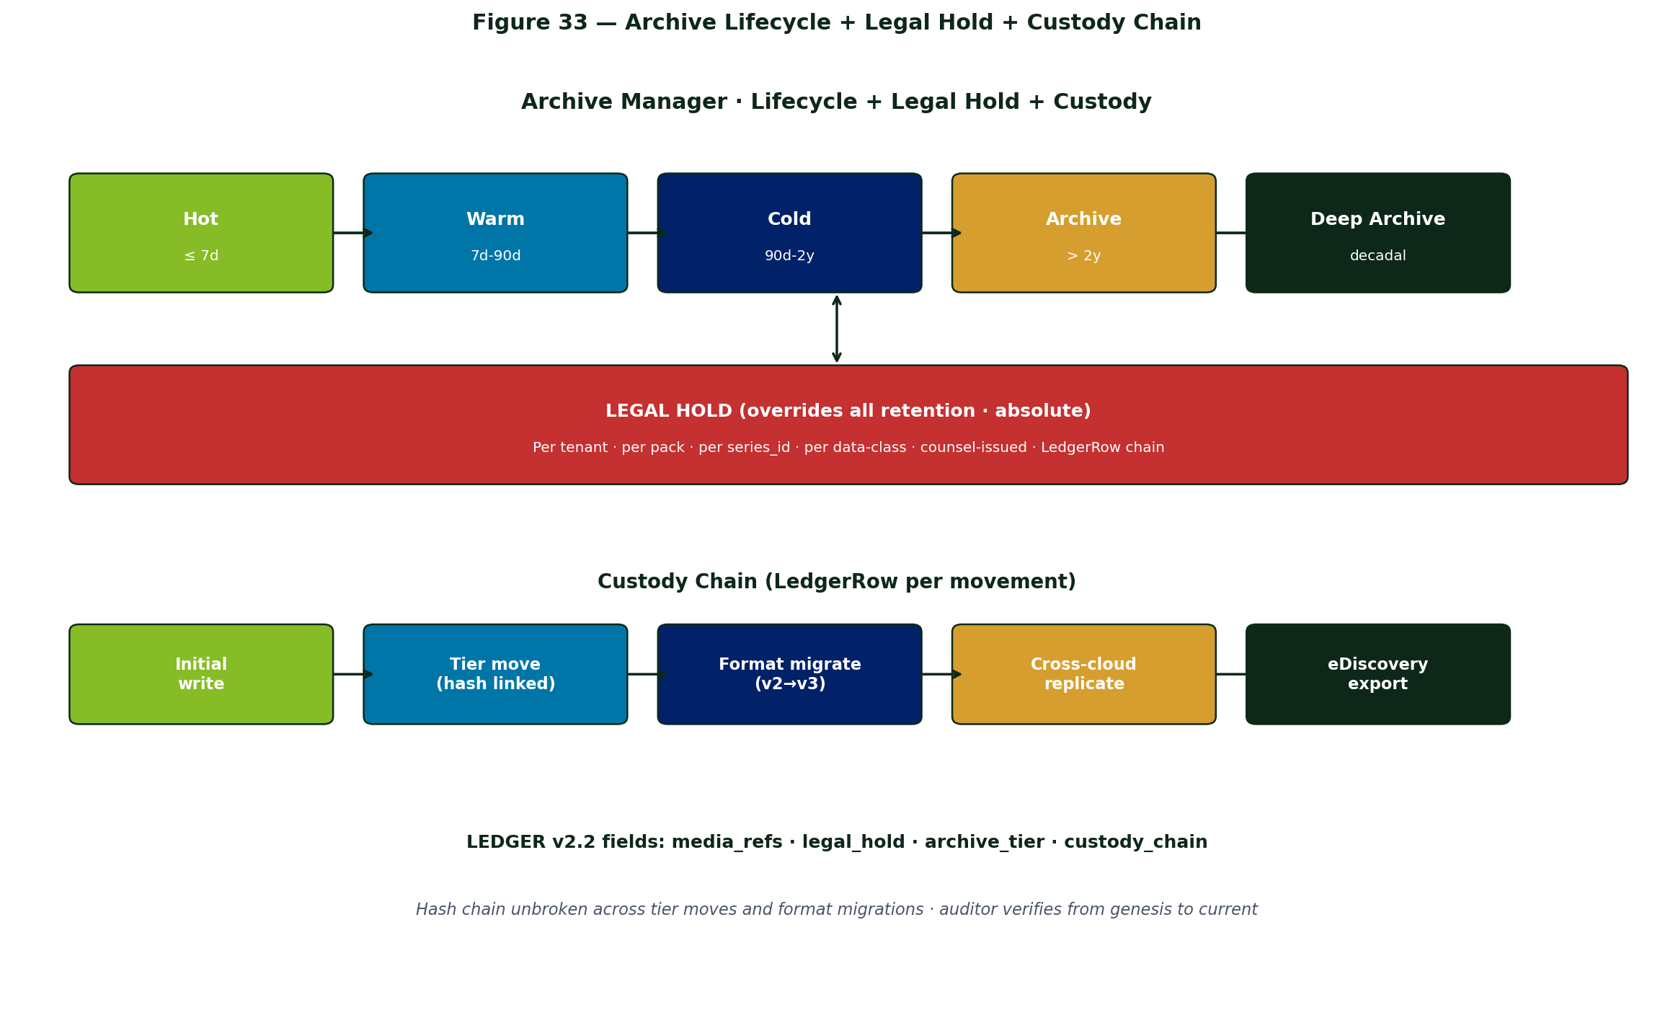
Figure 33 — Archive Lifecycle + Legal Hold + Custody Chain

20.1 Two New Core Components

Archive Manager
- Lifecycle enforcement — per data-class retention (LedgerRow · snapshot · raw media · embedding · featurizer event)
- Tier movement — Cold → Archive → Deep Archive on schedule
- Format migration — rewrites stored objects on format deprecation · preserves hash chain via custody record
- Storage cost telemetry — FinOps metering of archive tier consumption
- Restore SLA — tiered restore time targets per data class

Legal Hold & eDiscovery Service
- Legal hold flag — per-tenant / per-pack / per-series_id · overrides all retention policies absolutely
- Hold ledger — LedgerRow records issuance · scope · responsible counsel · release
- eDiscovery query — time + topic + persona + pack predicates · returns matching LedgerRows + cross-references
- Export package — tamper-evident: LedgerRows + referenced media + custody chain + verification script
- Custody chain — every archive movement · format migration · export is itself a LedgerRow with hash

20.2 Data Class → Retention Policy
Data Class | Default Retention | Tier Path
LedgerRow (decision · breach · action) | 7y (SOX) · 10y (HIPAA) | Hot 90d → Warm 1y → Cold 3y → Archive
LedgerRow (tick / non-promoted) | 90d | Hot 7d → Warm 90d → purge
Snapshot tick | 1y@1m · 7y@1d · 30y@1mo (decimated) | Pyramid (§16.4)
Burst bundle | Same as breach LedgerRow | Promoted to LEDGER tier
Raw video / audio | 30d default · 7y on legal hold | Bronze cold → archive
Documents (contracts · filings) | 7y · indefinite | Cold → archive
Featurizer event rows | Same as derived VV | Silver path

20.3 LEDGER v2.2 Schema Additions
Field | Purpose
media_refs | Raw-media URIs the row references (clips · audio · doc pages · images)
legal_hold | { hold_id · scope · issued_by · issued_ts · released_ts }
archive_tier | Current tier of the row's payload (hot/warm/cold/archive/deep_archive)
custody_chain | Lineage of tier moves · format migrations · replications

20.4 Format Migration
When storage format deprecates (e.g., Parquet v2 → v3 in 2030), Archive Manager runs migration jobs:
- Read the old format object
- Verify hash against custody record
- Write the new format object
- Compute new hash
- Write a custody-migration LedgerRow linking old_hash → new_hash → tool_version
- Optionally retain both for a transition window
Audit chain stays unbroken across format changes — auditor can verify back to the genesis row even after the storage format changes underneath.

20.5 Cross-Cloud Archive
For clients requiring geographic redundancy:
- Primary archive in primary cloud's archive tier (Azure Archive · GCS Archive · S3 Glacier Deep Archive)
- Secondary archive replicated to a different cloud profile via signed-MCP federation
- Custody chain records the replication event
- Restore from either tier · verification re-hashes from genesis

Chapter 21 — Live Translation Layer (Financial + Language)
APEX has been implicitly English-and-USD. Real enterprise use is multi-currency, multi-fiscal-calendar, multi-jurisdiction (GAAP/IFRS), and multi-language. The Translation Layer makes APEX work globally without compromising audit defensibility. It is the eighth Core component cluster and the seventh new design extension.
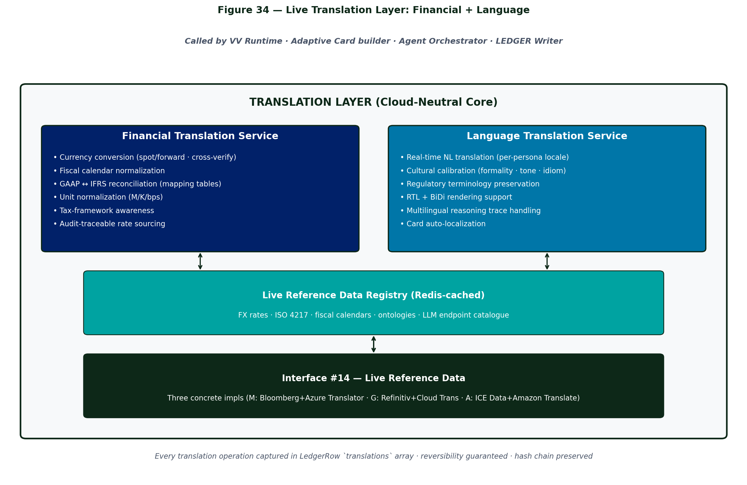
Figure 34 — Live Translation Layer: Financial + Language

21.1 Two Services, Shared Infrastructure
Service | Capabilities
Financial Translation | Currency conversion (spot/forward) · fiscal calendar normalization · GAAP↔IFRS reconciliation · unit normalization · hedging-aware · audit-traceable rate sourcing
Language Translation | Real-time NL translation · cultural calibration (formality · tone · idiom) · regulatory terminology preservation · RTL + BiDi rendering · persona locale binding

21.2 Interface #14 — Live Reference Data
Bumps Cloud Profile contract from 13 to 14. Same pattern as other interfaces: one abstract API, three concrete implementations.
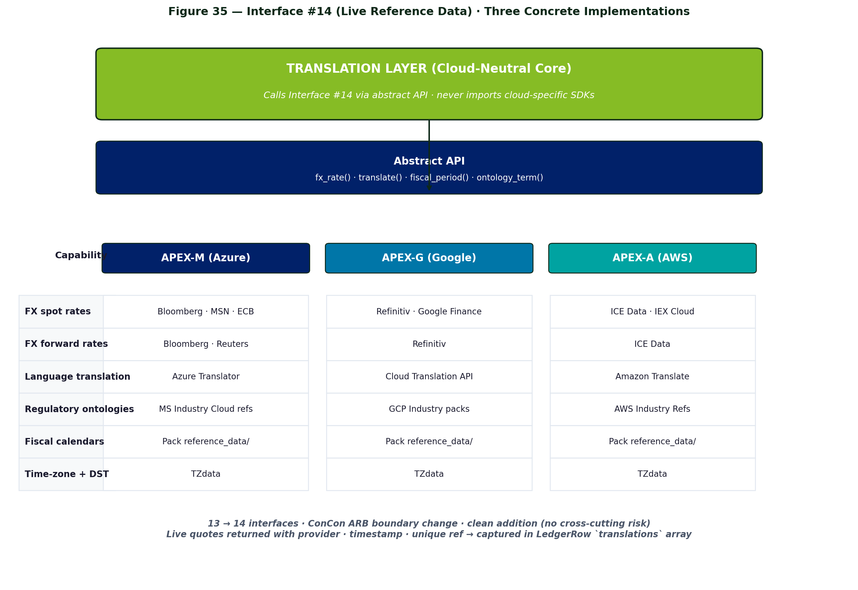
Figure 35 — Interface #14 (Live Reference Data) — Three Implementations
Capability | APEX-M | APEX-G | APEX-A
FX spot rates | Bloomberg · MSN · ECB | Refinitiv · Google Finance | ICE Data · IEX Cloud
FX forward rates | Bloomberg · Reuters | Refinitiv | ICE Data
Language translation | Azure Translator | Cloud Translation API | Amazon Translate
Regulatory ontologies | MS Industry Cloud refs | GCP Industry packs | AWS Industry Refs
Fiscal calendars | Pack reference_data/ | Pack reference_data/ | Pack reference_data/

21.3 VV Manifest Extensions
projection:
- col: revenue_usd
from: src.amount_local
translate:
financial:
kind: currency
from: src.currency_iso
to: @tenant.display_currency
rate_source: ecb_daily # or bloomberg_spot · refinitiv_spot
as_of: src.posting_ts # historical rate at posting time
rounding: half_even
- col: incident_summary
from: src.description_text
translate:
language:
from: src.lang_iso
to: @user.locale # per-persona
preserve_terms: [regulatory_event_codes, product_codes]
formality: business
- col: gl_amount_ifrs
from: src.gl_amount_local_gaap
translate:
financial:
kind: gaap_to_ifrs
mapping_table: finance@1.7/gaap_ifrs_v3

21.4 LEDGER v2.3 Schema Additions
Field | Type | Purpose
translations | array<translation_record> | Every translation operation · kind · src/dst · transformer · transformer_ref · applied_at · hashes
source_locale | json | { lang · currency · fiscal_convention · jurisdiction } at source
presentation_locale | json | { lang · currency · fiscal_convention } as rendered
Reversibility guaranteed — original value always recoverable via the source ref + transformer ref. Hash chain integrity preserved.

21.5 Agent + Adaptive Card Integration
- Reasoning trace kept in canonical (English) for cross-tenant comparability
- Card Builder consults persona's presentation_locale and translates free-text, currency, and date fields at render time
- Hover-tip on translated fields shows canonical original + transformer ref
- Multimodal context: agent transcripts/sentiment translated; raw clip unchanged
- Persona language detection — personas.yaml setting > recent-interaction history > tenant default

21.6 Constitution Implications
Rule type | Translation enforcement
Preserved terminology (hard) | Regulatory terms never machine-translated: 'material weakness' · 'going concern' · CPT · ICD-10 codes
Audit-defensible rates (Independence) | SOX-class engagements restricted to Independence-approved rate sources via Constitution allowlist
GAAP↔IFRS for materiality (hard) | Cross-framework reconciliation > $1M requires HITL gate · both views retained
Regulatory filings (hard) | Auto-translation flagged · routed to certified-translator review · never auto-published

21.7 Operating Profile Integration
Knob | lean | balanced | defensive | realtime
FX rate source priority | ecb_daily (free) | bloomberg_spot | bloomberg + refinitiv (cross-verify) | bloomberg_spot (tick)
Rate freshness max | 1h | 15m | 5m | 30s
Translation model | small / fast | standard | high-fidelity | latency-optimized
Translation audit | summary | structured | full | structured
Preserve-terms | best-effort | strict | strict + human review > $1M | strict
Multi-rate cross-verify | off | off | on (warn if drift > 0.5%) | off

21.8 Worked Examples
Global manufacturer roll-up
EUR · JPY · BRL plant revenues converted inline via Bloomberg rates (cross-verified with Refinitiv on defensive profile; 0.04% drift, within tolerance). CFO opens Card in en-US, sees USD figures, hover-tip shows local currency + rate used. Auditor 6 months later replays the day — same rate, same result — cryptographically verified.
Multi-language SOX cycle
Japanese controller posts narrative in JA. VV translates to EN for US-based PMO, preserving regulatory term 重要な不備 → 'material weakness' (canonical). GL data translated from J-GAAP to IFRS via versioned mapping table. Card to US SOX PMO Lead in en-US with bilingual hover showing original JA. Constitution H2 fires (material > $1M) · escalates to CFO + LCSP. If reopened by Japanese audit team, Card re-renders in ja-JP — roundtrip verified.

21.9 Phasing
Phase | Scope | Weeks
TL1 | Foundation — Interface #14 · Live Reference Data Registry · Financial Translation (currency only) · LEDGER v2.3 · APEX-M impl | 6-8
TL2 | Language Translation Service · Adaptive Card auto-localization · persona locale binding · APEX-M impl | 5-7
TL3 | Financial depth — fiscal calendars · GAAP↔IFRS · unit normalization · hedging-aware · cross-rate verify | 6-8
TL4 | APEX-G + APEX-A concrete implementations | 4-5
TL5 | Cultural calibration · preserve-terms strict mode · regulatory glossary integration | 4-5
TL6 | Operating Profile knobs · FinOps telemetry for translation costs | 3-4
Total ~30 weeks. Runs in parallel with other v4 phases.

Chapter 22 — Conceptual Gap Roadmap
The seven design extensions in Chapters 15-21 substantially reshape the framework. Fifteen concepts remain under-addressed. They are catalogued here for future design iterations.

22.1 Tier 1 — Framework v1 Blockers
# | Gap | Why It Blocks v1
1 | Human-Agent Collaboration Patterns | HITL is one mode · need coaching · advisory · async · multi-persona · override-rationale · voice · shadow · handoff
2 | Long-Running Workflows | Decision-centric design · SOX cycles · contract negotiations · CAPA span weeks · need workflow above Scenario Chain
3 | Real-Time Streaming Patterns | Live source is a label · need watermarks · windowing · exactly-once · stream-stream joins · backpressure
4 | Continuous Learning Loops | Outcome learning closes one loop · missing active learning · A/B agent strategies · RL bandit · red-team
5 | Security Beyond Identity | Prompt injection · jailbreak · sensitive-info leak · pack signing · featurizer provenance · adversarial inputs

22.2 Tier 2 — Scale-Out
# | Gap
6 | Knowledge Management Layer (curated reg text · ISO standards · research papers)
7 | ISV / Partner Ecosystem (third-party packs · marketplace · featurizer marketplace · revenue share)
8 | Edge / Mobile / Offline (featurizers on plant floor · mobile HITL · disconnected ops)
9 | Tenant Lifecycle Management (provision · GDPR export · delete · cloud-profile migration)
10 | Self-Service / Citizen Development (natural language to VV · low-code Studio · cost guard)

22.3 Tier 3 — Long Tail
# | Gap
11 | Cross-tenant insights (anonymised industry benchmarks · federated learning)
12 | Composition with non-APEX (embed VVs in Power BI · LedgerRows to client SIEM)
13 | Internationalization (beyond what Translation Layer in Ch 21 provides — full UI/UX localization)
14 | Governance Lifecycle (pack deprecation · VV retirement · persona changes mid-workflow)
15 | Sustainability of APEX itself (carbon per LedgerRow · green region routing · off-peak scheduling)

Chapter 23 — Conformance Matrix (ConCon Review)
This chapter maps the six conformance concerns raised in the ConCon engagement to the design sections and evidence artifacts that satisfy them. ConCon to validate each item. Updated for v5 with Translation Layer references.
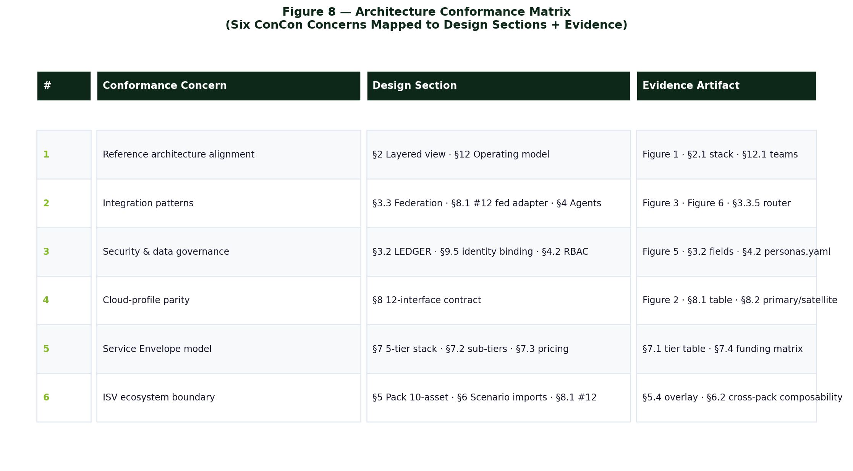
Figure 8 — Architecture Conformance Matrix
#1 Reference Architecture Alignment
- §3 Reference Architecture · Figure 1 layered view
- §15 Operating Profiles · §16 Temporal · §17 Intelligence · §21 Translation as architectural extensions
- §17.1 Ecosystem placement · Figure 21 (hub-spoke into ConCon)

#2 Integration Patterns
- §5.1 14-interface contract (was 12 · now 14 with #13 Cache + #14 Live Reference Data)
- §5.3 Multi-cloud Primary+Satellite via interface #12 (signed-MCP)
- §6 Federation · §16 Snapshot · §19 Featurization · §21 Translation pipelines
- §15 Operating Profiles enable client-tunable integration depth

#3 Security & Data Governance
- §6.2 LEDGER hash chain · v2.3 schema (Ch 16/17/20/21 additions)
- §17 Agent Intelligence Layer · Constitution Engine
- §15 Operating Profiles regulatory floor
- §20 Archive Manager · Legal Hold · custody chain
- §21.6 Translation constitutional rules (preserve-terms · audit-defensible rates · GAAP↔IFRS)

#4 Cloud-Profile Parity
- §5 14-interface contract · three concrete implementations per row
- §18 Vector + Cache parity (Interface #13)
- §21 Live Reference Data parity (Interface #14)

#5 Service Envelope Model
- §11 Five-tier stack
- §15 Operating Profiles decouple commercial from operational tier
- §21.7 Translation knobs in Operating Profile axes

#6 ISV Ecosystem Boundary
- §9 10-asset pack · ISV touch surface
- §19 Featurizer plug-in surface
- §5.1 Interface #12 federation · #13 Redis · #14 Live Reference Data — ISV partner integration points

23.2 Requested ConCon Verdict
- CONFORMS — no action required
- CONFORMS WITH CONDITIONS — list conditions; APEX core to remediate
- DOES NOT CONFORM — list gaps; APEX core to remediate + reschedule review

Chapter 23 — Operating Model & Teams

23.1 Team Structure
Team | Owns | Cadence
APEX Core | apex-core/runtime · apex-core/ledger · apex-core/mcp-contracts · Intelligence Layer · Profile Engine · Snapshot Scheduler · Featurization Layer · Archive Manager | Quarterly release
APEX-M profile | apex-m/ · 13-interface impls | Quarterly · Microsoft fiscal
APEX-G profile | apex-g/ · 13-interface impls | Quarterly · Google fiscal
APEX-A profile | apex-a/ · 13-interface impls | Quarterly · AWS fiscal
Industry pack (×6) | packs/<industry>/ + featurizers/ + intelligence.yaml + constitution.yaml + profile-overrides.yaml | Continuous
Delivery teams | Per-client engagements drawing from the catalogs | Per engagement
Cross-team contract = the 13-interface Cloud Profile contract + Floor constitution + Pack intelligence schema. Core owns the spec; profile teams implement; pack teams write to the abstract API.

23.2 Pack Contribution Model
Contributor | Process | Certification
Core platform team | Internal review | Deloitte-Certified
Industry CCM team | Internal review + industry-domain SME sign-off | Deloitte-Certified
Partner / vendor | Co-build with Deloitte; legal review of IP · pack signing | Deloitte-Verified
Client | Overlay only (no base-pack contribution) | n/a

23.3 Governance Bodies
- APEX Architecture Council — Core, Cloud-profile leads, pack leads. Owns the 13-interface contract + Floor constitution.
- APEX Pack Review — Cross-functional review of new pack proposals; ensures industry alignment and Independence compliance.
- APEX Operate Steering — Quarterly review of FinOps metrics, SLA performance, threshold tuning recommendations, profile adoption.
- ConCon ARB (external) — Architecture Integration review board; gates 13-interface and LEDGER-schema changes (see Ch 15.6).

Chapter 24 — Implementation Roadmap

24.1 Tier-A v1 Blockers (must close before production)
# | Gap | Section | Owner
1 | Persona / Role / RBAC model | §7.2 | Core
2 | Reasoning-trace standard | §7.3 | Core
3 | Replay & forensics tooling | §6.11 | Core
4 | Cross-cloud federation (interface #12) | §5.1 | Cloud-profile teams
5 | Pack lifecycle: versioning + migration | §9.3 | Core + pack teams
6 | Threshold tuning loop | §13.3 | Core (loop) + pack teams (data)
7 | Multi-tenancy | §13.1 | Core
8 | ConCon ecosystem onboarding (M/G/A) | §15 | Cloud-profile teams + ConCon platform
9 | Profile Engine + Floor enforcement | §15 | Core
10 | Snapshot Layer + Burst capture | §16 | Core
11 | Intelligence Layer P1 (Memory + Constitution) | §17 | Core
12 | Interface #13 promoted · Redis adapters | §18 | Cloud-profile teams
13 | Featurization Layer + multimodal context | §19 | Core + pack teams
14 | Archive Manager + Legal Hold | §20 | Core

24.2 Timeline Targets
Milestone | Target
Tier-A close · APEX-M GA · v4 ConCon ARB conformance | Q3 FY27
APEX-G beta · Manufacturing pack v1 GA · Intelligence P2-P3 · Snapshot Layer GA | Q4 FY27
APEX-A beta · Finance + Risk packs v1 GA · Intelligence P4-P5 · Multimodal GA | Q1 FY28
All three profiles GA · Retail Merchandising + CX packs v1 GA · Forward sim GA | Q2 FY28
ESG pack v1 GA · Tier-1 framework-gap close · Archival GA | Q3 FY28

Chapter 25 — Architectural Risks & Mitigations
Risk | Description | Mitigation
Single LEDGER as a write bottleneck | High write rates from many tenants could stress the WORM substrate. | Per-tenant LEDGER partition · Snapshot Layer absorbs high-cadence ticks · LedgerRow rate is linear in business activity not clock ticks (Ch 15.4 capture modes).
Cross-cloud federation latency | Pulling rows from a satellite cloud over signed-MCP adds wall-clock to every query. | Cache-on-primary for hot satellite queries · pre-materialize via interface #12 · cost-model dispatcher prefers in-lake reads.
Threshold band drift over time | Industry norms shift; static thresholds in packs can become wrong. | Threshold-tuning loop (§13.3) · Outcome Learning Loop (§17.3) re-ranks · Tier-C ML-driven dynamic thresholds.
Pack version skew across clients | Different clients on different pack versions complicates support. | SemVer with n−2 support · compatibility matrix · runtime refuses incompatible loads · overlay model isolates client deltas.
Independence violations during commercial structuring | Account teams may inadvertently propose ECIF-direct deals. | Envelope configurator enforces approved funding paths · Constitution I-rules · APEX Pack Review owns Independence compliance.
LLM provider lock-in by Core | Core depending on Foundry-specific features would break multi-cloud parity. | Interface #8 abstracts LLM service · agents target abstract API · per-profile adapters translate · reasoning-trace canonicalizes the cloud-native trace format.
Source adapter sprawl | Every client wants a custom source connector. | Adapter library shipped per pack · custom adapters live in client overlay or T4 Custom Build envelope · not in core packs.
Identity claim propagation across federation | User identity must propagate from primary cloud to satellite for row-level policy. | claim_provider per Cloud Profile resolves claims at query-plan time · signed-MCP envelope carries claims · LedgerRow records resolved value.
ConCon ARB delays blocking sprint cadence | Changes to 13-interface contract require ARB review. | Pack-content changes don't require ARB · ARB only for boundary changes · core team batches interface changes quarterly.
ConCon shared-service version drift | ConCon may upgrade a shared service that breaks APEX. | Bicep module version pinning · subscribe to ConCon platform change notifications · regression pack runs on upgrade announcements.
Redis (Interface #13) as a single point of failure for SLA timers | Loss of Redis stalls SLA timers · escalation chains break. | Redis Enterprise persistence + geo-replication · circuit breaker fallback to cloud-native queue · timer state journaled to LedgerRow on transition.
Profile change thrash · cost predictability | Tenants flipping profiles daily would thrash caches and confuse FinOps. | Profile changes throttled to once per 24h per tenant · emergency override via Operate envelope with governance approval · profile change is a LedgerRow event.
Multimodal LLM cost spike | Vision/audio LLMs are 10-30× text-only cost. | Operating Profile knob: multimodal default on critical band only · warn band stays text-summary · per-tenant rate limit via Interface #13.
Featurizer model drift | Pack-shipped ML featurizers degrade silently over time. | Featurizer observability VVs (confidence distribution · OOV rate) · drift alerts · scheduled model refresh per pack release cadence.
Vector embedding storage at scale | Embedding columns add 6-8KB per row at scale. | Selective vectorization · only Silver canonical entities + Snapshot decision/burst tier · archive decimation strips embeddings on old data.
Legal hold scope ambiguity | Hold on Pack X for Tenant Y — does it cover Episodic Memory · Redis cache · cold snapshots? | Legal hold cascades to ALL derived artifacts via custody chain · eDiscovery export includes derived unless explicitly excluded.

Chapter 26 — Customer Focused Merchandise Pack (CFMP) v0.2
This chapter documents the Customer Focused Merchandise Pack (CFMP) — the seventh Industry Solution Pack in the APEX catalog and the first organized around a customer-moment spine rather than an operator function. CFMP is a sibling to (not a replacement for) the Retail Merchandising Pack documented in §9.6: that pack serves the Chief Merchant / DMM / Planning Lead buyers via MERML; CFMP serves the CMO / CX-VP buyer via a CXML-led journey spine, with MERML and SCML as supporting data planes. This chapter records CFMP's position in the family, the Core-interface extensions it requires (a new persona type, a new HITL surface, and a proposed Interface #15), and the Phase-1 live status of the working demo running on APEX-M.

26.1 Position in the Pack Catalog
CFMP is the customer-side counterpart to the Retail Merchandising Pack v1 documented in §9.6. Both packs share the RC practice bundle (apex-rc) and the MERML + CXML schemas, but the buyer, persona, HITL surface, and KPI roll-up differ:
- Buyer — Retail Merchandising serves the Chief Merchant / DMM / Planning Lead via internal data. CFMP serves the CMO / CX-VP / Loyalty Director via customer-facing flows.
- Primary persona — Retail Merchandising binds operator roles to Entra group OIDs. CFMP introduces a NEW persona type (`customer`) bound to loyalty ID + consent gate (see §26.4).
- HITL surface — Retail Merchandising uses Teams Adaptive Cards. CFMP adds the `customer_phone` transport (see §26.5).
- KPI roll-up — trip conversion, basket size, in-store NPS, loyalty retention, cart-abandon recovery, BOPIS attach. These are the metrics CMOs are graded on.
Pack ID: cfmp. Status: v0.2 draft (May 2026). Cloud profiles supported: APEX-M primary, APEX-G / APEX-A via the shared 10-asset bundle and the proposed Interface #15.

26.2 The Customer-Journey Spine
CFMP organizes all 18 scenarios in its v0.2 manifest around four customer moments. Every Adaptive Card, Virtual View, and agent tool maps to exactly one phase:
- CHOOSE — "What should I buy?" Recipes, pairings, dietary filters, personalized offers, in-store ad attribution.
- SELECT — "Where is it / is it on the shelf?" Indoor wayfinding (see §26.3), OSA / shelf-gap detection, planogram compliance.
- BUY — "How do I pay and leave?" Scan-and-go, self-checkout assist, queue prediction, BOPIS pickup, returns trust.
- SERVICES — "What's next from you?" Loyalty winback (featured chain rc-loyalty-churn-prediction-winback), complaint triage, review summarization, sentiment, NPS.
Sub-tier sizing follows the standard APEX additive rule (Lite ⊂ Standard ⊂ Enterprise): Pack Lite ships 3 scenarios at $150–250K, Standard ships 10 at $500K–$1.5M, Enterprise ships all 18 at $1.5M–$3.5M. Scenario detail is in the companion workbook CFMP-Scenario-Chains-v0.2.xlsx (Featured Chains sheet matches the 14-column schema from APEX-Scenario-Chains.xlsx).

26.3 Proposed Interface #15 — Maps & Wayfinding
Architecture v5 §6 enumerates 14 Cloud Profile interfaces, with §21 (Live Translation Layer) adding #14. CFMP proposes #15 — Maps & Wayfinding — to support the cfmp-wayfinding-walk-to-product scenario and the eight downstream capabilities that ride on the same indoor-map dataset.
The abstract Core contract is: an indoor-map dataset (geometry + units + levels), a routing service that returns turn-by-turn directions plus a GeoJSON polyline, and a live state set for dynamic occupancy or availability.
Cloud-profile bindings:
- APEX-M — Azure Maps Creator. Drawing Package upload → Conversion → Dataset + Tileset + Stateset. Wayfinding REST: POST /wayfinding/route. Web SDK indoor view renders the Tileset + route polyline.
- APEX-G — Google Maps Geospatial Creator (equivalent indoor dataset + routing surface).
- APEX-A — Amazon Location Service indoor maps + routing.
CFMP runtime: orchestrator/azure_maps.py wraps the APEX-M binding. When the per-tenant Creator dataset is configured (env vars DEMO_AZURE_MAPS_DATASET_ID + DEMO_AZURE_MAPS_KEY), the agent's route_to_product tool calls the Wayfinding REST API. When unconfigured, the orchestrator falls back to a local storemap.yaml graph for dev (the response carries a `source: local_storemap_yaml` field so the demo narrative is honest about which path executed).
Strategic note: once a retailer's CAD floor plans are captured into the Creator dataset, eight other CFMP capabilities ride on the same data — "find an associate," "skip the queue," "get a tour," BOPIS counter routing, spill-hazard distance, aisle-engagement attribution, shelf-gap dispatch, and accessibility routing. The dataset is the moat.

26.4 New Persona Type — `customer`
Existing APEX personas are employees with Entra group OID bindings. The customer has none of that. CFMP extends personas.yaml with a new persona type:
- id: customer
identity_binding:
source: loyalty_id
scope: opted_in_only
consent_gate: required
channel: customer_phone
Identity is the retailer's loyalty ID (anonymous-customer flow is a Wave-1 design item — see §26.8). The `consent_gate: required` declaration means every customer-facing action stamps a consent hash into the LedgerRow (see §11.2 audit-row schema). Auditors can replay any customer-facing decision and verify the consent was in effect at the time.
This persona type is reusable across future customer-facing Packs (Banking-Customer, Telco-Customer, Hospitality-Guest) and should be promoted from Pack-specific to Foundation-level when CFMP exits Pack Lite into Standard.

26.5 New HITL Surface — `customer_phone`
Architecture v5 §6 interface #9 (HITL surface) binds to Teams Adaptive Cards by default on APEX-M. The customer doesn't have Teams. CFMP adds the `customer_phone` transport binding:
- APEX-M — Azure Notification Hubs signed-link push → phone app → MCP callback.
- APEX-G — Firebase Cloud Messaging.
- APEX-A — Amazon Pinpoint / SNS.
The runtime contract is identical to the Teams binding: an Adaptive Card is built, the persona's channel is resolved, the card is pushed, an approval/decline/timeout returns via the MCP callback, and the LedgerRow's hitl_status moves from PENDING through APPROVED / REJECTED / OVERRIDDEN per §11.2.
CFMP today: cart-add subtotals crossing the consent threshold (default $50, configurable via DEMO_CART_HITL_THRESHOLD) mark the LedgerRow `hitl_status=pending` with rationale stamped. The orchestrator pauses cleanly in apex_orchestrator.SequentialRunner once Phase 1.5 wraps in (see §26.6 status).

26.6 Phase 1 Live Status
The Phase 1 framework wedge is live on APEX-M in the dev (Lab) substrate today. The demo is reachable at https://ca-visionkit-portal.gentlestone-9b49b099.eastus2.azurecontainerapps.io and surfaces the live framework state via the APEX panel + /architecture page.
What's live:
- Vendored apex_core + apex_audit + apex_purview packages inside the orchestrator container. The orchestrator stamps a sealed 14-field LedgerRow per /agent/ask, with HMAC-SHA256 chain, three-version stamps (manifest/policy/prompt/model), and content-addressed ToolCallRecord entries.
- Atlas-shaped Purview lineage edges (apex_orchestration_to_audit, apex_agent_to_orchestration, apex_mcp_to_agent per distinct tool) buffered offline; Phase 3 swaps the buffer for live /atlas/v2/entity/bulk uploads.
- HITL consent gate live at $50 cart-add (see §26.5).
- Microsoft Agent Framework 1.6.0 (GA) with provider toggle (Azure OpenAI default → Anthropic optional). Default model gpt-5-mini.
- Azure Speech (en-US-AvaMultilingualNeural) for STT (mic) and TTS (chip/typed replies via /agent/tts).
- Five agent tools: search_products (pgvector), get_product, recipe_for_items, suggest_pairings, route_to_product (Interface #15 binding).
What's planned (Phase 1.5 → 2 → 3):
- Phase 1.5 — wrap the agent in apex_orchestrator.SequentialRunner with the canonical 4×4 gate matrix; replace untyped Product dict with apex_merml entities.
- Phase 2 — provision Fabric capacity (F2 trial). Bronze (raw) → Silver (canonical MERML) → Gold (Direct Lake) catalog. AuditStore swaps from in-memory to OneLake WORM Bronze. fabric-mcp + merml-mcp become the data-plane MCPs.
- Phase 3 — provision Purview account; install APEX classifications via CI; flush lineage buffer to live Atlas REST; drop AOAI subscription key in favor of Container App managed identity.
- Phase 4 — provision per-tenant Azure Maps Creator resource; upload retailer Drawing Package; embed Web SDK indoor view in the portal.

26.7 10-Asset Pack Bundle (CFMP specifics)
CFMP follows the standard 10-asset bundle structure documented in §14.1. The CFMP-specific contents:
- VV manifests — merml.product_with_planogram_location, merml.osa_by_aisle, cxml.customer_session_with_route, cxml.cart_dwell_event, cxml.dietary_profile, cfmp.storemap_view (new, references the Azure Maps Creator Dataset).
- Scenario manifests — 18 YAMLs spanning the four journey phases (3 Lite / 10 Standard / 18 Enterprise per the additive sub-tier rule).
- Source adapters — POS + Loyalty CRM + Planogram + Beacon vendor SDK (Estimote / Kontakt) + Vision AI Dev Kit MQTT + phone-app event stream.
- Adaptive Cards — operator cards for Teams (associate dispatch, restock alerts) AND customer-facing cards for the new customer_phone transport (route, recipe suggestion, consent prompt, loyalty milestone).
- Persona map — `customer` (new type, see §26.4) plus store_associate, assistant_manager, store_manager, merch_director, loyalty_director.
- Demo data — synthetic 800-product catalog with planogram, 30 beacons, 50 simulated shopper sessions; runs on a laptop (Lite substrate).
- BVA worksheet — cfmp-roi.xlsx aggregates trip-conversion, basket-size, NPS, churn, BOPIS-attach uplift.
- Sample SOW — Lite / Standard / Enterprise templates at $150–250K / $500K–$1.5M / $1.5–3.5M.
- Acceptance tests — 80+ tests including the Pack-specific wayfinding shortest-path correctness, beacon-loss camera-recovery, and customer-consent gate enforcement.
- Runbook + training — beacon field install + storemap capture procedure + store-team training deck + customer-consent FAQ.

26.8 ARB Asks (decisions required before Pack Lite ships)
Three Foundation-level enhancements need ARB sign-off before CFMP can move from dev (Lab) to stage:
- Promote `customer` persona type (§26.4) from Pack-specific to Foundation. It is reusable across all future customer-facing Packs.
- Add `customer_phone` HITL transport (§26.5) to interface #9 implementations on all three cloud profiles (APEX-M / G / A).
- Ratify Interface #15 — Maps & Wayfinding (§26.3) as a Core interface, with the proposed bindings for APEX-M / G / A.
Three Wave-1 BVA-workshop decisions for the first CFMP engagement:
- Localization primary — BLE beacons (Estimote / Kontakt) vs. Wi-Fi RTT (802.11mc). Pick one per Pack v1; the adapter abstraction supports either.
- Phone-app deployment model — SDK into the retailer's existing app (production path) vs. CFMP-branded Deloitte demo app (closeable-pilot path).
- Anonymous-customer flow design — consent-on-first-tap UX and identity-binding fallback when loyalty ID is unavailable.
Recommendation: CFMP is sold separately from Retail Merchandising Pack. Different buyer (CMO / CX-VP), different envelope-curve, different KPI dashboard. Cross-pack Fuse opportunities to Retail Merchandising (planogram refresh, OTB simulation outputs) and to ESG (sustainability-attribute filter on dietary prefs) are tracked as Wave-2 expansions.

26.9 Related Artifacts
- docs/packs/CFMP-v0.2.md — full Pack design document (12 sections).
- docs/packs/CFMP-Scenario-Chains-v0.2.xlsx — 18-scenario workbook (Summary · Scenario Library · Featured Chains · Scenario→KPI Chain · Pack Sub-Tiers).
- Live demo — https://ca-visionkit-portal.gentlestone-9b49b099.eastus2.azurecontainerapps.io with /architecture and /api/apex/* endpoints surfacing real-time framework state.
- orchestrator/apex_integration.py — 341 LOC integration glue wrapping apex_audit and apex_purview at /agent/ask time.
- orchestrator/azure_maps.py — Interface #15 client (Azure Maps Creator Wayfinding REST + local storemap.yaml fallback).

Appendix A — Reference Manifests

A.1 Virtual View Manifest (Full Schema)
view: <namespace>.<view_name>
description: <human readable>
namespace: MFGML | FINML | CXML | SCML | MERML | OPSML | RISKML | ESGML
industry_pack: <pack id, optional>
domain: <subdomain within pack, optional>
sources:
- id: <local alias>
binding: <medallion ref | live source URI>
projection:
- { col: <name>, from?: <source.col>, expr?: <expression> }
predicates_pushable: [<list of cols suitable for source-side filter>]
thresholds:
- metric: <col or expression>
bands:
good: <predicate>
warn: <predicate>
critical: <predicate>
breach_emits: Exception
severity_from: bands
sustain_window: <e.g. 2_shifts | 1_cycle>
resolution_route:
on_warn:
notify: { role: <role_id>, card: <card_template>, sla: <duration> }
actions: [<action subtype ids>]
on_critical:
notify: { role: <role_id>, card: <card_template>, sla: <duration> }
escalate_after: <duration>
escalate_to: { role: <role_id>, card: <card_template> }
actions: [<action subtype ids with optional requires_approval flag>]
policies:
row_level: <predicate using @user.* claims>
column_mask: [{ col: <name>, mask: <transform_id> }]
cache:
mode: time_bounded | materialized | none
ttl: <duration>
invalidate_on: [<source refs>]
mcp_tool:
name: <auto-tool-name>
schema_from_projection: true
ledger:
record_per_query: true
record_per_resolution: true

A.2 Scenario Chain Manifest
See Chapter 10.2.

A.3 Persona Manifest
See Chapter 7.2.

A.4 Overlay Manifest
See Chapter 9.4.

Appendix B — Glossary
Term | Definition
APEX | Agentic-AI delivery framework — the subject of this document
APEX-M / G / A | Microsoft / Google / AWS cloud profile implementations
Adaptive Card | Microsoft Teams interactive card; HITL surface for resolution routes (M); Google Chat cards (G) and Slack blocks (A) are equivalents
Agent Fleet | The 6 named agent roles: Assess / Classify / Quantify / Approve / Act / Evidence-Write
BVA | Business Value Assessment — client-funded discovery workshop
Bronze / Silver / Gold | The medallion data layers
Chain pattern | Scenario → Solution → Use Case → Service → Persona → KPI sequencing
Cloud Profile | The 12-interface implementation of cloud-specific services for one cloud
Cloud-Neutral Core | The cloud-agnostic IP shared across APEX-M/G/A
ConCon | Deloitte Architecture Integration practice (the conformance-review body)
DCIF | Deloitte Co-Investment Fund
ECIF | Microsoft Enterprise Commitment Investment Funding (Deloitte cannot receive directly — Independence)
Federation engine | The VV runtime component that executes queries across in-lake + live sources
HITL | Human-in-the-loop — explicit human approval gate
Industry Pack | A bundle of VVs + scenarios + 8 other assets curated for one industry
LEDGER | The 14-field WORM hash-chained audit row store
LedgerRow | One event in the LEDGER
MACC | Microsoft Azure Consumption Commitment
MCP | Model Context Protocol — APEX's transport for exposing data + tools to agents
Margin Spine | The Deloitte IP layer (methodology + canonical schemas + LEDGER + commercial arc) that sits above the cloud agent runtime
Operate | Tier-5 envelope: 24×7 managed-service run-rate offering
Overlay | Client-specific delta over a base pack (vs. forking)
Persona | A named human role (Plant Manager, Controller) bound to identity groups and SLAs
Resolution route | The declarative path from threshold breach to action: notify → decide → escalate → act → ledger
Reasoning trace | Canonical record of how an agent arrived at a decision (model, inputs, steps, output)
Scenario Chain | A named end-to-end business outcome composed from VVs, agents, personas, briefs
Schema entity | A canonical table in the medallion (e.g., LedgerRow, Exception)
Service Envelope | A sellable tier of Deloitte work (T1 Foundation … T5 Operate)
SOR | System of Record — upstream source system (SAP, Salesforce, MES)
Threshold band | good / warn / critical predicate set on a VV metric
Virtual View (VV) | A manifest-defined federated sensing surface with thresholds + resolution route
View Studio | The web-based design surface for authoring Virtual View manifests visually
WORM | Write-Once-Read-Many — the LEDGER append-only model

Appendix C — List of Figures
Figure | Title | Chapter
Figure 1 | APEX Layered Reference Architecture | Chapter 3
Figure 2 | 14-Interface Cloud Profile Contract (updated) | Chapter 5
Figure 3 | Virtual View Federation Engine | Chapter 6
Figure 4 | 6-Agent Fleet Sequence | Chapter 7
Figure 5 | LEDGER WORM Hash Chain | Chapter 6
Figure 6 | Multi-Cloud Topology (Primary + Satellite) | Chapter 5
Figure 7 | View Studio Canvas Surfaces | Chapter 8
Figure 8 | Architecture Conformance Matrix | Chapter 23
Figure 9 | Deployment View per Cloud Profile | Chapter 14
Figure 10 | Service Envelope 5-Tier Stack | Chapter 11
Figure 11 | Component-to-Interface Dependency Graph | Chapter 4
Figure 12 | End-to-End Resolution Route Sequence | Chapter 7
Figure 13 | VV Runtime: Detailed Component Architecture | Chapter 4
Figure 14 | Agent Orchestrator: Detailed Component Architecture | Chapter 4
Figure 15 | LEDGER Writer: Detailed Component Architecture | Chapter 4
Figure 16 | Resolution Router: Detailed Component Architecture | Chapter 4
Figure 17 | VV Manifest Deployment Sequence | Chapter 6
Figure 18 | VV Query Execution Sequence | Chapter 6
Figure 19 | Threshold Breach End-to-End Sequence | Chapter 7
Figure 20 | Cross-Cloud Federation Query Sequence | Chapter 5
Figure 21 | APEX Placement in the ConCon Ecosystem | Chapter 15
Figure 22 | APEX Consumption of ConCon Shared Services | Chapter 15
Figure 23 | APEX CI/CD Through ConCon Pipeline | Chapter 15
Figure 24 | APEX-M Network + Identity Topology Inside ConCon | Chapter 15
Figure 25 | Operating Profiles: Cost / Latency / Audit Trilemma | Chapter 15
Figure 26 | Override Hierarchy + LEDGER Capture Modes | Chapter 15
Figure 27 | Snapshot Layer · Cadence Pyramid · Burst Lifecycle | Chapter 16
Figure 28 | Forward Simulation: Monte Carlo Branching | Chapter 16
Figure 29 | Agent Intelligence Layer: Seven Components | Chapter 17
Figure 30 | Constitution Flow + Outcome Learning Loop | Chapter 17
Figure 31 | Vectorized Medallion + Interface #13 (Cache) | Chapter 18
Figure 32 | Multimodal Featurization Pipeline | Chapter 19
Figure 33 | Archive Lifecycle + Legal Hold + Custody Chain | Chapter 20
Figure 34 | Live Translation Layer: Financial + Language | Chapter 21
Figure 35 | Interface #14 (Live Reference Data) — Three Implementations | Chapter 21

