DELOITTE DMTSP — INTERNAL
APEX Marketing Playbook
Start-Up Guide for Offshore Contributors — with Internal Positioning

Owner
Keven Markham — Vice President, Deloitte's Microsoft practice (DMTSP), Consumer Industry
Audience
Offshore contributors supporting APEX demand generation, account research, content production, and — new in v2 — internal stakeholder positioning
Version
v2.0 — adds Part H. Marketing APEX Internally
What changed in v2
New Part H on positioning against internal competing approaches. Updated A.3 audience map with Tier 0 (Deloitte-internal). Updated Part D with two new internal-facing content types. Updated Part G ramp.

Contents
Part A Foundations — Read Before Doing Anything
A.1 Purpose and scope of this playbook
A.2 What APEX is — and what it is not
A.3 Who we are marketing to — four audience tiers
A.4 The non-negotiable Independence rules
A.5 What “marketing” means in this context
Part B The Core Methodology
B.1 Corporate Visions in one page
B.2 The APEX “Why Change” thesis
B.3 The message pyramid
B.4 The value-wedge test
Part C The Marketing Workflow
C.1–C.8 Eight steps · brief to archive
Part D The Content Types You Will Build
D.1 Account one-pager
D.2 Persona-tuned cold email and LinkedIn message
D.3 Industry primer and point-of-view post
D.4 Meeting prep pack
D.5 Nurture and follow-up sequence
D.6 Objection-handling snippet
D.7 Case-study adaptation
D.8 Internal positioning memo (new in v2)
D.9 Internal objection-response card (new in v2)
Part E Templates and Checklists
Part F What You Must Never Do
Part G Your First 30 Days — updated for v2
Part H Marketing APEX Internally — new in v2
H.1 The internal landscape
H.2 Where the disagreement actually lives
H.3 The unification thesis — three tiers, one kernel
H.4 The silo problem in concrete terms
H.5 What APEX unifies that generic horizontal cannot
H.6 The economics — why canonical wins over multiple engagements
H.7 When generic IS the right answer — honest framing
H.8 Objections you will hear — and how to respond
H.9 Stakeholder personas and what moves each of them
H.10 Review process for internal-marketing content

Part A. Foundations
You are joining a high-stakes motion. APEX is how Deloitte's Microsoft practice wins and delivers agentic AI on the Microsoft platform. Before you produce a single artifact, you need the shared mental model in this section. Read Part A slowly. Re-read Section A.4 every week. New in v2: Section A.3 now names a fourth audience tier — internal Deloitte stakeholders — which Part H will address in depth.

A.1 Purpose and scope of this playbook
This playbook exists to turn a capable offshore contributor into a productive APEX marketing contributor in thirty days. It defines the workflow, the content types, the templates, the guardrails, and the review gates. It is deliberately narrow — you will not find delivery methodology, architecture, or pricing here. For that, you will be pointed at the APEX Sellers Guide under onshore supervision.
What this playbook covers:
- The full marketing workflow from brief to archive
- The nine content types you are authorized to produce in draft form (seven external, two internal)
- The Corporate Visions selling methodology in the minimal form you need
- The Independence language rules you will follow without exception
- New in v2: Part H on marketing APEX to internal Deloitte stakeholders who propose competing approaches
What this playbook does not cover:
- Client-facing sales conversations — you will never have these
- Pricing, SOW language, or commercial negotiation
- Technical architecture details beyond the positioning level

A.2 What APEX is — and what it is not
APEX stands for Agentic Platform for Enterprise eXecution. It is Deloitte's internal delivery accelerator for agentic AI engagements on the Microsoft platform.
CRITICAL DISTINCTION — MEMORIZE THIS
APEX is an internal Deloitte accelerator. Clients do not license APEX. Clients do not buy APEX. Clients never see “APEX” on an invoice, a contract, or a statement of work.

What clients license and buy: (1) Microsoft platform capacity from Microsoft — Fabric, Azure AI Foundry, Purview, Entra, Copilot. (2) Agent-delivery services from Deloitte — discovery, design, build, run.

Where APEX fits: APEX is how Deloitte delivers those services faster and more reliably. It is a private methodology, a set of canonical schemas, orchestration patterns, and accumulated reference assets.

How APEX shows up across industries
Edition code | Industry | Notes for offshore
RC | Retail and Consumer | Most mature; 34 canonical entities, 44 MCP tools
TH | Transportation and Hospitality | Growing; tied to Consumer Industry
HLS | Healthcare and Life Sciences | Regulated; stricter language review
TMT | Technology, Media, Telecom | Sophisticated buyers
ER | Energy and Resources | Safety-critical contexts
ICE | Industrial and Construction Engineering | Newest edition
Core | Cross-industry foundation | Inherits into all editions

A.3 Who we are marketing to — four audience tiers
You will produce content aimed at four distinct audience tiers. Every artifact should be tagged to a tier in the brief. Tier 0 is new in v2 and is the focus of Part H.
Tier 0 — Deloitte-internal stakeholders (new in v2)
Deloitte practice leaders, DMTSP sellers in adjacent industries, firm-wide AI leadership, delivery partners staffing agentic-AI engagements, and Microsoft relationship managers inside the firm. They decide which framework Deloitte brings to pursuits. They are also the audience for competing internal approaches that push generic, horizontal, non-industry-specific architectures. APEX must win here first. Part H covers this tier in depth.
Tier 1 — Client economic buyers
CFO, COO, CIO, CDO, Chief Compliance Officer, General Counsel. They care about outcomes, risk, and measured ROI. Your content speaks in dollars, days, and defensibility.
Tier 2 — Client technical evaluators
Chief Architects, Data leaders, Enterprise Architecture, Heads of AI. They care about the Microsoft stack, interoperability, governance, and the practical “how.”
Tier 3 — Client functional owners
VP of Finance Controlling, Supply Chain leaders, Store Operations leaders, Clinical Ops. They care about specific workflow pain — close velocity, inventory accuracy, dispatcher productivity.

A.4 The non-negotiable Independence rules
Deloitte is the auditor for many of the accounts we pursue. That creates an Independence obligation that constrains the language we use about our work with Microsoft.
FORBIDDEN WORDS AND PHRASES
Never use these, anywhere, in any context: “partner,” “partnership,” “alliance,” “strategic alliance” to describe the Deloitte–Microsoft relationship.

Approved substitutes: “Deloitte's Microsoft practice,” “DMTSP,” “Microsoft platform capabilities,” “Microsoft-native deployment.”

Why this matters: The forbidden terms imply a commercial relationship structure that conflicts with Independence requirements when Deloitte also audits the client. A single use of a forbidden term in an externally distributed artifact is a compliance incident. Note: Tier 0 (internal-only) content is still subject to these rules — internal drafts can and do leak externally.

A.5 What “marketing” means in this context
You produce the upstream materials that help a seller or practice leader start, accelerate, or sustain a conversation. You are not a seller. You are not the person who walks into the SteerCo. You are the person who makes both ten times more effective.

Part B. The Core Methodology
Every piece of marketing uses the Corporate Visions methodology — Conversations That Win. The four mental models in this section apply to all four audience tiers, including Tier 0 internal stakeholders.

B.1 Corporate Visions in one page
Every commercial conversation moves through three questions in order. Get the order wrong and you lose. The same three questions apply when the “buyer” is an internal Deloitte decision-maker choosing between APEX and a competing internal approach.
Question | External buyer version | Internal stakeholder version
Why Change? | Status quo of no AI transformation is unsustainable | Status quo of per-engagement rebuilds is unsustainable
Why Now? | External trend forces decision | Velocity pressure forces framework choice
Why You? | Deloitte delivery advantage | APEX canonical kernel advantage vs. generic

B.2 The APEX “Why Change” thesis
# | Step | What to write
1 | Business goal | The client's (or Deloitte leader's) stated goal, in their language.
2 | Current trend | The external or internal pressure threatening the goal.
3 | Flawed approach | What they are doing today that will not get them there.
4 | Consequence of no change | What breaks — revenue, cost, risk, talent, or compliance.
5 | New way | The action the decision-maker takes, not a product they buy.
6 | Likely outcome | The measurable result, tied back to the goal in step 1.

B.3 The message pyramid
You draft bottom-up. You deliver top-down.
Layer | Name | Example (external) | Example (internal, Tier 0)
Top | Means | Close completes in 5 days instead of 12 | Eng. 3 onward: 40–55% lower canonical-layer cost
Middle | Do | Run a continuous close with agentic reconciliations | Inherit 34 entities, 44 MCP tools, Purview classes
Bottom | Is | Deloitte delivers on Fabric + Foundry + Azure AI Agent Service | APEX RC edition is the canonical kernel under Core

B.4 The value-wedge test
Every claim must pass three tests. Strike any claim that fails.
# | Test | Question to ask
1 | Important | Does the target care about this? Is it a top-five priority for them?
2 | Unique | Are we genuinely the only ones who can do this, or meaningfully better than alternatives (including internal competing approaches)?
3 | Defensible | Can we prove it with a measurable reference or architectural fact?

Part C. The Marketing Workflow
Eight steps for every piece of content. Skipping any step is grounds for re-work. For Tier 0 internal-marketing content, step 7 (compliance clearance) is replaced with a practice-leadership review — see H.10.
THE WORKFLOW IN ONE LINE
Brief → Research → Draft → Self-QA → Peer review → Onshore review → Compliance (ext) or Practice review (int) → Publish.

Every step has a defined input, a defined output, and a defined owner.

C.1 Step 1 — Pick up the brief
Seven-field brief: account, persona tier (0–3), APEX edition, content type (D.1–D.9), primary goal, deadline, onshore reviewer. If any field is missing, request it before starting.

C.2 Step 2 — Account and persona research
Four-hour time-box. For Tier 0 content, “account research” becomes “stakeholder research” — see H.9 for the stakeholder personas and what moves each of them.

C.3 Step 3 — Draft using the right template
Part D lists the nine authorized content types. You will not invent a new format.

C.4 Step 4 — Self-QA against the checklist
Run the 20-point checklist twice — once immediately after drafting, once after a two-hour break.

C.5 Step 5 — Peer review
Exchange drafts with a designated peer. They run the same checklist independently. Incorporate their feedback before onshore hand-off.

C.6 Step 6 — Onshore reviewer hand-off
Send the draft with the original brief, the one-page research summary, and the completed Self-QA checklist with your peer reviewer's initials.

C.7 Step 7 — Compliance or practice review
External drafts (Tiers 1–3) go to Independence Office when applicable. Tier 0 drafts go to a practice leadership reviewer — see H.10 for the routing path. You never initiate either contact; the onshore lead does.

C.8 Step 8 — Publish, send, archive
Distribution is done by the onshore lead. You archive the approved version with the naming convention: [ACCOUNT-or-TIER0]_[EDITION]_[CONTENT-TYPE]_[YYYY-MM-DD]_[REV].docx

Part D. The Content Types You Will Build
Nine authorized content types. Seven for external audiences (D.1–D.7, Tiers 1–3). Two for internal audiences (D.8–D.9, Tier 0, new in v2).

D.1 Account one-pager
Field | Value
Purpose | Give an onshore seller everything they need about an account in a single page
Length | One page, 800–1200 words
Audience | Internal only — never distributed externally
Structure | Snapshot | Strategy | Microsoft footprint | Likely pain | Recommended APEX edition | Entry point | Risks

D.2 Persona-tuned cold email and LinkedIn message
Field | Value
Purpose | Open a first conversation with a targeted persona
Length | Email 120–180 words. LinkedIn 40–60 words.
Audience | External — requires compliance clearance
Structure | Grabber | External data point | Unconsidered need | Single ask

D.3 Industry primer and point-of-view post
Field | Value
Purpose | Establish Deloitte thought leadership on a specific agentic AI topic
Length | 800–1500 words
Audience | External — compliance clearance and attribution review
Structure | Hook | Trend | Flawed approach | New way | Deloitte angle | CTA

D.4 Meeting prep pack
Field | Value
Purpose | Give the onshore seller everything they need 48 hours before a client meeting
Length | 6–10 pages
Audience | Internal only
Structure | Objective | Attendee profiles | Agenda | Three talking points | Two discovery questions each | Known objections | CTA option

D.5 Nurture and follow-up sequence
Field | Value
Purpose | Keep a prospective client warm between active conversations
Length | 3–5 touches, 80–120 words each
Audience | External — requires compliance clearance
Structure | Each touch follows the message pyramid; sequence opens with insight, closes with a low-friction ask

D.6 Objection-handling snippet
Field | Value
Purpose | Pre-cleared response to a common client objection
Length | 60–120 words per snippet
Audience | Internal use; seller may recite in client conversation
Structure | Acknowledge | Reframe | Proof | Forward motion

D.7 Case-study adaptation
Field | Value
Purpose | Retune an existing anonymized Deloitte reference for a new industry or persona
Length | One page, 500–800 words
Audience | Typically internal; external requires client reference approval
Rule | Never modify measured outcomes. Only retune framing, industry context, and persona language.

D.8 Internal positioning memo (new in v2)
Field | Value
Purpose | Position APEX against an internal competing approach for a specific Deloitte stakeholder or leadership audience
Length | 2–3 pages, 1000–1500 words
Audience | Tier 0 — Deloitte-internal. Typically a practice leader, a Microsoft relationship lead, or a sector GPL
Structure | Shared premise | Where we agree with the alternative | Where we disagree and why | The unification thesis | One or two diagrams from H.3/H.4 | Recommended decision framework
Forbidden | Attacking named individuals. Using Independence-forbidden language. Claiming APEX wins on axes where it does not (see H.7).
Time budget | Six hours drafting, two hours revision. Practice-leadership reviewer required before distribution.

D.9 Internal objection-response card (new in v2)
Field | Value
Purpose | Give a Deloitte practice leader a pre-cleared response to a common internal objection against APEX
Length | One page with multiple objections; each response 60–120 words
Audience | Tier 0 — practice leaders, sellers, sector GPLs
Structure | Objection verbatim | Why the objection is partially right | The full picture | One-line position
Source | H.8 of this playbook is your reference list; do not invent objections not already sourced

Part E. Templates and Checklists

E.1 Why Change Planner
Used for acquisition content. Columns: Target | Business goal | Trend | Flawed approach | Consequence | New way | Likely outcome | Grabber.

E.2 Why Evolve Planner
Used for expansion content on an existing client. Columns: Target | Document results | Evolving pressures | Hard truths | Risk of no change | Upside | Quantified impact.

E.3 Message Pyramid template
Fill bottom-up (Is → Do → Means). Deliver top-down.

E.4 Self-QA checklist — 20 points
Five each on Positioning, Evidence, Independence language, and Craft. Run every draft through it twice. Any single no is grounds for revision.

E.5 Independence language checklist
Hard-stop check. Zero instances of partner, partnership, alliance, strategic alliance. No implied client-buys-APEX language. Sources approved.

E.6 Red-flag / green-flag account screener
Ten of each. See onshore lead for the full screener.

Part F. What You Must Never Do

F.1 Forbidden language list
Forbidden | Approved substitute
partner / partnership | Deloitte's Microsoft practice | DMTSP
alliance / strategic alliance | Deloitte delivery on the Microsoft platform
joint offering | Deloitte agent-delivery services on Microsoft-native infrastructure
APEX license | APEX subscription | (remove — APEX is internal)
buy APEX | purchase APEX | engage Deloitte for agent-delivery services
guaranteed ROI | illustrative or measured outcomes from prior engagements

F.2 Actions requiring onshore approval
- Using the name APEX externally
- Naming any individual Deloitte leader externally
- Citing a specific client reference, even anonymized
- Making outcome claims with specific percentages or dollar figures
- Publishing to a public channel
- Contacting any Microsoft individual, client individual, or external party
- New in v2: distributing Tier 0 content beyond the named audience of the brief

F.3 Actions requiring Independence Office clearance
- Any externally distributed artifact naming a client that Deloitte audits
- Any artifact linking Deloitte commercial activity to a specific Microsoft product SKU
- Any artifact using co-branded imagery
- Any draft contract, SOW, or commercial proposal language

F.4 Escalation paths
Missing brief → onshore lead. Suspected compliance issue → onshore lead immediately, then pursuit QR. Source conflict → onshore reviewer. External contact reaches you → onshore lead, do not reply. Tier 0 escalations → practice leadership reviewer named in the brief.

Part G. Your First 30 Days (updated for v2)
Ramp plan adjusted to account for Part H content types introduced in v2.

Week 1 — Read and internalize
- Read this playbook in full, twice
- Read Parts A, F, and H one more time — H is the newest and most consequential addition
- Complete the onshore-led walk-through of the APEX Sellers Guide table of contents
- Shadow a peer on one live external draft and one Tier 0 internal draft
- Deliverable: a one-page written summary of Parts A and H in your own words

Week 2 — Supervised first drafts
- Produce two account one-pagers (D.1)
- Produce one objection-handling snippet (D.6)
- Produce one internal objection-response card (D.9) — supervised, using H.8 as the source
- Deliverable: four approved artifacts

Week 3 — Semi-independent production
- Produce one persona-tuned cold email (D.2) and one nurture sequence (D.5)
- Produce one meeting prep pack (D.4)
- Begin research for an industry primer (D.3)
- Deliverable: three approved artifacts plus the research pack

Week 4 — Full workflow including Part H content
- Draft and publish the industry primer (D.3) through full workflow
- Produce one case-study adaptation (D.7)
- Produce one full internal positioning memo (D.8) — this is the most complex deliverable in the playbook
- Deliverable: three approved artifacts and a 30-minute retrospective with your onshore lead

Part H. Marketing APEX Internally
This part is new in v2 and is, strategically, the most consequential section of the playbook. If APEX loses the internal argument, it never reaches the external market. Part H is the playbook for winning that argument.
WHY THIS PART EXISTS
Inside Deloitte there are competing proposals for how to deliver agentic AI on the Microsoft platform. The most vocal competing approach is a generic, horizontal architecture — build agents directly on Microsoft Fabric and Azure AI Foundry without an industry-specific canonical schema layer. That approach is not wrong on every axis; it is wrong on the axes that matter for multi-engagement velocity, cross-tier consistency, and governance at scale.
Your job in Tier 0 content is not to attack the competing approach. Your job is to make the unification case for APEX so concrete that a Deloitte practice leader, a Microsoft relationship lead, or a sector GPL can pick between the two on merits.

H.1 The internal landscape
Three internal constituencies decide which framework Deloitte uses on an agentic-AI engagement. Every Tier 0 artifact must be tuned to one of these three, not written as a generic internal memo.
Constituency | Who they are | What they weigh
Practice leadership | DMTSP partners, sector GPLs, firm-wide AI leadership | Delivery risk · repeatability · pursuit-win economics
Delivery partners | Engagement partners and senior managers staffing pursuits | Staffing curve · onboarding time · demo-ability
Microsoft relationship leads | Deloitte-side Microsoft co-sell and ECIF leads | Microsoft joint pipeline · Fabric/Foundry consumption at the client

H.2 Where the disagreement actually lives
Most internal debates about agentic-AI frameworks waste time on points of violent agreement. Before you draft any Tier 0 content, locate the one real disagreement.

Points of agreement (stop debating these)
- Microsoft is the right platform. Fabric, Azure AI Foundry, Purview, Entra, Copilot — yes, all of it.
- Agents should be composed through orchestration, not monoliths. Sub-agents with typed contracts, backtested in isolation.
- HITL oversight is mandatory for any agent action that writes to a source system.
- Purview classification and Entra-scoped identity are non-negotiable.
- Deloitte delivers the services; clients license the Microsoft platform directly.

The one point of disagreement
THE REAL DEBATE
Generic horizontal position: “Fabric already handles schema. Just build agents against the client's data and move fast.”

APEX canonical position: “Fabric is a substrate; it does not know what a retail Item is. A canonical schema layer is the acceleration kernel, without which every engagement pays a rebuild tax of roughly 30–40% of delivery.”

This is the fight. Your Tier 0 content should hold the reader's attention on this one question and not wander.

H.3 The unification thesis — three tiers, one kernel
Enterprise AI use cases fall into three natural tiers — Enterprise, Operations, and Frontline. In every real enterprise, agents across these tiers touch the same entities: Customer, Item, Location, Order, Inventory, Price. The unification thesis says that one canonical definition of those entities — served through one set of MCP tools — is what makes the three tiers cohere.
The diagram below is the single most important visual in any Tier 0 pitch. Memorize it.
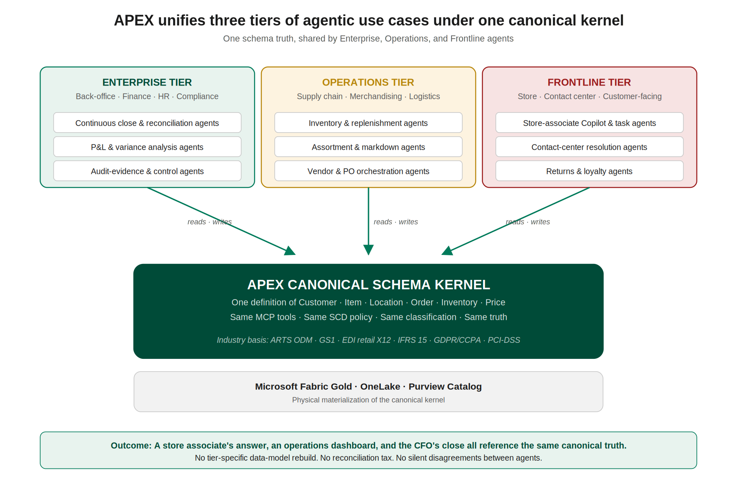
Figure 1. APEX unifies three tiers of agentic use cases under one canonical kernel. The Enterprise tier's CFO close, the Operations tier's inventory optimization, and the Frontline tier's store-associate Copilot all read from and write to the same canonical schema. Source: APEX RC Logical Architecture v0.1, §2.

What each tier actually does
Tier | Typical agents | Pain without unification
Enterprise | Continuous close, P&L variance, audit-evidence, control agents | Finance reports built on its own data model; numbers never reconcile with what the operations team sees
Operations | Inventory, replenishment, assortment, markdown, vendor agents | Each operational system has its own Item and Location model; agents inherit the silo
Frontline | Store-associate Copilot, contact-center resolution, returns, loyalty | Customer-facing agent contradicts the operations agent; customer trust erodes

H.4 The silo problem in concrete terms
Abstractions are lost on skeptical audiences. The unification thesis only lands if you can name the specific failure mode of the alternative approach. The diagram below contrasts the two approaches using the same business question.
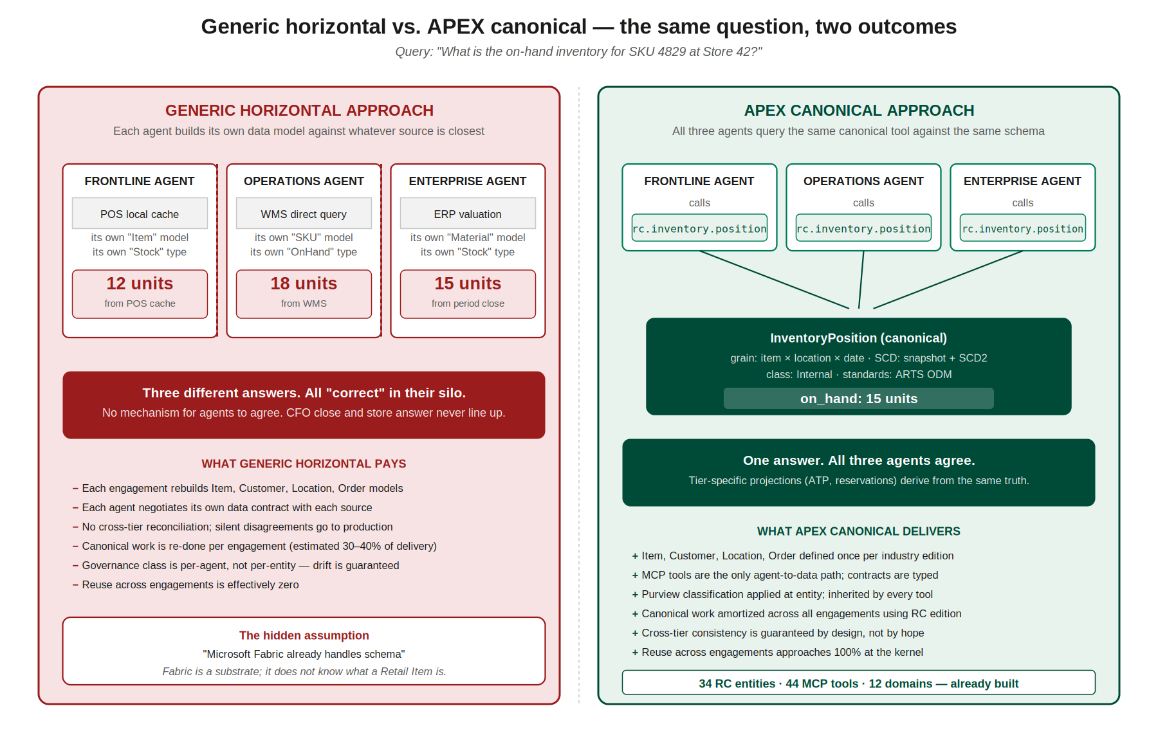
Figure 2. Generic horizontal vs. APEX canonical — the same question, two outcomes. In the generic horizontal approach, three agents give three different answers to the same question; all three are “correct” in their silo. In the APEX canonical approach, all three agents call the same MCP tool against the same canonical entity and return one truth. Tier-specific projections (available-to-promise, reservations) derive from that single truth, not from parallel rebuilds.

Three questions that break without unification
Business question | Without canonical — what happens | With APEX canonical
What is on-hand inventory for SKU X at Store 42? | POS cache: 12 units · WMS: 18 units · ERP period close: 15 units. All correct, none agree. | One call to rc.inventory.position returns the governed canonical answer. Tier projections derive from it.
Who is this customer? | Loyalty account ID, CRM master ID, eCom guest ID — three identities for one person. Stitching is per-agent. | Canonical Customer entity with declared identity resolution. One call to rc.customer.get returns the stitched identity.
What is the price of this item right now? | Price engine, ERP master, promo system each have their own effective-date logic. Markdowns may or may not be applied. | Canonical Price entity with effective-date SCD. rc.price.current returns the governed price at the requested moment.

H.5 What APEX unifies that generic horizontal cannot
Six dimensions of unification. When a Deloitte practice leader asks “what exactly does APEX give us that Fabric plus Foundry does not?” this table is the answer.
Dimension | Generic horizontal | APEX canonical
Schema authority | Per-engagement, ad-hoc | 34 RC entities defined once, inherited per engagement
Cross-tier consistency | Relies on manual reconciliation | Guaranteed by the kernel; agents cannot drift
Agent data path | Direct query into whatever source is closest | Typed MCP tool calls against canonical contracts
Governance class | Per-agent, applied after the fact | Per-entity in Purview, inherited by every tool
Identity enforcement | Per-agent Entra scope; easy to miss | Per-entity scope class, enforced at tool response
SCD discipline | Left to each engagement's data engineer | Declared per entity in the registry, materialized at Gold
Industry standards basis | Optional, project-dependent | ARTS ODM, GS1, EDI retail X12, IFRS 15, GDPR/CCPA, PCI-DSS
Reuse across engagements | Approaches zero at the schema layer | Approaches 100% at the kernel
Time-to-first-agent on Eng. 1 | Comparable | Comparable (APEX not meaningfully slower)
Time-to-first-agent on Eng. 3+ | Unchanged (rebuild every time) | 2–3x faster (kernel amortized)
Audit evidence | Per-agent, per-engagement construction | Per-entity Purview lineage from Bronze to Gold to tool
Multi-tier demo-ability | Usually shown as a single-tier demo | Cross-tier demo is the default configuration

H.6 The economics — why canonical wins over multiple engagements
The economic argument is the one that moves practice leaders. It is simple: canonical schema work is a substantial share of any agentic-AI delivery. Generic horizontal pays it every engagement. APEX amortizes it once per industry edition.
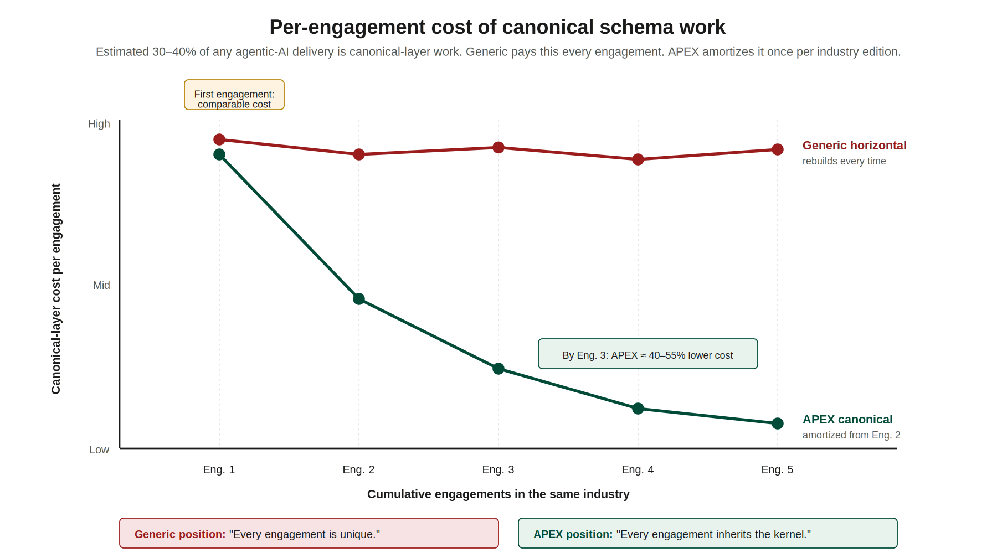
Figure 3. Per-engagement cost of canonical schema work over cumulative engagements. On engagement 1, the two approaches are comparable. By engagement 3, APEX delivery is estimated 40–55% lower cost at the schema layer because the canonical kernel is amortized. Generic horizontal stays flat because each engagement rebuilds. Figures are illustrative; use your actual practice-level estimates when customizing a D.8 memo.

How to frame the economics in a Tier 0 memo
- Never lead with the percentage. Lead with the mechanism: “Generic rebuilds the canonical layer. APEX inherits it.”
- Quantify using your practice's actual data where possible. If you don't have data, use “estimated 30–40% of delivery” as the canonical-work share — this is a defensible industry range.
- Avoid precision that implies certainty. “40–55% lower cost by engagement 3” is defensible. “47% lower cost by engagement 3” is not.
- Always acknowledge that engagement 1 costs are comparable. The argument is about engagement 2 onward. Practice leaders know this; pretending otherwise loses you credibility.

H.7 When generic IS the right answer — honest framing
The fastest way to lose a Tier 0 argument is to claim APEX wins everywhere. It does not. Be honest about the four scenarios where a generic horizontal approach is the correct choice. This honesty is what makes your other claims defensible.
Scenario | Why generic wins here
Single-tier, single-workflow use case | Cross-tier consistency is not a constraint. Canonical overhead is not justified.
Throw-away or experimental prototype | Time-to-first-demo matters more than multi-engagement reuse. Spend the canonical budget on the next engagement.
Non-industry-specific entity space | Some ITSM, some HR, some internal-facing IT use cases simply don't benefit from retail or healthcare canonical schemas.
Client insists on their proprietary data model | Their model is the canonical, by contract. APEX becomes pattern-only (MCP conventions, ORCH contracts, HITL gates) without the entity registry.
The decision flowchart below is the artifact you include when this honest framing is expected. In three of four paths, the answer is APEX. In one path, generic is acceptable.
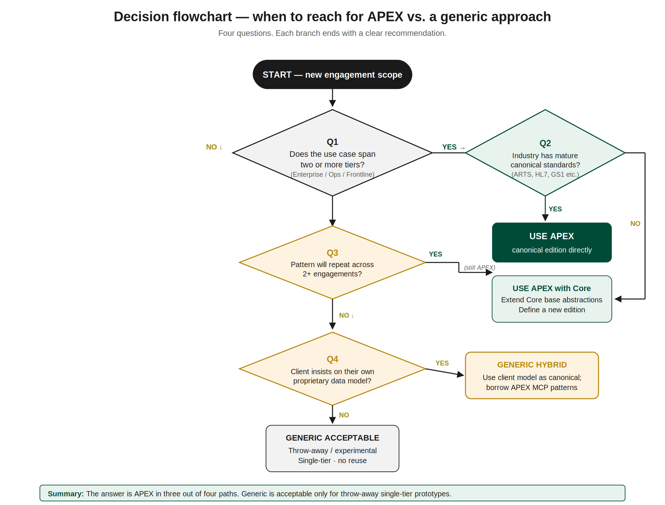
Figure 4. Decision flowchart — when to reach for APEX vs. a generic approach. Four questions: cross-tier use case? industry standards mature? pattern repeats across engagements? client-proprietary data model? Three of four paths lead to APEX or APEX-with-Core. Only single-tier throw-away prototypes justify the generic approach.

H.8 Objections you will hear — and how to respond
Eight objections come up repeatedly in Tier 0 conversations. Draft Internal Objection-Response Cards (D.9) from this list. Each response follows the same shape: acknowledge the partial truth, reframe to the full picture, land one defensible line.
Objection you will hear | What is partially right | APEX response
“Fabric already handles schema.” | Fabric gives you storage and compute. It does give lineage and DLP. | Fabric is a substrate, not a schema. It does not know what a retail Item is. Canonical is the industry-aware layer on top.
“We just need a Copilot, not a framework.” | Single-Copilot use cases do not need a full framework. | The moment a second agent touches the same entity, you need the canonical layer or the two disagree in production.
“Industry-specific is too narrow.” | A pure industry play does limit cross-industry reuse. | Core + editions IS the cross-industry approach. 80% of value is in Core; editions add the remaining 20% where regulatory and standards bases differ.
“Canonical schemas are over-engineered for agents.” | Over-engineered canonical layers from the data-warehouse era were a real problem. | APEX entities are lean — grain, SCD, class, standards basis. Not ERP-style mega-schemas. They're the minimum viable shared contract.
“GraphRAG and vectors make canonical obsolete.” | Vector retrieval is excellent for unstructured content. | Vectors answer ‘what is similar.’ Canonical answers ‘what is true.’ Finance close needs the second. Both coexist.
“This slows down the first engagement.” | Engagement 1 cost is comparable, not cheaper. | The argument is about engagement 2 onward. Skip canonical and you pay the tax every time.
“Microsoft does not endorse this approach.” | Microsoft is neutral on frameworks; they care about consumption. | APEX maximizes Microsoft consumption because the kernel runs on Fabric, Foundry, Purview, Entra. This is a pro-Microsoft argument.
“We already have an internal accelerator.” | Multiple accelerators exist; duplication is real. | Converge on one. APEX is the candidate with industry editions, a registry, a tool catalog, and measured RC maturity. Bring it to the table as the reference, not the competitor.

H.9 Stakeholder personas and what moves each of them
Three personas, three different framings of the same APEX story. When drafting a D.8 memo, the onshore brief names the persona — you tune the content accordingly.
Persona 1 — Practice leader (DMTSP partner, sector GPL)
Concerns: delivery risk, pursuit economics, repeatability, staffing. Moved by: multi-engagement velocity argument (H.6), cross-tier consistency (H.3), measured RC maturity (34 entities, 44 MCP tools already built). Language: “repeatability,” “velocity,” “win rate,” “staffing curve.” Opening grabber: “The canonical layer is 30–40% of any agentic-AI engagement. Pay it once per edition or pay it every time.”
Persona 2 — Delivery partner (engagement partner, senior manager)
Concerns: staffing time-to-productive, demo-ability, rework rate, technical debt by engagement 3. Moved by: the silo failure in concrete terms (H.4), the decision flowchart (H.7), evidence that APEX reduces rework. Language: “onboarding,” “demo,” “rework,” “technical debt.” Opening grabber: “When your third engagement starts, will you hand your team a kernel to inherit or a clean slate to rebuild?”
Persona 3 — Microsoft relationship lead (Deloitte side)
Concerns: Microsoft joint pipeline, consumption growth at the client (Fabric TB, Foundry tokens, Copilot seats), ECIF efficiency. Moved by: the Microsoft consumption argument (APEX maximizes Fabric/Foundry usage because the kernel runs on them), the multi-tier demo-ability that drives Copilot seat expansion. Language: “consumption,” “joint pipeline,” “ECIF,” “Fabric TB,” “Copilot seats.” Opening grabber: “A framework that maximizes canonical entities on Fabric Gold is a framework that maximizes Microsoft consumption. APEX is that framework.”

H.10 Review process for internal-marketing content
Tier 0 content follows the same eight-step workflow as external content, with two specific modifications.

What changes for Tier 0 content
- Step 7 (compliance clearance) is replaced with practice-leadership review. The named reviewer is specified in the brief and is typically a DMTSP partner or senior manager.
- Practice-leadership review focuses on: positioning fairness (H.2), economic claims (H.6), and persona fit (H.9). It does NOT focus on Independence language — that remains the offshore author's responsibility under F.1/F.3.

What does NOT change
- Independence language rules (A.4, F.1) still apply. Internal drafts leak. A forbidden term in a Tier 0 memo is still a compliance incident.
- The Self-QA checklist (E.4) still runs, twice.
- Peer review (step 5) still runs. Your peer may not be an APEX expert; your draft must stand on its own.
- Archive naming convention still applies.

Special rule for D.8 memos
NEVER WRITE A TIER 0 MEMO WITHOUT ONSHORE BRIEF APPROVAL
D.8 memos discuss internal competitive dynamics. The wrong framing in the wrong hands damages practice relationships. Your onshore lead must approve the brief — specifically the named audience, the named stakeholder persona, and the named competing approach — before you begin research. If any of those three is missing or ambiguous, stop and ask.
A D.8 memo is never distributed beyond the named audience of the brief without a second approval cycle.

End of Playbook v2.0. Questions, corrections, and improvement suggestions go to Keven Markham.
H.11 APEX vs the Common Agentic Framework — Side-by-Side
H.11.1 The framework you may encounter
The Common Agentic Framework (CAF) is a Deloitte-internal agentic framework authored by a practice group outside DMTSP. You will encounter CAF proposals when: (a) a client has a hyperscaler-agnostic directive; (b) a practitioner outside DMTSP leads the discovery; (c) a cross-practice program spans multi-cloud workloads. CAF is real, is capable in its lane, and is not a competitor to be disparaged. The right posture is: understand both, position APEX where APEX fits, and support CAF where CAF fits. This subsection gives you the detail to do so credibly.
H.11.2 What both frameworks share
Start every internal conversation with the shared baseline. The comparison begins from agreement, not from competition.
- LLM orchestration with tool and function calling.
- Guardrail patterns for PII detection, prompt-injection defense, toxicity filtering.
- Conversation context and memory layers for multi-turn interaction.
- Tracing and observability (APEX uses Purview + Foundry audit; CAF uses LangFuse).
- Agent catalog with reusable patterns.
- Deloitte IP authored by Deloitte practitioners for internal acceleration.
H.11.3 Where APEX is materially stronger
- Four-plane Microsoft-native composition. APEX runs on Fabric (data), Foundry (reasoning), Purview (trust), Entra (identity) natively integrated — no custom glue code. CAF's LLM Gateway abstraction is engineering-intensive to maintain in production and loses the native integration benefits (OneLake shortcuts, Purview lineage across agent tool calls, Entra Agent ID per agent).
- Practice-specific canonical schemas. APEX ships ~40 schemas across seven Practices — SCML, MERML, CXML, PatientML, ClaimML, StudyML, UOGML, AXLEML sub-models, TravelerML, ConnectedICEML, and more. CAF is domain-neutral with product and common agents; no equivalent canonical semantic layer by industry.
- Practice-specific agent catalogs. APEX ships approximately 40 RC agents, 35 HLS, 30 AXLE, and 20–25 each for ER, TMT, TH, and ICE, productized with personas, KPIs, SLOs, and commercial envelope. CAF has generic Model Run Validator, Alternative Model Selection, Model Run, and Model Alert — capable but not industry-productized.
- 47 orchestration archetypes. APEX specializes these into approximately 150 Practice orchestrations with sequential, parallel, hierarchical, and feedback patterns. CAF has an LLM-based dynamic orchestrator that routes at runtime but without a pre-built archetype library.
- Audit row and oversight spectrum. APEX emits a 14-field audit row per decision with version-pinned manifest, policy, and prompt SHAs, plus the HITL / HOTL / HIC oversight spectrum. CAF's LangFuse tracing is excellent dev-time observability; the APEX audit row is regulatory-grade evidence that a regulator can use to reconstruct decisions without custom tooling. This matters for HIPAA, 21 CFR Part 11, FERC, SOX.
- File-first context architecture. APEX's file-first context (per the OpenClaw community pattern) eliminates session-to-session drift and makes the agent's cognitive baseline deterministic. CAF uses conversation context plus database-backed session state — works, but without the manifest-pinning guarantee.
- Microsoft Agent365 (E7) integration path. APEX engagements leverage Agent365 as the native governance layer when the client has E7 licensing. CAF's hyperscaler-agnostic posture does not leverage Agent365 natively.
- Independence discipline. APEX is Microsoft-only by design — Deloitte is Microsoft's auditor, and the two-contract model works because Deloitte does not carry the same audit-independence posture on AWS or GCP. Multi-cloud frameworks introduce complications for audit-client engagements that APEX avoids by architectural choice.
- Wave 1 / 2 / 3 commercial envelope. APEX is a delivery model, not just a technical framework. Wave 1 envisioning at \$300K–\$1.2M, Wave 2 scale at \$4M–\$15M, Wave 3 sustain multi-year, with KPI bands per Industry per Function. CAF is a technical framework without a corresponding commercial motion.
H.11.4 Where the Common Agentic Framework is more appropriate
Honest framing — use this when the scope genuinely fits CAF:
- Strategic multi-cloud mandates. Client explicitly wants agents running across AWS Bedrock, Azure, and GCP with no hyperscaler preference. CAF's LLM Gateway abstraction was built for this.
- Generic ML-ops workloads. Model retraining, alternative-model selection, model-alert workflows that are cross-industry and do not benefit from a Practice semantic model.
- Engagements led outside DMTSP. When the engagement lead is more comfortable with CAF and the scope is not Microsoft-anchored, do not force-fit APEX.
- Cross-LLM benchmarking. When the client explicitly wants to benchmark Claude, GPT, Gemini on the same task, CAF's hyperscaler-agnostic posture is natural.
H.11.5 How they compose rather than compete
In mixed engagements, APEX and CAF can coexist:
- LLM Gateway fronting Foundry. CAF's LLM Gateway handles model selection across hyperscalers; APEX's Foundry-hosted Practice agents call the Gateway for non-Microsoft model invocations while Microsoft-native workloads remain on Foundry directly.
- Cross-validation layer. CAF's Model Run Validator can validate APEX agent outputs as an additional check layer, particularly useful for cross-industry programs.
- Scope split by workload. CAF Common Agents handle generic ML operations; APEX handles Practice-specific agentic orchestration with canonical schemas and the audit row.
Do not propose coexistence reflexively — wait for discovery to confirm a genuine mixed estate. Proposing both frameworks without a scope-driven rationale signals indecision.
H.11.6 Independence posture
APEX's Microsoft-only posture is an Independence feature, not a constraint. At a Deloitte audit client:
- APEX at audit clients. APEX runs on the Microsoft platform the client licenses directly, with Deloitte delivering services on a separate contract — the two-contract model.
- CAF at audit clients. CAF spanning AWS + Azure + GCP raises the question: how does Deloitte maintain Independence across platform relationships where it is Microsoft's auditor but not AWS's or Google's?
- The practical answer. This is not an argument against CAF; it is a constraint that must be resolved per engagement. At audit clients, APEX's posture is inherently cleaner. At non-audit clients, CAF's multi-cloud flexibility may be net-positive. Always route audit-client questions to the Independence Office.
H.11.7 Objection responses specific to this comparison
“CAF is already approved by another practice — why would we do a parallel APEX engagement?”
“If the scope is genuinely multi-cloud and hyperscaler-agnostic, CAF is the right answer. If the scope is Microsoft-heavy, Practice-intensive (RC, HLS, AXLE), and regulatory (audit, HIPAA, 21 CFR Part 11, FERC), APEX's native composition and audit-row discipline carry you further for fewer dollars. A quick scope confirmation will tell us which fits.”
“CAF supports any LLM — APEX forces Microsoft?”
“APEX runs on Azure AI Foundry, which supports Anthropic Claude, Meta Llama, OpenAI, Mistral, and others — all accessible through one Entra-scoped endpoint with Purview classification propagating natively. Model flexibility is preserved; the four-plane integration is what differs.”
“CAF has LangFuse tracing — APEX has what?”
“APEX emits a 14-field audit row per decision, version-pinned to manifest, policy, and prompt SHAs, with Purview lineage from source SOR to agent output. It is designed for regulator reconstruction without custom tooling. LangFuse tracing is excellent for dev-time observability; the APEX audit row is regulatory-grade evidence.”
“CAF is hyperscaler-agnostic and future-proof. APEX is Microsoft-bound.”
“APEX is Microsoft-aligned because the four-plane composition — Fabric, Foundry, Purview, Entra — is genuinely differentiated at enterprise scale. If the client's strategic direction is away from Microsoft, APEX is not the right framework. If the client is Microsoft-anchored, which is most enterprise clients per 2026 telemetry, APEX capitalizes on that fully with Independence posture built in.”
H.11.8 Comparison table
Use this table as the anchor artifact in internal conversations. Every row is defensible from the Sellers Guide v1.4.
Dimension | APEX | Common Agentic Framework
Platform posture | Microsoft-native; four-plane composition | Hyperscaler-agnostic via LLM Gateway
Canonical schemas | ~40 per-Practice (SCML, PatientML, AXLEML, etc.) | Domain-neutral; no industry schemas
Agent catalog | Practice-specific (~40 RC, ~35 HLS, ~30 AXLE, etc.) | Generic (Model Run Validator, Alt Model, Alert)
Orchestration | 47 archetypes → ~150 Practice orchestrations | LLM-based dynamic orchestrator (runtime)
Audit / observability | 14-field audit row, Purview lineage, version-pinned SHAs | LangFuse tracing + Guardrails
Identity | Entra Agent ID; Agent365 (E7) path | AEF RBAC (custom)
Commercial model | Wave 1/2/3 envelope + KPI bands by Industry | Technical framework; no commercial motion
Independence fit (audit clients) | Clean — Microsoft two-contract model | Complicated — multi-cloud posture
H.11.9 The one-paragraph summary
“APEX and the Common Agentic Framework are both Deloitte-internal agentic frameworks, and both are capable in their respective lanes. APEX is the Microsoft-native, Practice-specific, regulatory-grade, commercially-productized framework for enterprise engagements where the client is Microsoft-anchored. CAF is the hyperscaler-agnostic generic framework for multi-cloud mandates and cross-industry ML-ops. The offshore contributor's job is never to disparage CAF; it is to understand both, produce content that positions APEX credibly where APEX fits, and recognize when a CAF handoff is the right answer.”
— end of H.11. When in doubt on CAF-vs-APEX positioning, route to onshore before drafting. —
Part I. APEX v0.2 Updates (April 2026)
APEX v0.2 introduced substantial new content to the Sellers Guide (now v1.4). This part gives offshore contributors the minimum mental model needed to tag and produce content against the new material. Do not attempt to explain these concepts in client-facing content without onshore review — they are architecture-level topics.
I.1 New Sellers Guide sections you will hear referenced
The following sections were added in v1.4 of the Sellers Guide. When an onshore reviewer mentions any of these by number, treat it as authoritative and route any questions through the standard QR flow.
- §6.11 Microsoft Orchestrator Agent Types — Semantic Kernel, Copilot Studio, and Agent365 (E7). Three Microsoft runtimes that compose rather than compete. APEX engagements at scale use all three.
- §6.12 File-First Context Architecture — the paradigm shift from vector-first retrieval to file-first agent identity. Credits the OpenClaw community pattern as the paradigm source.
- §6.13 Parent-Child Agent Orchestration + Redis — production-grade orchestration primitives (cancellation token, budget envelope, status channel) plus the Redis hot-path cache with strict governance rules — control-plane only, never data-plane.
- Seven Practice deep-dives — §9.11 RC, §10.10 HLS, §11.10 ER, §12.10 AXLE, §13.13 TMT, §14.9 TH, §15.9 ICE. Each covers data foundations, agent consumption, governance, and envelope linkages for its Practice.
- §2.2C Human Oversight Spectrum — HITL (Human-in-the-Loop) for consequential decisions, HOTL (Human-on-the-Loop) for routine monitoring, HIC (Human-in-Command) for strategic governance.
- §6.10 & §8.8 Audit — the APEX audit row (what agents emit, 14 required fields, version-pinned) and the audit architecture (how Purview stores and surfaces it end-to-end).
- §4.8 Complementary Platforms — how APEX composes with Palantir, C3.ai, Databricks, Snowflake, Salesforce, ServiceNow, UiPath, IBM watsonx, and Google Vertex. Never as competitors, always as composable.
I.2 New talking points cleared for offshore drafts
The following positioning statements are cleared for offshore-drafted content at Tier 2 (broad functional audience). Use them verbatim; paraphrasing invalidates the Independence review.
On Microsoft orchestrators
“Microsoft now ships three orchestrator runtimes — Semantic Kernel, Copilot Studio, and Agent365. They compose rather than compete. APEX engagements at scale use all three, with the trace_id binding every cross-runtime call into one forensic thread.”
On file-first context
“APEX agents wake with the same cognitive baseline every session. Identity, canonical schema, and governance rules are carried in files, not retrieved at runtime. Vectors and graphs remain useful for unstructured content and relationship traversal; the hybrid model preserves every investment.”
On the oversight spectrum
“APEX scales agent autonomy through a designed spectrum: Human-in-the-Loop for consequential decisions, Human-on-the-Loop for routine monitoring, Human-in-Command for strategic governance. Every service declares which mode applies to which decision class.”
On the audit row
“Every APEX agent decision writes a structured, version-pinned, tamper-evident audit row. A regulator can reconstruct any decision through Purview lineage without custom tooling.”
On complementary platforms
“APEX does not replace Palantir, C3.ai, Databricks, or Snowflake. APEX orchestrates across them. The Microsoft platform is the agentic substrate; the complementary platforms remain load-bearing where the client invested.”
I.3 New objection responses
“Why Microsoft when our stack is AWS / GCP?”
“APEX is Microsoft-native because of the four-plane composition — Fabric, Foundry, Purview, Entra. If your strategic stack is AWS or GCP for new AI workloads, APEX may not be the right answer, and we will tell you honestly in discovery. Many APEX clients coexist with other clouds where those clouds are load-bearing for non-agentic workloads.”
“Doesn’t file-first context conflict with our vector store?”
“File-first is complementary to vectors. Files carry identity and canonical schema; vectors carry unstructured semantic search; graphs carry relationships. The hybrid model keeps your vector investment useful — it just is not the carrier of agent identity anymore.”
“We don’t have Microsoft E7 — is Agent365 required?”
“No. APEX works with Semantic Kernel and Copilot Studio without E7. Agent365 is a governance accelerator for enterprises with E7 licensing; it reduces the custom-governance lift but is not a prerequisite.”
“Is Redis caching our data?”
“Redis is strictly control-plane only — cancel tokens, budget counters, heartbeats, HITL deadlines, session state. Your canonical data never touches Redis. It lives in Fabric Gold, served to agents through typed MCP tools with full audit row emission.”
I.4 Forbidden language — additions to §F.1
Never write these phrases in any externally-distributed content. Each is either architecturally wrong or Independence-problematic:
- “APEX uses Palantir ontology” / “APEX includes C3.ai” / “APEX is built on Databricks / Snowflake” — these platforms are complementary, not ingredients of APEX.
- “The OpenClaw partnership” / “Deloitte-OpenClaw alliance” — OpenClaw is a credited community pattern. It is not a partnership, an alliance, or a commercial relationship.
- “Redis stores APEX data” / “Redis caches customer records” — Redis is control-plane only. Data-plane content lives in Fabric Gold.
- “APEX is fully autonomous” / “APEX replaces human approval” — APEX uses the oversight spectrum. Human governance is always present, across HITL, HOTL, or HIC modes.
- “APEX includes Agent365” / “APEX ships with E7” — Agent365 is a Microsoft E7 tier the client may license. APEX leverages it when available; APEX does not include or resell it.
- “Our audit row is cryptographic blockchain” — the audit row uses content hashes and Git SHAs, not blockchain. Do not overclaim the mechanism.
I.5 Required qualifications when referencing the new content
- File-first context → always credit OpenClaw as the community pattern. Never imply Deloitte invented file-first.
- Microsoft orchestrators → always name all three (SK, Copilot Studio, Agent365). Never single-source without onshore review.
- Audit row → always note it is version-pinned to manifest, policy, and prompt SHAs with content-addressable evidence.
- Redis → always qualify “control-plane only.” Data-plane references are forbidden per §F.1.
- Oversight spectrum → always name all three modes (HITL, HOTL, HIC). Never imply binary autonomous-vs-supervised.
- Practices → there are seven, acronym-correct: RC, HLS, ER, AXLE, TMT, TH, ICE. Tagging errors cause cross-Practice content leakage.
- AXLE → always clarify it is both the APEX Industrial Practice AND a sibling Deloitte framework for automotive. They coexist, federate, and are sometimes both engaged in the same client.
I.6 Updated Appendix map in the Sellers Guide
The Sellers Guide now has 25 appendices, A through Y. Key entries you may tag against:
- Appendix F — Data Platform Co-Existence (Fabric with Databricks / Snowflake)
- Appendix T — KPI Expectations per Industry and Function
- Appendix U — Cost Calculation (Fabric + Agentic AI)
- Appendix V — Cross-Reference Index (problem-indexed navigation)
- Appendix W — Discovery-to-SOW Artifact Set (templates)
- Appendix Y — Comprehensive Glossary of Terms
I.7 Reference
APEX Sellers Guide v1.4 is the authoritative reference for everything in this Part. All talking points, objection responses, and qualifications above derive directly from it. When uncertain, cite the Sellers Guide section number (for example, §6.12) and route to your onshore reviewer. Never paraphrase the positioning statements in Part I.2 without review — they are the Independence-cleared wording.
— end of Part I —

