Hi Welcome to my OctagonAssessment

You will have to start with this url for the git page:

<https://github.com/KeveshaP/OctagenAssessment.git>

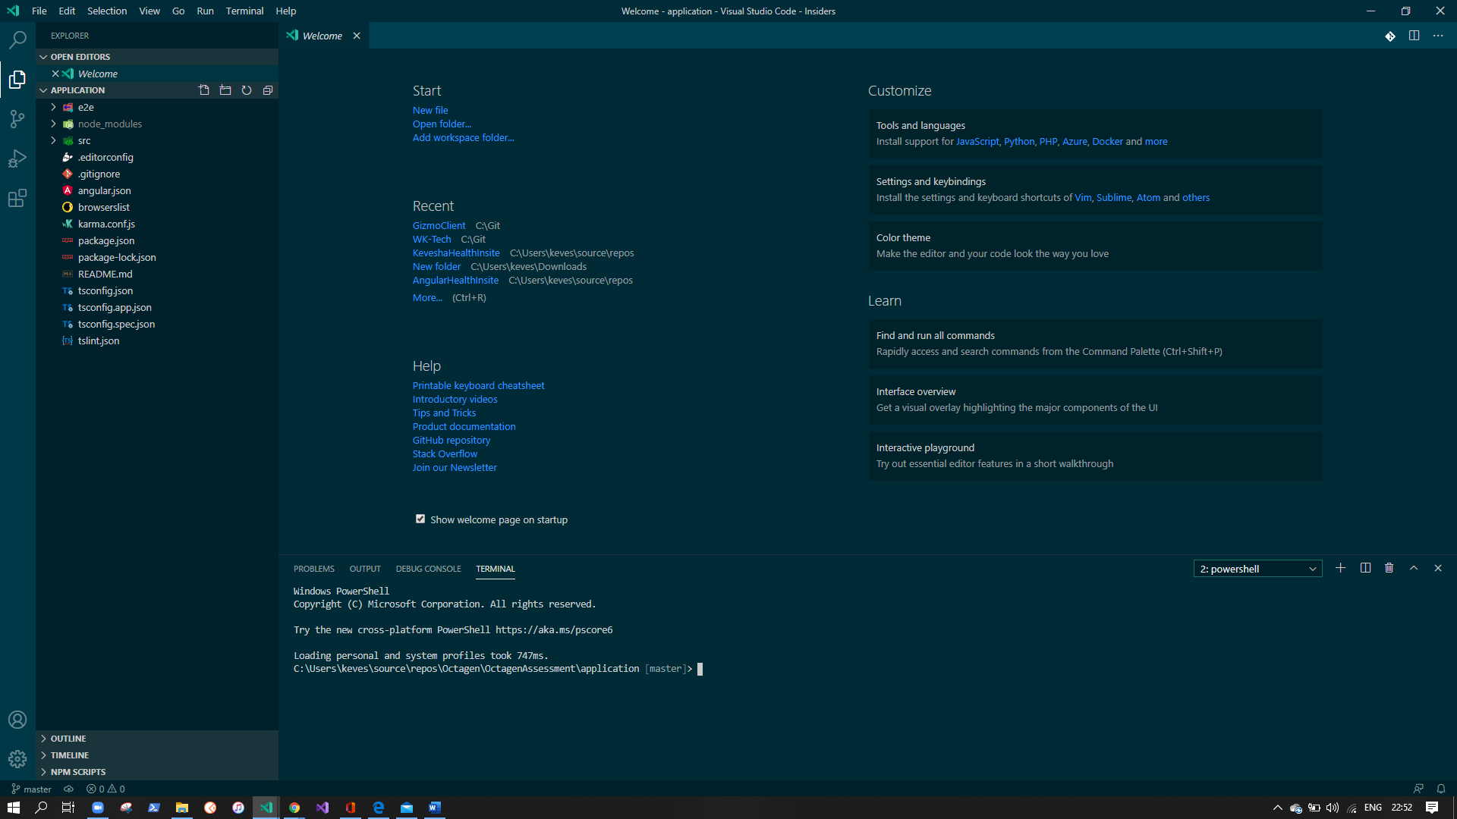

The above picture is visual studio code this is the ide I used to run and code my angular application.

I then navigate to the folder with the command cd (folderpath)

Step 1 :

Cd into application folder

Step 2:

npm i

Step 3:

Go back to your folder where you cloned the application

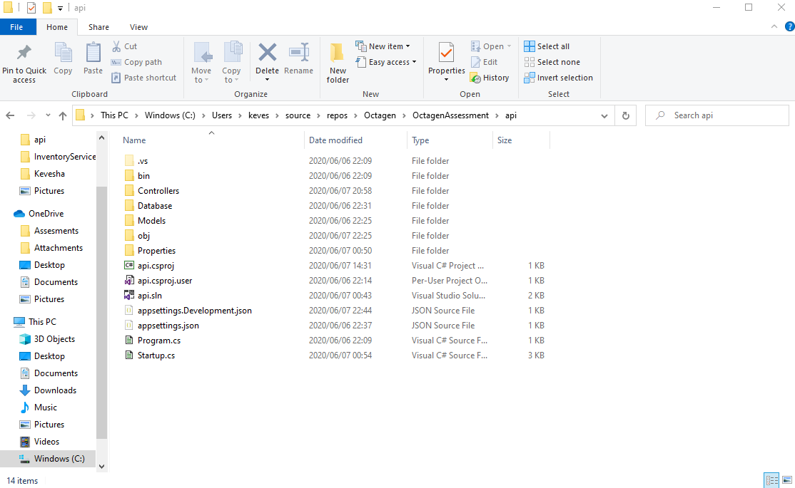

Step 4: open the api.sln visual studio application

Step 5:

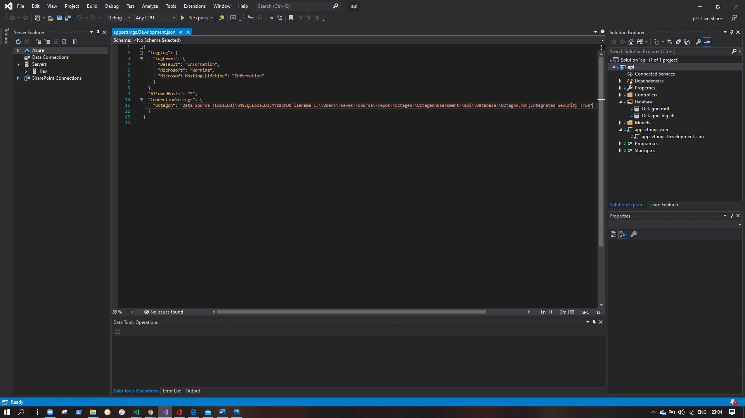

In the solution explorer you will see the

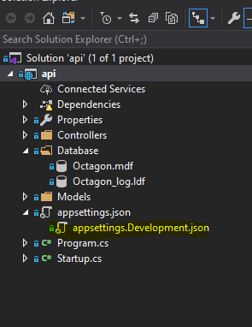

Open that and you will have to change the connection string

To change the connection string you need to

Open the database folder and click on the .mdf file.

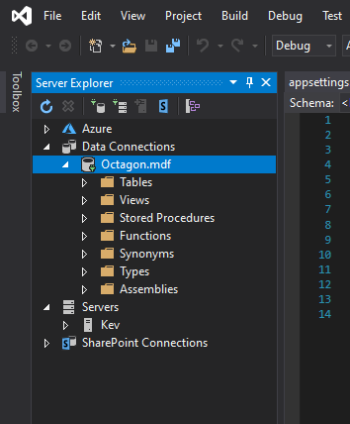

You will see the Octagon.mdf database file will appear in the data connections if you click on the database you will see this in the properties explorer. 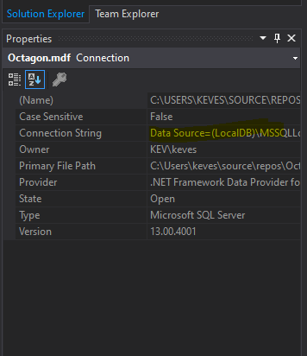

Here you will find the connection string

You will then change the appsettings.Development.json from the current connection string to the new location of the connection string to the database.

The text file for upload you can upload what ever you feel like from any location but I have added a test.txt file for you to see the format of the text that I require it to be in when uploadding

There after you can just run the web api and then you can run the angular application and you should be good to go and play around.

Please let me know if you have any other issues I am sure the application should be all ok I made it as simple as possible

Thank you

Kevesha