[GYMIFY] Requirements Specification

Version 0.9

April 7, 2023

**Table of Contents**

**[GYMIFY] REQUIREMENTS SPECIFICATION 1**

**VERSION 0.2 1**

**APRIL 7, 2023 1**

**1.** **EXECUTIVE SUMMARY 3**

1.1 Project Overview 3

1.2 Purpose and Scope of this Specification 3

**2.** **PRODUCT/SERVICE DESCRIPTION 3**

2.1 Product Context 3

2.2 User Characteristics 3

2.3 Assumptions 3

2.4 Constraints 3

2.5 Dependencies 4

**3.** **REQUIREMENTS 4**

3.1 Functional Requirements 5

3.2 Non-Functional Requirements 5

*3.2.1* *Product Requirements 5*

**3.2.1.1** **User Interface Requirements** 6

**3.2.1.2** **Usability** 6

**3.2.1.3** **Efficiency** 6

3.2.1.3.1 Performance Requirements 6

3.2.1.3.2 Space Requirements 6

**3.2.1.4** **Dependability** 6

**3.2.1.5** **Security** 7

*3.2.2* *Organizational Requirements 7*

**3.2.2.1** **Environmental Requirements** 7

**3.2.2.2** **Operational Requirements** 7

**3.2.2.3** **Development Requirements** 7

*3.2.3* *External Requirements 7*

**3.2.3.1** **Regulatory Requirements** 7

**3.2.3.2** **Ethical Requirements** 7

**3.2.3.3** **Legislative Requirements** 7

3.2.3.3.1 Accounting Requirements 7

3.2.3.3.2 Security Requirements 7

3.3 Domain Requirements 7

**4.** **USER SCENARIOS/USE CASES 7**

# Executive Summary

## Project Overview

This project is based on a Web-Based application and acts as a convenient way for an entire gym chain to maintain and manage the gym and it provides a platform for coaches as well as managers to stay organized and work more efficiently. This project is designed for people who want to go to the gym, and have previous experience with gyms. For most people going to the gym happens on a whim and usually those same people lack the motivation to go back, the design and purpose of this application is to make it so these people can keep track of their progress whilst going on the gym and they can stay motivated.

The app will help individuals better communicate with coaches and help them choose their desired courses, the plan they want most and the time and location they want to go to. After the users have selected a course, the coach can choose to accept or decline said course, and they can choose to change the appointed time and location based on their needs and the users needs.

This app was made to make people rely more on courses and coaches rather than just working alone but it also allows them other features to choose from such as an online shop where people can buy gym products and have them delivered at their houses, chatting with their instructors, watching videos from a video catalog, see their schedules and other features. The app provides an effective way to conveniently manage gyms online and on a real time basis, using a system that will include all gyms in a certain city, district or region. It gives all user levels a self-explanatory and easy to use tool which they can fulfill their jobs with.

In order for our product to work in the desired way, the users of the system must be able to correctly and effectively use each feature and by coherently using the in app systems such as reviews and reports we will be able to create a community which will continue improving with the app, that is our goal as every feature of the app is designed with improvement in mind and it will be implemented in such a way that change will be welcomed. The end goal is to have a system that functions without a lot of maintenance on an international level.

## Purpose and Scope of this Specification

The purpose of this document is to create a way to guide us through creating an application without missing any of the requirements while also staying within the scope, and not breaking any guidelines.

The specification addresses the following aspects of the design process:

* Documentation of all product features and functionality
* Technical overview of the application
* Requirements Explanation
* Product Interfaces
* Thorough explanation of all ways the application will be used
* Dependencies and Constraints

Out of the scope of the project are:

* Legislative Requirements
* Financial Aspects of the project
* Unnecessary Requirements with QoL features (unneeded)

# Product/Service Description

Our application will allow members of the gym to flexibly access any particular gym. The user can buy membership that will be accessible at any gym that is part of the same chain. The user can choose a course, which is split into 2 categories, group courses and individual courses. For the individual ones we have provided each member with the ability to flexibly arrange the desired time and location by having the option of communicating directly with their coach and creating the plan that will suit them the most. Also they will be able to watch videos, and purchase a variety of products from our online shop.

The coach will be able to have its own courses and will benefit from the larger user base of this system by having more people reach them. They can submit an application form to the managers with the courses they want to teach and after acceptance, they will be able to accept and decline members, report them and chat with them and manage their schedules according to their desire.

## Product Context

This software is a tool which serves the current owners of the gyms and the people working in them. It establishes an easy way to interact with customers and coaches, by providing them with a number of different ways to achieve their goals, such as personal courses and group sessions with the idea of training in mind. It also allows for a better management of user data and overall gym functionality by keeping track of every process performed within the environment. Since to this day, this type of system is yet to introduce itself within our country we choose the initiative to design such a software.

Its main focus is the user, and it is designed with accessibility and practicality in mind. It is there to provide a simple solution to current problems and an effective way of organizing and managing information. It is a real time tracking system that helps all people going in and out of gyms.

## User Characteristics

* Member
* choose membership plan
* choose course (and gym coach for specific type of course)
* buy from an online shop
* set-up appointment with their coach
* review a course after finishing it
* chat with coach/customer service within the app
* watch videos from a video catalog
* Coach/Trainer/Gym Expert
* Create and publish their own courses
* decline/accept customers course
* set-up appointment with customer
* chat with their customers
* create custom plan based on customer availability
* review gym equipment / recommend new equipment
* report customer / cancel ongoing course
* Manager
* approve reviews / reports ( from both users and coaches)
* analyze equipment complaints (whether the complaint was needed or just skip it)
* order new equipment
* manage users (includes banning/unbanning)
* manage coaches and their courses
* manage gym schedule (will include the ability to close the gym for certain reasons)
* manage income/expenses
* see statistics about customer flow

## Assumptions

* It is assumed that coaches and managers are familiar with technology and know how to handle and use the software.
* It is assumed that the users will have up to date browsers on their computers and will use android or ios operating system on their mobile devices.
* It is assumed that the users will be connected to the internet when using the application.
* It is assumed that a higher level user such as an admin will have access to the source code and all the database and will be able to change or add new managers when needed.
* It is assumed that there will be a group of people who want to go the gym.

## Constraints

* Users of the system will need to have an account to use the gym facilities.
* There will need to be a good enough server connection with high end hardware in order to process many users at a time
* The members of the gym will have to apply to courses via the online app and they will be unable to do so live.
* Coaches will need to rely on the app to manage their work and members. THey will need to have a device with them always for their work to be flawless.

## Dependencies

* The coach cannot create a course without it being approved by the manager.
* The coach cannot report and ban a certain member without the permission of the manager.
* The member cannot chat with a coach without first checking a course.
* The coach cannot register without being approved by the manager.
* If the coach changes an appointment they have to wait for the approval of the member in order for the change to occur.
* An order will not proceed to checkout if the selected products are out of stock.
* A member will be unable to cancel an order after the payment has been made.
* A member of the gym will need to go to the membership page in order to change/unsubscribe from the membership.

# Requirements

**Priority Definitions**

The following definitions are intended as a guideline to prioritize requirements.

* Priority 1 – The requirement is a “must have” as outlined by policy/law
* Priority 2 – The requirement is needed for improved processing, and the fulfillment of the requirement will create immediate benefits
* Priority 3 – The requirement is a “nice to have” which may include new functionality

## Functional Requirements

| **Req#** | **Requirement** | **Comments** | **Priority** | **Date Rvwd** | **SME Reviewed / Approved** |
| --- | --- | --- | --- | --- | --- |
| BR_01 | The app will open with different views for different user levels (Members, Coaches, Managers) | The app will be able to differentiate users based on their credentials when they first registered | 1 | 4/14/2023 | Kevin Cela |
| BR_02 | The app must be able to correctly handle in-app transactions. | The user will be able to purchase products just by entering their credit card information. | 1 | 4/14/2023 | Kevin Cela |
| BR_03 | The user will log in using email and password or phone number and password | The app will have 2 ways of logging in. | 2 | 4/14/2023 | Kevin Cela |
| BR_04 | The user can choose from different membership plans | The app will have a couple of different options to choose a plan from. | 3 | 4/14/2023 | Kevin Cela |
| BR_05 | The user will receive immediate feedback on purchases and when choosing an option. | The server will need to update on real time | 1 | 4/14/2023 | Kevin Cela |
| BR_06 | The user can contact customer service within the app | The user will be able to click on an option to contact or inform the customer service. | 2 | 4/14/2023 | Kevin Cela |
| BR_07 | The user can choose from different available courses. | The courses will all be listed in a separate page. | 1 | 4/14/2023 | Kevin Cela |
| BR_08 | The coach can create or change existing courses on their account. | So that they don't have to fill a form or contact the manager. | 1 | 4/15/2023 | Kevin Cela |
| BR_09 | The manager will be able to generate records of all individuals currently assigned to that gym. | It will be needed by every manager. | 1 | 4/15/2023 | Kevin Cela |
| BR_010 | The user can enroll and quit a course whenever they want. | It is important to allow user freedom. | 2 | 4/15/2023 | Kevin Cela |
| BR_11 | The manager will be provided with all product information. | They will see which needs restocking and how many were bought within a certain time period. | 2 | 4/15/2023 | Kevin Cela |
| BR_12 | The coach will be able to change and set-up appointments based on their schedule. | To make an effective scheduling method for coaches. | 1 | 4/15/2023 | Kevin Cela |
| BR_13 | The coach can decline/accept members. | They will also provide a reason as to why a user was declined. | 1 | 4/15/2023 | Kevin Cela |
| BR_14 | The manager can generate records for all income and expenses.. | Such as employer salaries and membership incomes.. | 1 | 4/15/2023 | Kevin Cela |
| BR_15 | The user can select a video from the catalog to watch from. | A separate section within the app will have a number of different videos to select from. | 3 | 4/15/2023 | Kevin Cela |
| BR_16 | The users can create a customized plan for themselves. | Coaches can help the users to create a custom plan shaped to their specific body type and goals. |  | 4/16/2023 | Henri Hatija |
| BR_17 | The manager should be able to change the amount of supplies available in the store. | When more supply becomes available, the manager has the right to put the change in the system. |  | 4/16/2023 | Henri Hatija |
| BR_18 | The user shall be able to buy supplies and equipment directly from the online store. | There will be an online store page where the users can buy and order supplies such as protein shakes, bars, and also gym equipment such as dumbbells and barbells. |  | 4/16/2023 | Henri Hatija |
| BR_19 | The manager has the right to review the course material for each coach before it is made available to the users. | Based on the review, the manager can either accept or decline the course. |  | 4/16/2023 | Henri Hatija |
| BR_20 | During and after completing a certain course, the user has the right to give feedback. | Based on their experience, the users can give their opinion on the course. |  | 4/16/2023 | Henri Hatija |
| BR_21 | The user shall be able to report or leave a comment on a coach. | The report should be based on a violation of a law or a TOS break and the comment can be either positive or negative. |  | 4/16/2023 | Henri Hatija |
| BR_22 | The manager will have access to all the reviews and reports. | This includes courses and coaches. |  | 4/16/2023 | Henri Hatija |
| BR_23 | The manager has the right to suspend a coach. | The suspension can be based on the reports or the negative comments. |  | 4/16/2023 | Henri Hatija |
| BR_24 | The user should be notified of the busy hours in the gym. | When a certain number of people sign in to the physical gym, the users that go there should get a notification. |  | 4/16/2023 | Henri Hatija |
| BR_25 | The user should be able to connect with the coaches via the app. | There should be a chat feature which will serve for that purpose. |  | 4/16/2023 | Henri Hatija |
| BR_26 | The coaches can book a certain gym for a certain amount of hours a day. | During that time the coaches can conduct their personal training with the users. |  | 4/16/2023 | Henri Hatija |
| BR_27 | The users must have available a report on their progress after each training session with the coach. | This report will highlight what was achieved during the week or workout and how much closer the user is to his/her goal. |  | 4/16/2023 | Henri Hatija |
| BR_28 | A qualified user can sign up to become a coach on the app. | His/Her application will be reviewed by a manager. |  | 4/17/2023 | Henri Hatija |
| BR_29 | The coach can leave a review on a client. | This review should be based on their interaction including the personal training and social interaction. |  | 4/17/2023 | Henri Hatija |
| BR_30 | The coach can review the gym equipment. | Coaches can leave reviews based on the state of the equipment of a certain gym. |  | 4/17/2023 | Henri Hatija |
| BR_31 | The coach can recommend new or extra equipment for a gym. | Coaches can make requests for additional or new equipment based on their courses. |  | 4/17/2023 | Henri Hatija |
| BR_32 | The coach shall be able to cancel a course or terminate the course for a single/group of clients. | Coaches are free to terminate their courses at any time. |  | 4/17/2023 | Henri Hatija |
| BR_33 | The manager will handle all the reviews on the current equipment as well as the requests for the new equipment. | The manager must determine if the requests are reasonable or not. |  | 4/17/2023 | Henri Hatija |
| BR_34 | The manager has the right to ban/unban a user based on complaints or appeal from the user. | After reviewing the complaints the manager has the right to suspend users and he/she can also unban users if they appeal the decision and their appeal is reasonable. |  | 4/17/2023 | Henri Hatija |
| BR_35 | The manager is responsible for managing a certain gym’s daily schedule. | The manager must make sure that no more than a previously defined number of coaches hold private trainings in a given time period to prevent overcrowding in the gym. |  | 04/17/2023 | Henri Hatija |
| BR_36 | The manager has the right to close a gym temporarily/indefinitely. | The manager can close his gym if the situation calls for it. |  | 0417/2023 | Henri Hatija |
| BR_37 | The subscribed users should get a notification if their gym is closed. | The notification should be in the form of a text message or an email. |  | 04/17/2023 | Henri Hatija |
| BR_38 | A banned user has the right to appeal the decision. | When appealing, the user should provide proof and information on why his suspension is unreasonable. |  | 04/17/2023 | Henri Hatija |
| BR_39 | Each user in the app will be identified by a unique ID number. | Users will have an 8 digit code, coaches will have a 4 digit code, and managers will have a 3 digit code. |  | 04/17/2023 | Henri Hatija |
| BR_40 | The system should associate a single unique manager with a single unique gym. | Managers and gyms have a 1:1 relationship. |  | 04/17/2023 | Henri Hatija |
| BR_41 | The system should keep track of how many appointments each user has left for the current month. | This includes private sessions and also general gym appointments. |  | 04/17/2023 | Henri Hatija |
| BR_42 | Before creating an account, users must accept the Terms and Conditions of the application. | In order to sign up, the user must review the gym’s written conditions. |  | 04/17/2023 | Henri Hatija |
| BR_43 | In order to create a customized plan, the user must fill out a form with their physical and medical information. | This will help the coach determine the best path to take in helping the user reach their goal. |  | 04/17/2023 | Henri Hatija |
| BR_44 | The coaches can have their social media accounts linked to their system profiles. | The social media accounts can help the coaches with their marketing strategy. |  | 04/17/2023 | Henri Hatija |
| BR_45 | A group of users can receive a discount if they enroll in a course together. | The discount will be set by the coaches. |  | 04/17/2023 | Henri Hatija |
| BR_46 | The user can refer other people to a certain coach or gym and receive a discount in their next course in doing so. | The referral discounts can be set by the managers or the coaches. |  | 04/17/2023 | Henri Hatija |
| BR_47 | The user can visit the system without having an account. | When viewed by an unregistered user, the system will display general information about itself and also have a contact section for inquiries. |  | 04/17/2023 | Henri Hatija |
| BR_48 | The system must have available a map with the locations of all the gyms that are part of it. | This can make it easier for coaches and users to schedule their appointments throughout the day. |  | 04/17/2023 | Henri Hatija |
| BR_49 | The online shop should provide descriptions and tips on how to use the products. | This will help the customer decide which product suits their needs best. |  | 04/17/2023 | Henri Hatija |
| BR_50 | The app should send invoices and receipts to the subscribed users. | The invoices and receipts should be sent automatically through email. |  | 04/17/2023 | Henri Hatija |

## Non-Functional Requirements

### Product Requirements

#### **User Interface Requirements**

The user interface will be split into 4 different interfaces based on the user level at the time of using the app.

* Login Interface

It will be the basic interface where each separate user can login to. It will have a button for logging in and another to redirect to the sign up page which will be the page where each user will register. Also the user will be able to view some general information about the gym chain.

* Member Interface

The member interface will include a home page where they can view their profile, their membership type and expiration date, their schedule for that day, and their current course progress.

They will have the option to travel to other pages using the menu at the top of the page.

* The video catalog

In the video catalog users will be able to watch videos on how to perform different exercises and using the menu they can also go back to other pages.

* The online shop

Users here will be able to choose from different products to purchase from and they will have the option to select the payment method, the option to choose where to deliver the product and an option to print the receipt after the payment has been made.

* The courses interface

It will display all currently available courses with their price, the coach that is providing them and their rating, the members will have the option to check the courses they are enrolled in, and will have the option to choose to chat with their coach. Also they will be able to check their schedule, review the course and report the coach assigned to them by icons at the top of the screen.

* The membership interface

Here members will have the option to select from many different membership plans which will be displayed as cards with their features below their icons. Each option will provide a pop up with more information and users can select to buy the membership or not.

* The schedule interface

Where the user can check their schedule and look at each day specifically to check their appointments. It will include a calendar with interactive boxes where each one displays details about their appointments.

* The chat interface

Where the user will be able to chat with their coach, which will include a quick chatting system.

* Coach Interface

The coach interface will include some views from the member interface as well as some coach specific interfaces such as course creation and display, enlisted members, monthly income, schedule and shop.

* Coach Course Interface

Similar to that of the member this interface will list all of the coach courses but this time it will be specific to the coach, they can change/delete/add new courses by using the corresponding icons on the page and they can check the members enlisted in those courses, their current schedule, their locations and their reviews.

* The enlisted members interface

It is one where the coach will be able to view all their current members, see which courses they are subscribed to and here they can report specific members and request to drop them out of the course.

* Monthly Income interface

Is one where the coach can see the amount of subscriptions currently active and the total amount of income he is getting per subscription, and the tax deduction along with the gym deductions.

* Equipment Interface

Here a coach can select a piece of gym equipment and report it for different reasons. They will also have an option to request new equipment so the manager of that gym will know if new equipment is needed and he can choose to order that equipment.

* Manager Interface

The manager will have totally different views from the coach and member, they will have the current Coaches in the gym, Courses active, Equipment view, Income and Expenses, User view, Gym Schedule.

* Employees Interface

Will list all gym employees including gym specific staff such as maintenance workers, receptionists, cleaners etc. It will display their names and salaries, there will also be the option of removing them and changing their data such as salary, or add new employees based on current employees in the gym. Here there will be a separate section that will list all of the coaches approved to work in this gym.

* The courses active interface

It will list all courses currently being held within said gym and their prices and there will be listed courses awaiting approval and courses removed but not reviewed. The manager will be able to approve new courses, request certain courses and remove some, they will be able to check reviews of them and their coaches.

* Equipment Interface

Here there will be listed every equipment in the gym and the reports received about those equipment as well as equipment order requests from other coaches, the manager can choose to review and decline requests or they can choose to provide the date and time for the arrival of a new equipment that has been ordered.

#### **Usability**

**Accessibility**

Since coaches, members and managers will operate at the same time the app must be accessible at all times, and the connection must be stable.

**Responsiveness**

The app will be designed to be very responsive as it is crucial that information is flawlessly and quickly transmitted between the database and the app.

**Flexibility**

The app will be designed with change and updates in mind so that it will be easily maintained and adapt to new requirements. The development and deployment of the app will be designed to capture and isolate defects and bugs that may appear in system changes, so that the app is not compromised.

**Effectiveness**

The app should have an easy and understandable interface that appeals to all age groups, so that it will provide convenience over current gyms. The coaches and managers of the app should think of the app as an easy, usable tool for their current jobs.

#### **Efficiency**

##### Performance Requirements

* The system will have a server dedicated to each gym of the chain
* The system should be able to compute at most 2000 transactions per minute.
* The system will be capable of withstanding 10000 active users at peak time.
* The system will be able to handle incoming messages at 1000 messages per minute.
* There will be 1 main terminal per city which will handle connections with all gyms within the city.
* Currently the system is designed to support at most 100 gyms at the same time.

##### Space Requirements

* The server shall require 64-128GB of ram
* 2 x E5 CPUs
* 8 to 10 SSD with RAID10 Configuration

#### **Dependability**

**Availability**

Include specific and measurable requirements for:

* The system will be operating 99.9% of the time, with a downtime of approximately 9 hours per year.
* The application has to be partially available to users without internet connection
* The application will have coverage on any geographical area, however gym specific services will only be offered within the geographical coverage of the gyms.
* Downtime will heavily affect gyms, as it will halt the processing of information and may therefore cause scheduling issues as well as cause loss of information.
* Unscheduled maintenance will cause some minor disturbance within the app but it will be easily covered by the backup system, while scheduled maintenence may cause the app to not function for 5-10 minutes during its update period, users will still be able to use most of the features.
* The mean failure rate of the system will be 1 in 10^5 hours.

**Reliability**

The system must be available 99.9% of the time.

The application must work during maintenance transition and during updates.

The deployment of the new features must happen asynchronously with little to no disturbance.

**Monitoring**

The application must be monitored and moderated at all times.

The system will be undergoing continuous tests and each module of the system must be continuously checked to ensure that the system stays live.

**Maintenance**

The development of new features will be conducted within pipelines with thorough testing and monitoring before deployment. The system will have a backup server at all times that will account for half of the users at peak times and will cover 100% of users at normal working hours. The app will be modular and constructed with maintenance in mind.

#### **Security**

The system will use end to end encryption within chats and data transfers. Users will be able to access only their data. Modules within the system will only be able to access information within their category. There will be constant monitoring of malicious activity within the system. All modules will be isolated from one another and their access will be limited to that of read-only access.

The users shall authenticate using cookies which will hold a randomly generated key for that session which will be saved in both ends of the system user and that code shall allow users to authenticate without data exposure in between redirecting.

### Organizational Requirements

#### **Environmental Requirements**

Coach licenses must be provided by the users themselves, allowing us to view their license and save it within our system. Our system relies on getting orders and other statistical information from the gyms themselves for managers to fully operate,

#### **Operational Requirements**

* Approval of some transactions, such as report, review, course enrollment, coach application, member removal, ban, unban requests.
* The user will not be able to utilize all of the application's features with pending approvals.
* The application must be available 24/7.
* Information flow in the system will be handled and accessed according to the importance of the information, private information will only be accessible to the manager under certain circumstances.
* The system will handle the creation, update, and deletion of the user.
* The system will need to be able to create, read, delete courses.
* Delete and Update Managers.
* Create, Delete and Update Schedules.
* Create, Delete and Update Products.

#### **Development Requirements**

The app will require an active connection to Wi-Fi or mobile data.

### External Requirements

#### **Regulatory Requirements**

To ensure that our app complies with guidelines, and legal requirements we have created several regulation records. Our privacy policy and other regulations will act according to some of the laws stated below:

Under Law No. 9887/2008 "On the Protection of Personal Data." regulating the collection, processing, and storage of personal data and establishes the rights of individuals regarding their data.

Under Law No. 9918/2008 "On Electronic Communications," which regulates electronic communications services, including internet services.

Under Law No. 9902/2008 "On Consumer Protection" outlines the rights and obligations of consumers and sets requirements for fair business practices, including the provision of accurate information, transparency in pricing, and proper handling of consumer complaints.

Under Law No. 9947/2008 "On Industrial Property" and the Law No. 9380/2005 "On Copyright and Related Rights" provide the legal framework for intellectual property protection in Albania.

Business Licensing: Ensures compliance with any applicable licensing requirements for gyms in Albania.

#### **Ethical Requirements**

User private information will stay within the app and never be outsourced, sold or exchanged to other parties.

The system may provide information about a user to third parties according to one of the following cases:

* User has allowed for this information to be made available.
* By the power of a higher authority, falling under court orders, legislation or other acts, a manager of the app may be required to reveal certain information.

To further protect user privacy, managers will not be allowed to reveal information under no circumstances for users who have never been within the gym the manager operates. In this scenario the administrator or a person with more authority is required to disclose information.

#### **Legislative Requirements**

We must take into account that during development of the application we must integrate legislative requirements during the planning process. All users of the system should be aware of the laws that govern how we should proceed and the way an act should be carried out during specific or normal circumstances. The manager shall be held liable for any misinformation or misinterpretation of products displayed within the shop. The coach shall be held liable for any damages to the gym members or equipment whilst working with them/ working hours. Under the law protecting customers and private data, the system shall be held liable for any loss of information, exposure of private data and theft or misused customer income, such as loss of a transaction, loss of membership and loss of order.

##### Accounting Requirements

The system must have a system that tracks income and expenses according to gyms or on a more broad perspective. The system must log all transactions and orders in any given moment. The system must consider tax compliance when operating an online shop and online transactions. The system and the team working with transactions must provide multi-currency support so that more than ALL can be used for transactions within the app, the exchange rates shall be provided.

##### Security Requirements

The users of the system will be able to securely authenticate allowing only authorized users to access the application by implementing features such as 2FA (2 factor authentication). Under the protection of personal data law the users personal data shall be accessed only by authorized actors. Therefore all data shall include encryption and other security measures in order to comply with the current laws and fulfill the requirements necessary for the protection of private data.

## Domain Requirements

Our application will provide a fully working and easy to use tool for managers to manage members and courses. Create, update and delete profiles. A tool which will display all information such as membership details, schedule and payment history.

The same thing will be applied to coaches but on a narrower scale since they will only manage members and courses specific to them while managers will work on a more broad perspective.

Users will also be able to actively chat with one another allowing interaction and notification for specific events.

The ability to report and analyze the state of the gym at any moment is also something that the managers will have at hand which falls under the category of domain requirements.

Payment and Billing which will deal with handling membership and other fees such as product buying and course enrollment.

Also integration with third party systems may be made available in the future, allowing for nutrition tracking, fitness tracking, heart rate monitoring apps etc, to be recorded within the app which would prove useful to members of the gym.

# User Scenarios/Use Cases

Provide a summary of the major functions that the product will perform. Organize the functions to be understandable to the customer or a first time reader. Include use cases and business scenarios, or provide a link to a separate document (or documents). A business scenario:

* Describes a significant business need
* Identifies, documents, and ranks the problem that is driving the scenario
* Describes the business and technical environment that will resolve the problem
* States the desired objectives
* Shows the “Actors” and where they fit in the business model
* Is specific, and measurable, and uses clear metrics for success

# 4.1 MEMBER

* Member is not registered on the application
  + 1. The unregistered member can view the main page
    2. The unregistered member can view images, videos, etc, displayed on the main page.
    3. The unregistered member can click the sign up button, so he can be registered to the database of the application.
    4. The unregistered member can access the shop on the main page, but cannot order anything.
* Unregistered member is signing up on the application
  + 1. The unregistered member will be displayed a form by the application
    2. After filling the required information, he can click the register button.
    3. After clicking the register button, the member profile page will be displayed.
* Member decides what membership he will choose.
  + 1. The member clicks on choose membership button.
    2. The member chooses the plan which suits them most.
    3. They are displayed with a form for the transaction procedure.
* Member decides what course he may prefer.
  + 1. The member clicks on choose course button.
    2. An individual course or group course are displayed. 3. The member chooses which one he prefers

4. The available courses are displayed.

* The member chooses the individual plan.
  1. The member clicks on courses.
  2. The coach plans are displayed on each distinctive course.
  3. The member chooses the plan that he/she decides its best for themselves.
  4. The member specifies the details for his/her weekly plan for the course.
  5. The customized plan will be sent to the coach, which he will approve or decline.
  6. If approved, they are displayed with a form for the transaction procedure.
* The member chooses group plan
  1. The pertaining courses are displayed with their following plans.
  2. They provide a brief descriptive video.
  3. The member chooses which course suits him best.
  4. They are displayed with a form for the transaction procedure.
* The member wants to buy item/items from the shop
  1. The member clicks on the shop button
  2. The member gets redirected to the shop page.
  3. They choose a product or many products which are added to cart.
  4. The proceed checkout button is displayed after selecting the first item
  5. When the proceed checkout button is clicked, the payment method is displayed.
* The member reviews the course after finishing it.
  + 1. Member clicks on “Review Course” button after finishing a course, where he can review the trainer too.
    2. After pressing the submit button, the review is approved by the manager, and posted on course reviews.
* The member clicks “Video catalog”.

1. The member has access to a broad catalog of videos showing how different exercises are performed.

# GYM-COACH

* Gym coach registers for the first time.
  + 1. Gym coach chooses the “apply for coach” button on the sign up page.
    2. He turns in his CV which will be approved or denied by the manager.
    3. They will receive the answer by signing in back again with the account they created first.
* Gym coach signs in after being approved of the job.
  + 1. The application checks if the account has been approved of the job.
    2. The Gym Coach profile page is displayed.
* Gym coach creates and publishes his own course.
  + 1. Gym coach chooses which type of course they will teach.
    2. Gym coach clicks “Create” button to implement his course plan*(either individual or group)* and publishes it.
* The gym coach accepts/declines customized customer individual plans.
  1. Gym coach will receive a notification on offers tab
  2. After reviewing the offer he will either approve or suggest to the customer some changes corresponding to his availability.
  3. If no compromise is reached, the offer will be declined.
* Chatting with the customer.
  1. The chat field will be always on display.
  2. Every user will have an indicator to show whether they are online or not.
  3. A customer may message the coach and vice-versa.
* Create a customer plan based on the customer’s requirements.
  1. The gym coach will receive this request on the request tab.
  2. After conducting the plan , they will deliver it to the customer and wait for their response.
  3. If the customer approves, they will continue this plan.
* Review gym equipment / recommend new equipment.
  1. While working they will keep an eye for the equipment’s quality.
  2. If some equipment needs to be fixed or changed, they will report to the manager on their profile.
* Report customer / cancel course
  + 1. The coach decides if he wants to report a customer or cancel a course with a specific customer regarding their behavior.
    2. They need to provide an explanation about their decision.
    3. The report will be sent and reviewed by the manager.

# GYM-MANAGER

* Approves reviews / reports for both users and coach
  + 1. A notification symbol will appear on the button “reviews & reports” in the main bar.
    2. When the button is clicked, each review or report will be displayed with their corresponding time and date.
    3. After reviewing them, the manager will make a decision.
* Analyze equipment complaints
  + 1. A notification symbol will appear on the button “Equipments” in the main bar.
    2. After clicking the “Equipments” button, the equipment page will be displayed.
    3. It will contain reviews from different trainers in that gym about damaged or destroyed equipment.
    4. Based on the review, they can order new equipment.
* Manage users

1. Based on different reviews, the manager can ban or unban different users, whether it’s coaches or members

* Manage coaches and their courses.
  1. A notification symbol will appear on the “Applications” button on the main bar.
  2. When the button is clicked, the Applications page will be displayed.
  3. It will contain every application from different users who want to apply for the coach position, where they will show their course plan
  4. The manager reviews the CV and the courses plan and decides if they will be approved or rejected
* Manage gym schedule
  1. Manager can decide when to close the gym for a specific reason, and leave a short notice.
* See statistics about customer flow
  1. The manager clicks ”Statistics” on the main bar.
  2. The Statistic page displays the flow of customers and gives a review of each month.
* Manage income/expenses
  1. Manager clicks the “Finances” button on the main bar.
  2. The Finance page is displayed.
  3. Based on the income/expenses, the manages decides if there should be a shortage of employees, if they should promote the gym more, etc.

# 4.2 Use case diagrams member

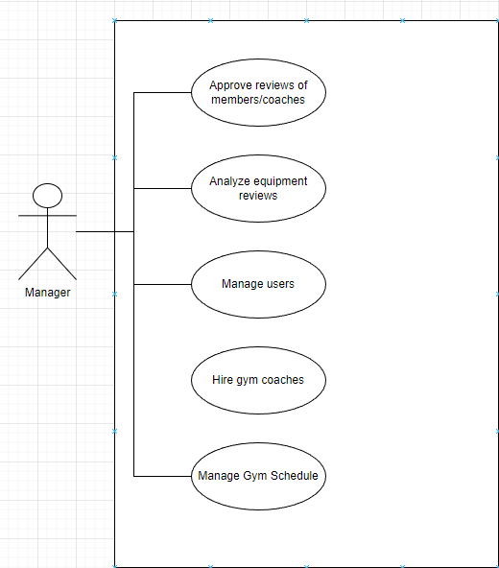

# Use case diagram member/manager

4.3 Use Case Extended

| **Use Case(UC_1.1):** | Choose membership |
| --- | --- |
| Scope: | Gym App |
| Level: | User level |
| Intention Context: | Member chooses the membership which suits him/her best |
| Minimum Guarantees: | Member chooses the membership but cannot proceed to transaction |
| Success Guarantees: | Member chooses the membership and the transaction is processed successfully |
| Primary actor: | Member |
| Stakeholders Interest: | To have users who know and use the application for the necessary app services |
| Precondition: | The member must be logged in |

| **Use Case(UC_1.2):** | Buy from online shop |
| --- | --- |
| Scope: | Gym App |
| Level: | User level |
| Intention Context: | Member chooses the training equipments, supplements etc. which he/she likes |
| Minimum Guarantees: | Member chooses the items but cannot proceed to transaction |
| Success Guarantees: | Member chooses the items and the transaction is processed successfully |
| Primary actor: | Member |
| Stakeholders Interest: | Browsing of items will be easier, and the members only have to pick them up on their gym |
| Precondition: | The member must be logged in |

| **Use Case(UC_1.3):** | Set up appointment with their coach |
| --- | --- |
| Scope: | Gym App |
| Level: | User level |
| Intention Context: | Member sets up an appointment with his/her coach if he wants help with his training. |
| Minimum Guarantees: | Member sets up an appointment but the coach doesn’t approve |
| Success Guarantees: | Member sets up an appointment and has training with the coach |
| Primary actor: | Member |
| Stakeholders Interest: | A quick way to interact with the coach |
| Precondition: | The member must be logged in |

| **Use Case(UC_1.4):** | Review a course after finishing it |
| --- | --- |
| Scope: | Gym App |
| Level: | User level |
| Intention Context: | Member reviews a course he/she has finished it |
| Minimum Guarantees: | Member reviews the course but it isn’t approved by the admin |
| Success Guarantees: | Member reviews the course but it is displayed on the purses review section |
| Primary actor: | Member |
| Stakeholders Interest: | Each course gets a rating based on its performance and helps the admin to choose which one need to be improved |
| Precondition: | The member must be logged in |

| **Use Case(UC_1.5):** | Chat with coach/customer service within the app |
| --- | --- |
| Scope: | Gym App |
| Level: | User level |
| Intention Context: | Member chats with coach if he/she needs help with something |
| Minimum Guarantees: | Member sends a message to the coach but they don’t reply |
| Success Guarantees: | Member sends a message and the coach replies successfully |
| Primary actor: | Member |
| Stakeholders Interest: | Gives the app more personality by providing the customers the ability to chat through it |
| Precondition: | The member must be logged in |

| **Use Case(UC_1.6):** | Watch videos from catalog |
| --- | --- |
| Scope: | Gym App |
| Level: | User level |
| Intention Context: | Member is provided videos to introduce them to a course |
| Minimum Guarantees: | The videos do not play |
| Success Guarantees: | Videos are displayed and play successfully |
| Primary actor: | Member |
| Stakeholders Interest: | Helps the member to choose whatever course he likes |
| Precondition: | The member must be logged in |

| **Use Case(UC_2.1):** | Create and publish their own courses |
| --- | --- |
| Scope: | Gym App |
| Level: | User level |
| Intention Context: | Coach creates and publishes his own videos so different members can choose |
| Minimum Guarantees: | The course cannot be published |
| Success Guarantees: | The course is published successfully on the app |
| Primary actor: | Gym Coach |
| Stakeholders Interest: | Member has more choices on course selection |
| Precondition: | The gym coach must be logged in |

| **Use Case(UC_2.2):** | Decline/Accept customer course |
| --- | --- |
| Scope: | Gym App |
| Level: | User level |
| Intention Context: | Coach can decline or accept a customized member plan based on his availability |
| Minimum Guarantees: | Coach cannot decline or accept the plan |
| Success Guarantees: | Coach successfully sends back his decision to the member |
| Primary actor: | Gym Coach |
| Stakeholders Interest: | Coach is in charge of his work time |
| Precondition: | The gym coach must be logged in |

| **Use Case(UC_2.3):** | Create custom plan based on member availability |
| --- | --- |
| Scope: | Gym App |
| Level: | User level |
| Intention Context: | Coach can create a plan for a member based on his/her details |
| Minimum Guarantees: | Coach cannot create the custom plan |
| Success Guarantees: | Coach successfully creates a custom plan for the member |
| Primary actor: | Gym Coach |
| Stakeholders Interest: | Member can have a custom plan advised from a professional gym coach |
| Precondition: | The gym coach must be logged in |

| **Use Case(UC_2.4):** | Review equipment/recommend new equipment |
| --- | --- |
| Scope: | Gym App |
| Level: | User level |
| Intention Context: | Coach can view the equipment around the gym and request for replacement if needed. |
| Minimum Guarantees: | Coach cannot publish his review/request |
| Success Guarantees: | Coach successfully publishes his request/review for new equipment |
| Primary actor: | Gym Coach |
| Stakeholders Interest: | Gyms will have working and great equipment all the time |
| Precondition: | The gym coach must be logged in |

| **Use Case(UC_2.5):** | Report member / cancel ongoing course |
| --- | --- |
| Scope: | Gym App |
| Level: | Manager level |
| Intention Context: | A coach can report a member based on their behavior during a course |
| Minimum Guarantees: | Coach cannot report member |
| Success Guarantees: | Coach successfully reports a specified member and waits for approval from manager |
| Primary actor: | Gym Coach |
| Stakeholders Interest: | Whenever a client is not respecting the gym rules he/she should be banned |
| Precondition: | The gym coach must be logged in |

| **Use Case(UC_3.1):** | Approve reviews / reports (from both members and coaches) |
| --- | --- |
| Scope: | Gym App |
| Level: | Manager level |
| Intention Context: | Manager will review the reviews and see if they are valid or not |
| Minimum Guarantees: | Member and coach reviews do not display |
| Success Guarantees: | The reviews and reports are displayed and the manager takes action |
| Primary actor: | Gym Manager |
| Stakeholders Interest: | The reviews are updated by the manager |
| Precondition: | The gym manager must be logged in |

| **Use Case(UC_3.2):** | Order new equipment |
| --- | --- |
| Scope: | Gym App |
| Level: | Manager level |
| Intention Context: | The manager will order the damaged equipment which were requested by the gym coaches |
| Minimum Guarantees: | A replacement for the equipment cannot be found |
| Success Guarantees: | The manager successfully replaces the damaged equipment |
| Primary actor: | Gym manager |
| Stakeholders Interest: | The equipment are always functional and new |
| Precondition: | The gym coach must be logged in |

| **Use Case(UC_3.3):** | Manage members |
| --- | --- |
| Scope: | Gym App |
| Level: | Manager level |
| Intention Context: | The manager will see the reviews and will decide if a member needs to be banned or not |
| Minimum Guarantees: | The manager is unable to ban a member from the gym |
| Success Guarantees: | The manager can ban or unban a certain member |
| Primary actor: | Gym manager |
| Stakeholders Interest: | The social environment of the gym will be healthy and energetic |
| Precondition: | The gym coach must be logged in |

| **Use Case(UC_3.4):** | Manage coaches and their courses |
| --- | --- |
| Scope: | Gym App |
| Level: | Manager level |
| Intention Context: | Manger will review coach application and their courses and decide who to hire |
| Minimum Guarantees: | The applications cannot display |
| Success Guarantees: | Applications are displayed and manager decides who to hire |
| Primary actor: | Gym manager |
| Stakeholders Interest: | The gym coach accounts are verified by the manager, and their profile is activated after the manager confirms it. |
| Precondition: | The gym coach must be logged in |

| **Use Case(UC_3.5):** | Manage gym schedule |
| --- | --- |
| Scope: | Gym App |
| Level: | Manager Level |
| Intention Context: | The manager may close the gym for a specific occasion or reason |
| Minimum Guarantees: | Manager closes the gym and the notification is not sent to all gym users |
| Success Guarantees: | Manager closes the gym and the notification is sent to all gym users |
| Primary actor: | Gym manager |
| Stakeholders Interest: | The manager can notify members of the gym before closing it |
| Precondition: | The gym coach must be logged in |

| **Use Case(UC_3.6):** | Manage income/expenses |
| --- | --- |
| Scope: | Gym App |
| Level: | User level |
| Intention Context: | Manager generates different reports for income and expenses |
| Minimum Guarantees: | Manager cannot generate reports. |
| Success Guarantees: | Manager can access the reports |
| Primary actor: | Gym manager |
| Stakeholders Interest: | The manager keeps track of how the gym economy is doing |
| Precondition: | The gym coach must be logged in |

4.4 BPMN Diagrams

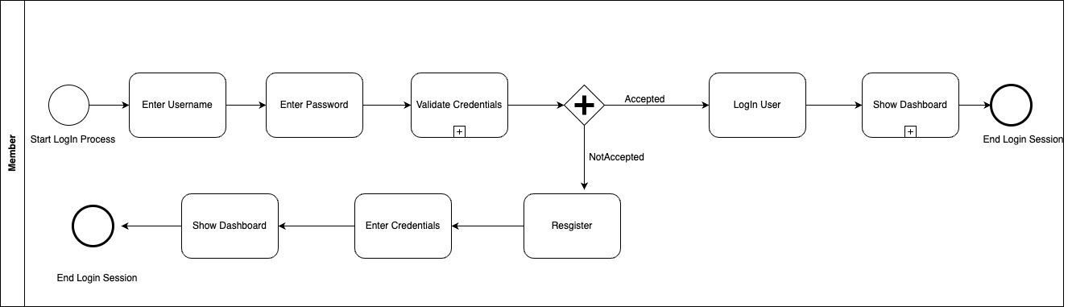

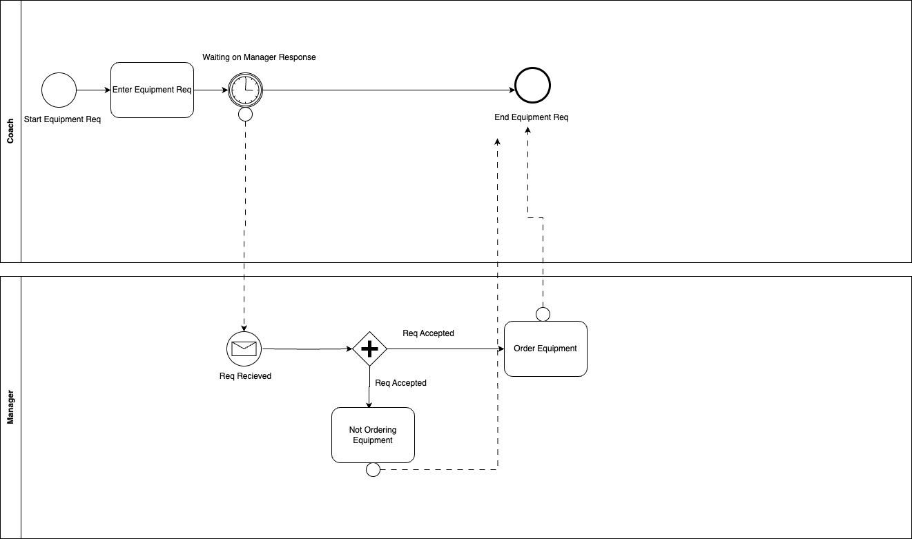

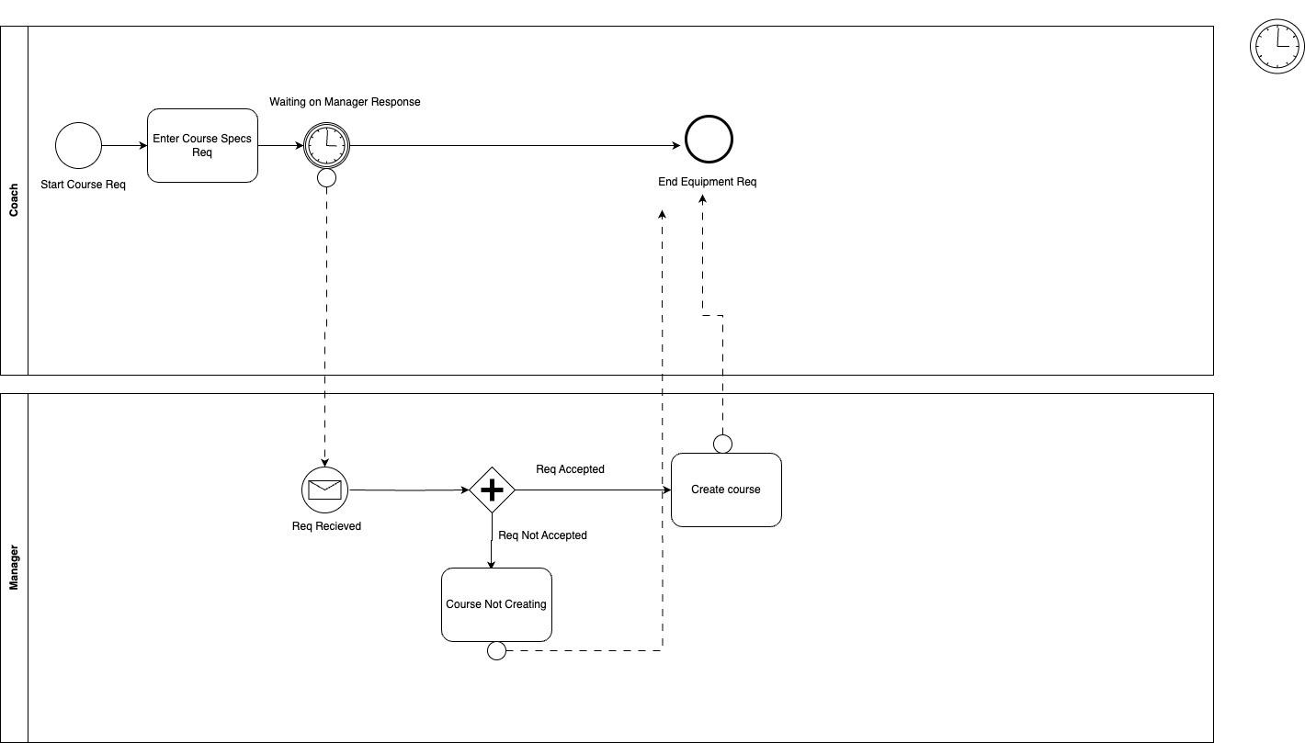

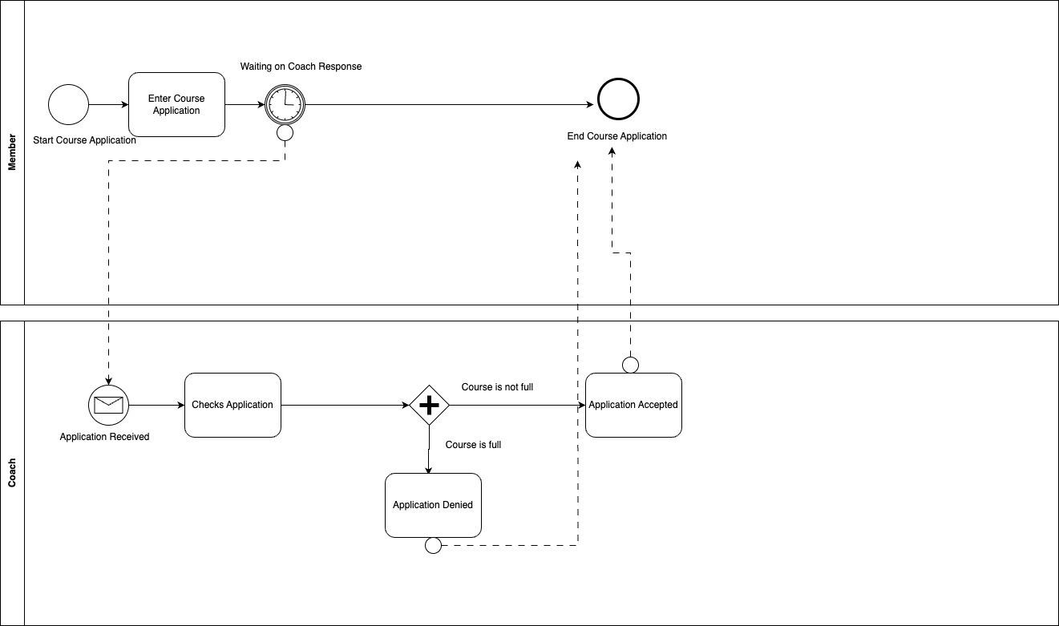

4.5 Data Flow Diagrams

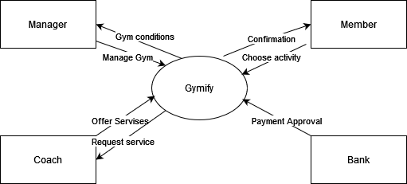

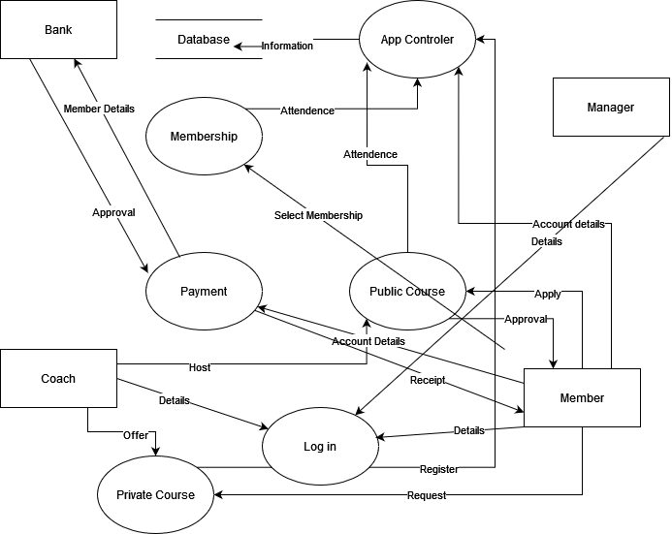

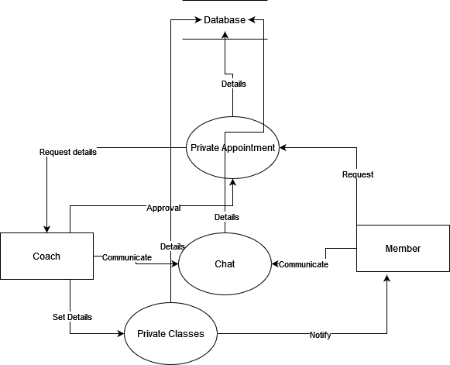

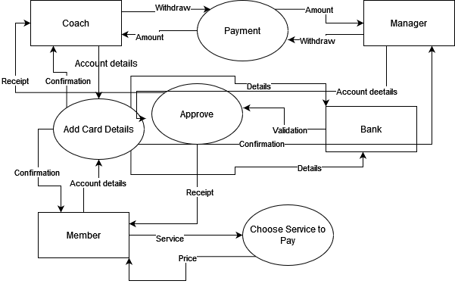

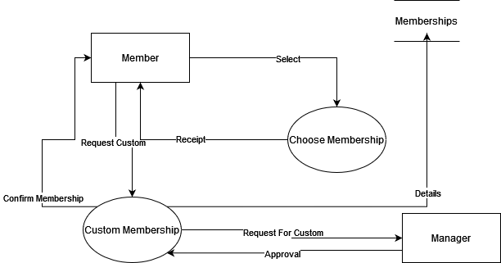

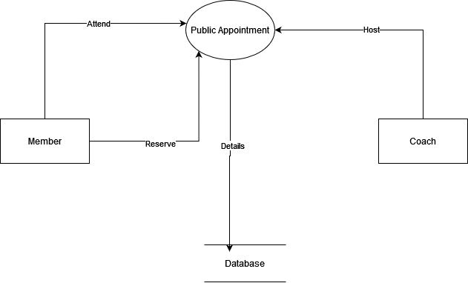

4.6 ERD / RS Diagram

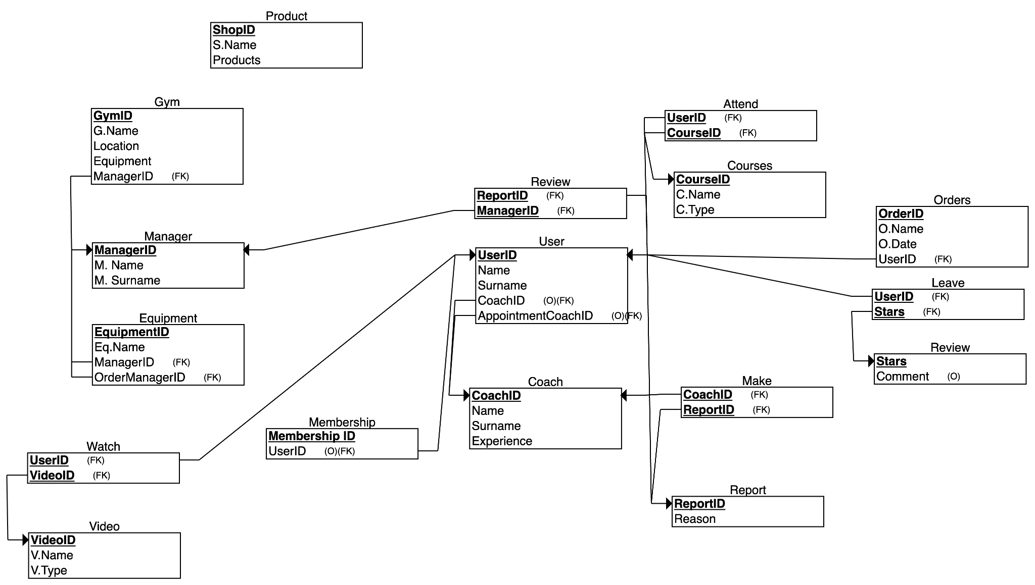

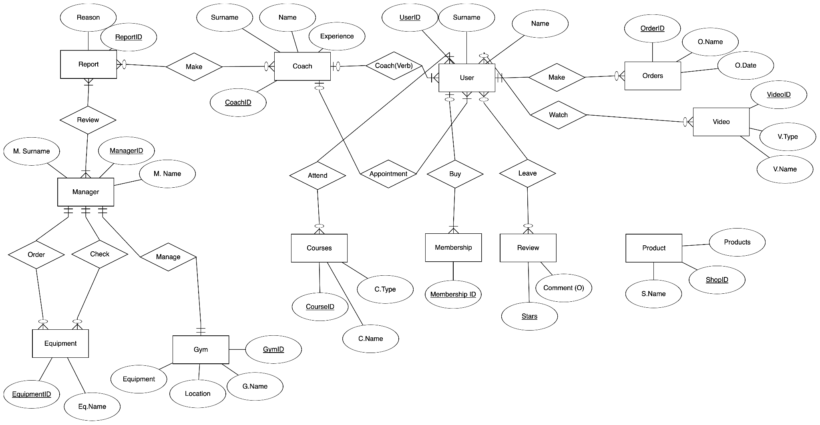

4.7 ACTIVITY DIAGRAMS

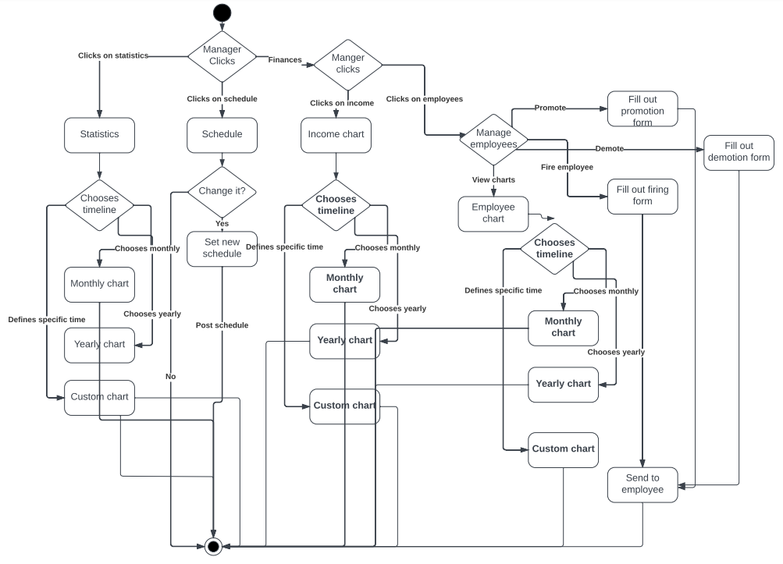

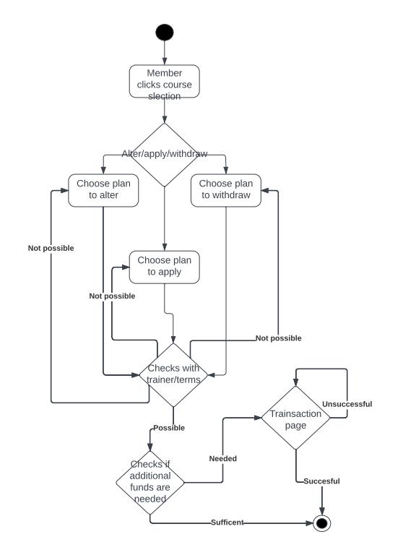

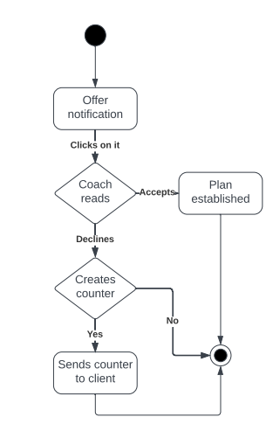

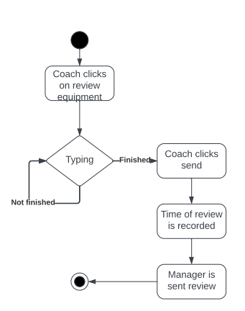

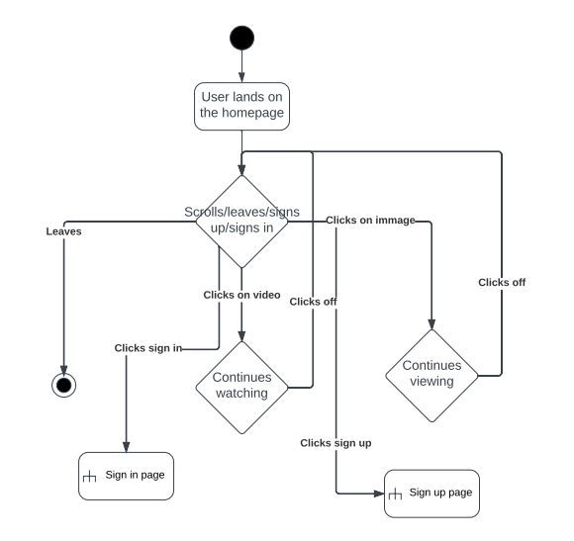

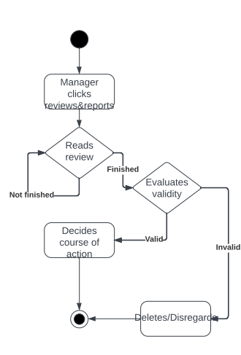

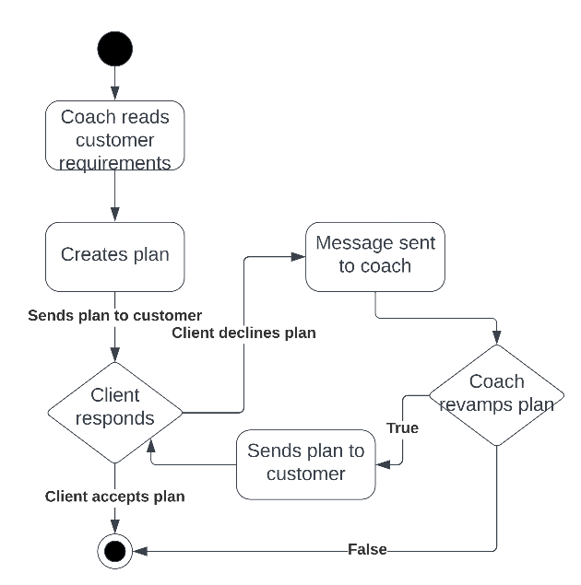

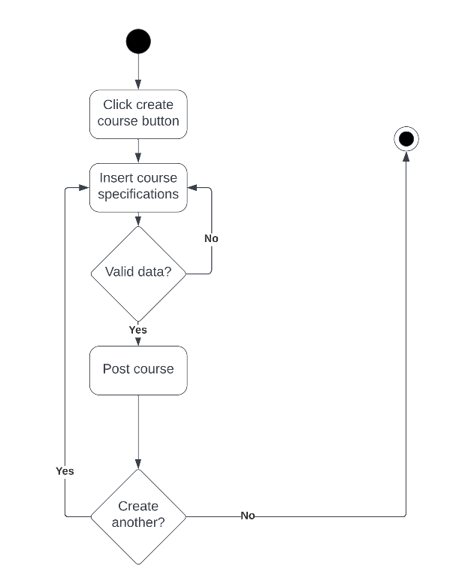

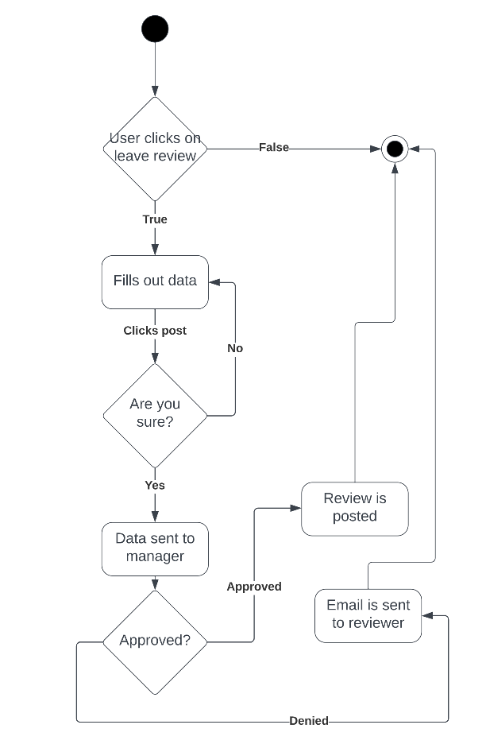

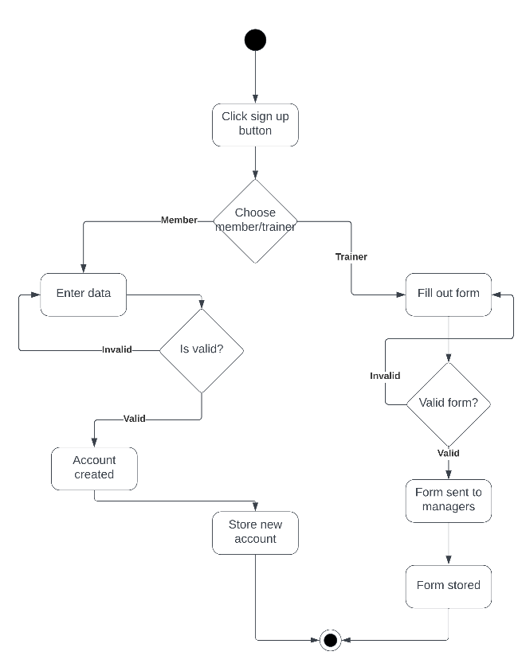

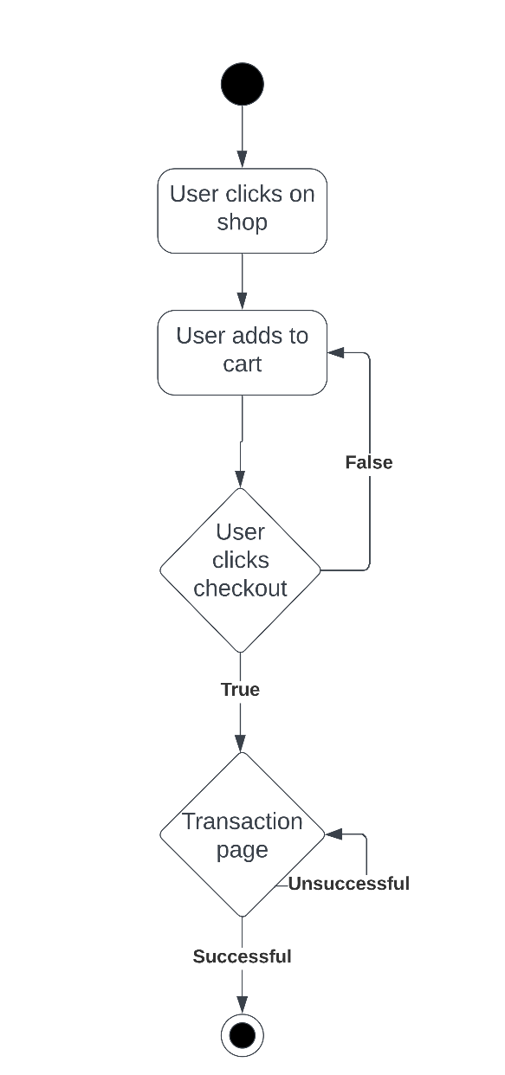

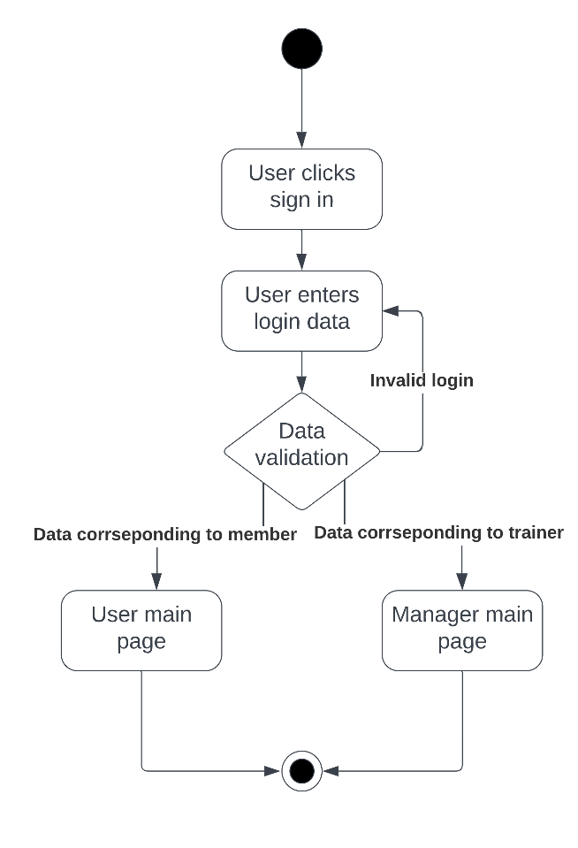

4.9 STATE DIAGRAMS

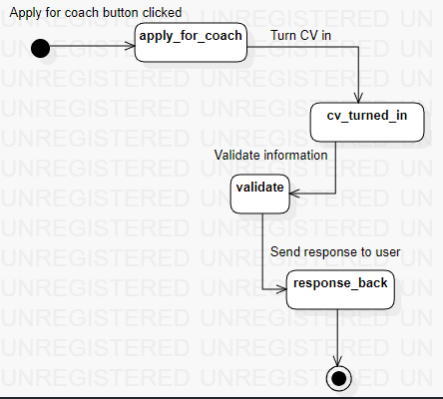

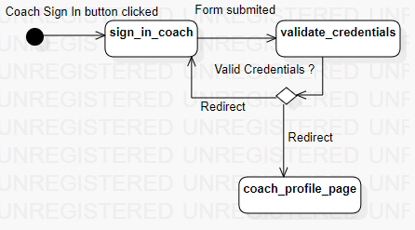

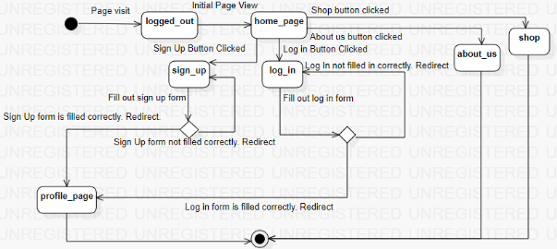

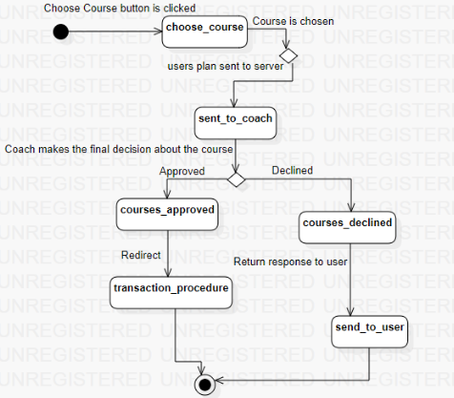

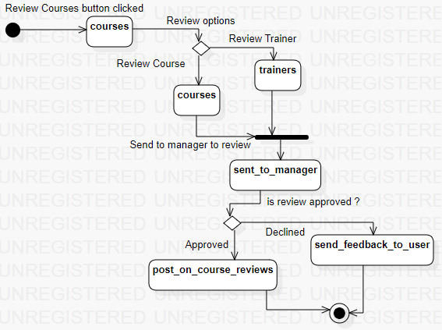

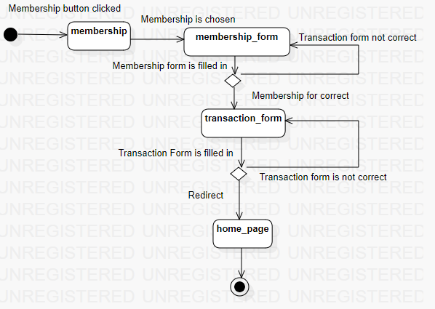

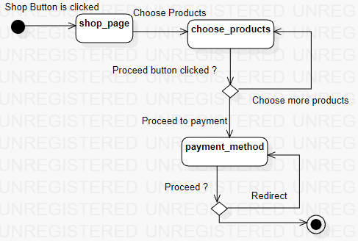

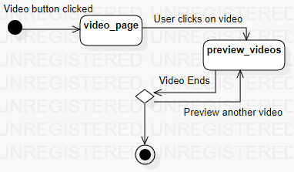

4.10 SEQUENCE DIAGRAMS

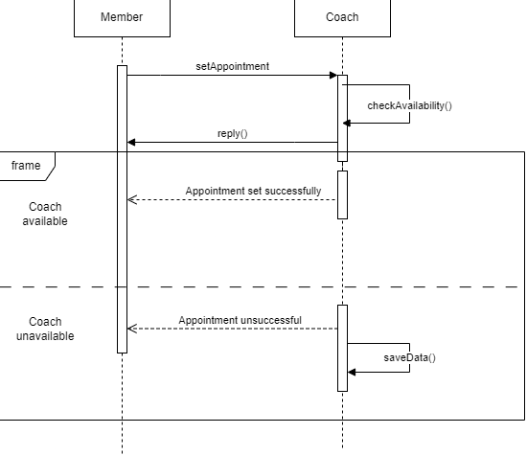

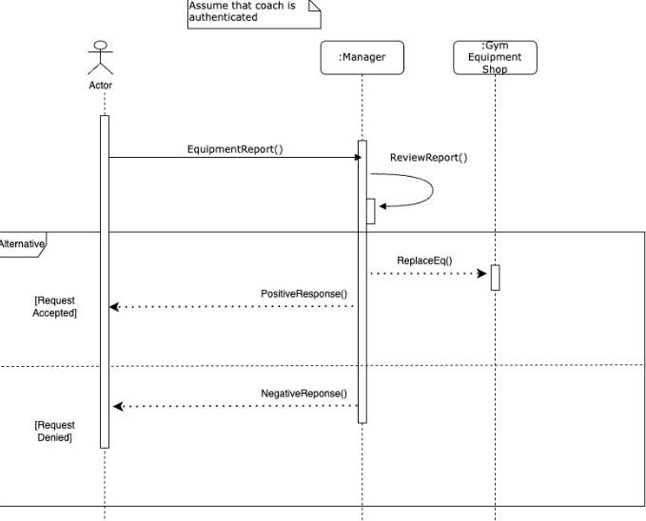

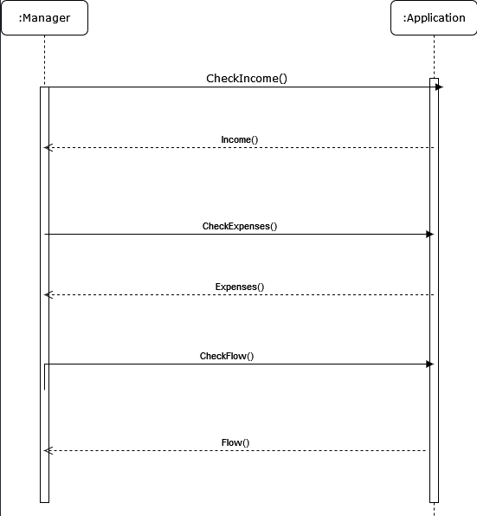

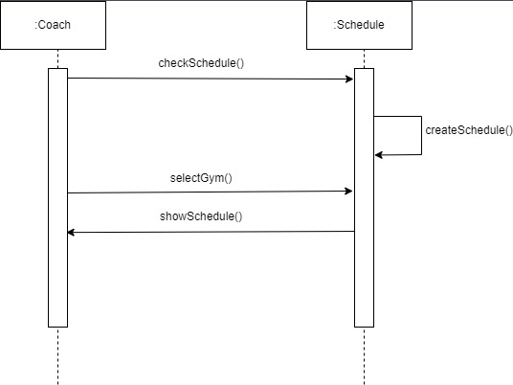

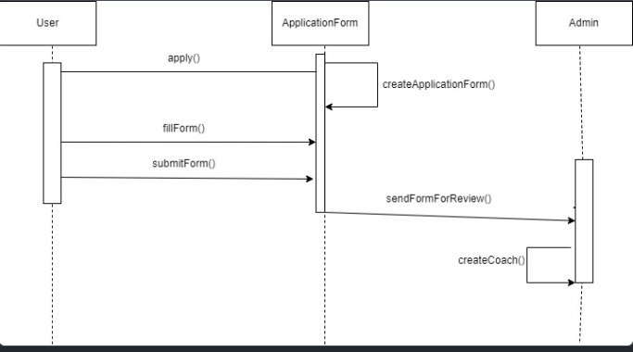

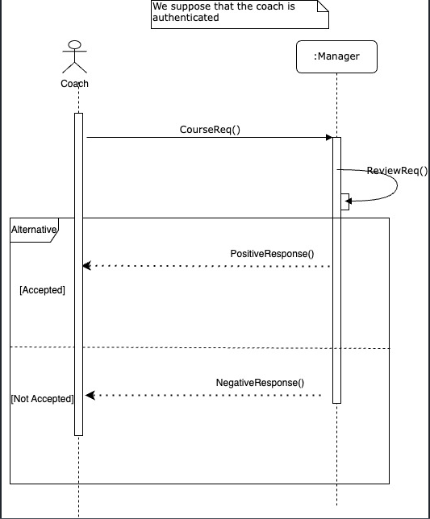

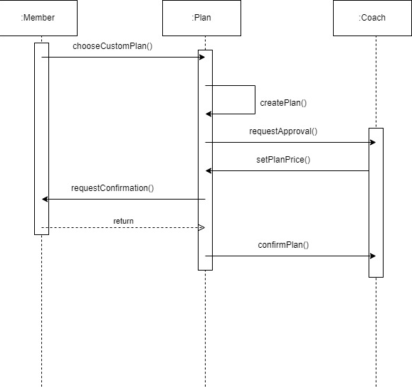

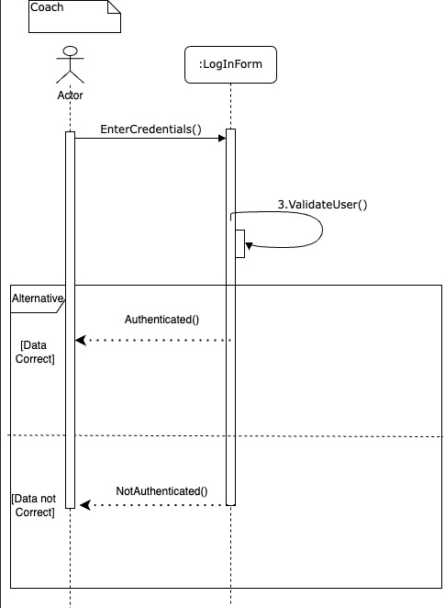

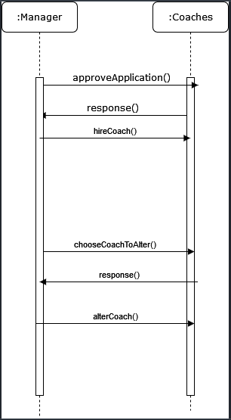

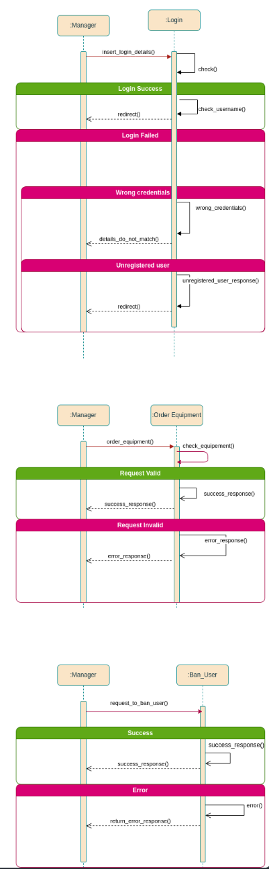

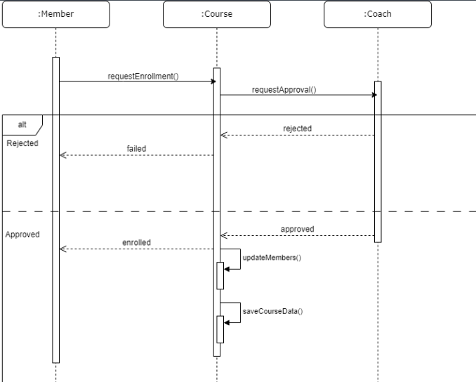

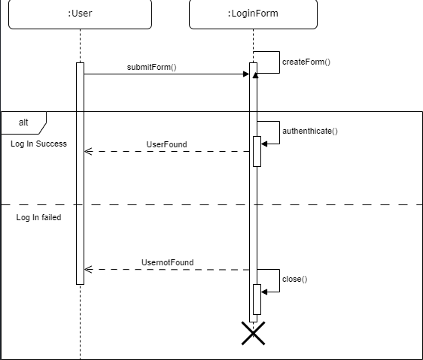

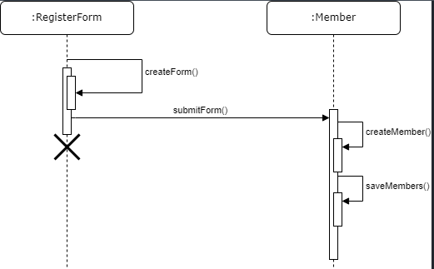

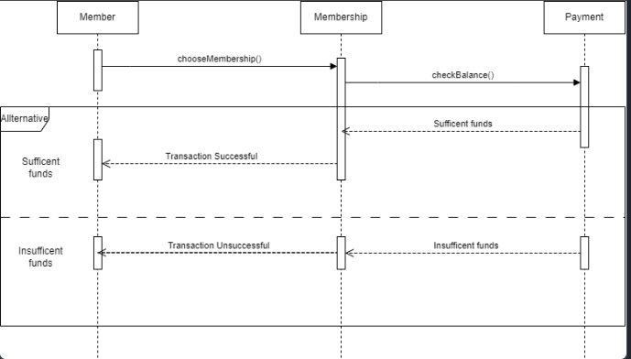

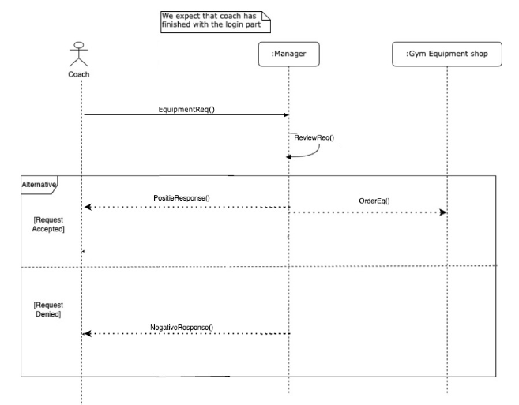

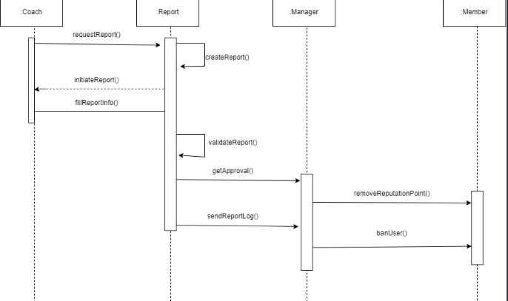

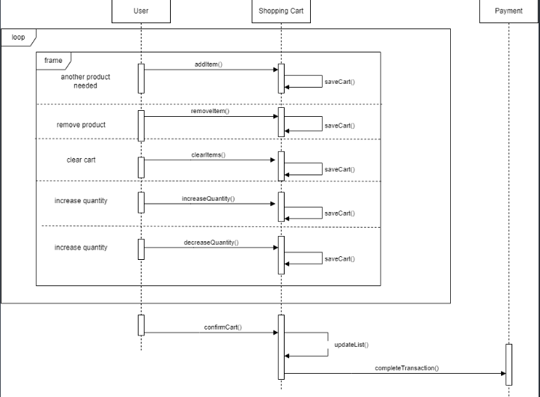

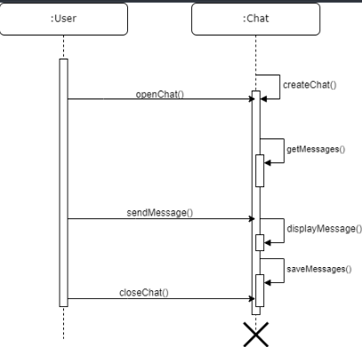

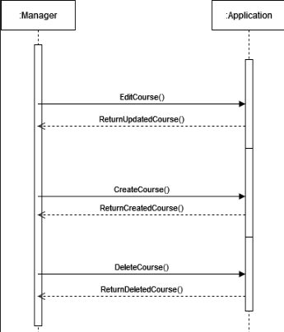

4.11 COLLABORATION DIAGRAMS

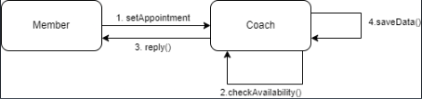



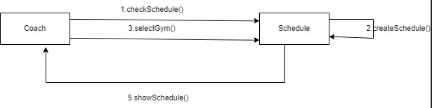

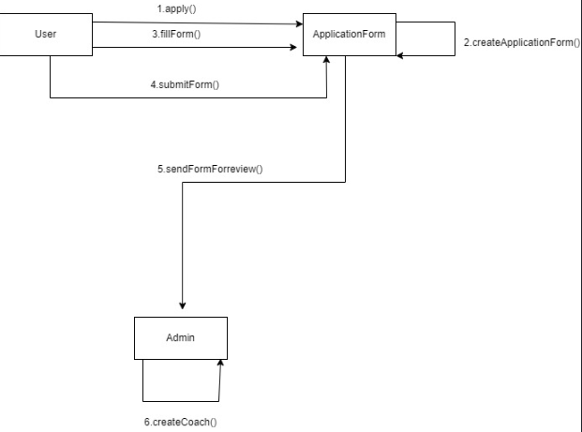

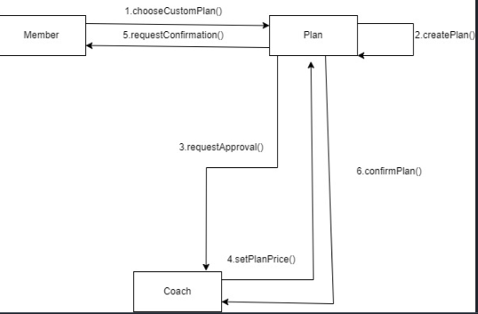

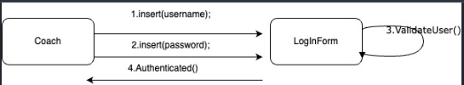

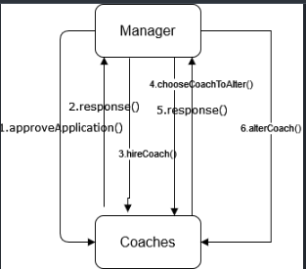

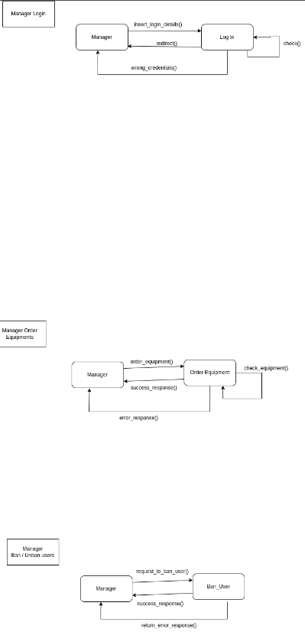

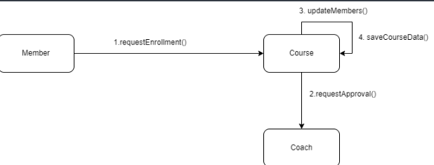

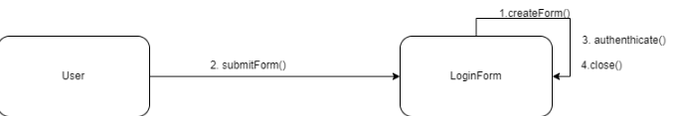

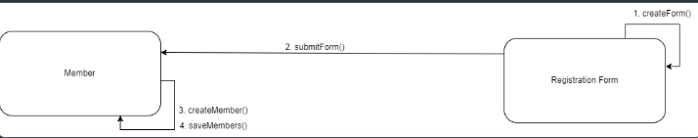



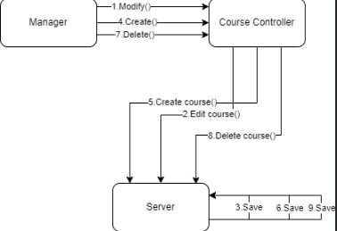

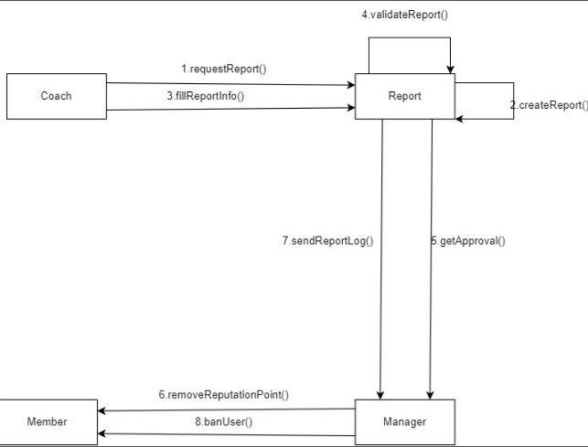

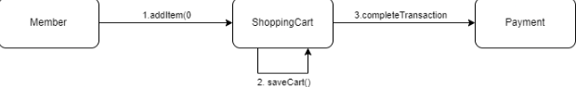

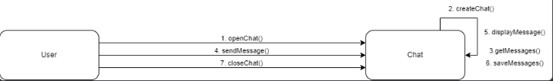

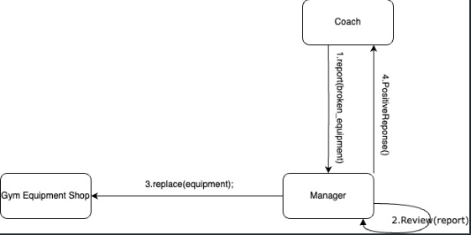

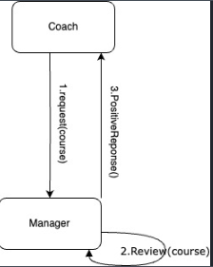



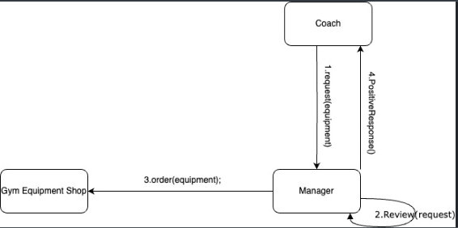

4.12 CLASS DIAGRAM

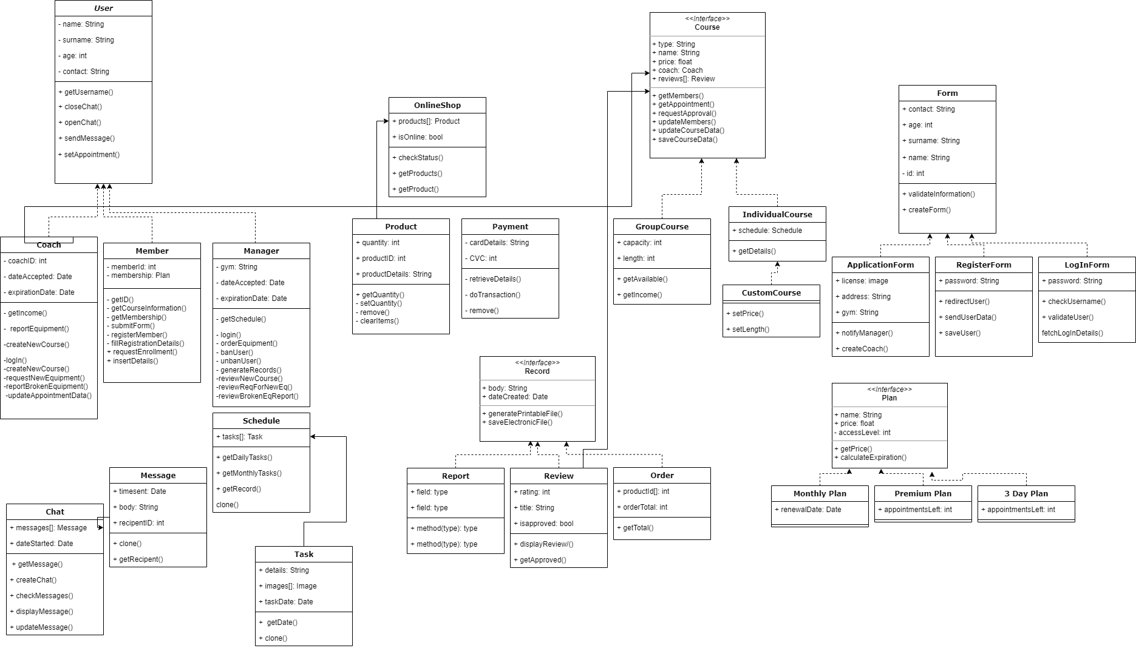

# 5. Design Patterns

1.FACTORY - The Factory design pattern provides a way to create objects without exposing the object creation logic to the client. In the Gymify application, we can utilize the Factory pattern to create instances of the Course class, representing the courses given by private coaches. The CourseFactory class acts as the factory responsible for creating instances of the Course class. The CourseFactory class contains a static method create_course() that accepts the course name and coach as parameters. This method encapsulates the creation logic and returns a new instance of the Course class with the provided details.

2.SINGLETON - The Singleton pattern ensures a class has only one instance and provides a global point of access to it. In the GYMIFY application, we can implement the Singleton Design Pattern for the Database class to ensure there is only one instance responsible for managing the gym-related data and operations. The _instance variable keeps track of the single instance of the Database class. The get_instance() method provides a global point of access to this instance. When get_instance() is called, it either returns the existing instance or creates a new instance if it doesn't exist yet. This approach ensures that all parts of the application that require access to the gym-related data will use the same instance of the Database class, preventing multiple instances and ensuring consistent data management. To use the Database class in GymApplication, you can retrieve the instance by calling Database.get_instance(). Then, you can perform various operations such as saving gym data, retrieving gym data by ID, and deleting gym data using the methods provided by the Database class.

3.DECORATOR - The Decorator design pattern allows you to add additional functionality to an object dynamically without modifying its structure. In the GYMIFY application, we can apply the Decorator pattern to enhance the Product and Order classes, where an Order can act as a decorator for a Product by adding extra features or information. The Product class represents a basic product with properties such as name and price. The Order class serves as a decorator for a Product object. It enhances the product by adding additional functionality or information. To utilize the Decorator pattern in GymApplication, you can create a Product object and then wrap it with an Order decorator to add shipping information.

4.PROTOTYPE - The Prototype pattern enables the creation of new objects by cloning existing objects. To implement the Prototype Design Pattern in GymApplication, we can use a GymPrototype interface with a clone() method. Gym objects can implement this interface and provide a mechanism to create new instances by cloning themselves.

