**Classification**

As a first step, try building a classifier that uses the provided pre-extracted features. Next, try creating a set of your own features. Finally, examine the errors you're making and see what you can do to improve.

Submissions will be evaluated using the multi-class logarithmic loss. Each sample has been labeled with one true species. For each sample, you must submit a set of predicted probabilities (one for every species). The formula is then,

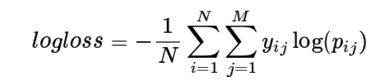

Where *N* is the number of samples in the test set, *M* is the number of classes (species labels), log() is the natural logarithm,  is 1 if sample  is in class  and 0 otherwise,  is the predicted probability that sample  belongs to class .

**Regression**

For each sample, predict the value of *loss* based on the input 100 features. Submissions are scored on the root mean squared error. RMSE is defined as:

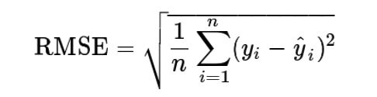

Where  is the predicted value,  is the ground truth value, and n is the number of rows in the test data.

**Submission File**

For each row id in the test set, you must predict the value of the target *loss*, each on a separate row in the submission file.