

**Instituto Politécnico Nacional**

**Escuela Superior de Computo**

Arquitectura de Computadoras.

Archivo de Registros.

“Implementación y pruebas.”

Profesor: García Ortega Víctor Hugo.

Grupo: 3CM3

Integrantes:

* García Martinez Kevin
* Piña Hernández Luis Enrique

19 de enero de 2021.

**Simulación.  
Gráfica de simulación.**

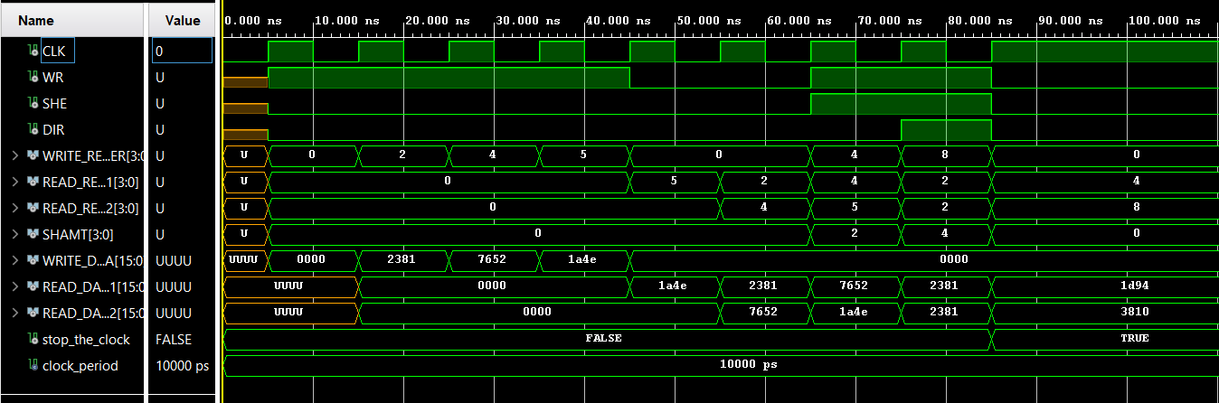

**Resultados:**

|  |  |  |  |  |  |  |  |  |  |  |
| --- | --- | --- | --- | --- | --- | --- | --- | --- | --- | --- |
| Prueba | RR1 | RR2 | SHAMT | WREG | WD | WR | SHE | DIR | RD1 | RD2 |
| **1** | 0 | 0 | 0 | 0 | 0x0000 | 1 | 0 | 0 | Undefined | Undefined |
| **2** | 0 | 0 | 0 | 2 | 0x2381 | 1 | 0 | 0 | 0x000 | 0x000 |
| **3** | 0 | 0 | 0 | 4 | 0x7652 | 1 | 0 | 0 | 0x000 | 0x000 |
| **4** | 0 | 0 | 0 | 5 | 0x1A4E | 1 | 0 | 0 | 0x000 | 0x000 |
| **5** | 5 | 0 | 0 | 0 | 0x0000 | 0 | 0 | 0 | 0x1A4E | 0x000 |
| **6** | 2 | 4 | 0 | 0 | 0x0000 | 0 | 0 | 0 | 0x2381 | 0x7652 |
| **7** | 4 | 5 | 2 | 4 | 0x0000 | 1 | 1 | 0 | 0x7652 | 0x1A4E |
| **8** | 2 | 2 | 4 | 8 | 0x0000 | 1 | 1 | 1 | 0x2381 | 0x2381 |
| **9** | 4 | 8 | 0 | 0 | 0x0000 | 0 | 0 | 0 | 0x1D94 | 0x3810 |

Tabla de recursos:

|  |  |  |  |
| --- | --- | --- | --- |
| Recurso | Usado | Disponible | Porcentaje utilizado |
| No. de LUT's | 100 | 63400 | 0.16 |
| No. De FF's | - | - | - |
| No. De Slices | - | - | - |
| No. De RAM's de un puerto | - | - | - |
| No. de RAM's de dos puertos | - | - | - |

Dispositivo usado: xc7a100tcsg324-1

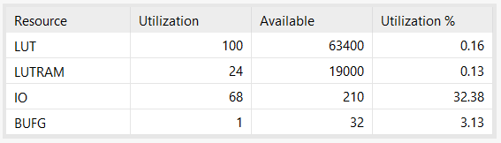  
Figura 2. Recursos usados para la implementación