1.When to use (Rapid Application Development) RAD model & When not to use (Rapid Application Development) RAD model

Rapid Application Development can be used when

- there’s high availability of designers
- budget is high enough
- there is a need to produce the system in a short span of time
- only if resources with high business knowledge are available
- System can be modularised
- Quality is not an issue

Rapid Application Development should not be used when

- no highly skilled developers/designers are available
- budget is low
- High quality software is required
- There is a lot of time to develop a efficient software

3. Describe the Entity Relationships for the following diagram
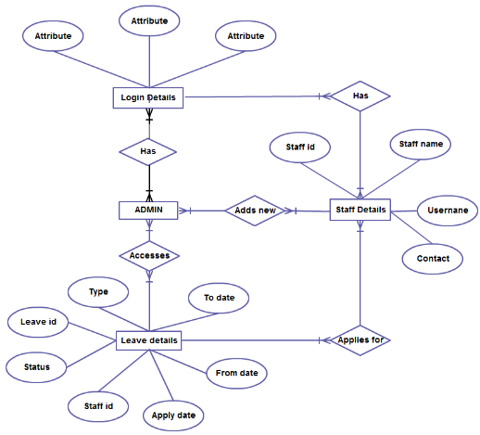
- One or more Admin have their own login details
- One or more Admin can access leave details
- One or more Admin can add new Staff and their details
- One or more Staff have their own login details
- One or more staff can apply for leave

Each staff has
- Staff id
- Staff name
- Username
- Contact
- Login details

Leave details consists of
- Type
- leave id
- Status
- From date
- To date
- Staff id
- Apply date

Project management Team
Has
Software Organisation
id
city
place
address
id
Project name
Tasks
Has
Has
Development Team
Quality Team
Testing Team
Has
id
Testing tools
id
Analysis
project
Project
id
Project
Works on
Project
Softwares
2. Define an ER diagram of a software Organization with all the relationship model that was discussed in the classroom

