PROBLEM 1

  - Design Problem

When quantity of cash store or drink store is changed by controller using the machinery panel, cash/drink quantity on maintenance panel is not updated automatically.

When drink price is changed by maintainer using the maintenance panel, drink brand price on customer panel is not updated automatically

After customer purchases a drink, the cash/drink store quantity is not updated automatically on maintenance/machinery panel

  - Candidate Design Patterns

- Observer Pattern
Define a one-to-many dependency between objects where a state change in one object results in all its dependents being notified and updated automatically.

- Mediator Pattern
Define an object that encapsulates how a set of objects interact. Mediator promotes loose coupling by keeping objects from referring to each other explicitly, and it lets you vary their interaction independently.

  - Motivation

The mediator pattern can be used when we have cases of complex cases of many subjects and many observers

The observer pattern handles the communication between observers and subjects or subject. It's very probable to have new observable objects added. Decouples subject and observers.

  - Structure

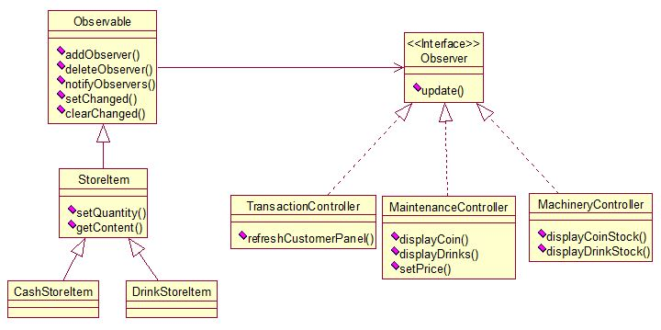

  - Collaborations

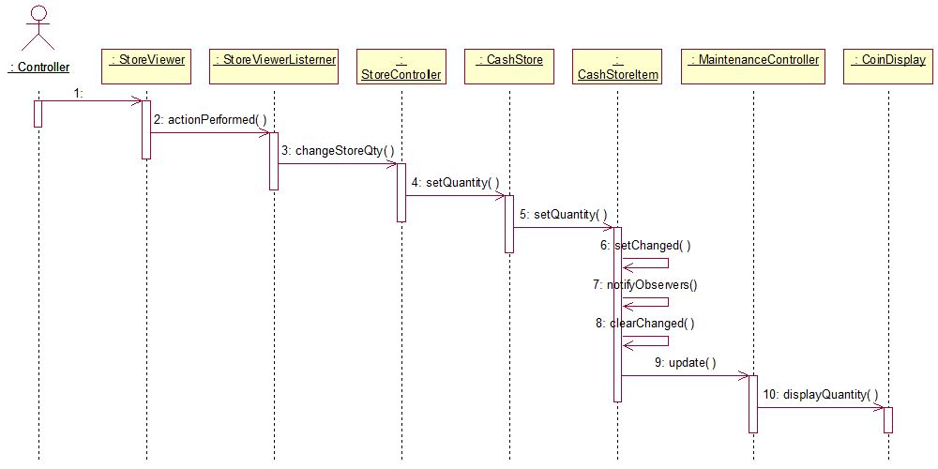

  - Implementation Decisions

    - Mapping subjects to their observers: using an associative look-up (eg. Hash table) to reduce storage.

    - Observing more than one subject: Extend the Update interface to let observer know which subject is sending the notification.

    - Who trigger the updates? : Use state-settings on subject call because the client don’t need to remember to call notify in order to reduce the code complicity.

    - Dangling references to deleted subjects: To avoid, make subject notify its observers as it’s deleted.

    - Making sure Subject state is self-consistent before notification: Document which subject trigger notifications instead of using Template Method.

    - Avoiding observer-specific update protocols: Push mode, the subject sends observers detailed information in order to make it more efficient.

    - Specifying modifications of interest explicitly: Extend the subject’s registration interface using notion of aspects, subject only informs the observers that registered interest in that event. Eg. Void Update(Subject *, Aspect&interest).

    - Encapsulating complex update semantics: Change Manager object using Mediator and Singleton. Since we only have one observer and less than five subject so far, there is no need to implement this yet.

    - Combining the subject and observer classes: Avoid multiple inheritance, put mostly all interface in subjects STORE. The observer only has Constructor/Destructor/Update functions.

PROBLEM 2

  - Design Problem

Description

  - Candidate Design Patterns

- State Pattern
Define a one-to-many dependency between objects where a state change in one object results in all its dependents being notified and updated automatically.

- Strategy Pattern
Define a family of algorithms, encapsulate each one, and make them interchangeable. Strategy lets the algorithm vary independently from clients that use it.

  - Motivation

The mediator pattern can be used when we have cases of complex cases of many subjects and many observers

The observer pattern handles the communication between observers and subjects or subject. It's very probable to have new observable objects added. Decouples subject and observers.

  - Structure

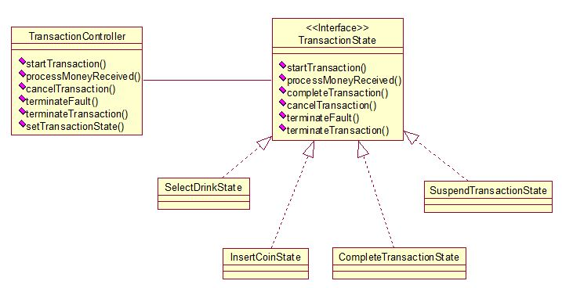

  - Collaborations

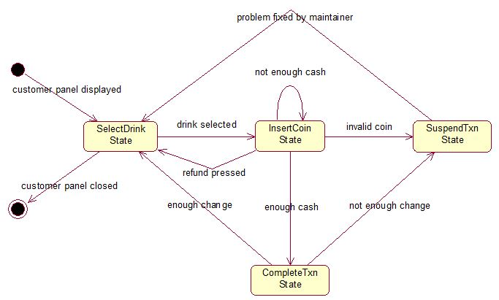

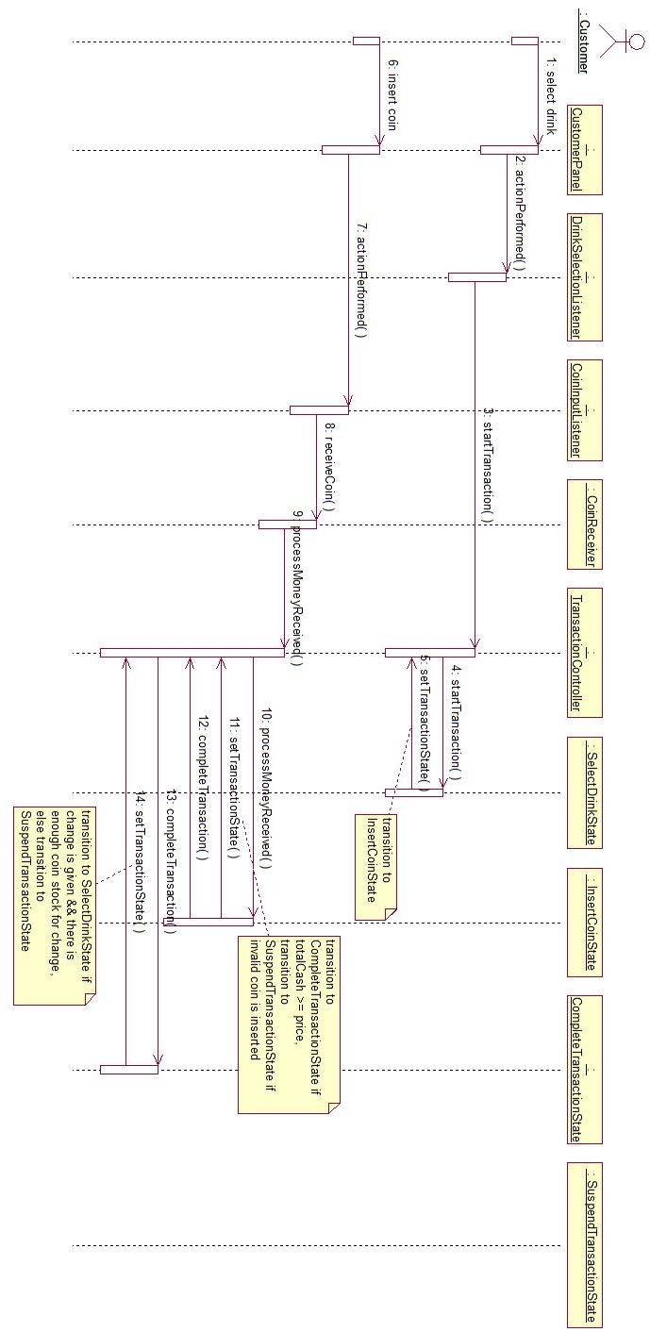

  - Implementation Decisions

    - impl1
    - impl2

PROBLEM 3

  - Design Problem

Description

  - Candidate Design Patterns

- Bridge Pattern
Decouple an abstraction from its implementation allowing the two to vary independently.

- Abstract Factory Pattern
Provide an interface for creating families of related or dependent objects without specifying their concrete classes.

  - Motivation

The mediator pattern can be used when we have cases of complex cases of many subjects and many observers

The observer pattern handles the communication between observers and subjects or subject. It's very probable to have new observable objects added. Decouples subject and observers.

  - Structure

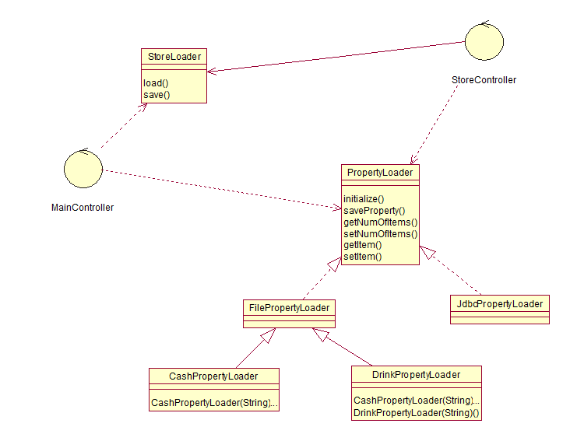

  - Collaborations

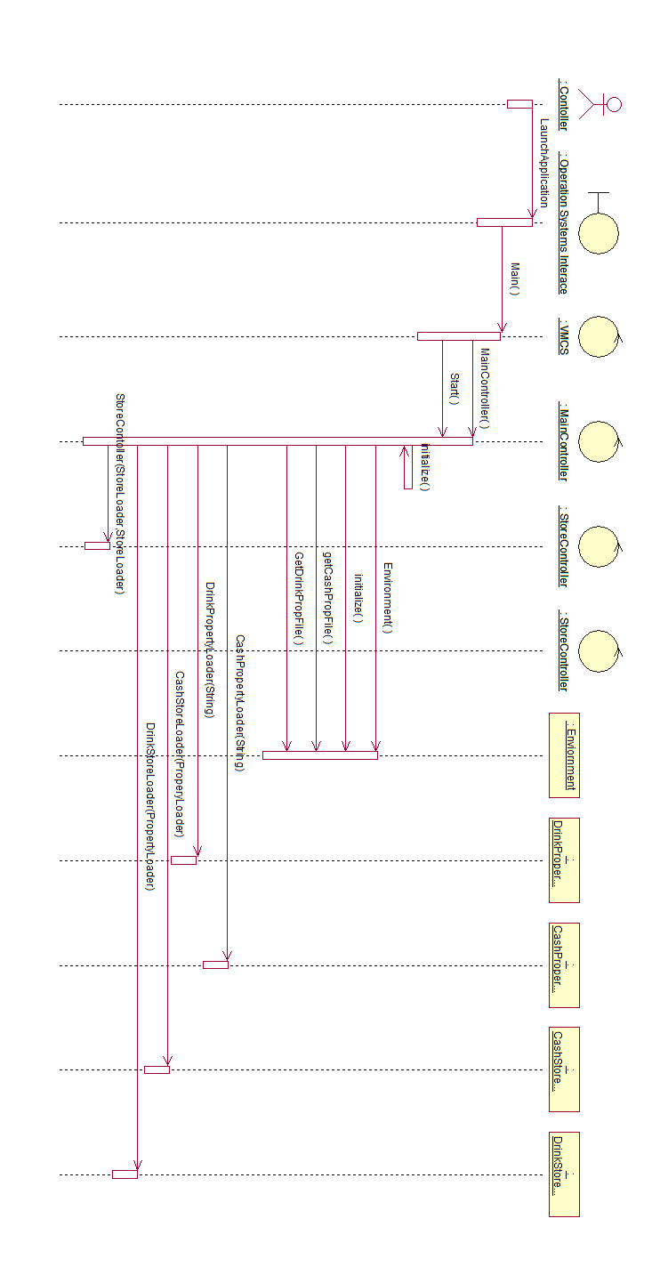

  - Implementation Decisions

    - impl1
    - impl2

PROBLEM 4

  - Design Problem

Description

  - Candidate Design Patterns

- Abstract Factory Pattern
Provide an interface for creating families of related or dependent objects without specifying their concrete classes.

- Abstract Factory Pattern
Define an object that encapsulates how a set of objects interact. Mediator promotes loose coupling by keeping objects from referring to each other explicitly, and it lets you vary their interaction independently.

  - Motivation

The mediator pattern can be used when we have cases of complex cases of many subjects and many observers

The observer pattern handles the communication between observers and subjects or subject. It's very probable to have new observable objects added. Decouples subject and observers.

  - Structure

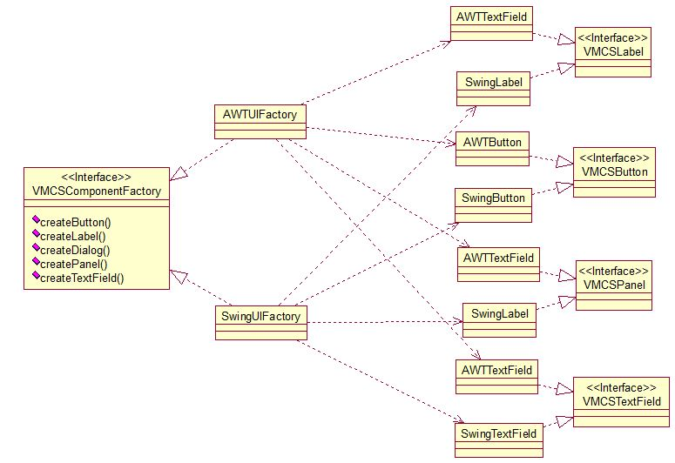

  - Collaborations

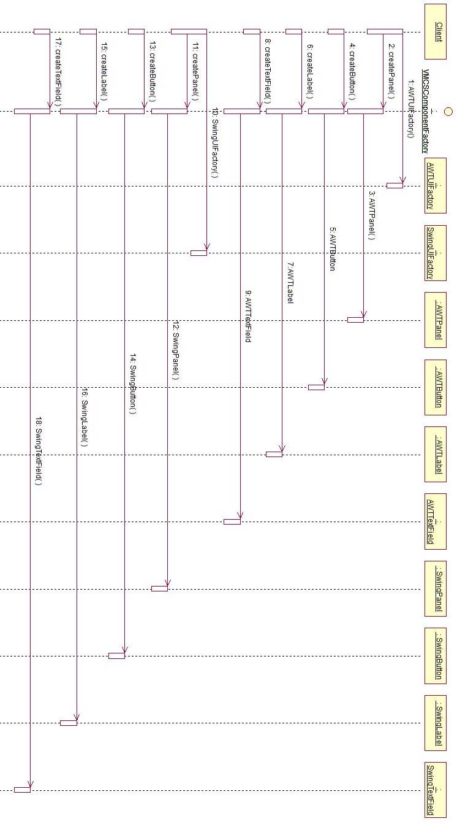

  - Implementation Decisions

    - impl1
    - impl2

PROBLEM 5
  - Design Problem

Description

  - Candidate Design Patterns

- Factory Method Pattern
Define an interface for creating a single object, but let subclasses decide which class to instantiate. Factory Method lets a class defer instantiation to subclasses.

- Abstract Factory Pattern
Define an object that encapsulates how a set of objects interact. Mediator promotes loose coupling by keeping objects from referring to each other explicitly, and it lets you vary their interaction independently.

  - Motivation

The mediator pattern can be used when we have cases of complex cases of many subjects and many observers

The observer pattern handles the communication between observers and subjects or subject. It's very probable to have new observable objects added. Decouples subject and observers.

  - Structure

  - Collaborations

  - Implementation Decisions

    - impl1
    - impl2

