VMCS with a New Perspective
SE-OODP Continuous Assessment

SE21 Part-Time Team 3
Chen Hao (A0107679R)
Chong Wenchang ()
Han Kai (A0092701M)
Wang Jiqin (A0107596W)
Xiong Gaogao (A0015118U)
Zhang Shizhen (A0107583A)

Table of Contents

PROBLEM 1 3
PROBLEM 2 7
PROBLEM 3 11
PROBLEM 4 15
PROBLEM 5 19
PROBLEM 6 22

PROBLEM 1

  - Design Problem

Update of cash/drink store quantity is not reflected immediately on VMCS panels i.e. Maintenance Panel, Machinery Panel and Customer Panel. The user must manually close and reopen, refresh, or click on a button to get the updated quantity value.

- When quantity of cash store or drink store is changed by controller using the machinery panel, cash/drink quantity on maintenance panel is not updated automatically.
- When drink price is changed by maintainer using the maintenance panel, drink brand price on customer panel is not updated automatically
- After customer purchases a drink, the cash/drink store quantity is not updated automatically on maintenance/machinery panel

  - Candidate Design Patterns

- Observer Pattern
Define a one-to-many dependency between objects where a state change in one object results in all its dependents being notified and updated automatically.

- Mediator Pattern
Define an object that encapsulates how a set of objects interact. Mediator promotes loose coupling by keeping objects from referring to each other explicitly, and it lets you vary their interaction independently.

  - Motivation

Observer Pattern is chosen.

- The mediator pattern can be used when we have complex cases of many subjects and many observers.

- The observer pattern handles the communication between observers and subjects or subject. It's very probable to have new observable objects added.

- It decouples the subject and the observers.

  - Structure

Participants
Subject: |  | Observable
Concrete Subject: |  | StoreItem
Observer: |  | Observer
Concrete Observer: |  | TransactionController, MaintenanceController,  MachineryController

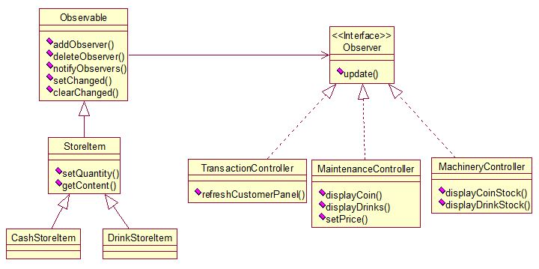

  - Collaborations

The sequence diagram below shows the flow of events when:
- The controller modifies the stock quantity of coins
- The quantity of coins displayed on the Maintenance Panel is updated automatically

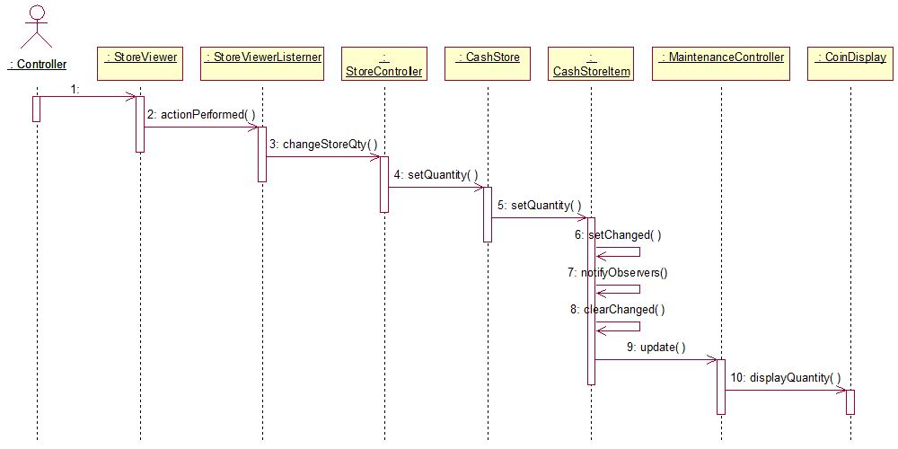

  - Implementation Decisions

    - Mapping subjects to their observers: using an associative look-up (eg. Hash table) to reduce storage.

    - Observing more than one subject: Extend the Update interface to let observer know which subject is sending the notification.

    - Who trigger the updates? : Use state-settings on subject call because the client does not need to remember to call notify in order to reduce the code complicity.

    - Dangling references to deleted subjects: To avoid, make subject notify its observers as it’s deleted.

    - Making sure Subject state is self-consistent before notification: Document which subject trigger notifications instead of using Template Method.

    - Avoiding observer-specific update protocols: Push mode, the subject sends observers detailed information in order to make it more efficient.

    - Specifying modifications of interest explicitly: Extend the subject’s registration interface using notion of aspects, subject only informs the observers that registered interest in that event. e.g. Void Update (Subject *, Aspect & interest).

    - Encapsulating complex update semantics: Change Manager object using Mediator and Singleton. Since we only have one observer and less than five subjects so far, there is no need to implement this yet.

    - Combining the subject and observer classes: Avoid multiple inheritance, put mostly all interface in subjects STORE. The observer only has Constructor/Destructor/Update functions.

PROBLEM 2

  - Design Problem

Operations (user triggered events) should be handled differently, when the transaction is at different stages. The current design mixes the controller operations at different stages of transaction. If a new transaction state is to be introduced, or the order of existing states to be altered (insert coins first, then select drink brand, versus select drink brand first, then insert coins), all transaction related methods in the TransactionController has to be modified, thus violating the Open Close Principle.

  - Candidate Design Patterns

- State Pattern
Allow an object to alter its behavior when its internal state changes. The object will appear to change its class.

- Strategy Pattern
Define a family of algorithms, encapsulate each one, and make them interchangeable. Strategy lets the algorithm vary independently from clients that use it.

  - Motivation

State Pattern is chosen.

Strategy is a bind-once pattern, whereas State is more dynamic.

The implementation of the State pattern builds on the Strategy pattern. The difference between State and Strategy is in the intent. With Strategy, the choice of algorithm is fairly stable. With State, a change in the state of the “context” object causes it to select from its “palette” of Strategy objects.

  - Structure

Participants
Context: |  | TransactionController
State: |  | TransactionState
Concrete State: |  | SelectDrinkState, InsertCoinState,  CompleteTransactionState, SuspendTransactionState
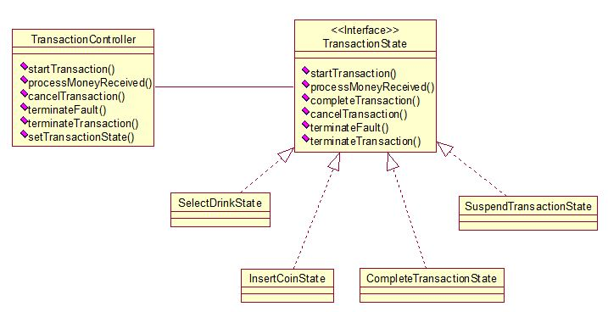

  - Collaborations
    - Transition between states
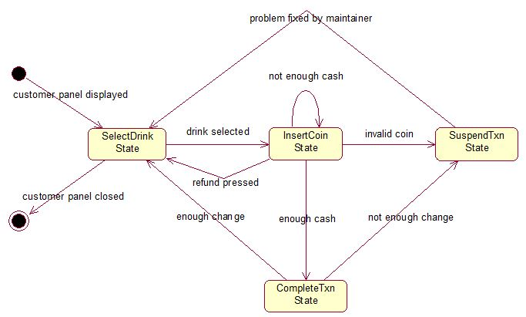

    - Sequence diagram
The sequence diagram below shows the flow of events when:
- the customer selects a drink brand
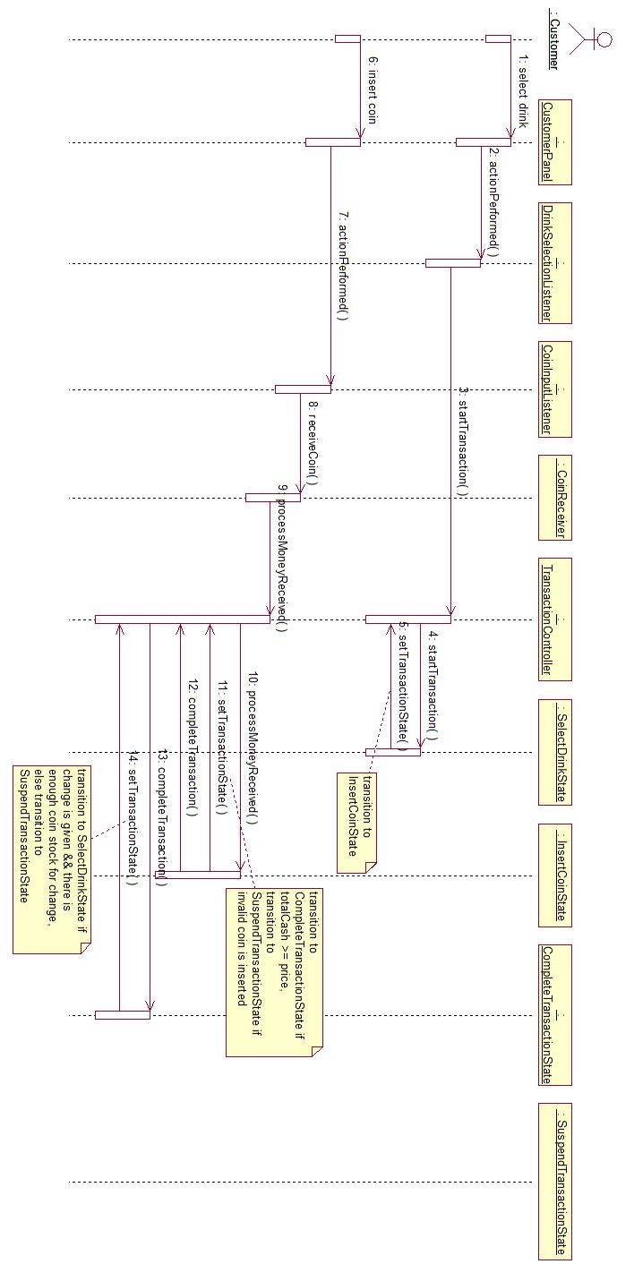
- the customer then inserts coins
- the vending machine dispenses drink can and gives changes

  - Implementation Decisions

    - Who defines the state transitions?
The State subclasses themselves define the transition, which is more flexible and appropriate as compared to defining transition criteria in the Context. An interface to set the context’s current state is provided.

    - A table-based alternative?
For our implementation, table based state diagram is not needed since the state change is not so complex.

    - Creating and destroying State objects?
We use the second way by creating the States ahead of time until garbage collector destroys them, as the state change occurs rapidly.

    - Using dynamic inheritance?
We’re not using it since Java doesn’t specifically support this behavior.

PROBLEM 3

  - Design Problem

In the current design, the implementation of the loading of property file is tightly coupled to flat file. If in future, the requirement changes and XML or database is to be used for storing property values, the loaders code will have to be modified. In order to make it possible to flexibly add new loading mechanisms, the abstraction and the implementation of the loading process need to be separated.

  - Candidate Design Patterns

- Bridge Pattern
Decouple an abstraction from its implementation allowing the two to vary independently.

- Adaptor Pattern
Convert the interface of a class into another interface clients expect. An adapter lets classes work together that could not otherwise because of incompatible interfaces.

- Abstract Factory Pattern
Provide an interface for creating families of related or dependent objects without specifying their concrete classes.

  - Motivation

Bridge Pattern is chosen.

- Adapter makes things work after they’re designed; Bridge makes them work before they are.

- Bridge is designed up-front to let the abstraction and the implementation vary independently. Adapter is retrofitted to make unrelated classes work together.

- If interface classes delegate the creation of their implementation classes (instead of creating/coupling themselves directly), then the design usually uses the Abstract Factory pattern to create the implementation objects.

  - Structure

Participants
Abstraction: |  | StoreLoader
Refined Abstraction: |  | CashPropertyLoader, DrinkPropertyLoader
Implementor: |  | PropertyLoader
Concrete Implementor: |  | FilePropertyProperty, JdbcPropertyLoader

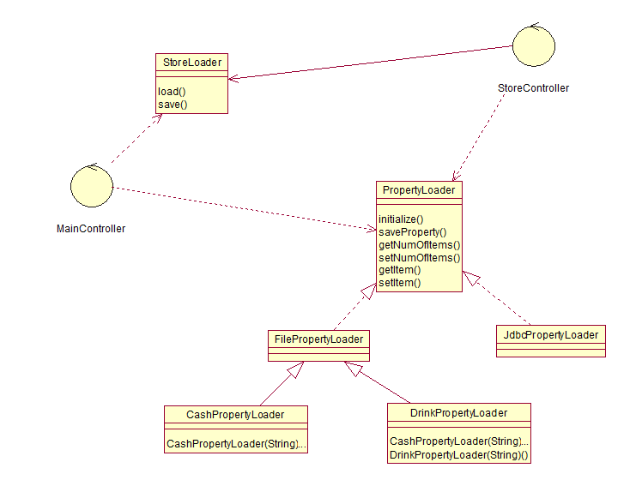

  - Collaborations
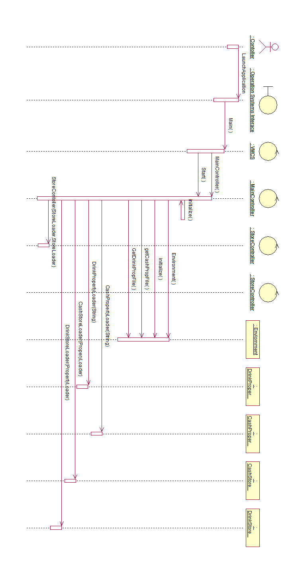

  - Implementation Decisions

    - Although in this vmcs application, it is highly possible that we only need to implement one property file system, say txt file for example. But it will still be better if we use bridge design pattern to do a separation for the exact implementation of property file system and the abstracted interfaces, because when some specific changed need to be made on the property file readings, we only need to re-link the whole system rather than re-compile the whole system.

    - When this vmcs system is designed to be deployed on different platforms, on the implementation side we use a parameter in the constructor to decide which platform interfaces should be used, in other words, we will choose the correct implementer dynamically. In this case, the abstract factory pattern also can be applied.

PROBLEM 4

  - Design Problem

In the current design, the creation of UI components, i.e. Panels, Buttons, Labels, TextFields, Dialogs, Frames, is tightly coupled with business logic code, i.e. the Controllers. If the VMCS is to be ported to and executed under other operation system other than Windows, The UI code and the Controllers will have to be rewritten. A mechanism or framework is needed to allow switching of UI by simply updating the configuration file.

  - Candidate Design Patterns

- Abstract Factory Pattern
Provide an interface for creating families of related or dependent objects without specifying their concrete classes.

- Builder Pattern
Separate the construction of a complex object from its representation allowing the same construction process to create various representations.

- Prototype Pattern
Specify the kinds of objects to create using a prototypical instance, and create new objects by copying this prototype.

  - Motivation

Abstract Factory Pattern is chosen.

Abstract Factory, Builder, and Prototype define a factory object that’s responsible for knowing and creating the class of product objects, and make it a parameter of the system.
- Prototype has the factory object (aka prototype) building a product by copying a prototype object.
- Builder has the factory object building a complex product incrementally using a correspondingly complex protocol.
- Abstract Factory has the factory object producing objects of several classes.
- Builder focuses on constructing a complex object step by step.
- Abstract Factory emphasizes a family of product objects (either simple or complex).
- Builder returns the product as a final step, but as far as the Abstract Factory is concerned, the product gets returned immediately.
  - Structure

Participants
Abstract Factory: |  | VMCSComponentFactory
Concrete Factory: |  | AWTUIFactory, SwingUIFactory
Abstract Product: |  | VMCSLabel, VMCSButton, VMCSPanel, VMCSTextField
Concrete Product: |  | AWTLabel, AWTButton, AWTPanel, AWTTextField,  SwingLabel, SwingButton, SwingPanel, SwingTextField

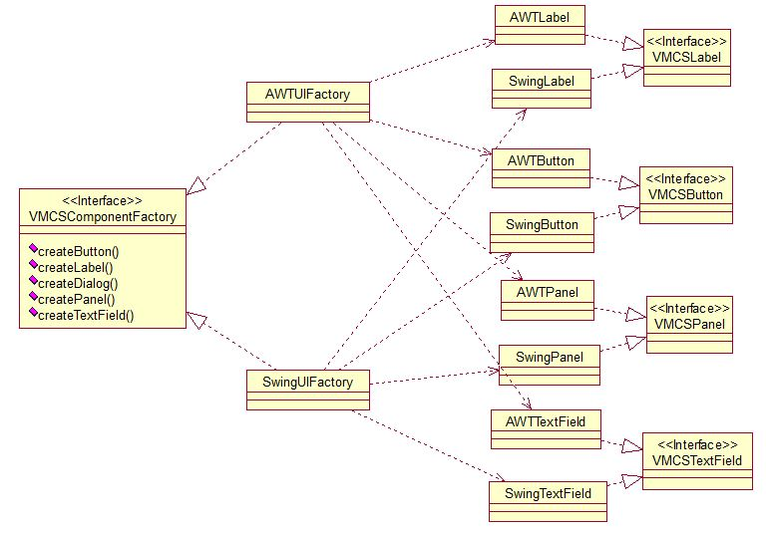

  - Collaborations

The sequence diagram below shows
- the creation of AWT family of UI components at program start-up, when uiFactory is set to AWTUIFactory in vmcs.properties, or alternatively,
- the creation of Swing family of UI components at program start-up, when uiFactory is set to SwingUIFactory in vmcs.properties

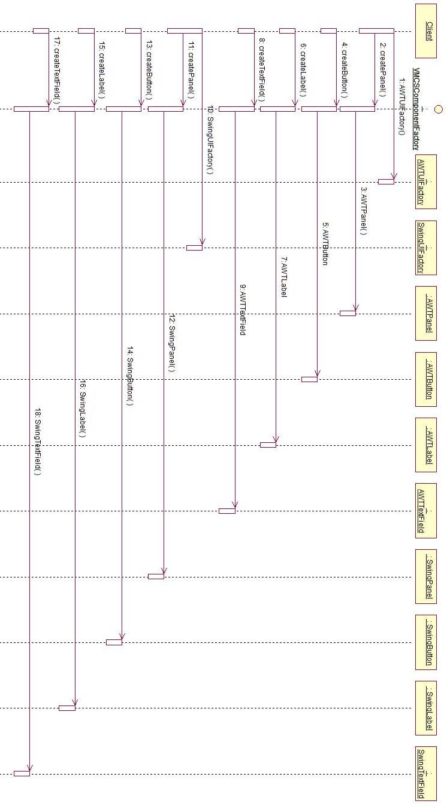

  - Implementation Decisions

    - Because for every single UI Factory, typically we only need one instance, we use singleton design pattern per UI factory.

    - For each UI factory, we can apply factory method pattern or prototype pattern. Since in this case, the UI components like buttons, labels, layouts, combox and images etc are different from each other, instead of the prototype design pattern, we will use factory method pattern to create each special UI component.

    - Adding a parameter to the UI component creation interfaces so that we can more easily to extend any other possible UI components.

PROBLEM 5
  - Design Problem

In the current design, all user panels i.e. CustomerPanel, MachineryPanel, MaintenancePanel consist a Panel showing coin items and a Panel showing drink items. Besides the exact layout of the store items, these panels are created and added to the container in similar ways. Thus, the similar code can be extracted and pulled into a common parent class, leaving only the creation of exact store items’ Panel to the subclass.

  - Candidate Design Patterns

- Factory Method Pattern
Define an interface for creating a single object, but let subclasses decide which class to instantiate. Factory Method lets a class defer instantiation to subclasses.

- Prototype Pattern
Specify the kinds of objects to create using a prototypical instance, and create new objects by copying this prototype.

- Abstract Factory Pattern
Define an object that encapsulates how a set of objects interact. Mediator promotes loose coupling by keeping objects from referring to each other explicitly, and it lets you vary their interaction independently.

  - Motivation

Factory Method Pattern is chosen.

- Factory Method: creation through inheritance, whereas Prototype: creation through delegation.
- Prototype doesn’t require subclassing, but it does require an Initialize operation. Factory Method requires subclassing, but doesn’t require Initialize.
- Often, designs start out using Factory Method (less complicated, more customizable, subclasses proliferate) and evolve toward Abstract Factory, Prototype, or Builder (more flexible, more complex) as the designer discovers where more flexibility is needed.

  - Structure

Participants
Creator: |  | VendingMachinePanel
Concrete Creator: |  | MachinerySimulatorPanel, CustomerPanel,  MaintenancePanel
Product: |  | Panel
Concrete Product: |  | StoreViewer, CoinInputBox, DrinkSelectionBox,  CoinDisplay, DrinkDisplay

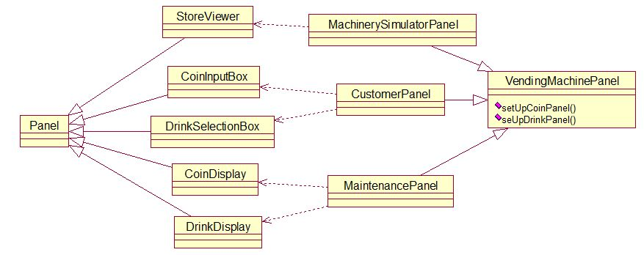

  - Collaborations

Sequence diagram below shows the creation of CoinInputBox and DrinkSelectionBox using factory method of CustomerPanel class.

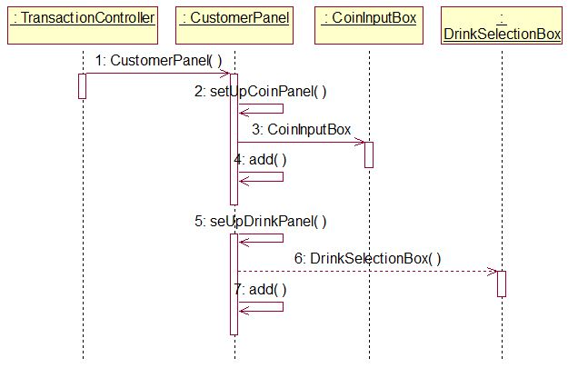

  - Implementation Decisions

    - Two Major Varieties? Creator class is abstract class or concrete class?
: The VendingMachinePanel and Panel from Java Library are all abstract classes; we are using first type that let subclasses define an implementation.

    - Parameterized factory methods.
: We don’t need to consider multiple instances for the vending machine project. For every panel, they’re unique and there is no need to provide a ProductID for panel creation.

    - Language-specific variants and issues
: We are not providing any language variant changes in VMCS project.

PROBLEM 6
  - Design Problem

The store items i.e. CashStore and DrinksStore are instantiated and initialized when the program starts. This process may become more expensive, as the size of the store grows with the application. Meanwhile, one and only one Store for each store type should exist at any time, in order to ensure to integrity of the store. The above issue is not addressed in the current design.

  - Candidate Design Patterns

- Singleton Pattern
Ensure a class has only one instance, and provide a global point of access to it.

- Prototype Pattern
Specify the kinds of objects to create using a prototypical instance, and create new objects by copying this prototype.

  - Motivation

The application requires one and only one instance of the store class, rather than copying the same existing instance.

  - Structure

Participants
Singleton: |  | CashStore, DrinksStore

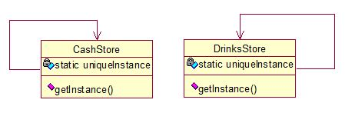
  - Collaborations

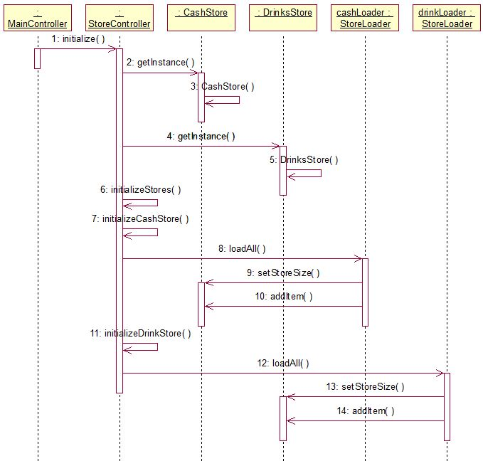
The sequence diagram below shows the instantiation and initialization of CashStore and DrinksStore.

  - Implementation Decisions

    - Ensuring a unique instance:

Java has a key word called “synchronized”, it can help to make sure the unique instance can be created. We are using “synchronized” so there is no need to hide NEW operations behind the class operation like C++.

    - Subclassing the Singleton class:

Since CASH STORE or DRINK STORE is not used by any other module, we are not defining any subclass for this singleton class.

