Bellabeat Analysis

Kevin Larkin

12/15/2021

#Loading libraries  
library(tidyverse)

## ── Attaching packages ─────────────────────────────────────── tidyverse 1.3.1 ──

## ✓ ggplot2 3.3.5 ✓ purrr 0.3.4  
## ✓ tibble 3.1.4 ✓ dplyr 1.0.7  
## ✓ tidyr 1.1.3 ✓ stringr 1.4.0  
## ✓ readr 2.0.1 ✓ forcats 0.5.1

## ── Conflicts ────────────────────────────────────────── tidyverse_conflicts() ──  
## x dplyr::filter() masks stats::filter()  
## x dplyr::lag() masks stats::lag()

library(lubridate)

##   
## Attaching package: 'lubridate'

## The following objects are masked from 'package:base':  
##   
## date, intersect, setdiff, union

library(tidyr)  
library(here)

## here() starts at /Users/kevinwlarkin/Desktop/Computer Skills Learning/Google Data Analytics/Course 8 _ Capstone/Bellabeat Case Study/Fitabase Data For Analyzing

library(skimr)  
library(janitor)

##   
## Attaching package: 'janitor'

## The following objects are masked from 'package:stats':  
##   
## chisq.test, fisher.test

library(vroom)  
library(ggthemes)  
  
  
# Loading intensity dataset  
intensity <- read_csv('hourlyIntensities_merged.csv')

## Rows: 22099 Columns: 4

## ── Column specification ────────────────────────────────────────────────────────  
## Delimiter: ","  
## chr (1): ActivityHour  
## dbl (3): Id, TotalIntensity, AverageIntensity

##   
## ℹ Use `spec()` to retrieve the full column specification for this data.  
## ℹ Specify the column types or set `show_col_types = FALSE` to quiet this message.

# Getting general overview of dataset and checking for empty cells  
skim_without_charts(intensity)

Data summary

|  |  |
| --- | --- |
| Name | intensity |
| Number of rows | 22099 |
| Number of columns | 4 |
| _______________________ |  |
| Column type frequency: |  |
| character | 1 |
| numeric | 3 |
| ________________________ |  |
| Group variables | None |

**Variable type: character**

|  |  |  |  |  |  |  |  |
| --- | --- | --- | --- | --- | --- | --- | --- |
| skim_variable | n_missing | complete_rate | min | max | empty | n_unique | whitespace |
| ActivityHour | 0 | 1 | 19 | 21 | 0 | 736 | 0 |

**Variable type: numeric**

|  |  |  |  |  |  |  |  |  |  |
| --- | --- | --- | --- | --- | --- | --- | --- | --- | --- |
| skim_variable | n_missing | complete_rate | mean | sd | p0 | p25 | p50 | p75 | p100 |
| Id | 0 | 1 | 4.848235e+09 | 2.4225e+09 | 1503960366 | 2320127002 | 4.445115e+09 | 6.962181e+09 | 8877689391 |
| TotalIntensity | 0 | 1 | 1.204000e+01 | 2.1130e+01 | 0 | 0 | 3.000000e+00 | 1.600000e+01 | 180 |
| AverageIntensity | 0 | 1 | 2.000000e-01 | 3.5000e-01 | 0 | 0 | 5.000000e-02 | 2.700000e-01 | 3 |

# Separating 'ActivityHour' column into 'Date' and 'Time' columns  
intensity <- intensity %>%   
 separate(ActivityHour, into = c('Date', 'Time', 'am_pm'), sep = ' ')  
intensity <- intensity %>%   
 separate(Time, into = c('Time', 'Time1', 'Time2'), sep = ':')  
intensity <- intensity %>%   
 unite('Time', Time, Time1, sep = ':')  
intensity <- intensity %>%   
 subset(select = -c(Time2))  
intensity <- intensity %>%   
 unite('Time', Time, am_pm, sep = ' ')  
# Converting 'Date' from character to date type  
intensity$Date <- as.Date(intensity$Date, '%m/%d/%Y')  
# Checking for duplicates and displaying new dataset  
which(duplicated(intensity))

## integer(0)

View(intensity)  
  
# Loading sleep dataset  
sleep <- read_csv('sleepDay_merged.csv')

## Rows: 413 Columns: 5

## ── Column specification ────────────────────────────────────────────────────────  
## Delimiter: ","  
## chr (1): SleepDay  
## dbl (4): Id, TotalSleepRecords, TotalMinutesAsleep, TotalTimeInBed

##   
## ℹ Use `spec()` to retrieve the full column specification for this data.  
## ℹ Specify the column types or set `show_col_types = FALSE` to quiet this message.

# Getting general overview of dataset and checking for empty cells  
skim_without_charts(sleep)

Data summary

|  |  |
| --- | --- |
| Name | sleep |
| Number of rows | 413 |
| Number of columns | 5 |
| _______________________ |  |
| Column type frequency: |  |
| character | 1 |
| numeric | 4 |
| ________________________ |  |
| Group variables | None |

**Variable type: character**

|  |  |  |  |  |  |  |  |
| --- | --- | --- | --- | --- | --- | --- | --- |
| skim_variable | n_missing | complete_rate | min | max | empty | n_unique | whitespace |
| SleepDay | 0 | 1 | 20 | 21 | 0 | 31 | 0 |

**Variable type: numeric**

|  |  |  |  |  |  |  |  |  |  |
| --- | --- | --- | --- | --- | --- | --- | --- | --- | --- |
| skim_variable | n_missing | complete_rate | mean | sd | p0 | p25 | p50 | p75 | p100 |
| Id | 0 | 1 | 5.000979e+09 | 2.06036e+09 | 1503960366 | 3977333714 | 4702921684 | 6962181067 | 8792009665 |
| TotalSleepRecords | 0 | 1 | 1.120000e+00 | 3.50000e-01 | 1 | 1 | 1 | 1 | 3 |
| TotalMinutesAsleep | 0 | 1 | 4.194700e+02 | 1.18340e+02 | 58 | 361 | 433 | 490 | 796 |
| TotalTimeInBed | 0 | 1 | 4.586400e+02 | 1.27100e+02 | 61 | 403 | 463 | 526 | 961 |

# Separating 'SleepDay' column into 'Date' and 'Time' columns  
sleep <- sleep %>%   
 separate(SleepDay, into = c('Date', 'Time'), sep = ' ')

## Warning: Expected 2 pieces. Additional pieces discarded in 413 rows [1, 2, 3, 4,  
## 5, 6, 7, 8, 9, 10, 11, 12, 13, 14, 15, 16, 17, 18, 19, 20, ...].

# Converting 'Date' column from character to date type  
sleep$Date <- as.Date(sleep$Date, '%m/%d/%Y')  
# Removing 'Time' column as it's unnecessary  
sleep <- subset(sleep, select = -c(Time))  
# Removing rows where 'TotalMinutesAsleep <= 60 (as the definition  
# dictates sleep records are for naps > 60)  
sleep <- sleep[!(sleep$TotalMinutesAsleep <= 60),]  
# Adding columns converting time spent in bed and sleeping from minutes to hours  
sleep$TotalHoursAsleep <- sleep$TotalMinutesAsleep / 60  
sleep$TotalTimeInBedHours <- sleep$TotalTimeInBed / 60  
# Checking for and removing duplicates, and displaying new dataset  
which(duplicated(sleep))

## [1] 161 223 379

sleep <- sleep[!duplicated(sleep),]  
View(sleep)  
  
# Loading activity dataset  
activity <- read_csv('dailyActivity_merged.csv')

## Rows: 940 Columns: 15

## ── Column specification ────────────────────────────────────────────────────────  
## Delimiter: ","  
## chr (1): ActivityDate  
## dbl (14): Id, TotalSteps, TotalDistance, TrackerDistance, LoggedActivitiesDi...

##   
## ℹ Use `spec()` to retrieve the full column specification for this data.  
## ℹ Specify the column types or set `show_col_types = FALSE` to quiet this message.

# Getting general overview of dataset and checking for empty cells  
skim_without_charts(activity)

Data summary

|  |  |
| --- | --- |
| Name | activity |
| Number of rows | 940 |
| Number of columns | 15 |
| _______________________ |  |
| Column type frequency: |  |
| character | 1 |
| numeric | 14 |
| ________________________ |  |
| Group variables | None |

**Variable type: character**

|  |  |  |  |  |  |  |  |
| --- | --- | --- | --- | --- | --- | --- | --- |
| skim_variable | n_missing | complete_rate | min | max | empty | n_unique | whitespace |
| ActivityDate | 0 | 1 | 8 | 9 | 0 | 31 | 0 |

**Variable type: numeric**

|  |  |  |  |  |  |  |  |  |  |
| --- | --- | --- | --- | --- | --- | --- | --- | --- | --- |
| skim_variable | n_missing | complete_rate | mean | sd | p0 | p25 | p50 | p75 | p100 |
| Id | 0 | 1 | 4.855407e+09 | 2.424805e+09 | 1503960366 | 2.320127e+09 | 4.445115e+09 | 6.962181e+09 | 8.877689e+09 |
| TotalSteps | 0 | 1 | 7.637910e+03 | 5.087150e+03 | 0 | 3.789750e+03 | 7.405500e+03 | 1.072700e+04 | 3.601900e+04 |
| TotalDistance | 0 | 1 | 5.490000e+00 | 3.920000e+00 | 0 | 2.620000e+00 | 5.240000e+00 | 7.710000e+00 | 2.803000e+01 |
| TrackerDistance | 0 | 1 | 5.480000e+00 | 3.910000e+00 | 0 | 2.620000e+00 | 5.240000e+00 | 7.710000e+00 | 2.803000e+01 |
| LoggedActivitiesDistance | 0 | 1 | 1.100000e-01 | 6.200000e-01 | 0 | 0.000000e+00 | 0.000000e+00 | 0.000000e+00 | 4.940000e+00 |
| VeryActiveDistance | 0 | 1 | 1.500000e+00 | 2.660000e+00 | 0 | 0.000000e+00 | 2.100000e-01 | 2.050000e+00 | 2.192000e+01 |
| ModeratelyActiveDistance | 0 | 1 | 5.700000e-01 | 8.800000e-01 | 0 | 0.000000e+00 | 2.400000e-01 | 8.000000e-01 | 6.480000e+00 |
| LightActiveDistance | 0 | 1 | 3.340000e+00 | 2.040000e+00 | 0 | 1.950000e+00 | 3.360000e+00 | 4.780000e+00 | 1.071000e+01 |
| SedentaryActiveDistance | 0 | 1 | 0.000000e+00 | 1.000000e-02 | 0 | 0.000000e+00 | 0.000000e+00 | 0.000000e+00 | 1.100000e-01 |
| VeryActiveMinutes | 0 | 1 | 2.116000e+01 | 3.284000e+01 | 0 | 0.000000e+00 | 4.000000e+00 | 3.200000e+01 | 2.100000e+02 |
| FairlyActiveMinutes | 0 | 1 | 1.356000e+01 | 1.999000e+01 | 0 | 0.000000e+00 | 6.000000e+00 | 1.900000e+01 | 1.430000e+02 |
| LightlyActiveMinutes | 0 | 1 | 1.928100e+02 | 1.091700e+02 | 0 | 1.270000e+02 | 1.990000e+02 | 2.640000e+02 | 5.180000e+02 |
| SedentaryMinutes | 0 | 1 | 9.912100e+02 | 3.012700e+02 | 0 | 7.297500e+02 | 1.057500e+03 | 1.229500e+03 | 1.440000e+03 |
| Calories | 0 | 1 | 2.303610e+03 | 7.181700e+02 | 0 | 1.828500e+03 | 2.134000e+03 | 2.793250e+03 | 4.900000e+03 |

# Renaming 'ActivityDate' column to just 'Date'   
activity <- rename(activity, Date = ActivityDate)  
# Converting 'Date' from character to date type  
activity$Date <- as.Date(activity$Date, '%m/%d/%Y')  
# Checking count of records and removing inconsistent observations  
activity <- subset(activity, Id != 4057192912)  
# Adding columns converting kilometers of distance traveled to miles  
activity$VeryActiveDistance_mi <- activity$VeryActiveDistance * 0.62  
activity$ModeratelyActiveDistance_mi <- activity$ModeratelyActiveDistance * 0.62  
activity$LightActiveDistance_mi <- activity$LightActiveDistance * 0.62  
# Adding columns converting time spent at various intensities from minutes to hours  
activity$VeryActiveHours <- activity$VeryActiveMinutes / 60  
activity$ModeratelyActiveHours <- activity$FairlyActiveMinutes / 60  
activity$LightActiveHours <- activity$LightlyActiveMinutes / 60  
# Checking for duplicates and displaying new dataset  
which(duplicated(activity))

## integer(0)

View(activity)  
  
  
# Finding the number of unique participants in each data frame  
n_distinct(activity$Id)

## [1] 32

n_distinct(sleep$Id)

## [1] 24

n_distinct(intensity$Id)

## [1] 33

# Summaries of tables  
summary(activity)

## Id Date TotalSteps TotalDistance   
## Min. :1.504e+09 Min. :2016-04-12 Min. : 0 Min. : 0.000   
## 1st Qu.:2.320e+09 1st Qu.:2016-04-19 1st Qu.: 3790 1st Qu.: 2.620   
## Median :4.445e+09 Median :2016-04-26 Median : 7441 Median : 5.265   
## Mean :4.859e+09 Mean :2016-04-26 Mean : 7654 Mean : 5.501   
## 3rd Qu.:6.962e+09 3rd Qu.:2016-05-04 3rd Qu.:10734 3rd Qu.: 7.720   
## Max. :8.878e+09 Max. :2016-05-12 Max. :36019 Max. :28.030   
## TrackerDistance LoggedActivitiesDistance VeryActiveDistance  
## Min. : 0.000 Min. :0.0000 Min. : 0.000   
## 1st Qu.: 2.620 1st Qu.:0.0000 1st Qu.: 0.000   
## Median : 5.265 Median :0.0000 Median : 0.220   
## Mean : 5.487 Mean :0.1086 Mean : 1.509   
## 3rd Qu.: 7.713 3rd Qu.:0.0000 3rd Qu.: 2.090   
## Max. :28.030 Max. :4.9421 Max. :21.920   
## ModeratelyActiveDistance LightActiveDistance SedentaryActiveDistance  
## Min. :0.0000 Min. : 0.000 Min. :0.000000   
## 1st Qu.:0.0000 1st Qu.: 1.945 1st Qu.:0.000000   
## Median :0.2400 Median : 3.365 Median :0.000000   
## Mean :0.5697 Mean : 3.344 Mean :0.001613   
## 3rd Qu.:0.8000 3rd Qu.: 4.790 3rd Qu.:0.000000   
## Max. :6.4800 Max. :10.710 Max. :0.110000   
## VeryActiveMinutes FairlyActiveMinutes LightlyActiveMinutes SedentaryMinutes  
## Min. : 0.00 Min. : 0.00 Min. : 0.0 Min. : 0.0   
## 1st Qu.: 0.00 1st Qu.: 0.00 1st Qu.:127.0 1st Qu.: 729.0   
## Median : 4.00 Median : 7.00 Median :199.0 Median :1057.0   
## Mean : 21.25 Mean : 13.62 Mean :193.2 Mean : 990.2   
## 3rd Qu.: 32.00 3rd Qu.: 19.00 3rd Qu.:264.2 3rd Qu.:1226.8   
## Max. :210.00 Max. :143.00 Max. :518.0 Max. :1440.0   
## Calories VeryActiveDistance_mi ModeratelyActiveDistance_mi  
## Min. : 0 Min. : 0.0000 Min. :0.0000   
## 1st Qu.:1830 1st Qu.: 0.0000 1st Qu.:0.0000   
## Median :2134 Median : 0.1364 Median :0.1488   
## Mean :2305 Mean : 0.9355 Mean :0.3532   
## 3rd Qu.:2794 3rd Qu.: 1.2958 3rd Qu.:0.4960   
## Max. :4900 Max. :13.5904 Max. :4.0176   
## LightActiveDistance_mi VeryActiveHours ModeratelyActiveHours  
## Min. :0.000 Min. :0.00000 Min. :0.0000   
## 1st Qu.:1.206 1st Qu.:0.00000 1st Qu.:0.0000   
## Median :2.086 Median :0.06667 Median :0.1167   
## Mean :2.073 Mean :0.35420 Mean :0.2269   
## 3rd Qu.:2.970 3rd Qu.:0.53333 3rd Qu.:0.3167   
## Max. :6.640 Max. :3.50000 Max. :2.3833   
## LightActiveHours  
## Min. :0.000   
## 1st Qu.:2.117   
## Median :3.317   
## Mean :3.220   
## 3rd Qu.:4.404   
## Max. :8.633

summary(sleep)

## Id Date TotalSleepRecords TotalMinutesAsleep  
## Min. :1.504e+09 Min. :2016-04-12 Min. :1.00 Min. : 61.0   
## 1st Qu.:3.977e+09 1st Qu.:2016-04-19 1st Qu.:1.00 1st Qu.:362.5   
## Median :4.703e+09 Median :2016-04-27 Median :1.00 Median :433.0   
## Mean :4.992e+09 Mean :2016-04-26 Mean :1.12 Mean :420.9   
## 3rd Qu.:6.962e+09 3rd Qu.:2016-05-04 3rd Qu.:1.00 3rd Qu.:490.5   
## Max. :8.792e+09 Max. :2016-05-12 Max. :3.00 Max. :796.0   
## TotalTimeInBed TotalHoursAsleep TotalTimeInBedHours  
## Min. : 65.0 Min. : 1.017 Min. : 1.083   
## 1st Qu.:406.0 1st Qu.: 6.042 1st Qu.: 6.767   
## Median :463.5 Median : 7.217 Median : 7.725   
## Mean :460.4 Mean : 7.016 Mean : 7.674   
## 3rd Qu.:526.2 3rd Qu.: 8.175 3rd Qu.: 8.771   
## Max. :961.0 Max. :13.267 Max. :16.017

summary(intensity)

## Id Date Time TotalIntensity   
## Min. :1.504e+09 Min. :2016-04-12 Length:22099 Min. : 0.00   
## 1st Qu.:2.320e+09 1st Qu.:2016-04-19 Class :character 1st Qu.: 0.00   
## Median :4.445e+09 Median :2016-04-26 Mode :character Median : 3.00   
## Mean :4.848e+09 Mean :2016-04-26 Mean : 12.04   
## 3rd Qu.:6.962e+09 3rd Qu.:2016-05-03 3rd Qu.: 16.00   
## Max. :8.878e+09 Max. :2016-05-12 Max. :180.00   
## AverageIntensity  
## Min. :0.0000   
## 1st Qu.:0.0000   
## Median :0.0500   
## Mean :0.2006   
## 3rd Qu.:0.2667   
## Max. :3.0000

# TotalSteps Plot  
  
bold_text <- element_text(face = 'bold')  
activity %>%   
 ggplot(aes(x = TotalSteps)) +  
 geom_histogram(fill = '#F07C98', color = '#000000', bins = 13) +  
 labs(x = 'Number of Steps', y = 'Count', title = 'Total Steps Per Day') +  
 geom_vline(aes(xintercept = mean(TotalSteps, na.rm = TRUE)), lwd = 2.5) +  
 geom_vline(aes(xintercept = 10000), color = '#009E73', lwd = 2.5) +  
 geom_vline(aes(xintercept = 4912), color = '#0072B2', lwd = 2.5) +  
 scale_color_manual(values = c(mean = '#000000'))

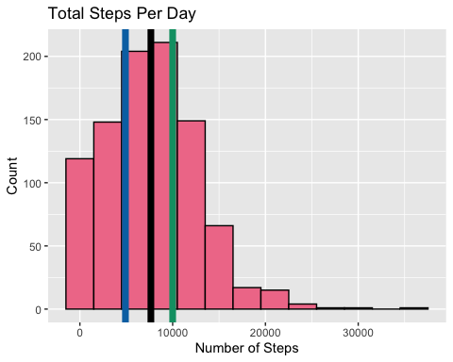

theme_fivethirtyeight(base_size = 10) +  
 theme(axis.title = element_text()) +  
 theme(axis.text = bold_text)

## List of 93  
## $ line :List of 6  
## ..$ colour : chr "black"  
## ..$ size : num 0.455  
## ..$ linetype : num 1  
## ..$ lineend : chr "butt"  
## ..$ arrow : logi FALSE  
## ..$ inherit.blank: logi FALSE  
## ..- attr(*, "class")= chr [1:2] "element_line" "element"  
## $ rect :List of 5  
## ..$ fill : Named chr "#F0F0F0"  
## .. ..- attr(*, "names")= chr "Light Gray"  
## ..$ colour : logi NA  
## ..$ size : num 0.455  
## ..$ linetype : num 0  
## ..$ inherit.blank: logi FALSE  
## ..- attr(*, "class")= chr [1:2] "element_rect" "element"  
## $ text :List of 11  
## ..$ family : chr "sans"  
## ..$ face : chr "plain"  
## ..$ colour : Named chr "#3C3C3C"  
## .. ..- attr(*, "names")= chr "Dark Gray"  
## ..$ size : num 10  
## ..$ hjust : num 0.5  
## ..$ vjust : num 0.5  
## ..$ angle : num 0  
## ..$ lineheight : num 0.9  
## ..$ margin : 'margin' num [1:4] 0points 0points 0points 0points  
## .. ..- attr(*, "unit")= int 8  
## ..$ debug : logi FALSE  
## ..$ inherit.blank: logi FALSE  
## ..- attr(*, "class")= chr [1:2] "element_text" "element"  
## $ title : NULL  
## $ aspect.ratio : NULL  
## $ axis.title :List of 11  
## ..$ family : NULL  
## ..$ face : NULL  
## ..$ colour : NULL  
## ..$ size : NULL  
## ..$ hjust : NULL  
## ..$ vjust : NULL  
## ..$ angle : NULL  
## ..$ lineheight : NULL  
## ..$ margin : NULL  
## ..$ debug : NULL  
## ..$ inherit.blank: logi FALSE  
## ..- attr(*, "class")= chr [1:2] "element_text" "element"  
## $ axis.title.x :List of 11  
## ..$ family : NULL  
## ..$ face : NULL  
## ..$ colour : NULL  
## ..$ size : NULL  
## ..$ hjust : NULL  
## ..$ vjust : num 1  
## ..$ angle : NULL  
## ..$ lineheight : NULL  
## ..$ margin : 'margin' num [1:4] 2.5points 0points 0points 0points  
## .. ..- attr(*, "unit")= int 8  
## ..$ debug : NULL  
## ..$ inherit.blank: logi TRUE  
## ..- attr(*, "class")= chr [1:2] "element_text" "element"  
## $ axis.title.x.top :List of 11  
## ..$ family : NULL  
## ..$ face : NULL  
## ..$ colour : NULL  
## ..$ size : NULL  
## ..$ hjust : NULL  
## ..$ vjust : num 0  
## ..$ angle : NULL  
## ..$ lineheight : NULL  
## ..$ margin : 'margin' num [1:4] 0points 0points 2.5points 0points  
## .. ..- attr(*, "unit")= int 8  
## ..$ debug : NULL  
## ..$ inherit.blank: logi TRUE  
## ..- attr(*, "class")= chr [1:2] "element_text" "element"  
## $ axis.title.x.bottom : NULL  
## $ axis.title.y :List of 11  
## ..$ family : NULL  
## ..$ face : NULL  
## ..$ colour : NULL  
## ..$ size : NULL  
## ..$ hjust : NULL  
## ..$ vjust : num 1  
## ..$ angle : num 90  
## ..$ lineheight : NULL  
## ..$ margin : 'margin' num [1:4] 0points 2.5points 0points 0points  
## .. ..- attr(*, "unit")= int 8  
## ..$ debug : NULL  
## ..$ inherit.blank: logi TRUE  
## ..- attr(*, "class")= chr [1:2] "element_text" "element"  
## $ axis.title.y.left : NULL  
## $ axis.title.y.right :List of 11  
## ..$ family : NULL  
## ..$ face : NULL  
## ..$ colour : NULL  
## ..$ size : NULL  
## ..$ hjust : NULL  
## ..$ vjust : num 0  
## ..$ angle : num -90  
## ..$ lineheight : NULL  
## ..$ margin : 'margin' num [1:4] 0points 0points 0points 2.5points  
## .. ..- attr(*, "unit")= int 8  
## ..$ debug : NULL  
## ..$ inherit.blank: logi TRUE  
## ..- attr(*, "class")= chr [1:2] "element_text" "element"  
## $ axis.text :List of 11  
## ..$ family : NULL  
## ..$ face : chr "bold"  
## ..$ colour : NULL  
## ..$ size : 'rel' num 0.8  
## ..$ hjust : NULL  
## ..$ vjust : NULL  
## ..$ angle : NULL  
## ..$ lineheight : NULL  
## ..$ margin : NULL  
## ..$ debug : NULL  
## ..$ inherit.blank: logi FALSE  
## ..- attr(*, "class")= chr [1:2] "element_text" "element"  
## $ axis.text.x :List of 11  
## ..$ family : NULL  
## ..$ face : NULL  
## ..$ colour : NULL  
## ..$ size : NULL  
## ..$ hjust : NULL  
## ..$ vjust : num 1  
## ..$ angle : NULL  
## ..$ lineheight : NULL  
## ..$ margin : 'margin' num [1:4] 2points 0points 0points 0points  
## .. ..- attr(*, "unit")= int 8  
## ..$ debug : NULL  
## ..$ inherit.blank: logi TRUE  
## ..- attr(*, "class")= chr [1:2] "element_text" "element"  
## $ axis.text.x.top :List of 11  
## ..$ family : NULL  
## ..$ face : NULL  
## ..$ colour : NULL  
## ..$ size : NULL  
## ..$ hjust : NULL  
## ..$ vjust : num 0  
## ..$ angle : NULL  
## ..$ lineheight : NULL  
## ..$ margin : 'margin' num [1:4] 0points 0points 2points 0points  
## .. ..- attr(*, "unit")= int 8  
## ..$ debug : NULL  
## ..$ inherit.blank: logi TRUE  
## ..- attr(*, "class")= chr [1:2] "element_text" "element"  
## $ axis.text.x.bottom : NULL  
## $ axis.text.y :List of 11  
## ..$ family : NULL  
## ..$ face : NULL  
## ..$ colour : NULL  
## ..$ size : NULL  
## ..$ hjust : num 1  
## ..$ vjust : NULL  
## ..$ angle : NULL  
## ..$ lineheight : NULL  
## ..$ margin : 'margin' num [1:4] 0points 2points 0points 0points  
## .. ..- attr(*, "unit")= int 8  
## ..$ debug : NULL  
## ..$ inherit.blank: logi TRUE  
## ..- attr(*, "class")= chr [1:2] "element_text" "element"  
## $ axis.text.y.left : NULL  
## $ axis.text.y.right :List of 11  
## ..$ family : NULL  
## ..$ face : NULL  
## ..$ colour : NULL  
## ..$ size : NULL  
## ..$ hjust : num 0  
## ..$ vjust : NULL  
## ..$ angle : NULL  
## ..$ lineheight : NULL  
## ..$ margin : 'margin' num [1:4] 0points 0points 0points 2points  
## .. ..- attr(*, "unit")= int 8  
## ..$ debug : NULL  
## ..$ inherit.blank: logi TRUE  
## ..- attr(*, "class")= chr [1:2] "element_text" "element"  
## $ axis.ticks : list()  
## ..- attr(*, "class")= chr [1:2] "element_blank" "element"  
## $ axis.ticks.x : NULL  
## $ axis.ticks.x.top : NULL  
## $ axis.ticks.x.bottom : NULL  
## $ axis.ticks.y : NULL  
## $ axis.ticks.y.left : NULL  
## $ axis.ticks.y.right : NULL  
## $ axis.ticks.length : 'simpleUnit' num 2.5points  
## ..- attr(*, "unit")= int 8  
## $ axis.ticks.length.x : NULL  
## $ axis.ticks.length.x.top : NULL  
## $ axis.ticks.length.x.bottom: NULL  
## $ axis.ticks.length.y : NULL  
## $ axis.ticks.length.y.left : NULL  
## $ axis.ticks.length.y.right : NULL  
## $ axis.line : list()  
## ..- attr(*, "class")= chr [1:2] "element_blank" "element"  
## $ axis.line.x : NULL  
## $ axis.line.x.top : NULL  
## $ axis.line.x.bottom : NULL  
## $ axis.line.y : NULL  
## $ axis.line.y.left : NULL  
## $ axis.line.y.right : NULL  
## $ legend.background :List of 5  
## ..$ fill : NULL  
## ..$ colour : logi NA  
## ..$ size : NULL  
## ..$ linetype : NULL  
## ..$ inherit.blank: logi FALSE  
## ..- attr(*, "class")= chr [1:2] "element_rect" "element"  
## $ legend.margin : 'margin' num [1:4] 5points 5points 5points 5points  
## ..- attr(*, "unit")= int 8  
## $ legend.spacing : 'simpleUnit' num 10points  
## ..- attr(*, "unit")= int 8  
## $ legend.spacing.x : NULL  
## $ legend.spacing.y : NULL  
## $ legend.key :List of 5  
## ..$ fill : NULL  
## ..$ colour : NULL  
## ..$ size : NULL  
## ..$ linetype : NULL  
## ..$ inherit.blank: logi TRUE  
## ..- attr(*, "class")= chr [1:2] "element_rect" "element"  
## $ legend.key.size : 'simpleUnit' num 1.2lines  
## ..- attr(*, "unit")= int 3  
## $ legend.key.height : NULL  
## $ legend.key.width : NULL  
## $ legend.text :List of 11  
## ..$ family : NULL  
## ..$ face : NULL  
## ..$ colour : NULL  
## ..$ size : 'rel' num 0.8  
## ..$ hjust : NULL  
## ..$ vjust : NULL  
## ..$ angle : NULL  
## ..$ lineheight : NULL  
## ..$ margin : NULL  
## ..$ debug : NULL  
## ..$ inherit.blank: logi TRUE  
## ..- attr(*, "class")= chr [1:2] "element_text" "element"  
## $ legend.text.align : NULL  
## $ legend.title :List of 11  
## ..$ family : NULL  
## ..$ face : NULL  
## ..$ colour : NULL  
## ..$ size : NULL  
## ..$ hjust : num 0  
## ..$ vjust : NULL  
## ..$ angle : NULL  
## ..$ lineheight : NULL  
## ..$ margin : NULL  
## ..$ debug : NULL  
## ..$ inherit.blank: logi TRUE  
## ..- attr(*, "class")= chr [1:2] "element_text" "element"  
## $ legend.title.align : NULL  
## $ legend.position : chr "bottom"  
## $ legend.direction : chr "horizontal"  
## $ legend.justification : chr "center"  
## $ legend.box : chr "vertical"  
## $ legend.box.just : NULL  
## $ legend.box.margin : 'margin' num [1:4] 0cm 0cm 0cm 0cm  
## ..- attr(*, "unit")= int 1  
## $ legend.box.background : list()  
## ..- attr(*, "class")= chr [1:2] "element_blank" "element"  
## $ legend.box.spacing : 'simpleUnit' num 10points  
## ..- attr(*, "unit")= int 8  
## $ panel.background :List of 5  
## ..$ fill : NULL  
## ..$ colour : NULL  
## ..$ size : NULL  
## ..$ linetype : NULL  
## ..$ inherit.blank: logi TRUE  
## ..- attr(*, "class")= chr [1:2] "element_rect" "element"  
## $ panel.border :List of 5  
## ..$ fill : logi NA  
## ..$ colour : NULL  
## ..$ size : NULL  
## ..$ linetype : NULL  
## ..$ inherit.blank: logi FALSE  
## ..- attr(*, "class")= chr [1:2] "element_rect" "element"  
## $ panel.spacing : 'simpleUnit' num 5points  
## ..- attr(*, "unit")= int 8  
## $ panel.spacing.x : NULL  
## $ panel.spacing.y : NULL  
## $ panel.grid :List of 6  
## ..$ colour : NULL  
## ..$ size : NULL  
## ..$ linetype : NULL  
## ..$ lineend : NULL  
## ..$ arrow : logi FALSE  
## ..$ inherit.blank: logi FALSE  
## ..- attr(*, "class")= chr [1:2] "element_line" "element"  
## $ panel.grid.major :List of 6  
## ..$ colour : Named chr "#D2D2D2"  
## .. ..- attr(*, "names")= chr "Medium Gray"  
## ..$ size : NULL  
## ..$ linetype : NULL  
## ..$ lineend : NULL  
## ..$ arrow : logi FALSE  
## ..$ inherit.blank: logi FALSE  
## ..- attr(*, "class")= chr [1:2] "element_line" "element"  
## $ panel.grid.minor : list()  
## ..- attr(*, "class")= chr [1:2] "element_blank" "element"  
## $ panel.grid.major.x : NULL  
## $ panel.grid.major.y : NULL  
## $ panel.grid.minor.x : NULL  
## $ panel.grid.minor.y : NULL  
## $ panel.ontop : logi FALSE  
## $ plot.background :List of 5  
## ..$ fill : NULL  
## ..$ colour : NULL  
## ..$ size : NULL  
## ..$ linetype : NULL  
## ..$ inherit.blank: logi TRUE  
## ..- attr(*, "class")= chr [1:2] "element_rect" "element"  
## $ plot.title :List of 11  
## ..$ family : NULL  
## ..$ face : chr "bold"  
## ..$ colour : NULL  
## ..$ size : 'rel' num 1.5  
## ..$ hjust : num 0  
## ..$ vjust : num 1  
## ..$ angle : NULL  
## ..$ lineheight : NULL  
## ..$ margin : 'margin' num [1:4] 0points 0points 5points 0points  
## .. ..- attr(*, "unit")= int 8  
## ..$ debug : NULL  
## ..$ inherit.blank: logi FALSE  
## ..- attr(*, "class")= chr [1:2] "element_text" "element"  
## $ plot.title.position : chr "panel"  
## $ plot.subtitle :List of 11  
## ..$ family : NULL  
## ..$ face : NULL  
## ..$ colour : NULL  
## ..$ size : NULL  
## ..$ hjust : num 0  
## ..$ vjust : num 1  
## ..$ angle : NULL  
## ..$ lineheight : NULL  
## ..$ margin : 'margin' num [1:4] 0points 0points 5points 0points  
## .. ..- attr(*, "unit")= int 8  
## ..$ debug : NULL  
## ..$ inherit.blank: logi TRUE  
## ..- attr(*, "class")= chr [1:2] "element_text" "element"  
## $ plot.caption :List of 11  
## ..$ family : NULL  
## ..$ face : NULL  
## ..$ colour : NULL  
## ..$ size : 'rel' num 0.8  
## ..$ hjust : num 1  
## ..$ vjust : num 1  
## ..$ angle : NULL  
## ..$ lineheight : NULL  
## ..$ margin : 'margin' num [1:4] 5points 0points 0points 0points  
## .. ..- attr(*, "unit")= int 8  
## ..$ debug : NULL  
## ..$ inherit.blank: logi TRUE  
## ..- attr(*, "class")= chr [1:2] "element_text" "element"  
## $ plot.caption.position : chr "panel"  
## $ plot.tag :List of 11  
## ..$ family : NULL  
## ..$ face : NULL  
## ..$ colour : NULL  
## ..$ size : 'rel' num 1.2  
## ..$ hjust : num 0.5  
## ..$ vjust : num 0.5  
## ..$ angle : NULL  
## ..$ lineheight : NULL  
## ..$ margin : NULL  
## ..$ debug : NULL  
## ..$ inherit.blank: logi TRUE  
## ..- attr(*, "class")= chr [1:2] "element_text" "element"  
## $ plot.tag.position : chr "topleft"  
## $ plot.margin : 'simpleUnit' num [1:4] 1lines 1lines 1lines 1lines  
## ..- attr(*, "unit")= int 3  
## $ strip.background :List of 5  
## ..$ fill : NULL  
## ..$ colour : NULL  
## ..$ size : NULL  
## ..$ linetype : NULL  
## ..$ inherit.blank: logi FALSE  
## ..- attr(*, "class")= chr [1:2] "element_rect" "element"  
## $ strip.background.x : NULL  
## $ strip.background.y : NULL  
## $ strip.placement : chr "inside"  
## $ strip.text :List of 11  
## ..$ family : NULL  
## ..$ face : NULL  
## ..$ colour : NULL  
## ..$ size : 'rel' num 0.8  
## ..$ hjust : NULL  
## ..$ vjust : NULL  
## ..$ angle : NULL  
## ..$ lineheight : NULL  
## ..$ margin : 'margin' num [1:4] 4points 4points 4points 4points  
## .. ..- attr(*, "unit")= int 8  
## ..$ debug : NULL  
## ..$ inherit.blank: logi TRUE  
## ..- attr(*, "class")= chr [1:2] "element_text" "element"  
## $ strip.text.x : NULL  
## $ strip.text.y :List of 11  
## ..$ family : NULL  
## ..$ face : NULL  
## ..$ colour : NULL  
## ..$ size : NULL  
## ..$ hjust : NULL  
## ..$ vjust : NULL  
## ..$ angle : num -90  
## ..$ lineheight : NULL  
## ..$ margin : NULL  
## ..$ debug : NULL  
## ..$ inherit.blank: logi TRUE  
## ..- attr(*, "class")= chr [1:2] "element_text" "element"  
## $ strip.switch.pad.grid : 'simpleUnit' num 2.5points  
## ..- attr(*, "unit")= int 8  
## $ strip.switch.pad.wrap : 'simpleUnit' num 2.5points  
## ..- attr(*, "unit")= int 8  
## $ strip.text.y.left :List of 11  
## ..$ family : NULL  
## ..$ face : NULL  
## ..$ colour : NULL  
## ..$ size : NULL  
## ..$ hjust : NULL  
## ..$ vjust : NULL  
## ..$ angle : num 90  
## ..$ lineheight : NULL  
## ..$ margin : NULL  
## ..$ debug : NULL  
## ..$ inherit.blank: logi TRUE  
## ..- attr(*, "class")= chr [1:2] "element_text" "element"  
## - attr(*, "class")= chr [1:2] "theme" "gg"  
## - attr(*, "complete")= logi TRUE  
## - attr(*, "validate")= logi TRUE

# Active Distance plots  
# activity_mean is a table that contains the means for 'TotalDistance',   
# 'VeryActiveDistance', "ModeratelyActiveDistance', and 'LightActiveDistance'  
activity_mean <- read_csv('activity_means.csv')

## Rows: 4 Columns: 2

## ── Column specification ────────────────────────────────────────────────────────  
## Delimiter: ","  
## chr (1): activity_type  
## dbl (1): mean

##   
## ℹ Use `spec()` to retrieve the full column specification for this data.  
## ℹ Specify the column types or set `show_col_types = FALSE` to quiet this message.

View(activity_mean)  
  
activity_mean$activity_type <- factor(activity_mean$activity_type, levels = c('Total Distance', 'Very Active', 'Moderately Active', 'Lightly Active'))  
bold_text <- element_text(face = 'bold')  
activity_mean %>%   
 ggplot(aes(x = activity_type, y = mean, label = mean)) +  
 geom_bar(stat = 'identity', fill = '#F07C98', color = '#000000') + geom_text(size = 5, vjust = -0.4) +  
 ylim(0,8) +  
 labs(title = 'Average Distance Traveled at Various Intensities (km)',  
 y = 'Average Distance (km)',  
 x = 'Activity Type',  
 theme_fivethirtyeight(base_size = 10) +  
 theme(axis.title = element_text())) +  
 theme(axis.text = bold_text)

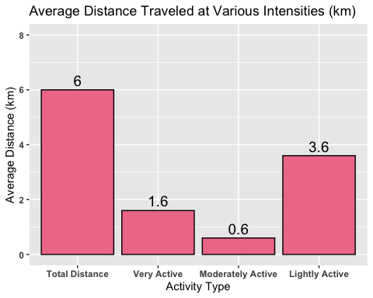

# Same plot as above but converted into miles  
# activity_mean_miles is the same as activity_mean just converted to miles  
# distance_plot_mi.png  
  
activity_mean_miles <- read_csv('activity_mean_miles.csv')

## Rows: 4 Columns: 2

## ── Column specification ────────────────────────────────────────────────────────  
## Delimiter: ","  
## chr (1): activity_type  
## dbl (1): mean

##   
## ℹ Use `spec()` to retrieve the full column specification for this data.  
## ℹ Specify the column types or set `show_col_types = FALSE` to quiet this message.

View(activity_mean_miles)  
  
activity_mean_miles$activity_type <- factor(activity_mean_miles$activity_type, levels = c('Total Distance', 'Very Active', 'Moderately Active', 'Lightly Active'))  
bold_text <- element_text(face = 'bold')  
activity_mean_miles %>%   
 ggplot(aes(x = activity_type, y = mean, label = mean)) +  
 geom_bar(stat = 'identity', fill = '#F07C98', color = '#000000') + geom_text(size = 5, vjust = -0.4) +  
 ylim(0,5) +  
 labs(title = 'Average Distance Traveled at Various Intensities (mi)',  
 y = 'Average Distance (mi)',  
 x = 'Activity Type',  
 theme_fivethirtyeight(base_size = 10) +  
 theme(axis.title = element_text())) +  
 theme(axis.text = bold_text)

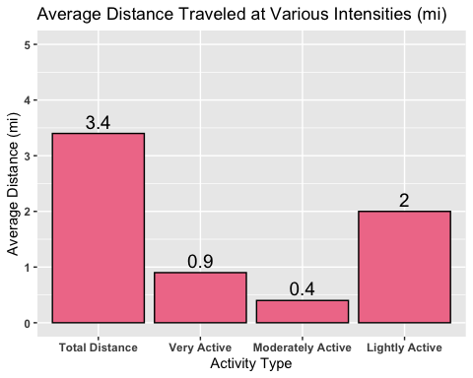

# Average Time plot  
# minutes_active is a table with the means for each activity intensity level  
# minutes_plot.png  
minutes_active <- read_csv('minutes_active.csv')

## Rows: 4 Columns: 2

## ── Column specification ────────────────────────────────────────────────────────  
## Delimiter: ","  
## chr (1): activity_type  
## dbl (1): mean

##   
## ℹ Use `spec()` to retrieve the full column specification for this data.  
## ℹ Specify the column types or set `show_col_types = FALSE` to quiet this message.

View(minutes_active)  
  
minutes_active$activity_type <- factor(minutes_active$activity_type, levels = c('Very Active', 'Moderately Active', 'Lightly Active', 'Sitting'))  
bold_text <- element_text(face = 'bold')  
minutes_active %>%   
 ggplot(aes(x = activity_type, y = mean, label = mean)) +  
 geom_bar(stat = 'identity', fill = '#F07C98', color = '#000000') +  
 annotate('text', x = 'Very Active', y = 0.8, label = '21 min', size = 5) +  
 annotate('text', x = 'Moderately Active', y = 0.6, label = '14 min', size = 5) +  
 annotate('text', x = 'Lightly Active', y = 3.6, label = '3hrs 13min ', size = 5) +   
 annotate('text', x = 'Sitting', y = 9.2, label = '8hrs 50min ', size = 5) +   
 ylim(0,10) +  
 labs(title = 'Average Time Spent At Each Intensity Level',  
 y = 'Average Time (hrs)',  
 x = 'Activity Type',  
 theme_fivethirtyeight(base_size = 10) +  
 theme(axis.title = element_text())) +  
 theme(axis.text = bold_text)

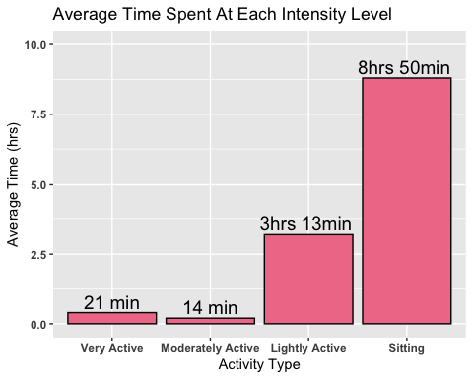

# Relationship between distance traveled and time spent  
# min_dist_very_plot_km.png'  
activity %>%   
 ggplot(aes(x = VeryActiveDistance, y = VeryActiveHours)) +  
 geom_point(col = 'black', pch = 21, fill = '#F07C98', size = 2.5) +  
 labs(title = 'Distance Vs. Time: Very Active',  
 y = 'Hours',  
 x = 'Distance (km)',  
 theme_fivethirtyeight(base_size = 10) +  
 theme(axis.title = element_text())) +  
 theme(axis.text = bold_text)

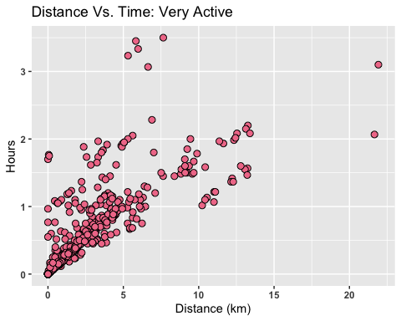

# min_dist_very_plot_avg_mi.png  
activity %>%   
 ggplot(aes(x = VeryActiveDistance_mi, y = VeryActiveHours)) +  
 geom_point(col = 'black', pch = 21, fill = '#F07C98', size = 2.5) +  
 geom_point(aes(x = 0.9355, y = 0.35420), col = 'black', pch = 21, fill = '#009E73', size = 8) +  
 annotate('text', x = 7.2, y = 0.2, label = 'Average Distance and Time (0.9 mi, 21 min 15 sec)', size = 4) +   
 labs(title = 'Distance Vs. Time: Very Active',  
 y = 'Hours',  
 x = 'Distance (mi)',  
 theme_fivethirtyeight(base_size = 10) +  
 theme(axis.title = element_text())) +  
 theme(axis.text = bold_text)

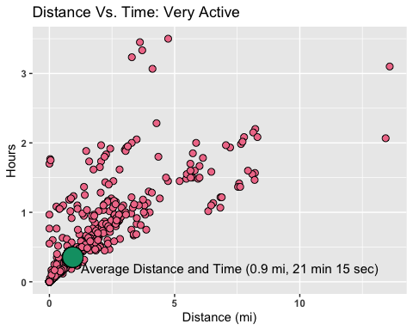

# min_dist_moderately_plot_km.png  
activity %>%   
 ggplot(aes(x = ModeratelyActiveDistance, y = ModeratelyActiveHours)) +  
 geom_point(col = 'black', pch = 21, fill = '#F07C98', size = 2.5) +  
 labs(title = 'Distance Traveled vs. Time Spent Jogging',  
 y = 'Hours',  
 x = 'Distance (km)',  
 theme_fivethirtyeight(base_size = 10) +  
 theme(axis.title = element_text())) +  
 theme(axis.text = bold_text)

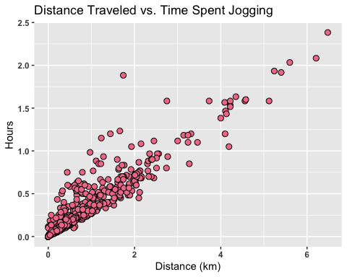

# min_dist_moderately_plot_avg_mi.png  
activity %>%   
 ggplot(aes(x = ModeratelyActiveDistance_mi, y = ModeratelyActiveHours)) +  
 geom_point(col = 'black', pch = 21, fill = '#F07C98', size = 2.5) +  
 geom_point(aes(x = 0.3532, y = 0.2269), col = 'black', pch = 21, fill = '#009E73', size = 8) +  
 annotate('text', x = 2, y = 0.1, label = 'Average Distance and Time (0.4 mi, 14 min)', size = 4) +   
 labs(title = 'Distance Vs. Time: Moderately Active',  
 y = 'Hours',  
 x = 'Distance (mi)',  
 theme_fivethirtyeight(base_size = 10) +  
 theme(axis.title = element_text())) +  
 theme(axis.text = bold_text)

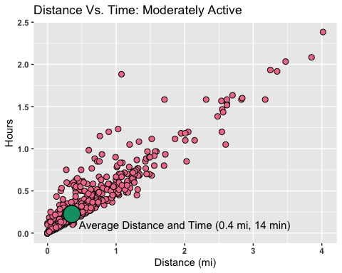

# min_dist_light_plot_km.png  
activity %>%   
 ggplot(aes(x = LightActiveDistance, y = LightActiveHours)) +  
 geom_point(col = 'black', pch = 21, fill = '#F07C98', size = 2.5) +  
 labs(title = 'Distance Traveled vs. Time Spent Walking',  
 y = 'Hours',  
 x = 'Distance (km)',  
 theme_fivethirtyeight(base_size = 10) +  
 theme(axis.title = element_text())) +  
 theme(axis.text = bold_text)

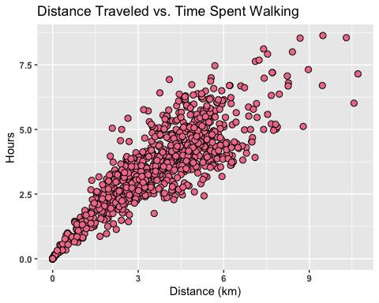

# min_dist_light_plot_avg_mi.png  
activity %>%   
 ggplot(aes(x = LightActiveDistance_mi, y = LightActiveHours)) +  
 geom_point(col = 'black', pch = 21, fill = '#F07C98', size = 2.5) +  
 geom_point(aes(x = 2, y = 3.2), col = 'black', pch = 21, fill = '#009E73', size = 8) +  
 annotate('text', x = 4.25, y = 1, label = 'Average Distance and Time (2 mi, 3 hours 13 min)', size = 4) +   
 labs(title = 'Distance Vs. Time: Lightly Active',  
 y = 'Hours',  
 x = 'Distance (mi)',  
 theme_fivethirtyeight(base_size = 10) +  
 theme(axis.title = element_text())) +  
 theme(axis.text = bold_text)

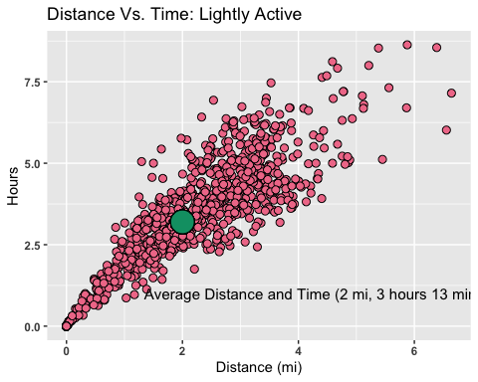

# Sleep  
# asleep_bed_plot.png  
sleep %>%   
 ggplot(aes(x = TotalHoursAsleep, y = TotalTimeInBedHours)) +  
 geom_point(col = 'black', pch = 21, fill = '#F07C98', size = 2.5) +  
 geom_point(aes(x = 7.016, y = 7.674), col = 'black', pch = 21, fill = '#009E73', size = 8) +  
 annotate('text', x = 9.5, y = 4.5, label = 'Asleep vs. Bed (7 hrs 1 min, 7 hrs 40 min)', size = 4) +   
 labs(title = 'Total Hours Asleep vs. Total Time in Bed',  
 y = 'Hours Asleep',  
 x = 'Hours in Bed',  
 theme_fivethirtyeight(base_size = 10) +  
 theme(axis.title = element_text())) +  
 theme(axis.text = bold_text)

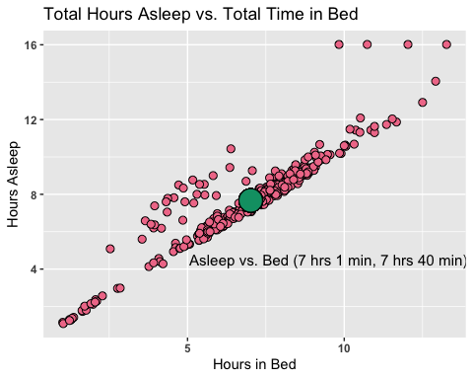

# Intensity  
# Finding the mean for the TotalIntensity column  
intensity_mean <- intensity %>%  
 group_by(Time) %>%  
 drop_na() %>%  
 summarise(mean_intensity = mean(TotalIntensity))  
summary(intensity_mean)

## Time mean_intensity   
## Length:24 Min. : 0.4437   
## Class :character 1st Qu.: 4.9852   
## Mode :character Median :14.5040   
## Mean :12.0822   
## 3rd Qu.:17.9813   
## Max. :21.9216

#total_intensity_vs_hour_plot.png  
intensity_mean %>%   
 mutate(Time = fct_relevel(Time, '12:00 AM', '1:00 AM', '2:00 AM', '3:00 AM', '4:00 AM',   
 '5:00 AM', '6:00 AM', '7:00 AM', '8:00 AM', '9:00 AM',  
 '10:00 AM', '11:00 AM', '12:00 PM', '1:00 PM', '2:00 PM',  
 '3:00 PM', '4:00 PM', '5:00 PM', '6:00 PM', '7:00 PM',  
 '8:00 PM', '9:00 PM', '10:00 PM', '11:00 PM')) %>%   
 ggplot(., aes(x = Time, y = mean_intensity)) +   
 geom_bar(stat = 'identity', fill='#F07C98', col = 'black') +  
 theme(axis.text.x = element_text(angle = 90)) +  
 labs(title = 'Average Total Intensity vs. Hour',  
 y = 'Numeric Intensity Level',  
 x = 'Time',  
 theme_fivethirtyeight(base_size = 10) +  
 theme(axis.title = element_text())) +  
 theme(axis.text = bold_text)

## 