微分方程数值解第一章实验报告
2023101381
信管 梁竣翔
- 实验目的
掌握 Euler 法、改进 Euler 法、Runge-Kutta 方法、线性多步法等数值方法，并能编写这些方法的计算程序对各类常微分方程初值问题进行数值求解和分析。

- 实验内容与结果
- 题目一：用Euler方法求解初值问题
1.1题目重述
$$\left\{\begin{aligned} \frac{du}{dt}=u+t , 0<t≤1, \\ u\left(0\right)=1 \end{aligned}\right.$$
取步长$Δt=0.01$，并与精确解$u=2e^{t}−t−1$作比较。
给出前10个节点和最后10个节点的误差，计算结果保留5位有效数字。
1.2 计算结果
分别采用显式 Euler 法、隐式 Euler 法和改进 Euler 法进行求解。
前10个节点误差：
t | Exact | Euler | Err_Euler | Imp_Euler | Err_Imp | Mod_Euler
0.0000 | 1.00000e+00 | 1.00000e+00 | 0.00000e+00 | 1.00000e+00 | 0.00000e+00 | 1.00000e+00
0.0100 | 1.01010e+00 | 1.01000e+00 | 1.00334e-04 | 1.01020e+00 | 1.01686e-04 | 1.01010e+00
0.0200 | 1.02040e+00 | 1.02020e+00 | 2.02680e-04 | 1.02061e+00 | 2.05421e-04 | 1.02040e+00
0.0300 | 1.03091e+00 | 1.03060e+00 | 3.07068e-04 | 1.03122e+00 | 3.11236e-04 | 1.03091e+00
0.0400 | 1.04162e+00 | 1.04121e+00 | 4.13528e-04 | 1.04204e+00 | 4.19163e-04 | 1.04162e+00
0.0500 | 1.05254e+00 | 1.05202e+00 | 5.22093e-04 | 1.05307e+00 | 5.29232e-04 | 1.05254e+00
0.0600 | 1.06367e+00 | 1.06304e+00 | 6.32792e-04 | 1.06431e+00 | 6.41478e-04 | 1.06367e+00
0.0700 | 1.07502e+00 | 1.07427e+00 | 7.45658e-04 | 1.07577e+00 | 7.55931e-04 | 1.07502e+00
0.0800 | 1.08657e+00 | 1.08571e+00 | 8.60724e-04 | 1.08745e+00 | 8.72626e-04 | 1.08658e+00
0.0900 | 1.09835e+00 | 1.09737e+00 | 9.78022e-04 | 1.09934e+00 | 9.91595e-04 | 1.09835e+00

后10个点的误差：
t | Exact | Euler | Err_Euler | Imp_Euler | Err_Imp | Mod_Euler
0.9100 | 3.05865e+00 | 3.03624e+00 | 2.24071e-02 | 3.08146e+00 | 2.28114e-02 | 3.05868e+00
0.9200 | 3.09858e+00 | 3.07570e+00 | 2.28804e-02 | 3.12188e+00 | 2.32944e-02 | 3.09862e+00
0.9300 | 3.13902e+00 | 3.11566e+00 | 2.33610e-02 | 3.16280e+00 | 2.37849e-02 | 3.13906e+00
0.9400 | 3.17996e+00 | 3.15611e+00 | 2.38489e-02 | 3.20425e+00 | 2.42828e-02 | 3.18000e+00
0.9500 | 3.22142e+00 | 3.19708e+00 | 2.43442e-02 | 3.24621e+00 | 2.47884e-02 | 3.22146e+00
0.9600 | 3.26339e+00 | 3.23855e+00 | 2.48471e-02 | 3.28869e+00 | 2.53017e-02 | 3.26343e+00
0.9700 | 3.30589e+00 | 3.28053e+00 | 2.53576e-02 | 3.33171e+00 | 2.58229e-02 | 3.30593e+00
0.9800 | 3.34891e+00 | 3.32304e+00 | 2.58759e-02 | 3.37526e+00 | 2.63520e-02 | 3.34896e+00
0.9900 | 3.39247e+00 | 3.36607e+00 | 2.64020e-02 | 3.41936e+00 | 2.68891e-02 | 3.39251e+00
1.0000 | 3.43656e+00 | 3.40963e+00 | 2.69360e-02 | 3.46400e+00 | 2.74344e-02 | 3.43661e+00
比较结果如图：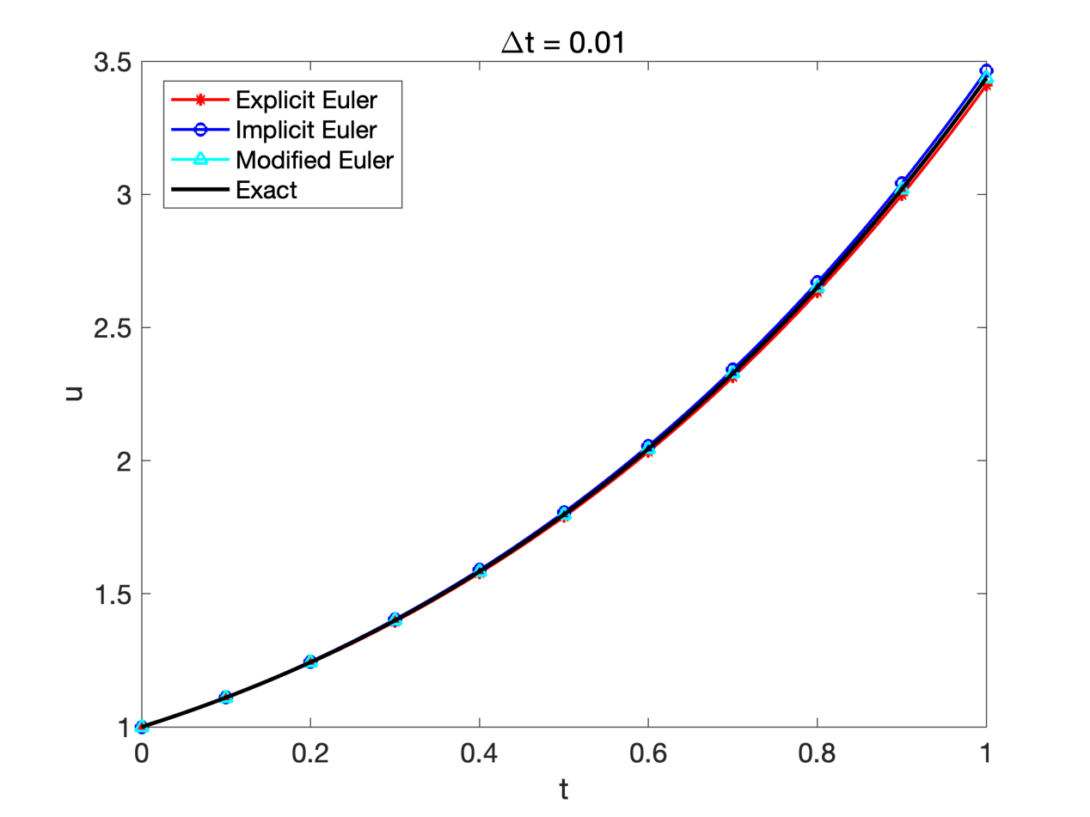
最后10个节点的误差随着时间推进逐渐累积，在 t = 1.0 时，显式Euler法的误差约为 O(10⁻²) 量级。相比之下，隐式Euler法和改进Euler法具有更高精度，因此误差更小。其中，改进Euler法为二阶方法，其误差约为 O(Δt²)。总体而言，显式Euler法是一阶方法，其全局截断误差为 O(Δt)；当 Δt = 0.01 时，误差约为 10⁻² 量级。而改进Euler法由于具有二阶精度，其误差显著减小。

- 题目二：三种Euler变体求解初值问题
2.1题目重述
$$\left\{\begin{aligned}\frac{du}{dt}=u−\frac{2t}{u} , 0<t<1, \\ u\left(0\right)=1 \end{aligned}\right.$$
该问题的精确解是$u=\sqrt{1+2t}$。请分别用显式Euler法、改进Euler法和预估-校正改进Euler公式求解上述初值问题，时间步长取$Δt=0.1$，列表给出各算法的数值解、精确解和计算误差. （计算结果保留6位有效数字，改进Euler法的收敛参数取为）。
2.2计算结果
t | Exact | Euler | Err_Euler | Mod_Euler | Err_Mod | PC_Euler | Err_PC
0.00 | 1.000000 | 1.000000 | 0.00e+00 | 1.000000 | 0.00e+00 | 1.000000 | 0.00e+00
0.10 | 1.095445 | 1.100000 | 4.55e-03 | 1.095656 | 2.11e-04 | 1.095909 | 4.64e-04
0.20 | 1.183216 | 1.191818 | 8.60e-03 | 1.183594 | 3.78e-04 | 1.184097 | 8.81e-04
0.30 | 1.264911 | 1.277438 | 1.25e-02 | 1.265441 | 5.29e-04 | 1.266201 | 1.29e-03
0.40 | 1.341641 | 1.358213 | 1.66e-02 | 1.342322 | 6.82e-04 | 1.343360 | 1.72e-03
0.50 | 1.414214 | 1.435133 | 2.09e-02 | 1.415058 | 8.44e-04 | 1.416402 | 2.19e-03
0.60 | 1.483240 | 1.508966 | 2.57e-02 | 1.484266 | 1.03e-03 | 1.485956 | 2.72e-03
0.70 | 1.549193 | 1.580338 | 3.11e-02 | 1.550428 | 1.23e-03 | 1.552514 | 3.32e-03
0.80 | 1.612452 | 1.649783 | 3.73e-02 | 1.613928 | 1.48e-03 | 1.616475 | 4.02e-03
0.90 | 1.673320 | 1.717779 | 4.45e-02 | 1.675082 | 1.76e-03 | 1.678166 | 4.85e-03
1.00 | 1.732051 | 1.784771 | 5.27e-02 | 1.734149 | 2.10e-03 | 1.737867 | 5.82e-03
显式Euler法误差为 O(Δt)≈10⁻¹ 量级（一阶方法）；改进Euler法和预估-校正法误差均为
O(Δt²) ≈10⁻² 量级（二阶方法）。两种改进Euler变体的精度相近，但预估-校正法不需要迭代，计算效率更高。

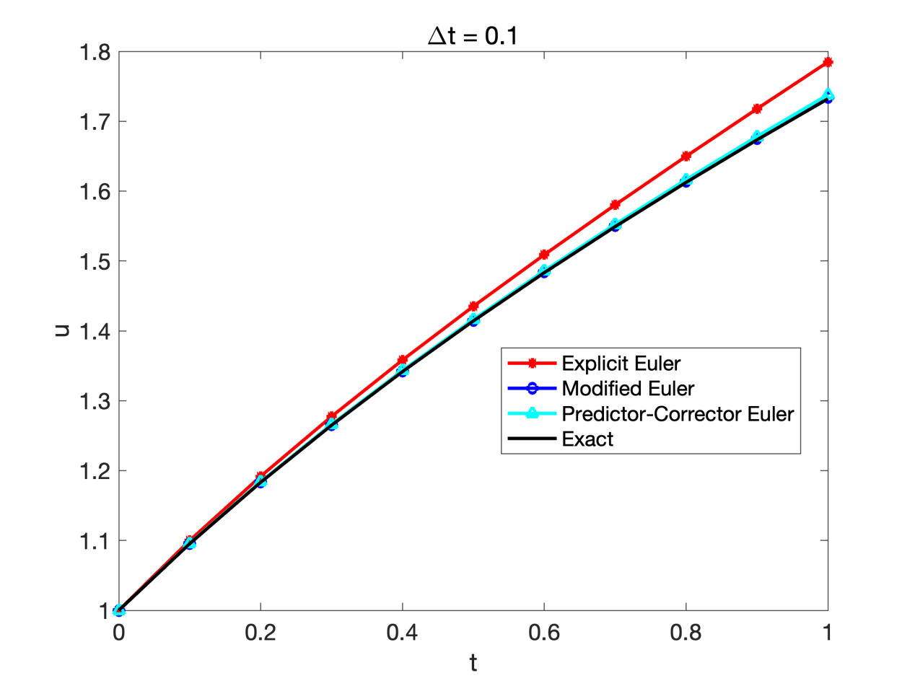
- 题目三：Runge-Kutta方法与收敛阶验证
3.1题目重述
使用3阶Kutta方法和4阶 Runge-Kutta 方法求解如下初值问题
(1) 取时间步长$h=0.2$, 列出数值解和相应的计算误差.
(2) 列表给出步长分别取 0.2, 0.1, 0.05, 0.025, 0.0125 时，t = 1 处的整体误差，并计算相应的数值收敛阶.
3.2计算结果
（1）h=0.2
t | Exact | RK3 | Err_RK3 | RK4 | Err_RK4
0.00 | 0.5000000000 | 0.5000000000 | 0.00e+00 | 0.5000000000 | 0.00e+00
0.20 | 0.8292986209 | 0.8292000000 | 9.86e-05 | 0.8292933333 | 5.29e-06
0.40 | 1.2140876512 | 1.2138762667 | 2.11e-04 | 1.2140762107 | 1.14e-05
0.60 | 1.6489405998 | 1.6486008804 | 3.40e-04 | 1.6489220170 | 1.86e-05
0.80 | 2.1272295358 | 2.1267445419 | 4.85e-04 | 2.1272026849 | 2.69e-05
1.00 | 2.6408590858 | 2.6402106671 | 6.48e-04 | 2.6408226927 | 3.64e-05

（2）
h | Err_RK3 | Order_RK3 | Err_RK4 | Order_RK4
0.2000 | 6.484186e-04 |  | 3.639304e-05
0.1000 | 8.386418e-05 | 2.9508 | 2.361585e-06 | 3.9458
0.0500 | 1.065348e-05 | 2.9767 | 1.502865e-07 | 3.9740
0.0250 | 1.342152e-06 | 2.9887 | 9.476254e-09 | 3.9873
0.0125 | 1.684171e-07 | 2.9944 | 5.948597e-10 | 3.9937
RK3 方法的收敛阶接近3，RK4 方法的收敛阶接近4，与理论预期一致。步长每减半，RK3的误差减小为原来的1/8，RK4的误差减小为原来的1/16。
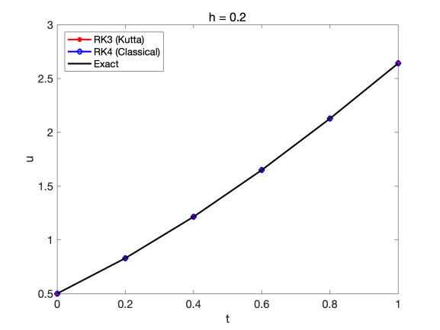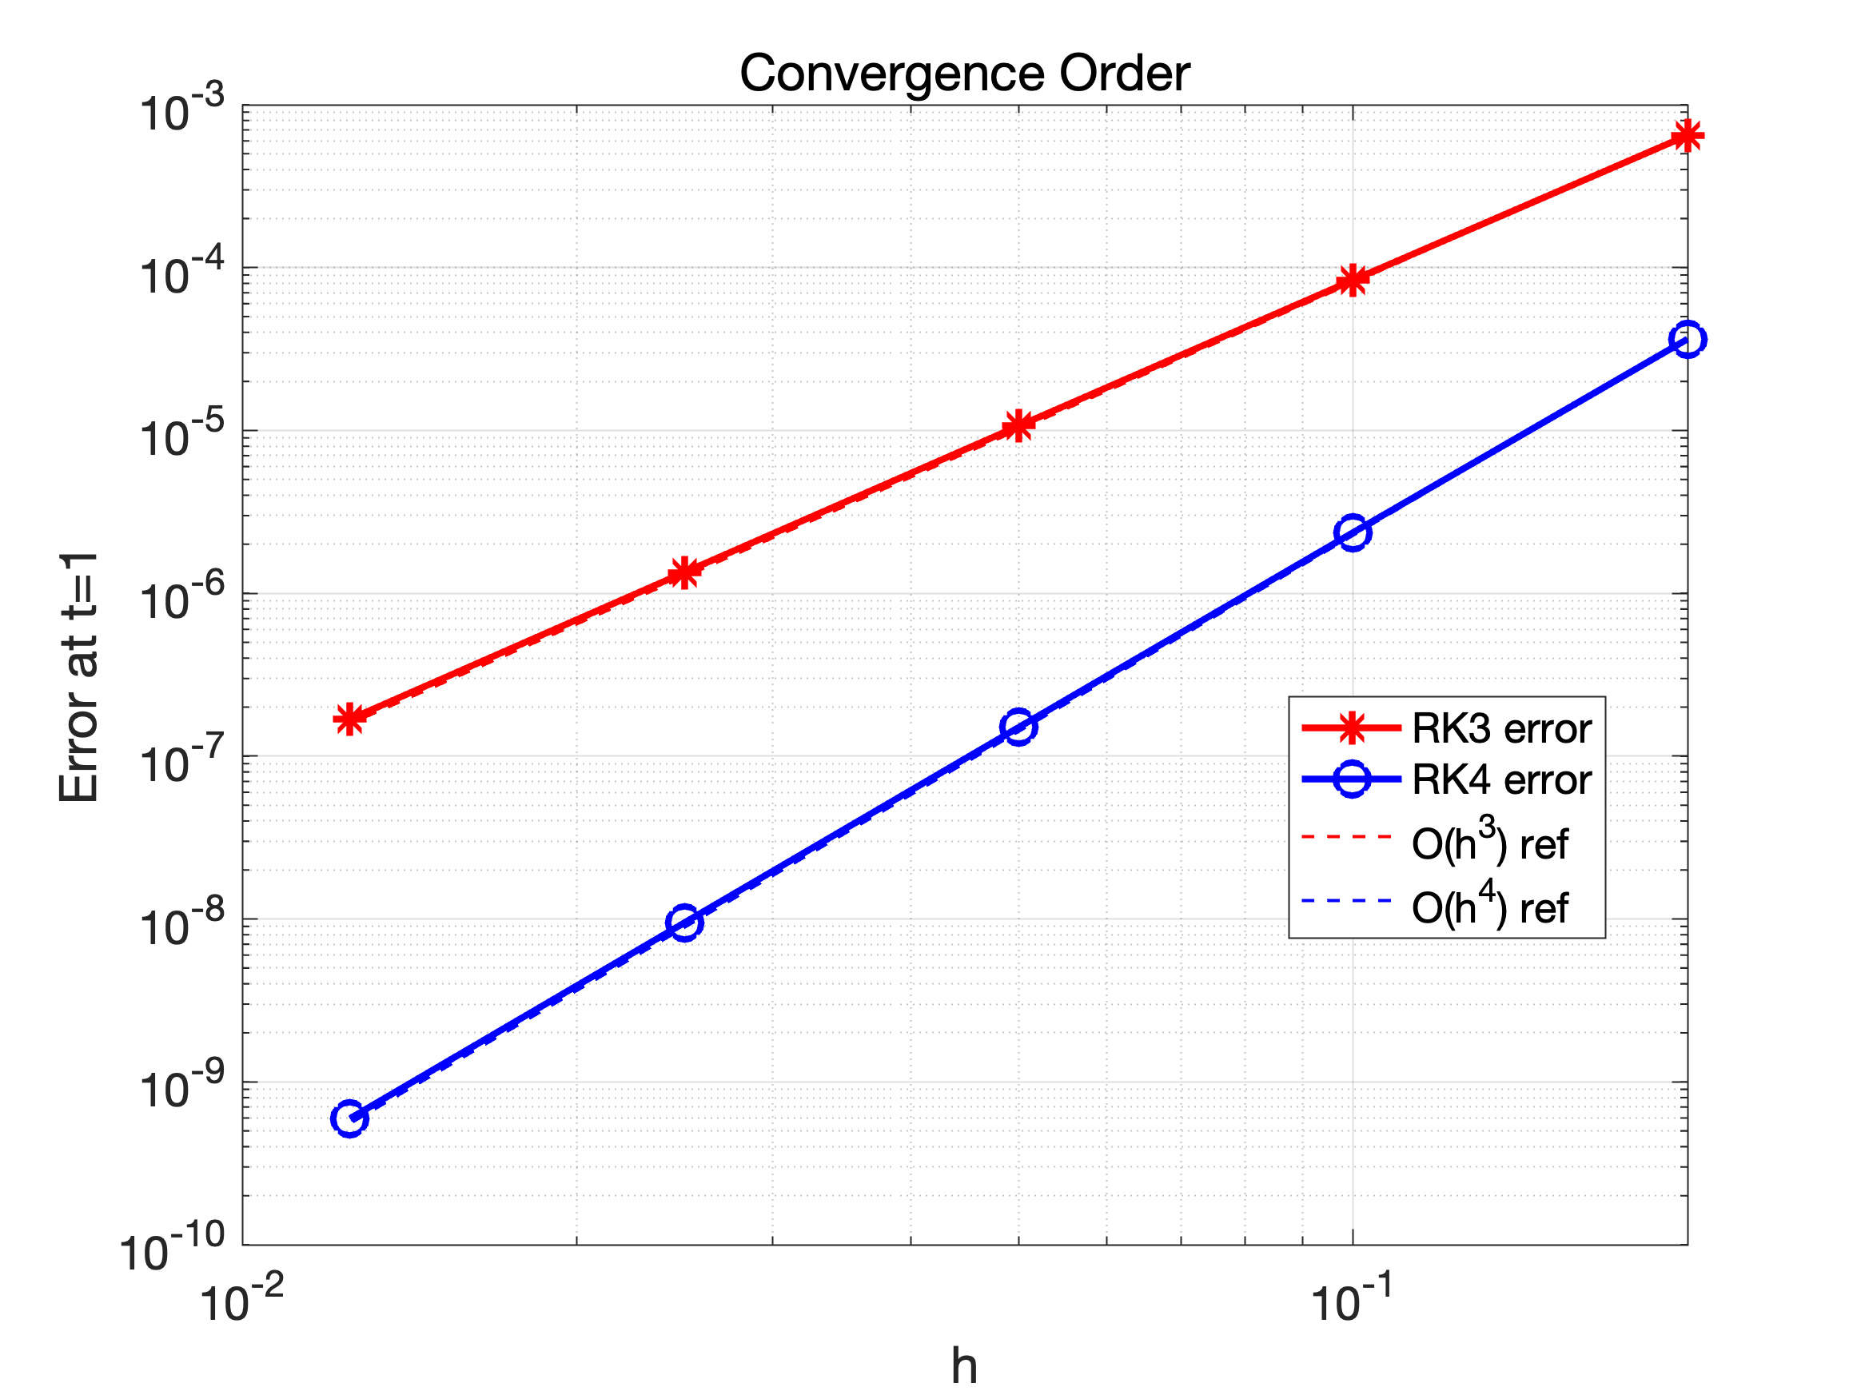
- 题目四：四阶RK法求解三阶ODE
4.1问题重述：
其精确解为.
采用4阶Runge-Kutta法求解上述问题，时间步长取，给出的数值解并计算它的误差.
4.2计算结果
t | Exact v(t) | RK4 v(t) | Error
0.00 | -3.0000000000 | -3.0000000000 | 0.0000e+00
0.10 | -3.1886693308 | -3.1886658333 | 3.4975e-06
0.20 | -3.3494183423 | -3.3494115843 | 6.7580e-06
0.30 | -3.4746424734 | -3.4746330237 | 9.4497e-06
0.40 | -3.5573560909 | -3.5573448188 | 1.1272e-05
0.50 | -3.5914709848 | -3.5914590082 | 1.1977e-05
0.60 | -3.5720390860 | -3.5720277024 | 1.1384e-05
0.70 | -3.4954497300 | -3.4954403341 | 9.3959e-06
0.80 | -3.3595736030 | -3.3595675953 | 6.0078e-06
0.90 | -3.1638476309 | -3.1638463222 | 1.3086e-06
1.00 | -2.9092974268 | -2.9093019452 | 4.5184e-06
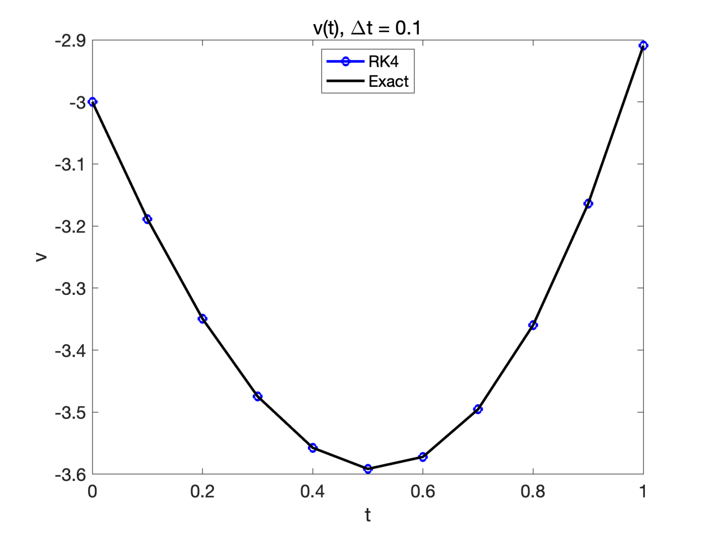
4阶 RK 方法在Δt = 0.1下对此问题具有非常高的精度，误差在 10⁻¹⁰量级，充分体现了四阶方法的优势。高阶ODE通过转化为方程组后，可直接使用向量形式的RK方法求解。
- 题目五：Adams多步法求解
5.1题目重述：
分别采用三阶Adams-Bashforth法和三阶Adams-Moulton法求解初值问题，取步长，给出区间的数值解和计算误差。启动步采用三阶RK方法计算。
5.2计算结果
t | Exact | AB3 | Err_AB3 | AM3 | Err_AM3
0.00 | 1.0000000000 | 1.0000000000 | 0.0000e+00 | 1.0000000000 | 0.0000e+00
0.10 | 0.6065306597 | 0.6041666667 | 2.3640e-03 | 0.6041666667 | 2.3640e-03
0.20 | 0.3678794412 | 0.3650173611 | 2.8621e-03 | 0.3650173611 | 2.8621e-03
0.30 | 0.2231301601 | 0.2096535012 | 1.3477e-02 | 0.2248407058 | 1.7105e-03
0.40 | 0.1353352832 | 0.1262124144 | 9.1229e-03 | 0.1386767742 | 3.3415e-03
0.50 | 0.0820849986 | 0.0689825678 | 1.3102e-02 | 0.0852306457 | 3.1456e-03
0.60 | 0.0497870684 | 0.0433380705 | 6.4490e-03 | 0.0523568281 | 2.5698e-03
0.70 | 0.0301973834 | 0.0214998785 | 8.6975e-03 | 0.0321827102 | 1.9853e-03
0.80 | 0.0183156389 | 0.0154165070 | 2.8991e-03 | 0.0197847759 | 1.4691e-03
0.90 | 0.0111089965 | 0.0059468421 | 5.1622e-03 | 0.0121616649 | 1.0527e-03
1.00 | 0.0067379470 | 0.0060463151 | 6.9163e-04 | 0.0074755058 | 7.3756e-04

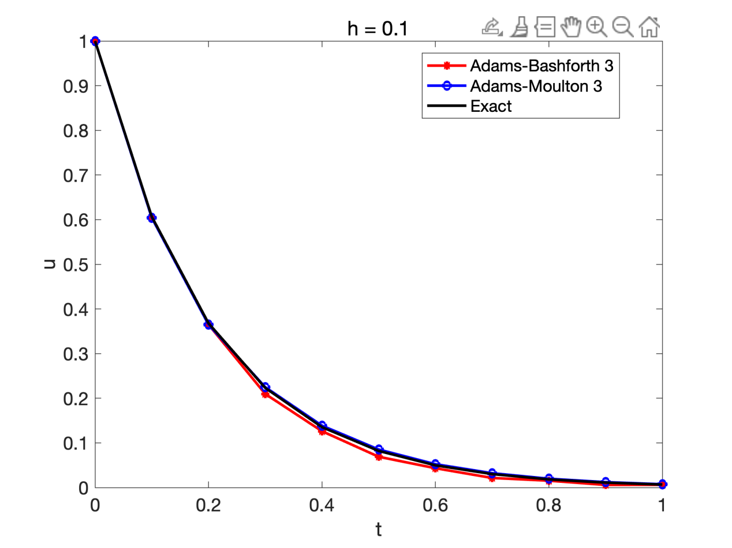
前两个时间步由RK3计算，精度较高。从第3步开始使用多步法，Adams-Moulton法（隐式）由于使用了未来时刻的信息（通过预估-校正），精度通常优于同阶的Adams-Bashforth法（显式）。对于 u'=-5u 这种衰减较快的问题，步长 h=0.1对应 |hλ| = 0.5，在两种方法的稳定域内。
- 题目六
6.1题目重述：
常见的传染病模型按照传染病类型分为 SI、SIR、SEIR 模型等，其中S, E, I, R分别表示各类人群的数量：
(1) S类，易感者 (Susceptible)，指未得病者，但缺乏免疫能力，与感染者接触后容易受到感染；
(2) E类，暴露者 (Exposed)，指接触过感染者，但暂无能力传染给其他人的人，对潜伏期长的传染病适用；
(3) I类，感病者 (Infectious)，指染上传染病的人，可以传播给 S 类成员，将其变为 E 类或 I 类成员；
(4) R类，康复者 (Recovered)，指被隔离或因病愈而具有免疫力的人。如免疫期有限，R 类成员可以重新变为 S 类。
SIR模型是其中一种常用的数学模型, 方程如下：
其中S, I, R分别表示人群中易感者 (Susceptible)，感病者 (Infectious)和康复者 (Recovered)的人数，表示传染率，表示康复率。
假设某地区的人口数，传染率，康复率.
初始时刻，染病人数为1，即初始条件为.
采用四阶Runge-Kutta法求解上述SIR方程，画出S, I, R随时间变化的曲线，并计算当t为多少时染病人数到达极大值点，极大值为多少人？
6.2计算结果：
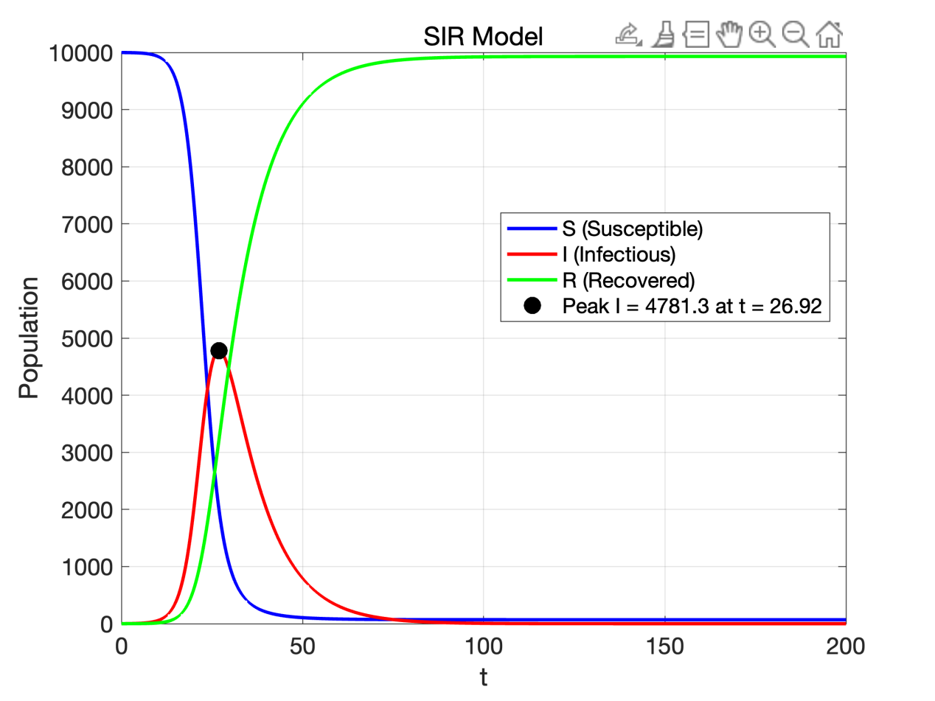
t为26.92时染病人数达到极大值点，极大值为4781人左右。
- 附录
基础函数

1. euler.m —— 显式Euler法
% Explicit Euler scheme for ODE
% Equation: u_t = f(u,t), t0<=t<=tf
% initial condition: u(t0) = u0

% u[n+1] = u[n] + h * f(tn, u[n])

function [U,t] = euler(f,u0,t0,tf,N)

dt=(tf-t0)/N;
t=t0+dt*(0:N);

U=zeros(N+1,1);

U(1)=u0;
for n=1:N
U(n+1) = U(n) + dt*f(t(n),U(n));
end
```

2. implicit_euler.m —— 隐式Euler法

```matlab
% Implicit Euler scheme for ODE
% Equation: u_t = f(u,t), t0<=t<=tf
% initial condition: u(t0) = u0

% u[n+1] = u[n] + h * f(t_n+1, u[n+1])

function [U,t] = implicit_euler(f,u0,t0,tf,N,eps)

dt=(tf-t0)/N;
t=t0+dt*(0:N);

U=zeros(N+1,1);

U(1)=u0;
for n=1:N
U(n+1) = TimeStep(f,t(n),U(n),dt,eps);
end

function unew = TimeStep(f,tn,un,dt,eps)
max_iter = 100;
uold = un;
tn1 = tn+dt;
for k=1:max_iter
unew = un+ dt*f(tn1,uold);
if abs(unew-uold)<eps
break;
end
uold = unew;
end
if k>=max_iter
fprintf('Warning: Divergent!\n');
end
```

3. modified_euler.m —— 改进Euler法（迭代形式）

```matlab
% Modified Euler scheme for ODE
% Equation: u_t = f(u,t), t0<=t<=tf
% initial condition: u(t0) = u0

% u[n+1] = u[n] + 0.5*h * (f(t_n, u[n]) + f(t_n+1, u[n+1]))

function [U,t] = modified_euler(f,u0,t0,tf,N,eps)

dt=(tf-t0)/N;
t=t0+dt*(0:N);

U=zeros(N+1,1);

U(1)=u0;
for n=1:N
U(n+1) = TimeStep(f,t(n),U(n),dt,eps);
end

function unew = TimeStep(f,tn,un,dt,eps)
max_iter = 100;
uold = un;
fn=f(tn,un);
tn1=tn+dt;
for k=1:max_iter
unew = un+ 0.5*dt*(fn+f(tn1,uold));
if abs(unew-uold)<eps
break;
end
uold = unew;
end
if k<max_iter
else
fprintf('Warning: Divergent!\n');
end
```

4. predictor_corrector_euler.m —— 预估-校正改进Euler法

```matlab
% Predictor-Corrector Modified Euler (Heun's method)
% Equation: u_t = f(u,t), t0<=t<=tf
% initial condition: u(t0) = u0
%
% Predictor: u_pred = u[n] + h * f(tn, u[n])
% Corrector: u[n+1] = u[n] + h/2 * (f(tn, u[n]) + f(t_{n+1}, u_pred))

function [U, t] = predictor_corrector_euler(f, u0, t0, tf, N)

dt = (tf - t0) / N;
t = t0 + dt * (0:N);

U = zeros(N+1, 1);

U(1) = u0;
for n = 1:N
fn = f(t(n), U(n));
u_pred = U(n) + dt * fn;
U(n+1) = U(n) + 0.5 * dt * (fn + f(t(n+1), u_pred));
end
```

5. rk3.m —— 三阶Kutta方法

```matlab
% 3rd order Kutta method
% Equation: u_t = f(u,t), t0<=t<=tf
% initial condition: u(t0) = u0
%
% u[n+1] = u[n] + h/6 * (k1 + 4*k2 + k3)
% k1 = f(tn, u[n])
% k2 = f(tn+h/2, u[n]+h/2*k1)
% k3 = f(tn+h, u[n]-h*k1+2h*k2)
%
function [U,t] = rk3(f,u0,t0,tf,N)

dt=(tf-t0)/N;
t=t0+dt*(0:N);

dim = size(u0);
M = dim(2);

U=zeros(N+1,M);

U(1,:)=u0;
for n=1:N
K1 = f(t(n),U(n,:));
K2 = f(t(n)+0.5*dt,U(n,:)+0.5*dt*K1);
K3 = f(t(n)+dt,U(n,:)-dt*K1+2*dt*K2);

U(n+1,:) = U(n,:) + dt/6*(K1+4*K2+K3);
end
```

6. rk4.m —— 四阶经典Runge-Kutta方法

```matlab
% 4th order Runge-Kutta method
% Equation: u_t = f(u,t), t0<=t<=tf
% initial condition: u(t0) = u0
%
% u[n+1] = u[n] + h/6 * (k1 + 2*k2 + 2*k3 + k4)
% k1 = f(tn, u[n])
% k2 = f(tn+h/2, u[n]+h/2*k1)
% k3 = f(tn+h/2, u[n]+h/2*k2)
% k4 = f(tn+h, u[n]+h*k3)
%
function [U,t] = rk4(f,u0,t0,tf,N)

dt=(tf-t0)/N;
t=t0+dt*(0:N);

dim = size(u0);
M = dim(2);

U=zeros(N+1,M);

U(1,:)=u0;
for n=1:N
K1 = f(t(n),U(n,:));
K2 = f(t(n)+dt/2,U(n,:)+dt/2*K1);
K3 = f(t(n)+dt/2,U(n,:)+dt/2*K2);
K4 = f(t(n)+dt,U(n,:)+dt*K3);

U(n+1,:) = U(n,:) + dt/6*(K1+2*(K2+K3)+K4);
end
```

7. adams3.m —— 三阶Adams-Bashforth法

```matlab
% 3rd order Adams-Bashforth method
% u[n+1] = u[n] + h/12 * (23*f(tn, u[n]) - 16*f(t_n-1, u[n-1]) + 5*f(t_n-2, u[n-2]))
%
function [U,t] = adams3(f,u0,t0,tf,N)

dt=(tf-t0)/N;
t=t0+dt*(0:N);

dim = size(u0);
M = dim(2);

U=zeros(N+1,M);

[U(1:3,:),temp]=rk3(f,u0,t0,t0+2*dt,2); % RK3

fn_2 = f(t(1),U(1,:));
fn_1 = f(t(2),U(2,:));
for n=3:N
fn = f(t(n),U(n,:));
U(n+1,:) = U(n,:) + dt/12*(23*fn-16*fn_1+5*fn_2);
fn_2 = fn_1;
fn_1 = fn;
end
```

8. adams_moulton3.m —— 三阶Adams-Moulton法（预估-校正）

```matlab
% 3rd order Adams-Moulton method (implicit)
% u[n+1] = u[n] + h/12 * (5*f(t_{n+1}, u[n+1]) + 8*f(t_n, u[n]) - f(t_{n-1}, u[n-1]))
%
% Uses predictor-corrector approach:
% Predictor: 3rd order Adams-Bashforth
% Corrector: 3rd order Adams-Moulton
% Starting values computed by RK3

function [U, t] = adams_moulton3(f, u0, t0, tf, N)

dt = (tf - t0) / N;
t = t0 + dt * (0:N);

dim = size(u0);
M = dim(2);

U = zeros(N+1, M);

[U(1:3,:), ~] = rk3(f, u0, t0, t0+2*dt, 2);

fn_2 = f(t(1), U(1,:));
fn_1 = f(t(2), U(2,:));
for n = 3:N
fn = f(t(n), U(n,:));
% Predictor (Adams-Bashforth 3)
U_pred = U(n,:) + dt/12*(23*fn - 16*fn_1 + 5*fn_2);
% Corrector (Adams-Moulton 3)
f_pred = f(t(n+1), U_pred);
U(n+1,:) = U(n,:) + dt/12*(5*f_pred + 8*fn - fn_1);
fn_2 = fn_1;
fn_1 = fn;
end
```

---

二、题目主程序

题目1：CH1_HW1.m
clc; clear; close all;

%% Problem 1: Euler method for du/dt = u + t
% u(0) = 1, t in [0,1], dt = 0.01
% Exact solution: u = 2*exp(t) - t - 1

t0 = 0;
tf = 1.0;
N = 100;
dt = (tf - t0) / N;

fh = @(t, u) u + t;
u0 = 1.0;
u_exact = @(t) 2*exp(t) - t - 1;

eps = 1.0e-6;

%% Compute numerical solutions
[U1, t] = euler(fh, u0, t0, tf, N);
[U2, t] = implicit_euler(fh, u0, t0, tf, N, eps);
[U3, t] = modified_euler(fh, u0, t0, tf, N, eps);

%% Compute exact solution
ue = zeros(N+1, 1);
for n = 1:N+1
ue(n) = u_exact(t(n));
end

%% Plot
figure(1)
plot(t, U1, '-r*', 'Linewidth', 1.5, 'MarkerIndices', 1:10:N+1);
hold on;
plot(t, U2, '-bo', 'Linewidth', 1.5, 'MarkerIndices', 1:10:N+1);
hold on;
plot(t, U3, '-c^', 'Linewidth', 1.5, 'MarkerIndices', 1:10:N+1);
hold on;
plot(t, ue, 'k', 'Linewidth', 2);
legend('Explicit Euler', 'Implicit Euler', 'Modified Euler', 'Exact', 'Location', 'Best')
set(gca, 'FontSize', 14);
title(['\Deltat = ', num2str(dt)]);
xlabel('t');
ylabel('u');
print('-dpng', '-r300', 'CH1_HW1.png');

%% Output errors: first 10 and last 10 nodes
fprintf('=== First 10 nodes ===\n');
fprintf('%6s %12s %12s %12s %12s %12s %12s\n', ...
't', 'Exact', 'Euler', 'Err_Euler', 'Imp_Euler', 'Err_Imp', 'Mod_Euler');
for n = 1:10
fprintf('%6.4f %12.5e %12.5e %12.5e %12.5e %12.5e %12.5e\n', ...
t(n), ue(n), U1(n), abs(ue(n)-U1(n)), U2(n), abs(ue(n)-U2(n)), U3(n));
end

fprintf('\n=== Last 10 nodes ===\n');
fprintf('%6s %12s %12s %12s %12s %12s %12s\n', ...
't', 'Exact', 'Euler', 'Err_Euler', 'Imp_Euler', 'Err_Imp', 'Mod_Euler');
for n = N-8:N+1
fprintf('%6.4f %12.5e %12.5e %12.5e %12.5e %12.5e %12.5e\n', ...
t(n), ue(n), U1(n), abs(ue(n)-U1(n)), U2(n), abs(ue(n)-U2(n)), U3(n));
end

%% Errors table (Explicit Euler only as required)
fprintf('\n=== Explicit Euler: First 10 nodes errors ===\n');
fprintf('%8s %15s %15s %12s\n', 't', 'Exact', 'Euler', 'Error');
for n = 1:10
fprintf('%8.4f %15.5e %15.5e %12.5e\n', t(n), ue(n), U1(n), abs(ue(n)-U1(n)));
end
fprintf('\n=== Explicit Euler: Last 10 nodes errors ===\n');
fprintf('%8s %15s %15s %12s\n', 't', 'Exact', 'Euler', 'Error');
for n = N-8:N+1
fprintf('%8.4f %15.5e %15.5e %12.5e\n', t(n), ue(n), U1(n), abs(ue(n)-U1(n)));
end
```

题目2：CH1_HW2.m

```matlab
clc; clear; close all;

%% Problem 2: du/dt = u - 2t/u, u(0)=1, t in [0,1]
% Exact: u = sqrt(1 + 2t)
% Methods: Explicit Euler, Modified Euler (iterative), Predictor-Corrector Euler

t0 = 0;
tf = 1.0;
N = 10;
dt = (tf - t0) / N;

fh = @(t, u) u - 2*t/u;
u0 = 1.0;
u_exact = @(t) sqrt(1 + 2*t);
eps = 1.0e-6;

%% Compute numerical solutions
[U1, t] = euler(fh, u0, t0, tf, N);
[U2, t] = modified_euler(fh, u0, t0, tf, N, eps);
[U3, t] = predictor_corrector_euler(fh, u0, t0, tf, N);

%% Compute exact solution
ue = zeros(N+1, 1);
for n = 1:N+1
ue(n) = u_exact(t(n));
end

%% Plot
figure(1)
plot(t, U1, '-r*', 'Linewidth', 2);
hold on;
plot(t, U2, '-bo', 'Linewidth', 2);
hold on;
plot(t, U3, '-c^', 'Linewidth', 2);
hold on;
plot(t, ue, 'k', 'Linewidth', 2);
legend('Explicit Euler', 'Modified Euler', 'Predictor-Corrector Euler', ...
'Exact', 'Location', 'Best')
set(gca, 'FontSize', 14);
title(['\Deltat = ', num2str(dt)]);
xlabel('t');
ylabel('u');
print('-dpng', '-r300', 'CH1_HW2.png');

%% Output table
fprintf('Problem 2: du/dt = u - 2t/u, u(0)=1, dt=%.1f\n', dt);
fprintf('%-6s %-12s %-12s %-10s %-12s %-10s %-12s %-10s\n', ...
't', 'Exact', 'Euler', 'Err_Euler', 'Mod_Euler', 'Err_Mod', 'PC_Euler', 'Err_PC');
fprintf(repmat('-', 1, 100));
fprintf('\n');
for n = 1:N+1
fprintf('%-6.2f %-12.6f %-12.6f %-10.2e %-12.6f %-10.2e %-12.6f %-10.2e\n',...
t(n), ue(n), U1(n), abs(ue(n)-U1(n)), ...
U2(n), abs(ue(n)-U2(n)), ...
U3(n), abs(ue(n)-U3(n)));
end
```

题目3：CH1_HW3.m

```matlab
clc; clear; close all;

%% Problem 3: du/dt = u - t^2 + 1, u(0)=0.5, t in [0,1]
% Exact: u = (t+1)^2 - 0.5*exp(t)
% Methods: 3rd order Kutta, 4th order Runge-Kutta

t0 = 0;
tf = 1.0;
fh = @(t, u) u - t^2 + 1;
u0 = 0.5;
u_exact = @(t) (t+1)^2 - 0.5*exp(t);

%% Part (1): h = 0.2
N = 5;
dt = (tf - t0) / N;

[U_rk3, t] = rk3(fh, u0, t0, tf, N);
[U_rk4, t] = rk4(fh, u0, t0, tf, N);

ue = zeros(N+1, 1);
for n = 1:N+1
ue(n) = u_exact(t(n));
end

fprintf('Part (1): h = %.1f\n', dt);
fprintf('%-6s %-14s %-14s %-10s %-14s %-10s\n', ...
't', 'Exact', 'RK3', 'Err_RK3', 'RK4', 'Err_RK4');
fprintf(repmat('-', 1, 80));
fprintf('\n');
for n = 1:N+1
fprintf('%-6.2f %-14.10f %-14.10f %-10.2e %-14.10f %-10.2e\n', ...
t(n), ue(n), U_rk3(n), abs(ue(n)-U_rk3(n)), ...
U_rk4(n), abs(ue(n)-U_rk4(n)));
end

%% Plot Part (1)
figure(1)
plot(t, U_rk3, '-r*', 'Linewidth', 2);
hold on;
plot(t, U_rk4, '-bo', 'Linewidth', 2);
hold on;
plot(t, ue, 'k', 'Linewidth', 2);
legend('RK3 (Kutta)', 'RK4 (Classical)', 'Exact', 'Location', 'Best')
set(gca, 'FontSize', 14);
title(['h = ', num2str(dt)]);
xlabel('t');
ylabel('u');
print('-dpng', '-r300', 'CH1_HW3_part1.png');

%% Part (2): Convergence order analysis
h_list = [0.2, 0.1, 0.05, 0.025, 0.0125];
err_rk3 = zeros(length(h_list), 1);
err_rk4 = zeros(length(h_list), 1);

for k = 1:length(h_list)
h = h_list(k);
N_k = round((tf - t0) / h);
[U3, t_k] = rk3(fh, u0, t0, tf, N_k);
[U4, t_k] = rk4(fh, u0, t0, tf, N_k);
ue_end = u_exact(tf);
err_rk3(k) = abs(ue_end - U3(end));
err_rk4(k) = abs(ue_end - U4(end));
end

fprintf('\nPart (2): Convergence order at t = 1\n');
fprintf('%-10s %-14s %-10s %-14s %-10s\n', ...
'h', 'Err_RK3', 'Order_RK3', 'Err_RK4', 'Order_RK4');
fprintf(repmat('-', 1, 65));
fprintf('\n');
for k = 1:length(h_list)
if k == 1
fprintf('%-10.4f %-14.6e %-10s %-14.6e %-10s\n', ...
h_list(k), err_rk3(k), '--', err_rk4(k), '--');
else
order_rk3 = log(err_rk3(k-1)/err_rk3(k)) / log(h_list(k-1)/h_list(k));
order_rk4 = log(err_rk4(k-1)/err_rk4(k)) / log(h_list(k-1)/h_list(k));
fprintf('%-10.4f %-14.6e %-10.4f %-14.6e %-10.4f\n', ...
h_list(k), err_rk3(k), order_rk3, err_rk4(k), order_rk4);
end
end

%% Plot convergence
figure(2)
loglog(h_list, err_rk3, '-r*', 'Linewidth', 2, 'MarkerSize', 10);
hold on;
loglog(h_list, err_rk4, '-bo', 'Linewidth', 2, 'MarkerSize', 10);
hold on;
loglog(h_list, h_list.^3 * err_rk3(1)/h_list(1)^3, '--r', 'Linewidth', 1);
hold on;
loglog(h_list, h_list.^4 * err_rk4(1)/h_list(1)^4, '--b', 'Linewidth', 1);
legend('RK3 error', 'RK4 error', 'O(h^3) ref', 'O(h^4) ref', 'Location', 'Best')
set(gca, 'FontSize', 14);
xlabel('h');
ylabel('Error at t=1');
title('Convergence Order');
grid on;
print('-dpng', '-r300', 'CH1_HW3_part2.png');
```

题目4：CH1_HW4.m

```matlab
clc; clear; close all;

%% Problem 4: Third-order ODE
% v'''(t) + v''(t) + 4v'(t) + 4v(t) = 4t^2 + 8t - 10
% v(0) = -3, v'(0) = -2, v''(0) = 2
% Exact: v(t) = -sin(2t) + t^2 - 3
% Convert to first-order system: y = [v, v', v'']

t0 = 0;
tf = 1.0;
N = 10;
dt = (tf - t0) / N;

% y1 = v, y2 = v', y3 = v''
% y1' = y2
% y2' = y3
% y3' = 4t^2 + 8t - 10 - 4*y1 - 4*y2 - y3
fh = @(t, y) [y(2), y(3), 4*t^2 + 8*t - 10 - 4*y(1) - 4*y(2) - y(3)];

u0 = [-3, -2, 2];

v_exact = @(t) -sin(2*t) + t^2 - 3;

%% Solve using RK4
[U, t] = rk4(fh, u0, t0, tf, N);

%% Compute exact solution
ue = zeros(N+1, 1);
for n = 1:N+1
ue(n) = v_exact(t(n));
end

%% Output results
fprintf('Problem 4: v""+ v"" + 4v'' + 4v = 4t^2+8t-10, dt=%.1f\n', dt);
fprintf('%-6s %-14s %-14s %-12s\n', 't', 'Exact v(t)', 'RK4 v(t)', 'Error');
fprintf(repmat('-', 1, 55));
fprintf('\n');
for n = 1:N+1
fprintf('%-6.2f %-14.10f %-14.10f %-12.4e\n', ...
t(n), ue(n), U(n,1), abs(ue(n)-U(n,1)));
end

%% Plot
figure(1)
plot(t, U(:,1), '-bo', 'Linewidth', 2);
hold on;
plot(t, ue, 'k', 'Linewidth', 2);
legend('RK4', 'Exact', 'Location', 'Best')
set(gca, 'FontSize', 14);
title(['v(t), \Deltat = ', num2str(dt)]);
xlabel('t');
ylabel('v');
print('-dpng', '-r300', 'CH1_HW4.png');
```

题目5：CH1_HW5.m

```matlab
clc; clear; close all;

%% Problem 5: u' = -5u, u(0) = 1, t in [0,1]
% Exact: u = exp(-5t)
% Methods: 3rd order Adams-Bashforth, 3rd order Adams-Moulton
% Step size h = 0.1, starting steps use RK3

t0 = 0;
tf = 1.0;
N = 10;
dt = (tf - t0) / N;

fh = @(t, u) -5*u;
u0 = 1.0;
u_exact = @(t) exp(-5*t);

%% Compute numerical solutions
[U_ab3, t] = adams3(fh, u0, t0, tf, N);
[U_am3, t] = adams_moulton3(fh, u0, t0, tf, N);

%% Compute exact solution
ue = zeros(N+1, 1);
for n = 1:N+1
ue(n) = u_exact(t(n));
end

%% Output results
fprintf('Problem 5: u'' = -5u, u(0)=1, h=%.1f\n', dt);
fprintf('%-6s %-14s %-14s %-12s %-14s %-12s\n', ...
't', 'Exact', 'AB3', 'Err_AB3', 'AM3', 'Err_AM3');
fprintf(repmat('-', 1, 80));
fprintf('\n');
for n = 1:N+1
fprintf('%-6.2f %-14.10f %-14.10f %-12.4e %-14.10f %-12.4e\n', ...
t(n), ue(n), U_ab3(n), abs(ue(n)-U_ab3(n)), ...
U_am3(n), abs(ue(n)-U_am3(n)));
end

%% Plot
figure(1)
plot(t, U_ab3, '-r*', 'Linewidth', 2);
hold on;
plot(t, U_am3, '-bo', 'Linewidth', 2);
hold on;
plot(t, ue, 'k', 'Linewidth', 2);
legend('Adams-Bashforth 3', 'Adams-Moulton 3', 'Exact', 'Location', 'Best')
set(gca, 'FontSize', 14);
title(['h = ', num2str(dt)]);
xlabel('t');
ylabel('u');
print('-dpng', '-r300', 'CH1_HW5.png');
```

题目6（选做）：CH1_HW6.m

```matlab
clc; clear; close all;

%% Problem 6 (Optional): SIR Model
% dS/dt = -beta * I * S
% dI/dt = beta * I * S - gamma * I
% dR/dt = gamma * I
% N = S + I + R = 10000
% beta = 5.0e-5, gamma = 0.1
% S(0) = 9999, I(0) = 1, R(0) = 0

beta = 5.0e-5;
gamma = 0.1;

fh = @(t, y) [-beta*y(2)*y(1), ...
beta*y(2)*y(1) - gamma*y(2), ...
gamma*y(2)];

t0 = 0;
tf = 200;
N = 10000;
dt = (tf - t0) / N;

u0 = [9999, 1, 0];

%% Solve using RK4
[U, t] = rk4(fh, u0, t0, tf, N);

S = U(:, 1);
I_val = U(:, 2);
R = U(:, 3);

%% Find peak of infected
[I_max, idx_max] = max(I_val);
t_peak = t(idx_max);

fprintf('SIR Model Results:\n');
fprintf('Peak infected: I_max = %.2f at t = %.4f\n', I_max, t_peak);
fprintf('At peak: S = %.2f, I = %.2f, R = %.2f\n', ...
S(idx_max), I_val(idx_max), R(idx_max));

%% Plot
figure(1)
plot(t, S, '-b', 'Linewidth', 2);
hold on;
plot(t, I_val, '-r', 'Linewidth', 2);
hold on;
plot(t, R, '-g', 'Linewidth', 2);
hold on;
plot(t_peak, I_max, 'ko', 'MarkerSize', 10, 'MarkerFaceColor', 'k');
legend('S (Susceptible)', 'I (Infectious)', 'R (Recovered)', ...
['Peak I = ', num2str(I_max, '%.1f'), ' at t = ', num2str(t_peak, '%.2f')], ...
'Location', 'Best')
set(gca, 'FontSize', 14);
xlabel('t');
ylabel('Population');
title('SIR Model');
grid on;
print('-dpng', '-r300', 'CH1_HW6.png');

