Implementation of a State-Dependent Pricing Strategy for EZ Car Rental
Module Project Paper • Thompson Sampling • Exploration vs. Exploitation
Key takeaway. In the simulated environment calibrated from the provided data, Thompson Sampling approximately learned demand probabilities and discovered a pricing policy that beat fixed-price benchmarks.
Objective and setup
We model EZ Car Rental as a state-dependent bandit problem. The state is city, time of day, and utilization rate; the actions are three price levels (low, medium, and high); and the reward is rental revenue. The journeys and utilization files are used only to calibrate a simulator. The algorithm then interacts with that simulator, observes rental outcomes after choosing prices, and updates its beliefs about which action works best in each state.
Method
We use Thompson Sampling to balance exploration and exploitation. For every state-action pair, the model maintains a posterior belief about rental success. Early in training it explores because uncertainty is high; later it increasingly favors prices that appear to produce stronger revenue. This makes the method a good fit for dynamic pricing under uncertainty.
Question 1. Were we able to learn the probability distribution used to simulate the environment?
Yes, approximately. After 120,000 training steps, the posterior mean estimates achieved an RMSE of about 0.135 relative to the simulator's true rental probabilities. Figure 1 shows a consistent decline in error from roughly 0.30 to near 0.135. This supports the conclusion that the model learned a meaningful approximation of the demand-probability structure embedded in the simulator.
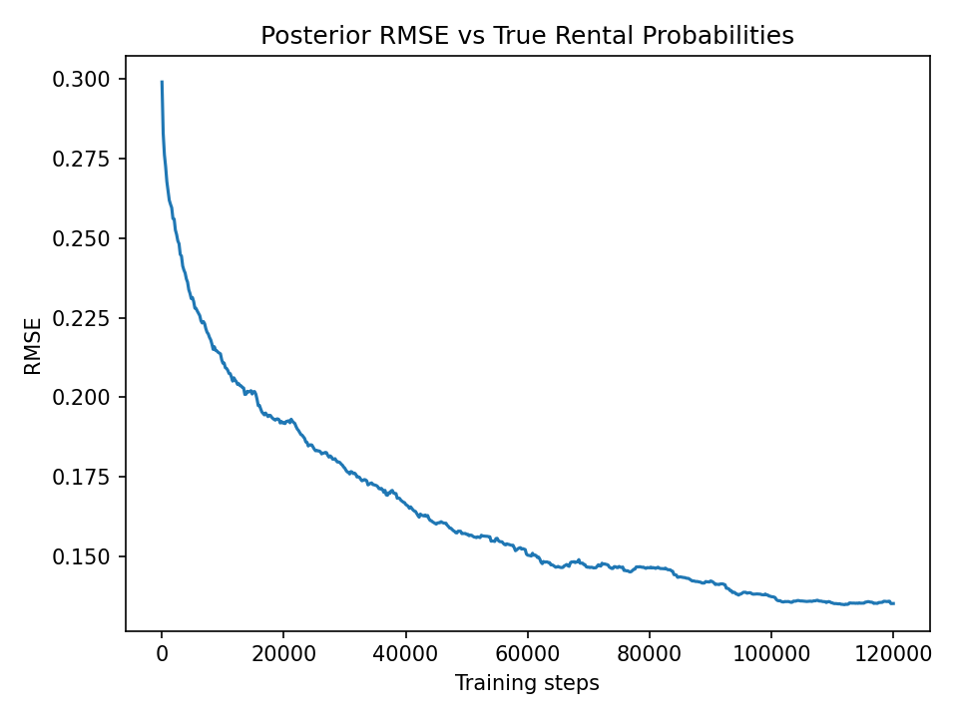
Figure 1. Posterior RMSE vs. true rental probabilities over training.
State coverage mattered. Learning quality was stronger in frequently visited states than in sparse states. The weighted policy accuracy reached about 63.5%, while the unweighted policy accuracy was about 30.8%. That gap is expected because high-traffic states generate feedback more quickly, which allows posterior beliefs to converge faster.
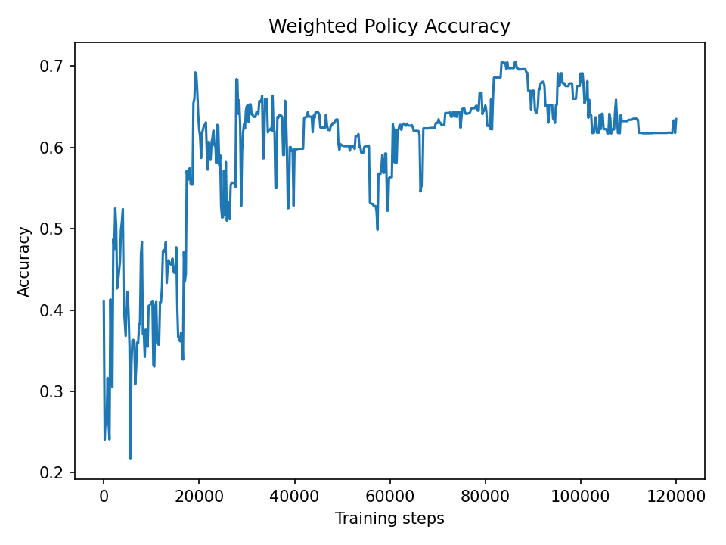 | 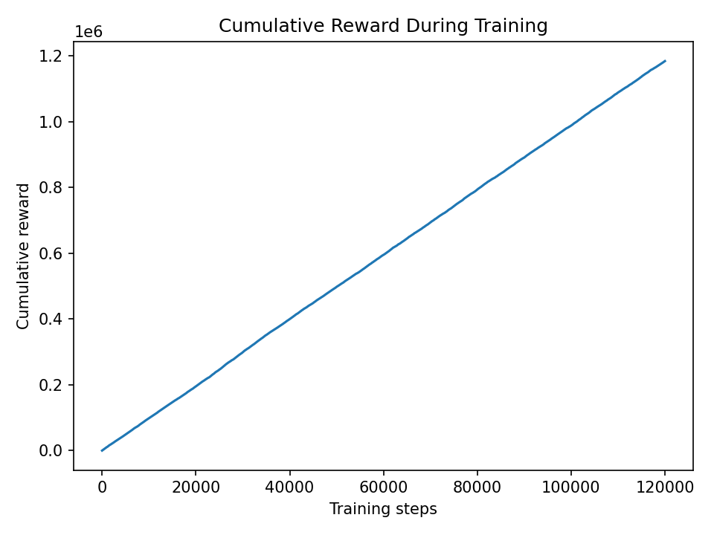
Figure 2. Weighted policy accuracy stabilizes near 0.63. | Figure 3. Cumulative reward grows steadily through training.
Question 2. Were we able to uncover a pricing policy in the simulated environment?
Yes. The benchmark comparison in Table 1 provides the clearest evidence. The learned Thompson Sampling policy achieved an average reward per step of 9.93, which outperformed always-high pricing (9.79), always-medium pricing (9.66), random pricing (9.65), and always-low pricing (9.52). In other words, the model did more than estimate demand: it used those beliefs to choose prices in a way that improved revenue relative to fixed or random rules.
Policy | Average Reward per Step
Learned Ts | 9.93
Always High | 9.79
Always Medium | 9.66
Random | 9.65
Always Low | 9.52
Table 1. Reward comparison between the learned policy and simple benchmark rules.
Interpretation and conclusion
The learned policy is state dependent rather than one-size-fits-all: it adapts prices to market conditions represented by city, time of day, and utilization level. The result should still be interpreted carefully, because the historical data do not contain randomized pricing experiments and the simulator therefore depends on an assumed relationship between price and rental probability. The project does not claim to recover the exact real-world demand curve. Instead, it shows that within a simulated environment calibrated from the provided data, Thompson Sampling can learn approximate demand probabilities and uncover a profitable pricing strategy.

