On Object-relational Mappers with Emphasis on Entity Framework Core
Kevin Morales
Database Systems

Introduction
In the early 2000’s, business and data-driven applications were written without portability in mind. The SQL dialects used were not compatible with every relational database management system. Furthermore, applications had to be written in such a way that tied them to a particular operating system. To overcome these limitations, object-relational mapping technologies were created. The sections that follow will introduce object-relational mappers and will give an overview of the different object-relational mapping libraries and frameworks written for various programming languages. A particular object-relational mapper will be examined, and a reflection on the possible future of object-relational mapping technologies will be made.

What is an Object-relational Mapper?
Object-relational mappers (ORM’s) are collections of application programming interfaces, code generation and command line tools, and database drivers that translate programming language constructs to database concepts. Such a translation is known as “mapping.” Hence, classes and objects are converted to entities, variables are converted to attributes, and annotations aid in adding constraints to the entities and attributes. In its rudimentary form, an object-relational mapper detects a language construct in order to generate the appropriate code (which could be SQL, BSON, and so on) needed to interact with a particular database management software system. A software developer is then able to work at the level of abstraction permitted by his or her language in which a particular program is written or maintained. This is accomplished by mapping object graphs to relations (Red Hat).

Why Use an Object-relational Mapper?
Object-relational mappers are quite useful for purposes of portability, integration, and they can aid in developing applications faster. However, no tool is free, and with great abstractions come great responsibilities. Some advantages of using an object-relational mapper are as follows:
- One is able to work at the level of abstraction provided by the programming language.
- Most of the code that is written is portable, which can aid in switching from an old database management system to a new one.
- It is a useful tool to integrate into micro services and desktop applications.
- It greatly simplifies the interaction between a database management system and an application that needs to connect to it, thus it prevents the developer from writing code that interoperates with the DBMS.
Despite the innovative and powerful nature of object-relational mappers, there are disadvantages that can cause a system to perform poorly if developers do not have the knowledge require to administrate and work with a database. Such disadvantages are as follows:
- The object-relational mapper can generate query language code that performs poorly.
- Not all data types provided by the programming language can be mapped to the DBMS being used.
- Some classes do not map correctly to data tables (LiangOne, 2021).
- There’s much overhead involved (memory and garbage collection overhead, the overhead of extra CPU cycles, and access time overhead).
- There is a learning curve when working with a new object-relational mapper; this adds to the complexities of learning the tools included in the programming language development kit.
Nevertheless, an object-relational mapper, when used carefully, is suitable for modern applications and architectures. They can be used in micro services, monolithic applications, distributed systems, and desktop applications. Object-relational mappers, however, are used in server applications, integrated in micro services or legacy monoliths.

Object-relational Mappers are Language Agnostic
Although the Entity Framework Core relational mapper will be emphasized, ORM technology is not tied to a specific programming language. In fact, in a later section, it will be shown that there are object-relational mappers for the most used programming languages. Since ORM technology is not specific to a particular language, this also means that ORM technology is not tied to a particular programming paradigm; however, relational mappers are popular within object-oriented programming communities, such as those of Java and C#.

Components of an Object-relational Mapper
The functionality of an ORM can be summarized in three tasks:
- The ORM needs to communicate between a developer’s language of choice and the DBMS being used.
- It needs to create new databases, and generate code for the DBMS, and code for the programming language of choice (E.g., from SQL to C#, and vice-versa).
- It needs to retrieve and query data, as well as store new data.
To accomplish these tasks, object-relational mappers have the following components:
- Database drivers: Also known as database providers, they are used to communicate between the developer’s language, and the various database management systems that are not written in the developer’s chosen language; for example, an ORM written in Java must provide drivers for Mongo DB, SQL Server, MySQL, and PostgreSQL.
- Applications programming interfaces: They are used by developers to create applications that retrieve, query, and store data in a systematic, pattern-based manner.
- Code generation facilities: They are used to generate code for a compiler, or for a DBMS to read; some relational mappers have optional command line tools to accomplish this, but command line tooling is not essential to an ORM

Programming Language Features Used in Object-relational Mapping
There are various types of programming language constructs that play a role in some or all components of object-relational mappers. The constructs that will be emphasized are placed within the context of the C# language and the .NET Core platform, but there are equivalent features for the rest of the languages that implement such technologies.

Object-Oriented Features
Classes, object composition, methods, interfaces, inheritance, and polymorphism are used by programmers to build entities, express entity associations, and execute queries. Such features are also used to utilize the code common to every session or database connection and the application being produced. Interfaces are used to implement iterator-like patterns so that sublanguages such as Language Integrated Query (LINQ, a subset of C# and SQL) can be incorporated; a particular class that implement certain iteration-based interfaces are then able to be utilized with LINQ. Furthermore, fields and properties are used to reference entities, include relations in a particular database connection class, and express attributes within entities. Events and polymorphism are used to override configuration options at the time of connection to a database management system. Interfaces and function pointers (also known as delegates) are used to specify actions as parameters to queries in the form of lambda expressions, which are anonymous functions that, in the context of data-driven applications, aid in transforming data; they are used in conjunction with events as well. Finally, classes are used to implement reflection, a technique that allows for the creation of metaprograms and generation of query expressions at runtime.

Compile-Time Features
One useful feature that takes effect during compilation is parameterized types. They aid in the design of classes that represent a database table. They also aid in creating containers such as lists, which hold data returned by a query.
A second feature useful during compilation is facilities provided by a programming platform to call native libraries. The .NET Core platform, for example, provides such capabilities through its DLL Import attribute which is part of the Platform Invoke functionality (Deseyn, 2019). (Although such attribute spells DLL Import, this language feature is functional on operating systems other than Windows.)

A Survey of Object-relational Mappers
The following subsections present object-relational mappers written in the languages commonly used in the industry. Attempts are made to mention the object-relational mappers that are widely used and those which have companies behind their development. However, at least two of these products were developed by the open-source community, and they are written in emerging or fairly new languages such as GO and Rust. Furthermore, this survey will only mention the products which have the features necessary to implement the components listed in “Components of an Object-relational Mapper.”

ODB: Object-Relational Mapping for C++
ODB is developed and maintained by the company Code Synthesis, which develops systems software and programming language translators (Code Synthesis, 2015). ODB can interact with SQLite, MySQL, PostgreSQL, Oracle DB, and Microsoft SQL Server. Through the ODB compiler, C++ developers can generate DDL code to create databases. Furthermore, through the use of type definitions, classes, smart pointers, and pragmas, developers can perform CRUD operations, commit transactions, annotate member fields as primary keys, and execute SQL queries. There is support for optimistic concurrency as well. This product is used by companies such as INTEL. Finally, the functionality of ODB is documented extensively in the ODB Manual, which can be accessed online.

Hibernate: Object-Relational Mapping for Java
Hibernate is developed by the company Red Hat, which develops software that ranges from frameworks to build Java-based services, to software for the cloud. Some database systems supported by the hibernate framework include (Red Hat, 2021)e PostgreSQL, Microsoft SQL Server, Oracle Database, and even Microsoft Access. Hibernate supports object-relational mapping through classes, annotations, methods, and its own query language. Developers of this product have also created command line tools to facilitate working with the framework, and have produced a comprehensive documentation, which aids in learning the various APIs of the framework.

SQL Alchemy: Object-Relational Mapping for Python
SQL Alchemy was initially developed by Michael Bayer, a contributor of software libraries to the Python community (Myers, 2015). This object-relational mapper supports PostgreSQL, MariaDB, MySQL, Oracle Database, and Microsoft SQL Server. Patterns such as factory and iterator are used to create connections, input SQL code, and traverse each query result.

Miscellaneous Object-Relational Mappers
Languages such as GO, Rust, JavaScript, and PHP have object-relational mapping technologies built for their ecosystems of tools. However, they are either emerging languages, or languages that are normally used in other domains (i.e., JavaScript is used for website development). The following list briefly describes some of the object-relational mappers that can be used when working with these languages:
- Propel is the object-relational mapping technology for PHP (Propel ORM).
- GORM is the fully featured object-relational mapper used in the GO community (Jinzhu, 2021).
- Diesel is an object-relational mapper built for the Rust programming language (The Diesel Core Team, 2021).
- JavaScript has various libraries: Sequelize, Mongoose, Bookshelf, and others (Wanyoike, 2021).

Entity Framework Core: Object-Relational Mapping for C#
This object-relational mapper is developed by Microsoft, and it is a cross-platform version of Entity Framework. It supports all of the components of a high-quality object-relational mapper, through object-oriented programming and command line tools. It also supports validation and can be connected to various database systems outside of the Microsoft software ecosystem, such as PostgreSQL, SQLite, MySQL, and Oracle Database. To configure database entities, Entity Framework Core supports a fluent API. The following section shows how to apply Entity Framework core after a database is conceptualized.

Applying Entity Framework Core

Description of the Database
The database that will be used to illustrate concepts pertaining to the utilization of Entity Framework Core is based on a company that produces teaching materials for various programs pertaining to different types of content being transcribed in a written language. The participant entities include employees and programs in which teaching materials are produced (i.e., programs for transcribing mathematical content versus musical scores in the written language). The code used to illustrate the capabilities of the framework will also describe the rest of the database, in order to show how each concept maps to the facilities provided.

The Entity Framework Core Process

Initial Setup
Entity Framework Core requires a project-creation stage (Microsoft, 2017), and the installation of its packages, as shown in the screenshot below:
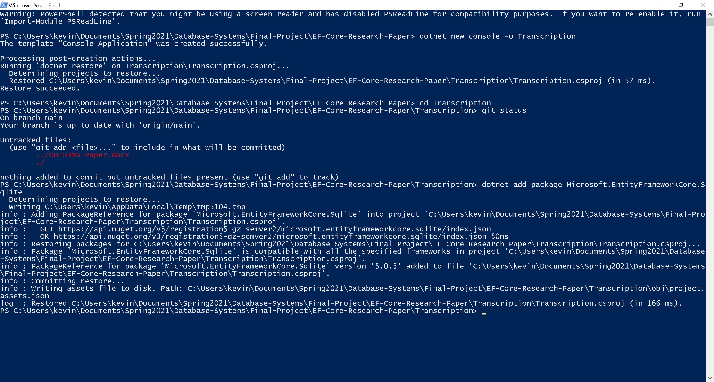

Entity Creation
During this stage, classes are created, which represent the entities that were conceptualized in the design stage. Furthermore, there are packages within the .NET framework core and the entity framework core, which need to be included in each class through the using directive mechanism of the C# language. Those packages are System.Collection.Generic (where generic containers reside), Microsoft.EntityFrameworkCore (which will be required by context classes), and System.ComponentModel.DataAnnotations (where the Key and Required attributes reside). The following code fragment represent two entities that conforms to the Entity Framework patterns:
public class Employee {
[Key]
[Required]
public string EmployeeId { get; set; }
public string ProgramId { get; set; }
[Required]
public string FirstName { get; set; }
[Required]
public string LastName { get; set; }
}
public class TransccriptionProgram {
[Key] [Required]
public string ProgramId { get; set; }
public string EmployeeId { get; set; }
[Required]
public string Type { get; set; }
}
The Key and Required attributes are used to generate a NOT NULL SQL integrity constraint on the database. The C# properties map to attributes of each entity. The keywords get and set allows for modification of the instances of each entity at runtime.

Context Class Creation
Context classes represent a connection between a program and a database system. There are two important events for which actions need to be executed. During configuration of a particular connection, it is necessary to indicate which database system needs to be connected with. During the creation of entities, known as models in Entity Framework Core, relationships between entities need to be specified (one can also specify relationship connectivity by making one entity a property of the other, but the method shown below results in clearer code).
public class TranscriptionDbContext : DbContext {
public DbSet<Employee> Employees { get; set; }
public DbSet<TransccriptionProgram> TransccriptionPrograms { get; set; }
protected override void OnConfiguring(DbContextOptionsBuilder optionsBuilder) {
optionsBuilder.UseSqlite(@"Data Source=Transcription.db");
}
protected override void OnModelCreating(ModelBuilder modelBuilder) {
modelBuilder.Entity<Employee>()
.HasOne<TransccriptionProgram>()
.WithMany()
.HasForeignKey(e => e.ProgramId);
}
}
The properties having the data type of DbSet represent the relations that make up the database. Inside the method OnModelCreating(), a 1-to-many relationship is specified, along with a foreign key for the employee entity. Inheritance is needed because there is code that is executed for all database connections.

Database Creation
The framework also requires the creation of the database through command line tools, once entity classes and context classes are created. The following screenshot shows a sample session where database creation commands are executed:
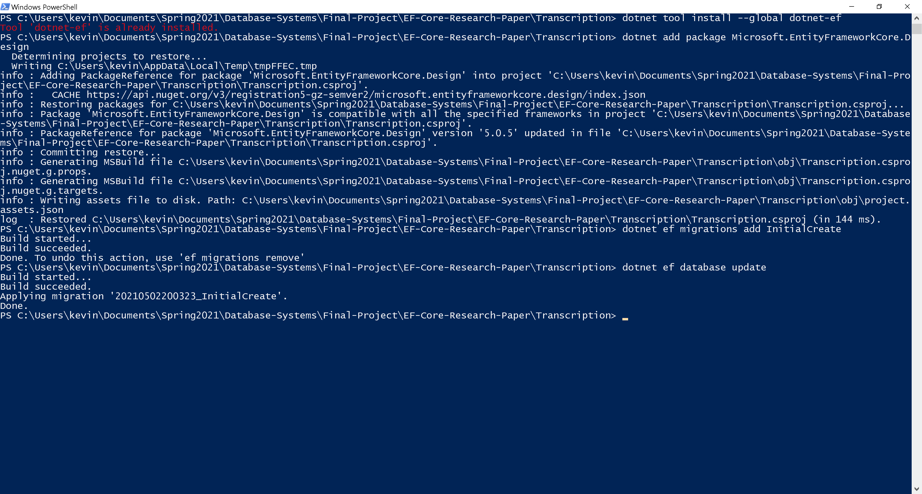

Execution of CRUD Operations
The following screenshot is the result of executing a query that joins both entities by the employee identification:
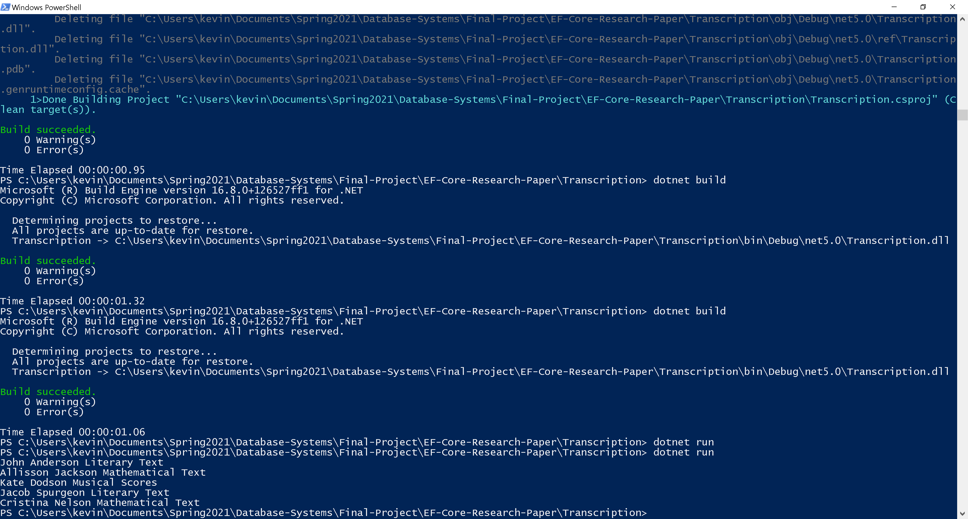
This is accomplished by writing methods inside of a Program class, which makes the connection with the database system of choice by instantiating the corresponding context class. The following code is taken from Program.cs, which adds employees to the database:
static void addEmployees() {
using (var dbContext = new TranscriptionDbContext()) {
dbContext.AddRangeAsync(employeeList);
dbContext.SaveChanges();
}
}
In a similar manner, program records are added to the database. Methods such as AddRangeAsync() add collections of records, including arrays and lists.
The following code fragment performs the join operation between the two relations. It uses LINQ expressions, which are translated to a version of the query that makes use of lambda expressions, and a fluent API that filters and joins the data accordingly.
var query = from employee in dbContext.Set<Employee>()
join program in dbContext.Set<TransccriptionProgram>()
on employee.EmployeeId equals program.EmployeeId
select new { employee, program };
The resulting object, when executing this code fragment, is a touple that contains the data obtained from a join operation from the SQL commands generated at runtime. Applications can iterate through the set of touples, as the following code shows:
foreach (var q in query) {
Console.WriteLine(q.employee.FirstName+" "+q.employee.LastName+" "+q.program.Type);
}

Miscellaneous Features of Entity Framework Core
Other features supported by the framework include:
- The concept of migrations, which allows changes to be made to the database as entities and context classes are refined (Smith, 2021).
- Concurrency control via the [CheckConcurrency] attribute.
- Performance tuning.
- The ability to work with asynchronous input and output operations, so that database operations do not block the main execution thread of an application; this is accomplished through the C# language keywords async and await, and through the generic types for asynchronous operations, found within the package System.Threading.Tasks.
- Other forms of validation via the [RegularExpression] attribute.
- SQL query customizations via the .FromSql() method of the DbSet generic container.
- The ability to save user-defined static methods as stored procedures; this is useful when functions such as COUNT() and AVG() need to be available.
- A rich ecosystem of tools, since the framework is extensible; visual editors and other database providers can be supported by extending the framework.
- The ability to write unit tests for the data-access layer of an application.
Due to the extensibility of Entity Framework Core, cloud database support is also possible; such a database is Cosmos DB.

A Possible Future for Object-Relational Mappers
Object-relational mappers have certain limitations which can make applications perform poorly and have the potential for developers to render them obsolete. Some of these limitations include performance, the lack of support for integration within machine-learning software, and the lack of support for graphic processing units (GPU’s). Some of these limitations are currently being addressed, however.
To address the performance limitations of object-relational mappers, reduced versions of such technologies are being written; the reduced version of an object-relational mapper is known as a micro ORM. Dapper is a Micro ORM that allows developers to have more control over queries, and only the necessary layers to work at the level of abstraction that the C# programming language requires.
Academics have noticed the limitation that relational database management systems do not currently run-on graphics processing units. They have proposed a general scheme for adapting such software systems for CUDA-based graphics processors (Li, Tu, & Zeng, 2019). Academics have conducted a thorough study of graphics-processing devices to take advantage of their capabilities and be able to distribute database-management tasks so that such software can run efficiently on those devices.
The third type of limitation can be addressed by allowing for classes to be designed in such a way that machine-learning models and database systems can communicate. Entity attributes can be part of features that train particular models. Queries can be written as methods that are executed by cross-validation objects, and training and test sets can be retrieved through such queries.

Conclusion
Object-relational mappers are software packages that allow software developers to communicate with database systems from their chosen programming language(s). The functionality provided by object-relational mapping technology is provided via command line tools and application programming interfaces. Many of the programming languages used in the industry support object-relational mapping technology, some having more than one choice of framework or library. Entity Framework Core is a fully featured object-relational mapper that takes advantage of the most important features of the C# language, including object-oriented programming, asynchronous input and output operations, and its language-integrated query expressions. The most important conclusion that can be made when working with object-relational mappers is that such technologies require database design and development concepts to be understood precisely. Without database design and development skills, developers are prone to writing inefficient queries, and create databases that may contain data redundancy and integrity problems.

References
Code Synthesis. (2015). C++ Object Persistence with ODB. Retrieved from Code Synthesis .com: https://www.codesynthesis.com/products/odb/doc/manual.xhtml
Deseyn, T. (2019, 09 06). Interacting With Native Libraries in .NET Core 3.0. Retrieved from Red Hat Developer .com: https://developers.redhat.com/blog/2019/09/06/interacting-with-native-libraries-in-net-core-3-0/
Jinzhu. (2021). GORM. Retrieved from GORM .io: https://gorm.io/index.html
Li, H., Tu, Y.-C., & Zeng, B. (2019, 04 16). Concurrent query processing in a GPU-based database system. PLOS ONE. doi:10.1371/journal.pone.0214720
LiangOne, M. (2021, 04 11). Understanding Object-Relational Mapping. Retrieved from AltexSoft.com: https://www.altexsoft.com/blog/object-relational-mapping/
Microsoft. (2017, 09 17). Getting Started with EF Core. Retrieved from Microsoft Docs .com: https://docs.microsoft.com/en-us/ef/core/get-started/overview/first-app?tabs=netcore-cli
Myers, J. (2015). Essential SQLAlchemy: Mapping Python to Databases 2nd Edition (2 ed.). O'Reilly Media.
Propel ORM. (n.d.). Propel 3. Retrieved from Git Hub .com: https://github.com/propelorm/Propel3
Red Hat. (2021, 01 05). Hibernate ORM. Retrieved from Hibernate ORM .com: https://hibernate.org/orm/
Red Hat. (n.d.). What is Object / Relational Mapping? Retrieved 04 10, 2021, from Hibernate ORM: https://hibernate.org/orm/what-is-an-orm/
Smith, J. P. (2021). Entity Framework Core in Action (2 ed.). Shelter Island, NY: Manning Publications. Retrieved from https://www.manning.com/books/entity-framework-core-in-action-second-edition
The Diesel Core Team. (2021). Diesel is a Safe, Extensible ORM and Query Builder for Rust. Retrieved from Diesel .rs: https://diesel.rs/
Wanyoike, M. (2021, 03 22). 9 Best JavaScript and TypeScript ORMs for 2021. Retrieved from SitePoint .com: https://www.sitepoint.com/javascript-typescript-orms/

