**An interactive smartphone application for species identification**

Nathalie Isabelle ChardonEnvironmental Studies Program

nathalie.chardon@colorado.edu University of Colorado, Boulder

***Introduction:*** Scientists in the Environmental Studies department need your help creating a tool to allow almost anyone with a smartphone to help document the effects of climate change in alpine environments. For our research, we are planning to recruit an army of “citizen scientists” (volunteers who do not necessarily have any scientific training) in order to collect data at a scale beyond what a few researchers could accomplish, while increasing scientific literacy and public awareness of our changing natural environment. Have you ever gone hiking and seen a beautiful flower but did not how to begin to figure out what it is? I am proposing a smartphone application (app) to let volunteers and researchers quickly identify and navigate to the many different plant species that live on the the [Niwot Ridge Long Term Ecological Research](http://niwot.colorado.edu/) (LTER) site above University of Colorado’s (CU’s) [Mountain Research Station](http://www.colorado.edu/mrs/). Not only will the user appreciate discovering exactly what they’re looking at, but they will also be able to upload the geographic coordinates of the species occurrences to a publicly available database. In this way, the app will engage outdoor recreationalists in learning more about their environment, while also contributing meaningful data to scientific research. Both the research and education components of this work are centered on fragility of alpine ecosystems that are very sensitive to climate change.

Every year visitors and researchers from around the world come to Niwot Ridge to learn, recreate, and conduct various research activities, yet few have a grasp on the immense species diversity present. With the support of students in CU Boulder’s Computer Science (CS) Department, I hope to develop a smartphone app that functions as a digital field guide specifically for Niwot Ridge and includes photos of plant species as well descriptions to help aid their identification. Furthermore, this app will have the option to upload a user’s own picture of a plant and the corresponding geographic location to a server accessible to all app users via a website. The resulting species distribution maps will not only greatly aid researchers in studying how species are affected by climate change, but will also allow visitors at Niwot Ridge to navigate to plants of interest. Such spatial data will also lay the foundation for additional citizen science projects, such as allowing elementary school children to record flowering events at Niwot Ridge.

During the 2014-2015 academic year, I worked with students in the CS Department to develop the existing Luminous ID version 1 (Fig. 1; Chardon et al. 2015), which is a mobile species field guide for the alpine flowers at Niwot Ridge and includes a recognition algorithm for the abundant cushion plant, moss campion (*Silene acaulis*) ([Chardon & Smith 2015](http://news.lternet.edu/Article3224.html)). This fully functional app has greatly increased public awareness of alpine plants in Colorado while providing an interactive citizen science project.

(A) (B) (C)

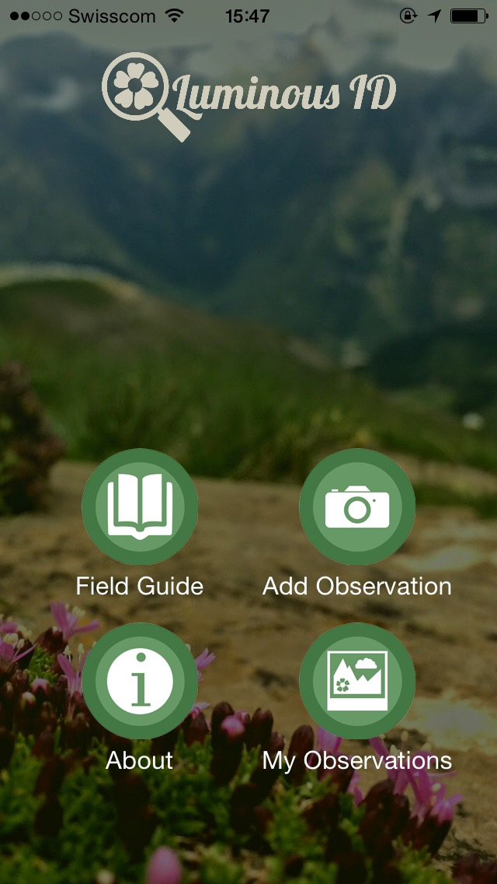 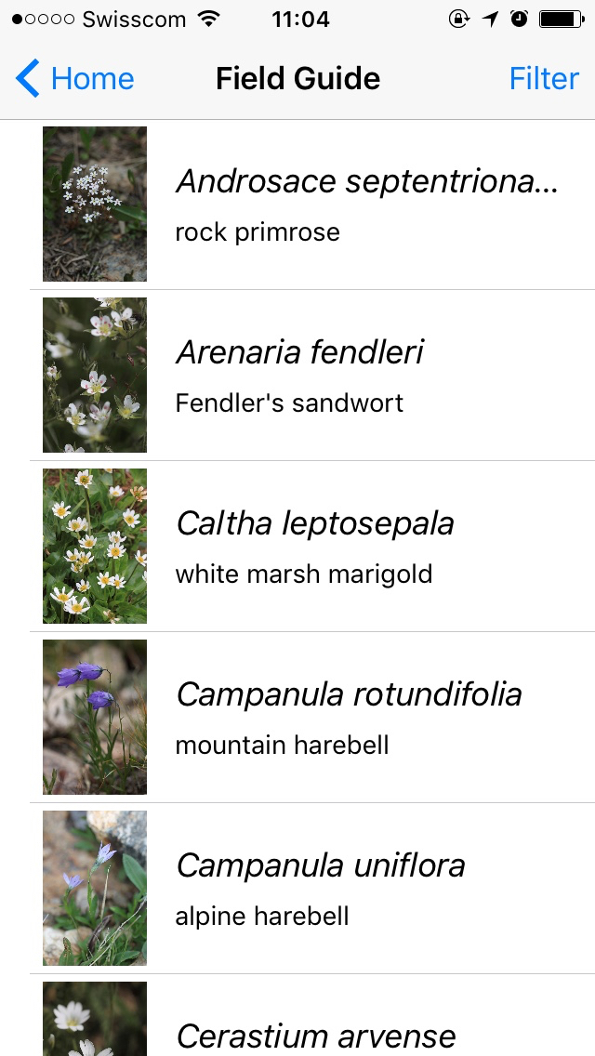 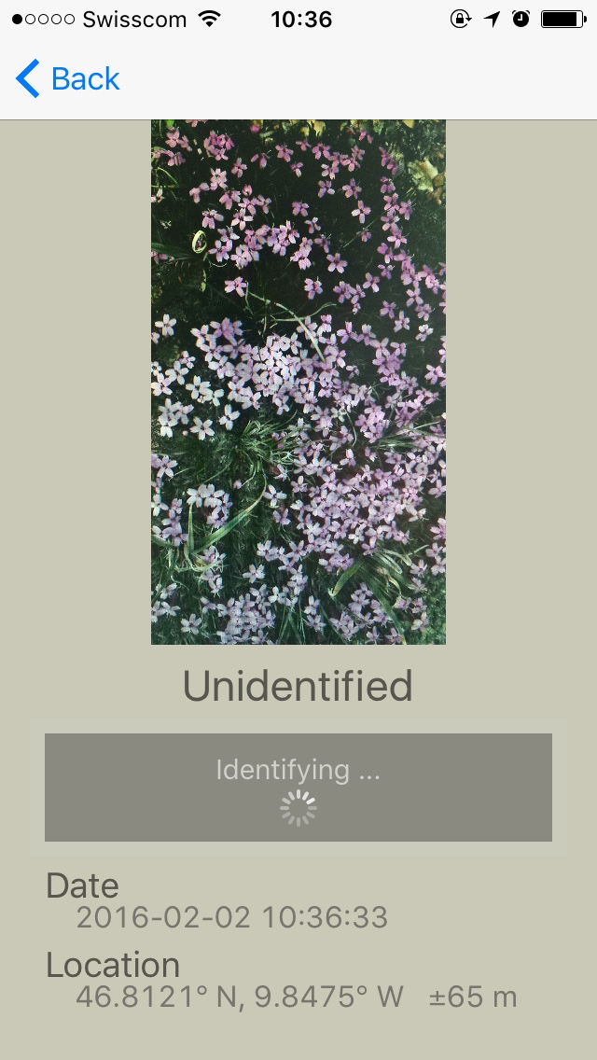

**Figure 1.** The home screen (A) of Luminous ID ver. 1 gives the user the option to access the field guide (B) and run a recognition algorithm of a photograph taken of a plant (C). Plants recognized as moss campion are uploaded to a server, and users can review all observations.

***Current functions:*** Luminous ID ver. 1 currently has two main functions. One, it uses a binary classifier visual recognition algorithm to identify moss campionwith a photograph taken by the user, and correctly identified observations are recorded with the corresponding geographic data and the photograph. Once back in an area with cellular reception, the user synchronizes these observations with the server. Two, it has a photographic field guide for the alpine flowers at Niwot Ridge, which are searchable by a filter based on seven plant characteristics (e.g., flower color, habitat). The [developed code](https://github.com/Aardevarken/LuminousMossBosses) is open source, and one of the developers of ver. 1 is based in Boulder and is available for questions both at the Project Fair and during the academic year. Developers may choose to keep any or no aspects of Luminous ID ver. 1.

***Project Goals:*** With the support of students in the CU Boulder’s CS Department, the smartphone app Luminous ID ver. 2 will be an interactive app that includes a full species list of all plants (e.g., trees, grasses, etc.) found at the Niwot LTER searchable by a filter function, an observation upload option of species photographs and their geographic locations, and a species distribution map with navigation capabilities. All information will be hosted on a public website, allowing users and researchers to interact. Specifically, the goals of Luminous ID ver. 2 are the following:

1. A major expansion to the existing species field guide, which currently only includes alpine flowers, to include all plant species found at Niwot Ridge.
2. An additional set of search filters so users can quickly find any species in this new species field guide.
3. A new option to upload a GPS observation for any of the species in the field guide by users, instead of just the option to upload moss campion observations. A ‘researcher verified’ function available to public researchers, instead of just the development team, will ensure that the species observations uploaded are either uploaded by researchers themselves or verified by a researcher post-upload.
4. The development of species distribution maps based on uploaded observations that allows users to navigate to species of interest with the app.
5. Additions to the current website to allow for interactive functions. Users will be able to manage their observations, view other observations, and see where a species of interest is distributed. Approved researchers will be able to verify species observation uploads. This allows for a useful feedback loop between users and researchers.

The overarching goals of this project are not only to develop a smartphone app that will generate useful data for researchers while involving the public in science, but also to encourage collaboration between the Environmental Studies and CS departments. I will work closely with students to ensure that the application’s design and functions suit the needs of this application, yet will leave most design and coding decisions up to the students. I will provide a full list of species, their descriptions, and photographs. I will be involved in this project throughout the academic year, and propose to visit the Niwot LTER with the development team in September to gain a better understanding of the user’s physical environment.

***Requirements:*** Developers need development platforms for iOS and Android phone apps, and have the option of choosing iPad and Tablet app development if desired. Users need iOS or Android smartphone operating systems. The Luminous ID [website](http://luminousid.com/) currently uses Amazon Web Services (AWS) and the free app is hosted on the Apple AppStore and on GooglePlay. Developers can choose an alternate web hosting service if desired. Yearly funding for AWS and for an Apple Developer License to distribute the app on the AppStore is provided by the Niwot LTER, and funding is available for additional server requirements. All accounts run under my name, but access is readily available to developers.

This project requires a great deal of creativity to solve several exciting challenges, such as ensuring that the app and website user interface is intuitive to use, designing an effective method to store a large amount of geographic data so that it can be accessed by users, and allowing app users to navigate to species of interest. This project is thus an ideal one for student developers who seek experience in mobile app development to connect with a large body of users while providing an important research and citizen science app for CU Boulder’s Niwot LTER site. The proprietary rights will remain with the students, the code can remain open source, and the app will be available free of charge to all iOS and Android users.

**References**

Chardon NI & Smith JG. (2015). Researchers at Niwot LTER develop an alpine plant

smartphone app. *LTER Network News: Network News Summer 2015*. 28(2).

<http://news.lternet.edu/Article3224.html>.

Chardon NI,Miller J, Bauer B, Garske M, Rail J, Shprengel A, Skinner J & Smith JG. (2015).

Luminous ID (Version 1) [Mobile Application Software]. Available on iOS App Store

and Android Google Play. <luminousid.com>.