Save As this document listing your entire groups’ names and the project number. (**curry_timmer_smith_Project4**)  
You will only need to send it to me **once**. If someone’s name is not included, they will not receive a grade.

Group Members:

**Project 4: Turtle Graphics: STOP sign**

Write a program that uses a loop to draw an octagon with the word “STOP” displayed in its center. The STOP sign should be centered in the graphics window. Then create two more traffic signs. All three Signs should demonstrate practicality, including, proper colors, patterns, etc.

**Requirements:**

1. **Create a Flowchart**

(Flowcharts help you catch possible mistakes early on and also let you see if you want to add more functionality.)  
Example:   
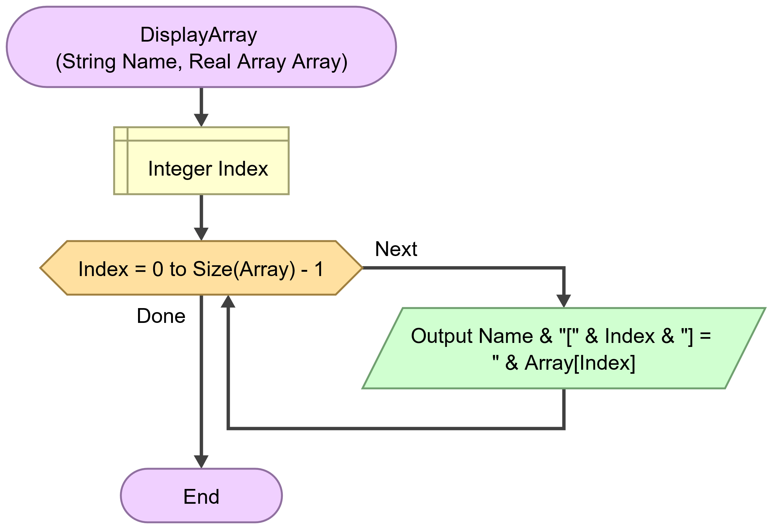

**Delete the above description of Flowcharts and then copy and paste your Flowchart(s) here, #1:**

1. **Write Pseudocode**

(Pseudocode is an informal high-level representation of the actual code that shows how an algorithm or a computer program works in plain English.)

Example:  
Say you want to write a program that prints odd numbers from 00 to 99. Let’s start by writing it in simple pseudocode. Remember, this code won’t compile and execute on its own.

set i to 0

for each i from 0 to 9

if i is odd

print i

end for loop

**Note:** Pseudocode does not have a specific syntax. Your pseudocode can look different from ours.

Pseudocoding may sound trivial to you, and you may want to jump right into coding, but it does make things a lot easier. Now, all you need to do is convert this plain English into actual code.

**Delete the above description of pseudocode and then copy and paste your pseudocode here, under #2:**

1. **Write Python Code**

(Use your choice of IDLE, write the Python code(s) associated with your project. Copy and paste each here. I must be able to copy and paste each into my own IDLE in order to test it. If I am unable, you will not receive points.)

1. **Show and Tell Final Results**

(Screenshot and paste to show your Signs (3 total). Include feedback regarding the process: what worked, what did not work, what did you have to do to overcome, learning points, etc…Think ‘write up’ like results in a Research project.)