# Lab 04: Task Management and Kanban

Our next step is to extend our task management system beyond simple GitHub issues. We will use a task board approach that comes from [Kanban](https://en.wikipedia.org/wiki/Kanban_(development)). [Lecture 8](../../lectures/lecture08) goes into more detail about Kanban.

## Behavioural Objectives

* [ ] **Create** a *Kanban Board on Zube.*
* [ ] **Create** a *Sprint Board on Zube.*
* [ ] **Run** a *Sprint*.

## Setting up Zube.io

GitHub does support task boards - see the **Projects** tab in your repository for details. We are going to use a different system provided by [Zube](https://zube.io/). This is because Zube:

* Integrates with GitHub tasks.
* Provides more functionality, such as story points.

Connecting your GitHub repository is simple. Just go to https://zube.io/ and click the **Signup with GitHub** button.



Zube Main Screen

Follow the instructions to connect your account. Once you get to the main screen you are ready to start setting up your project.

### Creating an Organisation

Next we need to create a new organisation in Zube. An organisation is a way of managing projects. You should see a button with **Create a new organization**. Click this button to open the new organisation window.

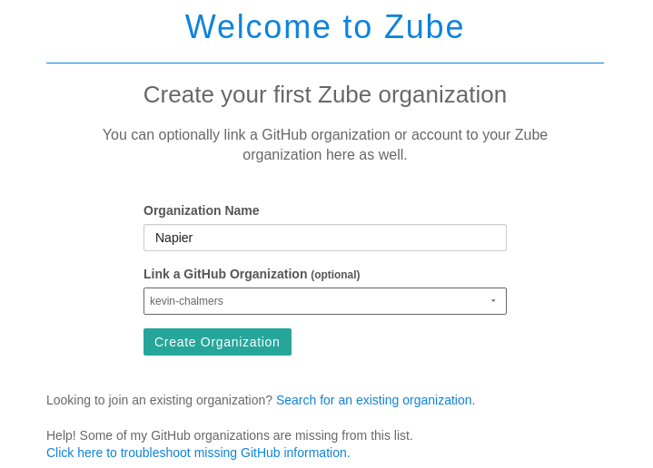

Zube New Organisation

Use **Napier** as the organisation name, and **ensure you link to your GitHub account name as an organisation** and click **Create Organization**. This will open the new project window.

### Creating a Project

Next we need to create a project:

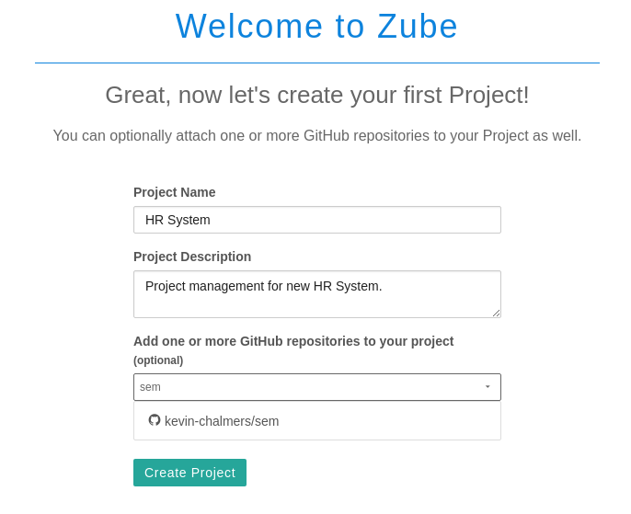

Zube New Project

**Ensure you link the repository you are using for the labs.** Use the same details as above and click **Create Project**.

## Organising Your Task Board

You should now see your project task board:

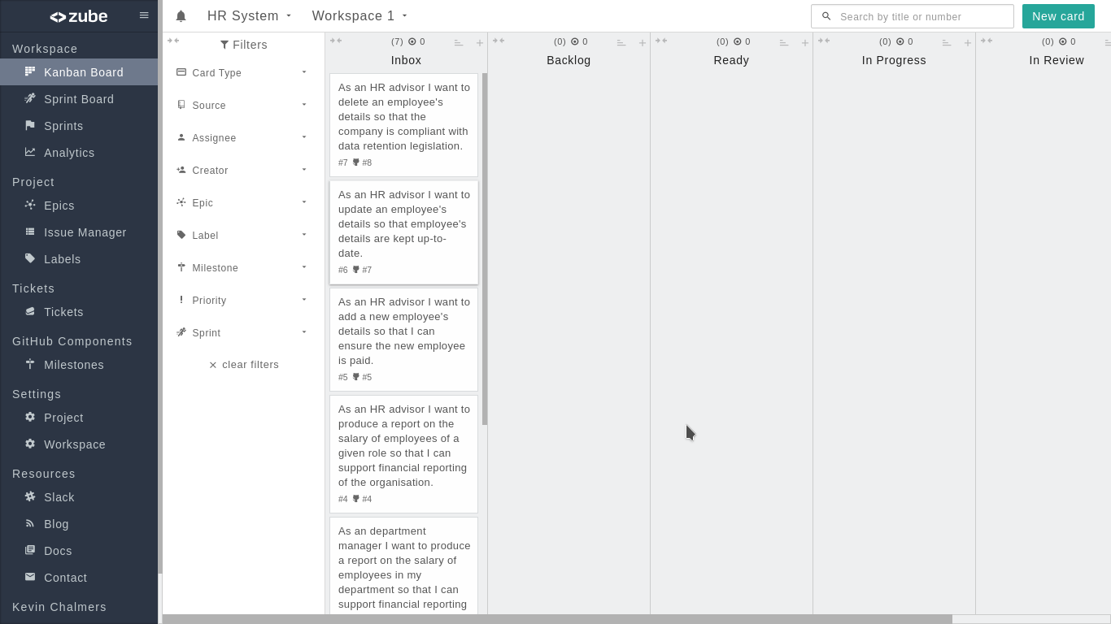

Zube Kanban Board

We are now going to go through two processes:

1. Assigning story points to our current tasks.
2. Prioritising tasks.

### Assigning Story Points

In the notes for [Lecture 2](../../lectures/lecture02) we looked at how we assign points to tasks. It is all about estimating the size of a task against other tasks. Zube lets us assign story points to tasks. To do so, **Click** on a **task card** on the Kanban board. This will open the task details window:

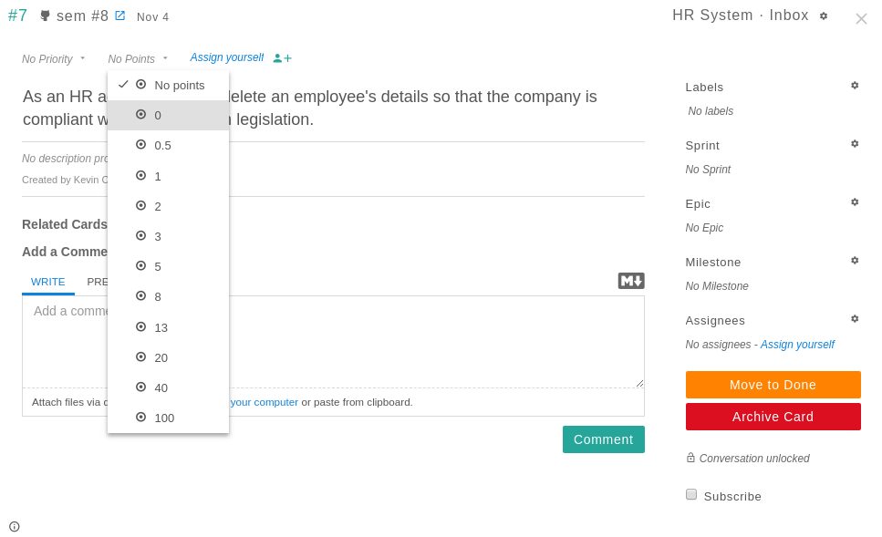

Zube Task Details

As you can see, there is a drop-down menu where you can set the points for a task. To close the details of a task **click** the **cross** at the top-right of the details window.

#### Exercise

Assign points to our current tasks. It is up-to-you to decide the scores based on your own estimate.

### Prioritising Tasks

Next we will prioritise tasks. This is done by moving task cards up and down in the task board. It is that simple. Ordering tasks is the job of the **Product Owner**. At present, the order of tasks needs to be:

* #1 Produce a report of all salaries.
* #4 Produce a report of salaries by role.
* #2 Produce a report of salaries by department (HR advisor).
* #3 Produce a report of salaries by department (department manager).
* #5 Add new employee.
* #7 Update employee details.
* #8 Delete employee details.

This is the current order tasks will be completed for the project, but it is subject to change. Remember, we have planned, but we will keep planning.

## Setting up a Sprint Board

Now it is time to set up a *Sprint*. Remember from [Lecture 02](../../lectures/lecture02) that a Sprint is a fixed-time where we attempt to do work. A Sprint can have different durations, but for the labs we are going to work in a single week (as that is the amount of time to do a lab). We define the work we are going to do and then we work on it - **not adding any new work to the sprint.**

Zube features **Sprint Boards**. To use these, first we need to set-up a Sprint. To do this, click on the **Sprints** menu option on the left. This will open up the following view:

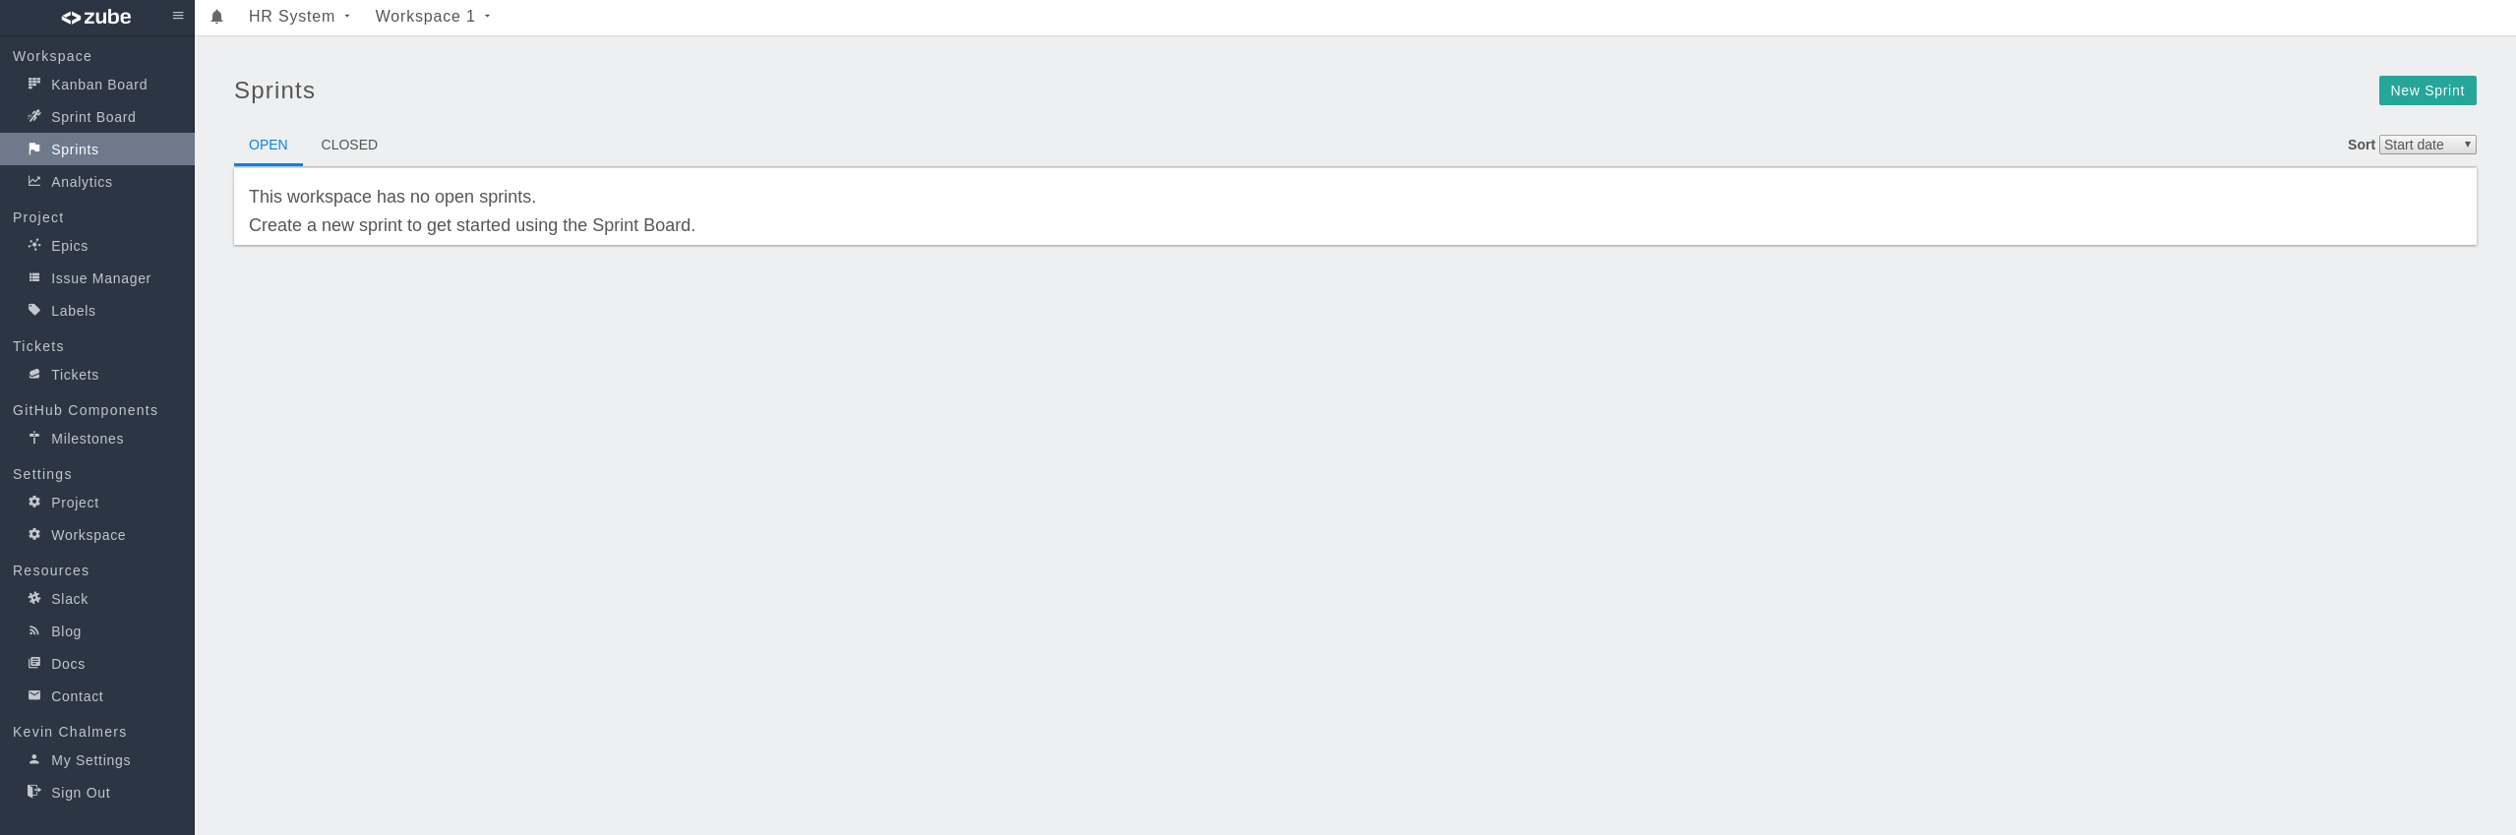

Zube Sprints Window

Now we need to create a new Sprint. **Click the New Sprint button** on the top-right to open the New Sprint view:

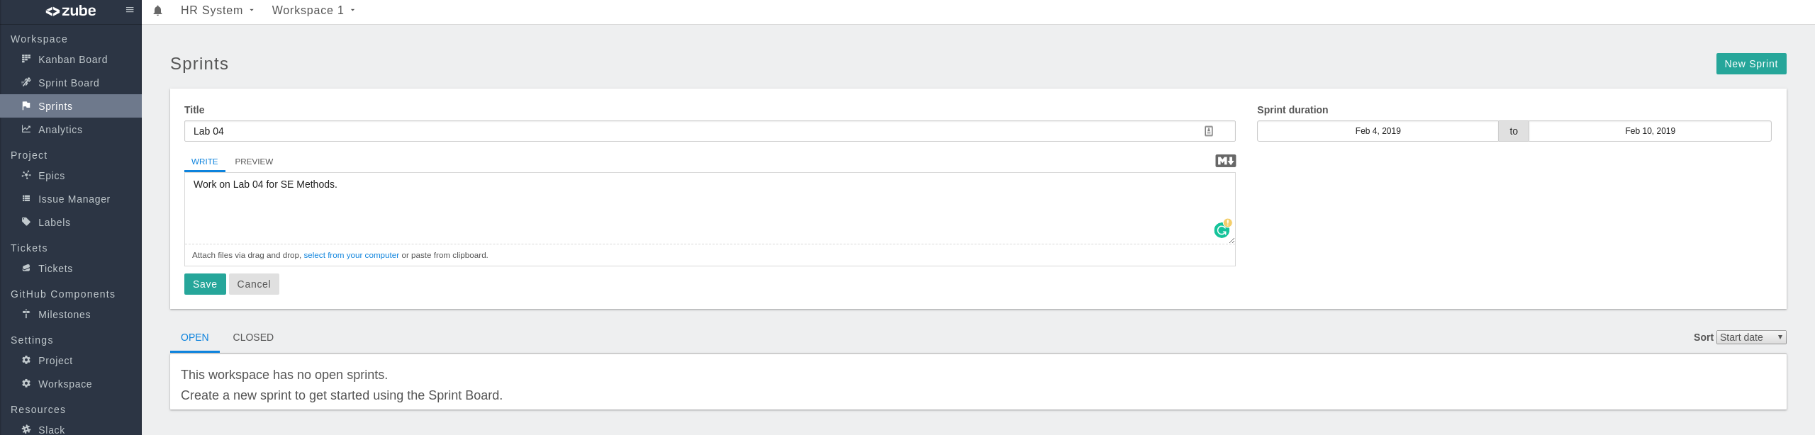

Zube New Sprint

Enter the details as shown in the image above:

* Title: Lab 04
* Description: Work on Lab 04 for SE Methods.
* Dates: As appropriate for the week you are doing this. In 2019, that was Feb 04 (Monday) until Feb 10 (Sunday).

**Click Save** and the Sprint will be created. Now click on **Sprint Board** on the left-hand menu to open the Sprint Board view:

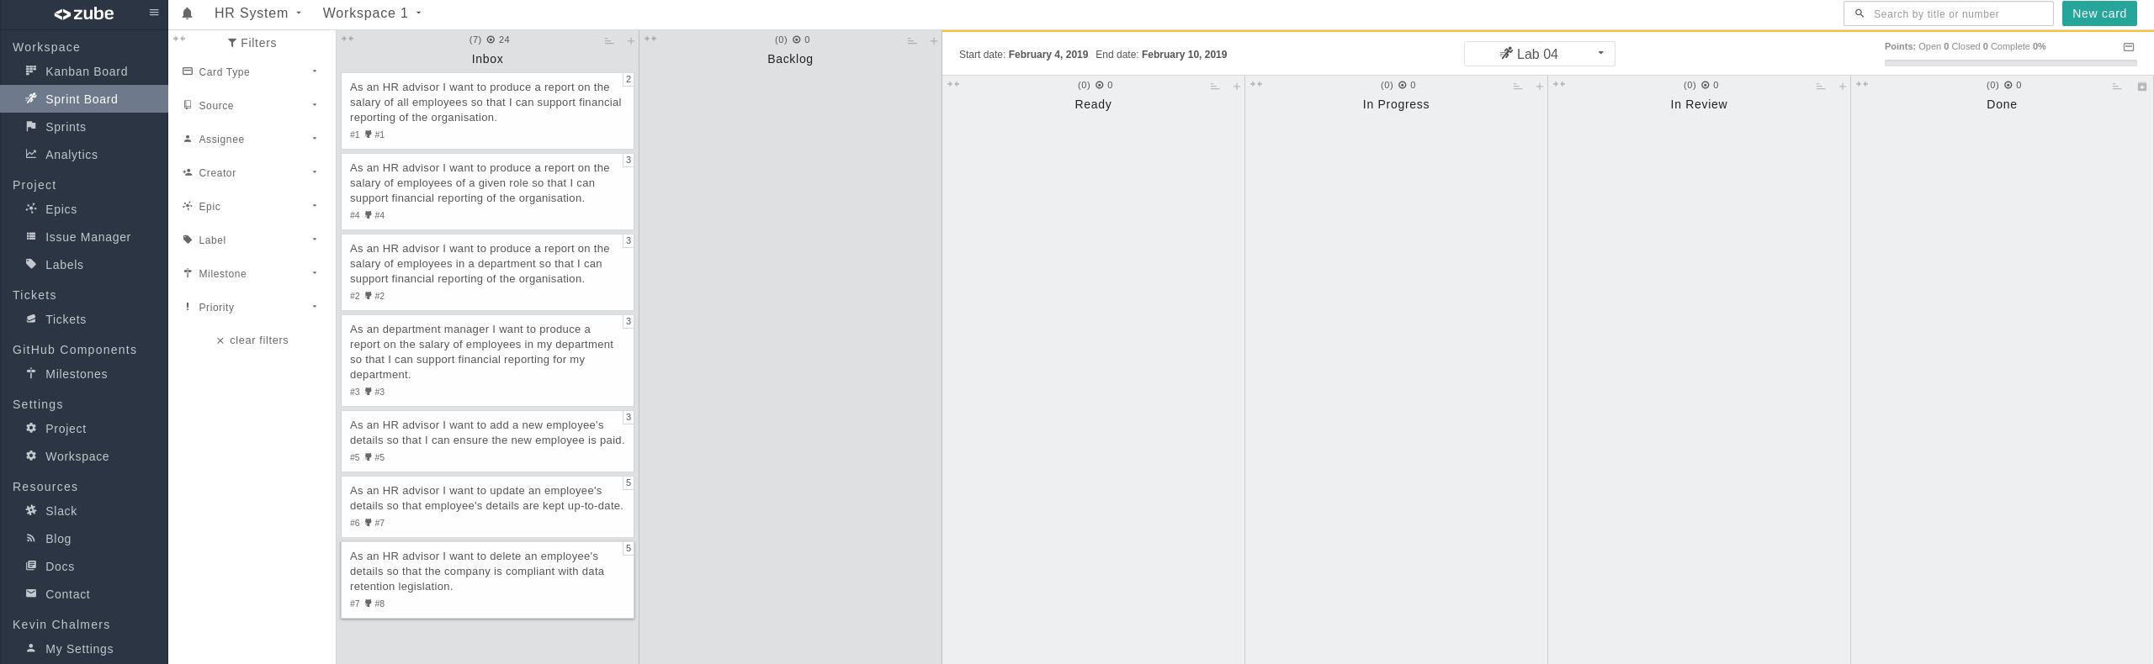

Zube Sprint Board

Notice that the columns to the right (Ready, In Progress, In Review, and Done) are now in the Sprint section of the Sprint Board. This is to indicate that these columns are related to the Sprint we are going to do. We will use these columns to manage our work during this Sprint.

## Next Feature: Salary Report

Now we are ready to start our next feature: the *Salary Report*. To do this, we first need to create a new **Feature Branch** in our Git repository, called feature/salary-report. **Do this now.** Remember to switch to the new branch in IntelliJ.

### Starting a Sprint

Next we need to setup our Sprint Board. The task we are going to work on (1. As an *HR advisor* I want *to produce a report on the salary of all employees* so that *I can support financial reporting of the organisation.*) must be placed in the **Ready** column of the Sprint Board. All other tasks should be put into the **Backlog**. Below is how your Sprint Board should look:

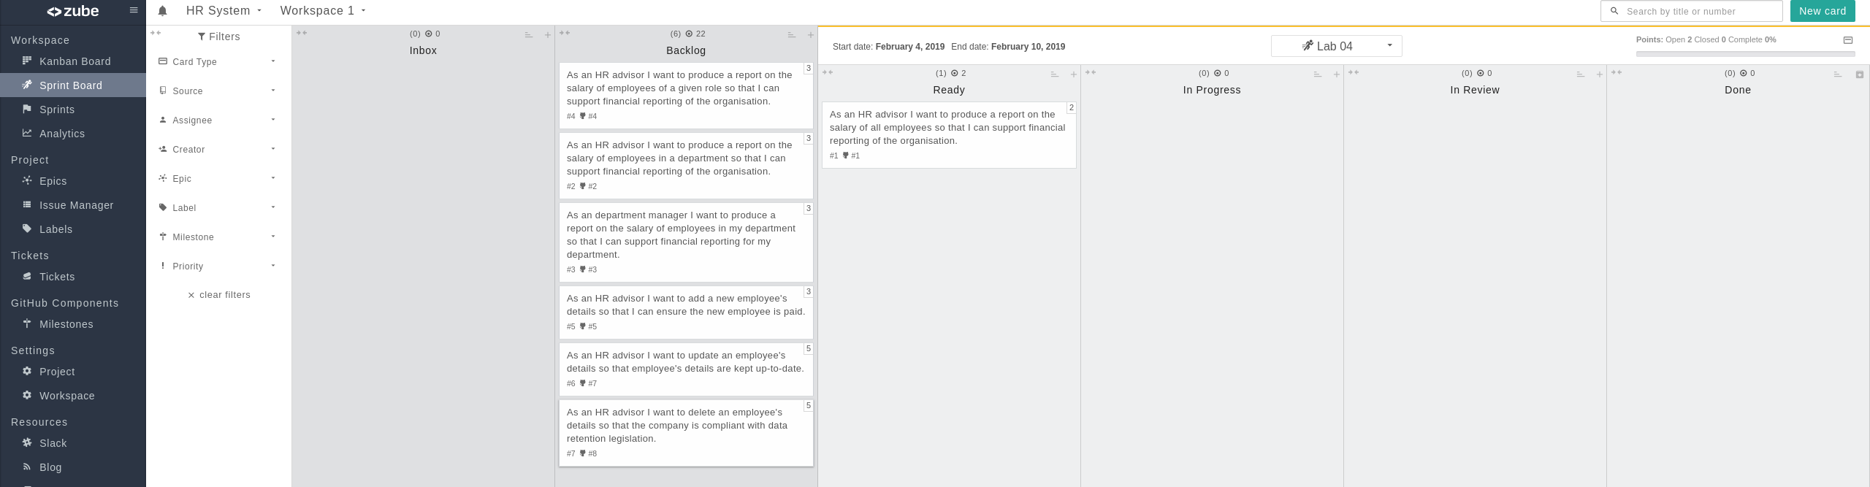

Zube Sprint Start

### Adding New Tasks

As in [Lab 03](../lab03) our user story has a few tasks:

1. Get all current salaries from the database.
2. Print list of salaries.

We can add these tasks as new **Cards** on Zube. This is to avoid them appearing as issues on GitHub. To do this, **click the New Card Button** at the top-right of the Sprint Board. This will open the **New Card Dialogue Window**:

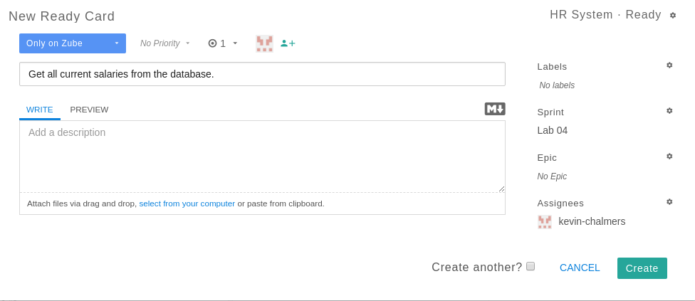

Adding Zube Card

We now need to add the details for each of the tasks above. Enter the details for task 1 as shown:

* Only on Zube.
* 1 story point.
* Assign to yourself.
* Title: Get all current salaries from the database.
* Sprint: Lab 04.

The details for task 2 are the same but with a different title. After both cards are added, reorder your **Ready Column** on the Sprint Board to look as follows:

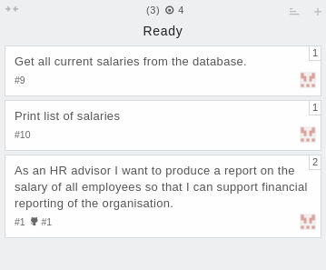

Zube Ready Tasks

We are now ready to get to work.

### Getting Salary Information

Our first task is to get all the current salaries. First, move this card into the **In Progress Column** on Zube:

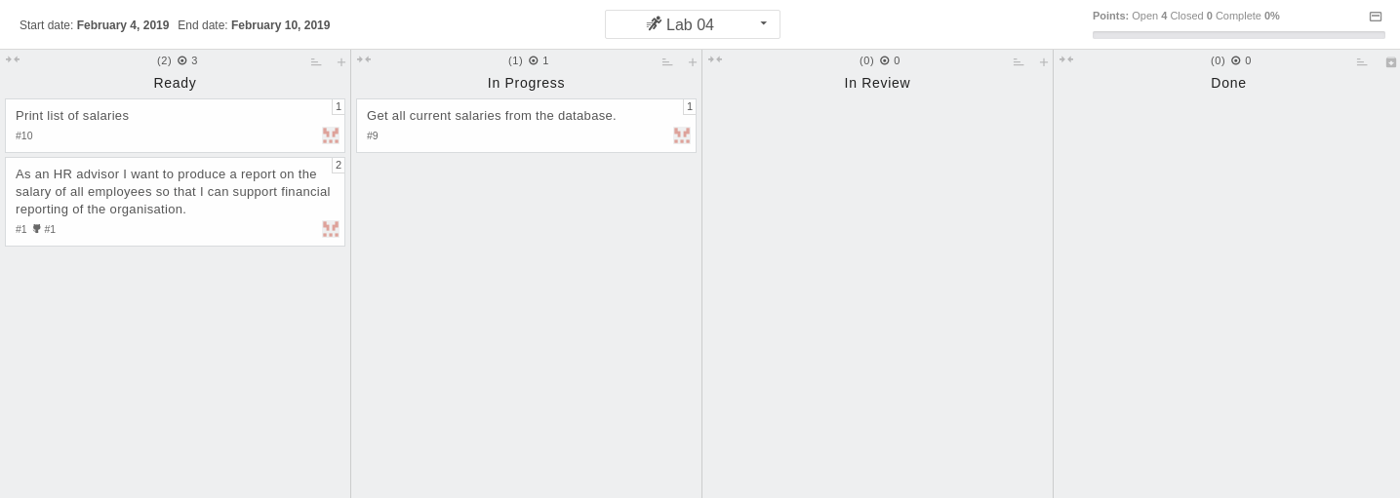

Zube In Progress Card

First we need to work out our SQL statement. Examine the [database schema](https://dev.mysql.com/doc/employee/en/sakila-structure.html)

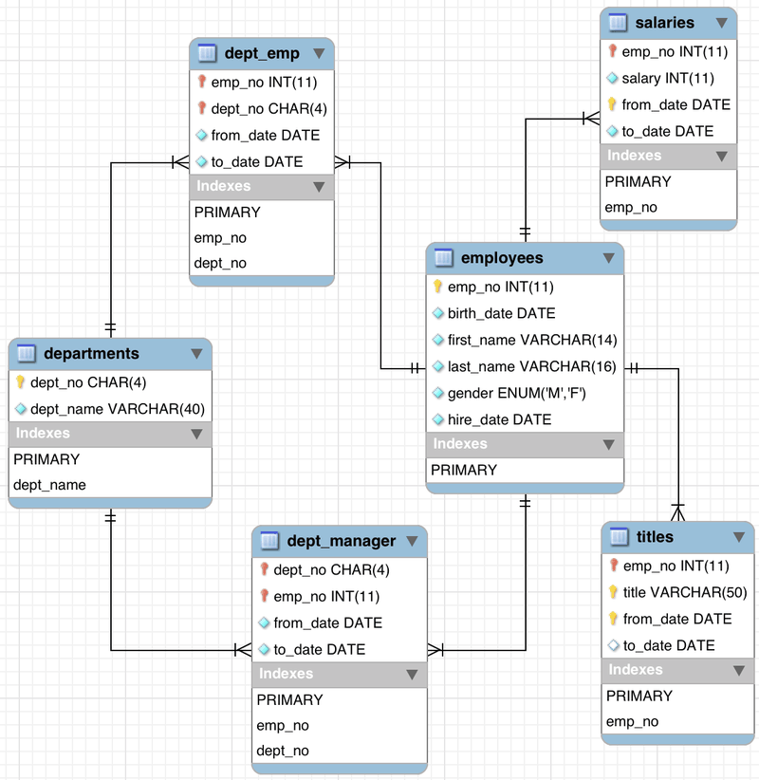

Employees Database Schema

We have to *join* the employees and salaries tables. We do this by selecting both of them with the FROM clause and using WHERE to define how we will join the tables:

SELECT ???  
FROM employees, salaries  
WHERE employees.emp_no = salaries.emp_no

We must also select only current salaries. Remember that the database uses 9999-01-01 as an undefined date, so any current salary will have salaries.to_date equal to 9999-01-01:

SELECT ???  
FROM employees, salaries  
WHERE employees.emp_no = salaries.emp_no AND salaries.to_date = '9999-01-01'

We need the following information at least:

* emp_no
* first_name
* last_name
* salary

We add that to our SELECT statement:

SELECT employees.emp_no, employees.first_name, employees.last_name, salaries.salary  
FROM employees, salaries  
WHERE employees.emp_no = salaries.emp_no AND salaries.to_date = '9999-01-01'

Finally, just to make life easier, we will sort on emp_no. We can do this in SQL as follows:

SELECT employees.emp_no, employees.first_name, employees.last_name, salaries.salary  
FROM employees, salaries  
WHERE employees.emp_no = salaries.emp_no AND salaries.to_date = '9999-01-01'  
ORDER BY employees.emp_no ASC

With our SQL statement ready, we can write the Java code to get the employees. It is very similar to the single get employee method last week but now returns an ArrayList of Employee. To use this type, add java.util.ArrayList to your import statements.

/**  
* Gets all the current employees and salaries.  
* @return A list of all employees and salaries, or null if there is an error.  
*/  
public ArrayList<Employee> getAllSalaries()  
{  
 try  
 {  
 // Create an SQL statement  
 Statement stmt = con.createStatement();  
 // Create string for SQL statement  
 String strSelect =  
 "SELECT employees.emp_no, employees.first_name, employees.last_name, salaries.salary "  
 + "FROM employees, salaries "  
 + "WHERE employees.emp_no = salaries.emp_no AND salaries.to_date = '9999-01-01' "  
 + "ORDER BY employees.emp_no ASC";  
 // Execute SQL statement  
 ResultSet rset = stmt.executeQuery(strSelect);  
 // Extract employee information  
 ArrayList<Employee> employees = new ArrayList<Employee>();  
 while (rset.next())  
 {  
 Employee emp = new Employee();  
 emp.emp_no = rset.getInt("employees.emp_no");  
 emp.first_name = rset.getString("employees.first_name");  
 emp.last_name = rset.getString("employees.last_name");  
 emp.salary = rset.getInt("salaries.salary");  
 employees.add(emp);  
 }  
 return employees;  
 }  
 catch (Exception e)  
 {  
 System.out.println(e.getMessage());  
 System.out.println("Failed to get salary details");  
 return null;  
 }  
}

We will do a quick update to main just to check everything works:

public static void main(String[] args)  
{  
 // Create new Application  
 App a = new App();  
  
 // Connect to database  
 a.connect();  
  
 // Extract employee salary information  
 ArrayList<Employee> employees = a.getAllSalaries();  
  
 // Test the size of the returned data - should be 240124  
 System.out.println(employees.size());  
  
 // Disconnect from database  
 a.disconnect();  
}

And now we are ready to test. Remember what we have to do:

1. Ensure **all** previous versions of sem_app are deleted - containers and images.
2. **Compile** the project via Maven.
3. **Package** the project via Maven.
4. **Run** the docker-compose file.

Hopefully, you will eventually receive the following output:

Connecting to database...  
Successfully connected  
240124

And we have completed our first task. Go back to Zube, and click the card for the task to open it’s details:

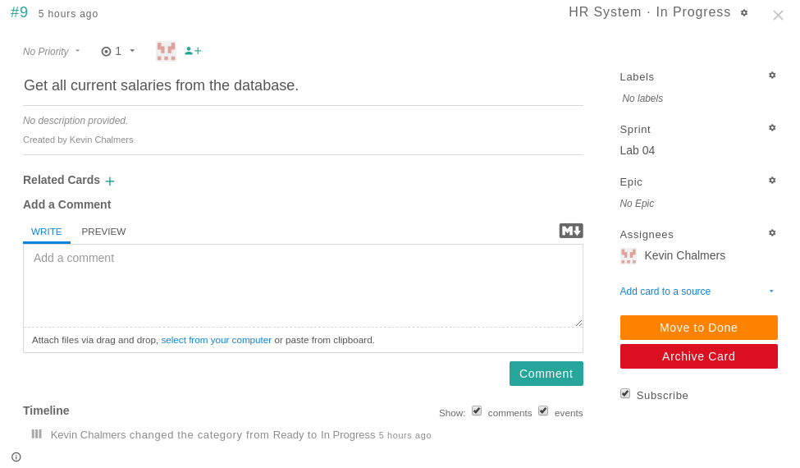

Zube Card

**Click Move to Done** and the task is finished. Close the card and you will see it in the **Done** column:

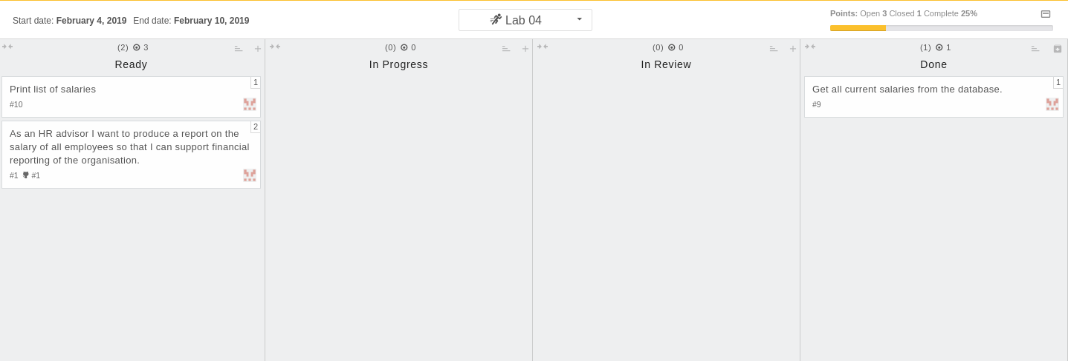

Zube Card Done

Notice in the top-right we have a visual indication of how much work we have done during this Sprint. If the card is also a *GitHub* issue this will close the issue. You can also **drag the card** to **Done** for the same effect.

**REMEMBER** - commit your code!

### Printing Salary Information

Now to complete the second task. **Move the card in Zube to the In Progress Column**. Remember, we are visualising the current work being undertaken. We must ensure our Sprint Board is kept up-to-date.

Printing the salaries just requires a new bit of Java code:

/**  
* Prints a list of employees.  
* @param employees The list of employees to print.  
*/  
public void printSalaries(ArrayList<Employee> employees)  
{  
 // Print header  
 System.out.println(String.format("%-10s %-15s %-20s %-8s", "Emp No", "First Name", "Last Name", "Salary"));  
 // Loop over all employees in the list  
 for (Employee emp : employees)  
 {  
 String emp_string =  
 String.format("%-10s %-15s %-20s %-8s",  
 emp.emp_no, emp.first_name, emp.last_name, emp.salary);  
 System.out.println(emp_string);  
 }  
}

We use String.format to put the data into columns based on the information we have from the database schema - mainly around column sizes. If you are unfamiliar with String.format examine the [Java API documentation](https://docs.oracle.com/javase/7/docs/api/java/util/Formatter.html#syntax).

When run, you will get a list of all the current salaries. The end of the list is below:

...  
499977 Martial Weisert 77858   
499979 Prasadram Waleschkowski 54088   
499980 Gino Usery 108364   
499981 Yunming Mitina 63193   
499983 Uri Juneja 52429   
499984 Kaijung Rodham 66202   
499985 Gila Lukaszewicz 47543   
499986 Nathan Ranta 119906   
499987 Rimli Dusink 56336   
499990 Khaled Kohling 45512   
499991 Pohua Sichman 52867   
499992 Siamak Salverda 80389   
499993 DeForest Mullainathan 44305

And now end the task on Zube. Either **drag the card to Done** or **open the card and Mark as Done**. Our tasks are now complete - we just need to finalise everything.

### Committing and Cleaning Up

We are now ready to complete everything for the Sprint. First **commit and push your work to GitHub.** Next, we need to perform our release steps:

1. Update the version number in Maven and the Dockerfile. You should be at v0.1-alpha-4 (v0.1.0.4) now.
2. Merge the feature branch into develop.
3. Merge develop into release.
4. Create the release - including version tag.
5. Merged release into master.
6. Merged release into develop.
7. Clean up Docker containers and images.

We can also finish our user story on Zube - **drag** or **Move to Done** the user story card. We have now completed our Sprint work.

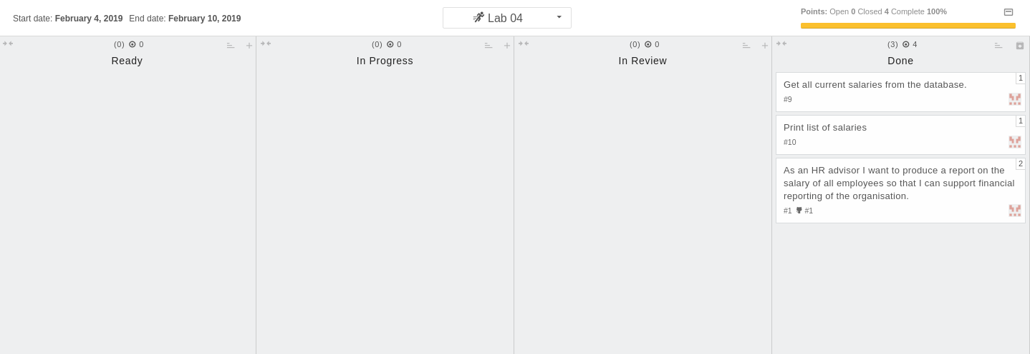

Zube Completed Sprint Board

Finally on Zube, select **Sprints** on the left-hand menu, and **click Close on the Lab 04 Sprint*. This will end the Sprint.

And we are done. You have successfully completed your first lab Sprint, and used tools to support the process.

## Our Current Process

We have expanded our process at the start and the end to incorporate our Sprint methodology:

1. Decide which user story/stories to work on for the next Sprint.
2. Create a new Sprint on Zube.
3. Add the user story card(s) to the Ready column in Zube.
4. Add any additional task cards to Zube and put in priority order.
5. Pull the latest develop branch.
6. Start a new feature branch for the task(s) or user story.
7. Select task to work on in Zube.
8. Work on task.
9. Repeat 7-8 until feature is complete.
10. Once feature is finished, create JAR file.
11. Update and test Docker configuration with Travis.
12. Update feature branch with develop to ensure feature is up-to-date.
13. Check feature branch still works.
14. Merge feature branch into develop.
15. Repeat 5-14 until Sprint is complete.
16. Merge develop branch into release and create release.
17. Merge release into master and develop.
18. Close the Sprint.

This is our main process now, and although we might add a few small additions (e.g. around testing), we are in a good place for the remainder of the module.