03-analisis-v3

# Estimaciones con grupo etario mov estudiantil 2006

Para esta estimación, se modifican los grupos etarios dando énfasis a que, además de los jóvenes, las personas mayores de 46 años participaron en el plebiscito del 88.

## Participación en marchas

#if (!require("pacman")) install.packages("pacman") # instalar pacman  
 # cargar librerias  
pacman::p_load(dplyr, # Manipulacion de datos  
 knitr,  
 kableExtra,  
 summarytools,  
 lme4,  
 texreg,  
 interactions,  
 ggplot2  
 )  
load(file = here::here("input/data-proc/df_study1_long_t7.RData"))  
  
# generate analytical sample  
df_study1 <-   
 df_study1_long_t7 %>%  
 select(idencuesta,ola,part_marchas, edad, sexo, pos_id, educ, universitaria, ponderador_long_total) %>%   
 na.omit() %>%   
 mutate(ola_num=as.numeric(ola),  
 ola=as.factor(ola),  
 edad = case_when(edad <=23~"Entre 18 y 23",  
 edad >23 & edad <=28 ~ "Entre 24 y 28",  
 edad >28 & edad <=45 ~ "Entre 29 y 45",  
 edad > 45 ~ "Más de 45"))   
df_study1$edad <- factor(df_study1$edad, levels = c("Más de 45", "Entre 29 y 45", "Entre 24 y 28", "Entre 18 y 23"))  
df_study1$sexo <- factor(df_study1$sexo, levels = c(1, 2), labels = c("Hombre", "Mujer"))  
  
sjmisc::frq(df_study1$edad)

x <categorical>   
# total N=11028 valid N=11028 mean=1.62 sd=0.85  
  
Value | N | Raw % | Valid % | Cum. %  
-----------------------------------------------  
Más de 45 | 6243 | 56.61 | 56.61 | 56.61  
Entre 29 y 45 | 3378 | 30.63 | 30.63 | 87.24  
Entre 24 y 28 | 761 | 6.90 | 6.90 | 94.14  
Entre 18 y 23 | 646 | 5.86 | 5.86 | 100.00  
<NA> | 0 | 0.00 | <NA> | <NA>

# Hipotesis  
h1 <- "ola"  
h2 <- "ola+edad"  
h3 <- "ola+edad+sexo"  
h4 <- "ola+edad+sexo+educ"  
h5 <- "ola+edad+sexo+educ+pos_id"  
h6 <- "ola*edad+sexo+educ+pos_id"  
h7 <- "ola*sexo+edad+sexo+educ+pos_id"  
h8 <- "ola*educ+edad+sexo+educ+pos_id"  
h9 <- "ola*pos_id+edad+sexo+educ+pos_id"  
h10 <- "ola*pos_id*edad+sexo+educ+pos_id"  
h11 <- "ola*educ*edad+sexo+educ+pos_id"  
h12 <- "ola*sexo*edad+sexo+educ+pos_id"  
  
marchar.null <- lmer(formula(paste0("part_marchas~","1 + (1|idencuesta)")),data = df_study1, weights = ponderador_long_total)  
marchar1 <- lmer(formula(paste0("part_marchas~",h1,"+(1|idencuesta)")),data = df_study1, weights = ponderador_long_total)  
marchar2 <- lmer(formula(paste0("part_marchas~",h2,"+(1|idencuesta)")),data = df_study1, weights = ponderador_long_total)  
marchar3 <- lmer(formula(paste0("part_marchas~",h3,"+(1|idencuesta)")),data = df_study1, weights = ponderador_long_total)  
marchar4 <- lmer(formula(paste0("part_marchas~",h4,"+(1|idencuesta)")),data = df_study1, weights = ponderador_long_total)  
marchar5 <- lmer(formula(paste0("part_marchas~",h5,"+(1|idencuesta)")),data = df_study1, weights = ponderador_long_total)  
marchar6 <- lmer(formula(paste0("part_marchas~",h6,"+(1|idencuesta)")),data = df_study1, weights = ponderador_long_total)  
marchar7 <- lmer(formula(paste0("part_marchas~",h7,"+(1|idencuesta)")),data = df_study1, weights = ponderador_long_total)  
marchar8 <- lmer(formula(paste0("part_marchas~",h8,"+(1|idencuesta)")),data = df_study1, weights = ponderador_long_total)  
marchar9 <- lmer(formula(paste0("part_marchas~",h9,"+(1|idencuesta)")),data = df_study1, weights = ponderador_long_total)  
marchar10 <- lmer(formula(paste0("part_marchas~",h10,"+(1|idencuesta)")),data = df_study1, weights = ponderador_long_total)  
marchar11 <- lmer(formula(paste0("part_marchas~",h11,"+(1|idencuesta)")),data = df_study1, weights = ponderador_long_total)  
marchar12 <- lmer(formula(paste0("part_marchas~",h12,"+(1|idencuesta)")),data = df_study1, weights = ponderador_long_total)

texreg::knitreg(list(marchar1, marchar2, marchar3, marchar4, marchar5, marchar6, marchar7, marchar8, marchar9, marchar10, marchar11),  
 custom.note = "*** p < 0.001; ** p < 0.01; * p < 0.05")

Statistical models

Model 1

Model 2

Model 3

Model 4

Model 5

Model 6

Model 7

Model 8

Model 9

Model 10

Model 11

(Intercept)

1.35***

1.23***

1.27***

1.18***

1.39***

1.43***

1.41***

1.32***

1.42***

1.44***

1.37***

(0.02)

(0.03)

(0.03)

(0.03)

(0.04)

(0.04)

(0.04)

(0.04)

(0.05)

(0.06)

(0.05)

ola2

-0.10***

-0.10***

-0.10***

-0.10***

-0.10***

-0.09**

-0.11***

-0.04

-0.05

-0.13*

-0.03

(0.02)

(0.02)

(0.02)

(0.02)

(0.02)

(0.03)

(0.03)

(0.03)

(0.04)

(0.06)

(0.04)

ola3

-0.15***

-0.16***

-0.16***

-0.16***

-0.16***

-0.13***

-0.27***

-0.03

-0.17***

-0.20**

-0.04

(0.02)

(0.02)

(0.02)

(0.02)

(0.02)

(0.03)

(0.03)

(0.03)

(0.04)

(0.06)

(0.04)

ola4

0.41***

0.40***

0.40***

0.40***

0.40***

0.08*

0.45***

0.33***

0.40***

0.19**

0.09*

(0.02)

(0.02)

(0.02)

(0.02)

(0.02)

(0.03)

(0.03)

(0.03)

(0.04)

(0.06)

(0.04)

ola5

-0.14***

-0.15***

-0.15***

-0.15***

-0.15***

-0.20***

-0.18***

-0.00

-0.23***

-0.34***

-0.06

(0.02)

(0.02)

(0.02)

(0.02)

(0.02)

(0.03)

(0.03)

(0.03)

(0.05)

(0.07)

(0.04)

ola6

-0.12***

-0.13***

-0.13***

-0.13***

-0.13***

-0.15***

-0.13***

-0.07*

-0.19***

-0.21**

-0.05

(0.02)

(0.02)

(0.02)

(0.02)

(0.02)

(0.03)

(0.03)

(0.03)

(0.04)

(0.07)

(0.04)

ola7

-0.23***

-0.24***

-0.24***

-0.24***

-0.24***

-0.18***

-0.31***

-0.06*

-0.34***

-0.30***

-0.05

(0.02)

(0.02)

(0.02)

(0.02)

(0.02)

(0.03)

(0.03)

(0.03)

(0.04)

(0.06)

(0.04)

edadEntre 29 y 45

0.18***

0.18***

0.12***

0.13***

0.01

0.13***

0.12***

0.13***

-0.04

0.05

(0.04)

(0.04)

(0.03)

(0.03)

(0.05)

(0.03)

(0.03)

(0.03)

(0.09)

(0.06)

edadEntre 24 y 28

0.34***

0.34***

0.23***

0.23***

0.17*

0.23***

0.23***

0.24***

0.36**

0.02

(0.06)

(0.06)

(0.06)

(0.05)

(0.07)

(0.05)

(0.05)

(0.05)

(0.14)

(0.10)

edadEntre 18 y 23

0.49***

0.49***

0.40***

0.40***

0.39***

0.41***

0.41***

0.40***

0.60***

0.15

(0.06)

(0.06)

(0.06)

(0.06)

(0.07)

(0.06)

(0.06)

(0.06)

(0.15)

(0.11)

sexoMujer

-0.06

-0.04

-0.03

-0.03

-0.07

-0.03

-0.02

-0.03

-0.03

(0.03)

(0.03)

(0.03)

(0.03)

(0.04)

(0.03)

(0.03)

(0.03)

(0.03)

educTécnica

0.22***

0.22***

0.22***

0.22***

0.40***

0.22***

0.21***

0.36***

(0.04)

(0.04)

(0.04)

(0.04)

(0.06)

(0.04)

(0.04)

(0.08)

educUniversitaria

0.36***

0.36***

0.37***

0.36***

0.51***

0.37***

0.37***

0.60***

(0.04)

(0.04)

(0.04)

(0.04)

(0.05)

(0.04)

(0.04)

(0.08)

pos_idCentro

-0.28***

-0.28***

-0.28***

-0.28***

-0.32***

-0.29***

-0.27***

(0.04)

(0.04)

(0.04)

(0.04)

(0.06)

(0.08)

(0.04)

pos_idDerecha

-0.41***

-0.42***

-0.41***

-0.41***

-0.42***

-0.43***

-0.40***

(0.05)

(0.05)

(0.05)

(0.05)

(0.07)

(0.09)

(0.05)

pos_idNo se identifica

-0.25***

-0.25***

-0.25***

-0.25***

-0.30***

-0.27***

-0.24***

(0.04)

(0.04)

(0.04)

(0.04)

(0.05)

(0.07)

(0.04)

ola2:edadEntre 29 y 45

0.09

0.30**

-0.02

(0.05)

(0.09)

(0.06)

ola3:edadEntre 29 y 45

0.05

0.21*

-0.02

(0.05)

(0.09)

(0.06)

ola4:edadEntre 29 y 45

0.30***

0.46***

0.20**

(0.05)

(0.10)

(0.06)

ola5:edadEntre 29 y 45

0.16**

0.36***

0.04

(0.05)

(0.10)

(0.07)

ola6:edadEntre 29 y 45

0.12*

0.25*

0.02

(0.05)

(0.10)

(0.07)

ola7:edadEntre 29 y 45

0.09

0.25**

-0.05

(0.05)

(0.10)

(0.06)

ola2:edadEntre 24 y 28

0.03

-0.01

0.06

(0.07)

(0.13)

(0.10)

ola3:edadEntre 24 y 28

-0.15*

-0.25

0.09

(0.07)

(0.13)

(0.10)

ola4:edadEntre 24 y 28

0.61***

0.07

0.41***

(0.07)

(0.13)

(0.10)

ola5:edadEntre 24 y 28

0.27***

-0.06

0.18

(0.07)

(0.13)

(0.11)

ola6:edadEntre 24 y 28

-0.02

-0.24

0.14

(0.07)

(0.13)

(0.11)

ola7:edadEntre 24 y 28

-0.24***

-0.65***

0.06

(0.07)

(0.13)

(0.10)

ola2:edadEntre 18 y 23

-0.30***

-0.27

0.01

(0.07)

(0.14)

(0.11)

ola3:edadEntre 18 y 23

-0.15*

-0.11

0.19

(0.07)

(0.15)

(0.11)

ola4:edadEntre 18 y 23

1.06***

0.44**

1.26***

(0.07)

(0.15)

(0.10)

ola5:edadEntre 18 y 23

-0.14*

-0.07

0.37***

(0.07)

(0.15)

(0.10)

ola6:edadEntre 18 y 23

-0.07

-0.28*

-0.05

(0.07)

(0.14)

(0.10)

ola7:edadEntre 18 y 23

-0.23***

-0.32*

0.19*

(0.06)

(0.13)

(0.09)

ola2:sexoMujer

0.02

(0.04)

ola3:sexoMujer

0.21***

(0.04)

ola4:sexoMujer

-0.10*

(0.05)

ola5:sexoMujer

0.06

(0.05)

ola6:sexoMujer

-0.00

(0.05)

ola7:sexoMujer

0.14**

(0.04)

ola2:educTécnica

-0.18**

-0.27**

(0.06)

(0.09)

ola3:educTécnica

-0.34***

-0.37***

(0.06)

(0.09)

ola4:educTécnica

0.02

-0.14

(0.06)

(0.09)

ola5:educTécnica

-0.21**

-0.39***

(0.06)

(0.09)

ola6:educTécnica

-0.17**

-0.29**

(0.06)

(0.09)

ola7:educTécnica

-0.40***

-0.40***

(0.06)

(0.09)

ola2:educUniversitaria

-0.13*

-0.10

(0.05)

(0.10)

ola3:educUniversitaria

-0.27***

-0.19*

(0.05)

(0.09)

ola4:educUniversitaria

0.33***

0.08

(0.05)

(0.10)

ola5:educUniversitaria

-0.41***

-0.59***

(0.05)

(0.10)

ola6:educUniversitaria

-0.10

-0.35***

(0.05)

(0.10)

ola7:educUniversitaria

-0.42***

-0.49***

(0.05)

(0.10)

ola2:pos_idCentro

-0.13*

-0.02

(0.06)

(0.09)

ola3:pos_idCentro

0.02

0.07

(0.06)

(0.09)

ola4:pos_idCentro

0.06

-0.13

(0.06)

(0.09)

ola5:pos_idCentro

0.11

0.11

(0.07)

(0.09)

ola6:pos_idCentro

0.13

0.08

(0.06)

(0.09)

ola7:pos_idCentro

0.18**

0.14

(0.06)

(0.09)

ola2:pos_idDerecha

-0.01

0.04

(0.07)

(0.10)

ola3:pos_idDerecha

0.04

0.15

(0.07)

(0.10)

ola4:pos_idDerecha

-0.22**

-0.25*

(0.07)

(0.11)

ola5:pos_idDerecha

0.08

0.24*

(0.08)

(0.11)

ola6:pos_idDerecha

-0.00

0.13

(0.07)

(0.11)

ola7:pos_idDerecha

0.14*

0.19

(0.07)

(0.11)

ola2:pos_idNo se identifica

-0.04

0.09

(0.06)

(0.08)

ola3:pos_idNo se identifica

0.03

0.09

(0.06)

(0.08)

ola4:pos_idNo se identifica

0.07

-0.12

(0.06)

(0.09)

ola5:pos_idNo se identifica

0.13*

0.22*

(0.06)

(0.09)

ola6:pos_idNo se identifica

0.08

0.06

(0.06)

(0.09)

ola7:pos_idNo se identifica

0.12*

0.15

(0.06)

(0.09)

pos_idCentro:edadEntre 29 y 45

0.18

(0.13)

pos_idDerecha:edadEntre 29 y 45

0.16

(0.15)

pos_idNo se identifica:edadEntre 29 y 45

-0.03

(0.12)

pos_idCentro:edadEntre 24 y 28

-0.22

(0.20)

pos_idDerecha:edadEntre 24 y 28

-0.50*

(0.24)

pos_idNo se identifica:edadEntre 24 y 28

-0.24

(0.18)

pos_idCentro:edadEntre 18 y 23

-0.71***

(0.21)

pos_idDerecha:edadEntre 18 y 23

0.04

(0.24)

pos_idNo se identifica:edadEntre 18 y 23

-0.10

(0.19)

ola2:pos_idCentro:edadEntre 29 y 45

-0.43**

(0.14)

ola3:pos_idCentro:edadEntre 29 y 45

-0.28*

(0.14)

ola4:pos_idCentro:edadEntre 29 y 45

-0.33*

(0.14)

ola5:pos_idCentro:edadEntre 29 y 45

-0.40**

(0.15)

ola6:pos_idCentro:edadEntre 29 y 45

-0.25

(0.14)

ola7:pos_idCentro:edadEntre 29 y 45

-0.29*

(0.14)

ola2:pos_idDerecha:edadEntre 29 y 45

-0.16

(0.16)

ola3:pos_idDerecha:edadEntre 29 y 45

-0.31

(0.16)

ola4:pos_idDerecha:edadEntre 29 y 45

-0.37*

(0.16)

ola5:pos_idDerecha:edadEntre 29 y 45

-0.29

(0.17)

ola6:pos_idDerecha:edadEntre 29 y 45

-0.33*

(0.17)

ola7:pos_idDerecha:edadEntre 29 y 45

-0.23

(0.16)

ola2:pos_idNo se identifica:edadEntre 29 y 45

-0.26*

(0.13)

ola3:pos_idNo se identifica:edadEntre 29 y 45

-0.13

(0.13)

ola4:pos_idNo se identifica:edadEntre 29 y 45

-0.08

(0.13)

ola5:pos_idNo se identifica:edadEntre 29 y 45

-0.20

(0.14)

ola6:pos_idNo se identifica:edadEntre 29 y 45

-0.06

(0.14)

ola7:pos_idNo se identifica:edadEntre 29 y 45

-0.18

(0.13)

ola2:pos_idCentro:edadEntre 24 y 28

0.04

(0.19)

ola3:pos_idCentro:edadEntre 24 y 28

-0.20

(0.19)

ola4:pos_idCentro:edadEntre 24 y 28

1.27***

(0.19)

ola5:pos_idCentro:edadEntre 24 y 28

0.95***

(0.20)

ola6:pos_idCentro:edadEntre 24 y 28

0.57**

(0.22)

ola7:pos_idCentro:edadEntre 24 y 28

0.37

(0.20)

ola2:pos_idDerecha:edadEntre 24 y 28

0.11

(0.24)

ola3:pos_idDerecha:edadEntre 24 y 28

0.38

(0.25)

ola4:pos_idDerecha:edadEntre 24 y 28

0.51*

(0.24)

ola5:pos_idDerecha:edadEntre 24 y 28

0.31

(0.25)

ola6:pos_idDerecha:edadEntre 24 y 28

0.27

(0.25)

ola7:pos_idDerecha:edadEntre 24 y 28

0.76**

(0.24)

ola2:pos_idNo se identifica:edadEntre 24 y 28

0.01

(0.18)

ola3:pos_idNo se identifica:edadEntre 24 y 28

0.27

(0.17)

ola4:pos_idNo se identifica:edadEntre 24 y 28

0.57***

(0.17)

ola5:pos_idNo se identifica:edadEntre 24 y 28

0.22

(0.18)

ola6:pos_idNo se identifica:edadEntre 24 y 28

0.24

(0.18)

ola7:pos_idNo se identifica:edadEntre 24 y 28

0.65***

(0.17)

ola2:pos_idCentro:edadEntre 18 y 23

0.30

(0.20)

ola3:pos_idCentro:edadEntre 18 y 23

0.61**

(0.20)

ola4:pos_idCentro:edadEntre 18 y 23

1.10***

(0.20)

ola5:pos_idCentro:edadEntre 18 y 23

0.32

(0.20)

ola6:pos_idCentro:edadEntre 18 y 23

0.68***

(0.19)

ola7:pos_idCentro:edadEntre 18 y 23

0.69***

(0.18)

ola2:pos_idDerecha:edadEntre 18 y 23

-0.04

(0.24)

ola3:pos_idDerecha:edadEntre 18 y 23

-0.45

(0.24)

ola4:pos_idDerecha:edadEntre 18 y 23

0.24

(0.23)

ola5:pos_idDerecha:edadEntre 18 y 23

-0.69**

(0.24)

ola6:pos_idDerecha:edadEntre 18 y 23

-0.28

(0.23)

ola7:pos_idDerecha:edadEntre 18 y 23

-0.36

(0.21)

ola2:pos_idNo se identifica:edadEntre 18 y 23

-0.28

(0.18)

ola3:pos_idNo se identifica:edadEntre 18 y 23

-0.30

(0.19)

ola4:pos_idNo se identifica:edadEntre 18 y 23

0.83***

(0.19)

ola5:pos_idNo se identifica:edadEntre 18 y 23

-0.18

(0.18)

ola6:pos_idNo se identifica:edadEntre 18 y 23

0.19

(0.18)

ola7:pos_idNo se identifica:edadEntre 18 y 23

-0.09

(0.17)

educTécnica:edadEntre 29 y 45

-0.08

(0.13)

educUniversitaria:edadEntre 29 y 45

-0.21

(0.12)

educTécnica:edadEntre 24 y 28

0.49*

(0.20)

educUniversitaria:edadEntre 24 y 28

-0.03

(0.16)

educTécnica:edadEntre 18 y 23

0.29

(0.20)

educUniversitaria:edadEntre 18 y 23

0.26

(0.17)

ola2:educTécnica:edadEntre 29 y 45

0.30*

(0.14)

ola3:educTécnica:edadEntre 29 y 45

0.29*

(0.14)

ola4:educTécnica:edadEntre 29 y 45

0.17

(0.14)

ola5:educTécnica:edadEntre 29 y 45

0.57***

(0.14)

ola6:educTécnica:edadEntre 29 y 45

0.24

(0.14)

ola7:educTécnica:edadEntre 29 y 45

0.40**

(0.13)

ola2:educUniversitaria:edadEntre 29 y 45

0.25

(0.13)

ola3:educUniversitaria:edadEntre 29 y 45

0.16

(0.13)

ola4:educUniversitaria:edadEntre 29 y 45

0.25

(0.13)

ola5:educUniversitaria:edadEntre 29 y 45

0.40**

(0.14)

ola6:educUniversitaria:edadEntre 29 y 45

0.41**

(0.14)

ola7:educUniversitaria:edadEntre 29 y 45

0.50***

(0.13)

ola2:educTécnica:edadEntre 24 y 28

-0.16

(0.20)

ola3:educTécnica:edadEntre 24 y 28

-0.53**

(0.19)

ola4:educTécnica:edadEntre 24 y 28

0.41*

(0.19)

ola5:educTécnica:edadEntre 24 y 28

0.06

(0.20)

ola6:educTécnica:edadEntre 24 y 28

-0.19

(0.21)

ola7:educTécnica:edadEntre 24 y 28

-0.46*

(0.19)

ola2:educUniversitaria:edadEntre 24 y 28

0.06

(0.17)

ola3:educUniversitaria:edadEntre 24 y 28

-0.21

(0.16)

ola4:educUniversitaria:edadEntre 24 y 28

0.32

(0.17)

ola5:educUniversitaria:edadEntre 24 y 28

0.61***

(0.17)

ola6:educUniversitaria:edadEntre 24 y 28

-0.06

(0.17)

ola7:educUniversitaria:edadEntre 24 y 28

-0.22

(0.17)

ola2:educTécnica:edadEntre 18 y 23

0.11

(0.19)

ola3:educTécnica:edadEntre 18 y 23

0.00

(0.19)

ola4:educTécnica:edadEntre 18 y 23

0.15

(0.19)

ola5:educTécnica:edadEntre 18 y 23

-0.28

(0.20)

ola6:educTécnica:edadEntre 18 y 23

0.21

(0.18)

ola7:educTécnica:edadEntre 18 y 23

-0.42*

(0.17)

ola2:educUniversitaria:edadEntre 18 y 23

-0.74***

(0.17)

ola3:educUniversitaria:edadEntre 18 y 23

-0.65***

(0.17)

ola4:educUniversitaria:edadEntre 18 y 23

-0.50**

(0.17)

ola5:educUniversitaria:edadEntre 18 y 23

-0.63***

(0.17)

ola6:educUniversitaria:edadEntre 18 y 23

0.13

(0.16)

ola7:educUniversitaria:edadEntre 18 y 23

-0.49**

(0.16)

AIC

40229.86

40153.45

40157.44

40082.24

40023.06

39435.06

40002.58

39775.32

40065.12

39430.69

39215.18

BIC

40295.63

40241.15

40252.45

40191.87

40154.61

39698.16

40177.97

39994.56

40328.21

40285.75

39872.92

Log Likelihood

-20105.93

-20064.73

-20065.72

-20026.12

-19993.53

-19681.53

-19977.29

-19857.66

-19996.56

-19598.35

-19517.59

Num. obs.

11028

11028

11028

11028

11028

11028

11028

11028

11028

11028

11028

Num. groups: idencuesta

1705

1705

1705

1705

1705

1705

1705

1705

1705

1705

1705

Var: idencuesta (Intercept)

0.22

0.20

0.19

0.18

0.16

0.16

0.16

0.16

0.16

0.16

0.16

Var: Residual

0.38

0.38

0.38

0.38

0.38

0.35

0.37

0.36

0.37

0.34

0.34

*** p < 0.001; ** p < 0.01; * p < 0.05

### interacciones

waves <- c("2016", "2017", "2018", "2019", "2021", "2022", "2023")  
interact_plot(marchar6, pred = ola, modx = edad, interval = TRUE)+  
 ylim(1,5)+  
 labs(y="Participación en marchas", x="Año")+  
 scale_x_discrete(labels = waves)

✖ Detected factor predictor.  
ℹ Plotting with cat_plot() instead.  
ℹ See `?interactions::cat_plot()` for full details on how to specify models  
 with categorical predictors.  
ℹ If you experience errors or unexpected results, try using cat_plot()  
 directly.  
Scale for x is already present.  
Adding another scale for x, which will replace the existing scale.

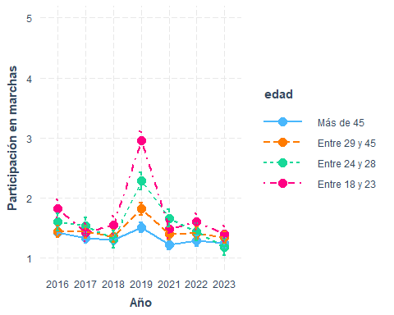

interact_plot(marchar7, pred = ola, modx = sexo, interval = TRUE,  
 modx.labels = c("Hombre", "Mujer")) +  
 ylim(1,5) +  
 labs(y = "Participación en marchas", x = "Año") +  
 scale_x_discrete(labels = waves)

✖ Detected factor predictor.  
ℹ Plotting with cat_plot() instead.  
ℹ See `?interactions::cat_plot()` for full details on how to specify models  
 with categorical predictors.  
ℹ If you experience errors or unexpected results, try using cat_plot()  
 directly.  
Scale for x is already present.  
Adding another scale for x, which will replace the existing scale.

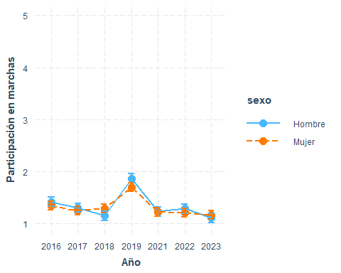

interact_plot(marchar8, pred = ola, modx = educ, interval = TRUE)+  
 ylim(1,5)+  
 labs(y="Participación en marchas", x="Año")+  
 scale_x_discrete(labels = waves)

✖ Detected factor predictor.  
ℹ Plotting with cat_plot() instead.  
ℹ See `?interactions::cat_plot()` for full details on how to specify models  
 with categorical predictors.  
ℹ If you experience errors or unexpected results, try using cat_plot()  
 directly.  
Scale for x is already present.  
Adding another scale for x, which will replace the existing scale.

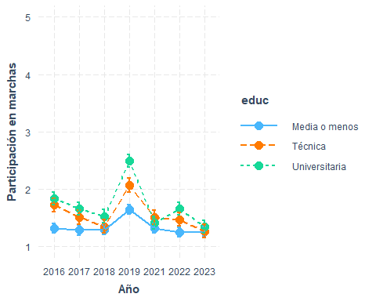

interact_plot(marchar9, pred = ola, modx = pos_id, interval = TRUE)+  
 ylim(0,5)+  
 labs(y="Participación en marchas", x="Año")+  
 scale_x_discrete(labels = waves)

✖ Detected factor predictor.  
ℹ Plotting with cat_plot() instead.  
ℹ See `?interactions::cat_plot()` for full details on how to specify models  
 with categorical predictors.  
ℹ If you experience errors or unexpected results, try using cat_plot()  
 directly.  
Scale for x is already present.  
Adding another scale for x, which will replace the existing scale.

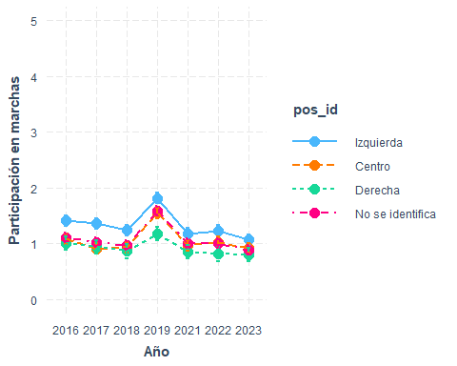

library(ggeffects)

Attaching package: 'ggeffects'

The following object is masked from 'package:interactions':  
  
 johnson_neyman

preds <- ggpredict(marchar10, terms = c("ola", "edad", "pos_id"))  
  
ggplot(preds, aes(x = x, y = predicted, color = group, group = group)) +  
 geom_line() +  
 geom_point() +  
 geom_errorbar(aes(ymin = conf.low, ymax = conf.high), width = 0.2) +  
 facet_wrap(~ facet, ncol = 2) +  
 labs(  
 x = "Año",  
 y = "Participación en marchas",  
 color = "Edad"  
 ) +  
 ylim(0, 5) +  
 scale_x_discrete(labels = waves) +   
 theme_minimal() +  
 theme(legend.position = "bottom")

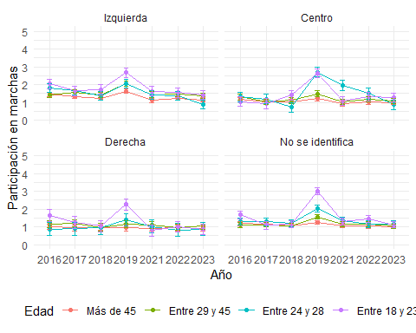

waves <- c("16", "17", "18", "19", "21", "22", "23")  
interact_plot(marchar11, pred = ola, modx = edad, mod2 = educ, interval = TRUE)+  
 ylim(1,5)+  
 labs(y="Participación en marchas", x="Año")+  
 scale_x_discrete(labels = waves)

✖ Detected factor predictor.  
ℹ Plotting with cat_plot() instead.  
ℹ See `?interactions::cat_plot()` for full details on how to specify models  
 with categorical predictors.  
ℹ If you experience errors or unexpected results, try using cat_plot()  
 directly.  
Scale for x is already present.  
Adding another scale for x, which will replace the existing scale.

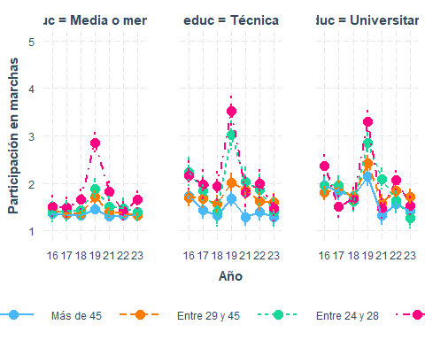

interact_plot(marchar12, pred = ola, modx = edad, mod2 = sexo, interval = TRUE)+  
 ylim(1,5)+  
 labs(y="Participación en marchas", x="Año")+  
 scale_x_discrete(labels = waves)

✖ Detected factor predictor.  
ℹ Plotting with cat_plot() instead.  
ℹ See `?interactions::cat_plot()` for full details on how to specify models  
 with categorical predictors.  
ℹ If you experience errors or unexpected results, try using cat_plot()  
 directly.  
Scale for x is already present.  
Adding another scale for x, which will replace the existing scale.

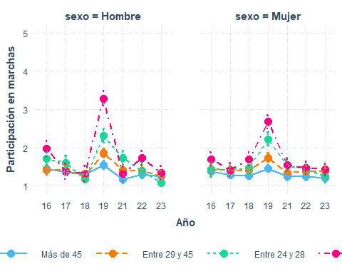

## Participación en redes sociales (en todas las olas)

if (!require("pacman")) install.packages("pacman") # instalar pacman

Loading required package: pacman

Warning: package 'pacman' was built under R version 4.3.3

# cargar librerias  
pacman::p_load(dplyr, # Manipulacion de datos  
 knitr,  
 kableExtra,  
 summarytools,  
 lme4,  
 texreg  
 )  
load(file = here::here("input/data-proc/df_study1_long_t7.RData"))  
  
# generate analytical sample  
df_study1 <-   
 df_study1_long_t7 %>%  
 select(idencuesta,ola,part_rrss, edad, sexo, pos_id, educ, universitaria, ponderador_long_total) %>%   
 na.omit() %>%   
 mutate(ola_num=as.numeric(ola),  
 ola=as.factor(ola),  
 edad = case_when(edad <=23~"Entre 18 y 23",  
 edad >23 & edad <=28 ~ "Entre 24 y 28",  
 edad >28 & edad <=45 ~ "Entre 29 y 45",  
 edad > 45 ~ "Más de 45"))   
df_study1$edad <- factor(df_study1$edad, levels = c("Más de 45", "Entre 29 y 45", "Entre 24 y 28", "Entre 18 y 23"))  
df_study1$sexo <- factor(df_study1$sexo, levels = c(1, 2), labels = c("Hombre", "Mujer"))  
  
marchar.null <- lmer(formula(paste0("part_rrss~","1 + (1|idencuesta)")),data = df_study1, weights = ponderador_long_total)  
marchar1 <- lmer(formula(paste0("part_rrss~",h1,"+(1|idencuesta)")),data = df_study1, weights = ponderador_long_total)  
marchar2 <- lmer(formula(paste0("part_rrss~",h2,"+(1|idencuesta)")),data = df_study1, weights = ponderador_long_total)  
marchar3 <- lmer(formula(paste0("part_rrss~",h3,"+(1|idencuesta)")),data = df_study1, weights = ponderador_long_total)  
marchar4 <- lmer(formula(paste0("part_rrss~",h4,"+(1|idencuesta)")),data = df_study1, weights = ponderador_long_total)  
marchar5 <- lmer(formula(paste0("part_rrss~",h5,"+(1|idencuesta)")),data = df_study1, weights = ponderador_long_total)  
marchar6 <- lmer(formula(paste0("part_rrss~",h6,"+(1|idencuesta)")),data = df_study1, weights = ponderador_long_total)  
marchar7 <- lmer(formula(paste0("part_rrss~",h7,"+(1|idencuesta)")),data = df_study1, weights = ponderador_long_total)  
marchar8 <- lmer(formula(paste0("part_rrss~",h8,"+(1|idencuesta)")),data = df_study1, weights = ponderador_long_total)  
marchar9 <- lmer(formula(paste0("part_rrss~",h9,"+(1|idencuesta)")),data = df_study1, weights = ponderador_long_total)  
marchar10 <- lmer(formula(paste0("part_rrss~",h10,"+(1|idencuesta)")),data = df_study1, weights = ponderador_long_total)  
marchar11 <- lmer(formula(paste0("part_rrss~",h11,"+(1|idencuesta)")),data = df_study1, weights = ponderador_long_total)  
marchar12 <- lmer(formula(paste0("part_rrss~",h12,"+(1|idencuesta)")),data = df_study1, weights = ponderador_long_total)

texreg::knitreg(list(marchar1, marchar2, marchar3, marchar4, marchar5, marchar6, marchar7, marchar8, marchar9, marchar10, marchar11),  
 custom.note = "*** p < 0.001; ** p < 0.01; * p < 0.05")

Statistical models

Model 1

Model 2

Model 3

Model 4

Model 5

Model 6

Model 7

Model 8

Model 9

Model 10

Model 11

(Intercept)

1.69***

1.42***

1.40***

1.27***

1.45***

1.50***

1.44***

1.40***

1.44***

1.46***

1.44***

(0.03)

(0.04)

(0.05)

(0.05)

(0.07)

(0.07)

(0.07)

(0.07)

(0.08)

(0.10)

(0.08)

ola2

0.01

0.01

0.01

0.01

0.01

-0.01

0.03

0.05

0.12*

0.22*

0.02

(0.03)

(0.03)

(0.03)

(0.03)

(0.03)

(0.05)

(0.05)

(0.04)

(0.06)

(0.09)

(0.05)

ola3

0.06

0.06

0.06

0.06

0.06

-0.05

0.04

0.14***

0.07

-0.11

-0.04

(0.03)

(0.03)

(0.03)

(0.03)

(0.03)

(0.05)

(0.05)

(0.04)

(0.06)

(0.09)

(0.05)

ola4

0.41***

0.41***

0.41***

0.41***

0.41***

0.13**

0.42***

0.39***

0.45***

0.25**

0.14*

(0.03)

(0.03)

(0.03)

(0.03)

(0.03)

(0.05)

(0.05)

(0.04)

(0.06)

(0.09)

(0.06)

ola5

0.19***

0.19***

0.19***

0.19***

0.19***

0.12*

0.10*

0.29***

0.27***

0.25**

0.15**

(0.03)

(0.03)

(0.03)

(0.03)

(0.03)

(0.05)

(0.05)

(0.04)

(0.06)

(0.10)

(0.06)

ola6

0.05

0.04

0.04

0.05

0.05

0.02

0.14**

0.08

-0.11

0.00

0.07

(0.03)

(0.03)

(0.03)

(0.03)

(0.03)

(0.05)

(0.05)

(0.04)

(0.06)

(0.10)

(0.06)

ola7

-0.04

-0.05

-0.05

-0.05

-0.05

0.07

-0.02

0.04

-0.11

0.10

0.10

(0.03)

(0.03)

(0.03)

(0.03)

(0.03)

(0.05)

(0.04)

(0.04)

(0.06)

(0.09)

(0.06)

edadEntre 29 y 45

0.48***

0.48***

0.41***

0.42***

0.42***

0.42***

0.42***

0.42***

0.44**

0.43***

(0.06)

(0.06)

(0.06)

(0.06)

(0.07)

(0.06)

(0.06)

(0.06)

(0.14)

(0.09)

edadEntre 24 y 28

0.70***

0.71***

0.55***

0.57***

0.45***

0.57***

0.57***

0.57***

0.34

0.30

(0.09)

(0.09)

(0.09)

(0.09)

(0.11)

(0.09)

(0.09)

(0.09)

(0.23)

(0.17)

edadEntre 18 y 23

0.87***

0.87***

0.74***

0.76***

0.40***

0.76***

0.76***

0.75***

0.78**

0.45**

(0.10)

(0.10)

(0.10)

(0.10)

(0.12)

(0.10)

(0.10)

(0.10)

(0.24)

(0.17)

sexoMujer

0.04

0.06

0.08

0.08

0.10

0.08

0.08

0.06

0.09

(0.05)

(0.05)

(0.05)

(0.05)

(0.07)

(0.05)

(0.05)

(0.05)

(0.05)

educTécnica

0.27***

0.24***

0.25***

0.24***

0.54***

0.24***

0.24***

0.37**

(0.07)

(0.07)

(0.07)

(0.07)

(0.09)

(0.07)

(0.07)

(0.13)

educUniversitaria

0.52***

0.48***

0.49***

0.49***

0.46***

0.48***

0.50***

0.70***

(0.07)

(0.07)

(0.07)

(0.07)

(0.08)

(0.07)

(0.07)

(0.13)

pos_idCentro

-0.21**

-0.21**

-0.21**

-0.21**

-0.09

-0.12

-0.20**

(0.07)

(0.07)

(0.07)

(0.07)

(0.09)

(0.12)

(0.07)

pos_idDerecha

-0.11

-0.12

-0.12

-0.12

-0.08

-0.12

-0.12

(0.08)

(0.08)

(0.08)

(0.08)

(0.11)

(0.15)

(0.08)

pos_idNo se identifica

-0.28***

-0.28***

-0.28***

-0.28***

-0.37***

-0.20

-0.27***

(0.07)

(0.07)

(0.07)

(0.07)

(0.08)

(0.12)

(0.06)

ola2:edadEntre 29 y 45

-0.02

-0.19

-0.09

(0.07)

(0.13)

(0.09)

ola3:edadEntre 29 y 45

0.12

0.15

0.16

(0.07)

(0.13)

(0.09)

ola4:edadEntre 29 y 45

0.17*

0.24

0.11

(0.07)

(0.14)

(0.09)

ola5:edadEntre 29 y 45

-0.02

-0.11

0.13

(0.08)

(0.15)

(0.10)

ola6:edadEntre 29 y 45

-0.04

-0.02

0.03

(0.08)

(0.14)

(0.10)

ola7:edadEntre 29 y 45

-0.23**

-0.22

-0.27**

(0.07)

(0.14)

(0.09)

ola2:edadEntre 24 y 28

-0.03

-0.19

0.11

(0.10)

(0.19)

(0.15)

ola3:edadEntre 24 y 28

0.30**

0.31

1.00***

(0.10)

(0.19)

(0.15)

ola4:edadEntre 24 y 28

0.74***

0.30

1.19***

(0.10)

(0.18)

(0.15)

ola5:edadEntre 24 y 28

0.03

-0.50**

0.25

(0.11)

(0.19)

(0.16)

ola6:edadEntre 24 y 28

-0.14

-0.61**

-0.05

(0.11)

(0.19)

(0.15)

ola7:edadEntre 24 y 28

-0.09

-0.77***

0.40**

(0.10)

(0.19)

(0.15)

ola2:edadEntre 18 y 23

0.24*

-0.05

0.59***

(0.10)

(0.20)

(0.16)

ola3:edadEntre 18 y 23

0.31**

0.84***

0.68***

(0.10)

(0.21)

(0.15)

ola4:edadEntre 18 y 23

0.96***

0.65**

1.13***

(0.10)

(0.22)

(0.14)

ola5:edadEntre 18 y 23

0.56***

1.04***

0.85***

(0.10)

(0.21)

(0.15)

ola6:edadEntre 18 y 23

0.42***

0.02

0.34*

(0.10)

(0.20)

(0.14)

ola7:edadEntre 18 y 23

0.00

-0.05

0.33*

(0.09)

(0.19)

(0.14)

ola2:sexoMujer

-0.04

(0.06)

ola3:sexoMujer

0.03

(0.06)

ola4:sexoMujer

-0.02

(0.06)

ola5:sexoMujer

0.18**

(0.07)

ola6:sexoMujer

-0.19**

(0.06)

ola7:sexoMujer

-0.06

(0.06)

ola2:educTécnica

-0.27**

-0.13

(0.08)

(0.12)

ola3:educTécnica

-0.38***

0.14

(0.09)

(0.13)

ola4:educTécnica

-0.27**

-0.14

(0.09)

(0.13)

ola5:educTécnica

-0.36***

-0.23

(0.09)

(0.13)

ola6:educTécnica

-0.36***

-0.35**

(0.09)

(0.13)

ola7:educTécnica

-0.44***

-0.21

(0.08)

(0.13)

ola2:educUniversitaria

0.04

-0.07

(0.08)

(0.14)

ola3:educUniversitaria

-0.06

-0.21

(0.08)

(0.14)

ola4:educUniversitaria

0.28***

0.14

(0.08)

(0.14)

ola5:educUniversitaria

-0.14

0.04

(0.08)

(0.14)

ola6:educUniversitaria

0.10

0.07

(0.08)

(0.15)

ola7:educUniversitaria

-0.05

0.14

(0.07)

(0.14)

ola2:pos_idCentro

-0.24**

-0.29*

(0.09)

(0.12)

ola3:pos_idCentro

-0.03

0.16

(0.09)

(0.13)

ola4:pos_idCentro

-0.07

-0.24

(0.09)

(0.13)

ola5:pos_idCentro

-0.34***

-0.34*

(0.09)

(0.13)

ola6:pos_idCentro

-0.05

-0.19

(0.09)

(0.13)

ola7:pos_idCentro

-0.15

-0.07

(0.09)

(0.13)

ola2:pos_idDerecha

-0.07

-0.38*

(0.10)

(0.15)

ola3:pos_idDerecha

-0.17

-0.04

(0.10)

(0.15)

ola4:pos_idDerecha

-0.26*

-0.09

(0.10)

(0.15)

ola5:pos_idDerecha

-0.10

-0.05

(0.11)

(0.16)

ola6:pos_idDerecha

0.19

0.37*

(0.10)

(0.16)

ola7:pos_idDerecha

0.14

0.17

(0.10)

(0.15)

ola2:pos_idNo se identifica

-0.13

-0.29*

(0.08)

(0.12)

ola3:pos_idNo se identifica

0.06

0.09

(0.08)

(0.12)

ola4:pos_idNo se identifica

0.05

-0.12

(0.08)

(0.12)

ola5:pos_idNo se identifica

0.07

-0.10

(0.08)

(0.13)

ola6:pos_idNo se identifica

0.39***

0.04

(0.08)

(0.13)

ola7:pos_idNo se identifica

0.23**

-0.09

(0.08)

(0.12)

pos_idCentro:edadEntre 29 y 45

0.16

(0.21)

pos_idDerecha:edadEntre 29 y 45

0.16

(0.24)

pos_idNo se identifica:edadEntre 29 y 45

-0.21

(0.19)

pos_idCentro:edadEntre 24 y 28

0.19

(0.32)

pos_idDerecha:edadEntre 24 y 28

0.45

(0.39)

pos_idNo se identifica:edadEntre 24 y 28

-0.06

(0.28)

pos_idCentro:edadEntre 18 y 23

-0.36

(0.34)

pos_idDerecha:edadEntre 18 y 23

-0.41

(0.39)

pos_idNo se identifica:edadEntre 18 y 23

-0.62*

(0.30)

ola2:pos_idCentro:edadEntre 29 y 45

0.15

(0.19)

ola3:pos_idCentro:edadEntre 29 y 45

-0.20

(0.19)

ola4:pos_idCentro:edadEntre 29 y 45

0.04

(0.20)

ola5:pos_idCentro:edadEntre 29 y 45

0.17

(0.21)

ola6:pos_idCentro:edadEntre 29 y 45

0.19

(0.20)

ola7:pos_idCentro:edadEntre 29 y 45

-0.26

(0.20)

ola2:pos_idDerecha:edadEntre 29 y 45

0.41

(0.23)

ola3:pos_idDerecha:edadEntre 29 y 45

-0.19

(0.23)

ola4:pos_idDerecha:edadEntre 29 y 45

-0.44

(0.23)

ola5:pos_idDerecha:edadEntre 29 y 45

-0.09

(0.24)

ola6:pos_idDerecha:edadEntre 29 y 45

-0.58*

(0.24)

ola7:pos_idDerecha:edadEntre 29 y 45

-0.22

(0.23)

ola2:pos_idNo se identifica:edadEntre 29 y 45

0.22

(0.18)

ola3:pos_idNo se identifica:edadEntre 29 y 45

0.15

(0.18)

ola4:pos_idNo se identifica:edadEntre 29 y 45

-0.05

(0.19)

ola5:pos_idNo se identifica:edadEntre 29 y 45

0.17

(0.20)

ola6:pos_idNo se identifica:edadEntre 29 y 45

0.03

(0.19)

ola7:pos_idNo se identifica:edadEntre 29 y 45

0.25

(0.18)

ola2:pos_idCentro:edadEntre 24 y 28

-0.25

(0.28)

ola3:pos_idCentro:edadEntre 24 y 28

-0.42

(0.27)

ola4:pos_idCentro:edadEntre 24 y 28

1.40***

(0.28)

ola5:pos_idCentro:edadEntre 24 y 28

0.51

(0.29)

ola6:pos_idCentro:edadEntre 24 y 28

0.59

(0.31)

ola7:pos_idCentro:edadEntre 24 y 28

0.46

(0.28)

ola2:pos_idDerecha:edadEntre 24 y 28

0.37

(0.35)

ola3:pos_idDerecha:edadEntre 24 y 28

0.35

(0.36)

ola4:pos_idDerecha:edadEntre 24 y 28

-0.45

(0.34)

ola5:pos_idDerecha:edadEntre 24 y 28

0.00

(0.36)

ola6:pos_idDerecha:edadEntre 24 y 28

0.24

(0.36)

ola7:pos_idDerecha:edadEntre 24 y 28

0.23

(0.34)

ola2:pos_idNo se identifica:edadEntre 24 y 28

0.41

(0.25)

ola3:pos_idNo se identifica:edadEntre 24 y 28

0.13

(0.24)

ola4:pos_idNo se identifica:edadEntre 24 y 28

0.52*

(0.25)

ola5:pos_idNo se identifica:edadEntre 24 y 28

1.16***

(0.26)

ola6:pos_idNo se identifica:edadEntre 24 y 28

0.87***

(0.25)

ola7:pos_idNo se identifica:edadEntre 24 y 28

1.47***

(0.25)

ola2:pos_idCentro:edadEntre 18 y 23

0.15

(0.29)

ola3:pos_idCentro:edadEntre 18 y 23

-0.64*

(0.29)

ola4:pos_idCentro:edadEntre 18 y 23

0.12

(0.29)

ola5:pos_idCentro:edadEntre 18 y 23

-1.04***

(0.29)

ola6:pos_idCentro:edadEntre 18 y 23

-0.07

(0.28)

ola7:pos_idCentro:edadEntre 18 y 23

-0.36

(0.26)

ola2:pos_idDerecha:edadEntre 18 y 23

1.15***

(0.34)

ola3:pos_idDerecha:edadEntre 18 y 23

-0.68*

(0.34)

ola4:pos_idDerecha:edadEntre 18 y 23

0.15

(0.33)

ola5:pos_idDerecha:edadEntre 18 y 23

-0.36

(0.34)

ola6:pos_idDerecha:edadEntre 18 y 23

-0.10

(0.32)

ola7:pos_idDerecha:edadEntre 18 y 23

0.01

(0.31)

ola2:pos_idNo se identifica:edadEntre 18 y 23

0.23

(0.26)

ola3:pos_idNo se identifica:edadEntre 18 y 23

-0.76**

(0.26)

ola4:pos_idNo se identifica:edadEntre 18 y 23

0.69*

(0.27)

ola5:pos_idNo se identifica:edadEntre 18 y 23

-0.43

(0.26)

ola6:pos_idNo se identifica:edadEntre 18 y 23

0.96***

(0.25)

ola7:pos_idNo se identifica:edadEntre 18 y 23

0.35

(0.24)

educTécnica:edadEntre 29 y 45

-0.19

(0.20)

educUniversitaria:edadEntre 29 y 45

-0.00

(0.19)

educTécnica:edadEntre 24 y 28

0.96**

(0.31)

educUniversitaria:edadEntre 24 y 28

-0.25

(0.26)

educTécnica:edadEntre 18 y 23

0.94**

(0.32)

educUniversitaria:edadEntre 18 y 23

-0.88**

(0.27)

ola2:educTécnica:edadEntre 29 y 45

0.19

(0.19)

ola3:educTécnica:edadEntre 29 y 45

-0.26

(0.20)

ola4:educTécnica:edadEntre 29 y 45

0.34

(0.20)

ola5:educTécnica:edadEntre 29 y 45

-0.11

(0.20)

ola6:educTécnica:edadEntre 29 y 45

0.52*

(0.20)

ola7:educTécnica:edadEntre 29 y 45

0.53**

(0.19)

ola2:educUniversitaria:edadEntre 29 y 45

0.17

(0.19)

ola3:educUniversitaria:edadEntre 29 y 45

0.11

(0.19)

ola4:educUniversitaria:edadEntre 29 y 45

-0.06

(0.19)

ola5:educUniversitaria:edadEntre 29 y 45

-0.51**

(0.20)

ola6:educUniversitaria:edadEntre 29 y 45

-0.65***

(0.20)

ola7:educUniversitaria:edadEntre 29 y 45

-0.24

(0.19)

ola2:educTécnica:edadEntre 24 y 28

-0.61*

(0.29)

ola3:educTécnica:edadEntre 24 y 28

-1.95***

(0.27)

ola4:educTécnica:edadEntre 24 y 28

-1.14***

(0.28)

ola5:educTécnica:edadEntre 24 y 28

-0.35

(0.29)

ola6:educTécnica:edadEntre 24 y 28

-0.67*

(0.30)

ola7:educTécnica:edadEntre 24 y 28

-1.43***

(0.27)

ola2:educUniversitaria:edadEntre 24 y 28

0.02

(0.24)

ola3:educUniversitaria:edadEntre 24 y 28

-0.67**

(0.24)

ola4:educUniversitaria:edadEntre 24 y 28

-0.69**

(0.24)

ola5:educUniversitaria:edadEntre 24 y 28

-0.42

(0.25)

ola6:educUniversitaria:edadEntre 24 y 28

0.08

(0.25)

ola7:educUniversitaria:edadEntre 24 y 28

-0.65**

(0.24)

ola2:educTécnica:edadEntre 18 y 23

-1.14***

(0.27)

ola3:educTécnica:edadEntre 18 y 23

-1.92***

(0.27)

ola4:educTécnica:edadEntre 18 y 23

-1.27***

(0.27)

ola5:educTécnica:edadEntre 18 y 23

-0.66*

(0.28)

ola6:educTécnica:edadEntre 18 y 23

-0.90***

(0.26)

ola7:educTécnica:edadEntre 18 y 23

-1.61***

(0.25)

ola2:educUniversitaria:edadEntre 18 y 23

-0.17

(0.25)

ola3:educUniversitaria:edadEntre 18 y 23

0.22

(0.24)

ola4:educUniversitaria:edadEntre 18 y 23

0.20

(0.24)

ola5:educUniversitaria:edadEntre 18 y 23

-0.20

(0.24)

ola6:educUniversitaria:edadEntre 18 y 23

0.64**

(0.23)

ola7:educUniversitaria:edadEntre 18 y 23

-0.07

(0.22)

AIC

47957.67

47829.70

47835.30

47779.52

47776.70

47630.47

47779.70

47770.90

47764.81

47492.49

47456.35

BIC

48023.44

47917.39

47930.30

47889.14

47908.24

47893.56

47955.09

47990.13

48027.90

48347.50

48114.06

Log Likelihood

-23969.83

-23902.85

-23904.65

-23874.76

-23870.35

-23779.24

-23865.85

-23855.45

-23846.41

-23629.24

-23638.18

Num. obs.

11024

11024

11024

11024

11024

11024

11024

11024

11024

11024

11024

Num. groups: idencuesta

1705

1705

1705

1705

1705

1705

1705

1705

1705

1705

1705

Var: idencuesta (Intercept)

0.65

0.57

0.57

0.54

0.53

0.53

0.53

0.53

0.53

0.53

0.52

Var: Residual

0.74

0.73

0.73

0.73

0.73

0.72

0.73

0.73

0.73

0.69

0.69

*** p < 0.001; ** p < 0.01; * p < 0.05

### interacciones

interact_plot(marchar6, pred = ola, modx = edad, interval = TRUE)+  
 ylim(1,5)+  
 labs(y="Participación en redes sociales", x="Año")+  
 scale_x_discrete(labels = waves)

✖ Detected factor predictor.  
ℹ Plotting with cat_plot() instead.  
ℹ See `?interactions::cat_plot()` for full details on how to specify models  
 with categorical predictors.  
ℹ If you experience errors or unexpected results, try using cat_plot()  
 directly.  
Scale for x is already present.  
Adding another scale for x, which will replace the existing scale.

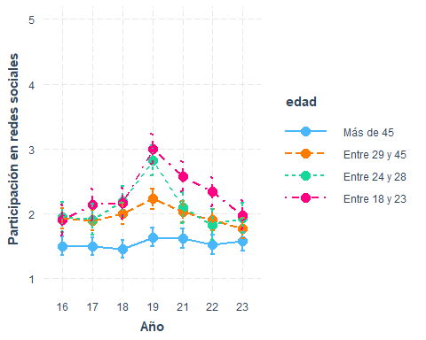

interact_plot(marchar7, pred = ola, modx = sexo, interval = TRUE)+  
 ylim(1,5)+  
 labs(y="Participación en redes sociales", x="Año")+  
 scale_x_discrete(labels = waves)

✖ Detected factor predictor.  
ℹ Plotting with cat_plot() instead.  
ℹ See `?interactions::cat_plot()` for full details on how to specify models  
 with categorical predictors.  
ℹ If you experience errors or unexpected results, try using cat_plot()  
 directly.  
Scale for x is already present.  
Adding another scale for x, which will replace the existing scale.

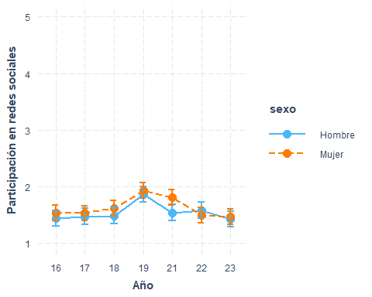

interact_plot(marchar8, pred = ola, modx = educ, interval = TRUE)+  
 ylim(1,5)+  
 labs(y="Participación en redes sociales", x="Año")+  
 scale_x_discrete(labels = waves)

✖ Detected factor predictor.  
ℹ Plotting with cat_plot() instead.  
ℹ See `?interactions::cat_plot()` for full details on how to specify models  
 with categorical predictors.  
ℹ If you experience errors or unexpected results, try using cat_plot()  
 directly.  
Scale for x is already present.  
Adding another scale for x, which will replace the existing scale.

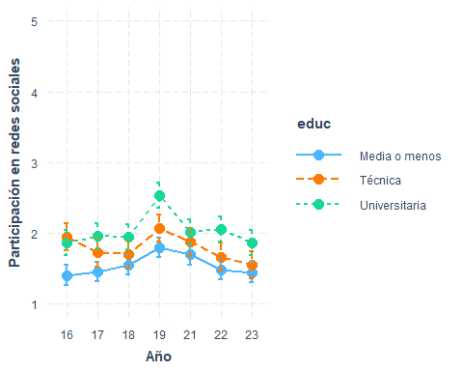

interact_plot(marchar9, pred = ola, modx = pos_id, interval = TRUE)+  
 ylim(1,5)+  
 labs(y="Participación en redes sociales", x="Año")+  
 scale_x_discrete(labels = waves)

✖ Detected factor predictor.  
ℹ Plotting with cat_plot() instead.  
ℹ See `?interactions::cat_plot()` for full details on how to specify models  
 with categorical predictors.  
ℹ If you experience errors or unexpected results, try using cat_plot()  
 directly.  
Scale for x is already present.  
Adding another scale for x, which will replace the existing scale.

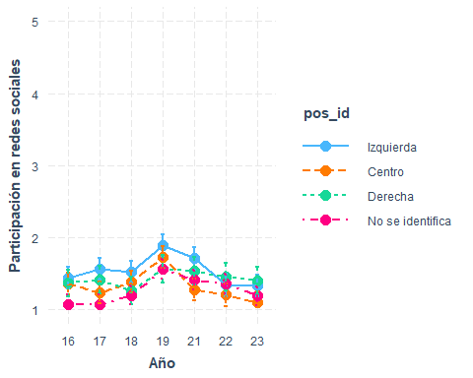

preds <- ggpredict(marchar10, terms = c("ola", "edad", "pos_id"))  
  
ggplot(preds, aes(x = x, y = predicted, color = group, group = group)) +  
 geom_line() +  
 geom_point() +  
 geom_errorbar(aes(ymin = conf.low, ymax = conf.high), width = 0.2) +  
 facet_wrap(~ facet, ncol = 2) +  
 labs(  
 x = "Año",  
 y = "Participación en redes sociales",  
 color = "Edad"  
 ) +  
 ylim(0, 5) +  
 scale_x_discrete(labels = waves) +   
 theme_minimal() +  
 theme(legend.position = "bottom")

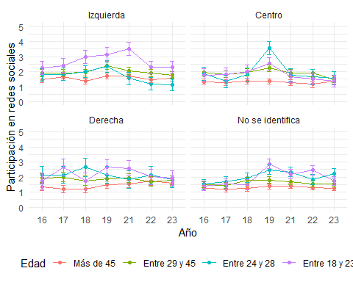

interact_plot(marchar11, pred = ola, modx = edad, mod2 = educ, interval = TRUE)+  
 ylim(1,5)+  
 labs(y="Participación en redes sociales", x="Año")+  
 scale_x_discrete(labels = waves)

✖ Detected factor predictor.  
ℹ Plotting with cat_plot() instead.  
ℹ See `?interactions::cat_plot()` for full details on how to specify models  
 with categorical predictors.  
ℹ If you experience errors or unexpected results, try using cat_plot()  
 directly.  
Scale for x is already present.  
Adding another scale for x, which will replace the existing scale.

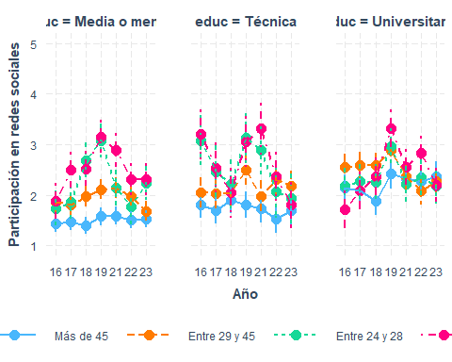

interact_plot(marchar12, pred = ola, modx = edad, mod2 = sexo, interval = TRUE)+  
 ylim(1,5)+  
 labs(y="Participación en redes sociales", x="Año")+  
 scale_x_discrete(labels = waves)

✖ Detected factor predictor.  
ℹ Plotting with cat_plot() instead.  
ℹ See `?interactions::cat_plot()` for full details on how to specify models  
 with categorical predictors.  
ℹ If you experience errors or unexpected results, try using cat_plot()  
 directly.  
Scale for x is already present.  
Adding another scale for x, which will replace the existing scale.

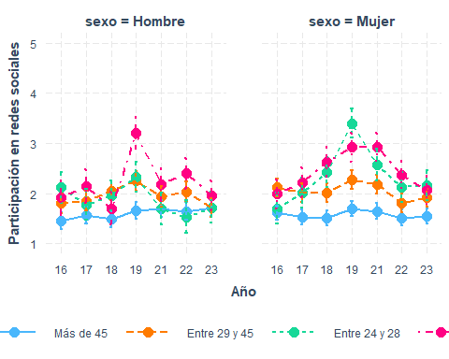

## Apoyo mov estudiantil (todas las olas)

#if (!require("pacman")) install.packages("pacman") # instalar pacman  
 # cargar librerias  
pacman::p_load(dplyr, # Manipulacion de datos  
 knitr,  
 kableExtra,  
 summarytools,  
 lme4,  
 texreg  
 )  
load(file = here::here("input/data-proc/df_study1_long_t7.RData"))  
  
# generate analytical sample  
df_study1 <-   
 df_study1_long_t7 %>%  
 select(idencuesta,ola,mov_estudiantil, edad, sexo, pos_id, educ, universitaria, ponderador_long_total) %>%   
 na.omit() %>%   
 mutate(ola_num=as.numeric(ola),  
 ola=as.factor(ola),  
 edad = case_when(edad <=23~"Entre 18 y 23",  
 edad >23 & edad <=28 ~ "Entre 24 y 28",  
 edad >28 & edad <=45 ~ "Entre 29 y 45",  
 edad > 45 ~ "Más de 45"))   
df_study1$edad <- factor(df_study1$edad, levels = c("Más de 45", "Entre 29 y 45", "Entre 24 y 28", "Entre 18 y 23"))  
df_study1$sexo <- factor(df_study1$sexo, levels = c(1, 2), labels = c("Hombre", "Mujer"))  
  
marchar.null <- glmer(formula(paste0("mov_estudiantil~","1 + (1|idencuesta)")),data = df_study1, weights = ponderador_long_total, family = 'binomial')

Warning in eval(family$initialize, rho): non-integer #successes in a binomial  
glm!

marchar1 <- glmer(formula(paste0("mov_estudiantil~",h1,"+(1|idencuesta)")),data = df_study1, weights = ponderador_long_total, family = 'binomial')

Warning in eval(family$initialize, rho): non-integer #successes in a binomial  
glm!

marchar2 <- glmer(formula(paste0("mov_estudiantil~",h2,"+(1|idencuesta)")),data = df_study1, weights = ponderador_long_total, family = 'binomial')

Warning in eval(family$initialize, rho): non-integer #successes in a binomial  
glm!

Warning in checkConv(attr(opt, "derivs"), opt$par, ctrl = control$checkConv, :  
Model failed to converge with max|grad| = 0.303436 (tol = 0.002, component 1)

marchar3 <- glmer(formula(paste0("mov_estudiantil~",h3,"+(1|idencuesta)")),data = df_study1, weights = ponderador_long_total, family = 'binomial')

Warning in eval(family$initialize, rho): non-integer #successes in a binomial  
glm!

Warning in checkConv(attr(opt, "derivs"), opt$par, ctrl = control$checkConv, :  
Model failed to converge with max|grad| = 0.411008 (tol = 0.002, component 1)

marchar4 <- lmer(formula(paste0("mov_estudiantil~",h4,"+(1|idencuesta)")),data = df_study1, weights = ponderador_long_total)  
marchar5 <- lmer(formula(paste0("mov_estudiantil~",h5,"+(1|idencuesta)")),data = df_study1, weights = ponderador_long_total)  
marchar6 <- lmer(formula(paste0("mov_estudiantil~",h6,"+(1|idencuesta)")),data = df_study1, weights = ponderador_long_total)  
marchar7 <- lmer(formula(paste0("mov_estudiantil~",h7,"+(1|idencuesta)")),data = df_study1, weights = ponderador_long_total)  
marchar8 <- lmer(formula(paste0("mov_estudiantil~",h8,"+(1|idencuesta)")),data = df_study1, weights = ponderador_long_total)  
marchar9 <- lmer(formula(paste0("mov_estudiantil~",h9,"+(1|idencuesta)")),data = df_study1, weights = ponderador_long_total)  
marchar10 <- lmer(formula(paste0("mov_estudiantil~",h10,"+(1|idencuesta)")),data = df_study1, weights = ponderador_long_total)  
marchar11 <- lmer(formula(paste0("mov_estudiantil~",h11,"+(1|idencuesta)")),data = df_study1, weights = ponderador_long_total)  
marchar12 <- lmer(formula(paste0("mov_estudiantil~",h12,"+(1|idencuesta)")),data = df_study1, weights = ponderador_long_total)

texreg::knitreg(list(marchar1, marchar2, marchar3, marchar4, marchar5, marchar6, marchar7, marchar8, marchar9, marchar10, marchar11),  
 custom.note = "*** p < 0.001; ** p < 0.01; * p < 0.05")

Statistical models

Model 1

Model 2

Model 3

Model 4

Model 5

Model 6

Model 7

Model 8

Model 9

Model 10

Model 11

(Intercept)

-2.26***

-2.47***

-2.74***

0.16***

0.18***

0.17***

0.18***

0.15***

0.23***

0.20***

0.15***

(0.12)

(0.15)

(0.18)

(0.01)

(0.02)

(0.02)

(0.02)

(0.02)

(0.02)

(0.03)

(0.02)

ola2

0.13

0.14

0.17

0.02

0.02

0.03

0.01

0.02

-0.01

0.07*

0.04*

(0.11)

(0.11)

(0.11)

(0.01)

(0.01)

(0.02)

(0.02)

(0.01)

(0.02)

(0.03)

(0.02)

ola3

-0.98***

-0.98***

-0.94***

-0.10***

-0.10***

-0.09***

-0.07***

-0.08***

-0.19***

-0.17***

-0.08***

(0.12)

(0.12)

(0.12)

(0.01)

(0.01)

(0.02)

(0.02)

(0.01)

(0.02)

(0.03)

(0.02)

ola4

-0.79***

-0.79***

-0.77***

-0.08***

-0.08***

-0.04*

-0.10***

-0.01

-0.12***

-0.07*

0.01

(0.12)

(0.12)

(0.12)

(0.01)

(0.01)

(0.02)

(0.02)

(0.01)

(0.02)

(0.03)

(0.02)

ola5

-0.61***

-0.62***

-0.58***

-0.06***

-0.06***

-0.06***

-0.06***

-0.01

-0.15***

-0.05

-0.03

(0.12)

(0.12)

(0.12)

(0.01)

(0.01)

(0.02)

(0.02)

(0.01)

(0.02)

(0.03)

(0.02)

ola6

-1.33***

-1.34***

-1.29***

-0.12***

-0.12***

-0.12***

-0.14***

-0.08***

-0.16***

-0.11**

-0.09***

(0.14)

(0.14)

(0.14)

(0.01)

(0.01)

(0.02)

(0.02)

(0.01)

(0.02)

(0.03)

(0.02)

ola7

-1.50***

-1.52***

-1.49***

-0.13***

-0.13***

-0.13***

-0.13***

-0.10***

-0.20***

-0.14***

-0.11***

(0.13)

(0.13)

(0.13)

(0.01)

(0.01)

(0.02)

(0.02)

(0.01)

(0.02)

(0.03)

(0.02)

edadEntre 29 y 45

0.29

0.40*

0.04**

0.04**

0.05*

0.04**

0.04**

0.04**

0.05

0.05

(0.18)

(0.18)

(0.01)

(0.01)

(0.02)

(0.01)

(0.01)

(0.01)

(0.04)

(0.03)

edadEntre 24 y 28

0.50

0.60*

0.05*

0.05*

0.04

0.05*

0.05*

0.05*

0.12*

0.07

(0.27)

(0.27)

(0.02)

(0.02)

(0.03)

(0.02)

(0.02)

(0.02)

(0.06)

(0.05)

edadEntre 18 y 23

0.94***

1.03***

0.11***

0.11***

0.19***

0.11***

0.11***

0.11***

0.24***

0.02

(0.27)

(0.27)

(0.02)

(0.02)

(0.03)

(0.02)

(0.02)

(0.02)

(0.07)

(0.05)

sexoMujer

0.32*

0.02

0.02

0.02

0.02

0.02

0.02

0.02

0.02

(0.16)

(0.01)

(0.01)

(0.01)

(0.02)

(0.01)

(0.01)

(0.01)

(0.01)

educTécnica

-0.03

-0.03

-0.03

-0.03

-0.01

-0.03

-0.03

0.03

(0.02)

(0.02)

(0.02)

(0.02)

(0.03)

(0.02)

(0.02)

(0.04)

educUniversitaria

-0.01

-0.01

-0.01

-0.01

0.09***

-0.01

-0.01

0.04

(0.02)

(0.02)

(0.02)

(0.02)

(0.02)

(0.02)

(0.02)

(0.04)

pos_idCentro

-0.01

-0.01

-0.01

-0.01

-0.04

0.01

-0.01

(0.02)

(0.02)

(0.02)

(0.02)

(0.03)

(0.04)

(0.02)

pos_idDerecha

-0.03

-0.03

-0.03

-0.03

-0.07*

-0.07

-0.03

(0.02)

(0.02)

(0.02)

(0.02)

(0.03)

(0.04)

(0.02)

pos_idNo se identifica

-0.02

-0.02

-0.02

-0.02

-0.12***

-0.11**

-0.02

(0.02)

(0.02)

(0.02)

(0.02)

(0.02)

(0.03)

(0.02)

ola2:edadEntre 29 y 45

-0.08**

-0.19***

-0.11***

(0.03)

(0.05)

(0.03)

ola3:edadEntre 29 y 45

-0.02

-0.07

-0.04

(0.03)

(0.05)

(0.03)

ola4:edadEntre 29 y 45

-0.02

0.00

-0.00

(0.03)

(0.05)

(0.03)

ola5:edadEntre 29 y 45

0.04

-0.08

0.07

(0.03)

(0.05)

(0.03)

ola6:edadEntre 29 y 45

0.02

-0.09

0.02

(0.03)

(0.05)

(0.03)

ola7:edadEntre 29 y 45

0.02

-0.01

0.01

(0.03)

(0.05)

(0.03)

ola2:edadEntre 24 y 28

0.04

-0.05

-0.08

(0.04)

(0.07)

(0.05)

ola3:edadEntre 24 y 28

0.03

0.02

0.01

(0.03)

(0.07)

(0.05)

ola4:edadEntre 24 y 28

-0.07*

-0.18**

-0.13*

(0.04)

(0.06)

(0.05)

ola5:edadEntre 24 y 28

0.01

-0.15*

0.07

(0.04)

(0.07)

(0.06)

ola6:edadEntre 24 y 28

0.03

-0.13*

-0.03

(0.04)

(0.07)

(0.05)

ola7:edadEntre 24 y 28

0.01

-0.18**

0.04

(0.04)

(0.07)

(0.05)

ola2:edadEntre 18 y 23

0.09*

-0.13

0.25***

(0.04)

(0.07)

(0.05)

ola3:edadEntre 18 y 23

-0.05

0.05

0.08

(0.04)

(0.07)

(0.05)

ola4:edadEntre 18 y 23

-0.21***

-0.26***

-0.03

(0.03)

(0.08)

(0.05)

ola5:edadEntre 18 y 23

-0.14***

-0.40***

-0.06

(0.03)

(0.07)

(0.05)

ola6:edadEntre 18 y 23

-0.10**

-0.07

0.06

(0.03)

(0.07)

(0.05)

ola7:edadEntre 18 y 23

-0.08*

-0.24***

0.06

(0.03)

(0.07)

(0.05)

ola2:sexoMujer

0.02

(0.02)

ola3:sexoMujer

-0.04*

(0.02)

ola4:sexoMujer

0.04*

(0.02)

ola5:sexoMujer

-0.01

(0.02)

ola6:sexoMujer

0.03

(0.02)

ola7:sexoMujer

-0.01

(0.02)

ola2:educTécnica

0.07*

-0.02

(0.03)

(0.04)

ola3:educTécnica

0.01

-0.02

(0.03)

(0.04)

ola4:educTécnica

-0.08**

-0.12**

(0.03)

(0.04)

ola5:educTécnica

-0.07*

-0.07

(0.03)

(0.05)

ola6:educTécnica

-0.01

-0.09

(0.03)

(0.05)

ola7:educTécnica

-0.03

-0.05

(0.03)

(0.04)

ola2:educUniversitaria

-0.04

-0.05

(0.03)

(0.05)

ola3:educUniversitaria

-0.06*

-0.04

(0.03)

(0.05)

ola4:educUniversitaria

-0.22***

-0.17***

(0.03)

(0.05)

ola5:educUniversitaria

-0.15***

-0.12*

(0.03)

(0.05)

ola6:educUniversitaria

-0.15***

-0.09

(0.03)

(0.05)

ola7:educUniversitaria

-0.10***

-0.08

(0.03)

(0.05)

ola2:pos_idCentro

-0.00

-0.08

(0.03)

(0.04)

ola3:pos_idCentro

0.09**

0.06

(0.03)

(0.04)

ola4:pos_idCentro

-0.01

-0.07

(0.03)

(0.05)

ola5:pos_idCentro

0.09**

-0.09

(0.03)

(0.05)

ola6:pos_idCentro

0.01

-0.08

(0.03)

(0.05)

ola7:pos_idCentro

0.06

-0.08

(0.03)

(0.05)

ola2:pos_idDerecha

-0.00

-0.09

(0.04)

(0.05)

ola3:pos_idDerecha

0.10**

0.12*

(0.04)

(0.05)

ola4:pos_idDerecha

0.06

0.07

(0.04)

(0.05)

ola5:pos_idDerecha

0.07

-0.06

(0.04)

(0.05)

ola6:pos_idDerecha

0.02

0.00

(0.04)

(0.06)

ola7:pos_idDerecha

0.07*

0.02

(0.03)

(0.05)

ola2:pos_idNo se identifica

0.09**

-0.02

(0.03)

(0.04)

ola3:pos_idNo se identifica

0.16***

0.15***

(0.03)

(0.04)

ola4:pos_idNo se identifica

0.12***

0.13**

(0.03)

(0.04)

ola5:pos_idNo se identifica

0.16***

0.09*

(0.03)

(0.05)

ola6:pos_idNo se identifica

0.10***

0.05

(0.03)

(0.05)

ola7:pos_idNo se identifica

0.12***

0.08

(0.03)

(0.04)

pos_idCentro:edadEntre 29 y 45

-0.09

(0.06)

pos_idDerecha:edadEntre 29 y 45

0.05

(0.07)

pos_idNo se identifica:edadEntre 29 y 45

0.03

(0.06)

pos_idCentro:edadEntre 24 y 28

-0.20*

(0.09)

pos_idDerecha:edadEntre 24 y 28

0.09

(0.11)

pos_idNo se identifica:edadEntre 24 y 28

-0.11

(0.08)

pos_idCentro:edadEntre 18 y 23

0.07

(0.09)

pos_idDerecha:edadEntre 18 y 23

-0.15

(0.11)

pos_idNo se identifica:edadEntre 18 y 23

-0.10

(0.08)

ola2:pos_idCentro:edadEntre 29 y 45

0.13*

(0.07)

ola3:pos_idCentro:edadEntre 29 y 45

0.10

(0.07)

ola4:pos_idCentro:edadEntre 29 y 45

0.14*

(0.07)

ola5:pos_idCentro:edadEntre 29 y 45

0.34***

(0.07)

ola6:pos_idCentro:edadEntre 29 y 45

0.30***

(0.07)

ola7:pos_idCentro:edadEntre 29 y 45

0.11

(0.07)

ola2:pos_idDerecha:edadEntre 29 y 45

0.16*

(0.08)

ola3:pos_idDerecha:edadEntre 29 y 45

-0.00

(0.08)

ola4:pos_idDerecha:edadEntre 29 y 45

-0.13

(0.08)

ola5:pos_idDerecha:edadEntre 29 y 45

0.14

(0.08)

ola6:pos_idDerecha:edadEntre 29 y 45

-0.01

(0.08)

ola7:pos_idDerecha:edadEntre 29 y 45

0.05

(0.08)

ola2:pos_idNo se identifica:edadEntre 29 y 45

0.15*

(0.06)

ola3:pos_idNo se identifica:edadEntre 29 y 45

0.10

(0.06)

ola4:pos_idNo se identifica:edadEntre 29 y 45

-0.11

(0.07)

ola5:pos_idNo se identifica:edadEntre 29 y 45

0.04

(0.07)

ola6:pos_idNo se identifica:edadEntre 29 y 45

0.09

(0.07)

ola7:pos_idNo se identifica:edadEntre 29 y 45

-0.00

(0.06)

ola2:pos_idCentro:edadEntre 24 y 28

0.05

(0.10)

ola3:pos_idCentro:edadEntre 24 y 28

0.13

(0.10)

ola4:pos_idCentro:edadEntre 24 y 28

0.22*

(0.10)

ola5:pos_idCentro:edadEntre 24 y 28

0.45***

(0.10)

ola6:pos_idCentro:edadEntre 24 y 28

0.36***

(0.11)

ola7:pos_idCentro:edadEntre 24 y 28

0.29**

(0.10)

ola2:pos_idDerecha:edadEntre 24 y 28

-0.09

(0.12)

ola3:pos_idDerecha:edadEntre 24 y 28

-0.26*

(0.12)

ola4:pos_idDerecha:edadEntre 24 y 28

-0.03

(0.12)

ola5:pos_idDerecha:edadEntre 24 y 28

-0.05

(0.12)

ola6:pos_idDerecha:edadEntre 24 y 28

0.08

(0.12)

ola7:pos_idDerecha:edadEntre 24 y 28

0.09

(0.12)

ola2:pos_idNo se identifica:edadEntre 24 y 28

0.23**

(0.09)

ola3:pos_idNo se identifica:edadEntre 24 y 28

0.01

(0.09)

ola4:pos_idNo se identifica:edadEntre 24 y 28

0.15

(0.09)

ola5:pos_idNo se identifica:edadEntre 24 y 28

0.15

(0.09)

ola6:pos_idNo se identifica:edadEntre 24 y 28

0.19*

(0.09)

ola7:pos_idNo se identifica:edadEntre 24 y 28

0.28***

(0.09)

ola2:pos_idCentro:edadEntre 18 y 23

0.24*

(0.10)

ola3:pos_idCentro:edadEntre 18 y 23

-0.19

(0.10)

ola4:pos_idCentro:edadEntre 18 y 23

-0.06

(0.10)

ola5:pos_idCentro:edadEntre 18 y 23

0.17

(0.10)

ola6:pos_idCentro:edadEntre 18 y 23

-0.16

(0.10)

ola7:pos_idCentro:edadEntre 18 y 23

0.36***

(0.09)

ola2:pos_idDerecha:edadEntre 18 y 23

0.32**

(0.12)

ola3:pos_idDerecha:edadEntre 18 y 23

-0.01

(0.12)

ola4:pos_idDerecha:edadEntre 18 y 23

0.24*

(0.12)

ola5:pos_idDerecha:edadEntre 18 y 23

0.58***

(0.12)

ola6:pos_idDerecha:edadEntre 18 y 23

0.10

(0.11)

ola7:pos_idDerecha:edadEntre 18 y 23

0.19

(0.11)

ola2:pos_idNo se identifica:edadEntre 18 y 23

0.30**

(0.09)

ola3:pos_idNo se identifica:edadEntre 18 y 23

-0.14

(0.09)

ola4:pos_idNo se identifica:edadEntre 18 y 23

0.08

(0.10)

ola5:pos_idNo se identifica:edadEntre 18 y 23

0.28**

(0.09)

ola6:pos_idNo se identifica:edadEntre 18 y 23

-0.01

(0.09)

ola7:pos_idNo se identifica:edadEntre 18 y 23

0.11

(0.08)

educTécnica:edadEntre 29 y 45

-0.11

(0.06)

educUniversitaria:edadEntre 29 y 45

0.04

(0.06)

educTécnica:edadEntre 24 y 28

-0.11

(0.09)

educUniversitaria:edadEntre 24 y 28

-0.05

(0.07)

educTécnica:edadEntre 18 y 23

0.12

(0.09)

educUniversitaria:edadEntre 18 y 23

0.32***

(0.08)

ola2:educTécnica:edadEntre 29 y 45

0.20**

(0.07)

ola3:educTécnica:edadEntre 29 y 45

0.14*

(0.07)

ola4:educTécnica:edadEntre 29 y 45

0.08

(0.07)

ola5:educTécnica:edadEntre 29 y 45

-0.03

(0.07)

ola6:educTécnica:edadEntre 29 y 45

0.09

(0.07)

ola7:educTécnica:edadEntre 29 y 45

0.16*

(0.07)

ola2:educUniversitaria:edadEntre 29 y 45

0.00

(0.07)

ola3:educUniversitaria:edadEntre 29 y 45

0.01

(0.07)

ola4:educUniversitaria:edadEntre 29 y 45

-0.02

(0.07)

ola5:educUniversitaria:edadEntre 29 y 45

-0.01

(0.07)

ola6:educUniversitaria:edadEntre 29 y 45

-0.01

(0.07)

ola7:educUniversitaria:edadEntre 29 y 45

-0.01

(0.07)

ola2:educTécnica:edadEntre 24 y 28

0.22*

(0.10)

ola3:educTécnica:edadEntre 24 y 28

0.06

(0.10)

ola4:educTécnica:edadEntre 24 y 28

0.20*

(0.10)

ola5:educTécnica:edadEntre 24 y 28

-0.01

(0.10)

ola6:educTécnica:edadEntre 24 y 28

0.20

(0.10)

ola7:educTécnica:edadEntre 24 y 28

0.07

(0.10)

ola2:educUniversitaria:edadEntre 24 y 28

0.25**

(0.08)

ola3:educUniversitaria:edadEntre 24 y 28

0.05

(0.08)

ola4:educUniversitaria:edadEntre 24 y 28

0.16

(0.08)

ola5:educUniversitaria:edadEntre 24 y 28

-0.04

(0.09)

ola6:educUniversitaria:edadEntre 24 y 28

0.12

(0.09)

ola7:educUniversitaria:edadEntre 24 y 28

-0.04

(0.08)

ola2:educTécnica:edadEntre 18 y 23

-0.11

(0.09)

ola3:educTécnica:edadEntre 18 y 23

-0.15

(0.09)

ola4:educTécnica:edadEntre 18 y 23

-0.05

(0.10)

ola5:educTécnica:edadEntre 18 y 23

0.02

(0.10)

ola6:educTécnica:edadEntre 18 y 23

0.12

(0.09)

ola7:educTécnica:edadEntre 18 y 23

-0.23**

(0.09)

ola2:educUniversitaria:edadEntre 18 y 23

-0.30***

(0.09)

ola3:educUniversitaria:edadEntre 18 y 23

-0.22**

(0.08)

ola4:educUniversitaria:edadEntre 18 y 23

-0.30***

(0.08)

ola5:educUniversitaria:edadEntre 18 y 23

-0.11

(0.08)

ola6:educUniversitaria:edadEntre 18 y 23

-0.33***

(0.08)

ola7:educUniversitaria:edadEntre 18 y 23

-0.15

(0.08)

AIC

6596.23

6587.19

6585.03

23320.79

23343.46

23318.84

23370.85

23323.41

23415.33

23436.89

23418.57

BIC

6654.60

6667.45

6672.58

23430.23

23474.79

23581.51

23545.96

23542.30

23677.99

24290.55

24075.23

Log Likelihood

-3290.12

-3282.59

-3280.51

-11645.39

-11653.73

-11623.42

-11661.42

-11631.71

-11671.66

-11601.44

-11619.29

Num. obs.

10897

10897

10897

10897

10897

10897

10897

10897

10897

10897

10897

Num. groups: idencuesta

1705

1705

1705

1705

1705

1705

1705

1705

1705

1705

1705

Var: idencuesta (Intercept)

2.81

2.77

2.73

0.02

0.02

0.02

0.02

0.02

0.02

0.02

0.02

Var: Residual

0.09

0.09

0.09

0.09

0.09

0.09

0.08

0.09

*** p < 0.001; ** p < 0.01; * p < 0.05

### interacciones

interact_plot(marchar6, pred = ola, modx = edad, interval = TRUE)+  
 ylim(0,1)+  
 labs(y="Apoyo movimiento estudiantil", x="Año")+  
 scale_x_discrete(labels = waves)

✖ Detected factor predictor.  
ℹ Plotting with cat_plot() instead.  
ℹ See `?interactions::cat_plot()` for full details on how to specify models  
 with categorical predictors.  
ℹ If you experience errors or unexpected results, try using cat_plot()  
 directly.  
Scale for x is already present.  
Adding another scale for x, which will replace the existing scale.

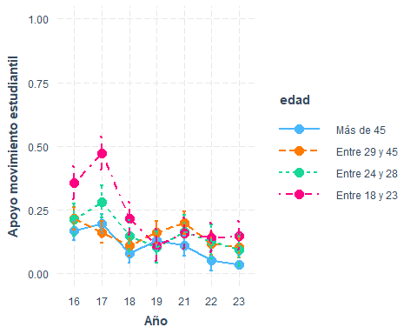

interact_plot(marchar7, pred = ola, modx = sexo, interval = TRUE)+  
 ylim(0,1)+  
 labs(y="Apoyo movimiento estudiantil", x="Año")+  
 scale_x_discrete(labels = waves)

✖ Detected factor predictor.  
ℹ Plotting with cat_plot() instead.  
ℹ See `?interactions::cat_plot()` for full details on how to specify models  
 with categorical predictors.  
ℹ If you experience errors or unexpected results, try using cat_plot()  
 directly.  
Scale for x is already present.  
Adding another scale for x, which will replace the existing scale.

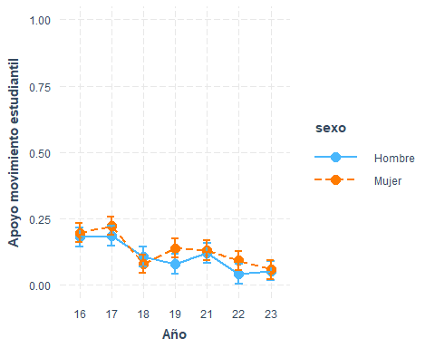

interact_plot(marchar8, pred = ola, modx = educ, interval = TRUE)+  
 ylim(0,1)+  
 labs(y="Apoyo movimiento estudiantil", x="Año")+  
 scale_x_discrete(labels = waves)

✖ Detected factor predictor.  
ℹ Plotting with cat_plot() instead.  
ℹ See `?interactions::cat_plot()` for full details on how to specify models  
 with categorical predictors.  
ℹ If you experience errors or unexpected results, try using cat_plot()  
 directly.  
Scale for x is already present.  
Adding another scale for x, which will replace the existing scale.

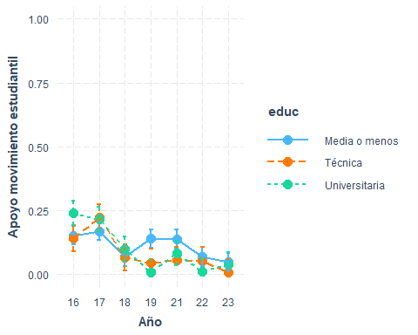

interact_plot(marchar9, pred = ola, modx = pos_id, interval = TRUE)+  
 ylim(0,1)+  
 labs(y="Apoyo movimiento estudiantil", x="Año")+  
 scale_x_discrete(labels = waves)

✖ Detected factor predictor.  
ℹ Plotting with cat_plot() instead.  
ℹ See `?interactions::cat_plot()` for full details on how to specify models  
 with categorical predictors.  
ℹ If you experience errors or unexpected results, try using cat_plot()  
 directly.  
Scale for x is already present.  
Adding another scale for x, which will replace the existing scale.

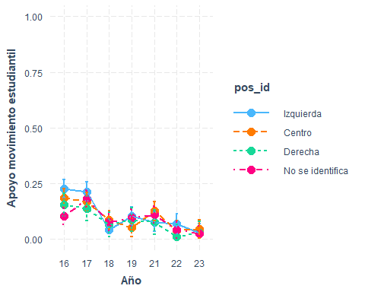

preds <- ggpredict(marchar10, terms = c("ola", "edad", "pos_id"))  
  
ggplot(preds, aes(x = x, y = predicted, color = group, group = group)) +  
 geom_line() +  
 geom_point() +  
 geom_errorbar(aes(ymin = conf.low, ymax = conf.high), width = 0.2) +  
 facet_wrap(~ facet, ncol = 2) +  
 labs(  
 x = "Año",  
 y = "Apoyo movimiento estudiantil",  
 color = "Edad"  
 ) +  
 ylim(-0.3, 1) +  
 scale_x_discrete(labels = waves) +   
 theme_minimal() +  
 theme(legend.position = "bottom")

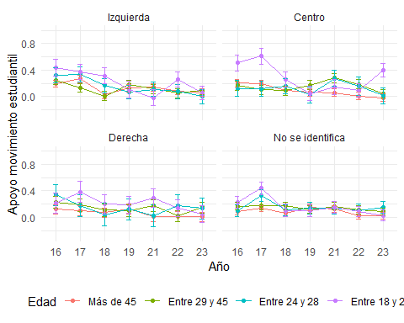

interact_plot(marchar11, pred = ola, modx = edad, mod2 = educ, interval = TRUE)+  
 ylim(0,1)+  
 labs(y="Apoyo movimiento estudiantil", x="Año")+  
 scale_x_discrete(labels = waves)

✖ Detected factor predictor.  
ℹ Plotting with cat_plot() instead.  
ℹ See `?interactions::cat_plot()` for full details on how to specify models  
 with categorical predictors.  
ℹ If you experience errors or unexpected results, try using cat_plot()  
 directly.  
Scale for x is already present.  
Adding another scale for x, which will replace the existing scale.

Warning: Removed 2 rows containing missing values or values outside the scale range  
(`geom_point()`).

Warning: Removed 1 row containing missing values or values outside the scale range  
(`geom_path()`).

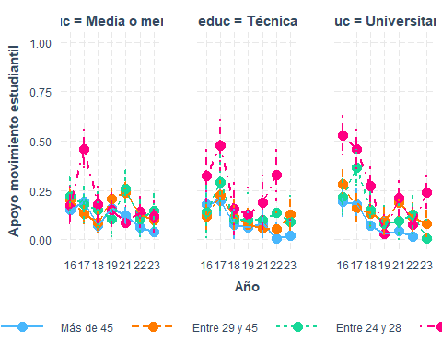

interact_plot(marchar12, pred = ola, modx = edad, mod2 = sexo, interval = TRUE)+  
 ylim(0,1)+  
 labs(y="Apoyo movimiento estudiantil", x="Año")+  
 scale_x_discrete(labels = waves)

✖ Detected factor predictor.  
ℹ Plotting with cat_plot() instead.  
ℹ See `?interactions::cat_plot()` for full details on how to specify models  
 with categorical predictors.  
ℹ If you experience errors or unexpected results, try using cat_plot()  
 directly.  
Scale for x is already present.  
Adding another scale for x, which will replace the existing scale.

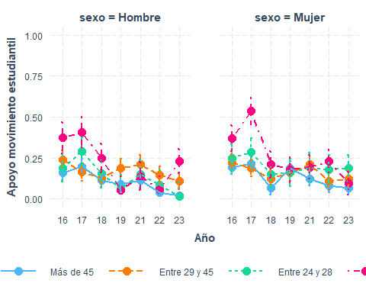

## Participación electoral

Variables: - Participación elecciones 2013 (ola 1 y 2) - Participación elecciones 2017 (ola 3 y 4) - Participación en plebiscito nueva constitución (ola 5) - Participación elecciones 2021 primera vuelta (ola 6) - Participación elecciones 2021 segunda vuelta (ola 7)

#if (!require("pacman")) install.packages("pacman") # instalar pacman  
 # cargar librerias  
pacman::p_load(dplyr, # Manipulacion de datos  
 knitr,  
 kableExtra,  
 summarytools,  
 lme4,  
 texreg  
 )  
load(file = here::here("input/data-proc/df_study1_long_t7.RData"))  
  
# generate analytical sample  
df_study1 <-   
 df_study1_long_t7 %>%  
 select(idencuesta,ola,part_electoral, edad, sexo, pos_id, educ, universitaria, ponderador_long_total) %>%   
 na.omit() %>%   
 mutate(ola_num=as.numeric(ola),  
 ola=as.factor(ola),  
 edad = case_when(edad <=23~"Entre 18 y 23",  
 edad >23 & edad <=28 ~ "Entre 24 y 28",  
 edad >28 & edad <=45 ~ "Entre 29 y 45",  
 edad > 45 ~ "Más de 45"))   
df_study1$edad <- factor(df_study1$edad, levels = c("Más de 45", "Entre 29 y 45", "Entre 24 y 28", "Entre 18 y 23"))  
df_study1$sexo <- factor(df_study1$sexo, levels = c(1, 2), labels = c("Hombre", "Mujer"))  
  
df_study1$part_electoral <- factor(df_study1$part_electoral, levels = c(1,2),  
 labels = c("Si", "No"))  
df_study1$part_electoral <- car::recode(df_study1$part_electoral, c("1=2; 2=1"))  
df_study1 <- df_study1 %>%  
 dplyr::mutate(part_electoral = ifelse(part_electoral == "Si", 1, 0))  
  
  
marchar.null <- glmer(formula(paste0("part_electoral~","1 + (1|idencuesta)")),data = df_study1, weights = ponderador_long_total, family = "binomial")

Warning in eval(family$initialize, rho): non-integer #successes in a binomial  
glm!

marchar1 <- glmer(formula(paste0("part_electoral~",h1,"+(1|idencuesta)")),data = df_study1, weights = ponderador_long_total, family = "binomial")

Warning in eval(family$initialize, rho): non-integer #successes in a binomial  
glm!

marchar2 <- glmer(formula(paste0("part_electoral~",h2,"+(1|idencuesta)")),data = df_study1, weights = ponderador_long_total, family = "binomial")

Warning in eval(family$initialize, rho): non-integer #successes in a binomial  
glm!

Warning in checkConv(attr(opt, "derivs"), opt$par, ctrl = control$checkConv, :  
Model failed to converge with max|grad| = 0.647782 (tol = 0.002, component 1)

marchar3 <- glmer(formula(paste0("part_electoral~",h3,"+(1|idencuesta)")),data = df_study1, weights = ponderador_long_total, family = "binomial")

Warning in eval(family$initialize, rho): non-integer #successes in a binomial  
glm!

Warning in checkConv(attr(opt, "derivs"), opt$par, ctrl = control$checkConv, :  
Model failed to converge with max|grad| = 0.658587 (tol = 0.002, component 1)

marchar4 <- lmer(formula(paste0("part_electoral~",h4,"+(1|idencuesta)")),data = df_study1, weights = ponderador_long_total)  
marchar5 <- lmer(formula(paste0("part_electoral~",h5,"+(1|idencuesta)")),data = df_study1, weights = ponderador_long_total)  
marchar6 <- lmer(formula(paste0("part_electoral~",h6,"+(1|idencuesta)")),data = df_study1, weights = ponderador_long_total)  
marchar7 <- lmer(formula(paste0("part_electoral~",h7,"+(1|idencuesta)")),data = df_study1, weights = ponderador_long_total)  
marchar8 <- lmer(formula(paste0("part_electoral~",h8,"+(1|idencuesta)")),data = df_study1, weights = ponderador_long_total)  
marchar9 <- lmer(formula(paste0("part_electoral~",h9,"+(1|idencuesta)")),data = df_study1, weights = ponderador_long_total)  
marchar10 <- lmer(formula(paste0("part_electoral~",h10,"+(1|idencuesta)")),data = df_study1, weights = ponderador_long_total)  
marchar11 <- lmer(formula(paste0("part_electoral~",h11,"+(1|idencuesta)")),data = df_study1, weights = ponderador_long_total)  
marchar12 <- lmer(formula(paste0("part_electoral~",h12,"+(1|idencuesta)")),data = df_study1, weights = ponderador_long_total)

texreg::knitreg(list(marchar1, marchar2, marchar3, marchar4, marchar5, marchar6, marchar7, marchar8, marchar9, marchar10, marchar11),  
 custom.note = "*** p < 0.001; ** p < 0.01; * p < 0.05")

Statistical models

Model 1

Model 2

Model 3

Model 4

Model 5

Model 6

Model 7

Model 8

Model 9

Model 10

Model 11

(Intercept)

1.54***

2.20***

2.22***

0.69***

0.73***

0.84***

0.72***

0.76***

0.73***

0.81***

0.87***

(0.13)

(0.16)

(0.20)

(0.02)

(0.03)

(0.03)

(0.03)

(0.03)

(0.03)

(0.04)

(0.03)

ola2

-0.06

-0.13

-0.12

-0.00

-0.00

0.00

0.00

-0.00

0.01

0.01

0.01

(0.12)

(0.12)

(0.12)

(0.01)

(0.01)

(0.02)

(0.02)

(0.02)

(0.02)

(0.03)

(0.02)

ola3

-0.04

-0.09

-0.10

-0.00

-0.00

-0.08***

0.03

-0.05***

0.03

-0.04

-0.10***

(0.12)

(0.12)

(0.12)

(0.01)

(0.01)

(0.02)

(0.02)

(0.02)

(0.02)

(0.03)

(0.02)

ola4

-0.09

-0.12

-0.15

-0.01

-0.01

-0.09***

0.03

-0.05***

0.04

-0.04

-0.11***

(0.12)

(0.12)

(0.12)

(0.01)

(0.01)

(0.02)

(0.02)

(0.02)

(0.02)

(0.03)

(0.02)

ola5

0.97***

0.91***

0.92***

0.09***

0.09***

-0.16***

0.08***

0.04*

0.09***

-0.13***

-0.20***

(0.13)

(0.13)

(0.13)

(0.01)

(0.01)

(0.02)

(0.02)

(0.02)

(0.02)

(0.03)

(0.02)

ola6

1.56***

1.51***

1.50***

0.15***

0.15***

-0.05**

0.19***

0.12***

0.11***

-0.03

-0.08***

(0.13)

(0.13)

(0.13)

(0.01)

(0.01)

(0.02)

(0.02)

(0.02)

(0.02)

(0.03)

(0.02)

ola7

1.15***

1.11***

1.11***

0.11***

0.11***

-0.09***

0.14***

0.08***

0.09***

-0.06

-0.11***

(0.13)

(0.13)

(0.13)

(0.01)

(0.01)

(0.02)

(0.02)

(0.02)

(0.02)

(0.03)

(0.02)

edadEntre 29 y 45

-1.32***

-1.31***

-0.15***

-0.15***

-0.30***

-0.15***

-0.15***

-0.15***

-0.24***

-0.34***

(0.21)

(0.22)

(0.02)

(0.02)

(0.03)

(0.02)

(0.02)

(0.02)

(0.05)

(0.03)

edadEntre 24 y 28

-1.17***

-1.22***

-0.18***

-0.17***

-0.40***

-0.17***

-0.17***

-0.17***

-0.33***

-0.54***

(0.33)

(0.33)

(0.03)

(0.03)

(0.04)

(0.03)

(0.03)

(0.03)

(0.08)

(0.06)

edadEntre 18 y 23

-1.54***

-1.55***

-0.20***

-0.19***

-0.48***

-0.19***

-0.19***

-0.20***

-0.57***

-0.67***

(0.34)

(0.35)

(0.04)

(0.04)

(0.04)

(0.04)

(0.04)

(0.04)

(0.09)

(0.07)

sexoMujer

-0.03

0.01

0.01

0.01

0.04

0.01

0.01

0.01

0.01

(0.19)

(0.02)

(0.02)

(0.02)

(0.02)

(0.02)

(0.02)

(0.02)

(0.02)

educTécnica

0.06*

0.05

0.06*

0.05

-0.04

0.05

0.06*

-0.06

(0.03)

(0.03)

(0.03)

(0.03)

(0.03)

(0.03)

(0.03)

(0.05)

educUniversitaria

0.18***

0.16***

0.17***

0.16***

0.11***

0.16***

0.17***

0.02

(0.02)

(0.02)

(0.02)

(0.02)

(0.03)

(0.03)

(0.02)

(0.05)

pos_idCentro

-0.04

-0.04

-0.04

-0.04

-0.02

0.01

-0.04

(0.03)

(0.03)

(0.03)

(0.03)

(0.03)

(0.05)

(0.03)

pos_idDerecha

-0.01

-0.02

-0.01

-0.01

0.03

-0.02

-0.01

(0.03)

(0.03)

(0.03)

(0.03)

(0.04)

(0.05)

(0.03)

pos_idNo se identifica

-0.08**

-0.08**

-0.08**

-0.07**

-0.09**

-0.04

-0.07**

(0.02)

(0.02)

(0.02)

(0.02)

(0.03)

(0.04)

(0.02)

ola2:edadEntre 29 y 45

-0.01

0.02

-0.02

(0.03)

(0.05)

(0.03)

ola3:edadEntre 29 y 45

0.11***

0.06

0.06

(0.03)

(0.05)

(0.03)

ola4:edadEntre 29 y 45

0.13***

0.09

0.11**

(0.03)

(0.05)

(0.03)

ola5:edadEntre 29 y 45

0.32***

0.34***

0.36***

(0.03)

(0.05)

(0.03)

ola6:edadEntre 29 y 45

0.30***

0.22***

0.30***

(0.03)

(0.05)

(0.03)

ola7:edadEntre 29 y 45

0.31***

0.28***

0.32***

(0.03)

(0.05)

(0.03)

ola2:edadEntre 24 y 28

-0.01

-0.02

-0.01

(0.04)

(0.07)

(0.05)

ola3:edadEntre 24 y 28

0.22***

0.19**

0.21***

(0.04)

(0.07)

(0.05)

ola4:edadEntre 24 y 28

0.25***

0.21**

0.24***

(0.04)

(0.07)

(0.05)

ola5:edadEntre 24 y 28

0.49***

0.28***

0.63***

(0.04)

(0.07)

(0.06)

ola6:edadEntre 24 y 28

0.40***

0.17*

0.52***

(0.04)

(0.07)

(0.06)

ola7:edadEntre 24 y 28

0.34***

0.20**

0.38***

(0.04)

(0.07)

(0.06)

ola2:edadEntre 18 y 23

-0.01

-0.01

-0.03

(0.04)

(0.08)

(0.06)

ola3:edadEntre 18 y 23

0.20***

0.35***

0.27***

(0.04)

(0.08)

(0.06)

ola4:edadEntre 18 y 23

0.16***

0.21*

0.26***

(0.04)

(0.09)

(0.06)

ola5:edadEntre 18 y 23

0.65***

0.72***

0.87***

(0.04)

(0.08)

(0.06)

ola6:edadEntre 18 y 23

0.44***

0.53***

0.63***

(0.04)

(0.08)

(0.05)

ola7:edadEntre 18 y 23

0.48***

0.41***

0.65***

(0.04)

(0.08)

(0.05)

ola2:sexoMujer

-0.01

(0.02)

ola3:sexoMujer

-0.06**

(0.02)

ola4:sexoMujer

-0.08***

(0.02)

ola5:sexoMujer

0.02

(0.02)

ola6:sexoMujer

-0.07**

(0.02)

ola7:sexoMujer

-0.04

(0.02)

ola2:educTécnica

-0.03

-0.03

(0.03)

(0.04)

ola3:educTécnica

0.14***

0.06

(0.03)

(0.05)

ola4:educTécnica

0.13***

0.06

(0.03)

(0.05)

ola5:educTécnica

0.13***

0.12*

(0.03)

(0.05)

ola6:educTécnica

0.16***

0.08

(0.03)

(0.05)

ola7:educTécnica

0.14***

0.07

(0.03)

(0.05)

ola2:educUniversitaria

0.01

-0.00

(0.03)

(0.05)

ola3:educUniversitaria

0.11***

0.06

(0.03)

(0.05)

ola4:educUniversitaria

0.08**

0.05

(0.03)

(0.05)

ola5:educUniversitaria

0.11***

0.15**

(0.03)

(0.05)

ola6:educUniversitaria

0.03

0.10

(0.03)

(0.05)

ola7:educUniversitaria

0.04

0.07

(0.03)

(0.05)

ola2:pos_idCentro

-0.02

-0.02

(0.03)

(0.04)

ola3:pos_idCentro

-0.03

-0.09

(0.03)

(0.05)

ola4:pos_idCentro

-0.05

-0.12*

(0.03)

(0.05)

ola5:pos_idCentro

-0.04

-0.07

(0.03)

(0.05)

ola6:pos_idCentro

0.01

-0.06

(0.03)

(0.05)

ola7:pos_idCentro

-0.02

-0.08

(0.03)

(0.05)

ola2:pos_idDerecha

-0.02

0.00

(0.04)

(0.05)

ola3:pos_idDerecha

-0.03

-0.00

(0.04)

(0.05)

ola4:pos_idDerecha

-0.04

0.00

(0.04)

(0.06)

ola5:pos_idDerecha

-0.11**

-0.04

(0.04)

(0.06)

ola6:pos_idDerecha

0.01

0.05

(0.04)

(0.06)

ola7:pos_idDerecha

-0.11**

0.00

(0.04)

(0.06)

ola2:pos_idNo se identifica

-0.00

0.01

(0.03)

(0.04)

ola3:pos_idNo se identifica

-0.07*

-0.05

(0.03)

(0.04)

ola4:pos_idNo se identifica

-0.09**

-0.06

(0.03)

(0.05)

ola5:pos_idNo se identifica

0.08**

-0.01

(0.03)

(0.05)

ola6:pos_idNo se identifica

0.10***

-0.02

(0.03)

(0.05)

ola7:pos_idNo se identifica

0.13***

-0.03

(0.03)

(0.05)

pos_idCentro:edadEntre 29 y 45

-0.06

(0.08)

pos_idDerecha:edadEntre 29 y 45

0.05

(0.09)

pos_idNo se identifica:edadEntre 29 y 45

-0.14

(0.07)

pos_idCentro:edadEntre 24 y 28

-0.13

(0.12)

pos_idDerecha:edadEntre 24 y 28

-0.01

(0.14)

pos_idNo se identifica:edadEntre 24 y 28

-0.11

(0.11)

pos_idCentro:edadEntre 18 y 23

0.05

(0.13)

pos_idDerecha:edadEntre 18 y 23

0.29

(0.15)

pos_idNo se identifica:edadEntre 18 y 23

0.11

(0.12)

ola2:pos_idCentro:edadEntre 29 y 45

-0.01

(0.07)

ola3:pos_idCentro:edadEntre 29 y 45

0.15*

(0.07)

ola4:pos_idCentro:edadEntre 29 y 45

0.13

(0.07)

ola5:pos_idCentro:edadEntre 29 y 45

-0.02

(0.08)

ola6:pos_idCentro:edadEntre 29 y 45

0.08

(0.07)

ola7:pos_idCentro:edadEntre 29 y 45

-0.02

(0.07)

ola2:pos_idDerecha:edadEntre 29 y 45

-0.06

(0.08)

ola3:pos_idDerecha:edadEntre 29 y 45

0.00

(0.08)

ola4:pos_idDerecha:edadEntre 29 y 45

-0.05

(0.09)

ola5:pos_idDerecha:edadEntre 29 y 45

-0.15

(0.09)

ola6:pos_idDerecha:edadEntre 29 y 45

-0.15

(0.09)

ola7:pos_idDerecha:edadEntre 29 y 45

-0.18*

(0.09)

ola2:pos_idNo se identifica:edadEntre 29 y 45

-0.05

(0.07)

ola3:pos_idNo se identifica:edadEntre 29 y 45

0.04

(0.07)

ola4:pos_idNo se identifica:edadEntre 29 y 45

0.04

(0.07)

ola5:pos_idNo se identifica:edadEntre 29 y 45

0.03

(0.07)

ola6:pos_idNo se identifica:edadEntre 29 y 45

0.28***

(0.07)

ola7:pos_idNo se identifica:edadEntre 29 y 45

0.20**

(0.07)

ola2:pos_idCentro:edadEntre 24 y 28

0.00

(0.10)

ola3:pos_idCentro:edadEntre 24 y 28

0.27**

(0.10)

ola4:pos_idCentro:edadEntre 24 y 28

0.28**

(0.10)

ola5:pos_idCentro:edadEntre 24 y 28

0.31**

(0.10)

ola6:pos_idCentro:edadEntre 24 y 28

0.47***

(0.11)

ola7:pos_idCentro:edadEntre 24 y 28

0.48***

(0.11)

ola2:pos_idDerecha:edadEntre 24 y 28

-0.02

(0.12)

ola3:pos_idDerecha:edadEntre 24 y 28

-0.15

(0.13)

ola4:pos_idDerecha:edadEntre 24 y 28

-0.16

(0.13)

ola5:pos_idDerecha:edadEntre 24 y 28

0.04

(0.13)

ola6:pos_idDerecha:edadEntre 24 y 28

-0.01

(0.13)

ola7:pos_idDerecha:edadEntre 24 y 28

-0.15

(0.14)

ola2:pos_idNo se identifica:edadEntre 24 y 28

0.03

(0.09)

ola3:pos_idNo se identifica:edadEntre 24 y 28

-0.03

(0.09)

ola4:pos_idNo se identifica:edadEntre 24 y 28

-0.03

(0.09)

ola5:pos_idNo se identifica:edadEntre 24 y 28

0.42***

(0.10)

ola6:pos_idNo se identifica:edadEntre 24 y 28

0.38***

(0.09)

ola7:pos_idNo se identifica:edadEntre 24 y 28

0.16

(0.09)

ola2:pos_idCentro:edadEntre 18 y 23

0.02

(0.11)

ola3:pos_idCentro:edadEntre 18 y 23

-0.10

(0.11)

ola4:pos_idCentro:edadEntre 18 y 23

0.07

(0.11)

ola5:pos_idCentro:edadEntre 18 y 23

0.00

(0.11)

ola6:pos_idCentro:edadEntre 18 y 23

-0.04

(0.10)

ola7:pos_idCentro:edadEntre 18 y 23

0.09

(0.10)

ola2:pos_idDerecha:edadEntre 18 y 23

-0.06

(0.14)

ola3:pos_idDerecha:edadEntre 18 y 23

-0.16

(0.13)

ola4:pos_idDerecha:edadEntre 18 y 23

-0.01

(0.13)

ola5:pos_idDerecha:edadEntre 18 y 23

-0.29*

(0.14)

ola6:pos_idDerecha:edadEntre 18 y 23

-0.09

(0.13)

ola7:pos_idDerecha:edadEntre 18 y 23

-0.28*

(0.13)

ola2:pos_idNo se identifica:edadEntre 18 y 23

-0.00

(0.10)

ola3:pos_idNo se identifica:edadEntre 18 y 23

-0.28**

(0.10)

ola4:pos_idNo se identifica:edadEntre 18 y 23

-0.21*

(0.11)

ola5:pos_idNo se identifica:edadEntre 18 y 23

-0.09

(0.10)

ola6:pos_idNo se identifica:edadEntre 18 y 23

-0.15

(0.10)

ola7:pos_idNo se identifica:edadEntre 18 y 23

0.19*

(0.10)

educTécnica:edadEntre 29 y 45

0.16*

(0.07)

educUniversitaria:edadEntre 29 y 45

0.14*

(0.07)

educTécnica:edadEntre 24 y 28

0.15

(0.12)

educUniversitaria:edadEntre 24 y 28

0.39***

(0.10)

educTécnica:edadEntre 18 y 23

0.18

(0.12)

educUniversitaria:edadEntre 18 y 23

0.52***

(0.10)

ola2:educTécnica:edadEntre 29 y 45

0.01

(0.07)

ola3:educTécnica:edadEntre 29 y 45

0.01

(0.07)

ola4:educTécnica:edadEntre 29 y 45

-0.02

(0.07)

ola5:educTécnica:edadEntre 29 y 45

-0.18*

(0.07)

ola6:educTécnica:edadEntre 29 y 45

-0.03

(0.07)

ola7:educTécnica:edadEntre 29 y 45

-0.12

(0.07)

ola2:educUniversitaria:edadEntre 29 y 45

0.03

(0.07)

ola3:educUniversitaria:edadEntre 29 y 45

0.12

(0.07)

ola4:educUniversitaria:edadEntre 29 y 45

0.08

(0.07)

ola5:educUniversitaria:edadEntre 29 y 45

-0.08

(0.07)

ola6:educUniversitaria:edadEntre 29 y 45

-0.04

(0.07)

ola7:educUniversitaria:edadEntre 29 y 45

-0.01

(0.07)

ola2:educTécnica:edadEntre 24 y 28

0.01

(0.10)

ola3:educTécnica:edadEntre 24 y 28

0.15

(0.10)

ola4:educTécnica:edadEntre 24 y 28

0.16

(0.10)

ola5:educTécnica:edadEntre 24 y 28

0.04

(0.11)

ola6:educTécnica:edadEntre 24 y 28

0.12

(0.11)

ola7:educTécnica:edadEntre 24 y 28

0.29**

(0.11)

ola2:educUniversitaria:edadEntre 24 y 28

-0.01

(0.09)

ola3:educUniversitaria:edadEntre 24 y 28

-0.07

(0.08)

ola4:educUniversitaria:edadEntre 24 y 28

-0.08

(0.09)

ola5:educUniversitaria:edadEntre 24 y 28

-0.43***

(0.09)

ola6:educUniversitaria:edadEntre 24 y 28

-0.40***

(0.09)

ola7:educUniversitaria:edadEntre 24 y 28

-0.26**

(0.09)

ola2:educTécnica:edadEntre 18 y 23

0.03

(0.10)

ola3:educTécnica:edadEntre 18 y 23

0.11

(0.10)

ola4:educTécnica:edadEntre 18 y 23

0.08

(0.10)

ola5:educTécnica:edadEntre 18 y 23

0.01

(0.10)

ola6:educTécnica:edadEntre 18 y 23

0.10

(0.10)

ola7:educTécnica:edadEntre 18 y 23

0.14

(0.10)

ola2:educUniversitaria:edadEntre 18 y 23

0.07

(0.09)

ola3:educUniversitaria:edadEntre 18 y 23

-0.28**

(0.09)

ola4:educUniversitaria:edadEntre 18 y 23

-0.31***

(0.09)

ola5:educUniversitaria:edadEntre 18 y 23

-0.63***

(0.09)

ola6:educUniversitaria:edadEntre 18 y 23

-0.56***

(0.09)

ola7:educUniversitaria:edadEntre 18 y 23

-0.53***

(0.09)

AIC

7501.84

7463.78

7465.76

24958.23

24970.54

24332.44

24985.93

24977.84

24943.77

24390.82

24320.14

BIC

7559.99

7543.74

7552.99

25067.27

25101.38

24594.13

25160.38

25195.91

25205.45

25241.29

24974.35

Log Likelihood

-3742.92

-3720.89

-3720.88

-12464.12

-12467.27

-12130.22

-12468.96

-12458.92

-12435.89

-12078.41

-12070.07

Num. obs.

10604

10604

10604

10604

10604

10604

10604

10604

10604

10604

10604

Num. groups: idencuesta

1704

1704

1704

1704

1704

1704

1704

1704

1704

1704

1704

Var: idencuesta (Intercept)

5.37

5.16

5.21

0.08

0.08

0.08

0.08

0.08

0.08

0.08

0.07

Var: Residual

0.10

0.10

0.09

0.10

0.10

0.10

0.09

0.09

*** p < 0.001; ** p < 0.01; * p < 0.05

### interacciones

elecciones<- c("Presidenciales  
2013", "Presidenciales  
2013", "Presidenciales  
2017", "Presidenciales  
2017", "Plebiscito   
nueva constitución","Primera vuelta  
2021", "Segunda vuelta  
2021")  
  
interact_plot(marchar6, pred = ola, modx = edad, interval = TRUE)+  
 ylim(0,1)+  
 labs(y="Participación electoral", x="Año")+  
 scale_x_discrete(labels = elecciones)

✖ Detected factor predictor.  
ℹ Plotting with cat_plot() instead.  
ℹ See `?interactions::cat_plot()` for full details on how to specify models  
 with categorical predictors.  
ℹ If you experience errors or unexpected results, try using cat_plot()  
 directly.  
Scale for x is already present.  
Adding another scale for x, which will replace the existing scale.

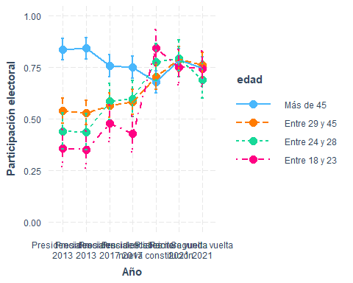

interact_plot(marchar7, pred = ola, modx = sexo, interval = TRUE)+  
 ylim(0,1)+  
 labs(y="Participación electoral", x="Año")+  
 scale_x_discrete(labels = elecciones)

✖ Detected factor predictor.  
ℹ Plotting with cat_plot() instead.  
ℹ See `?interactions::cat_plot()` for full details on how to specify models  
 with categorical predictors.  
ℹ If you experience errors or unexpected results, try using cat_plot()  
 directly.  
Scale for x is already present.  
Adding another scale for x, which will replace the existing scale.

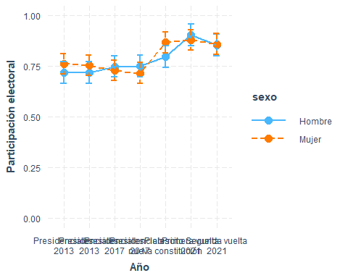

interact_plot(marchar8, pred = ola, modx = educ, interval = TRUE)+  
 ylim(0,1.2)+  
 labs(y="Participación electoral", x="Año")+  
 scale_x_discrete(labels = elecciones)

✖ Detected factor predictor.  
ℹ Plotting with cat_plot() instead.  
ℹ See `?interactions::cat_plot()` for full details on how to specify models  
 with categorical predictors.  
ℹ If you experience errors or unexpected results, try using cat_plot()  
 directly.  
Scale for x is already present.  
Adding another scale for x, which will replace the existing scale.

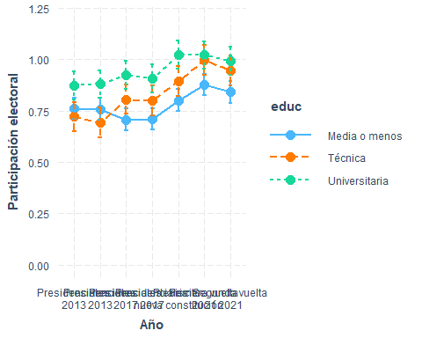

interact_plot(marchar9, pred = ola, modx = pos_id, interval = TRUE)+  
 ylim(0,1)+  
 labs(y="Participación electoral", x="Año")+  
 scale_x_discrete(labels = elecciones)

✖ Detected factor predictor.  
ℹ Plotting with cat_plot() instead.  
ℹ See `?interactions::cat_plot()` for full details on how to specify models  
 with categorical predictors.  
ℹ If you experience errors or unexpected results, try using cat_plot()  
 directly.  
Scale for x is already present.  
Adding another scale for x, which will replace the existing scale.

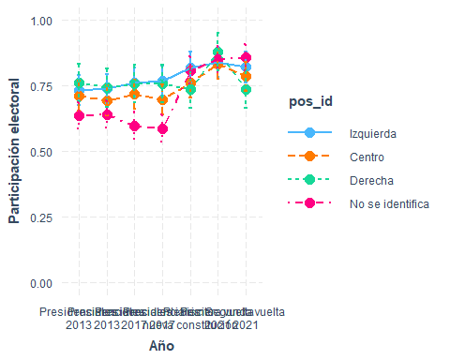

preds <- ggpredict(marchar10, terms = c("ola", "edad", "pos_id"))  
  
ggplot(preds, aes(x = x, y = predicted, color = group, group = group)) +  
 geom_line() +  
 geom_point() +  
 geom_errorbar(aes(ymin = conf.low, ymax = conf.high), width = 0.2) +  
 facet_wrap(~ facet, ncol = 2) +  
 labs(  
 x = "Año",  
 y = "Participación electoral",  
 color = "Edad"  
 ) +  
 ylim(0, 1) +  
 scale_x_discrete(labels = elecciones) +   
 theme_minimal() +  
 theme(legend.position = "bottom")

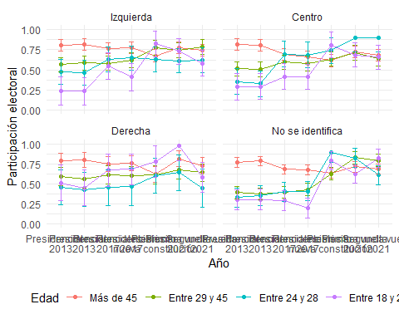

preds <- ggpredict(marchar11, terms = c("ola", "edad", "educ"))  
  
ggplot(preds, aes(x = x, y = predicted, color = group, group = group)) +  
 geom_line() +  
 geom_point() +  
 geom_errorbar(aes(ymin = conf.low, ymax = conf.high), width = 0.2) +  
 facet_wrap(~ facet, ncol = 2) +  
 labs(  
 x = "Año",  
 y = "Participación electoral",  
 color = "Edad"  
 ) +  
 ylim(0, 1.2) +  
 scale_x_discrete(labels = elecciones) +   
 theme_minimal() +  
 theme(legend.position = "bottom")

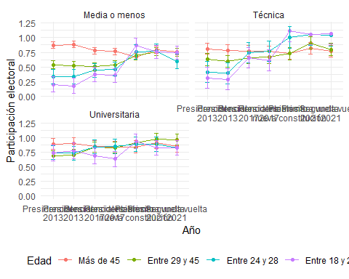

preds <- ggpredict(marchar12, terms = c("ola", "edad", "sexo"))  
  
ggplot(preds, aes(x = x, y = predicted, color = group, group = group)) +  
 geom_line() +  
 geom_point() +  
 geom_errorbar(aes(ymin = conf.low, ymax = conf.high), width = 0.2) +  
 facet_wrap(~ facet, ncol = 2) +  
 labs(  
 x = "Año",  
 y = "Participación electoral",  
 color = "Edad"  
 ) +  
 ylim(0, 1) +  
 scale_x_discrete(labels = elecciones) +   
 theme_minimal() +  
 theme(legend.position = "bottom")

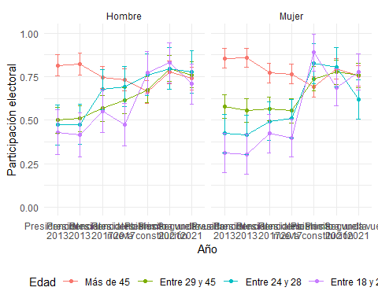

## Autoritarismo (casi todas las olas)

load(file = here::here("input/data-proc/df_study1_long_t7.RData"))  
  
df_study1 <- df_study1_long_t7 %>% dplyr::select(idencuesta,ola, segmento, estrato, ponderador_long_total, sexo, pos_id, educ, universitaria,  
 autoritarismo1, autoritarismo2, autoritarismo3, autoritarismo4, autoritarismo5,  
 edad) %>% na.omit()  
  
df_study1 <- df_study1 %>%   
 rowwise() %>%  
 mutate(autoritarismo = mean(c(autoritarismo1:autoritarismo4, na.rm=TRUE))) %>%   
 ungroup()

df_study1 <- df_study1 %>%   
 rowwise() %>%  
 mutate(ola_num=as.numeric(ola),  
 ola=as.factor(ola),  
 edad = case_when(edad <=23~"Entre 18 y 23",  
 edad >23 & edad <=28 ~ "Entre 24 y 28",  
 edad >28 & edad <=45 ~ "Entre 29 y 45",  
 edad > 45 ~ "Más de 45"))   
df_study1$edad <- factor(df_study1$edad, levels = c("Más de 45", "Entre 29 y 45", "Entre 24 y 28", "Entre 18 y 23"))  
df_study1$sexo <- factor(df_study1$sexo, levels = c(1, 2), labels = c("Hombre", "Mujer"))  
  
marchar.null <- lmer(formula(paste0("autoritarismo~","1 + (1|idencuesta)")),data = df_study1, weights = ponderador_long_total)  
marchar1 <- lmer(formula(paste0("autoritarismo~",h1,"+(1|idencuesta)")),data = df_study1, weights = ponderador_long_total)  
marchar2 <- lmer(formula(paste0("autoritarismo~",h2,"+(1|idencuesta)")),data = df_study1, weights = ponderador_long_total)  
marchar3 <- lmer(formula(paste0("autoritarismo~",h3,"+(1|idencuesta)")),data = df_study1, weights = ponderador_long_total)  
marchar4 <- lmer(formula(paste0("autoritarismo~",h4,"+(1|idencuesta)")),data = df_study1, weights = ponderador_long_total)  
marchar5 <- lmer(formula(paste0("autoritarismo~",h5,"+(1|idencuesta)")),data = df_study1, weights = ponderador_long_total)  
marchar6 <- lmer(formula(paste0("autoritarismo~",h6,"+(1|idencuesta)")),data = df_study1, weights = ponderador_long_total)  
marchar7 <- lmer(formula(paste0("autoritarismo~",h7,"+(1|idencuesta)")),data = df_study1, weights = ponderador_long_total)  
marchar8 <- lmer(formula(paste0("autoritarismo~",h8,"+(1|idencuesta)")),data = df_study1, weights = ponderador_long_total)  
marchar9 <- lmer(formula(paste0("autoritarismo~",h9,"+(1|idencuesta)")),data = df_study1, weights = ponderador_long_total)  
marchar10 <- lmer(formula(paste0("autoritarismo~",h10,"+(1|idencuesta)")),data = df_study1, weights = ponderador_long_total)  
marchar11 <- lmer(formula(paste0("autoritarismo~",h11,"+(1|idencuesta)")),data = df_study1, weights = ponderador_long_total)  
marchar12 <- lmer(formula(paste0("autoritarismo~",h12,"+(1|idencuesta)")),data = df_study1, weights = ponderador_long_total)

texreg::knitreg(list(marchar1, marchar2, marchar3, marchar4, marchar5, marchar6, marchar7, marchar8, marchar9, marchar10, marchar11),  
 custom.note = "*** p < 0.001; ** p < 0.01; * p < 0.05")

Statistical models

Model 1

Model 2

Model 3

Model 4

Model 5

Model 6

Model 7

Model 8

Model 9

Model 10

Model 11

(Intercept)

2.49***

2.56***

2.55***

2.63***

2.49***

2.49***

2.51***

2.48***

2.48***

2.57***

2.49***

(0.01)

(0.02)

(0.02)

(0.02)

(0.03)

(0.03)

(0.03)

(0.03)

(0.03)

(0.04)

(0.03)

ola2

0.03*

0.03*

0.03*

0.03*

0.03*

0.02

-0.02

0.05*

0.09***

-0.04

0.02

(0.01)

(0.01)

(0.01)

(0.01)

(0.01)

(0.02)

(0.02)

(0.02)

(0.03)

(0.04)

(0.02)

ola3

0.03*

0.03*

0.03*

0.03*

0.03*

0.01

0.00

0.05*

0.10***

-0.01

0.02

(0.01)

(0.01)

(0.01)

(0.01)

(0.01)

(0.02)

(0.02)

(0.02)

(0.03)

(0.04)

(0.03)

ola4

-0.10***

-0.10***

-0.10***

-0.10***

-0.10***

-0.11***

-0.12***

-0.05**

-0.17***

-0.29***

-0.11***

(0.01)

(0.01)

(0.01)

(0.01)

(0.01)

(0.02)

(0.02)

(0.02)

(0.03)

(0.04)

(0.03)

ola5

0.02

0.02

0.02

0.02

0.02

0.01

-0.01

0.04

0.04

-0.07

-0.00

(0.01)

(0.01)

(0.01)

(0.01)

(0.01)

(0.02)

(0.02)

(0.02)

(0.03)

(0.04)

(0.03)

ola6

0.02

0.02

0.02

0.02

0.02

0.01

-0.01

0.03

0.02

-0.07

-0.00

(0.02)

(0.02)

(0.02)

(0.02)

(0.02)

(0.02)

(0.02)

(0.02)

(0.03)

(0.05)

(0.03)

ola7

0.07***

0.08***

0.08***

0.08***

0.08***

0.13***

0.06**

0.09***

0.11***

0.10*

0.13***

(0.01)

(0.01)

(0.01)

(0.01)

(0.01)

(0.02)

(0.02)

(0.02)

(0.03)

(0.04)

(0.03)

edadEntre 29 y 45

-0.10***

-0.10***

-0.05*

-0.05*

-0.07*

-0.05*

-0.06*

-0.06*

-0.23***

-0.08*

(0.03)

(0.03)

(0.02)

(0.02)

(0.03)

(0.02)

(0.02)

(0.02)

(0.06)

(0.04)

edadEntre 24 y 28

-0.23***

-0.23***

-0.13**

-0.13**

-0.08

-0.12**

-0.12**

-0.13**

-0.17

-0.07

(0.04)

(0.04)

(0.04)

(0.04)

(0.05)

(0.04)

(0.04)

(0.04)

(0.10)

(0.07)

edadEntre 18 y 23

-0.21***

-0.21***

-0.12**

-0.12**

-0.13*

-0.12**

-0.12**

-0.12**

-0.49***

-0.17*

(0.04)

(0.04)

(0.04)

(0.04)

(0.05)

(0.04)

(0.04)

(0.04)

(0.10)

(0.07)

sexoMujer

0.01

-0.01

-0.02

-0.02

-0.06*

-0.02

-0.02

-0.01

-0.02

(0.02)

(0.02)

(0.02)

(0.02)

(0.03)

(0.02)

(0.02)

(0.02)

(0.02)

educTécnica

-0.13***

-0.13***

-0.13***

-0.13***

-0.11**

-0.13***

-0.13***

-0.12*

(0.03)

(0.03)

(0.03)

(0.03)

(0.04)

(0.03)

(0.03)

(0.06)

educUniversitaria

-0.36***

-0.37***

-0.37***

-0.37***

-0.32***

-0.37***

-0.37***

-0.31***

(0.03)

(0.03)

(0.03)

(0.03)

(0.04)

(0.03)

(0.03)

(0.06)

pos_idCentro

0.17***

0.17***

0.17***

0.17***

0.19***

0.04

0.16***

(0.03)

(0.03)

(0.03)

(0.03)

(0.04)

(0.05)

(0.03)

pos_idDerecha

0.30***

0.30***

0.30***

0.30***

0.35***

0.24***

0.29***

(0.03)

(0.03)

(0.04)

(0.03)

(0.05)

(0.06)

(0.03)

pos_idNo se identifica

0.15***

0.15***

0.15***

0.15***

0.17***

0.03

0.15***

(0.03)

(0.03)

(0.03)

(0.03)

(0.04)

(0.05)

(0.03)

ola2:edadEntre 29 y 45

0.04

0.20**

0.13**

(0.03)

(0.06)

(0.04)

ola3:edadEntre 29 y 45

0.02

0.16**

0.05

(0.03)

(0.06)

(0.04)

ola4:edadEntre 29 y 45

0.02

0.09

0.09*

(0.03)

(0.06)

(0.04)

ola5:edadEntre 29 y 45

0.06

0.11

0.14**

(0.03)

(0.07)

(0.04)

ola6:edadEntre 29 y 45

0.07

0.05

0.14**

(0.04)

(0.07)

(0.05)

ola7:edadEntre 29 y 45

-0.07*

-0.02

-0.05

(0.03)

(0.06)

(0.04)

ola2:edadEntre 24 y 28

-0.11*

0.11

-0.24***

(0.05)

(0.09)

(0.07)

ola3:edadEntre 24 y 28

0.05

0.26**

0.09

(0.05)

(0.09)

(0.07)

ola4:edadEntre 24 y 28

0.00

0.35***

0.19**

(0.05)

(0.08)

(0.07)

ola5:edadEntre 24 y 28

-0.14**

0.17

-0.03

(0.05)

(0.09)

(0.07)

ola6:edadEntre 24 y 28

-0.16**

0.13

-0.11

(0.05)

(0.09)

(0.07)

ola7:edadEntre 24 y 28

-0.05

0.20*

-0.08

(0.05)

(0.09)

(0.07)

ola2:edadEntre 18 y 23

0.09

0.52***

0.06

(0.05)

(0.09)

(0.07)

ola3:edadEntre 18 y 23

0.05

0.23*

0.05

(0.05)

(0.09)

(0.07)

ola4:edadEntre 18 y 23

0.03

0.40***

0.10

(0.05)

(0.10)

(0.07)

ola5:edadEntre 18 y 23

0.02

0.45***

-0.02

(0.05)

(0.10)

(0.07)

ola6:edadEntre 18 y 23

0.04

0.47***

-0.01

(0.05)

(0.09)

(0.07)

ola7:edadEntre 18 y 23

-0.10*

0.09

-0.10

(0.04)

(0.09)

(0.06)

ola2:sexoMujer

0.10***

(0.03)

ola3:sexoMujer

0.05

(0.03)

ola4:sexoMujer

0.03

(0.03)

ola5:sexoMujer

0.04

(0.03)

ola6:sexoMujer

0.04

(0.03)

ola7:sexoMujer

0.03

(0.03)

ola2:educTécnica

-0.01

-0.03

(0.04)

(0.06)

ola3:educTécnica

0.02

0.00

(0.04)

(0.06)

ola4:educTécnica

-0.09*

0.07

(0.04)

(0.06)

ola5:educTécnica

-0.05

0.10

(0.04)

(0.06)

ola6:educTécnica

-0.05

0.08

(0.04)

(0.06)

ola7:educTécnica

0.03

-0.01

(0.04)

(0.06)

ola2:educUniversitaria

-0.04

0.08

(0.03)

(0.06)

ola3:educUniversitaria

-0.08*

-0.07

(0.03)

(0.06)

ola4:educUniversitaria

-0.13***

-0.08

(0.03)

(0.06)

ola5:educUniversitaria

-0.04

-0.02

(0.03)

(0.07)

ola6:educUniversitaria

-0.03

-0.03

(0.04)

(0.07)

ola7:educUniversitaria

-0.06

0.03

(0.03)

(0.06)

ola2:pos_idCentro

-0.04

0.10

(0.04)

(0.06)

ola3:pos_idCentro

-0.09*

0.06

(0.04)

(0.06)

ola4:pos_idCentro

0.08

0.20***

(0.04)

(0.06)

ola5:pos_idCentro

-0.03

0.11

(0.04)

(0.06)

ola6:pos_idCentro

-0.01

0.10

(0.04)

(0.06)

ola7:pos_idCentro

0.00

0.09

(0.04)

(0.06)

ola2:pos_idDerecha

-0.07

0.02

(0.05)

(0.07)

ola3:pos_idDerecha

-0.21***

-0.07

(0.05)

(0.07)

ola4:pos_idDerecha

0.13**

0.25***

(0.05)

(0.07)

ola5:pos_idDerecha

-0.02

0.12

(0.05)

(0.07)

ola6:pos_idDerecha

0.01

0.10

(0.05)

(0.07)

ola7:pos_idDerecha

-0.15***

-0.05

(0.05)

(0.07)

ola2:pos_idNo se identifica

-0.12**

0.10

(0.04)

(0.05)

ola3:pos_idNo se identifica

-0.05

0.06

(0.04)

(0.06)

ola4:pos_idNo se identifica

0.09*

0.29***

(0.04)

(0.06)

ola5:pos_idNo se identifica

-0.03

0.10

(0.04)

(0.06)

ola6:pos_idNo se identifica

0.00

0.12*

(0.04)

(0.06)

ola7:pos_idNo se identifica

-0.02

0.06

(0.04)

(0.06)

pos_idCentro:edadEntre 29 y 45

0.28**

(0.09)

pos_idDerecha:edadEntre 29 y 45

0.15

(0.10)

pos_idNo se identifica:edadEntre 29 y 45

0.20*

(0.08)

pos_idCentro:edadEntre 24 y 28

0.23

(0.14)

pos_idDerecha:edadEntre 24 y 28

-0.04

(0.17)

pos_idNo se identifica:edadEntre 24 y 28

0.15

(0.12)

pos_idCentro:edadEntre 18 y 23

0.29*

(0.15)

pos_idDerecha:edadEntre 18 y 23

0.56***

(0.17)

pos_idNo se identifica:edadEntre 18 y 23

0.55***

(0.13)

ola2:pos_idCentro:edadEntre 29 y 45

-0.24**

(0.09)

ola3:pos_idCentro:edadEntre 29 y 45

-0.24**

(0.09)

ola4:pos_idCentro:edadEntre 29 y 45

-0.02

(0.09)

ola5:pos_idCentro:edadEntre 29 y 45

-0.10

(0.10)

ola6:pos_idCentro:edadEntre 29 y 45

-0.03

(0.10)

ola7:pos_idCentro:edadEntre 29 y 45

-0.13

(0.09)

ola2:pos_idDerecha:edadEntre 29 y 45

-0.15

(0.11)

ola3:pos_idDerecha:edadEntre 29 y 45

-0.20

(0.11)

ola4:pos_idDerecha:edadEntre 29 y 45

-0.14

(0.11)

ola5:pos_idDerecha:edadEntre 29 y 45

-0.07

(0.11)

ola6:pos_idDerecha:edadEntre 29 y 45

0.00

(0.11)

ola7:pos_idDerecha:edadEntre 29 y 45

-0.04

(0.10)

ola2:pos_idNo se identifica:edadEntre 29 y 45

-0.24**

(0.08)

ola3:pos_idNo se identifica:edadEntre 29 y 45

-0.18*

(0.08)

ola4:pos_idNo se identifica:edadEntre 29 y 45

-0.15

(0.09)

ola5:pos_idNo se identifica:edadEntre 29 y 45

-0.03

(0.09)

ola6:pos_idNo se identifica:edadEntre 29 y 45

0.05

(0.09)

ola7:pos_idNo se identifica:edadEntre 29 y 45

-0.04

(0.09)

ola2:pos_idCentro:edadEntre 24 y 28

-0.17

(0.13)

ola3:pos_idCentro:edadEntre 24 y 28

-0.32*

(0.13)

ola4:pos_idCentro:edadEntre 24 y 28

-0.67***

(0.13)

ola5:pos_idCentro:edadEntre 24 y 28

-0.51***

(0.13)

ola6:pos_idCentro:edadEntre 24 y 28

-0.62***

(0.14)

ola7:pos_idCentro:edadEntre 24 y 28

-0.19

(0.13)

ola2:pos_idDerecha:edadEntre 24 y 28

-0.03

(0.16)

ola3:pos_idDerecha:edadEntre 24 y 28

-0.23

(0.16)

ola4:pos_idDerecha:edadEntre 24 y 28

0.04

(0.16)

ola5:pos_idDerecha:edadEntre 24 y 28

-0.24

(0.16)

ola6:pos_idDerecha:edadEntre 24 y 28

-0.16

(0.17)

ola7:pos_idDerecha:edadEntre 24 y 28

-0.48**

(0.16)

ola2:pos_idNo se identifica:edadEntre 24 y 28

-0.50***

(0.12)

ola3:pos_idNo se identifica:edadEntre 24 y 28

-0.34**

(0.11)

ola4:pos_idNo se identifica:edadEntre 24 y 28

-0.56***

(0.11)

ola5:pos_idNo se identifica:edadEntre 24 y 28

-0.42***

(0.12)

ola6:pos_idNo se identifica:edadEntre 24 y 28

-0.38**

(0.12)

ola7:pos_idNo se identifica:edadEntre 24 y 28

-0.37***

(0.11)

ola2:pos_idCentro:edadEntre 18 y 23

-0.47***

(0.13)

ola3:pos_idCentro:edadEntre 18 y 23

-0.27*

(0.13)

ola4:pos_idCentro:edadEntre 18 y 23

-0.33*

(0.13)

ola5:pos_idCentro:edadEntre 18 y 23

-0.46***

(0.13)

ola6:pos_idCentro:edadEntre 18 y 23

-0.38**

(0.13)

ola7:pos_idCentro:edadEntre 18 y 23

-0.19

(0.12)

ola2:pos_idDerecha:edadEntre 18 y 23

-0.43**

(0.16)

ola3:pos_idDerecha:edadEntre 18 y 23

-0.34*

(0.15)

ola4:pos_idDerecha:edadEntre 18 y 23

-0.54***

(0.15)

ola5:pos_idDerecha:edadEntre 18 y 23

-0.74***

(0.15)

ola6:pos_idDerecha:edadEntre 18 y 23

-0.68***

(0.16)

ola7:pos_idDerecha:edadEntre 18 y 23

-0.40**

(0.14)

ola2:pos_idNo se identifica:edadEntre 18 y 23

-0.70***

(0.12)

ola3:pos_idNo se identifica:edadEntre 18 y 23

-0.17

(0.12)

ola4:pos_idNo se identifica:edadEntre 18 y 23

-0.62***

(0.12)

ola5:pos_idNo se identifica:edadEntre 18 y 23

-0.56***

(0.12)

ola6:pos_idNo se identifica:edadEntre 18 y 23

-0.62***

(0.12)

ola7:pos_idNo se identifica:edadEntre 18 y 23

-0.25*

(0.11)

educTécnica:edadEntre 29 y 45

0.06

(0.09)

educUniversitaria:edadEntre 29 y 45

-0.05

(0.08)

educTécnica:edadEntre 24 y 28

-0.14

(0.13)

educUniversitaria:edadEntre 24 y 28

0.02

(0.11)

educTécnica:edadEntre 18 y 23

0.04

(0.14)

educUniversitaria:edadEntre 18 y 23

0.08

(0.12)

ola2:educTécnica:edadEntre 29 y 45

-0.10

(0.09)

ola3:educTécnica:edadEntre 29 y 45

0.05

(0.09)

ola4:educTécnica:edadEntre 29 y 45

-0.19*

(0.09)

ola5:educTécnica:edadEntre 29 y 45

-0.22*

(0.09)

ola6:educTécnica:edadEntre 29 y 45

-0.16

(0.10)

ola7:educTécnica:edadEntre 29 y 45

-0.05

(0.09)

ola2:educUniversitaria:edadEntre 29 y 45

-0.34***

(0.09)

ola3:educUniversitaria:edadEntre 29 y 45

-0.11

(0.09)

ola4:educUniversitaria:edadEntre 29 y 45

-0.11

(0.09)

ola5:educUniversitaria:edadEntre 29 y 45

-0.14

(0.09)

ola6:educUniversitaria:edadEntre 29 y 45

-0.15

(0.09)

ola7:educUniversitaria:edadEntre 29 y 45

-0.07

(0.09)

ola2:educTécnica:edadEntre 24 y 28

0.44***

(0.13)

ola3:educTécnica:edadEntre 24 y 28

0.03

(0.12)

ola4:educTécnica:edadEntre 24 y 28

-0.43***

(0.13)

ola5:educTécnica:edadEntre 24 y 28

-0.37**

(0.13)

ola6:educTécnica:edadEntre 24 y 28

-0.36**

(0.14)

ola7:educTécnica:edadEntre 24 y 28

0.07

(0.13)

ola2:educUniversitaria:edadEntre 24 y 28

0.07

(0.11)

ola3:educUniversitaria:edadEntre 24 y 28

-0.08

(0.11)

ola4:educUniversitaria:edadEntre 24 y 28

-0.24*

(0.11)

ola5:educUniversitaria:edadEntre 24 y 28

-0.06

(0.11)

ola6:educUniversitaria:edadEntre 24 y 28

0.06

(0.12)

ola7:educUniversitaria:edadEntre 24 y 28

0.02

(0.11)

ola2:educTécnica:edadEntre 18 y 23

0.03

(0.12)

ola3:educTécnica:edadEntre 18 y 23

-0.12

(0.12)

ola4:educTécnica:edadEntre 18 y 23

-0.36**

(0.13)

ola5:educTécnica:edadEntre 18 y 23

-0.23

(0.13)

ola6:educTécnica:edadEntre 18 y 23

-0.21

(0.13)

ola7:educTécnica:edadEntre 18 y 23

0.19

(0.11)

ola2:educUniversitaria:edadEntre 18 y 23

-0.00

(0.11)

ola3:educUniversitaria:edadEntre 18 y 23

0.12

(0.11)

ola4:educUniversitaria:edadEntre 18 y 23

-0.01

(0.11)

ola5:educUniversitaria:edadEntre 18 y 23

0.17

(0.11)

ola6:educUniversitaria:edadEntre 18 y 23

0.19

(0.11)

ola7:educUniversitaria:edadEntre 18 y 23

-0.10

(0.10)

AIC

28975.48

28944.57

28952.08

28809.33

28754.57

28791.38

28787.17

28810.64

28786.13

28914.64

28872.53

BIC

29040.90

29031.80

29046.57

28918.37

28885.42

29053.06

28961.63

29028.71

29047.81

29765.12

29526.75

Log Likelihood

-14478.74

-14460.28

-14463.04

-14389.67

-14359.29

-14359.69

-14369.58

-14375.32

-14357.06

-14340.32

-14346.26

Num. obs.

10605

10605

10605

10605

10605

10605

10605

10605

10605

10605

10605

Num. groups: idencuesta

1705

1705

1705

1705

1705

1705

1705

1705

1705

1705

1705

Var: idencuesta (Intercept)

0.12

0.11

0.11

0.10

0.09

0.09

0.09

0.09

0.09

0.09

0.09

Var: Residual

0.15

0.15

0.15

0.15

0.15

0.15

0.15

0.15

0.15

0.14

0.15

*** p < 0.001; ** p < 0.01; * p < 0.05

### interacciones

interact_plot(marchar6, pred = ola, modx = edad, interval = TRUE)+  
 ylim(1,5)+  
 labs(y="Autoritarismo", x="Año")+  
 scale_x_discrete(labels = waves)

✖ Detected factor predictor.  
ℹ Plotting with cat_plot() instead.  
ℹ See `?interactions::cat_plot()` for full details on how to specify models  
 with categorical predictors.  
ℹ If you experience errors or unexpected results, try using cat_plot()  
 directly.  
Scale for x is already present.  
Adding another scale for x, which will replace the existing scale.

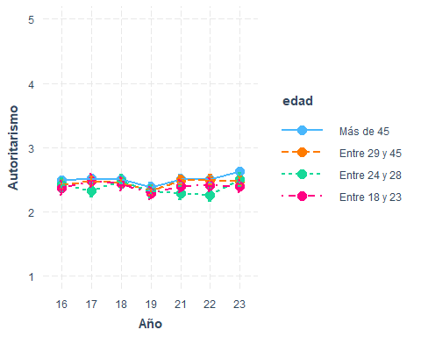

interact_plot(marchar7, pred = ola, modx = sexo, interval = TRUE)+  
 ylim(1,5)+  
 labs(y="Autoritarismo", x="Año")+  
 scale_x_discrete(labels = waves)

✖ Detected factor predictor.  
ℹ Plotting with cat_plot() instead.  
ℹ See `?interactions::cat_plot()` for full details on how to specify models  
 with categorical predictors.  
ℹ If you experience errors or unexpected results, try using cat_plot()  
 directly.  
Scale for x is already present.  
Adding another scale for x, which will replace the existing scale.

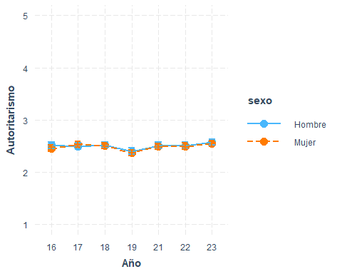

interact_plot(marchar8, pred = ola, modx = educ, interval = TRUE)+  
 ylim(1,5)+  
 labs(y="Autoritarismo", x="Año")+  
 scale_x_discrete(labels = waves)

✖ Detected factor predictor.  
ℹ Plotting with cat_plot() instead.  
ℹ See `?interactions::cat_plot()` for full details on how to specify models  
 with categorical predictors.  
ℹ If you experience errors or unexpected results, try using cat_plot()  
 directly.  
Scale for x is already present.  
Adding another scale for x, which will replace the existing scale.

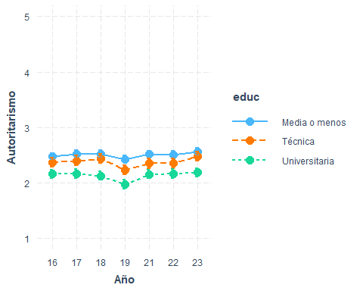

interact_plot(marchar9, pred = ola, modx = pos_id, interval = TRUE)+  
 ylim(1,5)+  
 labs(y="Autoritarismo", x="Año")+  
 scale_x_discrete(labels = waves)

✖ Detected factor predictor.  
ℹ Plotting with cat_plot() instead.  
ℹ See `?interactions::cat_plot()` for full details on how to specify models  
 with categorical predictors.  
ℹ If you experience errors or unexpected results, try using cat_plot()  
 directly.  
Scale for x is already present.  
Adding another scale for x, which will replace the existing scale.

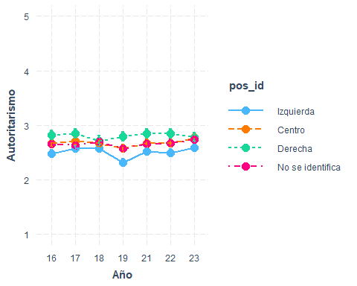

preds <- ggpredict(marchar10, terms = c("ola", "edad", "pos_id"))  
  
ggplot(preds, aes(x = x, y = predicted, color = group, group = group)) +  
 geom_line() +  
 geom_point() +  
 geom_errorbar(aes(ymin = conf.low, ymax = conf.high), width = 0.2) +  
 facet_wrap(~ facet, ncol = 2) +  
 labs(  
 x = "Año",  
 y = "Autoritarismo",  
 color = "Edad"  
 ) +  
 ylim(1, 5) +  
 scale_x_discrete(labels = waves) +   
 theme_minimal() +  
 theme(legend.position = "bottom")

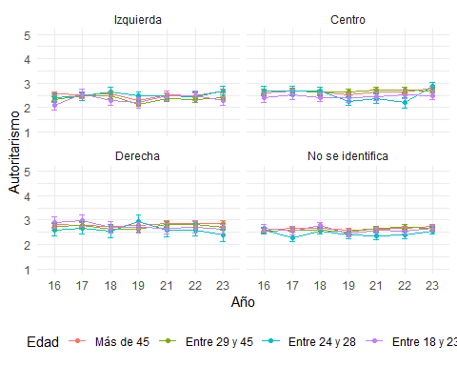

interact_plot(marchar11, pred = ola, modx = edad, mod2 = educ, interval = TRUE)+  
 ylim(1,5)+  
 labs(y="Autoritarismo", x="Año")+  
 scale_x_discrete(labels = waves)

✖ Detected factor predictor.  
ℹ Plotting with cat_plot() instead.  
ℹ See `?interactions::cat_plot()` for full details on how to specify models  
 with categorical predictors.  
ℹ If you experience errors or unexpected results, try using cat_plot()  
 directly.  
Scale for x is already present.  
Adding another scale for x, which will replace the existing scale.

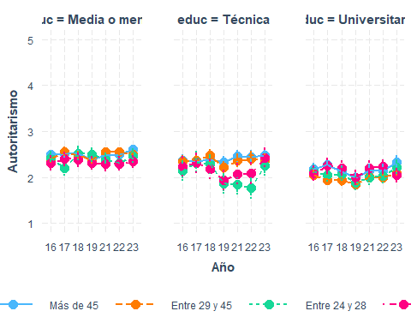

interact_plot(marchar12, pred = ola, modx = edad, mod2 = sexo, interval = TRUE)+  
 ylim(1,5)+  
 labs(y="Autoritarismo", x="Año")+  
 scale_x_discrete(labels = waves)

✖ Detected factor predictor.  
ℹ Plotting with cat_plot() instead.  
ℹ See `?interactions::cat_plot()` for full details on how to specify models  
 with categorical predictors.  
ℹ If you experience errors or unexpected results, try using cat_plot()  
 directly.  
Scale for x is already present.  
Adding another scale for x, which will replace the existing scale.

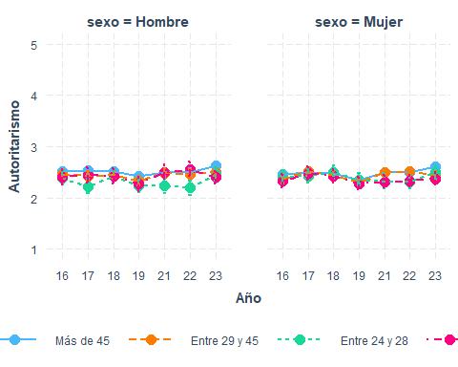

## Adopción homoparental (ola 2018 en adelante)

#if (!require("pacman")) install.packages("pacman") # instalar pacman  
 # cargar librerias  
pacman::p_load(dplyr, # Manipulacion de datos  
 knitr,  
 kableExtra,  
 summarytools,  
 lme4,  
 texreg  
 )  
load(file = here::here("input/data-proc/df_study1_long_t7.RData"))  
  
# generate analytical sample  
df_study1 <-   
 df_study1_long_t7 %>%  
 select(idencuesta,ola,adop_homo, edad, sexo, pos_id, educ, universitaria, ponderador_long_total) %>%   
 na.omit() %>%   
 mutate(ola_num=as.numeric(ola),  
 ola=as.factor(ola),  
 edad = case_when(edad <=23~"Entre 18 y 23",  
 edad >23 & edad <=28 ~ "Entre 24 y 28",  
 edad >28 & edad <=45 ~ "Entre 29 y 45",  
 edad > 45 ~ "Más de 45"))   
df_study1$edad <- factor(df_study1$edad, levels = c("Más de 45", "Entre 29 y 45", "Entre 24 y 28", "Entre 18 y 23"))  
df_study1$sexo <- factor(df_study1$sexo, levels = c(1, 2), labels = c("Hombre", "Mujer"))  
  
marchar.null <- lmer(formula(paste0("adop_homo~","1 + (1|idencuesta)")),data = df_study1, weights = ponderador_long_total)  
marchar1 <- lmer(formula(paste0("adop_homo~",h1,"+(1|idencuesta)")),data = df_study1, weights = ponderador_long_total)  
marchar2 <- lmer(formula(paste0("adop_homo~",h2,"+(1|idencuesta)")),data = df_study1, weights = ponderador_long_total)  
marchar3 <- lmer(formula(paste0("adop_homo~",h3,"+(1|idencuesta)")),data = df_study1, weights = ponderador_long_total)  
marchar4 <- lmer(formula(paste0("adop_homo~",h4,"+(1|idencuesta)")),data = df_study1, weights = ponderador_long_total)  
marchar5 <- lmer(formula(paste0("adop_homo~",h5,"+(1|idencuesta)")),data = df_study1, weights = ponderador_long_total)  
marchar6 <- lmer(formula(paste0("adop_homo~",h6,"+(1|idencuesta)")),data = df_study1, weights = ponderador_long_total)  
marchar7 <- lmer(formula(paste0("adop_homo~",h7,"+(1|idencuesta)")),data = df_study1, weights = ponderador_long_total)  
marchar8 <- lmer(formula(paste0("adop_homo~",h8,"+(1|idencuesta)")),data = df_study1, weights = ponderador_long_total)  
marchar9 <- lmer(formula(paste0("adop_homo~",h9,"+(1|idencuesta)")),data = df_study1, weights = ponderador_long_total)  
marchar10 <- lmer(formula(paste0("adop_homo~",h10,"+(1|idencuesta)")),data = df_study1, weights = ponderador_long_total)  
marchar11 <- lmer(formula(paste0("adop_homo~",h11,"+(1|idencuesta)")),data = df_study1, weights = ponderador_long_total)  
marchar12 <- lmer(formula(paste0("adop_homo~",h12,"+(1|idencuesta)")),data = df_study1, weights = ponderador_long_total)

texreg::knitreg(list(marchar1, marchar2, marchar3, marchar4, marchar5, marchar6, marchar7, marchar8, marchar9, marchar10, marchar11),  
 custom.note = "*** p < 0.001; ** p < 0.01; * p < 0.05")

Statistical models

Model 1

Model 2

Model 3

Model 4

Model 5

Model 6

Model 7

Model 8

Model 9

Model 10

Model 11

(Intercept)

2.90***

2.68***

2.54***

2.39***

2.55***

2.52***

2.61***

2.48***

2.65***

2.49***

2.51***

(0.03)

(0.04)

(0.06)

(0.06)

(0.08)

(0.08)

(0.08)

(0.08)

(0.08)

(0.10)

(0.08)

ola4

0.21***

0.21***

0.21***

0.21***

0.21***

0.19***

0.18***

0.26***

0.14**

0.10

0.20***

(0.03)

(0.03)

(0.03)

(0.03)

(0.03)

(0.04)

(0.04)

(0.03)

(0.05)

(0.08)

(0.05)

ola5

0.33***

0.33***

0.33***

0.32***

0.33***

0.35***

0.28***

0.40***

0.15**

0.30***

0.40***

(0.03)

(0.03)

(0.03)

(0.03)

(0.03)

(0.04)

(0.04)

(0.04)

(0.05)

(0.08)

(0.05)

ola6

0.31***

0.31***

0.31***

0.31***

0.31***

0.34***

0.25***

0.39***

0.14**

0.26**

0.39***

(0.03)

(0.03)

(0.03)

(0.03)

(0.03)

(0.04)

(0.04)

(0.03)

(0.05)

(0.08)

(0.05)

ola7

0.36***

0.36***

0.36***

0.36***

0.36***

0.47***

0.20***

0.49***

0.21***

0.44***

0.51***

(0.03)

(0.03)

(0.03)

(0.03)

(0.03)

(0.04)

(0.04)

(0.03)

(0.05)

(0.08)

(0.05)

edadEntre 29 y 45

0.34***

0.34***

0.26***

0.26***

0.24**

0.26***

0.26***

0.26***

0.47**

0.07

(0.07)

(0.07)

(0.07)

(0.07)

(0.08)

(0.07)

(0.07)

(0.07)

(0.15)

(0.10)

edadEntre 24 y 28

0.64***

0.65***

0.46***

0.46***

0.54***

0.46***

0.45***

0.46***

0.52*

0.51**

(0.11)

(0.11)

(0.11)

(0.11)

(0.12)

(0.11)

(0.11)

(0.11)

(0.24)

(0.17)

edadEntre 18 y 23

0.80***

0.82***

0.65***

0.66***

0.85***

0.65***

0.66***

0.65***

1.68***

0.71***

(0.11)

(0.11)

(0.11)

(0.11)

(0.12)

(0.11)

(0.11)

(0.11)

(0.26)

(0.17)

sexoMujer

0.23***

0.27***

0.29***

0.29***

0.17**

0.29***

0.29***

0.29***

0.28***

(0.06)

(0.06)

(0.06)

(0.06)

(0.07)

(0.06)

(0.06)

(0.06)

(0.06)

educTécnica

0.20*

0.19*

0.19*

0.19*

0.37***

0.19*

0.19*

0.13

(0.08)

(0.08)

(0.08)

(0.08)

(0.09)

(0.08)

(0.08)

(0.13)

educUniversitaria

0.71***

0.71***

0.72***

0.71***

0.87***

0.72***

0.71***

0.78***

(0.08)

(0.08)

(0.08)

(0.08)

(0.09)

(0.08)

(0.08)

(0.14)

pos_idCentro

-0.13

-0.13

-0.13

-0.13

-0.31***

-0.23

-0.12

(0.08)

(0.08)

(0.08)

(0.08)

(0.10)

(0.13)

(0.08)

pos_idDerecha

-0.37***

-0.38***

-0.38***

-0.37***

-0.56***

-0.26

-0.36***

(0.10)

(0.10)

(0.10)

(0.10)

(0.11)

(0.15)

(0.10)

pos_idNo se identifica

-0.21**

-0.21**

-0.21**

-0.21**

-0.31***

-0.10

-0.20**

(0.08)

(0.08)

(0.08)

(0.08)

(0.09)

(0.12)

(0.08)

ola4:edadEntre 29 y 45

0.04

0.21

0.11

(0.06)

(0.11)

(0.08)

ola5:edadEntre 29 y 45

0.08

-0.01

0.12

(0.07)

(0.13)

(0.08)

ola6:edadEntre 29 y 45

0.07

-0.00

0.10

(0.06)

(0.12)

(0.08)

ola7:edadEntre 29 y 45

-0.05

-0.10

0.05

(0.06)

(0.11)

(0.08)

ola4:edadEntre 24 y 28

0.03

0.02

0.15

(0.08)

(0.14)

(0.12)

ola5:edadEntre 24 y 28

-0.11

-0.10

-0.14

(0.09)

(0.15)

(0.13)

ola6:edadEntre 24 y 28

-0.05

0.11

-0.06

(0.09)

(0.15)

(0.12)

ola7:edadEntre 24 y 28

-0.26**

-0.65***

-0.24*

(0.08)

(0.15)

(0.12)

ola4:edadEntre 18 y 23

0.05

-0.45*

0.07

(0.08)

(0.18)

(0.11)

ola5:edadEntre 18 y 23

-0.22**

-1.30***

-0.18

(0.08)

(0.18)

(0.12)

ola6:edadEntre 18 y 23

-0.29***

-1.31***

-0.18

(0.08)

(0.17)

(0.11)

ola7:edadEntre 18 y 23

-0.39***

-1.04***

-0.12

(0.07)

(0.16)

(0.11)

ola4:sexoMujer

0.06

(0.05)

ola5:sexoMujer

0.08

(0.06)

ola6:sexoMujer

0.10

(0.05)

ola7:sexoMujer

0.30***

(0.05)

ola4:educTécnica

-0.21**

0.08

(0.07)

(0.11)

ola5:educTécnica

-0.19*

-0.03

(0.08)

(0.11)

ola6:educTécnica

-0.24***

-0.01

(0.07)

(0.11)

ola7:educTécnica

-0.26***

-0.02

(0.07)

(0.11)

ola4:educUniversitaria

-0.04

-0.23

(0.06)

(0.12)

ola5:educUniversitaria

-0.18**

-0.38**

(0.07)

(0.13)

ola6:educUniversitaria

-0.18**

-0.39**

(0.06)

(0.13)

ola7:educUniversitaria

-0.35***

-0.31*

(0.06)

(0.12)

ola4:pos_idCentro

0.17*

0.42***

(0.07)

(0.11)

ola5:pos_idCentro

0.29***

0.17

(0.08)

(0.12)

ola6:pos_idCentro

0.21**

0.24*

(0.07)

(0.11)

ola7:pos_idCentro

0.27***

0.08

(0.07)

(0.11)

ola4:pos_idDerecha

0.15

-0.17

(0.08)

(0.13)

ola5:pos_idDerecha

0.30**

0.05

(0.09)

(0.14)

ola6:pos_idDerecha

0.32***

0.10

(0.09)

(0.13)

ola7:pos_idDerecha

0.20*

-0.07

(0.08)

(0.13)

ola4:pos_idNo se identifica

0.03

-0.00

(0.07)

(0.10)

ola5:pos_idNo se identifica

0.17*

-0.03

(0.07)

(0.11)

ola6:pos_idNo se identifica

0.19**

-0.00

(0.07)

(0.11)

ola7:pos_idNo se identifica

0.14*

0.06

(0.07)

(0.11)

pos_idCentro:edadEntre 29 y 45

-0.30

(0.22)

pos_idDerecha:edadEntre 29 y 45

-0.29

(0.25)

pos_idNo se identifica:edadEntre 29 y 45

-0.32

(0.20)

pos_idCentro:edadEntre 24 y 28

0.16

(0.35)

pos_idDerecha:edadEntre 24 y 28

-0.35

(0.41)

pos_idNo se identifica:edadEntre 24 y 28

-0.00

(0.30)

pos_idCentro:edadEntre 18 y 23

-0.37

(0.36)

pos_idDerecha:edadEntre 18 y 23

-1.64***

(0.41)

pos_idNo se identifica:edadEntre 18 y 23

-1.22***

(0.32)

ola4:pos_idCentro:edadEntre 29 y 45

-0.49**

(0.17)

ola5:pos_idCentro:edadEntre 29 y 45

0.15

(0.18)

ola6:pos_idCentro:edadEntre 29 y 45

0.01

(0.17)

ola7:pos_idCentro:edadEntre 29 y 45

0.27

(0.16)

ola4:pos_idDerecha:edadEntre 29 y 45

-0.11

(0.20)

ola5:pos_idDerecha:edadEntre 29 y 45

0.02

(0.21)

ola6:pos_idDerecha:edadEntre 29 y 45

0.02

(0.20)

ola7:pos_idDerecha:edadEntre 29 y 45

0.04

(0.19)

ola4:pos_idNo se identifica:edadEntre 29 y 45

-0.06

(0.16)

ola5:pos_idNo se identifica:edadEntre 29 y 45

0.15

(0.17)

ola6:pos_idNo se identifica:edadEntre 29 y 45

0.22

(0.16)

ola7:pos_idNo se identifica:edadEntre 29 y 45

-0.04

(0.16)

ola4:pos_idCentro:edadEntre 24 y 28

-0.25

(0.23)

ola5:pos_idCentro:edadEntre 24 y 28

-0.00

(0.26)

ola6:pos_idCentro:edadEntre 24 y 28

-0.20

(0.26)

ola7:pos_idCentro:edadEntre 24 y 28

0.75**

(0.23)

ola4:pos_idDerecha:edadEntre 24 y 28

1.32***

(0.29)

ola5:pos_idDerecha:edadEntre 24 y 28

0.46

(0.31)

ola6:pos_idDerecha:edadEntre 24 y 28

0.24

(0.31)

ola7:pos_idDerecha:edadEntre 24 y 28

0.85**

(0.29)

ola4:pos_idNo se identifica:edadEntre 24 y 28

-0.17

(0.20)

ola5:pos_idNo se identifica:edadEntre 24 y 28

-0.11

(0.21)

ola6:pos_idNo se identifica:edadEntre 24 y 28

-0.32

(0.21)

ola7:pos_idNo se identifica:edadEntre 24 y 28

0.41*

(0.20)

ola4:pos_idCentro:edadEntre 18 y 23

-0.26

(0.23)

ola5:pos_idCentro:edadEntre 18 y 23

0.85***

(0.24)

ola6:pos_idCentro:edadEntre 18 y 23

0.46*

(0.22)

ola7:pos_idCentro:edadEntre 18 y 23

0.39

(0.21)

ola4:pos_idDerecha:edadEntre 18 y 23

1.60***

(0.26)

ola5:pos_idDerecha:edadEntre 18 y 23

1.70***

(0.28)

ola6:pos_idDerecha:edadEntre 18 y 23

1.75***

(0.26)

ola7:pos_idDerecha:edadEntre 18 y 23

1.41***

(0.24)

ola4:pos_idNo se identifica:edadEntre 18 y 23

0.79***

(0.23)

ola5:pos_idNo se identifica:edadEntre 18 y 23

1.51***

(0.22)

ola6:pos_idNo se identifica:edadEntre 18 y 23

1.53***

(0.21)

ola7:pos_idNo se identifica:edadEntre 18 y 23

0.83***

(0.20)

educTécnica:edadEntre 29 y 45

0.29

(0.21)

educUniversitaria:edadEntre 29 y 45

0.41*

(0.20)

educTécnica:edadEntre 24 y 28

-0.27

(0.32)

educUniversitaria:edadEntre 24 y 28

0.16

(0.27)

educTécnica:edadEntre 18 y 23

1.29***

(0.33)

educUniversitaria:edadEntre 18 y 23

-0.32

(0.29)

ola4:educTécnica:edadEntre 29 y 45

-0.40*

(0.16)

ola5:educTécnica:edadEntre 29 y 45

0.07

(0.18)

ola6:educTécnica:edadEntre 29 y 45

0.09

(0.17)

ola7:educTécnica:edadEntre 29 y 45

-0.13

(0.16)

ola4:educUniversitaria:edadEntre 29 y 45

0.13

(0.16)

ola5:educUniversitaria:edadEntre 29 y 45

0.00

(0.17)

ola6:educUniversitaria:edadEntre 29 y 45

0.04

(0.17)

ola7:educUniversitaria:edadEntre 29 y 45

-0.10

(0.16)

ola4:educTécnica:edadEntre 24 y 28

-0.18

(0.22)

ola5:educTécnica:edadEntre 24 y 28

0.23

(0.24)

ola6:educTécnica:edadEntre 24 y 28

0.17

(0.24)

ola7:educTécnica:edadEntre 24 y 28

0.26

(0.22)

ola4:educUniversitaria:edadEntre 24 y 28

-0.08

(0.20)

ola5:educUniversitaria:edadEntre 24 y 28

0.22

(0.21)

ola6:educUniversitaria:edadEntre 24 y 28

0.19

(0.21)

ola7:educUniversitaria:edadEntre 24 y 28

0.03

(0.20)

ola4:educTécnica:edadEntre 18 y 23

-0.96***

(0.22)

ola5:educTécnica:edadEntre 18 y 23

-1.49***

(0.24)

ola6:educTécnica:edadEntre 18 y 23

-1.73***

(0.22)

ola7:educTécnica:edadEntre 18 y 23

-1.43***

(0.20)

ola4:educUniversitaria:edadEntre 18 y 23

0.61**

(0.19)

ola5:educUniversitaria:edadEntre 18 y 23

0.74***

(0.20)

ola6:educUniversitaria:edadEntre 18 y 23

0.70***

(0.19)

ola7:educUniversitaria:edadEntre 18 y 23

0.20

(0.18)

AIC

30259.68

30195.53

30186.68

30112.53

30112.29

30113.44

30096.65

30106.11

30148.98

30079.53

30036.83

BIC

30308.14

30264.76

30262.83

30202.53

30223.05

30307.28

30235.11

30272.26

30342.82

30667.98

30493.74

Log Likelihood

-15122.84

-15087.76

-15082.34

-15043.27

-15040.14

-15028.72

-15028.32

-15029.06

-15046.49

-14954.77

-14952.41

Num. obs.

7502

7502

7502

7502

7502

7502

7502

7502

7502

7502

7502

Num. groups: idencuesta

1705

1705

1705

1705

1705

1705

1705

1705

1705

1705

1705

Var: idencuesta (Intercept)

0.92

0.86

0.85

0.78

0.77

0.77

0.77

0.77

0.77

0.78

0.78

Var: Residual

0.48

0.47

0.47

0.47

0.47

0.47

0.47

0.47

0.47

0.45

0.46

*** p < 0.001; ** p < 0.01; * p < 0.05

### interacciones

waves3 <- c("2018", "2019", "2021", "2022", "2023")  
interact_plot(marchar6, pred = ola, modx = edad, interval = TRUE)+  
 ylim(1,5)+  
 labs(y="Adopción homoparental", x="Año")+  
 scale_x_discrete(labels = waves3)

✖ Detected factor predictor.  
ℹ Plotting with cat_plot() instead.  
ℹ See `?interactions::cat_plot()` for full details on how to specify models  
 with categorical predictors.  
ℹ If you experience errors or unexpected results, try using cat_plot()  
 directly.  
Scale for x is already present.  
Adding another scale for x, which will replace the existing scale.

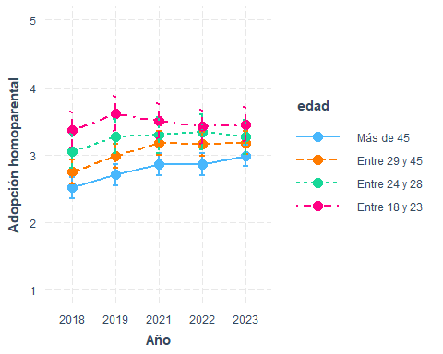

interact_plot(marchar7, pred = ola, modx = sexo, interval = TRUE)+  
 ylim(1,5)+  
 labs(y="Adopción homoparental", x="Año")+  
 scale_x_discrete(labels = waves3)

✖ Detected factor predictor.  
ℹ Plotting with cat_plot() instead.  
ℹ See `?interactions::cat_plot()` for full details on how to specify models  
 with categorical predictors.  
ℹ If you experience errors or unexpected results, try using cat_plot()  
 directly.  
Scale for x is already present.  
Adding another scale for x, which will replace the existing scale.

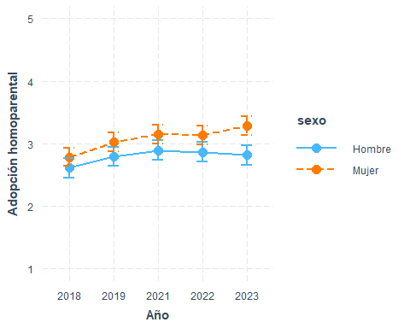

interact_plot(marchar8, pred = ola, modx = educ, interval = TRUE)+  
 ylim(1,5)+  
 labs(y="Adopción homoparental", x="Año")+  
 scale_x_discrete(labels = waves3)

✖ Detected factor predictor.  
ℹ Plotting with cat_plot() instead.  
ℹ See `?interactions::cat_plot()` for full details on how to specify models  
 with categorical predictors.  
ℹ If you experience errors or unexpected results, try using cat_plot()  
 directly.  
Scale for x is already present.  
Adding another scale for x, which will replace the existing scale.

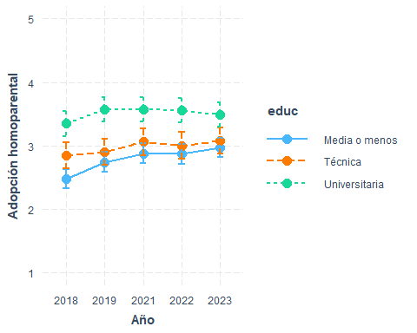

interact_plot(marchar9, pred = ola, modx = pos_id, interval = TRUE)+  
 ylim(1,5)+  
 labs(y="Adopción homoparental", x="Año")+  
 scale_x_discrete(labels = waves3)

✖ Detected factor predictor.  
ℹ Plotting with cat_plot() instead.  
ℹ See `?interactions::cat_plot()` for full details on how to specify models  
 with categorical predictors.  
ℹ If you experience errors or unexpected results, try using cat_plot()  
 directly.  
Scale for x is already present.  
Adding another scale for x, which will replace the existing scale.

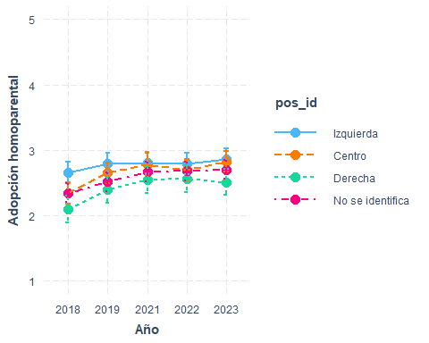

preds <- ggpredict(marchar10, terms = c("ola", "edad", "pos_id"))  
  
ggplot(preds, aes(x = x, y = predicted, color = group, group = group)) +  
 geom_line() +  
 geom_point() +  
 geom_errorbar(aes(ymin = conf.low, ymax = conf.high), width = 0.2) +  
 facet_wrap(~ facet, ncol = 2) +  
 labs(  
 x = "Año",  
 y = "Apoyo adopción homoparental",  
 color = "Edad"  
 ) +  
 ylim(1, 5) +  
 scale_x_discrete(labels = waves3) +   
 theme_minimal() +  
 theme(legend.position = "bottom")

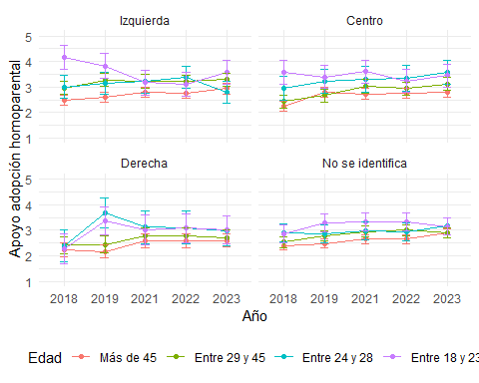

interact_plot(marchar11, pred = ola, modx = edad, mod2 = educ, interval = TRUE)+  
 ylim(1,5)+  
 labs(y="Adopción homoparental", x="Año")+  
 scale_x_discrete(labels = waves3)

✖ Detected factor predictor.  
ℹ Plotting with cat_plot() instead.  
ℹ See `?interactions::cat_plot()` for full details on how to specify models  
 with categorical predictors.  
ℹ If you experience errors or unexpected results, try using cat_plot()  
 directly.  
Scale for x is already present.  
Adding another scale for x, which will replace the existing scale.

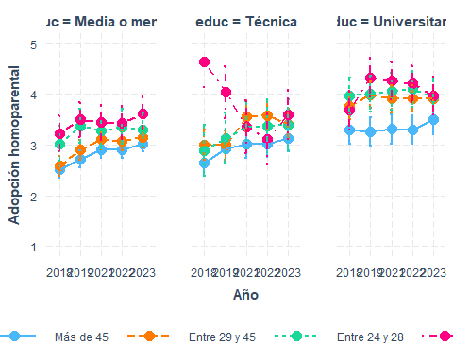

interact_plot(marchar12, pred = ola, modx = edad, mod2 = sexo, interval = TRUE)+  
 ylim(1,5)+  
 labs(y="Adopción homoparental", x="Año")+  
 scale_x_discrete(labels = waves3)

✖ Detected factor predictor.  
ℹ Plotting with cat_plot() instead.  
ℹ See `?interactions::cat_plot()` for full details on how to specify models  
 with categorical predictors.  
ℹ If you experience errors or unexpected results, try using cat_plot()  
 directly.  
Scale for x is already present.  
Adding another scale for x, which will replace the existing scale.

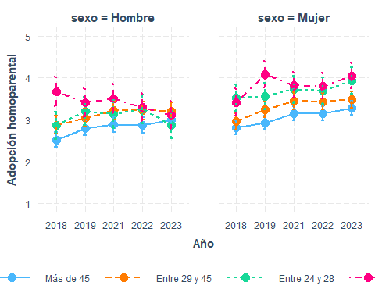

## Aborto (ola 2018 en adelante)

#if (!require("pacman")) install.packages("pacman") # instalar pacman  
 # cargar librerias  
pacman::p_load(dplyr, # Manipulacion de datos  
 knitr,  
 kableExtra,  
 summarytools,  
 lme4,  
 texreg  
 )  
load(file = here::here("input/data-proc/df_study1_long_t7.RData"))  
  
# generate analytical sample  
df_study1 <-   
 df_study1_long_t7 %>%  
 select(idencuesta,ola,aborto, edad, sexo, pos_id, educ, universitaria, ponderador_long_total) %>%   
 na.omit() %>%   
 mutate(ola_num=as.numeric(ola),  
 ola=as.factor(ola),  
 edad = case_when(edad <=23~"Entre 18 y 23",  
 edad >23 & edad <=28 ~ "Entre 24 y 28",  
 edad >28 & edad <=45 ~ "Entre 29 y 45",  
 edad > 45 ~ "Más de 45"))   
df_study1$edad <- factor(df_study1$edad, levels = c("Más de 45", "Entre 29 y 45", "Entre 24 y 28", "Entre 18 y 23"))  
df_study1$sexo <- factor(df_study1$sexo, levels = c(1, 2), labels = c("Hombre", "Mujer"))  
  
marchar.null <- lmer(formula(paste0("aborto~","1 + (1|idencuesta)")),data = df_study1, weights = ponderador_long_total)  
marchar1 <- lmer(formula(paste0("aborto~",h1,"+(1|idencuesta)")),data = df_study1, weights = ponderador_long_total)  
marchar2 <- lmer(formula(paste0("aborto~",h2,"+(1|idencuesta)")),data = df_study1, weights = ponderador_long_total)  
marchar3 <- lmer(formula(paste0("aborto~",h3,"+(1|idencuesta)")),data = df_study1, weights = ponderador_long_total)  
marchar4 <- lmer(formula(paste0("aborto~",h4,"+(1|idencuesta)")),data = df_study1, weights = ponderador_long_total)  
marchar5 <- lmer(formula(paste0("aborto~",h5,"+(1|idencuesta)")),data = df_study1, weights = ponderador_long_total)  
marchar6 <- lmer(formula(paste0("aborto~",h6,"+(1|idencuesta)")),data = df_study1, weights = ponderador_long_total)  
marchar7 <- lmer(formula(paste0("aborto~",h7,"+(1|idencuesta)")),data = df_study1, weights = ponderador_long_total)  
marchar8 <- lmer(formula(paste0("aborto~",h8,"+(1|idencuesta)")),data = df_study1, weights = ponderador_long_total)  
marchar9 <- lmer(formula(paste0("aborto~",h9,"+(1|idencuesta)")),data = df_study1, weights = ponderador_long_total)  
marchar10 <- lmer(formula(paste0("aborto~",h10,"+(1|idencuesta)")),data = df_study1, weights = ponderador_long_total)  
marchar11 <- lmer(formula(paste0("aborto~",h11,"+(1|idencuesta)")),data = df_study1, weights = ponderador_long_total)  
marchar12 <- lmer(formula(paste0("aborto~",h12,"+(1|idencuesta)")),data = df_study1, weights = ponderador_long_total)

texreg::knitreg(list(marchar1, marchar2, marchar3, marchar4, marchar5, marchar6, marchar7, marchar8, marchar9, marchar10, marchar11),  
 custom.note = "*** p < 0.001; ** p < 0.01; * p < 0.05")

Statistical models

Model 1

Model 2

Model 3

Model 4

Model 5

Model 6

Model 7

Model 8

Model 9

Model 10

Model 11

(Intercept)

2.73***

2.67***

2.72***

2.59***

2.81***

2.83***

2.96***

2.74***

2.87***

2.72***

2.83***

(0.04)

(0.05)

(0.06)

(0.06)

(0.08)

(0.08)

(0.08)

(0.08)

(0.09)

(0.11)

(0.09)

ola4

0.15***

0.15***

0.15***

0.15***

0.15***

0.16***

-0.00

0.17***

0.07

0.16

0.16**

(0.03)

(0.03)

(0.03)

(0.03)

(0.03)

(0.05)

(0.04)

(0.04)

(0.06)

(0.09)

(0.06)

ola5

0.14***

0.14***

0.14***

0.14***

0.14***

0.10

-0.07

0.29***

0.03

0.21*

0.21***

(0.03)

(0.03)

(0.03)

(0.03)

(0.03)

(0.05)

(0.05)

(0.04)

(0.06)

(0.10)

(0.06)

ola6

0.00

-0.00

-0.00

-0.00

-0.00

-0.02

-0.18***

0.11**

-0.06

0.07

0.11

(0.03)

(0.03)

(0.03)

(0.03)

(0.03)

(0.05)

(0.04)

(0.04)

(0.06)

(0.10)

(0.06)

ola7

0.14***

0.14***

0.14***

0.14***

0.14***

0.11*

-0.06

0.22***

0.06

0.08

0.16**

(0.03)

(0.03)

(0.03)

(0.03)

(0.03)

(0.05)

(0.04)

(0.04)

(0.06)

(0.09)

(0.06)

edadEntre 29 y 45

0.02

0.02

-0.06

-0.05

0.08

-0.05

-0.05

-0.05

0.54***

-0.15

(0.07)

(0.07)

(0.07)

(0.07)

(0.08)

(0.07)

(0.07)

(0.07)

(0.16)

(0.10)

edadEntre 24 y 28

0.20

0.19

0.03

0.03

-0.17

0.02

0.03

0.03

-0.30

-0.44*

(0.11)

(0.11)

(0.11)

(0.11)

(0.12)

(0.11)

(0.11)

(0.11)

(0.25)

(0.18)

edadEntre 18 y 23

0.39***

0.38***

0.24*

0.25*

0.00

0.25*

0.25*

0.25*

0.33

-0.07

(0.11)

(0.11)

(0.11)

(0.11)

(0.13)

(0.11)

(0.11)

(0.11)

(0.27)

(0.18)

sexoMujer

-0.07

-0.04

-0.02

-0.02

-0.31***

-0.02

-0.02

-0.03

-0.04

(0.06)

(0.06)

(0.06)

(0.06)

(0.07)

(0.06)

(0.06)

(0.06)

(0.06)

educTécnica

0.22**

0.21**

0.22**

0.21**

0.38***

0.21**

0.21**

0.33*

(0.08)

(0.08)

(0.08)

(0.08)

(0.10)

(0.08)

(0.08)

(0.14)

educUniversitaria

0.58***

0.59***

0.59***

0.59***

0.76***

0.59***

0.57***

0.41**

(0.08)

(0.08)

(0.08)

(0.08)

(0.09)

(0.08)

(0.08)

(0.15)

pos_idCentro

-0.21*

-0.21*

-0.21*

-0.21*

-0.32**

-0.01

-0.20*

(0.08)

(0.08)

(0.08)

(0.08)

(0.10)

(0.14)

(0.08)

pos_idDerecha

-0.51***

-0.51***

-0.52***

-0.51***

-0.52***

-0.33*

-0.49***

(0.10)

(0.10)

(0.10)

(0.10)

(0.12)

(0.16)

(0.10)

pos_idNo se identifica

-0.28***

-0.28***

-0.28***

-0.28***

-0.39***

-0.19

-0.27***

(0.08)

(0.08)

(0.08)

(0.08)

(0.09)

(0.13)

(0.08)

ola4:edadEntre 29 y 45

-0.26***

-0.50***

-0.09

(0.07)

(0.14)

(0.09)

ola5:edadEntre 29 y 45

-0.10

-0.53***

-0.01

(0.07)

(0.14)

(0.09)

ola6:edadEntre 29 y 45

-0.13

-0.43**

-0.09

(0.07)

(0.14)

(0.09)

ola7:edadEntre 29 y 45

-0.14*

-0.17

-0.03

(0.07)

(0.13)

(0.09)

ola4:edadEntre 24 y 28

0.23*

0.38*

0.18

(0.10)

(0.17)

(0.14)

ola5:edadEntre 24 y 28

0.13

-0.01

0.18

(0.10)

(0.18)

(0.15)

ola6:edadEntre 24 y 28

0.37***

0.14

0.71***

(0.10)

(0.18)

(0.15)

ola7:edadEntre 24 y 28

0.28**

0.03

0.49***

(0.10)

(0.18)

(0.14)

ola4:edadEntre 18 y 23

0.37***

0.14

0.23

(0.09)

(0.21)

(0.13)

ola5:edadEntre 18 y 23

0.39***

-0.00

0.56***

(0.10)

(0.21)

(0.14)

ola6:edadEntre 18 y 23

0.16

0.05

-0.14

(0.09)

(0.20)

(0.13)

ola7:edadEntre 18 y 23

0.28**

0.28

0.26*

(0.09)

(0.19)

(0.13)

ola4:sexoMujer

0.30***

(0.06)

ola5:sexoMujer

0.41***

(0.06)

ola6:sexoMujer

0.35***

(0.06)

ola7:sexoMujer

0.40***

(0.06)

ola4:educTécnica

-0.04

-0.12

(0.08)

(0.12)

ola5:educTécnica

-0.34***

-0.38**

(0.09)

(0.13)

ola6:educTécnica

-0.25**

-0.46***

(0.09)

(0.13)

ola7:educTécnica

-0.23**

-0.18

(0.08)

(0.13)

ola4:educUniversitaria

-0.06

0.07

(0.07)

(0.14)

ola5:educUniversitaria

-0.36***

-0.40**

(0.07)

(0.15)

ola6:educUniversitaria

-0.27***

-0.37*

(0.07)

(0.15)

ola7:educUniversitaria

-0.17*

-0.14

(0.07)

(0.14)

ola4:pos_idCentro

0.19*

0.11

(0.08)

(0.13)

ola5:pos_idCentro

0.13

-0.24

(0.09)

(0.13)

ola6:pos_idCentro

0.09

-0.14

(0.09)

(0.13)

ola7:pos_idCentro

0.10

-0.18

(0.08)

(0.13)

ola4:pos_idDerecha

-0.12

-0.17

(0.10)

(0.15)

ola5:pos_idDerecha

0.07

-0.30

(0.10)

(0.16)

ola6:pos_idDerecha

0.04

-0.21

(0.10)

(0.16)

ola7:pos_idDerecha

0.07

0.13

(0.10)

(0.15)

ola4:pos_idNo se identifica

0.16*

-0.04

(0.08)

(0.12)

ola5:pos_idNo se identifica

0.20*

-0.02

(0.08)

(0.13)

ola6:pos_idNo se identifica

0.08

-0.06

(0.08)

(0.13)

ola7:pos_idNo se identifica

0.14

0.19

(0.08)

(0.12)

pos_idCentro:edadEntre 29 y 45

-1.13***

(0.23)

pos_idDerecha:edadEntre 29 y 45

-0.28

(0.26)

pos_idNo se identifica:edadEntre 29 y 45

-0.41*

(0.21)

pos_idCentro:edadEntre 24 y 28

0.43

(0.36)

pos_idDerecha:edadEntre 24 y 28

0.41

(0.43)

pos_idNo se identifica:edadEntre 24 y 28

0.01

(0.31)

pos_idCentro:edadEntre 18 y 23

0.01

(0.37)

pos_idDerecha:edadEntre 18 y 23

-1.17**

(0.42)

pos_idNo se identifica:edadEntre 18 y 23

-0.38

(0.33)

ola4:pos_idCentro:edadEntre 29 y 45

0.54**

(0.19)

ola5:pos_idCentro:edadEntre 29 y 45

1.01***

(0.20)

ola6:pos_idCentro:edadEntre 29 y 45

0.99***

(0.20)

ola7:pos_idCentro:edadEntre 29 y 45

0.79***

(0.19)

ola4:pos_idDerecha:edadEntre 29 y 45

0.13

(0.23)

ola5:pos_idDerecha:edadEntre 29 y 45

0.42

(0.24)

ola6:pos_idDerecha:edadEntre 29 y 45

0.13

(0.24)

ola7:pos_idDerecha:edadEntre 29 y 45

-0.43

(0.23)

ola4:pos_idNo se identifica:edadEntre 29 y 45

0.32

(0.18)

ola5:pos_idNo se identifica:edadEntre 29 y 45

0.35

(0.19)

ola6:pos_idNo se identifica:edadEntre 29 y 45

0.08

(0.19)

ola7:pos_idNo se identifica:edadEntre 29 y 45

-0.29

(0.18)

ola4:pos_idCentro:edadEntre 24 y 28

-0.45

(0.27)

ola5:pos_idCentro:edadEntre 24 y 28

0.54

(0.28)

ola6:pos_idCentro:edadEntre 24 y 28

-0.10

(0.30)

ola7:pos_idCentro:edadEntre 24 y 28

0.17

(0.27)

ola4:pos_idDerecha:edadEntre 24 y 28

-0.42

(0.34)

ola5:pos_idDerecha:edadEntre 24 y 28

0.35

(0.35)

ola6:pos_idDerecha:edadEntre 24 y 28

0.46

(0.36)

ola7:pos_idDerecha:edadEntre 24 y 28

0.79*

(0.34)

ola4:pos_idNo se identifica:edadEntre 24 y 28

-0.08

(0.23)

ola5:pos_idNo se identifica:edadEntre 24 y 28

-0.12

(0.25)

ola6:pos_idNo se identifica:edadEntre 24 y 28

0.45

(0.24)

ola7:pos_idNo se identifica:edadEntre 24 y 28

0.28

(0.23)

ola4:pos_idCentro:edadEntre 18 y 23

-0.22

(0.28)

ola5:pos_idCentro:edadEntre 18 y 23

-0.13

(0.28)

ola6:pos_idCentro:edadEntre 18 y 23

-0.43

(0.27)

ola7:pos_idCentro:edadEntre 18 y 23

-0.06

(0.25)

ola4:pos_idDerecha:edadEntre 18 y 23

0.43

(0.31)

ola5:pos_idDerecha:edadEntre 18 y 23

1.23***

(0.32)

ola6:pos_idDerecha:edadEntre 18 y 23

0.86**

(0.31)

ola7:pos_idDerecha:edadEntre 18 y 23

0.09

(0.29)

ola4:pos_idNo se identifica:edadEntre 18 y 23

0.58*

(0.26)

ola5:pos_idNo se identifica:edadEntre 18 y 23

0.54*

(0.26)

ola6:pos_idNo se identifica:edadEntre 18 y 23

0.23

(0.25)

ola7:pos_idNo se identifica:edadEntre 18 y 23

-0.05

(0.23)

educTécnica:edadEntre 29 y 45

0.21

(0.22)

educUniversitaria:edadEntre 29 y 45

0.82***

(0.21)

educTécnica:edadEntre 24 y 28

-0.04

(0.34)

educUniversitaria:edadEntre 24 y 28

0.84**

(0.29)

educTécnica:edadEntre 18 y 23

0.40

(0.35)

educUniversitaria:edadEntre 18 y 23

0.08

(0.30)

ola4:educTécnica:edadEntre 29 y 45

-0.07

(0.19)

ola5:educTécnica:edadEntre 29 y 45

0.02

(0.20)

ola6:educTécnica:edadEntre 29 y 45

0.10

(0.20)

ola7:educTécnica:edadEntre 29 y 45

-0.01

(0.19)

ola4:educUniversitaria:edadEntre 29 y 45

-0.61**

(0.19)

ola5:educUniversitaria:edadEntre 29 y 45

-0.12

(0.20)

ola6:educUniversitaria:edadEntre 29 y 45

-0.05

(0.19)

ola7:educUniversitaria:edadEntre 29 y 45

-0.32

(0.19)

ola4:educTécnica:edadEntre 24 y 28

0.42

(0.26)

ola5:educTécnica:edadEntre 24 y 28

0.07

(0.27)

ola6:educTécnica:edadEntre 24 y 28

0.47

(0.29)

ola7:educTécnica:edadEntre 24 y 28

0.04

(0.26)

ola4:educUniversitaria:edadEntre 24 y 28

-0.10

(0.23)

ola5:educUniversitaria:edadEntre 24 y 28

0.13

(0.24)

ola6:educUniversitaria:edadEntre 24 y 28

-0.83***

(0.24)

ola7:educUniversitaria:edadEntre 24 y 28

-0.46*

(0.23)

ola4:educTécnica:edadEntre 18 y 23

0.23

(0.26)

ola5:educTécnica:edadEntre 18 y 23

0.00

(0.27)

ola6:educTécnica:edadEntre 18 y 23

0.52*

(0.25)

ola7:educTécnica:edadEntre 18 y 23

-0.49*

(0.24)

ola4:educUniversitaria:edadEntre 18 y 23

0.28

(0.23)

ola5:educUniversitaria:edadEntre 18 y 23

0.01

(0.23)

ola6:educUniversitaria:edadEntre 18 y 23

0.83***

(0.22)

ola7:educUniversitaria:edadEntre 18 y 23

0.40

(0.22)

AIC

32851.27

32851.80

32856.11

32810.70

32797.79

32790.48

32761.24

32797.79

32843.38

32779.78

32739.28

BIC

32899.86

32921.22

32932.47

32900.95

32908.87

32984.85

32900.08

32964.40

33037.76

33369.85

33197.45

Log Likelihood

-16418.63

-16415.90

-16417.05

-16392.35

-16382.90

-16367.24

-16360.62

-16374.90

-16393.69

-16304.89

-16303.64

Num. obs.

7647

7647

7647

7647

7647

7647

7647

7647

7647

7647

7647

Num. groups: idencuesta

1704

1704

1704

1704

1704

1704

1704

1704

1704

1704

1704

Var: idencuesta (Intercept)

0.81

0.81

0.80

0.76

0.74

0.74

0.74

0.74

0.74

0.73

0.74

Var: Residual

0.66

0.66

0.66

0.65

0.65

0.65

0.65

0.65

0.65

0.63

0.63

*** p < 0.001; ** p < 0.01; * p < 0.05

### interacciones

interact_plot(marchar6, pred = ola, modx = edad, interval = TRUE)+  
 ylim(1,5)+  
 labs(y="Apoyo legalización aborto", x="Año")+  
 scale_x_discrete(labels = waves3)

✖ Detected factor predictor.  
ℹ Plotting with cat_plot() instead.  
ℹ See `?interactions::cat_plot()` for full details on how to specify models  
 with categorical predictors.  
ℹ If you experience errors or unexpected results, try using cat_plot()  
 directly.  
Scale for x is already present.  
Adding another scale for x, which will replace the existing scale.

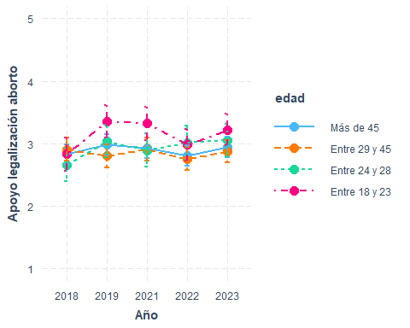

interact_plot(marchar7, pred = ola, modx = sexo, interval = TRUE)+  
 ylim(1,5)+  
 labs(y="Apoyo legalización aborto", x="Año")+  
 scale_x_discrete(labels = waves3)

✖ Detected factor predictor.  
ℹ Plotting with cat_plot() instead.  
ℹ See `?interactions::cat_plot()` for full details on how to specify models  
 with categorical predictors.  
ℹ If you experience errors or unexpected results, try using cat_plot()  
 directly.  
Scale for x is already present.  
Adding another scale for x, which will replace the existing scale.

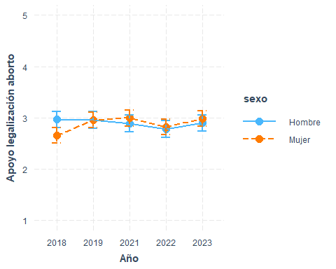

interact_plot(marchar8, pred = ola, modx = educ, interval = TRUE)+  
 ylim(1,5)+  
 labs(y="Apoyo legalización aborto", x="Año")+  
 scale_x_discrete(labels = waves3)

✖ Detected factor predictor.  
ℹ Plotting with cat_plot() instead.  
ℹ See `?interactions::cat_plot()` for full details on how to specify models  
 with categorical predictors.  
ℹ If you experience errors or unexpected results, try using cat_plot()  
 directly.  
Scale for x is already present.  
Adding another scale for x, which will replace the existing scale.

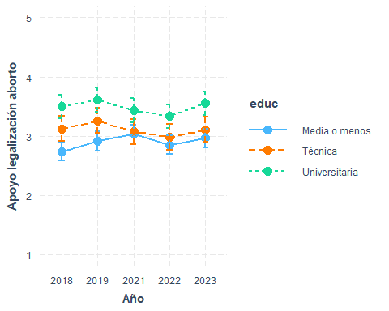

interact_plot(marchar9, pred = ola, modx = pos_id, interval = TRUE)+  
 ylim(1,5)+  
 labs(y="Apoyo legalización aborto", x="Año")+  
 scale_x_discrete(labels = waves3)

✖ Detected factor predictor.  
ℹ Plotting with cat_plot() instead.  
ℹ See `?interactions::cat_plot()` for full details on how to specify models  
 with categorical predictors.  
ℹ If you experience errors or unexpected results, try using cat_plot()  
 directly.  
Scale for x is already present.  
Adding another scale for x, which will replace the existing scale.

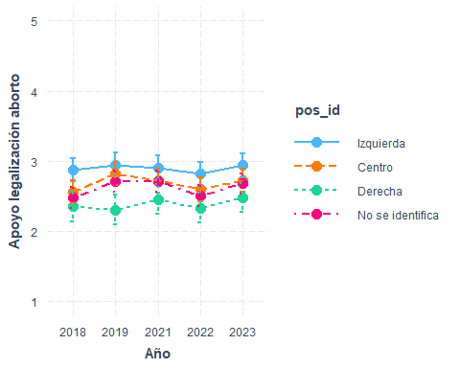

preds <- ggpredict(marchar10, terms = c("ola", "edad", "pos_id"))  
  
ggplot(preds, aes(x = x, y = predicted, color = group, group = group)) +  
 geom_line() +  
 geom_point() +  
 geom_errorbar(aes(ymin = conf.low, ymax = conf.high), width = 0.2) +  
 facet_wrap(~ facet, ncol = 2) +  
 labs(  
 x = "Año",  
 y = "Apoyo legalización aborto",  
 color = "Edad"  
 ) +  
 ylim(1, 5) +  
 scale_x_discrete(labels = waves3) +   
 theme_minimal() +  
 theme(legend.position = "bottom")

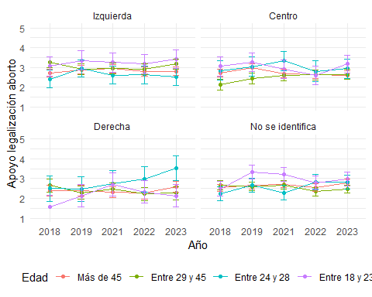

interact_plot(marchar11, pred = ola, modx = edad, mod2 = educ, interval = TRUE)+  
 ylim(1,5)+  
 labs(y="Apoyo legalización aborto", x="Año")+  
 scale_x_discrete(labels = waves3)

✖ Detected factor predictor.  
ℹ Plotting with cat_plot() instead.  
ℹ See `?interactions::cat_plot()` for full details on how to specify models  
 with categorical predictors.  
ℹ If you experience errors or unexpected results, try using cat_plot()  
 directly.  
Scale for x is already present.  
Adding another scale for x, which will replace the existing scale.

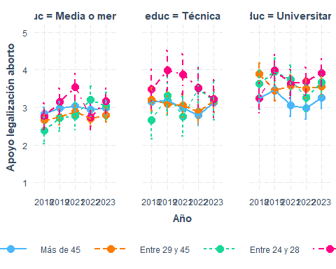

interact_plot(marchar12, pred = ola, modx = edad, mod2 = sexo, interval = TRUE)+  
 ylim(1,5)+  
 labs(y="Apoyo legalización aborto", x="Año")+  
 scale_x_discrete(labels = waves3)

✖ Detected factor predictor.  
ℹ Plotting with cat_plot() instead.  
ℹ See `?interactions::cat_plot()` for full details on how to specify models  
 with categorical predictors.  
ℹ If you experience errors or unexpected results, try using cat_plot()  
 directly.  
Scale for x is already present.  
Adding another scale for x, which will replace the existing scale.

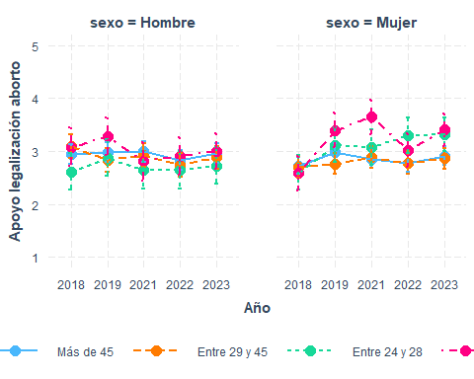

## Chile debería tomar medidas más drásticas para impedir el ingreso de inmigrantes al país

* Ola 2018 en adelante

#if (!require("pacman")) install.packages("pacman") # instalar pacman  
 # cargar librerias  
pacman::p_load(dplyr, # Manipulacion de datos  
 knitr,  
 kableExtra,  
 summarytools,  
 lme4,  
 texreg  
 )  
load(file = here::here("input/data-proc/df_study1_long_t7.RData"))  
  
# generate analytical sample  
df_study1 <-   
 df_study1_long_t7 %>%  
 select(idencuesta,ola,restriccion_migrantes, edad, sexo, pos_id, educ, universitaria, ponderador_long_total) %>%   
 na.omit() %>%   
 mutate(ola_num=as.numeric(ola),  
 ola=as.factor(ola),  
 edad = case_when(edad <=23~"Entre 18 y 23",  
 edad >23 & edad <=28 ~ "Entre 24 y 28",  
 edad >28 & edad <=45 ~ "Entre 29 y 45",  
 edad > 45 ~ "Más de 45"))   
df_study1$edad <- factor(df_study1$edad, levels = c("Más de 45", "Entre 29 y 45", "Entre 24 y 28", "Entre 18 y 23"))  
df_study1$sexo <- factor(df_study1$sexo, levels = c(1, 2), labels = c("Hombre", "Mujer"))  
  
marchar.null <- lmer(formula(paste0("restriccion_migrantes~","1 + (1|idencuesta)")),data = df_study1, weights = ponderador_long_total)  
marchar1 <- lmer(formula(paste0("restriccion_migrantes~",h1,"+(1|idencuesta)")),data = df_study1, weights = ponderador_long_total)  
marchar2 <- lmer(formula(paste0("restriccion_migrantes~",h2,"+(1|idencuesta)")),data = df_study1, weights = ponderador_long_total)  
marchar3 <- lmer(formula(paste0("restriccion_migrantes~",h3,"+(1|idencuesta)")),data = df_study1, weights = ponderador_long_total)  
marchar4 <- lmer(formula(paste0("restriccion_migrantes~",h4,"+(1|idencuesta)")),data = df_study1, weights = ponderador_long_total)  
marchar5 <- lmer(formula(paste0("restriccion_migrantes~",h5,"+(1|idencuesta)")),data = df_study1, weights = ponderador_long_total)  
marchar6 <- lmer(formula(paste0("restriccion_migrantes~",h6,"+(1|idencuesta)")),data = df_study1, weights = ponderador_long_total)  
marchar7 <- lmer(formula(paste0("restriccion_migrantes~",h7,"+(1|idencuesta)")),data = df_study1, weights = ponderador_long_total)  
marchar8 <- lmer(formula(paste0("restriccion_migrantes~",h8,"+(1|idencuesta)")),data = df_study1, weights = ponderador_long_total)  
marchar9 <- lmer(formula(paste0("restriccion_migrantes~",h9,"+(1|idencuesta)")),data = df_study1, weights = ponderador_long_total)  
marchar10 <- lmer(formula(paste0("restriccion_migrantes~",h10,"+(1|idencuesta)")),data = df_study1, weights = ponderador_long_total)  
marchar11 <- lmer(formula(paste0("restriccion_migrantes~",h11,"+(1|idencuesta)")),data = df_study1, weights = ponderador_long_total)  
marchar12 <- lmer(formula(paste0("restriccion_migrantes~",h12,"+(1|idencuesta)")),data = df_study1, weights = ponderador_long_total)

texreg::knitreg(list(marchar1, marchar2, marchar3, marchar4, marchar5, marchar6, marchar7, marchar8, marchar9, marchar10, marchar11),  
 custom.note = "*** p < 0.001; ** p < 0.01; * p < 0.05")

Statistical models

Model 1

Model 2

Model 3

Model 4

Model 5

Model 6

Model 7

Model 8

Model 9

Model 10

Model 11

(Intercept)

3.73***

3.81***

3.75***

3.88***

3.65***

3.73***

3.59***

3.71***

3.61***

3.81***

3.78***

(0.03)

(0.03)

(0.04)

(0.04)

(0.06)

(0.06)

(0.06)

(0.06)

(0.06)

(0.08)

(0.06)

ola4

-0.09**

-0.09**

-0.09**

-0.09**

-0.09**

-0.17***

0.04

-0.09**

-0.06

-0.29***

-0.17***

(0.03)

(0.03)

(0.03)

(0.03)

(0.03)

(0.04)

(0.04)

(0.03)

(0.05)

(0.08)

(0.05)

ola5

0.13***

0.13***

0.13***

0.13***

0.13***

0.02

0.14***

0.11**

0.13*

-0.16

-0.04

(0.03)

(0.03)

(0.03)

(0.03)

(0.03)

(0.04)

(0.04)

(0.04)

(0.05)

(0.08)

(0.05)

ola6

0.41***

0.41***

0.41***

0.41***

0.41***

0.28***

0.47***

0.28***

0.56***

0.24**

0.19***

(0.03)

(0.03)

(0.03)

(0.03)

(0.03)

(0.04)

(0.04)

(0.04)

(0.05)

(0.08)

(0.05)

ola7

0.52***

0.53***

0.53***

0.53***

0.52***

0.45***

0.61***

0.41***

0.58***

0.46***

0.36***

(0.03)

(0.03)

(0.03)

(0.03)

(0.03)

(0.04)

(0.04)

(0.03)

(0.05)

(0.08)

(0.05)

edadEntre 29 y 45

-0.10*

-0.10*

-0.02

-0.02

-0.14*

-0.02

-0.02

-0.02

-0.47***

-0.02

(0.05)

(0.05)

(0.05)

(0.05)

(0.06)

(0.05)

(0.05)

(0.05)

(0.12)

(0.08)

edadEntre 24 y 28

-0.30***

-0.30***

-0.12

-0.12

-0.27**

-0.12

-0.12

-0.12

-0.31

-0.36**

(0.08)

(0.08)

(0.08)

(0.07)

(0.09)

(0.07)

(0.07)

(0.07)

(0.18)

(0.13)

edadEntre 18 y 23

-0.34***

-0.33***

-0.18*

-0.19*

-0.35***

-0.19*

-0.19**

-0.18*

-0.47*

-0.59***

(0.08)

(0.08)

(0.08)

(0.08)

(0.09)

(0.08)

(0.08)

(0.08)

(0.20)

(0.13)

sexoMujer

0.10*

0.07

0.05

0.05

0.16**

0.05

0.05

0.06

0.04

(0.04)

(0.04)

(0.04)

(0.04)

(0.05)

(0.04)

(0.04)

(0.04)

(0.04)

educTécnica

-0.22***

-0.21***

-0.21***

-0.21***

-0.21**

-0.21***

-0.21***

-0.27*

(0.06)

(0.06)

(0.06)

(0.06)

(0.07)

(0.06)

(0.06)

(0.11)

educUniversitaria

-0.63***

-0.63***

-0.63***

-0.63***

-0.86***

-0.63***

-0.63***

-0.87***

(0.05)

(0.05)

(0.05)

(0.05)

(0.07)

(0.05)

(0.05)

(0.11)

pos_idCentro

0.27***

0.27***

0.27***

0.27***

0.31***

0.02

0.26***

(0.06)

(0.06)

(0.06)

(0.06)

(0.07)

(0.11)

(0.06)

pos_idDerecha

0.48***

0.48***

0.48***

0.48***

0.53***

0.33**

0.46***

(0.07)

(0.07)

(0.07)

(0.07)

(0.09)

(0.13)

(0.07)

pos_idNo se identifica

0.29***

0.29***

0.29***

0.28***

0.37***

0.28**

0.28***

(0.05)

(0.05)

(0.05)

(0.05)

(0.07)

(0.10)

(0.05)

ola4:edadEntre 29 y 45

0.14*

0.50***

0.09

(0.06)

(0.12)

(0.08)

ola5:edadEntre 29 y 45

0.21**

0.51***

0.11

(0.07)

(0.13)

(0.08)

ola6:edadEntre 29 y 45

0.18**

0.59***

0.01

(0.07)

(0.12)

(0.08)

ola7:edadEntre 29 y 45

0.09

0.32**

-0.10

(0.06)

(0.12)

(0.08)

ola4:edadEntre 24 y 28

0.07

0.22

0.12

(0.09)

(0.15)

(0.12)

ola5:edadEntre 24 y 28

0.01

0.48**

0.32*

(0.09)

(0.16)

(0.13)

ola6:edadEntre 24 y 28

0.34***

0.80***

0.53***

(0.09)

(0.16)

(0.13)

ola7:edadEntre 24 y 28

0.30***

0.36*

0.37**

(0.09)

(0.16)

(0.12)

ola4:edadEntre 18 y 23

0.23**

0.35

0.48***

(0.08)

(0.19)

(0.12)

ola5:edadEntre 18 y 23

0.29***

0.37*

0.77***

(0.08)

(0.18)

(0.12)

ola6:edadEntre 18 y 23

0.22**

0.00

0.46***

(0.08)

(0.18)

(0.11)

ola7:edadEntre 18 y 23

0.10

-0.23

0.51***

(0.08)

(0.16)

(0.11)

ola4:sexoMujer

-0.25***

(0.05)

ola5:sexoMujer

-0.01

(0.06)

ola6:sexoMujer

-0.11*

(0.05)

ola7:sexoMujer

-0.15**

(0.05)

ola4:educTécnica

0.06

0.08

(0.07)

(0.11)

ola5:educTécnica

-0.19*

0.11

(0.08)

(0.11)

ola6:educTécnica

0.02

0.16

(0.08)

(0.12)

ola7:educTécnica

0.08

0.06

(0.07)

(0.11)

ola4:educUniversitaria

-0.04

-0.08

(0.07)

(0.12)

ola5:educUniversitaria

0.24***

0.32*

(0.07)

(0.13)

ola6:educUniversitaria

0.52***

0.52***

(0.06)

(0.13)

ola7:educUniversitaria

0.41***

0.67***

(0.06)

(0.13)

ola4:pos_idCentro

-0.05

0.16

(0.07)

(0.11)

ola5:pos_idCentro

0.08

0.41***

(0.08)

(0.12)

ola6:pos_idCentro

-0.16*

0.12

(0.08)

(0.12)

ola7:pos_idCentro

-0.07

0.18

(0.07)

(0.11)

ola4:pos_idDerecha

-0.04

0.28*

(0.09)

(0.13)

ola5:pos_idDerecha

-0.04

0.36*

(0.09)

(0.14)

ola6:pos_idDerecha

-0.24**

0.19

(0.09)

(0.14)

ola7:pos_idDerecha

0.06

0.04

(0.09)

(0.13)

ola4:pos_idNo se identifica

-0.02

0.11

(0.07)

(0.11)

ola5:pos_idNo se identifica

-0.05

0.05

(0.07)

(0.11)

ola6:pos_idNo se identifica

-0.21**

-0.06

(0.07)

(0.11)

ola7:pos_idNo se identifica

-0.14*

-0.20

(0.07)

(0.11)

pos_idCentro:edadEntre 29 y 45

0.58***

(0.17)

pos_idDerecha:edadEntre 29 y 45

0.44*

(0.20)

pos_idNo se identifica:edadEntre 29 y 45

0.38*

(0.16)

pos_idCentro:edadEntre 24 y 28

0.29

(0.26)

pos_idDerecha:edadEntre 24 y 28

0.53

(0.32)

pos_idNo se identifica:edadEntre 24 y 28

-0.16

(0.23)

pos_idCentro:edadEntre 18 y 23

0.49

(0.27)

pos_idDerecha:edadEntre 18 y 23

0.04

(0.31)

pos_idNo se identifica:edadEntre 18 y 23

-0.05

(0.25)

ola4:pos_idCentro:edadEntre 29 y 45

-0.30

(0.17)

ola5:pos_idCentro:edadEntre 29 y 45

-0.41*

(0.18)

ola6:pos_idCentro:edadEntre 29 y 45

-0.47**

(0.18)

ola7:pos_idCentro:edadEntre 29 y 45

-0.50**

(0.17)

ola4:pos_idDerecha:edadEntre 29 y 45

-0.82***

(0.20)

ola5:pos_idDerecha:edadEntre 29 y 45

-0.53*

(0.21)

ola6:pos_idDerecha:edadEntre 29 y 45

-0.82***

(0.21)

ola7:pos_idDerecha:edadEntre 29 y 45

-0.22

(0.20)

ola4:pos_idNo se identifica:edadEntre 29 y 45

-0.53**

(0.16)

ola5:pos_idNo se identifica:edadEntre 29 y 45

-0.37*

(0.17)

ola6:pos_idNo se identifica:edadEntre 29 y 45

-0.53**

(0.17)

ola7:pos_idNo se identifica:edadEntre 29 y 45

-0.22

(0.16)

ola4:pos_idCentro:edadEntre 24 y 28

-0.23

(0.24)

ola5:pos_idCentro:edadEntre 24 y 28

-0.64**

(0.25)

ola6:pos_idCentro:edadEntre 24 y 28

-0.63*

(0.27)

ola7:pos_idCentro:edadEntre 24 y 28

-0.26

(0.24)

ola4:pos_idDerecha:edadEntre 24 y 28

-0.53

(0.30)

ola5:pos_idDerecha:edadEntre 24 y 28

-1.43***

(0.31)

ola6:pos_idDerecha:edadEntre 24 y 28

-1.41***

(0.32)

ola7:pos_idDerecha:edadEntre 24 y 28

-0.46

(0.30)

ola4:pos_idNo se identifica:edadEntre 24 y 28

-0.05

(0.21)

ola5:pos_idNo se identifica:edadEntre 24 y 28

-0.43*

(0.22)

ola6:pos_idNo se identifica:edadEntre 24 y 28

-0.48*

(0.22)

ola7:pos_idNo se identifica:edadEntre 24 y 28

0.16

(0.21)

ola4:pos_idCentro:edadEntre 18 y 23

-0.63**

(0.25)

ola5:pos_idCentro:edadEntre 18 y 23

-0.66**

(0.25)

ola6:pos_idCentro:edadEntre 18 y 23

-0.13

(0.24)

ola7:pos_idCentro:edadEntre 18 y 23

-0.26

(0.22)

ola4:pos_idDerecha:edadEntre 18 y 23

-0.10

(0.28)

ola5:pos_idDerecha:edadEntre 18 y 23

-0.43

(0.29)

ola6:pos_idDerecha:edadEntre 18 y 23

0.18

(0.27)

ola7:pos_idDerecha:edadEntre 18 y 23

0.82**

(0.26)

ola4:pos_idNo se identifica:edadEntre 18 y 23

0.19

(0.23)

ola5:pos_idNo se identifica:edadEntre 18 y 23

0.38

(0.23)

ola6:pos_idNo se identifica:edadEntre 18 y 23

0.59**

(0.22)

ola7:pos_idNo se identifica:edadEntre 18 y 23

0.76***

(0.21)

educTécnica:edadEntre 29 y 45

-0.11

(0.17)

educUniversitaria:edadEntre 29 y 45

-0.27

(0.16)

educTécnica:edadEntre 24 y 28

0.09

(0.25)

educUniversitaria:edadEntre 24 y 28

0.33

(0.21)

educTécnica:edadEntre 18 y 23

0.49

(0.25)

educUniversitaria:edadEntre 18 y 23

0.54*

(0.22)

ola4:educTécnica:edadEntre 29 y 45

0.16

(0.17)

ola5:educTécnica:edadEntre 29 y 45

0.11

(0.18)

ola6:educTécnica:edadEntre 29 y 45

0.26

(0.18)

ola7:educTécnica:edadEntre 29 y 45

0.52**

(0.17)

ola4:educUniversitaria:edadEntre 29 y 45

0.07

(0.17)

ola5:educUniversitaria:edadEntre 29 y 45

0.10

(0.17)

ola6:educUniversitaria:edadEntre 29 y 45

0.21

(0.17)

ola7:educUniversitaria:edadEntre 29 y 45

0.03

(0.16)

ola4:educTécnica:edadEntre 24 y 28

0.08

(0.23)

ola5:educTécnica:edadEntre 24 y 28

-1.41***

(0.24)

ola6:educTécnica:edadEntre 24 y 28

-0.93***

(0.25)

ola7:educTécnica:edadEntre 24 y 28

-0.49*

(0.23)

ola4:educUniversitaria:edadEntre 24 y 28

-0.06

(0.21)

ola5:educUniversitaria:edadEntre 24 y 28

-0.31

(0.22)

ola6:educUniversitaria:edadEntre 24 y 28

-0.42*

(0.21)

ola7:educUniversitaria:edadEntre 24 y 28

-0.39

(0.21)

ola4:educTécnica:edadEntre 18 y 23

-0.72**

(0.23)

ola5:educTécnica:edadEntre 18 y 23

-1.32***

(0.24)

ola6:educTécnica:edadEntre 18 y 23

-0.97***

(0.22)

ola7:educTécnica:edadEntre 18 y 23

-0.78***

(0.21)

ola4:educUniversitaria:edadEntre 18 y 23

-0.24

(0.20)

ola5:educUniversitaria:edadEntre 18 y 23

-0.85***

(0.20)

ola6:educUniversitaria:edadEntre 18 y 23

-0.53**

(0.19)

ola7:educUniversitaria:edadEntre 18 y 23

-1.11***

(0.19)

AIC

30714.66

30703.03

30704.30

30588.88

30551.88

30567.12

30547.39

30458.46

30590.46

30620.24

30428.62

BIC

30763.28

30772.49

30780.70

30679.17

30663.00

30761.60

30686.30

30625.15

30784.93

31210.61

30887.03

Log Likelihood

-15350.33

-15341.52

-15341.15

-15281.44

-15259.94

-15255.56

-15253.70

-15205.23

-15267.23

-15225.12

-15148.31

Num. obs.

7674

7674

7674

7674

7674

7674

7674

7674

7674

7674

7674

Num. groups: idencuesta

1705

1705

1705

1705

1705

1705

1705

1705

1705

1705

1705

Var: idencuesta (Intercept)

0.38

0.37

0.37

0.32

0.30

0.30

0.30

0.30

0.30

0.30

0.29

Var: Residual

0.52

0.52

0.52

0.52

0.52

0.51

0.51

0.51

0.51

0.50

0.49

*** p < 0.001; ** p < 0.01; * p < 0.05

### interacciones

interact_plot(marchar6, pred = ola, modx = edad, interval = TRUE)+  
 ylim(1,5)+  
 labs(y="Fortalecer restricciones inmigrantes", x="Año")+  
 scale_x_discrete(labels = waves3)

✖ Detected factor predictor.  
ℹ Plotting with cat_plot() instead.  
ℹ See `?interactions::cat_plot()` for full details on how to specify models  
 with categorical predictors.  
ℹ If you experience errors or unexpected results, try using cat_plot()  
 directly.  
Scale for x is already present.  
Adding another scale for x, which will replace the existing scale.

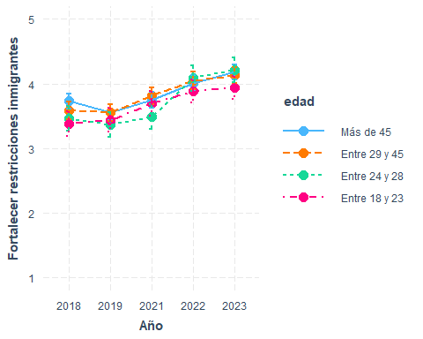

interact_plot(marchar7, pred = ola, modx = sexo, interval = TRUE)+  
 ylim(1,5)+  
 labs(y="Fortalecer restricciones inmigrantes", x="Año")+  
 scale_x_discrete(labels = waves3)

✖ Detected factor predictor.  
ℹ Plotting with cat_plot() instead.  
ℹ See `?interactions::cat_plot()` for full details on how to specify models  
 with categorical predictors.  
ℹ If you experience errors or unexpected results, try using cat_plot()  
 directly.  
Scale for x is already present.  
Adding another scale for x, which will replace the existing scale.

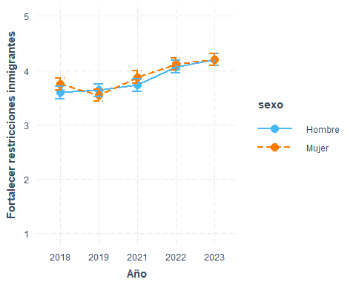

interact_plot(marchar8, pred = ola, modx = educ, interval = TRUE)+  
 ylim(1,5)+  
 labs(y="Fortalecer restricciones inmigrantes", x="Año")+  
 scale_x_discrete(labels = waves3)

✖ Detected factor predictor.  
ℹ Plotting with cat_plot() instead.  
ℹ See `?interactions::cat_plot()` for full details on how to specify models  
 with categorical predictors.  
ℹ If you experience errors or unexpected results, try using cat_plot()  
 directly.  
Scale for x is already present.  
Adding another scale for x, which will replace the existing scale.

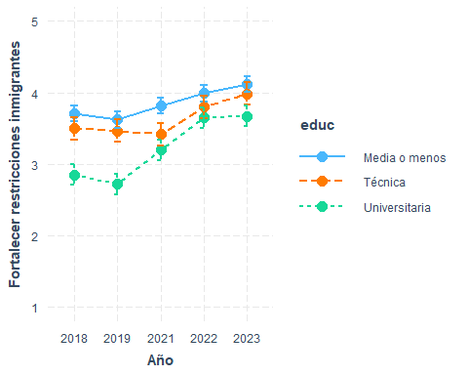

interact_plot(marchar9, pred = ola, modx = pos_id, interval = TRUE)+  
 ylim(1,5)+  
 labs(y="Fortalecer restricciones inmigrantes", x="Año")+  
 scale_x_discrete(labels = waves3)

✖ Detected factor predictor.  
ℹ Plotting with cat_plot() instead.  
ℹ See `?interactions::cat_plot()` for full details on how to specify models  
 with categorical predictors.  
ℹ If you experience errors or unexpected results, try using cat_plot()  
 directly.  
Scale for x is already present.  
Adding another scale for x, which will replace the existing scale.

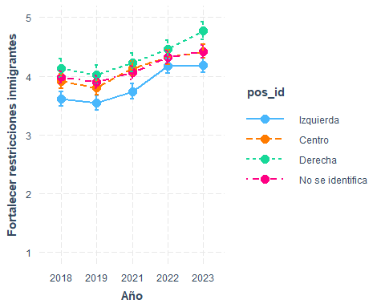

preds <- ggpredict(marchar10, terms = c("ola", "edad", "pos_id"))  
  
ggplot(preds, aes(x = x, y = predicted, color = group, group = group)) +  
 geom_line() +  
 geom_point() +  
 geom_errorbar(aes(ymin = conf.low, ymax = conf.high), width = 0.2) +  
 facet_wrap(~ facet, ncol = 2) +  
 labs(  
 x = "Año",  
 y = "Fortalecer restricciones inmigrantes",  
 color = "Edad"  
 ) +  
 ylim(1, 5) +  
 scale_x_discrete(labels = waves3) +   
 theme_minimal() +  
 theme(legend.position = "bottom")

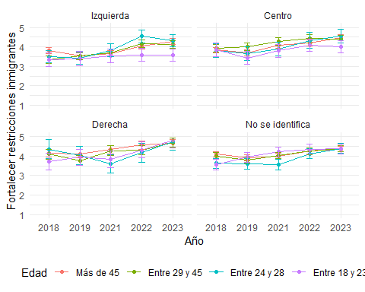

interact_plot(marchar11, pred = ola, modx = edad, mod2 = educ, interval = TRUE)+  
 ylim(1,5)+  
 labs(y="Fortalecer restricciones inmigrantes", x="Año")+  
 scale_x_discrete(labels = waves3)

✖ Detected factor predictor.  
ℹ Plotting with cat_plot() instead.  
ℹ See `?interactions::cat_plot()` for full details on how to specify models  
 with categorical predictors.  
ℹ If you experience errors or unexpected results, try using cat_plot()  
 directly.  
Scale for x is already present.  
Adding another scale for x, which will replace the existing scale.

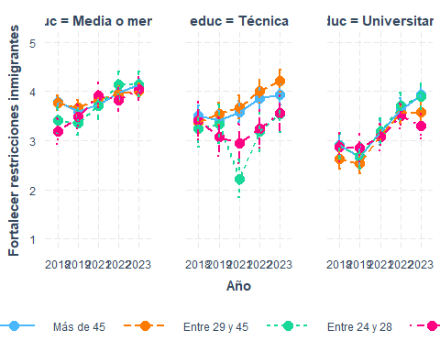

interact_plot(marchar12, pred = ola, modx = edad, mod2 = sexo, interval = TRUE)+  
 ylim(1,5)+  
 labs(y="Fortalecer restricciones inmigrantes", x="Año")+  
 scale_x_discrete(labels = waves3)

✖ Detected factor predictor.  
ℹ Plotting with cat_plot() instead.  
ℹ See `?interactions::cat_plot()` for full details on how to specify models  
 with categorical predictors.  
ℹ If you experience errors or unexpected results, try using cat_plot()  
 directly.  
Scale for x is already present.  
Adding another scale for x, which will replace the existing scale.

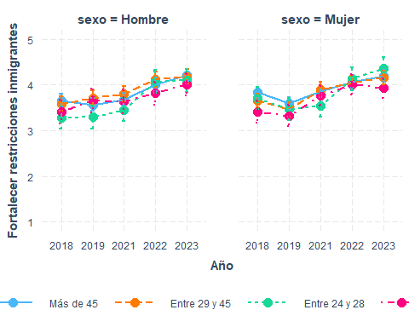

## En Chile, las diferencias de ingreso son demasiado grandes

* Todas las olas

#if (!require("pacman")) install.packages("pacman") # instalar pacman  
 # cargar librerias  
pacman::p_load(dplyr, # Manipulacion de datos  
 knitr,  
 kableExtra,  
 summarytools,  
 ggplot2,  
 sjPlot,  
 tidyverse,  
 ggalluvial,  
 survey,  
 shadowtext,  
 srvyr,  
 interactions  
 )  
load(file = here::here("input/data-proc/df_study1_long_t7.RData"))  
  
# generate analytical sample  
df_study1 <-   
 df_study1_long_t7 %>%  
 select(idencuesta,ola,perc_des, edad, sexo, pos_id, educ, universitaria, ponderador_long_total) %>%   
 na.omit() %>%   
 mutate(ola_num=as.numeric(ola),  
 ola=as.factor(ola),  
 edad = case_when(edad <=23~"Entre 18 y 23",  
 edad >23 & edad <=28 ~ "Entre 24 y 28",  
 edad >28 & edad <=45 ~ "Entre 29 y 45",  
 edad > 45 ~ "Más de 45"))   
df_study1$edad <- factor(df_study1$edad, levels = c("Más de 45", "Entre 29 y 45", "Entre 24 y 28", "Entre 18 y 23"))  
df_study1$sexo <- factor(df_study1$sexo, levels = c(1, 2), labels = c("Hombre", "Mujer"))  
  
marchar.null <- lmer(formula(paste0("perc_des~","1 + (1|idencuesta)")),data = df_study1, weights = ponderador_long_total)  
marchar1 <- lmer(formula(paste0("perc_des~",h1,"+(1|idencuesta)")),data = df_study1, weights = ponderador_long_total)  
marchar2 <- lmer(formula(paste0("perc_des~",h2,"+(1|idencuesta)")),data = df_study1, weights = ponderador_long_total)  
marchar3 <- lmer(formula(paste0("perc_des~",h3,"+(1|idencuesta)")),data = df_study1, weights = ponderador_long_total)  
marchar4 <- lmer(formula(paste0("perc_des~",h4,"+(1|idencuesta)")),data = df_study1, weights = ponderador_long_total)  
marchar5 <- lmer(formula(paste0("perc_des~",h5,"+(1|idencuesta)")),data = df_study1, weights = ponderador_long_total)  
marchar6 <- lmer(formula(paste0("perc_des~",h6,"+(1|idencuesta)")),data = df_study1, weights = ponderador_long_total)  
marchar7 <- lmer(formula(paste0("perc_des~",h7,"+(1|idencuesta)")),data = df_study1, weights = ponderador_long_total)  
marchar8 <- lmer(formula(paste0("perc_des~",h8,"+(1|idencuesta)")),data = df_study1, weights = ponderador_long_total)  
marchar9 <- lmer(formula(paste0("perc_des~",h9,"+(1|idencuesta)")),data = df_study1, weights = ponderador_long_total)  
marchar10 <- lmer(formula(paste0("perc_des~",h10,"+(1|idencuesta)")),data = df_study1, weights = ponderador_long_total)  
marchar11 <- lmer(formula(paste0("perc_des~",h11,"+(1|idencuesta)")),data = df_study1, weights = ponderador_long_total)  
marchar12 <- lmer(formula(paste0("perc_des~",h12,"+(1|idencuesta)")),data = df_study1, weights = ponderador_long_total)

texreg::knitreg(list(marchar1, marchar2, marchar3, marchar4, marchar5, marchar6, marchar7, marchar8, marchar9, marchar10, marchar11),  
 custom.note = "*** p < 0.001; ** p < 0.01; * p < 0.05")

### interacciones

interact_plot(marchar6, pred = ola, modx = edad, interval = TRUE)+  
 ylim(1,5)+  
 labs(y="Percepción desigualdad", x="Año")+  
 scale_x_discrete(labels = waves)

interact_plot(marchar7, pred = ola, modx = sexo, interval = TRUE)+  
 ylim(1,5)+  
 labs(y="Percepción desigualdad", x="Año")+  
 scale_x_discrete(labels = waves)

interact_plot(marchar8, pred = ola, modx = educ, interval = TRUE)+  
 ylim(1,5)+  
 labs(y="Percepción desigualdad", x="Año")+  
 scale_x_discrete(labels = waves)

interact_plot(marchar9, pred = ola, modx = pos_id, interval = TRUE)+  
 ylim(1,5)+  
 labs(y="Percepción desigualdad", x="Año")+  
 scale_x_discrete(labels = waves)

✖ Detected factor predictor.  
ℹ Plotting with cat_plot() instead.  
ℹ See `?interactions::cat_plot()` for full details on how to specify models  
 with categorical predictors.  
ℹ If you experience errors or unexpected results, try using cat_plot()  
 directly.  
Scale for x is already present.  
Adding another scale for x, which will replace the existing scale.

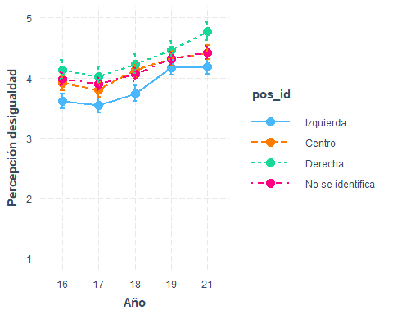

preds <- ggpredict(marchar10, terms = c("ola", "edad", "pos_id"))  
  
ggplot(preds, aes(x = x, y = predicted, color = group, group = group)) +  
 geom_line() +  
 geom_point() +  
 geom_errorbar(aes(ymin = conf.low, ymax = conf.high), width = 0.2) +  
 facet_wrap(~ facet, ncol = 2) +  
 labs(  
 x = "Año",  
 y = "Percepción desigualdad",  
 color = "Edad"  
 ) +  
 ylim(1, 5) +  
 scale_x_discrete(labels = waves) +   
 theme_minimal() +  
 theme(legend.position = "bottom")

interact_plot(marchar11, pred = ola, modx = edad, mod2 = educ, interval = TRUE)+  
 ylim(1,5.2)+  
 labs(y="Percepción desigualdad", x="Año")+  
 scale_x_discrete(labels = waves)