Appendix

Contents

1. Voting 1

1.1 Main effects 2

1.2 Interactions effects 3

1.3 Interaction effects graphs 4

2. Participation online 9

2.1 Main effects 9

2.2 Interaction effects 10

2.3 Interaction effects graphs 11

3. Participation in demonstrations 15

3.1 Main effects 15

3.2 Interaction effects 16

3.3 Interaction effects graphs 17

4. Support to same-sex adoption 21

4.1 Main effects 21

4.2 Interaction effects 22

4.3 Interaction effects graphs 23

5. Support for abortion decriminalization 27

5.1 Main effects 27

5.2 Interaction effects 28

5.3 Interaction effects graphs 29

6. Support to student’s social movement 33

6.1 Main effects 33

6.2 Interaction effects 34

6.3 Interaction effects graphs 35

# 

# 1. Voting

Variables:

* Participation in the 2013 elections (ola 1 y 2)
* Participation in the 2017 elections (ola 3 y 4)
* Participation in the constitutional plebiscite (ola 5)
* Participation in the 2021 election - First round (ola 6)
* Participation in the 2021 election - Runoff (ola 7)

## Main effects

|  |  |  |  |  |  |
| --- | --- | --- | --- | --- | --- |
|  | **Model 1** | **Model 2** | **Model 3** | **Model 4** | **Model 5** |
| Intercept | 1.54*** | 2.20*** | 2.22*** | 0.69*** | 0.73*** |
|  | (0.13) | (0.16) | (0.20) | (0.02) | (0.03) |
| Wave (Ref.= 2016) |  |  |  |  |  |
| 2017 | -0.06 | -0.13 | -0.12 | -0.00 | -0.00 |
|  | (0.12) | (0.12) | (0.12) | (0.01) | (0.01) |
| 2018 | -0.04 | -0.09 | -0.10 | -0.00 | -0.00 |
|  | (0.12) | (0.12) | (0.12) | (0.01) | (0.01) |
| 2019 | -0.09 | -0.12 | -0.15 | -0.01 | -0.01 |
|  | (0.12) | (0.12) | (0.12) | (0.01) | (0.01) |
| 2021 | 0.97*** | 0.91*** | 0.92*** | 0.09*** | 0.09*** |
|  | (0.13) | (0.13) | (0.13) | (0.01) | (0.01) |
| 2022 | 1.56*** | 1.51*** | 1.50*** | 0.15*** | 0.15*** |
|  | (0.13) | (0.13) | (0.13) | (0.01) | (0.01) |
| 2023 | 1.15*** | 1.11*** | 1.11*** | 0.11*** | 0.11*** |
|  | (0.13) | (0.13) | (0.13) | (0.01) | (0.01) |
| Age (Ref.= More than 45) |  |  |  |  |  |
| Between 29 and 45 |  | -1.32*** | -1.31*** | -0.15*** | -0.15*** |
|  |  | (0.21) | (0.22) | (0.02) | (0.02) |
| Between 24 and 28 |  | -1.17*** | -1.22*** | -0.18*** | -0.17*** |
|  |  | (0.33) | (0.33) | (0.03) | (0.03) |
| Between 18 and 23 |  | -1.54*** | -1.55*** | -0.20*** | -0.19*** |
|  |  | (0.34) | (0.35) | (0.04) | (0.04) |
| Woman (Ref.= Man) |  |  | -0.03 | 0.01 | 0.01 |
|  |  |  | (0.19) | (0.02) | (0.02) |
| Education (Ref.= Secondary) |  |  |  |  |  |
| Technical |  |  |  | 0.06* | 0.05 |
|  |  |  |  | (0.03) | (0.03) |
| University or more |  |  |  | 0.18*** | 0.16*** |
|  |  |  |  | (0.02) | (0.02) |
| Political position (Ref.= Left) |  |  |  |  |  |
| Center |  |  |  |  | -0.04 |
|  |  |  |  |  | (0.03) |
| Right |  |  |  |  | -0.01 |
|  |  |  |  |  | (0.03) |
| Doesn’t identify |  |  |  |  | -0.08** |
|  |  |  |  |  | (0.02) |
| BIC | 7559.99 | 7543.74 | 7552.99 | 25067.27 | 25101.38 |
| Numb. obs. | 10604 | 10604 | 10604 | 10604 | 10604 |
| Num. groups: individuals | 1704 | 1704 | 1704 | 1704 | 1704 |
| Var: individuals (Intercept) | 5.37 | 5.16 | 5.21 | 0.08 | 0.08 |
| Var: Residual |  |  |  | 0.10 | 0.10 |
| Note: Cells contain regression coefficients with standard errors in parentheses.  ***p < 0.001; **p < 0.01; *p < 0.05. | | | | | |

## Interactions effects

|  |  |  |  |  |  |  |  |
| --- | --- | --- | --- | --- | --- | --- | --- |
|  | | | **Education** | | **Political position** | | |
| **Year** | **Age** | **Woman** | **Technical** | **University** | **Center** | **Right** | **Doesn’t Identify** |
| **2017** | 29–45 | -0.03 | 0.01 | 0.03 | -0.01 | -0.06 | -0.05 |
| 24–28 | -0.01 | 0.01 | -0.01 | 0 | -0.02 | 0.03 |
| 18–23 | 0.02 | 0.03 | 0.07 | 0.02 | -0.06 | 0 |
| **2018** | 29–45 | -0.06 | 0.01 | 0.12 | 0.15* | 0 | 0.04 |
| 24–28 | -0.12 | 0.15 | -0.07 | 0.27** | -0.15 | -0.03 |
| 18–23 | 0.01 | 0.11 | -0.28** | -0.1 | -0.16 | -0.28** |
| **2019** | 29–45 | -0.13* | -0.02 | 0.08 | 0.13 | -0.05 | 0.04 |
| 24–28 | -0.13 | 0.16 | -0.08 | 0.28** | -0.16 | -0.03 |
| 18–23 | 0.05 | 0.08 | -0.31*** | 0.07 | -0.01 | -0.21* |
| **2021** | 29–45 | 0 | -0.18* | -0.08 | -0.02 | -0.15 | 0.03 |
| 24–28 | 0.12 | 0.04 | -0.43*** | 0.31** | 0.04 | 0.42*** |
| 18–23 | 0.25*** | 0.01 | -0.63*** | 0 | -0.29* | -0.09 |
| **2022** | 29–45 | -0.08 | -0.03 | -0.04 | 0.08 | -0.15 | 0.28*** |
| 24–28 | 0.08 | 0.12 | -0.4*** | 0.47*** | -0.01 | 0.38*** |
| 18–23 | 0 | 0.1 | -0.56*** | -0.04 | -0.09 | -0.15 |
| **2023** | 29–45 | -0.05 | -0.12 | -0.01 | -0.02 | -0.18* | 0.2** |
| 24–28 | -0.08 | 0.29** | -0.26** | 0.48*** | -0.15 | 0.16 |
| 18–23 | 0.22** | 0.14 | -0.53*** | 0.09 | -0.28* | 0.19* |
| *Note: ***p < 0.001; **p < 0.01; *p < 0.05.* The cells contain the effects of three-way interactions. For example, the first effect (-0.03) is the coefficient for the year 2017, for the age group 29-45 and being female, an effect that is not statistically significant. The full models are available at: | | | | | | | |

## 1.3 Interaction effects graphs

* Voting and age

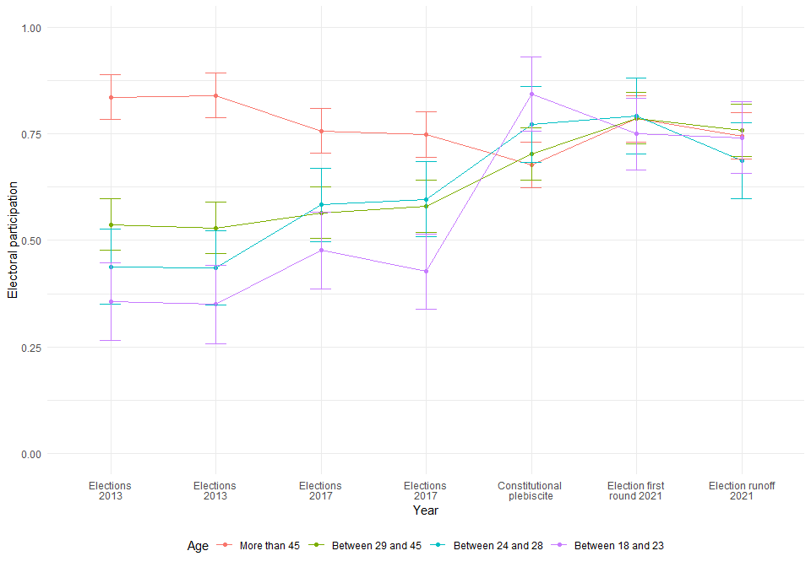

* Voting and sex

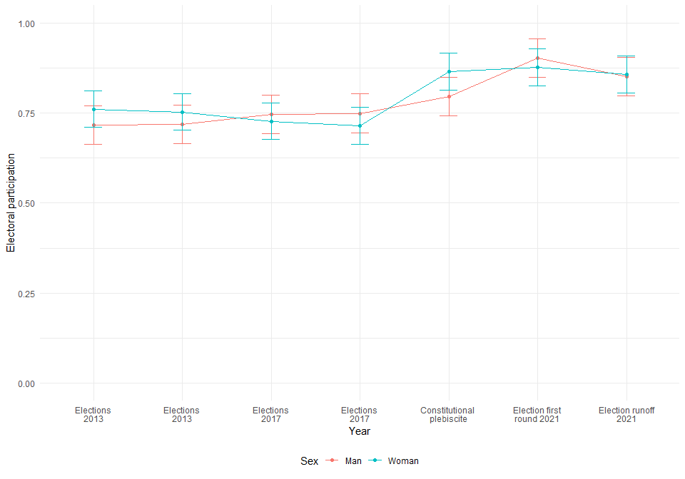

* Voting, age and sex

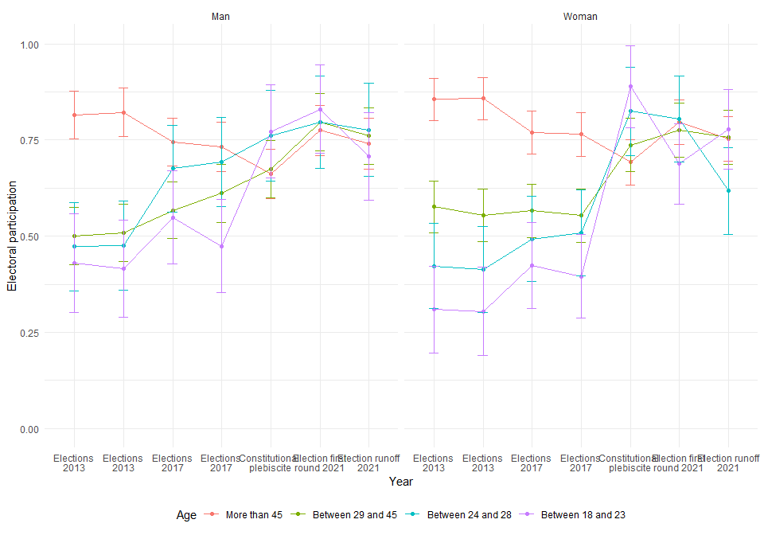

* Voting and Education

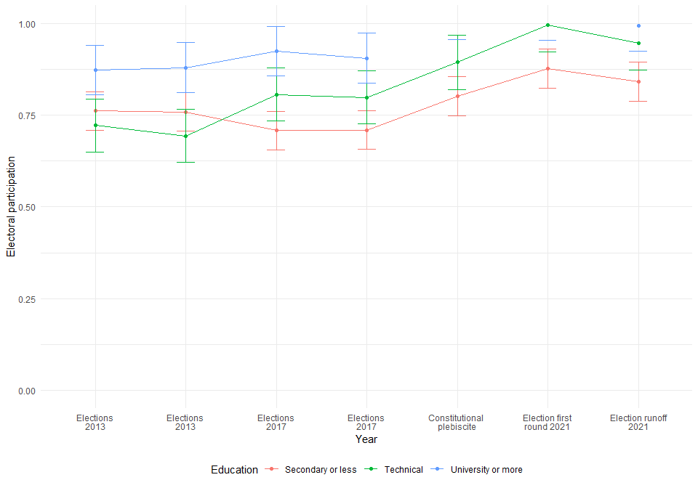

* Voting, age and education

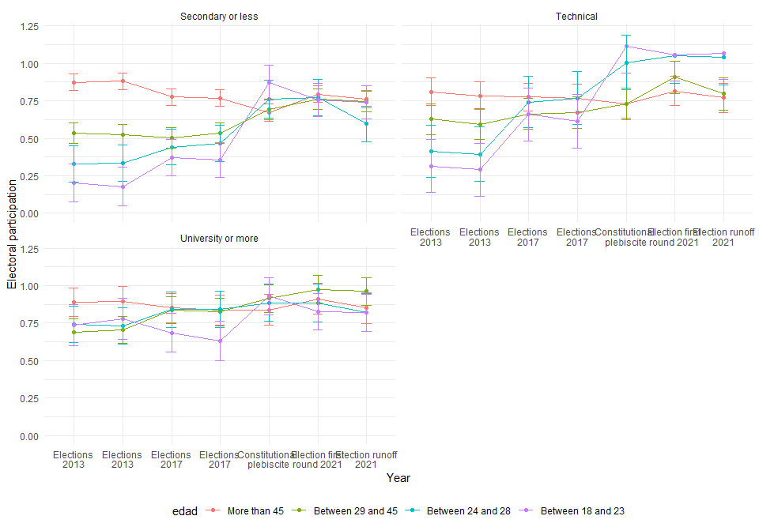

* Voting and political position

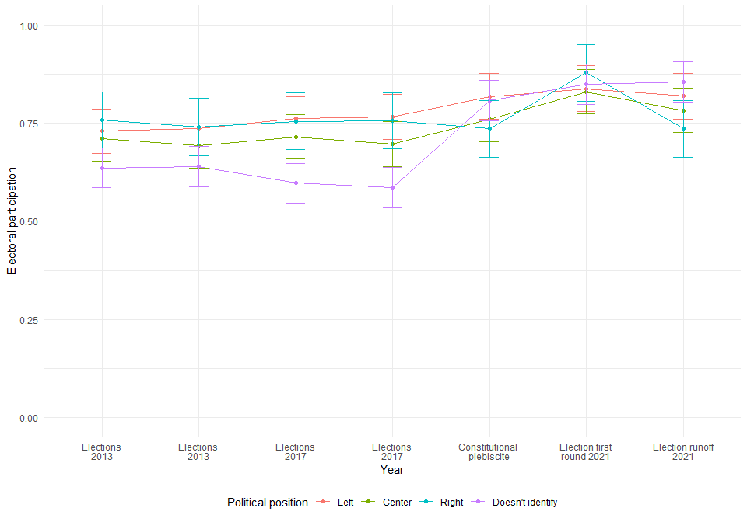

* Voting, age and political position

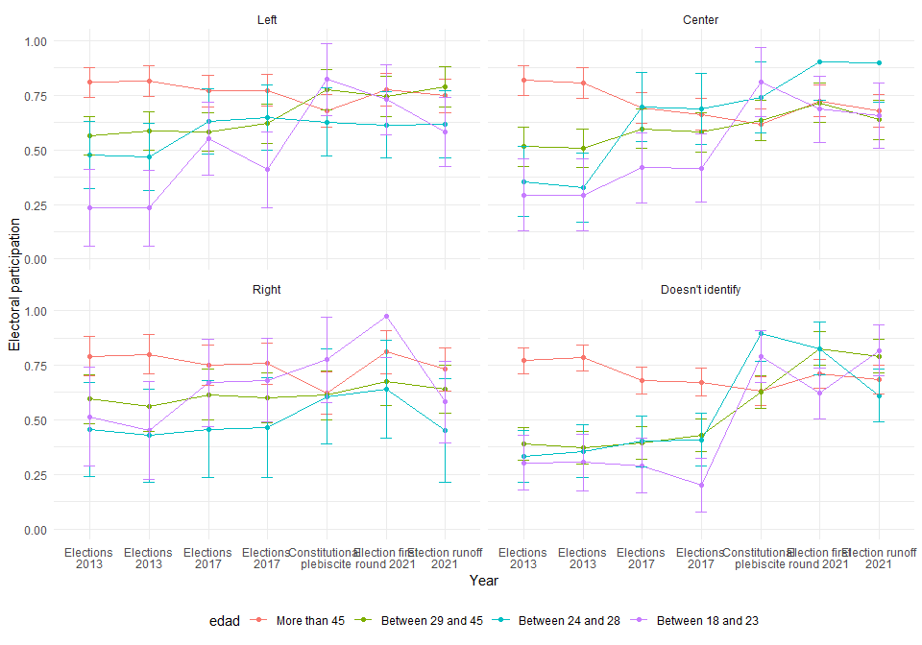

# 2. Participation online

## 2.1 Main effects

|  |  |  |  |  |  |
| --- | --- | --- | --- | --- | --- |
|  | **Model 1** | **Model 2** | **Model 3** | **Model 4** | **Model 5** |
| Intercept | 1.69*** | 1.42*** | 1.40*** | 1.27*** | 1.45*** |
|  | (0.03) | (0.04) | (0.05) | (0.05) | (0.07) |
| Wave (Ref.= 2016) |  |  |  |  |  |
| 2017 | 0.01 | 0.01 | 0.01 | 0.01 | 0.01 |
|  | (0.03) | (0.03) | (0.03) | (0.03) | (0.03) |
| 2018 | 0.06 | 0.06 | 0.06 | 0.06 | 0.06 |
|  | (0.03) | (0.03) | (0.03) | (0.03) | (0.03) |
| 2019 | 0.41*** | 0.41*** | 0.41*** | 0.41*** | 0.41*** |
|  | (0.03) | (0.03) | (0.03) | (0.03) | (0.03) |
| 2021 | 0.19*** | 0.19*** | 0.19*** | 0.19*** | 0.19*** |
|  | (0.03) | (0.03) | (0.03) | (0.03) | (0.03) |
| 2022 | 0.05 | 0.04 | 0.04 | 0.05 | 0.05 |
|  | (0.03) | (0.03) | (0.03) | (0.03) | (0.03) |
| 2023 | -0.04 | -0.05 | -0.05 | -0.05 | -0.05 |
|  | (0.03) | (0.03) | (0.03) | (0.03) | (0.03) |
| Age (Ref.= More than 45) |  |  |  |  |  |
| Between 29 and 45 |  | 0.48*** | 0.48*** | 0.41*** | 0.42*** |
|  |  | (0.06) | (0.06) | (0.06) | (0.06) |
| Between 24 and 28 |  | 0.70*** | 0.71*** | 0.55*** | 0.57*** |
|  |  | (0.09) | (0.09) | (0.09) | (0.09) |
| Between 18 and 23 |  | 0.87*** | 0.87*** | 0.74*** | 0.76*** |
|  |  | (0.10) | (0.10) | (0.10) | (0.10) |
| Woman (Ref.= Man) |  |  | 0.04 | 0.06 | 0.08 |
|  |  |  | (0.05) | (0.05) | (0.05) |
| Education (Ref.= Secondary) |  |  |  |  |  |
| Technical |  |  |  | 0.27*** | 0.24*** |
|  |  |  |  | (0.07) | (0.07) |
| University or more |  |  |  | 0.52*** | 0.48*** |
|  |  |  |  | (0.07) | (0.07) |
| Political position (Ref.= Left) |  |  |  |  |  |
| Center |  |  |  |  | -0.21** |
|  |  |  |  |  | (0.07) |
| Right |  |  |  |  | -0.11 |
|  |  |  |  |  | (0.08) |
| Doesn’t identify |  |  |  |  | -0.28*** |
|  |  |  |  |  | (0.07) |
| BIC | 48023.44 | 47917.39 | 47930.30 | 47889.14 | 47908.24 |
| Numb. obs. | 11024 | 11024 | 11024 | 11024 | 11024 |
| Num. groups: individuals | 1705 | 1705 | 1705 | 1705 | 1705 |
| Var: individuals (Intercept) | 0.65 | 0.57 | 0.57 | 0.54 | 0.53 |
| Var: Residual | 0.74 | 0.73 | 0.73 | 0.73 | 0.73 |
| Note: Cells contain regression coefficients with standard errors in parentheses.  ***p < 0.001; **p < 0.01; *p < 0.05. | | | | | |
|  |  |  |  |  |  |

## 2.2 Interaction effects

|  |  |  |  |  |  |  |  |
| --- | --- | --- | --- | --- | --- | --- | --- |
|  | | | **Education** | | **Political position** | | |
| **Year** | **Age** | **Woman** | **Technical** | **University** | **Center** | **Right** | **Doesnt Identify** |
| **2017** | 29–45 | 0.03 | 0.19 | 0.17 | 0.15 | 0.41 | 0.22 |
| 24–28 | 0.84*** | -0.61* | 0.02 | -0.25 | 0.37 | 0.41 |
| 18–23 | 0.18 | -1.14*** | -0.17 | 0.15 | 1.15*** | 0.23 |
| **2018** | 29–45 | -0.23 | -0.26 | 0.11 | -0.2 | -0.19 | 0.15 |
| 24–28 | 1.01*** | -1.95*** | -0.67** | -0.42 | 0.35 | 0.13 |
| 18–23 | 0.97*** | -1.92*** | 0.22 | -0.64* | -0.68* | -0.76** |
| **2019** | 29–45 | -0.18 | 0.34 | -0.06 | 0.04 | -0.44 | -0.05 |
| 24–28 | 1.6*** | -1.14*** | -0.69** | 1.4*** | -0.45 | 0.52* |
| 18–23 | -0.25 | -1.27*** | 0.2 | 0.12 | 0.15 | 0.69* |
| **2021** | 29–45 | 0.14 | -0.11 | -0.51** | 0.17 | -0.09 | 0.17 |
| 24–28 | 1.5*** | -0.35 | -0.42 | 0.51 | 0 | 1.16*** |
| 18–23 | 0.88*** | -0.66* | -0.2 | -1.04*** | -0.36 | -0.43 |
| **2022** | 29–45 | -0.25 | 0.52* | -0.65*** | 0.19 | -0.58* | 0.03 |
| 24–28 | 1.3*** | -0.67* | 0.08 | 0.59 | 0.24 | 0.87*** |
| 18–23 | 0.2 | -0.9*** | 0.64** | -0.07 | -0.1 | 0.96*** |
| **2023** | 29–45 | 0.21 | 0.53** | -0.24 | -0.26 | -0.22 | 0.25 |
| 24–28 | 1.18*** | -1.43*** | -0.65** | 0.46 | 0.23 | 1.47*** |
| 18–23 | 0.36 | -1.61*** | -0.07 | -0.36 | 0.01 | 0.35 |
| *Note: ***p < 0.001; **p < 0.01; *p < 0.05.* The cells contain the effects of three-way interactions. For example, the first effect (0.03) is the coefficient for the year 2017, for the age group 29-45 and being female, an effect that is not statistically significant. The full models are available at: | | | | | | | |

## 2.3 Interaction effects graphs

* Participation online and age

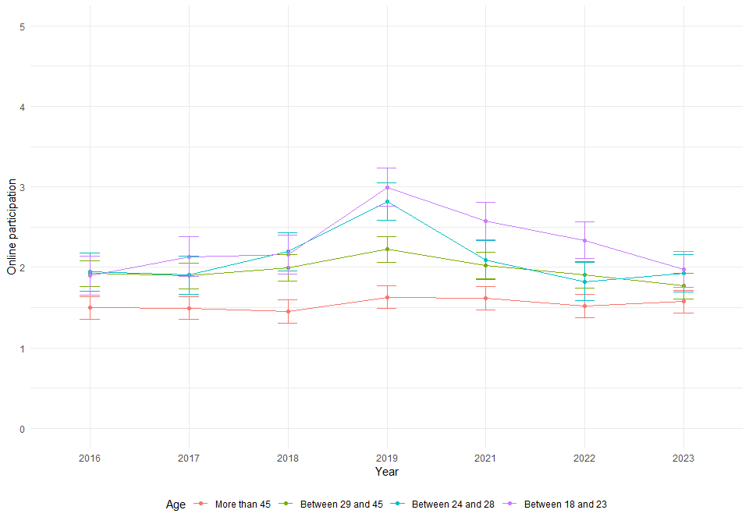

* Participation online and sex

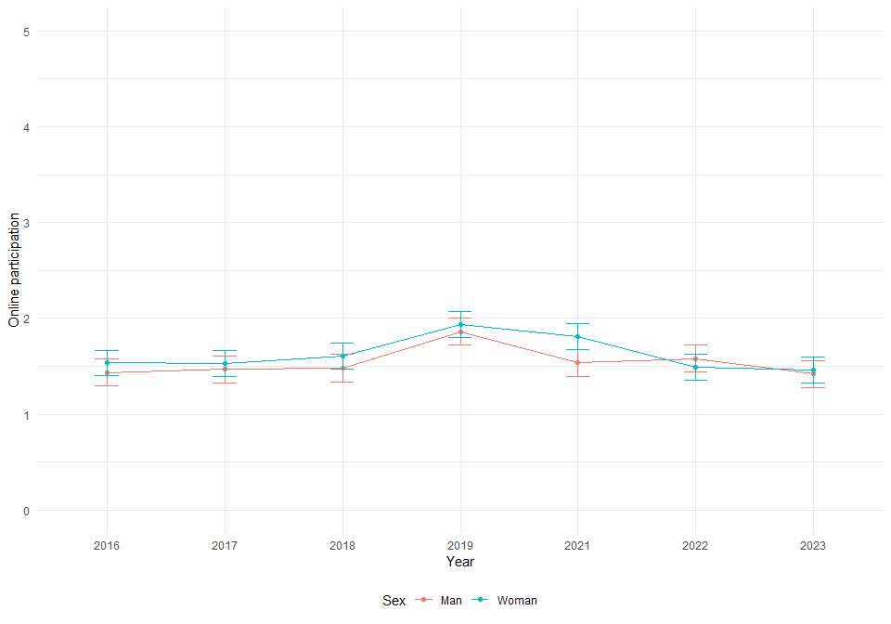

* Participation online, age and sex

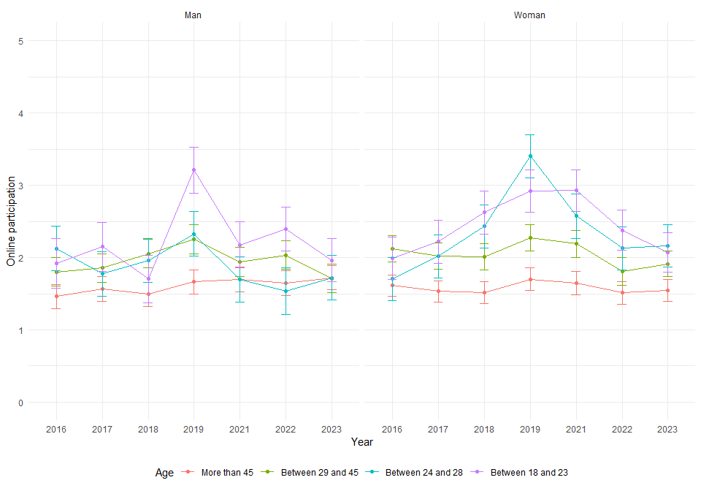

* Participation online and education

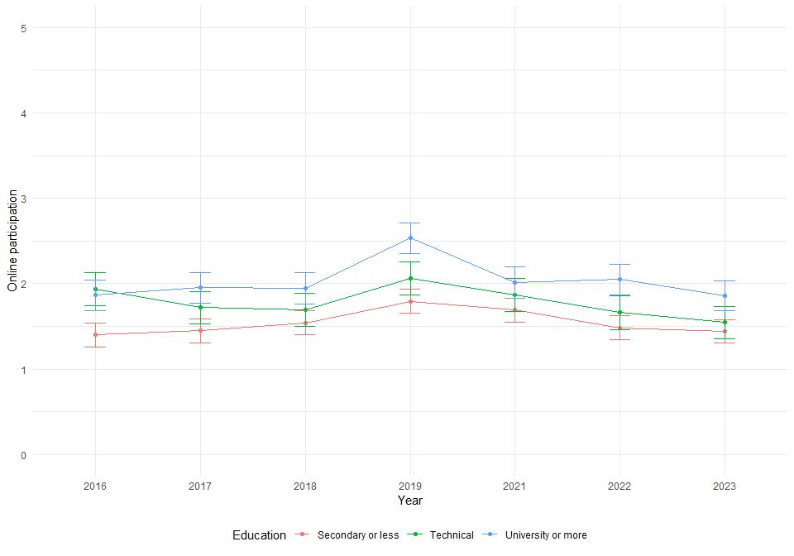

* Participation online, age and education

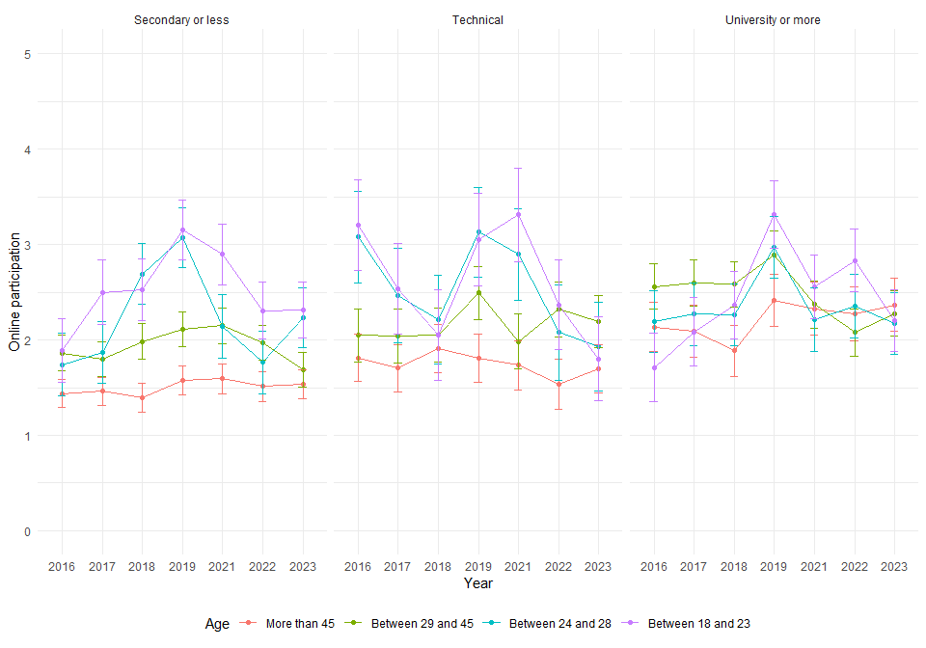

* Participation online and political position

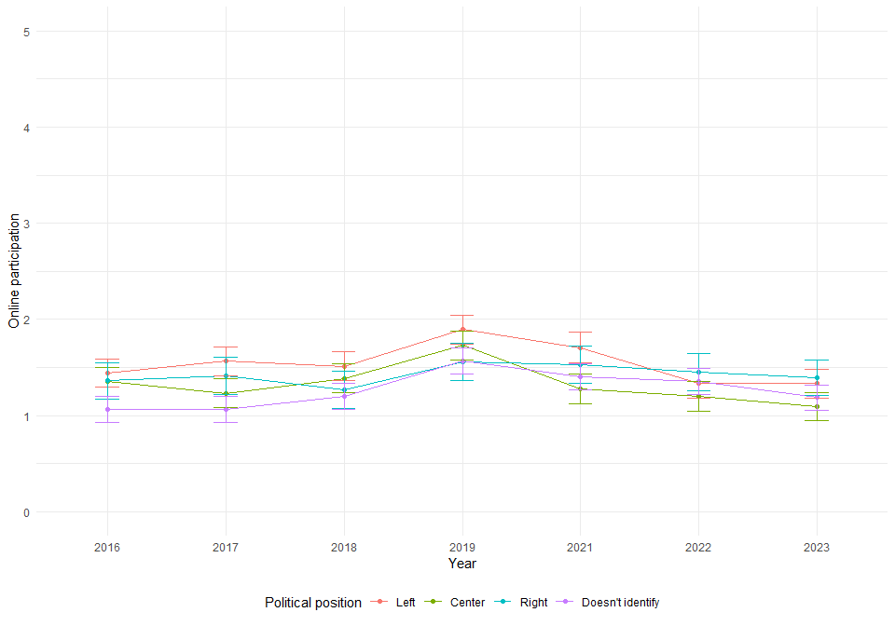

* Participation online. age and political position

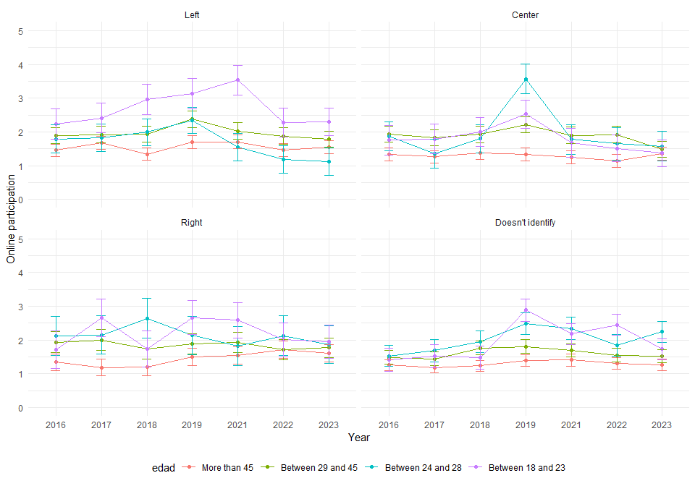

# 3. Participation in demonstrations

## 3.1 Main effects

|  |  |  |  |  |  |
| --- | --- | --- | --- | --- | --- |
|  | **Model 1** | **Model 2** | **Model 3** | **Model 4** | **Model 5** |
| Intercept | 1.35*** | 1.23*** | 1.27*** | 1.18*** | 1.39*** |
|  | (0.02) | (0.03) | (0.03) | (0.03) | (0.04) |
| Wave (Ref.= 2016) |  |  |  |  |  |
| 2017 | -0.10*** | -0.10*** | -0.10*** | -0.10*** | -0.10*** |
|  | (0.02) | (0.02) | (0.02) | (0.02) | (0.02) |
| 2018 | -0.15*** | -0.16*** | -0.16*** | -0.16*** | -0.16*** |
|  | (0.02) | (0.02) | (0.02) | (0.02) | (0.02) |
| 2019 | 0.41*** | 0.40*** | 0.40*** | 0.40*** | 0.40*** |
|  | (0.02) | (0.02) | (0.02) | (0.02) | (0.02) |
| 2021 | -0.14*** | -0.15*** | -0.15*** | -0.15*** | -0.15*** |
|  | (0.02) | (0.02) | (0.02) | (0.02) | (0.02) |
| 2022 | -0.12*** | -0.13*** | -0.13*** | -0.13*** | -0.13*** |
|  | (0.02) | (0.02) | (0.02) | (0.02) | (0.02) |
| 2023 | -0.23*** | -0.24*** | -0.24*** | -0.24*** | -0.24*** |
|  | (0.02) | (0.02) | (0.02) | (0.02) | (0.02) |
| Age (Ref.= More than 45) |  |  |  |  |  |
| Between 29 and 45 |  | 0.18*** | 0.18*** | 0.12*** | 0.13*** |
|  |  | (0.04) | (0.04) | (0.03) | (0.03) |
| Between 24 and 28 |  | 0.34*** | 0.34*** | 0.23*** | 0.23*** |
|  |  | (0.06) | (0.06) | (0.06) | (0.05) |
| Between 18 and 23 |  | 0.49*** | 0.49*** | 0.40*** | 0.40*** |
|  |  | (0.06) | (0.06) | (0.06) | (0.06) |
| Woman (Ref.= Man) |  |  | -0.06 | -0.04 | -0.03 |
|  |  |  | (0.03) | (0.03) | (0.03) |
| Education (Ref.= Secondary) |  |  |  |  |  |
| Technical |  |  |  | 0.22*** | 0.22*** |
|  |  |  |  | (0.04) | (0.04) |
| University or more |  |  |  | 0.36*** | 0.36*** |
|  |  |  |  | (0.04) | (0.04) |
| Political position (Ref.= Left) |  |  |  |  |  |
| Center |  |  |  |  | -0.28*** |
|  |  |  |  |  | (0.04) |
| Right |  |  |  |  | -0.41*** |
|  |  |  |  |  | (0.05) |
| Doesn’t identify |  |  |  |  | -0.25*** |
|  |  |  |  |  | (0.04) |
| BIC | 40295.63 | 40241.15 | 40252.45 | 40191.87 | 40154.61 |
| Numb. obs. | 11028 | 11028 | 11028 | 11028 | 11028 |
| Num. groups: individuals | 1705 | 1705 | 1705 | 1705 | 1705 |
| Var: individuals (Intercept) | 0.22 | 0.20 | 0.19 | 0.18 | 0.16 |
| Var: Residual | 0.38 | 0.38 | 0.38 | 0.38 | 0.38 |
| Note: Cells contain regression coefficients with standard errors in parentheses.  ***p < 0.001; **p < 0.01; *p < 0.05. | | | | | |

## 3.2 Interaction effects

|  |  |  |  |  |  |  |  |
| --- | --- | --- | --- | --- | --- | --- | --- |
|  |  |  | **Education** | | **Political position** | | |
| **Year** | **Age** | **Woman** | **Technical** | **University** | **Center** | **Right** | **Doesn’t Identify** |
| **2017** | 29–45 | -0.03 | 0.3* | 0.25 | -0.43** | -0.16 | -0.26* |
| 24–28 | 0.13 | -0.16 | 0.06 | 0.04 | 0.11 | 0.01 |
| 18–23 | 0.33* | 0.11 | -0.74*** | 0.3 | -0.04 | -0.28 |
| **2018** | 29–45 | 0.08 | 0.29* | 0.16 | -0.28* | -0.31 | -0.13 |
| 24–28 | 0.56*** | -0.53** | -0.21 | -0.2 | 0.38 | 0.27 |
| 18–23 | 0.61*** | 0 | -0.65*** | 0.61** | -0.45 | -0.3 |
| **2019** | 29–45 | -0.11 | 0.17 | 0.25 | -0.33* | -0.37* | -0.08 |
| 24–28 | 0.24 | 0.41* | 0.32 | 1.27*** | 0.51* | 0.57*** |
| 18–23 | -0.31* | 0.15 | -0.5** | 1.1*** | 0.24 | 0.83*** |
| **2021** | 29–45 | -0.24* | 0.57*** | 0.4** | -0.4** | -0.29 | -0.2 |
| 24–28 | -0.03 | 0.06 | 0.61*** | 0.95*** | 0.31 | 0.22 |
| 18–23 | 0.37** | -0.28 | -0.63*** | 0.32 | -0.69** | -0.18 |
| **2022** | 29–45 | -0.05 | 0.24 | 0.41** | -0.25 | -0.33* | -0.06 |
| 24–28 | 0.32* | -0.19 | -0.06 | 0.57** | 0.27 | 0.24 |
| 18–23 | 0.01 | 0.21 | 0.13 | 0.68*** | -0.28 | 0.19 |
| **2023** | 29–45 | 0.05 | 0.4** | 0.5*** | -0.29* | -0.23 | -0.18 |
| 24–28 | 0.44** | -0.46* | -0.22 | 0.37 | 0.76** | 0.65*** |
| 18–23 | 0.31* | -0.42* | -0.49** | 0.69*** | -0.36 | -0.09 |
| *Note: ***p < 0.001; **p < 0.01; *p < 0.05.* The cells contain the effects of three-way interactions. For example, the first effect (0.03) is the coefficient for the year 2017, for the age group 29-45 and being female, an effect that is not statistically significant. The full models are available at: | | | | | | | |

## 3.3 Interaction effects graphs

* Participation in demonstrations and age

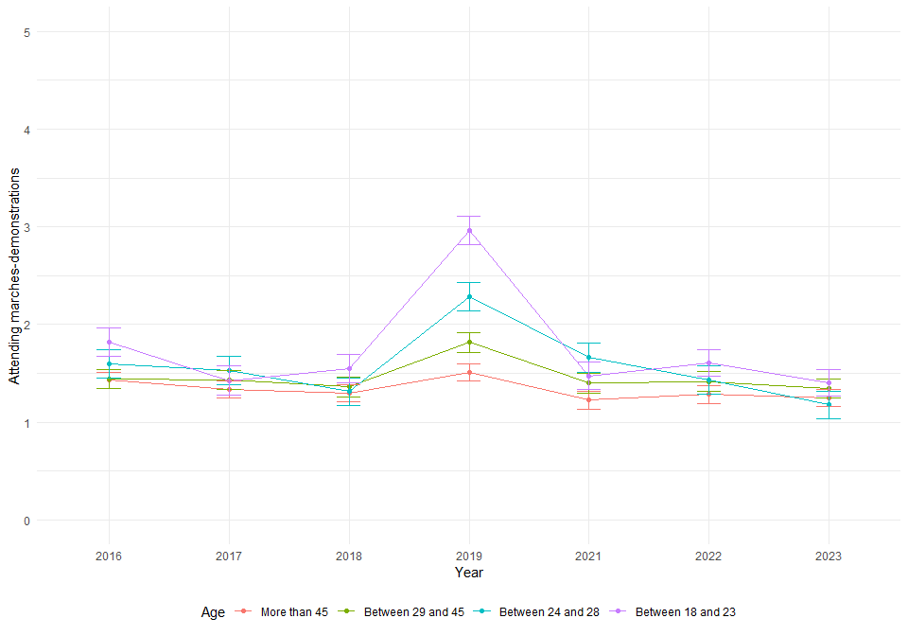

* Participation in demonstrations and sex

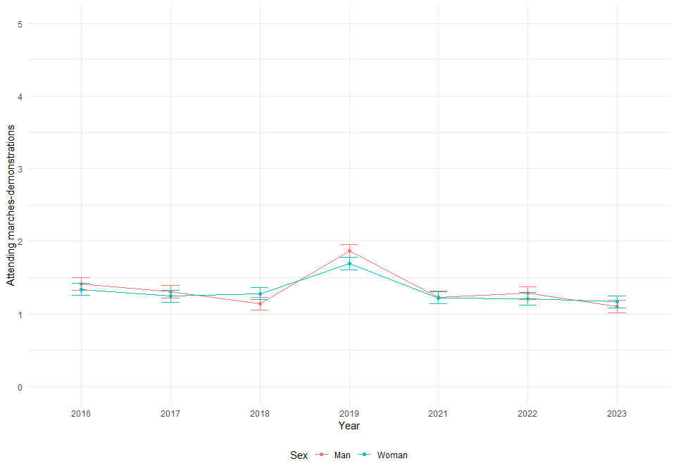

* Participation in demonstrations, age and sex

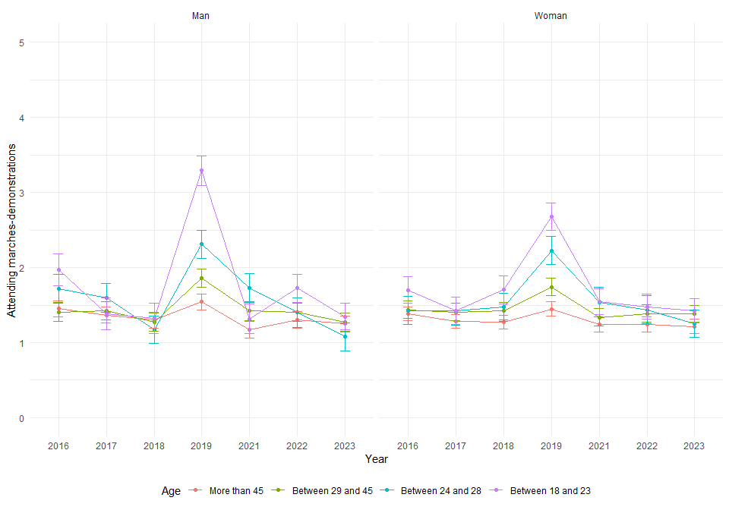

* Participation in demonstrations and education

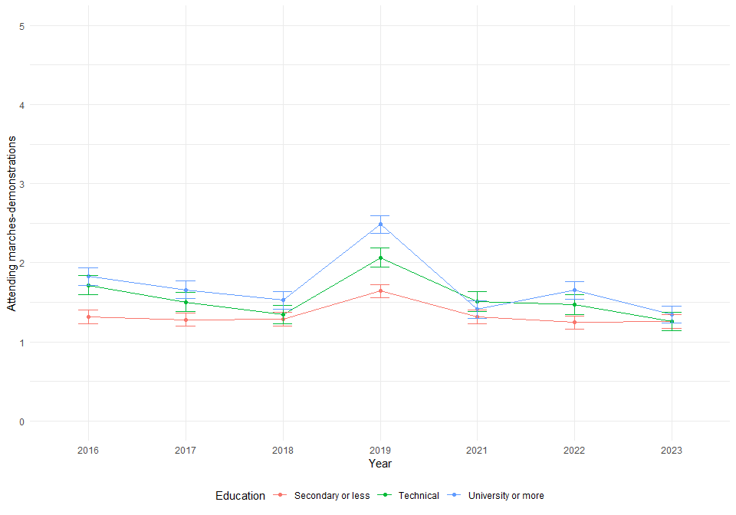

* Participation in demonstrations, age and education

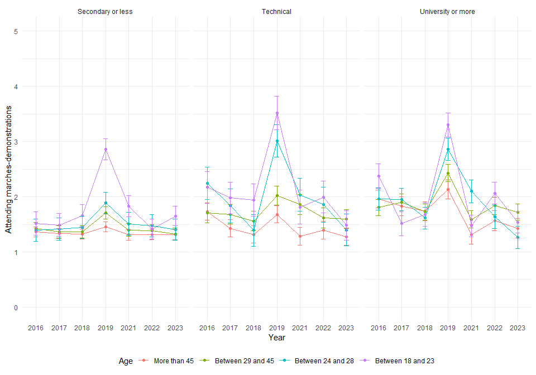

* Participation in demonstrations and political position

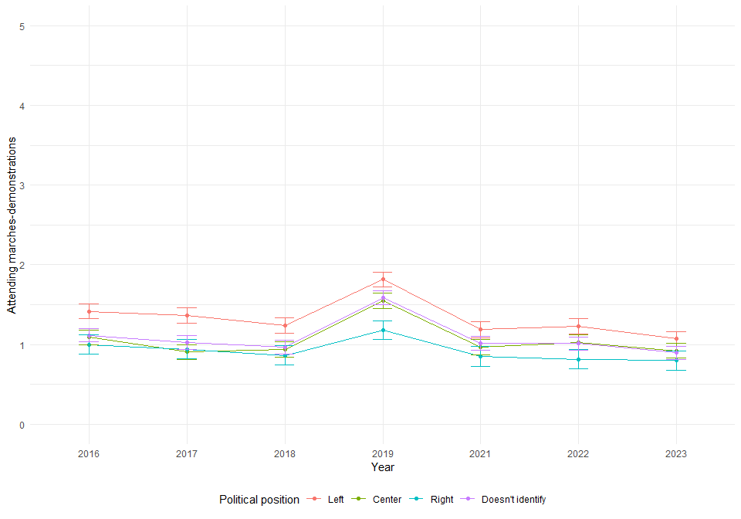

* Participation in demonstrations, age and political position

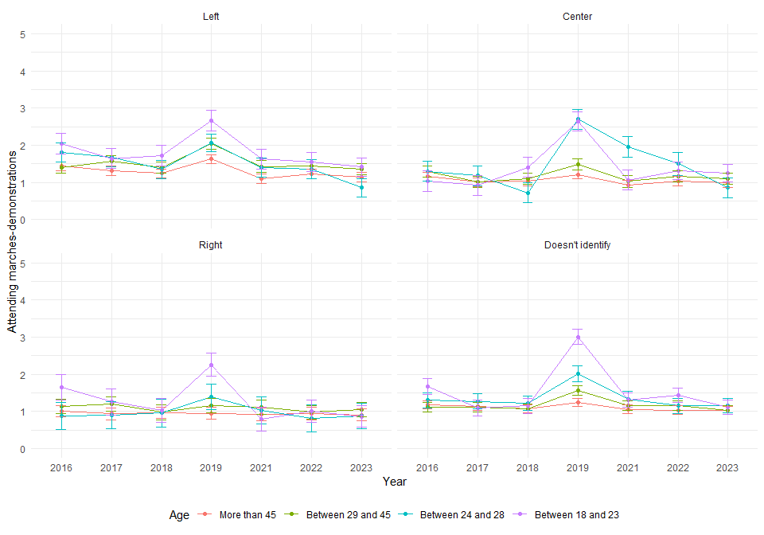

# 4. Support to same-sex adoption

## 4.1 Main effects

|  |  |  |  |  |  |
| --- | --- | --- | --- | --- | --- |
|  | **Model 1** | **Model 2** | **Model 3** | **Model 4** | **Model 5** |
| Intercept | 2.90*** | 2.68*** | 2.54*** | 2.39*** | 2.55*** |
|  | (0.03) | (0.04) | (0.06) | (0.06) | (0.08) |
| Wave (Ref.= 2018) |  |  |  |  |  |
| 2019 | 0.21*** | 0.21*** | 0.21*** | 0.21*** | 0.21*** |
|  | (0.03) | (0.03) | (0.03) | (0.03) | (0.03) |
| 2021 | 0.33*** | 0.33*** | 0.33*** | 0.32*** | 0.33*** |
|  | (0.03) | (0.03) | (0.03) | (0.03) | (0.03) |
| 2022 | 0.31*** | 0.31*** | 0.31*** | 0.31*** | 0.31*** |
|  | (0.03) | (0.03) | (0.03) | (0.03) | (0.03) |
| 2023 | 0.36*** | 0.36*** | 0.36*** | 0.36*** | 0.36*** |
|  | (0.03) | (0.03) | (0.03) | (0.03) | (0.03) |
| Age (Ref.= More than 45) |  |  |  |  |  |
| Between 29 and 45 |  | 0.34*** | 0.34*** | 0.26*** | 0.26*** |
|  |  | (0.07) | (0.07) | (0.07) | (0.07) |
| Between 24 and 28 |  | 0.64*** | 0.65*** | 0.46*** | 0.46*** |
|  |  | (0.11) | (0.11) | (0.11) | (0.11) |
| Between 18 and 23 |  | 0.80*** | 0.82*** | 0.65*** | 0.66*** |
|  |  | (0.11) | (0.11) | (0.11) | (0.11) |
| Woman (Ref.= Man) |  |  | 0.23*** | 0.27*** | 0.29*** |
|  |  |  | (0.06) | (0.06) | (0.06) |
| Education (Ref.= Secondary) |  |  |  |  |  |
| Technical |  |  |  | 0.20* | 0.19* |
|  |  |  |  | (0.08) | (0.08) |
| University or more |  |  |  | 0.71*** | 0.71*** |
|  |  |  |  | (0.08) | (0.08) |
| Political position (Ref.= Left) |  |  |  |  |  |
| Center |  |  |  |  | -0.13 |
|  |  |  |  |  | (0.08) |
| Right |  |  |  |  | -0.37*** |
|  |  |  |  |  | (0.10) |
| Doesn’t identify |  |  |  |  | -0.21** |
|  |  |  |  |  | (0.08) |
| BIC | 30308.14 | 30264.76 | 30262.83 | 30202.53 | 30223.05 |
| Numb. obs. | 7502 | 7502 | 7502 | 7502 | 7502 |
| Num. groups: individuals | 1705 | 1705 | 1705 | 1705 | 1705 |
| Var: individuals (Intercept) | 0.92 | 0.86 | 0.85 | 0.78 | 0.77 |
| Var: Residual | 0.48 | 0.47 | 0.47 | 0.47 | 0.47 |
| Note: Cells contain regression coefficients with standard errors in parentheses.  ***p < 0.001; **p < 0.01; *p < 0.05. | | | | | |

## 4.2 Interaction effects

|  |  |  |  |  |  |  |  |
| --- | --- | --- | --- | --- | --- | --- | --- |
|  | | | **Education** | | **Political position** | | |
| **Year** | **Age** | **Woman** | **Technical** | **University** | **Center** | **Right** | **Doesnt Identify** |
| **2019** | 29–45 | 0.28* | -0.4* | 0.13 | -0.49** | -0.11 | -0.06 |
| 24–28 | -0.14 | -0.18 | -0.08 | -0.25 | 1.32*** | -0.17 |
| 18–23 | 1.08*** | -0.96*** | 0.61** | -0.26 | 1.6*** | 0.79*** |
| **2021** | 29–45 | 0.19 | 0.07 | 0 | 0.15 | 0.02 | 0.15 |
| 24–28 | -0.02 | 0.23 | 0.22 | 0 | 0.46 | -0.11 |
| 18–23 | 0.62*** | -1.49*** | 0.74*** | 0.85*** | 1.7*** | 1.51*** |
| **2022** | 29–45 | 0.14 | 0.09 | 0.04 | 0.01 | 0.02 | 0.22 |
| 24–28 | -0.2 | 0.17 | 0.19 | -0.2 | 0.24 | -0.32 |
| 18–23 | 0.77*** | -1.73*** | 0.7*** | 0.46* | 1.75*** | 1.53*** |
| **2023** | 29–45 | 0.2 | -0.13 | -0.1 | 0.27 | 0.04 | -0.04 |
| 24–28 | 0.41* | 0.26 | 0.03 | 0.75** | 0.85** | 0.41* |
| 18–23 | 1.2*** | -1.43*** | 0.2 | 0.39 | 1.41*** | 0.83*** |
| *Note: ***p < 0.001; **p < 0.01; *p < 0.05.* The cells contain the effects of three-way interactions. For example, the first effect (0.03) is the coefficient for the year 2017, for the age group 29-45 and being female, an effect that is not statistically significant. The full models are available at: | | | | | | | |

## 4.3 Interaction effects graphs

* Support to same-sex adoption and age

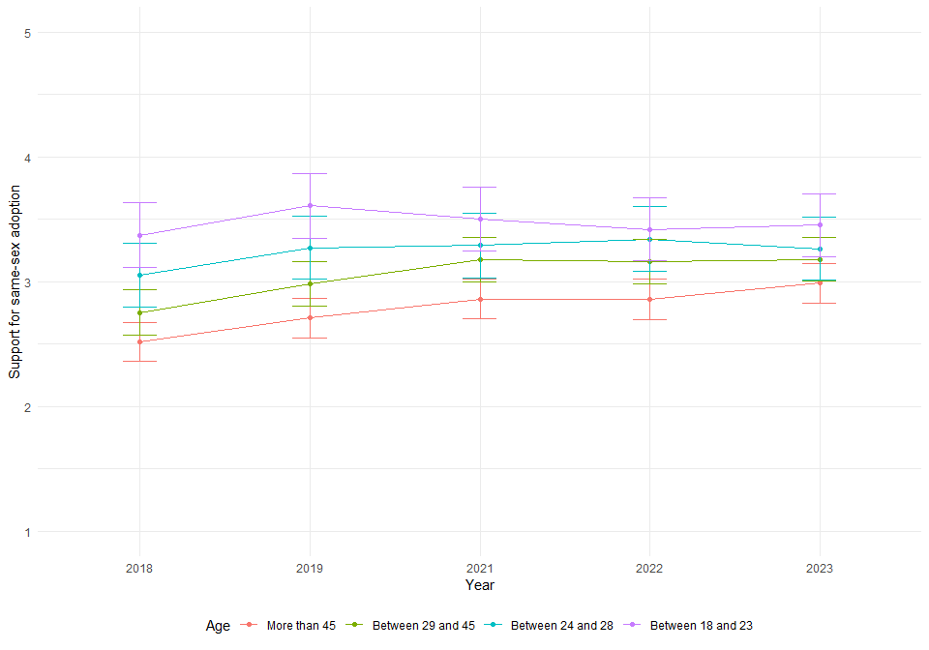

* Support to same-sex adoption and sex

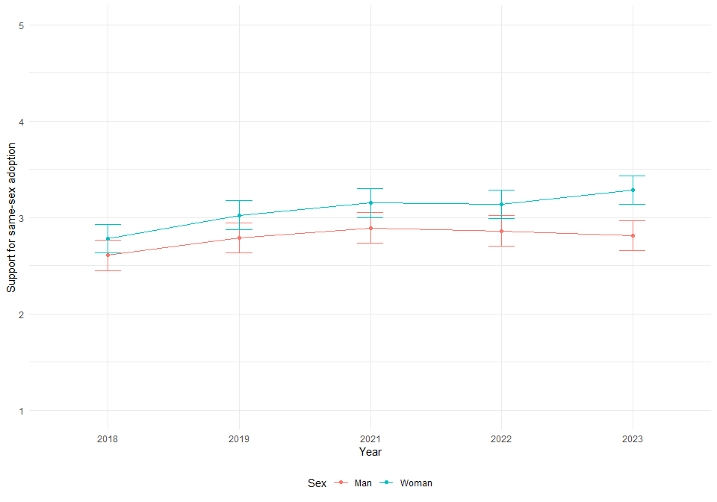

* Support to same-sex adoption, age and sex

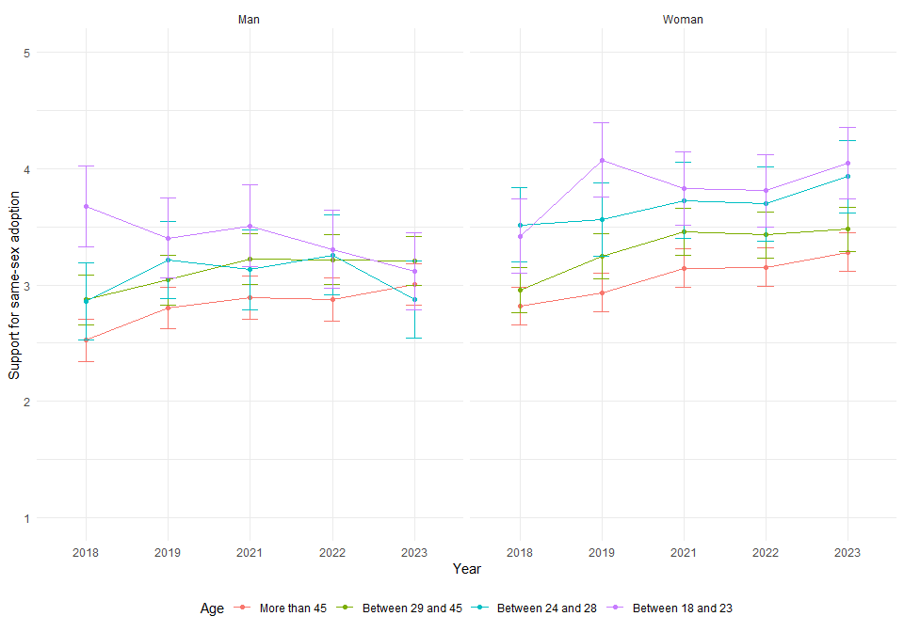

* Support to same-sex adoption and education

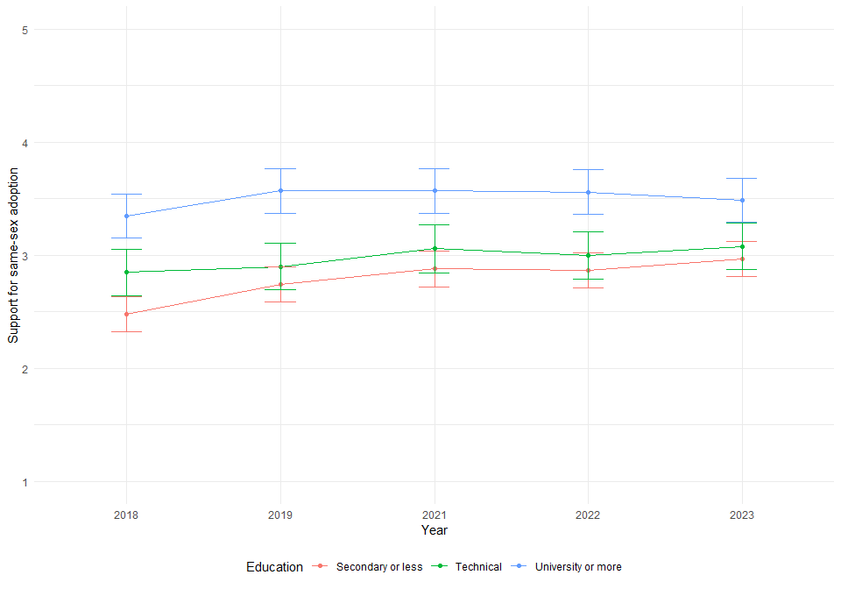

* Support to same-sex adoption, age and education

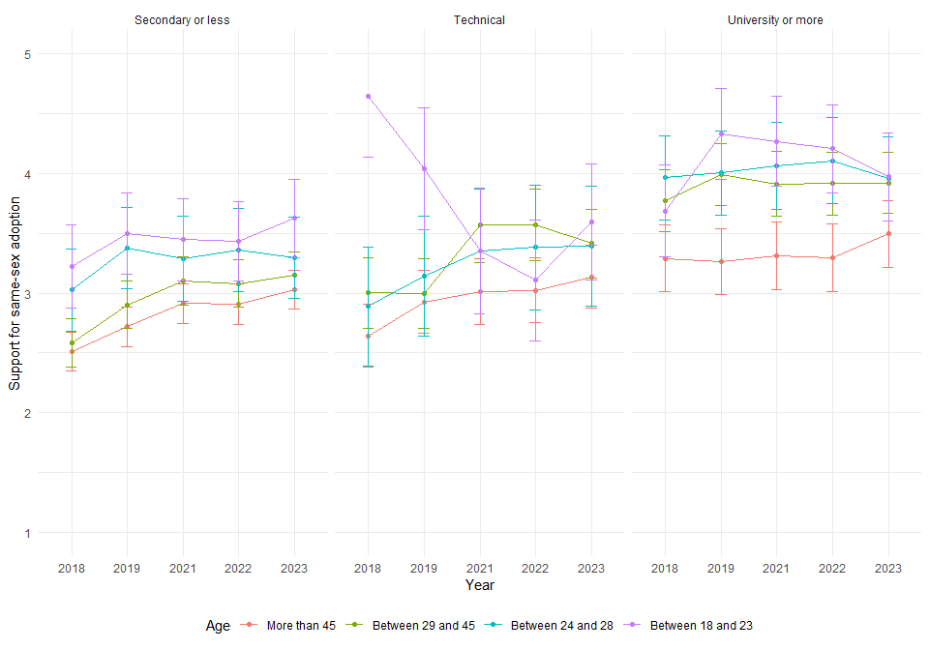

* Support to same-sex adoption and political position

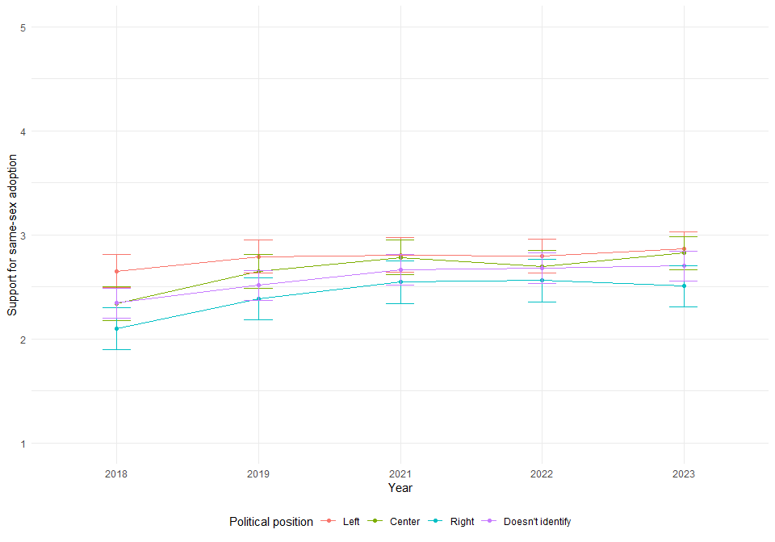

* Support to same-sex adoption, age and political position

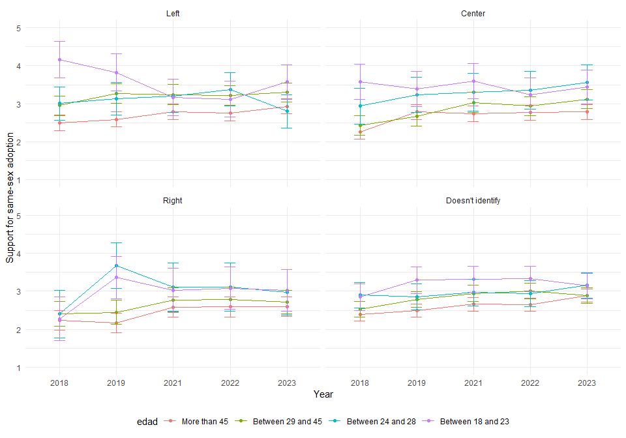

# 5. Support for abortion decriminalization

## 5.1 Main effects

|  |  |  |  |  |  |
| --- | --- | --- | --- | --- | --- |
|  | **Model 1** | **Model 2** | **Model 3** | **Model 4** | **Model 5** |
| Intercept | 2.73*** | 2.67*** | 2.72*** | 2.59*** | 2.81*** |
|  | (0.04) | (0.05) | (0.06) | (0.06) | (0.08) |
| Wave (Ref.= 2018) |  |  |  |  |  |
| 2019 | 0.15*** | 0.15*** | 0.15*** | 0.15*** | 0.15*** |
|  | (0.03) | (0.03) | (0.03) | (0.03) | (0.03) |
| 2021 | 0.14*** | 0.14*** | 0.14*** | 0.14*** | 0.14*** |
|  | (0.03) | (0.03) | (0.03) | (0.03) | (0.03) |
| 2022 | 0.00 | -0.00 | -0.00 | -0.00 | -0.00 |
|  | (0.03) | (0.03) | (0.03) | (0.03) | (0.03) |
| 2023 | 0.14*** | 0.14*** | 0.14*** | 0.14*** | 0.14*** |
|  | (0.03) | (0.03) | (0.03) | (0.03) | (0.03) |
| Age (Ref.= More than 45) |  |  |  |  |  |
| Between 29 and 45 |  | 0.02 | 0.02 | -0.06 | -0.05 |
|  |  | (0.07) | (0.07) | (0.07) | (0.07) |
| Between 24 and 28 |  | 0.20 | 0.19 | 0.03 | 0.03 |
|  |  | (0.11) | (0.11) | (0.11) | (0.11) |
| Between 18 and 23 |  | 0.39*** | 0.38*** | 0.24* | 0.25* |
|  |  | (0.11) | (0.11) | (0.11) | (0.11) |
| Woman (Ref.= Man) |  |  | -0.07 | -0.04 | -0.02 |
|  |  |  | (0.06) | (0.06) | (0.06) |
| Education (Ref.= Secondary) |  |  |  |  |  |
| Technical |  |  |  | 0.22** | 0.21** |
|  |  |  |  | (0.08) | (0.08) |
| University or more |  |  |  | 0.58*** | 0.59*** |
|  |  |  |  | (0.08) | (0.08) |
| Political position (Ref.= Left) |  |  |  |  |  |
| Center |  |  |  |  | -0.21* |
|  |  |  |  |  | (0.08) |
| Right |  |  |  |  | -0.51*** |
|  |  |  |  |  | (0.10) |
| Doesn’t identify |  |  |  |  | -0.28*** |
|  |  |  |  |  | (0.08) |
| BIC | 32899.86 | 32921.22 | 32932.47 | 32900.95 | 32908.87 |
| Numb. obs. | 7647 | 7647 | 7647 | 7647 | 7647 |
| Num. groups: individuals | 1704 | 1704 | 1704 | 1704 | 1704 |
| Var: individuals (Intercept) | 0.81 | 0.81 | 0.80 | 0.76 | 0.74 |
| Var: Residual | 0.66 | 0.66 | 0.66 | 0.65 | 0.65 |
| Note: Cells contain regression coefficients with standard errors in parentheses.  ***p < 0.001; **p < 0.01; *p < 0.05. | | | | | |

## 5.2 Interaction effects

|  |  |  |  |  |  |  |  |
| --- | --- | --- | --- | --- | --- | --- | --- |
|  | | | **Education** | | **Political position** | | |
| **Year** | **Age** | **Woman** | **Technical** | **University** | **Center** | **Right** | **Doesn’t Identify** |
| **2019** | 29–45 | 0.13 | -0.07 | -0.61** | 0.54** | 0.13 | 0.32 |
| 24–28 | 0.06 | 0.42 | -0.1 | -0.45 | -0.42 | -0.08 |
| 18–23 | 0.43* | 0.23 | 0.28 | -0.22 | 0.43 | 0.58* |
| **2021** | 29–45 | 0.31* | 0.02 | -0.12 | 1.01*** | 0.42 | 0.35 |
| 24–28 | 0.38 | 0.07 | 0.13 | 0.54 | 0.35 | -0.12 |
| 18–23 | 1.27*** | 0 | 0.01 | -0.13 | 1.23*** | 0.54* |
| **2022** | 29–45 | 0.29 | 0.1 | -0.05 | 0.99*** | 0.13 | 0.08 |
| 24–28 | 0.51* | 0.47 | -0.83*** | -0.1 | 0.46 | 0.45 |
| 18–23 | 0.45* | 0.52* | 0.83*** | -0.43 | 0.86** | 0.23 |
| **2023** | 29–45 | 0.21 | -0.01 | -0.32 | 0.79*** | -0.43 | -0.29 |
| 24–28 | 0.44* | 0.04 | -0.46* | 0.17 | 0.79* | 0.28 |
| 18–23 | 0.74*** | -0.49* | 0.4 | -0.06 | 0.09 | -0.05 |
| *Note: ***p < 0.001; **p < 0.01; *p < 0.05.* The cells contain the effects of three-way interactions. For example, the first effect (0.03) is the coefficient for the year 2017, for the age group 29-45 and being female, an effect that is not statistically significant. The full models are available at: | | | | | | | |

## 5.3 Interaction effects graphs

* Support for abortion decriminalization and age

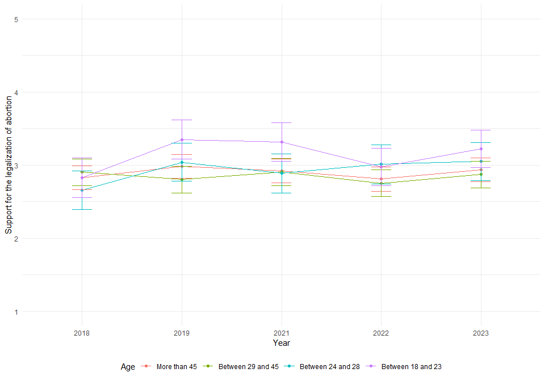

* Support for abortion decriminalization and sex

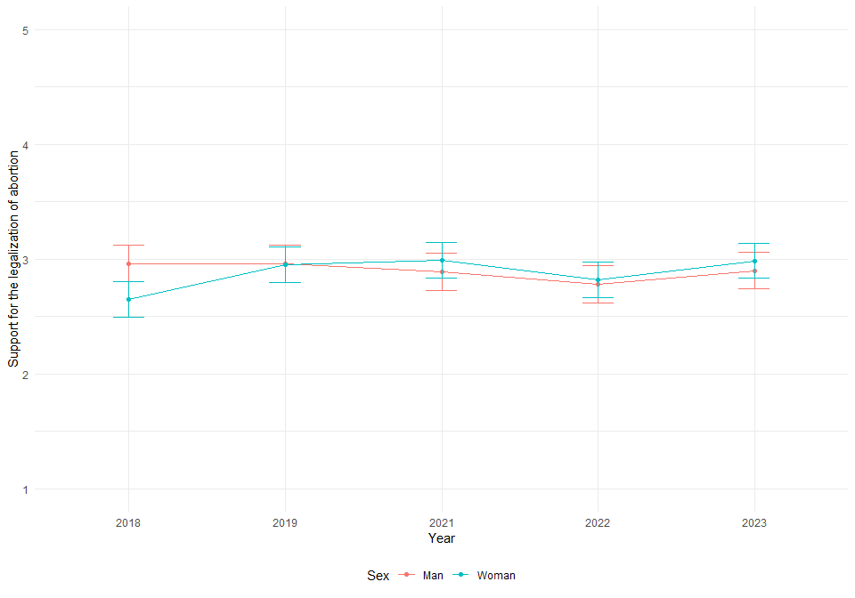

* Support for abortion decriminalization, age and sex

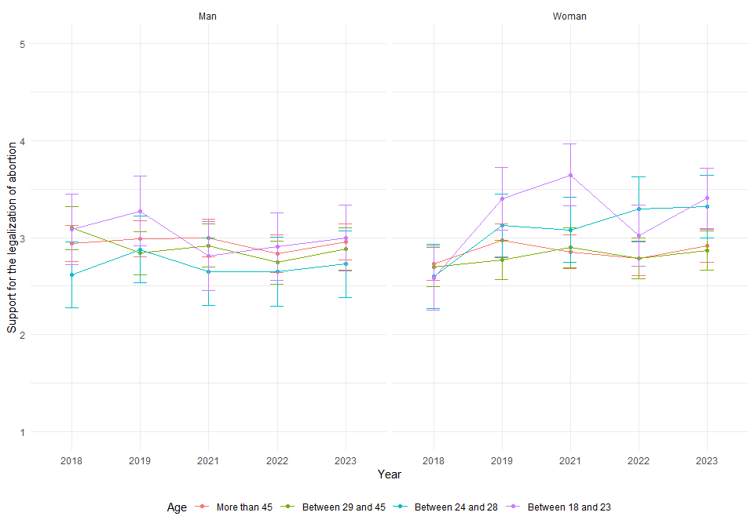

* Support for abortion decriminalization and education

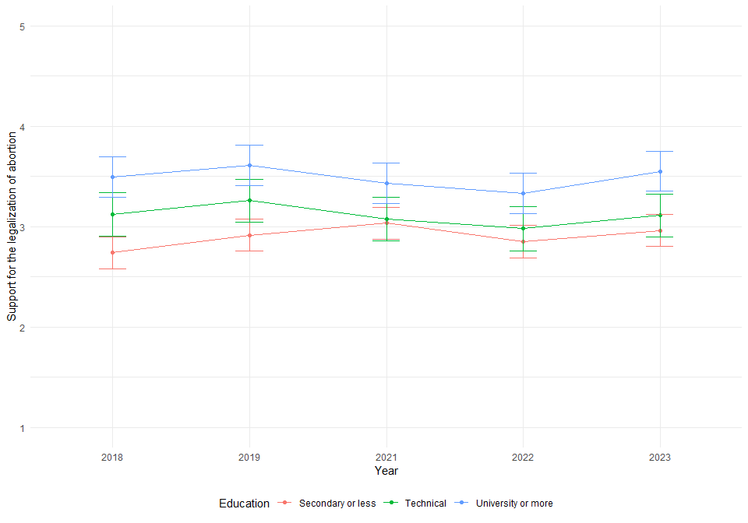

* Support for abortion decriminalization, age and education

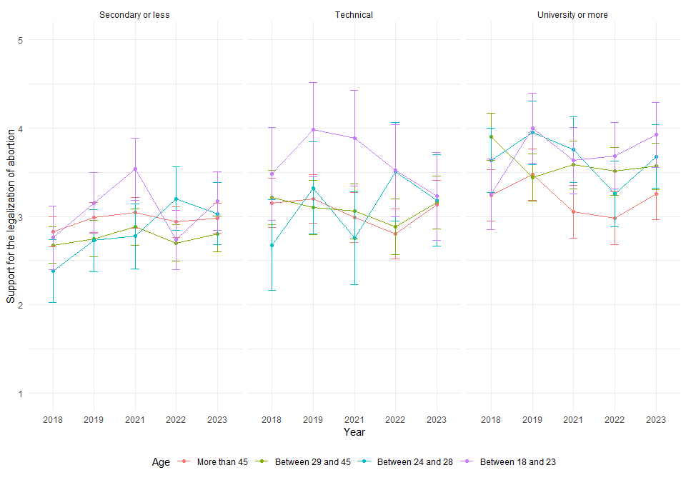

* Support for abortion decriminalization and political position

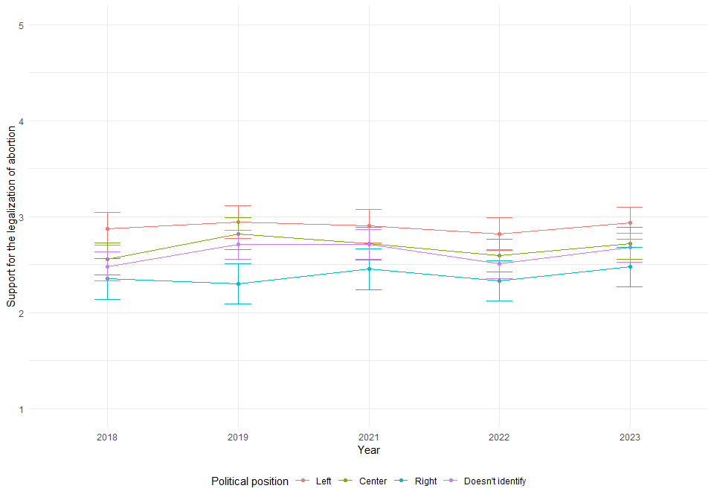

* Support for abortion decriminalization, agen and political position

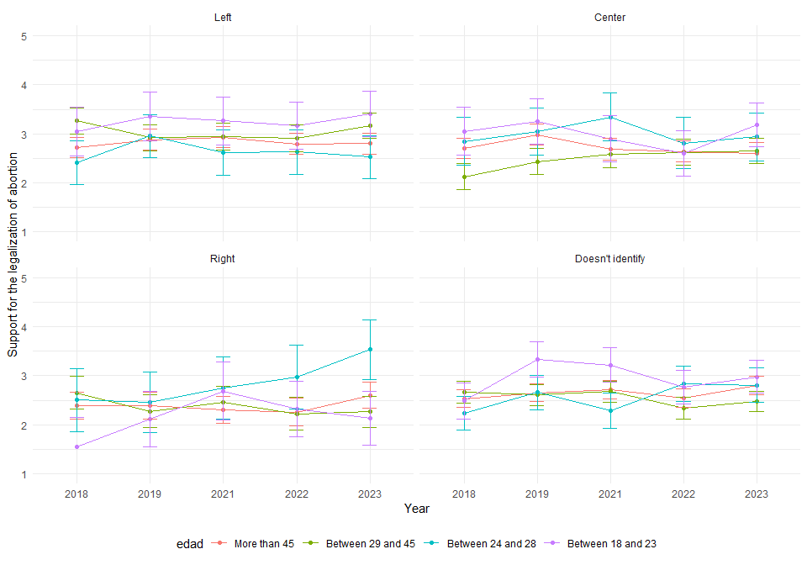

# 6. Support to student’s social movement

## 6.1 Main effects

|  |  |  |  |  |  |
| --- | --- | --- | --- | --- | --- |
|  | **Model 1** | **Model 2** | **Model 3** | **Model 4** | **Model 5** |
| Intercept | -2.26*** | -2.47*** | -2.74*** | 0.16*** | 0.18*** |
|  | (0.12) | (0.15) | (0.18) | (0.01) | (0.02) |
| Wave (Ref.= 2016) |  |  |  |  |  |
| 2017 | 0.13 | 0.14 | 0.17 | 0.02 | 0.02 |
|  | (0.11) | (0.11) | (0.11) | (0.01) | (0.01) |
| 2018 | -0.98*** | -0.98*** | -0.94*** | -0.10*** | -0.10*** |
|  | (0.12) | (0.12) | (0.12) | (0.01) | (0.01) |
| 2019 | -0.79*** | -0.79*** | -0.77*** | -0.08*** | -0.08*** |
|  | (0.12) | (0.12) | (0.12) | (0.01) | (0.01) |
| 2021 | -0.61*** | -0.62*** | -0.58*** | -0.06*** | -0.06*** |
|  | (0.12) | (0.12) | (0.12) | (0.01) | (0.01) |
| 2022 | -1.33*** | -1.34*** | -1.29*** | -0.12*** | -0.12*** |
|  | (0.14) | (0.14) | (0.14) | (0.01) | (0.01) |
| 2023 | -1.50*** | -1.52*** | -1.49*** | -0.13*** | -0.13*** |
|  | (0.13) | (0.13) | (0.13) | (0.01) | (0.01) |
| Age (Ref.= More than 45) |  |  |  |  |  |
| Between 29 and 45 |  | 0.29 | 0.40* | 0.04** | 0.04** |
|  |  | (0.18) | (0.18) | (0.01) | (0.01) |
| Between 24 and 28 |  | 0.50 | 0.60* | 0.05* | 0.05* |
|  |  | (0.27) | (0.27) | (0.02) | (0.02) |
| Between 18 and 23 |  | 0.94*** | 1.03*** | 0.11*** | 0.11*** |
|  |  | (0.27) | (0.27) | (0.02) | (0.02) |
| Woman (Ref.= Man) |  |  | 0.32* | 0.02 | 0.02 |
|  |  |  | (0.16) | (0.01) | (0.01) |
| Education (Ref.= Secondary) |  |  |  |  |  |
| Technical |  |  |  | -0.03 | -0.03 |
|  |  |  |  | (0.02) | (0.02) |
| University or more |  |  |  | -0.01 | -0.01 |
|  |  |  |  | (0.02) | (0.02) |
| Political position (Ref.= Left) |  |  |  |  |  |
| Center |  |  |  |  | -0.01 |
|  |  |  |  |  | (0.02) |
| Right |  |  |  |  | -0.03 |
|  |  |  |  |  | (0.02) |
| Doesn’t identify |  |  |  |  | -0.02 |
|  |  |  |  |  | (0.02) |
| BIC | 6654.60 | 6667.45 | 6672.58 | 23430.23 | 23474.79 |
| Numb. obs. | 10897 | 10897 | 10897 | 10897 | 10897 |
| Num. groups: individuals | 1705 | 1705 | 1705 | 1705 | 1705 |
| Var: individuals (Intercept) | 2.81 | 2.77 | 2.73 | 0.02 | 0.02 |
| Var: Residual |  |  |  | 0.09 | 0.09 |
| Note: Cells contain regression coefficients with standard errors in parentheses. ***p < 0.001; **p < 0.01; *p < 0.05. | | | | | |

## 6.2 Interaction effects

|  |  |  |  |  |  |  |  |
| --- | --- | --- | --- | --- | --- | --- | --- |
|  | | | **Education** | | **Political position** | | |
| **Year** | **Age** | **Woman** | **Technical** | **University** | **Center** | **Right** | **Doesn’t Identify** |
| **2017** | 29–45 | 0.06 | 0.2** | 0 | 0.13* | 0.16* | 0.15* |
| 24–28 | -0.06 | 0.22* | 0.25** | 0.05 | -0.09 | 0.23** |
| 18–23 | 0.14 | -0.11 | -0.3*** | 0.24* | 0.32** | 0.3** |
| **2018** | 29–45 | 0.09 | 0.14* | 0.01 | 0.1 | 0 | 0.1 |
| 24–28 | 0.01 | 0.06 | 0.05 | 0.13 | -0.26* | 0.01 |
| 18–23 | 0.04 | -0.15 | -0.22** | -0.19 | -0.01 | -0.14 |
| **2019** | 29–45 | -0.08 | 0.08 | -0.02 | 0.14* | -0.13 | -0.11 |
| 24–28 | -0.04 | 0.2* | 0.16 | 0.22* | -0.03 | 0.15 |
| 18–23 | 0.06 | -0.05 | -0.3*** | -0.06 | 0.24* | 0.08 |
| **2021** | 29–45 | 0.04 | -0.03 | -0.01 | 0.34*** | 0.14 | 0.04 |
| 24–28 | -0.01 | -0.01 | -0.04 | 0.45*** | -0.05 | 0.15 |
| 18–23 | 0.08 | 0.02 | -0.11 | 0.17 | 0.58*** | 0.28** |
| **2022** | 29–45 | -0.03 | 0.09 | -0.01 | 0.3*** | -0.01 | 0.09 |
| 24–28 | 0.02 | 0.2 | 0.12 | 0.36*** | 0.08 | 0.19* |
| 18–23 | 0.16* | 0.12 | -0.33*** | -0.16 | 0.1 | -0.01 |
| **2023** | 29–45 | 0.02 | 0.16* | -0.01 | 0.11 | 0.05 | 0 |
| 24–28 | 0.09 | 0.07 | -0.04 | 0.29** | 0.09 | 0.28*** |
| 18–23 | -0.15* | -0.23** | -0.15 | 0.36*** | 0.19 | 0.11 |
| *Note: ***p < 0.001; **p < 0.01; *p < 0.05.* The cells contain the effects of three-way interactions. For example, the first effect (0.03) is the coefficient for the year 2017, for the age group 29-45 and being female, an effect that is not statistically significant. The full models are available at: | | | | | | | |

## 6.3 Interaction effects graphs

* Support to student’s social movement and age

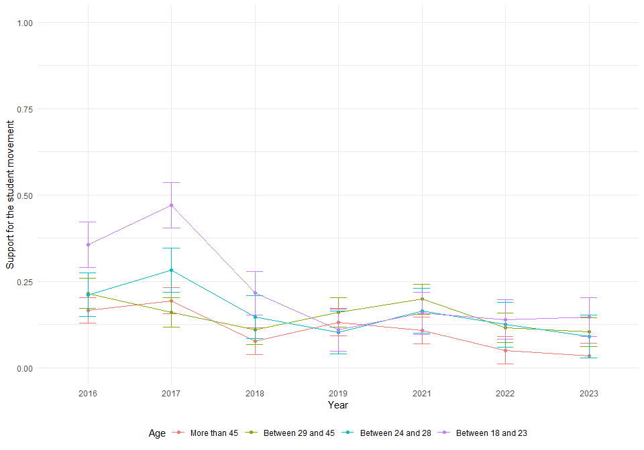

* Support to student’s social movement and sex

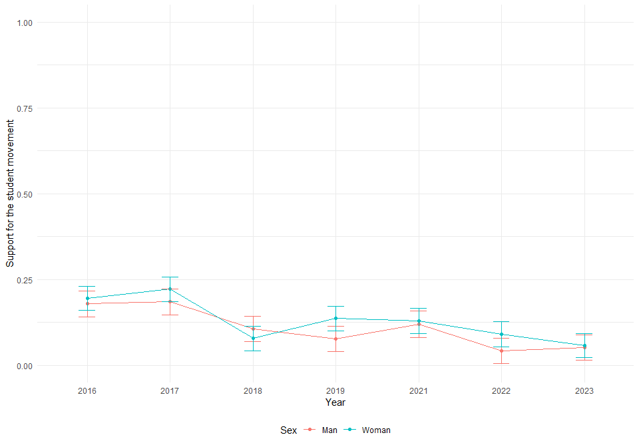

* Support to student’s social movement, age and sex

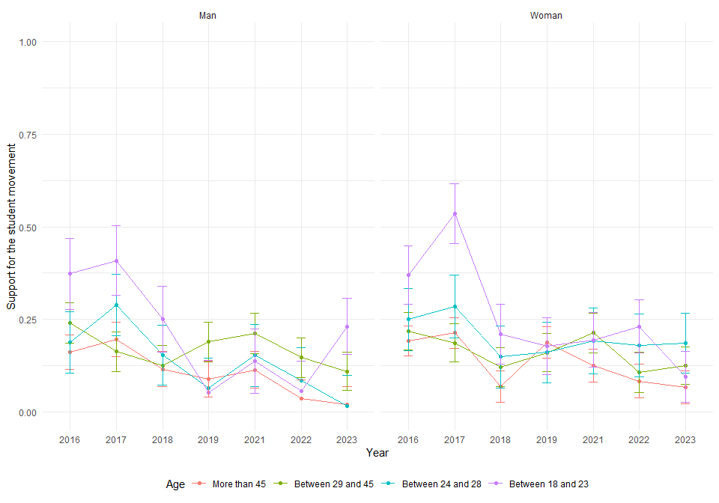

* Support to student’s social movement and education

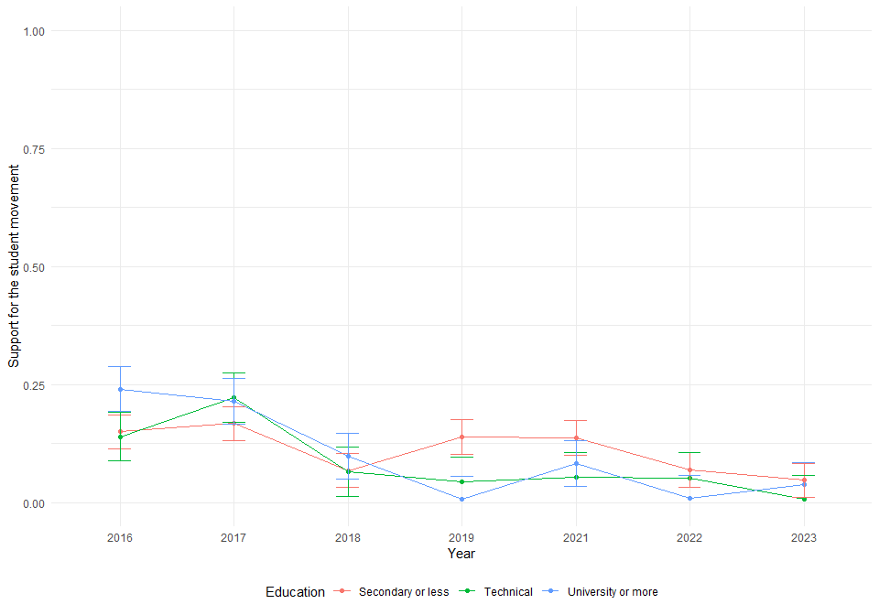

* Support to student’s social movement, age and education

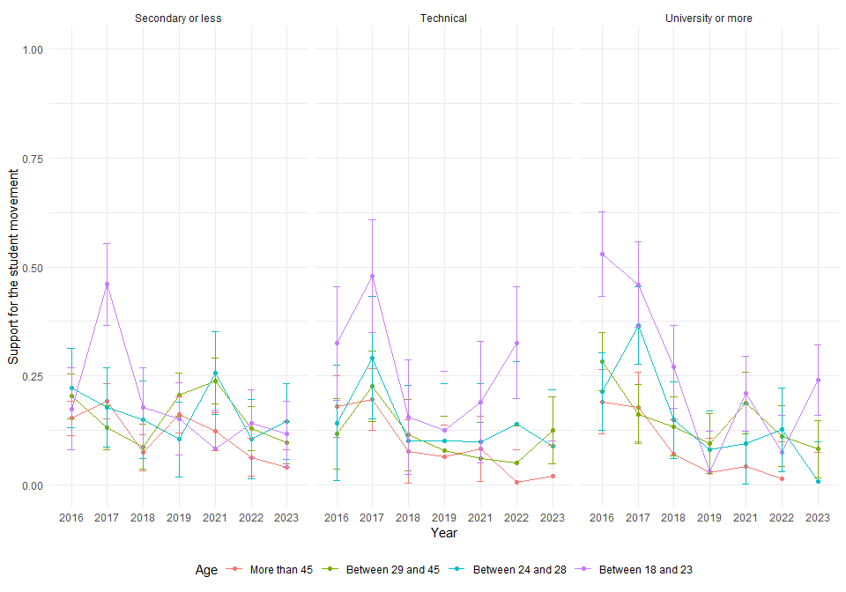

* Support to student’s social movement and political position

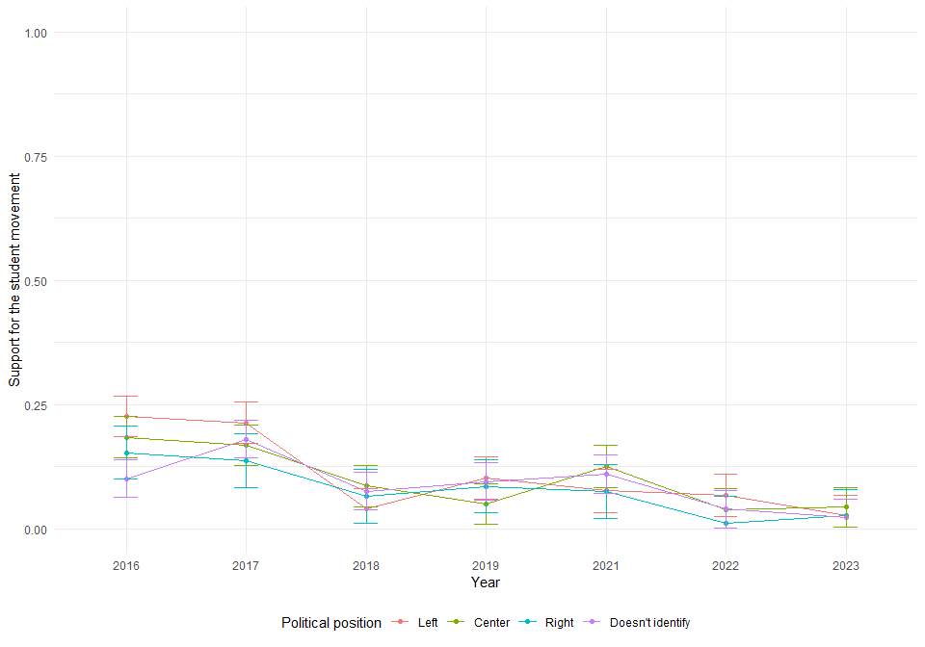

* Support to student’s social movement, age and political position

