
BRAND, CONTENT & DEVELOPER HANDOFF
Global Public Health Lens
Website Starter Pack
Complete first-version direction, brand assets, website copy, starter educational content, app concept, safety language, and build checklist.
READY FOR HANDOFF All non-personal foundational material is included. The remaining owner inputs are clearly marked in the final checklist.
Prepared August 2026 • Version 1.0

1. How to Use This Pack
This document supplies the non-personal material needed to begin designing and building the first version of the Global Public Health Lens website. It can be given directly to a web designer or developer as the content and brand reference.
PROJECT DECISION Build Global Public Health Lens as the expandable parent platform. Launch Global Nutrition and Micronutrient Health as its first featured initiative. Do not position the site as a supplement shop.

What is already decided
- Organization name: Global Public Health Lens
- Primary tagline: Understanding health through a global lens.
- First initiative: Global Nutrition and Micronutrient Health
- Working app name: GPH Lens: Nutrition
- Primary language: English-first, with a layout that can support Korean later
- Positioning: Educational global-public-health platform, not a commercial supplement website
- Launch navigation: Home; Global Micronutrient Guide; Nutrition App; Global Solutions & Action; About & Contact

What still needs owner input
- Organization email address
- Founder or team names and optional photographs
- Social-media or profile links
- Final domain name
- Country or jurisdiction for final privacy and legal review
- App Store and Google Play links when the app exists

2. Brand Foundation

Positioning statement
POSITIONING Global Public Health Lens makes global health understandable by connecting everyday health topics with the systems, places, policies, and inequalities that shape them.

Mission
To help students and the public understand how nutrition, access, environment, policy, and inequality influence health across communities and countries—and to make reliable public-health information easier to explore and act on.

Vision
A generation of globally minded learners who can look beyond individual choices, recognize the conditions that shape health, and participate responsibly in creating healthier and more equitable communities.

Brand promise
Every topic will connect three levels: what happens in the body, what happens in communities, and what public-health systems can do.

Core values
- Evidence: Use reliable sources and show them clearly.
- Equity: Explain how resources, opportunity, and social conditions influence health.
- Clarity: Translate complex information without oversimplifying it.
- Respect: Describe communities with dignity and avoid stereotypes or deficit-based imagery.
- Responsibility: Separate education from diagnosis, treatment, and advertising.
- Curiosity: Encourage questions and continued learning.

Voice and tone
Use | Avoid
Clear, calm, inclusive language | Fear-based or alarmist language
‘May,’ ‘can,’ and ‘is associated with’ when evidence requires caution | Guaranteed outcomes or cure claims
Population context and structural causes | Blaming individuals or communities
Food-first and evidence-based framing | Presenting supplements as shortcuts
Specific sources and review dates | Unsourced health claims

3. Visual Identity


Logo concept
The logo combines a magnifying lens with a globe. The lens represents examination, evidence, and perspective; the globe represents international health; and the small gold focus point suggests attention and discovery. The main organization mark intentionally avoids a vitamin pill or leaf so it can support future public-health topics beyond nutrition.

Logo usage
- Use the horizontal logo in website headers, formal documents, and partner materials.
- Use the mark-only version for social profiles, small spaces, and presentation covers.
- Use the favicon for browser tabs and small digital icons.
- Use the reverse logo on deep navy or other dark backgrounds.
- Keep clear space around the mark equal to at least one-quarter of the globe diameter.
- Do not stretch, rotate, recolor, outline, or add effects to the logo.

Color palette
Color | Hex | Primary use | Accessibility guidance
Deep Navy | #12314B | Headings, navigation, buttons | Use with white for primary buttons and dark text roles
Public Health Teal | #159A91 | Accents, links, charts | Use carefully for small text; darken if needed for contrast
Nutrition Green | #75B85A | Food and nutrition accents | Do not rely on color alone to communicate status
Warm Gold | #F2B84B | Highlights and calls to action | Pair with dark navy text rather than white
Cloud | #F5F8F7 | Page backgrounds | Use with dark navy or ink text
Ink | #17252E | Body text | Primary long-form reading color

Typography
- English interface: Inter, with Arial or another clean sans-serif fallback
- Korean interface: Noto Sans KR, with a system sans-serif fallback
- Headings: Bold, direct, and compact
- Body text: Comfortable line spacing, short paragraphs, and strong contrast

Image direction
- Show people as active community members, professionals, students, caregivers, and decision-makers—not passive recipients of help.
- Use globally diverse food imagery and avoid implying that one culture’s diet is the universal standard.
- Balance individual food photography with community, policy, environment, and public-health imagery.
- Avoid pill bottles as the dominant visual language.
- Use diagrams and illustrations to explain systems when photography would be too literal.
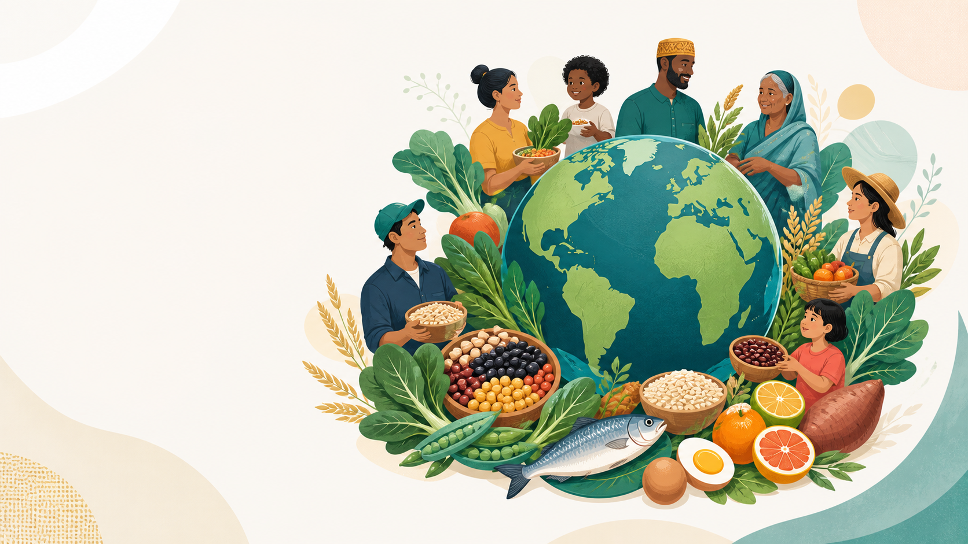
Suggested hero alt text: “Illustration of people from different generations gathered around a globe with vegetables, grains, legumes, citrus, eggs and fish.”

4. Website Architecture
Main page | Purpose
Home | Introduce the organization, its global-health lens, and the first nutrition initiative.
Global Micronutrient Guide | Explain nutrient functions, food sources, risks, inequities, and public-health context.
Nutrition App | Present the separate future app using concept screens and a coming-soon call to action.
Global Solutions & Action | Explain population-level responses and responsible ways to learn or participate.
About & Contact | Describe the club, invite collaboration, and collect non-emergency questions.

Recommended user journey
- Understand why micronutrients are a global-public-health issue.
- Learn what individual nutrients do and where they come from.
- See how food access, life stage, geography, and policy influence risk.
- Explore public-health solutions rather than defaulting to product purchasing.
- Discover the future educational app or contact the organization.
DEVELOPMENT PRINCIPLE Create reusable content types for nutrients, case studies, sources, and future projects. Do not hard-code every article as a unique page.

5. Finished Home-Page Copy

Navigation labels
Home • Micronutrient Guide • Nutrition App • Solutions & Action • About & Contact

Hero
HEADLINE Understanding health through a global lens.
Explore how nutrition, food access, geography, and inequality shape the health of communities around the world.
- Primary button: Explore the Micronutrient Guide
- Secondary button: Discover the Nutrition App

Mission section
Health is shaped by more than individual choices. Where people live, which foods are available and affordable, the services they can access, and the policies surrounding them all influence health. Global Public Health Lens turns these connections into clear, reliable learning experiences.

Featured initiative
Our first initiative explores global nutrition and micronutrient health. Learn why vitamins and minerals matter, how deficiencies affect different populations, and how public-health strategies—from dietary diversity to food fortification—can improve health at scale.

Feature cards
- Understand Micronutrients — Learn what essential vitamins and minerals do and which foods contain them.
- Explore the Global Context — See how income, geography, food systems, life stage, and policy shape nutrition.
- Discover Public-Health Solutions — Explore dietary diversity, fortification, targeted programs, and healthier food environments.
- Meet the Future App — Preview an educational tool for recording food, reviewing nutrient balance, and learning through daily feedback.

Future projects section
Nutrition is our first lens—not our last. Future projects may examine clean water and sanitation, infectious-disease prevention, maternal and child health, mental-health access, environmental health, and other issues that cross borders.

Closing call to action
CTA Start with one nutrient. See the bigger health story.

6. Global Micronutrient Guide Copy

Guide landing-page introduction
Micronutrients are vitamins and minerals that the body needs in small amounts, but their effects are essential. This guide connects the biology of each nutrient with food sources, population risk, and public-health action.
Nutrient needs differ by age, sex, pregnancy status, health conditions, medications, and other factors. The guide is educational and should not be used to diagnose deficiency or choose a supplement dose.

Suggested filter labels
- All nutrients
- Vitamins
- Minerals
- Blood and oxygen
- Bones and muscles
- Growth and development
- Immune function
- Maternal and child health

Standard nutrient-page fields
- Plain-language overview
- What it does in the body
- Food sources
- Who may be at greater risk
- Global public-health lens
- Deficiency and excess safety notes
- Public-health responses
- Sources and last-reviewed date

Vitamin A
Supports normal vision, immune function, reproduction, growth, and organ development.

Food sources
Liver, fish, eggs and dairy provide preformed vitamin A. Carrots, sweet potatoes, pumpkin, mangoes and dark-green leafy vegetables provide carotenoids that the body can convert to vitamin A.

Global public-health lens
Vitamin A deficiency is a significant child-health issue in some low-resource settings. It can contribute to preventable vision loss and increase vulnerability to severe infections. Public-health responses can include breastfeeding support, diverse diets, fortified foods and carefully targeted supplementation in places where deficiency is a recognized public-health problem.
SAFETY High-dose preformed vitamin A can be harmful, particularly during pregnancy. Supplements should not be used to self-treat suspected deficiency without appropriate guidance.
Starter source: NIH Office of Dietary Supplements

Vitamin D
Helps the body absorb calcium and supports bones, muscles, nerves, and immune function.

Food sources
Fatty fish, egg yolks and some mushrooms contain vitamin D. Many people also obtain it from fortified milk, plant-based beverages, cereals or other locally fortified foods. The body can make vitamin D after skin exposure to sunlight.

Global public-health lens
Vitamin D status is influenced by more than food. Sun exposure, latitude, season, skin pigmentation, age, cultural clothing practices, air pollution and fortification policies can all matter. This makes vitamin D a useful example of how biology and environment interact.
SAFETY Excess vitamin D from supplements can cause harmful calcium buildup. Sun exposure advice also needs to account for skin-cancer prevention and local conditions.
Starter source: NIH Office of Dietary Supplements

Vitamin B12
Helps maintain healthy blood and nerve cells and is needed to make DNA.

Food sources
Vitamin B12 occurs naturally in animal-source foods such as fish, meat, poultry, eggs and dairy. Fortified breakfast cereals, nutritional yeast and other fortified products can provide B12 for people who eat little or no animal food.

Global public-health lens
Risk can be shaped by both diet and absorption. People following vegan diets, older adults, people with certain digestive conditions, and infants born to or breastfed by mothers with low B12 status may require special attention. Access to animal-source or fortified foods varies widely.
SAFETY Symptoms can take time to appear, and untreated deficiency can affect the nervous system. Testing and professional guidance are important when deficiency is suspected.
Starter source: NIH Office of Dietary Supplements

Folate
A B vitamin needed for DNA production and cell division, with particular importance before and during pregnancy.

Food sources
Leafy vegetables, beans, peas, oranges and other foods naturally contain folate. Folic acid is the form commonly used in fortified grain products and supplements.

Global public-health lens
Folic-acid fortification of staple foods is a population-level strategy used to help reduce neural-tube defects. Effective programs require appropriate standards, food-industry participation, quality control, monitoring and access to fortified staples.
SAFETY High intakes of folic acid can conceal signs of vitamin B12 deficiency. Pregnancy-related recommendations should follow local clinical and public-health guidance.
Starter source: NIH Office of Dietary Supplements

Iron
Is needed to make hemoglobin and myoglobin, which carry oxygen in blood and muscle.

Food sources
Meat, seafood and poultry contain readily absorbed iron. Beans, lentils, tofu, dark-green vegetables and fortified cereals also contribute. Eating vitamin C-rich foods with plant sources can improve absorption.

Global public-health lens
Anaemia affects many populations, especially young children, adolescent girls and women. Iron deficiency is an important cause, but anaemia can also result from infections, inflammation, inherited conditions and blood loss. Public-health programs must identify the causes rather than assume every case is the same.
SAFETY Too much iron can be dangerous, and accidental ingestion is especially hazardous for children. Iron supplements should not be used solely because someone feels tired.
Starter source: NIH Office of Dietary Supplements

Iodine
Is required to produce thyroid hormones and supports metabolism, bone development, and brain development during pregnancy and infancy.

Food sources
Iodized salt, seafood, seaweed, dairy products and eggs can provide iodine. Iodine content varies, and specialty salts are not necessarily iodized.

Global public-health lens
Universal salt iodization is one of the best-known large-scale micronutrient interventions. It uses a commonly consumed food vehicle to reach broad populations. Programs should coordinate iodization with efforts to reduce excessive sodium intake.
SAFETY Both too little and too much iodine can affect thyroid function. Kelp and seaweed supplements can contain highly variable amounts.
Starter source: NIH Office of Dietary Supplements

Zinc
Supports immune function, growth, wound healing, DNA production, and the senses of taste and smell.

Food sources
Oysters are especially rich in zinc. Meat, fish, poultry, dairy foods and fortified cereals are useful sources; beans, nuts and whole grains also contribute.

Global public-health lens
Zinc inadequacy is connected to diet quality and food access, with young children often receiving particular public-health attention. The best intervention depends on local diets, deficiency burden, infection patterns and health-system guidance.
SAFETY Long-term excessive zinc can reduce copper status and interfere with some medicines. More is not automatically better.
Starter source: NIH Office of Dietary Supplements

Magnesium
Contributes to muscle and nerve function, blood glucose and blood-pressure regulation, and the production of protein, bone and DNA.

Food sources
Legumes, nuts, seeds, whole grains and green leafy vegetables are useful sources. Dairy foods and fortified cereals can also contribute.

Global public-health lens
Magnesium illustrates the importance of overall dietary quality. Unlike some micronutrients, population deficiency is difficult to assess with a single simple measure, so the website should avoid overstating global prevalence and instead emphasize access to varied, nutrient-dense foods.
SAFETY Magnesium from food is generally not a concern for healthy people, but high supplemental amounts can cause gastrointestinal effects and interact with medicines. Kidney disease changes the safety picture.
Starter source: NIH Office of Dietary Supplements

7. Nutrition App Page Copy
WORKING NAME GPH Lens: Nutrition. The name is a working project name and should receive a final app-store and trademark check before public launch.

Hero copy
HEADLINE Turn everyday food choices into a learning experience.
GPH Lens: Nutrition is a planned educational app that will help users record foods, explore nutrient balance, and understand how daily intake connects with the larger story of global nutrition.
- Primary button before launch: Get Launch Updates
- Primary button after launch: Download on the App Store
- Secondary button: Get it on Google Play
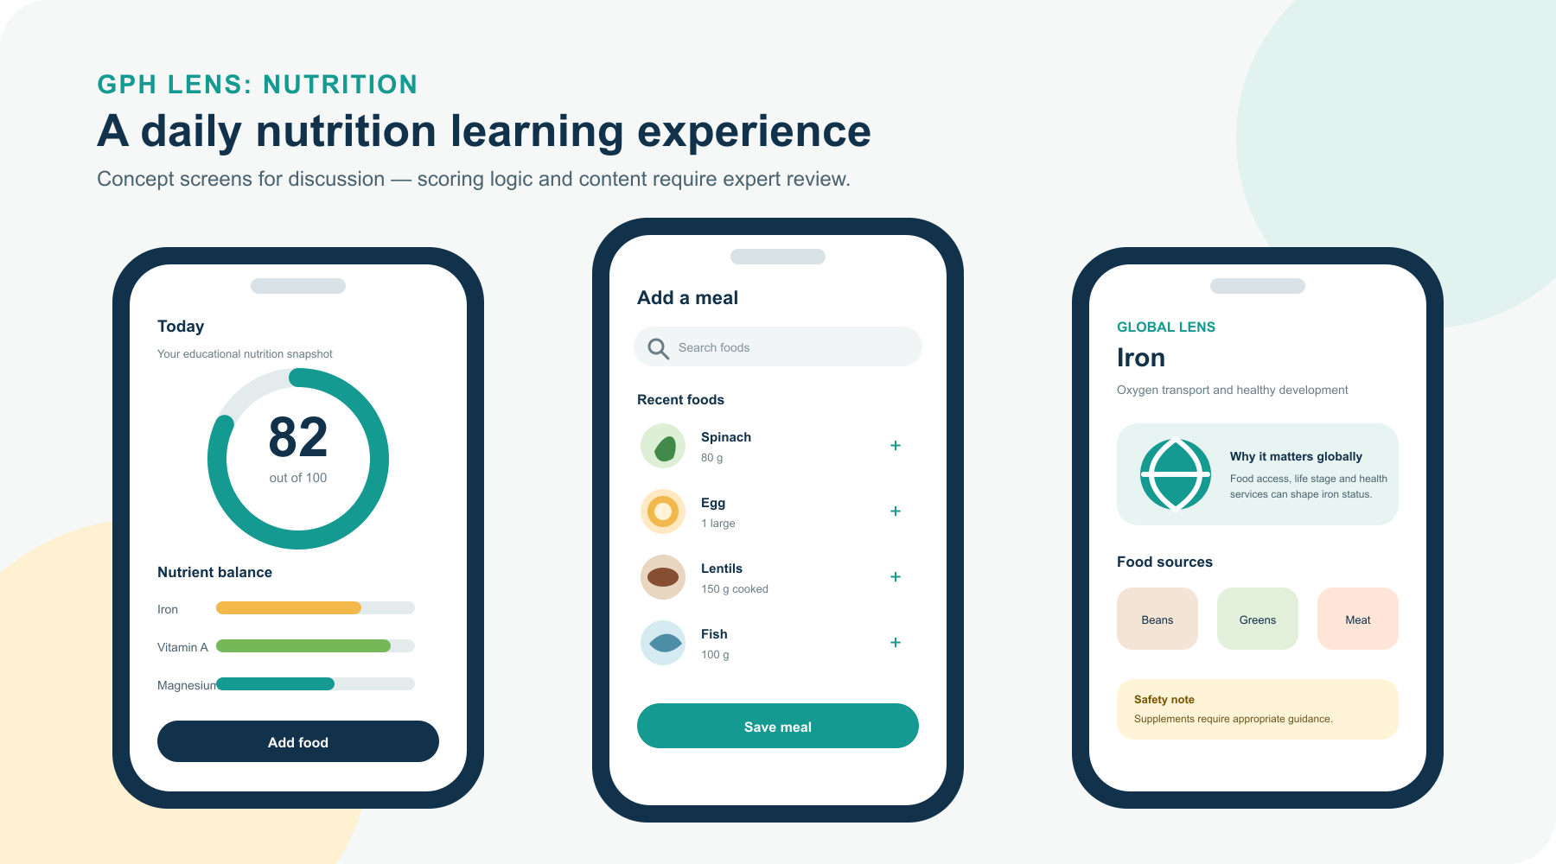

Feature cards
- Record food — Search for foods and enter grams or servings.
- Include supplements — Record supplements so food and product intake are considered together.
- See nutrient balance — Review nutrients that may be below, within, or above an educational target range.
- Learn the global context — Connect nutrients with food access, public-health programs, and population needs.
- Follow patterns — Explore daily and weekly trends without treating one day as a diagnosis.

Score explanation
The planned score will reward overall balance rather than high intake of a single nutrient. Intake below an appropriate range may reduce the score, and excessive intake may also reduce it. Food and supplements must be combined to avoid double counting.
IMPORTANT The scoring formula, nutrient targets, food database, personalization rules, and safety thresholds are not part of the first website build. They require a separate app project and expert review.

App-page disclaimer
App results will be educational estimates based on user-entered information and available food data. They will not diagnose deficiency, confirm nutritional status, or replace individualized advice from a qualified professional.

8. Global Solutions & Action Copy

Page introduction
Micronutrient problems cannot be solved by telling individuals to make better choices when nutritious foods are unaffordable, unavailable, unsafe, or culturally inappropriate. Effective public health combines individual knowledge with stronger food systems, health services, and policy.

Dietary diversity
Support access to varied, nutrient-dense foods, including fruits, vegetables, legumes, whole grains, nuts, seeds, and appropriate animal-source or fortified foods.

Food fortification
Add carefully selected vitamins or minerals to widely consumed staple foods or condiments under appropriate standards, quality control, and monitoring.

Targeted supplementation
Use supplements for defined populations and settings when evidence and public-health guidance support them, rather than treating supplementation as a universal solution.

Maternal and child nutrition
Prioritize critical periods such as pregnancy, infancy, childhood, and adolescence through nutrition services, breastfeeding support, healthy complementary feeding, and appropriate programs.

Healthier food environments
Improve affordability, labeling, school meals, public food procurement, retail access, and protections from harmful marketing.

Measurement and accountability
Assess local needs, monitor program quality and coverage, evaluate outcomes, and adjust programs when evidence changes.

Starter case studies

Universal salt iodization
Iodizing salt uses a widely consumed food vehicle to improve iodine intake across large populations. It demonstrates how policy, industry standards, quality monitoring, and household access can work together. Programs should also align with strategies to reduce excessive sodium consumption.

Fortifying staple flours and grains
Fortifying flour, maize meal, rice, or other staples can deliver nutrients such as iron and folic acid without requiring people to make major changes to established eating patterns. Success depends on choosing an appropriate food vehicle, setting safe standards, reaching small and large producers, and monitoring coverage and quality.

Vitamin A programs for young children
In settings where vitamin A deficiency is a public-health problem, targeted supplementation for children may be recommended as part of a wider strategy. It complements—not replaces—breastfeeding support, diverse diets, fortified foods, infection prevention, and accessible health services.

Take-action section
- Read and share information from reliable public-health sources.
- Compare how the same health issue is experienced in different settings.
- Join a club discussion, educational event, or research project.
- Suggest a country case study or future global-health topic.
- Support organizations responsibly after reviewing their evidence and community partnerships.

9. About & Contact Copy

About the organization
Global Public Health Lens is an educational initiative created to make global-health issues easier to understand. We examine how biology, environment, food systems, policy, and social conditions interact—and why the same health challenge can look different across countries and communities.

About the first project
Our first project focuses on global nutrition and micronutrient health. It begins with familiar questions about vitamins and food, then expands the lens to include access, inequality, public programs, and population-level solutions.

Founder or team block
OWNER INPUT Insert founder or team name, a short biography of approximately 80–120 words, and an optional photograph. Avoid publishing personal details that are not necessary.

Contact form
- Name
- Email address
- Question category
- Subject
- Message
- Required privacy-consent checkbox
- Submit button

Question categories
General question • Nutrition information • Nutrition app • Website feedback • Club participation • Collaboration • Technical issue • Other

Submission confirmation
SUCCESS MESSAGE Thank you for contacting Global Public Health Lens. Your message has been received. Please remember that we cannot provide emergency assistance, diagnosis, or personalized medical treatment through this form.

Automatic email reply
Subject: We received your Global Public Health Lens message
Thank you for getting in touch. We have received your message and will review it as soon as possible. This inbox is not monitored for medical emergencies, and our educational team cannot provide diagnosis or individualized treatment. If you have an urgent health concern, contact an appropriate local medical service.

10. Footer and Standard Interface Copy

Footer mission
Global Public Health Lens makes health easier to understand by connecting individual experiences with the global systems that shape them.

Footer links
Micronutrient Guide • Nutrition App • Solutions & Action • About • Contact • Sources • Privacy • Health Disclaimer

Footer contact placeholders
- Email: [INSERT ORGANIZATION EMAIL]
- Profile or social link: [INSERT LINK]
- Copyright: © [YEAR] Global Public Health Lens

Search empty state
No nutrients matched your search. Try a different name, body function, or category.

Error message
Something did not load correctly. Please try again. If the problem continues, contact us through the About & Contact page.

11. Safety, Privacy, and Disclosure Drafts
REVIEW REQUIRED These drafts provide a responsible starting point but are not legal advice. The final wording should be reviewed for the organization’s country, hosting setup, analytics, and data practices.

Health-information disclaimer
Global Public Health Lens provides general educational information about public health, nutrition, food, vitamins, minerals, and related topics. The website and any associated app do not provide medical advice, diagnosis, treatment, prescriptions, or emergency services. Nutrient needs and supplement safety can vary according to age, sex, pregnancy, health conditions, medications, laboratory results, and other individual factors. Do not start, stop, or change a supplement or treatment solely because of information on this website. Consult an appropriately qualified healthcare professional for personal guidance. If you may be experiencing a medical emergency, contact the emergency service available in your location.

Content-accuracy statement
We aim to use reliable sources and update material when appropriate. Public-health guidance and scientific evidence can change, and the website cannot guarantee that every page is complete or current for every location. Each educational article should display its sources and last-reviewed date.

Starter privacy notice
When a visitor submits the contact form, the site may collect the name, email address, category, subject, message, consent record, submission time, and technical information necessary to prevent spam and maintain security. This information should be used only to respond, operate the website, protect the service, and meet applicable obligations. It should not be sold. Access should be limited, retention should be defined, and visitors should be told how to request access or deletion where applicable. Insert the organization’s contact email, hosting providers, analytics tools, retention period, and jurisdiction before publication.

Affiliate disclosure
At initial launch, Global Public Health Lens does not require affiliate product links. If compensated links or sponsorships are added later, the relationship must be disclosed clearly near the relevant content, and educational conclusions must remain independent of compensation.

Emergency and contact limitation
The contact form and organization email are not monitored as emergency services. Do not use them for urgent medical concerns, crisis support, or time-sensitive treatment decisions.

12. Search and SEO Copy

Home
SEO title: Global Public Health Lens | Understanding Health Globally
Meta description: Explore how nutrition, food access, policy, geography, and inequality shape health across communities worldwide.

Micronutrient Guide
SEO title: Global Micronutrient Guide | Global Public Health Lens
Meta description: Learn what vitamins and minerals do, which foods contain them, who may be at risk, and how public health responds.

Nutrition App
SEO title: GPH Lens: Nutrition App | Concept and Updates
Meta description: Preview an educational nutrition app designed to connect daily food records with nutrient learning and global context.

Solutions & Action
SEO title: Global Nutrition Solutions | Global Public Health Lens
Meta description: Explore dietary diversity, food fortification, targeted programs, healthier food environments, and community action.

About & Contact
SEO title: About Global Public Health Lens | Contact and Collaborate
Meta description: Learn about the initiative, suggest a public-health topic, ask a question, or explore opportunities to collaborate.

Suggested social-sharing image
Use the supplied global nutrition hero illustration with the organization logo added separately in HTML or the social-image design file. Do not place important text inside the illustration itself.

13. Developer Build Requirements

Required first-version features
- Responsive layouts for mobile, tablet, and desktop
- Content management for nutrients, sources, case studies, pages, and future projects
- Basic nutrient search and category filters
- Contact form delivered to [INSERT ORGANIZATION EMAIL]
- Spam protection and clear submission states
- Editable app screenshots and download links
- Visible source links and last-reviewed dates
- Keyboard-accessible navigation and forms
- Alternative text for meaningful images
- Strong color contrast and visible focus indicators
- Basic page titles, descriptions, social metadata, and sitemap
- Secure hosting and administrator access owned by the organization

Reusable content types
Content type | Required fields
Nutrient | Name, summary, functions, foods, risk groups, global lens, safety, interventions, sources, review date
Food source | Food name, image, serving description, nutrient relationship, dietary labels, source
Case study | Location, issue, affected population, intervention, lessons, sources
Future project | Title, summary, status, hero image, related articles
Source | Organization, page title, URL, publication or review date, access date

Not included in the first website build
- Native mobile-app development
- Nutrition-score algorithm
- User accounts or stored health profiles
- Personalized medical recommendations
- Complete food-composition database
- E-commerce, checkout, or payment processing
- Live country-data integration
- Automatic supplement recommendations

Suggested optional features to quote separately
- Interactive world map
- English–Korean localization
- Advanced filters
- Newsletter or app waiting list
- Event calendar
- Interactive quizzes
- Custom motion design

14. Asset Inventory
Filename | Purpose
gphl-logo-horizontal.svg / .png | Primary header and document logo
gphl-logo-mark.svg / .png | Square and small-format organization mark
gphl-logo-reverse.svg / .png | Logo for dark backgrounds
gphl-favicon.svg / .png | Browser favicon and small icon
gphl-app-icon.svg / .png | Working icon for GPH Lens: Nutrition
gphl-app-preview.svg / .png | Three app concept screens for the app page
gphl-website-hero.png | Original global nutrition hero illustration
Global_Public_Health_Lens_Website_Starter_Pack.docx | Primary developer and content handoff

ASSET NOTE The SVG files are the preferred source for logos and interface artwork. PNG files are included for previews and software that cannot use SVG.

15. Owner Input Checklist
Owner item | Status / placeholder
Organization email | [INSERT ORGANIZATION EMAIL]
Founder or team names | [INSERT NAME OR TEAM LIST]
Short founder/team biography | [INSERT 80–120 WORD BIO]
Profile photograph | [OPTIONAL]
Social/profile links | [INSERT LINKS]
Final domain | [INSERT DOMAIN]
Privacy jurisdiction | [INSERT COUNTRY/REGION]
Contact response expectation | [INSERT, E.G. 3–5 WORKING DAYS]
App download links | [ADD WHEN AVAILABLE]
Qualified health-content reviewer | [IDENTIFY BEFORE PUBLISHING DOSAGE/SAFETY DETAILS]

16. Source Library
These sources support the initial educational direction. The web team should preserve article-level citations and add local sources when discussing country-specific guidance.
WHO — Micronutrients: Open official source
WHO — Food fortification: Open official source
WHO — Healthy diet: Open official source
WHO — Social determinants of health equity: Open official source
UNICEF — Undernourished and Overlooked: Open official source
UNICEF Data — Child Nutrition: Open official source
NIH Office of Dietary Supplements — Fact sheet index: Open official source
USDA FoodData Central: Open official source

17. Final Handoff Note
TO THE WEB MAKER Use this pack as the content and visual starting point for the first website version. Confirm the build platform, included content-entry quantity, revision rounds, administrator ownership, hosting costs, accessibility work, maintenance terms, and any optional-feature pricing before development begins.
The goal is a credible, expandable global-public-health education platform. Nutrition is the first project, but the information architecture and visual identity should make future topics feel native to the same organization.

A successful first version will
- Make the global-health purpose clear within the first screen.
- Give visitors useful micronutrient education without presenting diagnosis or treatment.
- Explain population-level causes and solutions alongside individual nutrition information.
- Let the owner add future nutrients, case studies, and global-health projects without rebuilding the site.

