IT617 Assignment One

Mobile Application - 2023

Kevin Young, Greg (Yu Han)

Te pukenga  SIT Branch

Contents

1 Introduction 1

2a. Wireframes/Sketches 1

2b. Material Design 2

2c. Layout 2

3 Database 2

4 Implementation 3

4a. Activity a 3

4b. Activity b 3

4c. Activity c 5

4d. String Resources 7

5 Testing 9

6 Conclusion 11

7 Referencing 11

# 1 Introduction

The motivation behind making the app is for a hypothetical restaurant call Impression. The restaurant contains a multitude of foods ranging from rice to noodles with different ingredients and meats. The target audience for the app are consistent customers of impression.

While the app does not solve any explicit problems or issues, the app is meant for loyal customers who enjoy the brand and want a easier way of meals from the restaurant.

## 2a. Wireframes/Sketches

Below are the original wireframing of the application. It was made with the thought of placing orders easily.

The original wireframing differed from the actual design of the application because of the various components within android studio. Since the template layout already looked nice and was easy to use, the look and layout of the app changed.

The original main activity was the first screen customers were meant to see. From there, they could choose from a range of food, drinks, or desserts. After pressing on selected category, it would take them to the third activity.

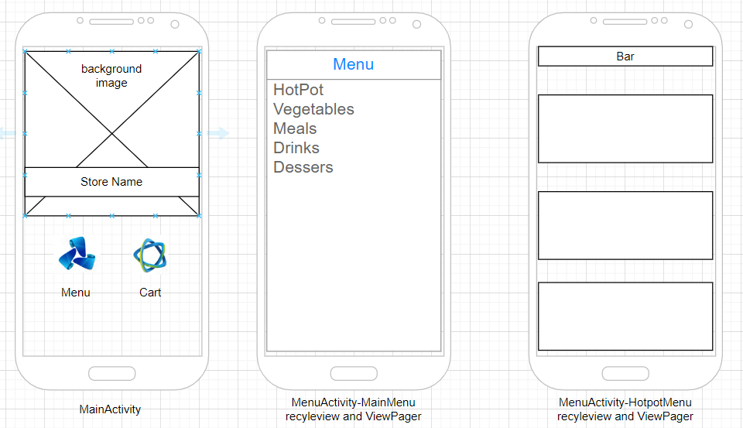

Figure Main menu and activities

## 2b. Material Design

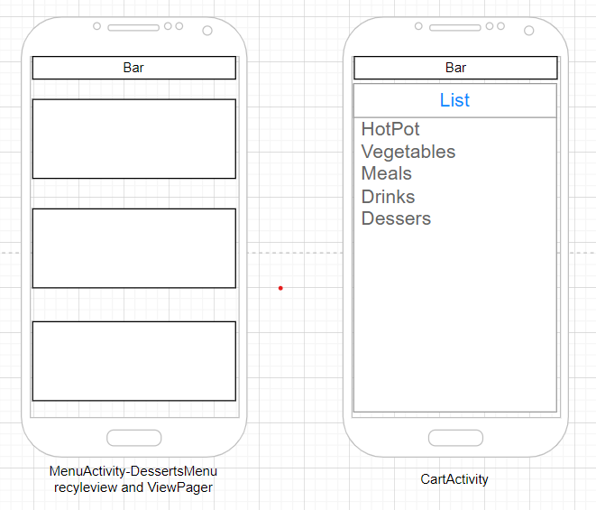

Figure Activities cont.

## 2c. Layout

Figure Activities cont.

# 3 Database

No database was implemented due to time constraints.

# 4 Implementation

## 4a. Activity a

The first screen that the user would see when the opened the app. The splash screen stays on for 1 seconds. The screen then navigates to the Main activity.

## 4b. Activity b

The main screen people could see after the splash screen. An automatic inflater is added to the activity with extensions to fragments.

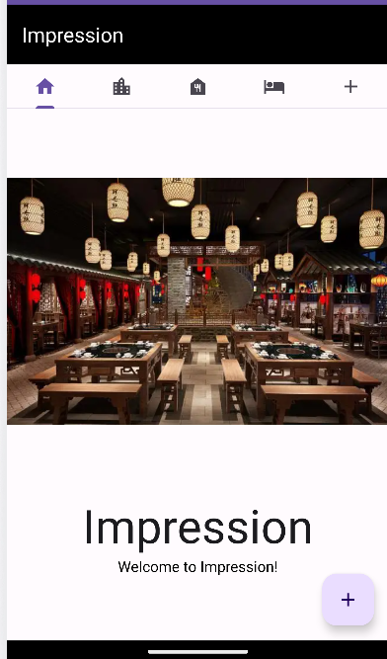

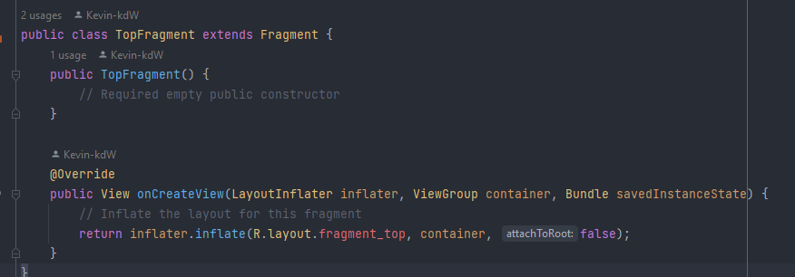

## 4c. Activity c

By following design suggestions, a recycler view was added for users to slide through featured food within the app.

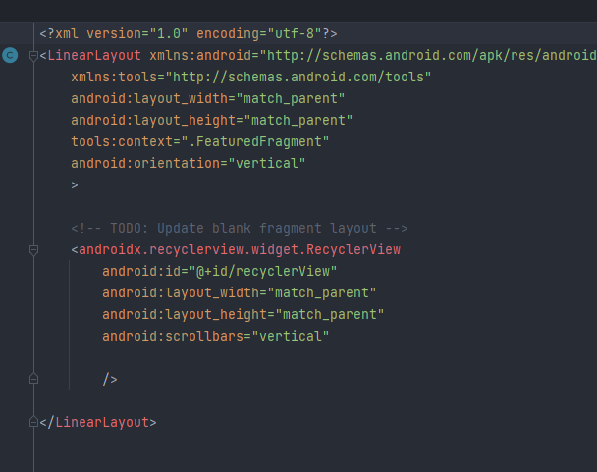

This is the main Activity. Most of the implementation was added here with sectionPageAdapters, toasts,ViewPager2, toolbars, tablyaout/tablayout mediators along with more boiler plate code.

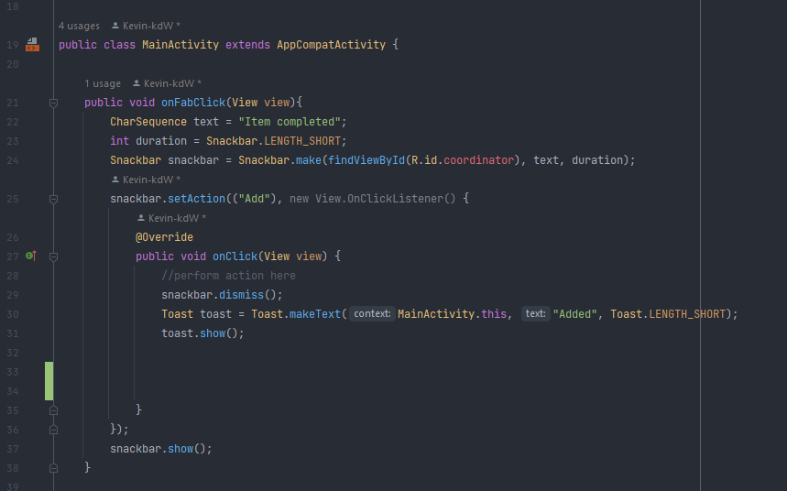

Above is the FAB button, intents, snackbar, and toast implementation

The section page adaptor orders which fragments will be show in a tab layout on the main activity.

## 

Above is the toolbar and supporting action bar. I also shows the Viewpage2, section pager adapter being initialised, and a brief view of the tablayout.

How the fragment layout is set and along wit the images of the tablayout mediator.

## 4d. String Resources

The string resources below was the main headings and item names given to the activities and items within the application. It followed a certain pattern because it was easier to keep track and navigate through.

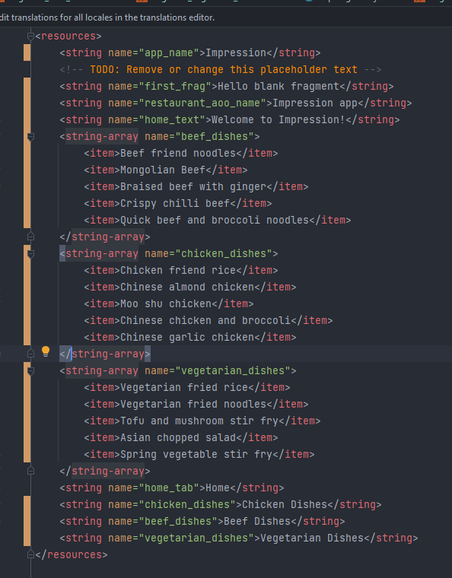

# 5 Testing

Most of the testing was done on a physical device since it gave a better perspective on how the app would look to customers. Like the image below, it is shown on a emulator and along with a tablet view for other testing purposes.  
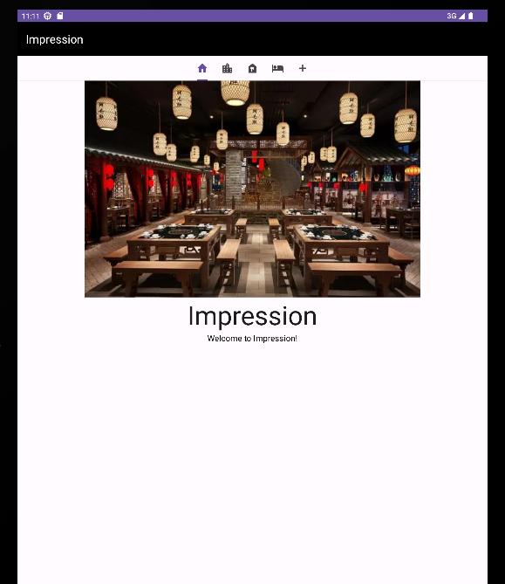

# 6 Conclusion

The app was made with the thought of customers and ease of use in mind. The application contains material views, adhered to certain design principles, has a recycler view. While the app didn’t have much functionality, it still works and looks nice.