ST10454553

IMAD5112

Table of Contents

ReadMe File: 2

Pseudocode: 3

Figure 1: Opening screen 4

Figure 3: Detailed page 5

Figure 2: Main screen and information 5

Bibliography: 6

# ReadMe File:

My name is Kevin van Aswegen, my student number is ST104553.

We were instructed to create a native android app using strictly KOTLIN within the program Android Studios. The purpose of the app was to be able to display information about the weather conditions in the surrounding area.

The app needed to be direct, but user-friendly. The design needed to be appropriate to the circumstances. The app needed to display each day of the week, with the minimum and maximum temperatures respectively.

While designing the app we need to utilize either pseudocode or flowcharts for a base and foundation on our design. While coding the project we needed to utilize GitHub to update and keep changes of our projects adjustments we make.

The following is a link to my GitHub repository.

<https://github.com/Kevin-van-Aswegen/Exam_Weather_app>

## Pseudocode:

Start

Declarations

String Exit button

String Back button

String Next button

FUN minTemps

FUN maxTemps

Print Weather Regionals

Print Kevin van Aswegen

Print ST104553

Exit button()

Closes app

nextButton()

backButton()

Returns to previous screen(Opening screen)

Switches screens to main screen

weekArray(Monday, Tuesday, Wednesday, Thursday, Friday, Saturday, Sunday)

minTemps(Random)

maxTemps(Randoms)

Stop

The opening screen has a view of earth from space, in white text (to compensate for the dark backround). From the top states the name of the app (Regional Weathers), my name (Kevin van Aswegen), and my student number (ST104553).

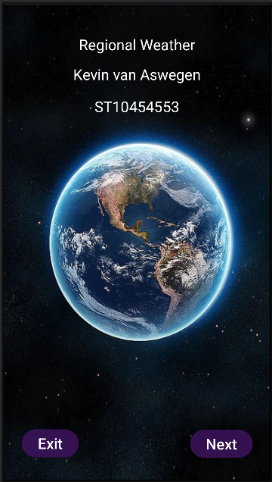

### Figure : Opening screen

There are 2 buttons available at this point, the Exit and Next buttons. The Exit button does as it reads, it force closes the app. The next Button switches the screen over to the Main screen.

On this screen is a back button to return to the previous screen. Each day of the week with their respective minimum and maximum temperatures.

As well as each day of the week is a button. Once any of the days are clicked, the screen will transition over to a detailed page, to ensure no confusion with the information, and the conditions of that day of the week.

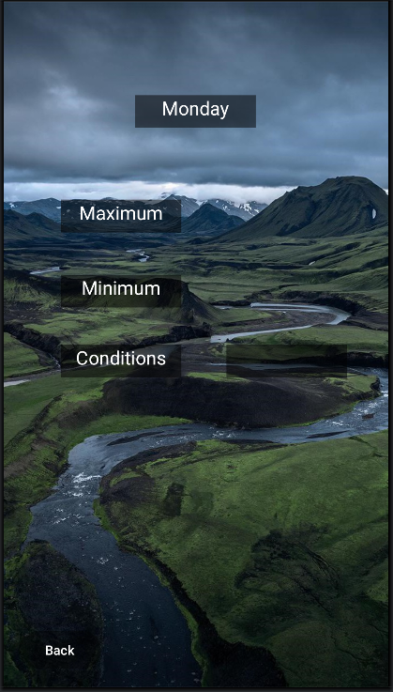

### Figure : Detailed page

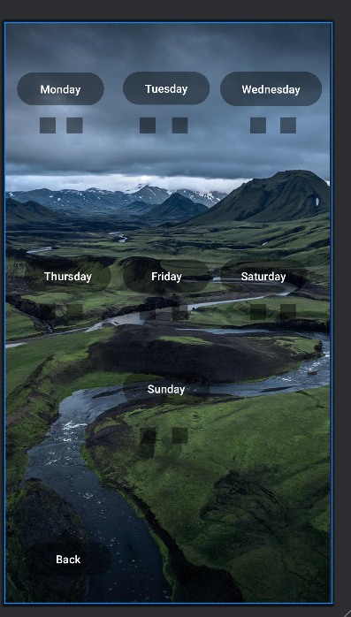

### Figure : Main screen and information

There is also a Back Button to return to the previous page is one would want to see another day in detail.

# Bibliography:

GITHub Link

<https://github.com/Kevin-van-Aswegen/Exam_Weather_app>