**Directions and steps to navigate my history app:**

Once the app is opened, you should be met by the following display.

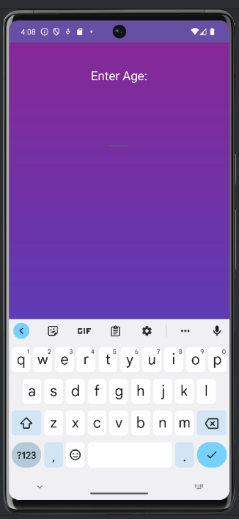Located centred, towards the top of the screen you should see the phrase “Enter Age”. Slightly below the phrase will be a short horizontal line. Once ready touch just barely above the line, and you will be able to input an age of your choice. Such as displayed below.

From this point input an age of your choice, avoid improper numbers such as fractions or decimals. Keep the number strictly a whole such as 25, 36, 53, etc.

Once you have inserted a number, located in the bottom right corner will be a button labelled “Next”. For reference, the below image utilized the number 39.

Once satisfied with your choice of number press the “Next” button.

The screen you should be displayed with should show you a popular person by their reputation in their age of death, time of death, description of how they passed and an image to show their identity. Such as displayed below.

Once read through and finished with the information, there will also be a button labelled “Return” located in the bottom left corner. If you press this button, you will return to the previous screen allowing you to insert another age of your choice.