Game Design Document

Fill up the following document

1. Write the title of your project.

Pirate Treasure Quest

1. What is the goal of the game?

Get high amounts of treasure

1. Write a brief story of your game.

The pirate wants to get a lot of treasure.

1. Which are the playing characters of this game?

* Playing characters are the ones who respond to the user based on the input from the user.
* Cars, monkeys, dinos, wizards, etc., are the playing characters in the game.

|  |  |  |
| --- | --- | --- |
| Number | Character Name | What can this character do? |
| 1 | Pirate ship | It sails across the sea |
| 2 |  |  |
| 3 |  |  |
| 4 |  |  |
| 5 |  |  |
| 6 |  |  |
| 7 |  |  |
| 8 |  |  |

1. Which are the Non-Playing Characters of this game?

* Non-Playing characters are the ones that don't have an action or behavior when the user interacts with the game.
* Hurdles, stones, bananas, coins, etc., are non-playing characters in the game.

|  |  |  |
| --- | --- | --- |
| Number | Character Name | What can this character do? |
| 1 | marines | They try to capture the pirate |
| 2 | rocks | Hitting the rocks reduces the hp of ur ship |
| 3 |  |  |
| 4 |  |  |
| 5 |  |  |
| 6 |  |  |
| 7 |  |  |
| 8 |  |  |

Draw your imagination of this game. What does this game look like?

* Draw the game either on your computer or on paper.
* Add images of the game scenes to show each of the playing and non-playing characters at least once.

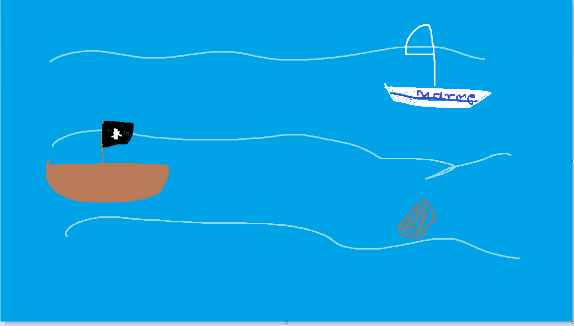

How do you plan to make your game engaging?

By increasing the speed the more the score increases