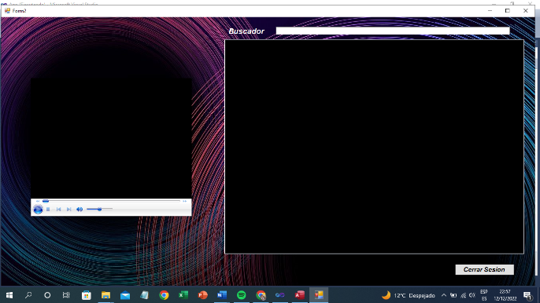**Login**

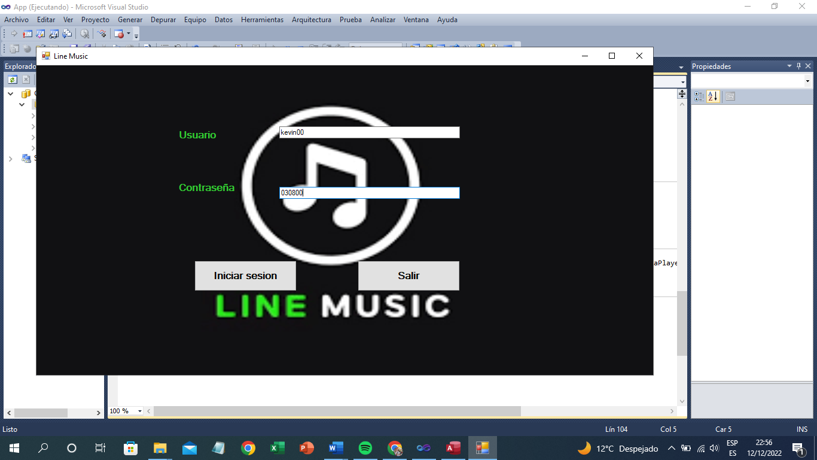

Public Class Login

Dim conexion As New OleDb.OleDbConnection

Dim Comandos As New OleDb.OleDbCommand

Dim adaptador As New OleDb.OleDbDataAdapter

Dim lector As OleDb.OleDbDataReader

Private Sub Form1_Load(ByVal sender As System.Object, ByVal e As System.EventArgs) Handles MyBase.Load

Dim consulta As String

Try

conexion.ConnectionString = ("Provider=Microsoft.Jet.OLEDB.4.0;Data Source=" & "C:\Users\dj_in\Desktop\App\App\B2.mdb")

conexion.Open()

consulta = "SELECT * FROM Administrador"

Comandos = New OleDb.OleDbCommand(consulta, conexion)

adaptador.SelectCommand = Comandos

Dim dt As DataTable = New DataTable("Administrador")

adaptador.Fill(dt)

Catch ex As Exception

MessageBox.Show(ex.Message)

MsgBox("Error al intentar Conecctarse a la base de datos", vbExclamation, "Error")

End Try

conexion.Close()

End Sub

Private Sub TextBox1_TextChanged(ByVal sender As System.Object, ByVal e As System.EventArgs) Handles TextBox1.TextChanged

End Sub

Private Sub Button1_Click(ByVal sender As System.Object, ByVal e As System.EventArgs) Handles Button1.Click

Dim consulta2 As String

conexion.Open()

consulta2 = "SELECT * FROM Administrador Where Usuario='" & TextBox1.Text & "'and Contraseña='" & TextBox2.Text & "'"

Comandos = New OleDb.OleDbCommand(consulta2, conexion)

adaptador.SelectCommand = Comandos

lector = Comandos.ExecuteReader

If lector.Read = True Then

TextBox1.Text = " "

TextBox2.Text = " "

Me.Hide()

Form2.Show()

conexion.Close()

Else

MsgBox("Usuario o contraseña Incorrectos")

conexion.Close()

End If

End Sub

Private Sub Button2_Click(ByVal sender As System.Object, ByVal e As System.EventArgs) Handles Button2.Click

End

End Sub

End Class

**Sistema**

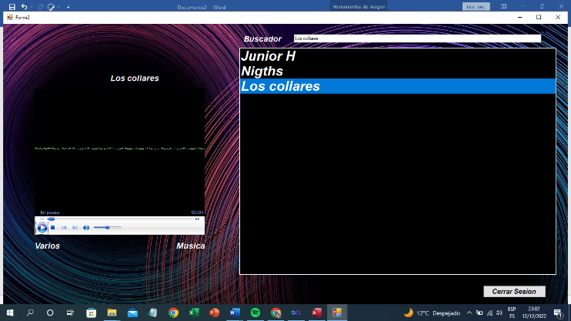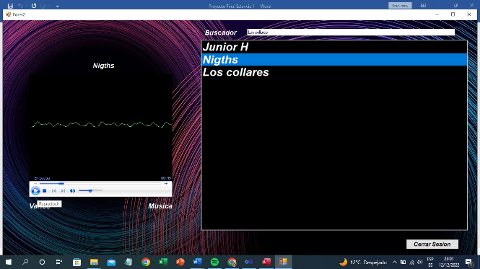

Imports System.Data

Imports System.Data.OleDb

Public Class Form2

Dim Cadena As New OleDbConnection

Dim Comando As New OleDbCommand

Public nom As String

Dim cancion As String

Public contador As Integer

Public conexion As Integer

Public contWhile As Integer

Private Sub Form2_Load(ByVal sender As System.Object, ByVal e As System.EventArgs) Handles MyBase.Load

End Sub

Private Sub TextBox1_KeyPress(ByVal sender As Object, ByVal e As System.Windows.Forms.KeyPressEventArgs) Handles TextBox1.KeyPress

If e.KeyChar.ToString = Chr(13) Then

nom = TextBox1.Text

Cadena.ConnectionString = "Provider=Microsoft.Jet.OLEDB.4.0;Data Source=C:\Users\dj_in\Desktop\App\App\B2.mdb" 'E:\App\App\B2.mdb'

Cadena.Open()

Dim Consulta As String

Dim oda As New OleDbDataAdapter

Dim Ods As DataSet

Dim registro As Byte

Cadena.Close()

buscar()

If TextBox1.Text <> "" Then

Consulta = "Select * from Musica where ID=" & contador & ""

oda = New OleDbDataAdapter(Consulta, Cadena)

Ods = New DataSet

oda.Fill(Ods, "Musica")

registro = Ods.Tables("Musica").Rows.Count

If registro <> 0 Then

ListBox1.Items.Add(Convert.ToString(Ods.Tables("Musica").Rows(0).Item("Nombre")))

Cadena.Close()

Else

MsgBox("Intente nuevamente")

Cadena.Close()

End If

End If

End If

End Sub

Public Sub buscar()

If conexion = 0 Then

Cadena.ConnectionString = "Provider=Microsoft.Jet.OLEDB.4.0;Data Source=C:\Users\dj_in\Desktop\App\App\B2.mdb"

Cadena.Open()

conexion = 2

End If

Dim Consulta As String

Dim oda As New OleDbDataAdapter

Dim Ods As DataSet

Dim registro As Byte

Dim RPG As String

contWhile = 1

contador = 0

While (contWhile = 1)

contador = contador + 1

Consulta = "Select * from Musica where ID =" & contador

oda = New OleDbDataAdapter(Consulta, Cadena)

Ods = New DataSet

oda.Fill(Ods, "Musica")

registro = Ods.Tables("Musica").Rows.Count

If registro <> 0 Then

RPG = Convert.ToString(Ods.Tables("Musica").Rows(0).Item("Nombre"))

If nom = RPG Then

contWhile = 2

Cadena.Close()

End If

If contador = 20 Then

contWhile = 2

contador = 0

Cadena.Close()

End If

End If

End While

conexion = 2

End Sub

Private Sub ListBox1_SelectedIndexChanged(ByVal sender As System.Object, ByVal e As System.EventArgs) Handles ListBox1.SelectedIndexChanged

nom = ListBox1.SelectedItem

reproductor()

End Sub

Public Sub reproductor()

Cadena.ConnectionString = "Provider=Microsoft.Jet.OLEDB.4.0;Data Source=C:\Users\dj_in\Desktop\App\App\B2.mdb"

Cadena.Open()

buscar()

Dim Consulta As String

Dim oda As New OleDbDataAdapter

Dim Ods As DataSet

Dim registro As Byte

Consulta = "Select * from Musica where ID=" & contador & ""

oda = New OleDbDataAdapter(Consulta, Cadena)

Ods = New DataSet

oda.Fill(Ods, "Musica")

registro = Ods.Tables("Musica").Rows.Count

If registro <> 0 Then

Nombre.Text = Ods.Tables("Musica").Rows(0).Item("Nombre")

Artista.Text = Ods.Tables("Musica").Rows(0).Item("Artista")

Album.Text = Ods.Tables("Musica").Rows(0).Item("Album")

cancion = Convert.ToString(Ods.Tables("Musica").Rows(0).Item("Dirreccion"))

AxWindowsMediaPlayer1.URL = cancion

End If

Cadena.Close()

End Sub

Private Sub Button1_Click(ByVal sender As System.Object, ByVal e As System.EventArgs) Handles Button1.Click

Me.Hide()

Login.Show()

ListBox1.Items.Clear()

Cadena.Close()

End Sub

Private Sub AxWindowsMediaPlayer1_Enter(ByVal sender As System.Object, ByVal e As System.EventArgs) Handles AxWindowsMediaPlayer1.Enter

End Sub

End Class