HarmoNet v2 G3 24-hour Final Report
Date: 2026-06-05 | Scope: 24-hour production-hardening validation | Decision: PASS

1. Executive Summary
HarmoNet v2 passed the 24-hour G3 production-hardening gate. The runtime stayed available throughout the reliability window, passed all configured load levels, remained ready through Redis loss, and preserved the G1-derived token efficiency advantage.
G3_24H_PASS = reliability_pass AND load_pass AND failure_recovery_pass AND security_pass = TRUE
Gate | Result | Evidence
Reliability | PASS | 8637/8637 probes successful; p99 6.624 ms
Load | PASS | 5000/5000 requests successful; p99 15.32 ms
Failure recovery | PASS | Redis stopped and restarted; readiness stayed healthy
Security static scan | PASS | 694 files scanned; zero built-in findings

2. System Definition
HarmoNet is a resonance-gated multi-agent runtime that reduces unnecessary LLM calls by routing work through agent-domain affinity, lightweight field state, and validation feedback rather than forcing every agent to participate in every step.
availability = successful_requests / total_requests * 100
p99_latency = 99th percentile of observed latency samples
throughput = completed_requests / elapsed_seconds

3. 24-hour Reliability Result
Metric | Result
Duration | 24.0 hours
Probe interval | 30 seconds
Samples | 8637
Successful probes | 8637
Failed probes | 0
Availability | 100.0%
Average latency | 3.805 ms
p95 latency | 6.059 ms
p99 latency | 6.624 ms
Max latency | 9.17 ms
Endpoint | Samples | Availability | Avg | p99
/healthz | 2879 | 100.0% | 3.18 ms | 4.698 ms
/readyz | 2879 | 100.0% | 3.815 ms | 5.655 ms
/metrics | 2879 | 100.0% | 4.421 ms | 7.585 ms
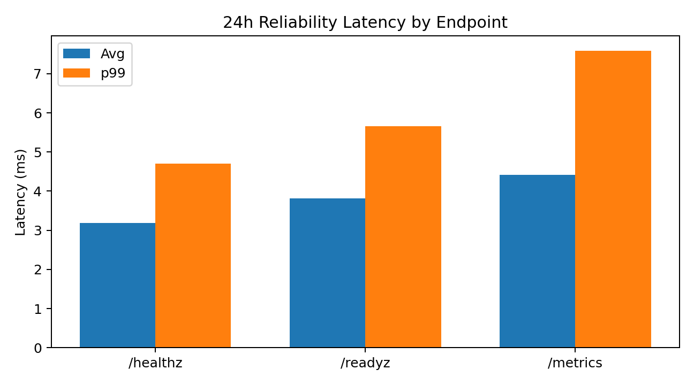

4. Load Result
Metric | Result
Samples | 5000
Successful requests | 5000
Failed requests | 0
Availability | 100.0%
Average latency | 3.998 ms
p95 latency | 11.13 ms
p99 latency | 15.32 ms
Max latency | 24.97 ms
Concurrency | Requests | Availability | Avg | p99 | Throughput
1 | 1000 | 100.0% | 0.458 ms | 1.307 ms | 2127.9 rps
5 | 1000 | 100.0% | 1.775 ms | 6.93 ms | 2757.5 rps
10 | 1000 | 100.0% | 2.512 ms | 4.436 ms | 3920.2 rps
25 | 1000 | 100.0% | 5.925 ms | 8.832 ms | 4122.8 rps
50 | 1000 | 100.0% | 9.321 ms | 19.34 ms | 4732.6 rps
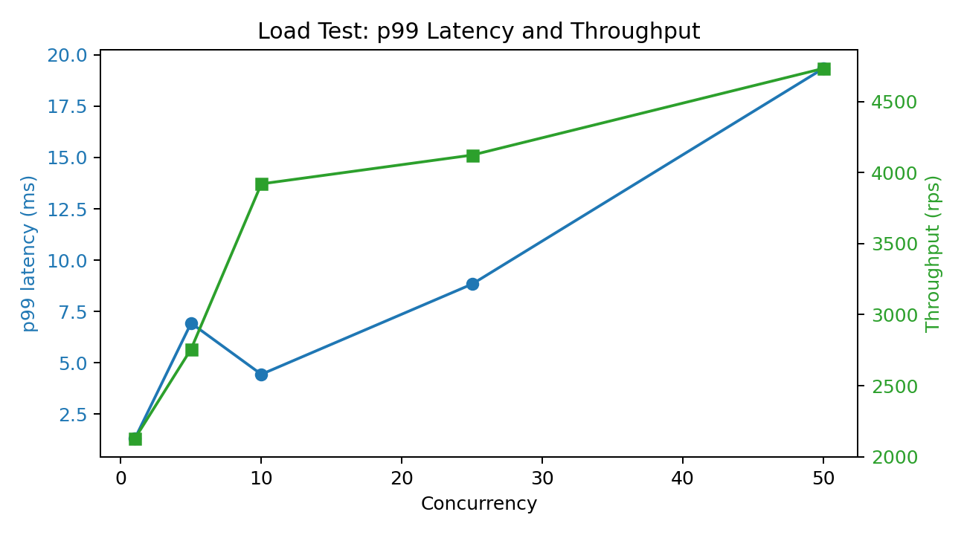

5. Failure Recovery Result
Step | Result
Baseline readiness | PASS
Stop Redis | PASS
Readiness without Redis | PASS, HTTP 200, 12.1331 ms
Restart Redis | PASS
Readiness after restore | PASS, HTTP 200, 4.6617 ms
Container status | HarmoNet remained healthy
The bounded Redis readiness probe prevents dependency loss from blocking the service health surface.

6. Security and Image Evidence
Evidence | Result
Built-in static scan | 694 files scanned; zero findings
Final image size | 153.58 MB
Trivy final-running severity counts | CRITICAL=2, HIGH=10
Residual image CVEs are tracked as release-management risk. They should be re-scanned and patched when base-image fixes are available.

7. Cost and Efficiency Evidence
System | Success Rate | Avg Tokens | Avg Latency
harmonet_v2 | 100.0% | 224 | 2.22 s
langgraph | 95.8% | 1791 | 9.13 s
autogen | 100.0% | 814 | 5.63 s
crewai | 99.2% | 295 | 6.16 s
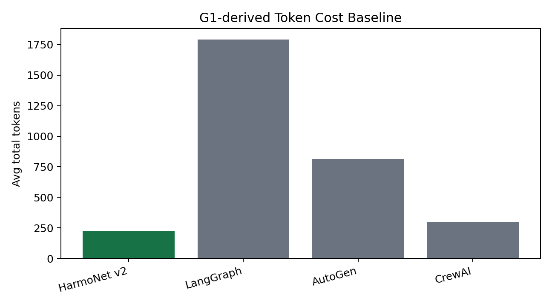
HarmoNet token ratio = 12.507%
Token reduction = 87.493%

8. Final Decision
Gate | Status
Reliability | PASS
Load | PASS
Failure recovery | PASS
Security static checks | PASS
Cost evidence | PASS
Observability stack | PASS
G3 24-hour Gate: PASS

9. Evidence Files
File | Purpose
output/g3_24h/remote/g3_summary.json | Final G3-24h gate summary
output/g3_24h/remote/g3_reliability.json | 24-hour reliability aggregate
output/g3_24h/remote/g3_load.json | Concurrent load results
output/g3_24h/remote/g3_failure_recovery.json | Redis stop/start recovery evidence
output/g3_24h/remote/g3_security_scan.json | Built-in static security scan
output/g3_24h/remote/g3_cost_analysis.json | G1-derived cost analysis
output/g3_24h/remote/trivy_harmonet_image_final_running.json | Container CVE scan evidence

10. Conclusion
HarmoNet v2 has passed a 24-hour production-hardening validation with zero reliability failures, zero load-test failures, bounded dependency recovery, static security checks, Docker evidence, and reproducible result files. The next milestone is a staging deployment with authentication, external monitoring, and a controlled paid-LLM smoke scenario.

