Spectrally Similar, Dynamically Invalid: A Single-Subject Diagnosis of Loophole Exploitation in Neural Mass Model Fitting
Author Name(s)
Affiliation, City, Country · email@domain
Abstract—Personalized neural mass models for sleep EEG are commonly fitted with spectral objectives. We show that such objectives can select solutions that are spectrally similar to a target recording yet leave the intended sleep dynamics unverified—and, when those dynamics are explicitly audited, invalid—a failure we call shape-alike, spirit-unalike (形似神不似). Using one Sleep-EDF subject (SC4001, N3) and a neurolib thalamocortical model (ALN cortical node coupled to a thalamic node), we diagnose this failure through an iterative V1–V7 fitting history. A spectral-only baseline reached high residual spectral similarity (shape_r = 0.8586) but gave no event-level guarantees; auditing that same solution against 12 event-level criteria shows it passes only 5/12, failing sustained UP states (T3), SO sharpness and regularity (T4, T6), spindle burstiness (T7), and the entire SO–spindle coupling triad (T9–T11, modulation index = 0). This makes “spectrally similar yet dynamically invalid” concrete on a single solution rather than inferred from version history. Later versions exposed further optimizer loopholes—persistent-DOWN solutions, SO–spindle decoupling, fake spindle transients, unreachable spectral spindle rewards. V7 replaced those rewards with event-level constraints, raising feasible solutions from 1/4960 (V6) to 364/4960 and yielding a point passing all 12 constraints. Because reward targets, bounds, duration, and one spindle-width threshold changed together, we report this trajectory as confounded and isolate the threshold effect: only 156/4960 V7 points survive V6’s stricter rule, so roughly half the recovery is threshold relaxation. Two held-out checks give mixed evidence: V7 is closer to real EEG on SO waveform morphology (RMSE 0.39 vs 0.57) but produces essentially zero cortical spindles, where V1 retains some. We claim neither model is correct; the result is a single-subject diagnostic existence claim and a transferable loophole-audit workflow.
Keywords—sleep EEG, neural mass model, thalamocortical model, spectral fitting, slow oscillation, sleep spindle, optimization, specification gaming

I. Introduction
Personalized neural mass models are attractive tools for building mechanistic “digital twins” of brain rhythms. In sleep modeling, the target signals are often summarized spectrally: N3 sleep is characterized by slow oscillations, delta activity, and sleep spindles, and a fitted model is commonly judged by whether its simulated power spectrum resembles the EEG target [1], [2], [3]. Spectral matching is useful because it compresses noisy electrophysiological time series into stable rhythm-level summaries. However, it can also hide mechanistic errors. Two signals may share similar spectral peaks while differing in whether they contain real UP/DOWN alternation, waxing–waning spindle events, or coordinated slow-oscillation–spindle coupling.
This paper diagnoses that failure mode in one subject: Sleep-EDF SC4001 during N3 sleep. We call the failure shape-alike, spirit-unalike (形似神不似): the simulated spectrum resembles the target, but the underlying dynamics do not implement the intended sleep physiology. The study is deliberately scoped as a single-subject diagnostic and existence claim. It does not establish a population-level fitting method, nor does it claim that the final model is globally more EEG-like on every metric. Instead, it shows that a standard spectral objective can select a dynamically invalid solution—one that fails an explicit event-level audit—and that the iterative history of failed optimizers is itself evidence of objective loopholes.
The key framing is to treat the optimizer as an adversarial loophole-searcher. Differential evolution does not know the intended physiology; it only searches for parameter settings that satisfy the objective it is given. If the objective rewards spectral similarity without event-level safeguards, or if a constraint admits a loophole, the optimizer can exploit it. Our V1–V7 development history repeatedly exposed such failures: spectral-only fitting, weak dynamics constraints, PAC-free spindle solutions, transient events masquerading as spindles, and FOOOF-based rewards that were unreachable in the SO-stable regime. V7 is the result of closing those specific loopholes with event-level constraints and redesigned rewards.
In estimation terms, this is a statement about objective misspecification and non-identifiability: a spectral summary does not uniquely determine the underlying dynamics, so an objective built on it is satisfiable by dynamically distinct solutions. Our contribution is not that observation, which is well known, but its iterative operationalization—treating differential evolution as an adversary and using each feasibility collapse to localize a specific objective loophole. The principle generalizes to any simulator fitted to summary statistics; we keep the evidence single-subject by design.
The contributions are:
1) We demonstrate, in a single SC4001 N3 case study, that high spectral similarity can coexist with dynamically invalid fitted solutions, and we make this concrete by auditing the V1 spectral-only solution against the same event-level criteria (Sec. V-A).
2) We present the V1–V7 fitting history as an empirical loophole audit of the objective—an adversarial red-teaming protocol—rather than as an implementation footnote.
3) We report both the positive event-level result and two independent held-out checks that give mixed evidence (V7 closer on SO waveform morphology, V1 closer on cortical spindle density), narrowing the claim to event-level loophole closure rather than global superiority—and we surface a residual loophole that survives inside the closed V7 audit.

II. Related Work

A. Neural mass fitting for sleep rhythms
Neural mass and mean-field models have been used to reproduce macroscopic sleep rhythms, including slow oscillations and spindle-band activity [1], [2], [4]. These models provide mechanistic structure beyond descriptive EEG statistics: parameters can represent cortical excitability, adaptation, thalamic conductances, and thalamocortical coupling. Prior work has often emphasized reproduction of rhythm-level or spectral phenomena. Our work is complementary but more diagnostic: we ask whether spectral matching is sufficient as an objective for personalization, and we show that it can select solutions that satisfy spectral appearance while failing event-level dynamics.

B. Slow oscillation–spindle physiology
N3 sleep is not defined by a spectrum alone. Slow oscillations involve alternating DOWN and UP states in cortical activity [5], [6], while spindles appear as transient waxing–waning sigma-band events associated with thalamocortical circuitry [7], [8]. Coupling between slow-oscillation phase and spindle amplitude has been studied as a marker of memory consolidation and sleep physiology [9], [10], [11]. These phenomena motivate event-level constraints: a model should not merely have power in the correct bands; it should produce plausible events with temporal structure. The event metrics used here are deliberately aligned with established detection conventions rather than invented: spindle event count and duration follow amplitude/duration criteria in the spirit of standard detectors [7], [12] and open implementations such as YASA [13], and the SO criteria follow zero-crossing/amplitude conventions [5], [6]. The thresholds attached to these metrics are empirical and subject-specific (Sec. III-D); the metric forms are not.

C. Optimizer loopholes and specification gaming
The failure studied here resembles specification gaming in machine learning: an optimizer exploits the literal objective rather than the designer’s intended goal [14], [15]. In neural model fitting, a candidate can score well by exploiting spectral artifacts, overly broad rewards, or incomplete constraints. We import that adversarial-optimizer framing into personalized sleep modeling. The claim is not that the optimizer is malicious, but that objective functions define incentives; if the incentive misses event-level physiology, the search can find shape-alike but dynamically invalid solutions. Statically, this is the familiar problem of model/objective misspecification and parameter non-identifiability. The framing earns its place by converting a static property into a procedure: each time a patched objective is re-attacked and feasibility collapses, the collapse localizes the next loophole. The reusable output is an audit workflow, not the already-accepted conclusion that constraints help.

III. Methods

A. Data and target spectrum
We used Sleep-EDF subject SC4001 and selected N3 sleep epochs. EEG epochs are aligned to the hypnogram, 30 s N3 epochs are extracted, epochs with peak-to-peak amplitude above 200 µV are rejected, and Welch PSD estimates are averaged across accepted epochs (channel EEG Fpz-Cz; 57 accepted N3 epochs enter the target PSD). The spectral fitting range is 0.5–20 Hz. The held-out SO-waveform check (Sec. III-E) uses a separate, larger pool of 142 clean N3 epochs under its own QC and is independent of this target PSD. We use “slow oscillation” (SO) for the < ~1.25 Hz band that carries the UP/DOWN alternation and “delta” for the ~1–4 Hz band; the V7 selected point reports T4_freq = 1.25 Hz, at this SO/delta boundary, and is treated as SO here.
For the spectral similarity term, the target PSD is decomposed using FOOOF/specparam-style aperiodic fitting [16]. The comparison is not raw PSD correlation: both target and simulated PSDs are converted to log-domain residual spectra after subtracting the fitted aperiodic background, and shape_r is the Pearson correlation between those residual spectra after aligning the simulated PSD to the target FOOOF frequency grid. This makes the objective more rhythm-specific than raw power matching, but the V1 result shows that even this residual spectral objective does not guarantee correct dynamics.

B. Thalamocortical model and free parameters
The simulator is a two-node thalamocortical mean-field model implemented with neurolib’s MultiModel: an ALN cortical node coupled to a thalamic node. The fitting procedure searches over eight parameters: mue, mui, b, tauA, g_LK, g_h, c_th2ctx, and c_ctx2th. These include cortical background inputs and adaptation parameters, thalamic TCR conductances, and directed thalamocortical / corticothalamic coupling strengths. Each candidate is simulated for 60 s at 1 kHz; the first 5 s are discarded as burn-in before any metric is computed. The search uses scipy.optimize.differential_evolution (strategy='best1bin', population size 20, 30 generations), and all stochastic components (Ornstein–Uhlenbeck noise and node initialization) are seeded deterministically (seed 42) so metrics are reproducible across calls with identical parameters. Each reported version corresponds to a single DE run under one seed; we therefore treat per-version feasible counts as point estimates without run-to-run variance and caution against over-reading small differences (Sec. V-B).

C. V7 fitness and feasibility
The V7 feasible-solution reward is:
fitness = 0.50 * shape_r + 0.25 * so_power + 0.25 * spindle_power
where shape_r is the FOOOF residual spectral correlation above. Unlike earlier versions, V7 computes so_power and spindle_power from event-level quantities:
so_power = clip((T4_q - 1) / 4, 0, 1)
spindle_power = clip(T12_n_verified / 15, 0, 1)
The denominators (4 and 15) are empirical reward-saturation scales, not normative targets. In particular, 15 is the spindle-event count at which spindle_power saturates to 1 over the 60 s window; it is set above realistic event counts to keep the reward discriminating among candidates, and should be read purely as an internal normalization factor—not a claim that physiological N3 contains 15 spindles per window (the held-out density measured here is ≈ 2.4–3.0 events/min, far lower; Sec. III-E).
This creates partial overlap between the reward and constraints, so we do not treat the V7 fitness score as held-out validation. Instead the paper uses the version history and feasibility audit as diagnostic evidence and separately reports held-out checks. Infeasible points are ranked by continuous constraint satisfaction rather than a single cliff penalty, preserving a search gradient: candidates that nearly satisfy the audit are distinguished from those that fail all checks, while all feasible solutions remain ranked above infeasible ones.

D. Event-level constraints
V7 uses 12 binary constraints in four physiological categories:
Cortical bistability: DOWN state, UP state, and sustained UP duration (T1–T3).
Slow-oscillation structure: SO peak sharpness/frequency and inter-burst-interval regularity (T4, T6).
Spindle reality: spindle spectral width, envelope burstiness, event count/duration, and event-internal sigma verification (T5, T7, T8, T12).
SO–spindle coordination: PAC strength, phase preference, and up/down-ratio / lag-like coupling metric (T9–T11).
The metric forms are physiologically motivated, but the thresholds are empirical and subject-specific; the paper does not claim every threshold is literature-derived. Two points guard against the reading that constraints were simply tuned until V7 passed. First, each constraint is motivated by a failure observed in an earlier version, independently of whether the final V7 point satisfies it: the UP-state tests (T1–T3) respond to persistent-DOWN solutions in V2–V3; the PAC three-pack (T9–T11) responds to SO–spindle decoupling in V5; and event-internal sigma verification (T12) responds to fake spindle transients in V6. Each motivating diagnostic precedes the V7 reward redesign and does not depend on its outcome. Second, the PAC metrics (T9–T11) use a convention-free, cycle-by-cycle estimator rather than the bandpass-plus-Hilbert phase used in early prototypes, which systematically biased the preferred SO phase for spike-like firing-rate signals; we therefore report PAC strength as a constraint but avoid preferred-phase point claims.

E. Held-out checks
To test whether event-level feasibility also improved independent statistics, we implemented two held-out checks, neither of which calls the V7 constraint function or reuses T1–T12, shape_r, so_power, or spindle_power.
SO average-cycle morphology. Real SC4001 N3 EEG and simulated cortical activity are bandpassed to the SO range, aligned to SO cycle anchors, normalized, averaged into templates, and compared by RMSE and correlation.
Cortical spindle density. Because the SO template primarily probes low-frequency cycle shape and can look unremarkable even for degenerate event dynamics, we add an event-level statistic disjoint from the audit: empirical spindle density (events/min), measured with a standard sigma-band RMS detector (band-pass to sigma, moving-RMS envelope, threshold = mean + 1.5·SD, accept events of 0.5–3.0 s). This detector is deliberately disjoint from the fitness machinery: it operates on the cortical (EEG-analog) signal, whereas T8/T12 operate on the thalamic signal; it uses a moving-RMS envelope and mean+SD threshold, whereas T8 uses a 75th-percentile Gaussian-smoothed Hilbert envelope and T12 adds Welch peak-inside verification; and it uses 0.5–3.0 s duration bounds rather than T8’s 0.3–2.0 s. We apply it identically to real EEG and to the simulated cortical firing rate of V1 and V7, over 300 s simulations and across two sigma bands (10–14 Hz, the model’s T-current resonance, and 11–15 Hz, the EEG sigma band), so the result is robust to duration and band choice. Using a held-out statistic able to favor V7—not only one favoring V1—lets the event-level result be read in either direction.

IV. Experiments

A. V1–V7 as an experimental design
The evidence lies in the V1–V7 sequence, where each version exposed a new objective loophole (Table I).
V1: spectral-only fitting. The initial Fig. 7-style baseline used FOOOF residual spectral similarity and SO/spindle spectral rewards. It reached high spectral similarity (shape_r = 0.8586) but imposed no event-level guarantees—the cleanest exhibit for the claim that spectral fit can look good without proving mechanistic validity.
V2–V3: persistent-DOWN loophole. Weak dynamics checks could be satisfied by solutions with inadequate UP-state behavior. V3 added explicit UP-state existence and sustained-UP tests, closing the persistent-DOWN loophole.
V4: constraints separated from rewards. V4 separated feasibility constraints from reward ranking and introduced SO sharpness, SO regularity, and spindle envelope burstiness checks. It produced feasible solutions, but only rarely (22/4703).
V5: PAC constraints. V5 added a three-part PAC audit to prevent SO–spindle decoupling. The best solution still had spindle_power = 0, showing PAC constraints alone did not guarantee robust spindle rewards.
V6: fake-spindle exposure. V6 fixed T8 event detection and added T12 to verify that detected events contain sigma-dominant oscillations. This made the search stricter but exposed another failure: only 1/4960 evaluations were feasible.
V7: reward and bound redesign. Diagnostics showed FOOOF spindle rewards were effectively unreachable in SO-stable regimes, 30 s simulations made T6 noisy, T5’s original FWHM threshold rejected mechanistically valid narrow spindles, and large c_th2ctx destabilized cortical SO. V7 doubled simulation duration to 60 s, replaced FOOOF SO/spindle rewards with T4/T12-derived event rewards, tightened c_th2ctx, and relaxed T5 FWHM to admit narrow T-current resonance peaks.

B. Evaluation measures
We report: (1) best score and shape_r for each version; (2) feasible rate for versions with explicit feasibility rules; (3) V7 final T1–T12 metrics; and (4) held-out SO waveform morphology distance and cortical spindle density. The held-out results are not used to select V7; they test and constrain the interpretation of V7’s event-level improvements.

V. Results

A. Spectral fit alone can look successful
The V1 spectral-only baseline achieved a high best shape_r = 0.8586, confirming the optimizer can find a solution whose FOOOF residual spectrum resembles the target EEG. V1 did not enforce UP/DOWN alternation, spindle event structure, event-internal sigma verification, or SO–spindle coupling.
To convert this from “unchecked” to “demonstrably invalid,” we evaluated the canonical V1 selected parameter vector (the shape_r = 0.8586 point) through the same event-level audit later formalized as V7’s T1–T12, using identical 60 s simulation, 5 s burn-in, and seed (42). The V1 point passes only 5/12 constraints. It retains a DOWN state (T1) and a momentary UP excursion (T2, max cortical rate 38.6 Hz), but fails: T3—longest sustained UP state 86 ms, below the 100 ms threshold, so UP/DOWN alternation is spiky rather than bistable; T4—SO spectral peak Q = 1.68 (< 2.0), no sharp slow-oscillation peak; T6—inter-burst-interval CV = 1.03 (≫ 0.4), an irregular slow rhythm; T7—spindle-envelope CV = 0.52 (< 0.7), not waxing–waning; and T9–T11—modulation index exactly 0, a complete absence of SO–spindle coupling. The corresponding cortical time series is shown in Fig. 3. This is the paper’s existence object: a single solution spectrally similar to the target (shape_r = 0.8586) yet absent two core N3 phenomena—sustained UP states and SO–spindle coupling. Re-scoring V1 under V7’s audit adds no degrees of freedom (the harness reproduces V7’s stored 12/12 exactly, confirming fidelity). Thus V1 is not merely unvalidated—under explicit audit it is invalid on named criteria—while remaining spectrally convincing. For reference, the V3 dynamics point also passes 5/12 (failing T4, T6, T7, T9–T11, T12), so the spectral-versus-event gap is not unique to V1.

B. Feasibility changed non-monotonically across versions
Table II. Version-level best score, shape_r, and feasible rate.
Version | Best score | Best shape_r | Feasible rate | Interpretation
V1 | 0.8586 | 0.8586 | N/A | Spectral objective can look good without event guarantees
V3 | 0.7722 | 0.8334 | N/A | UP-state tests close persistent-DOWN loophole
V4 | 0.4481 | 0.5449 | 22/4703 | Event feasibility introduced but rare
V5 | 0.5296 | 0.5867 | 5/4960 | PAC constraints added; spindle reward still problematic
V6 | 0.3080 | 0.6159 | 1/4960 | Fake-spindle loophole exposed
V7 | 0.7759 | 0.6226 | 364/4960 | Event-level loopholes closed much more often

The non-monotonic pattern matters: V5 and V6 did not simply improve over earlier versions; they became stricter and revealed new failures. V7 recovered feasibility only after reward targets and bounds were redesigned according to those diagnostics.
Two caveats keep this trajectory honest. First, the feasible rate is not a clean measure of loophole closure, because between V6 and V7 four things changed at once: simulation duration (30 → 60 s, reducing T6 sampling noise), the c_th2ctx bound (tightened), the SO/spindle reward definitions (FOOOF-based → reachable event-based), and the T5 spindle-width threshold (relaxed from > 2.0 Hz to > 0.2 Hz, mechanically admitting narrow T-current resonance peaks previously rejected). The last loosens a gate, so part of the recovery is threshold relaxation rather than better physiology. Re-scoring the V7 evaluation population under V6’s original T5 threshold isolates this: of V7’s 364 feasible points, only 156/4960 remain feasible under V6’s strict FWHM > 2.0 Hz rule, so 208 (57%) of the recovery is attributable to T5 relaxation alone and 156 to the duration/reward/bound redesign. The V7 selected solution itself has spindle FWHM exactly 2.0 Hz: under V6’s strict threshold it would be infeasible, confirming T5 is load-bearing rather than incidental. Second, because each version is a single seeded DE run, small absolute counts are within plausible run-to-run variation; the V5-vs-V6 difference (5 vs 1) should not be read as meaningful, and we draw conclusions only from the order-of-magnitude V6 → V7 shift after de-confounding.

C. V7 selected point passed the event-level audit
The selected V7 point passed all 12 constraints (n_passed = 12) with score = 0.7759, shape_r = 0.6226, T4_q = 4.433, T4_freq = 1.25 Hz, T6_ibi_cv = 0.197, T8_n_sp_events = 25, and T12_n_verified = 20.
This requires careful interpretation. V7’s shape_r is lower than V1’s spectral-only score, so V7 is not a better spectral fit. The comparison is also not on identical ground: V1 searched broad bidirectional coupling bounds, whereas V7 tightened c_th2ctx for SO stability, so part of the shape_r gap reflects a smaller, more physiologically constrained search space rather than a pure spectral/event trade-off. With that caveat, V7’s advantage is event-level feasibility: the final point satisfies the explicit audit for cortical bistability, SO regularity, spindle event structure, and SO–spindle coordination.

D. Held-out checks give mixed evidence
We evaluated two held-out statistics, both on the canonical V1 point (shape_r = 0.8586).
(1) SO average-cycle waveform morphology. Using 142 clean SC4001 N3 epochs from EEG Fpz-Cz, the real template comprised 3881 SO snippets. Distances to the real template are given in Table III. On this metric the canonical V1 point is the worst of the three, and V7 is closer to real EEG than V1 (RMSE 0.39 vs 0.57).
Table III. Held-out SO average-cycle waveform distances to the real SC4001 template (142 clean N3 epochs; 3881 SO snippets).
Version | RMSE | Correlation
V1 canonical (shape_r = 0.8586) | 0.5685 | 0.8390
V3 dynamics | 0.3424 | 0.9414
V7 event-constrained | 0.3909 | 0.9234

(2) Cortical spindle density. Real SC4001 N3 EEG has a cortical spindle density of 2.41/min (10–14 Hz) to 2.96/min (11–15 Hz); the canonical V1 point reaches 1.22–1.42/min—about half the real value—while V7 produces zero cortical spindles in both bands over a 300 s simulation. On this metric V1 is closer to real EEG than V7.
The two checks disagree: V7 is closer on SO morphology, V1 is closer on spindle density. Neither is decisive. The SO average-cycle metric is narrow—it normalizes amplitude and probes only low-frequency cycle shape—so V7’s edge there does not establish global fidelity; and V7’s complete absence of cortical spindles is a real deficiency the audit did not prevent (Sec. VI-F). We therefore retain only the audited-invalidity claim (Sec. V-A) and disclaim any global ranking. This is why the result settles on “invalid” (under explicit audit) rather than “wrong”: the audit demonstrates that the spectrally convincing V1 point violates named event-level criteria, but the held-out evidence does not support the stronger claim that either model is the more faithful one. V1 is not thereby validated—it passes only 5/12 audit checks and under-produces cortical spindles by about half—and V7, though it passes all 12, fails the cortical spindle check. Neither solution is correct; the spectral objective and the event audit each select a differently-deficient model.

VI. Discussion and Limitations

A. Main interpretation
The central result is not that V7 is globally superior to V1. It is that V1 demonstrates the danger of spectral fitting: a high residual spectral score can coexist with missing event-level guarantees. The V1–V7 sequence then shows how the optimizer exploited each objective or constraint loophole until a more explicit event-level audit was introduced. Under the adversarial-optimizer framing, the post-hoc nature of several constraints is not something to hide—it is evidence: each constraint was introduced because an apparently reasonable previous objective admitted an unintended solution. The result is a diagnostic methodology for discovering objective failures in personalized neural mass fitting.

B. Single-subject scope
This is a single-subject case study. It demonstrates that the failure mode exists for SC4001 N3, not that the same thresholds or final parameters generalize across subjects. A population-level analysis would require repeating the procedure across subjects and assessing whether the same loopholes and constraint responses recur.

C. Empirical thresholds
The constraints combine physiologically interpretable metrics with empirical thresholds. UP/DOWN states, spindle event duration, spindle envelope burstiness, and PAC are grounded in sleep physiology, but the exact values used here are subject- and model-specific. The manuscript should therefore be read as a diagnostic study of objective failure, not as a universal definition of N3 physiology.

D. Partial circularity
V7’s feasible-solution fitness includes a T4-derived SO reward and a T12-derived spindle reward, creating overlap between fitness and constraints. We therefore do not use the V7 score itself as held-out validation. Instead we report the overlap explicitly and include two independent held-out checks (Sec. V-D), which give mixed evidence and do not let us rank V1 against V7.

E. Mixed held-out results
The two held-out checks narrow the conclusion, and they disagree. On SO average-cycle morphology, V7 is closer to real EEG than canonical V1 (RMSE 0.39 vs 0.57); on cortical spindle density, V1 is closer because V7 produces no cortical spindles at all. Together they prevent both the claim that V7 is simply “more EEG-like” and the opposite claim that V1 is more EEG-like—the held-out evidence does not rank the two. A model can pass the event audit while still being deficient on an independent statistic (here, cortical spindle expression), and a spectrally selected model can be closer on one waveform statistic yet invalid under the audit. Neither model is correct: V1 fails 5/12 audit checks and under-produces cortical spindles, and V7, though it passes all 12, produces zero cortical spindles. The contribution is diagnostic, not a ranking.

F. Residual loophole: thalamic spindles without cortical expression
The spindle-density check exposes a residual loophole inside the “closed” V7 audit, and it is the sharpest illustration of this paper’s thesis. V7 passes T8 (25 detected spindle events) and T12 (20 sigma-verified events)—but those constraints are evaluated on the thalamic firing rate. Measured on the cortical signal, the EEG-analog quantity, V7 yields exactly zero events over 300 s in both the 10–14 Hz and 11–15 Hz bands. The mechanism is direct: V7’s selected c_th2ctx = 0.0127 is roughly eight times smaller than V1’s 0.099, because V7 tightened thalamocortical coupling toward zero for SO stability. At that coupling, thalamic spindles barely reach cortex, so the events satisfying the audit would not appear in EEG.
This is specification gaming one level deeper than the failures V7 was designed to close. The V7 audit verified spindle reality (an event must contain a genuine sigma oscillation, T12) but not spindle observability in the signal the EEG actually records. The optimizer, rewarded for thalamic spindle events, found a regime that produces them on the unobserved node while the SO-stability bound suppressed their cortical expression. The fix is straightforward to state—verify spindles on the cortical signal, or constrain c_th2ctx from below—but the loophole was invisible until an independent, signal-matched held-out check revealed it. It also reinforces that V1 is no remedy: V1’s larger coupling yields some cortical spindles (1.2–1.4/min) but still only about half the real density (2.4–3.0/min), and V1 fails 5/12 audit checks. Both models are deficient in different ways; the audit and the spectrum each hide a different failure.

G. Stage 2 SBI
Simulation-based inference is reserved for a future journal extension focused on posterior identifiability. It addresses a different question—which parameters are identifiable under selected summary statistics—and is not used here to prove V7 superiority. This paper remains focused on Stage 1 objective diagnosis and event-level loophole closure.

VII. Conclusion
This single-subject diagnostic study shows that spectral objectives can select thalamocortical model parameters that are shape-alike yet leave the intended dynamics unverified—and that, when those dynamics are explicitly audited, the spectrally convincing V1 solution is invalid on named event-level criteria (it passes only 5 of 12 checks, with no sustained UP states and zero SO–spindle coupling). Treating the optimizer as a loophole-searcher revealed a sequence of failure modes across V1–V6, including persistent-DOWN behavior, SO–spindle decoupling, fake spindle events, and unreachable spectral spindle rewards. V7 closed these event-level loopholes and increased feasible solutions from 1/4960 in V6 to 364/4960 (in part through threshold relaxation we quantify separately), yielding a final point that passed all 12 event-level constraints. At the same time, two independent held-out checks gave mixed evidence—V7 closer on SO waveform morphology, V1 closer on cortical spindle density—and a residual loophole emerged: V7 passes its thalamic spindle audit yet expresses zero spindles in the EEG-analog cortical signal at its small thalamocortical coupling. We therefore make no claim that V7 is the better model; V1 is itself invalid under the audit (5/12) and under-produces cortical spindles by roughly half. Both solutions are deficient in different ways. The contribution is not a universal fitting method, nor a ranking of V1 against V7, but a transferable diagnostic workflow: anchor a spectral objective, treat the optimizer as an adversary, and use each feasibility collapse—and each independent held-out check—to localize the next loophole, including loopholes that survive inside an apparently closed audit. We report this for one subject; whether the same loopholes recur across subjects is the natural next study.
Table I. Loophole-to-constraint map across V1–V7.
Ver. | Loophole exposed | Constraint / change introduced
V1 | Spectral fit without event guarantees | Baseline (FOOOF residual + spectral SO/spindle rewards)
V2–V3 | Persistent-DOWN solutions | UP-state existence + sustained-UP tests (T1–T3)
V4 | Rewards entangled with feasibility | Constraints separated; SO sharpness/regularity, spindle burstiness
V5 | SO–spindle decoupling | PAC three-pack (T9–T11)
V6 | Fake spindle transients | Event-internal sigma verification (T12)
V7 | Unreachable FOOOF rewards; noisy T6; over-strict T5; large c_th2ctx | 60 s sims; T4/T12 event rewards; tightened c_th2ctx; relaxed T5

Figures
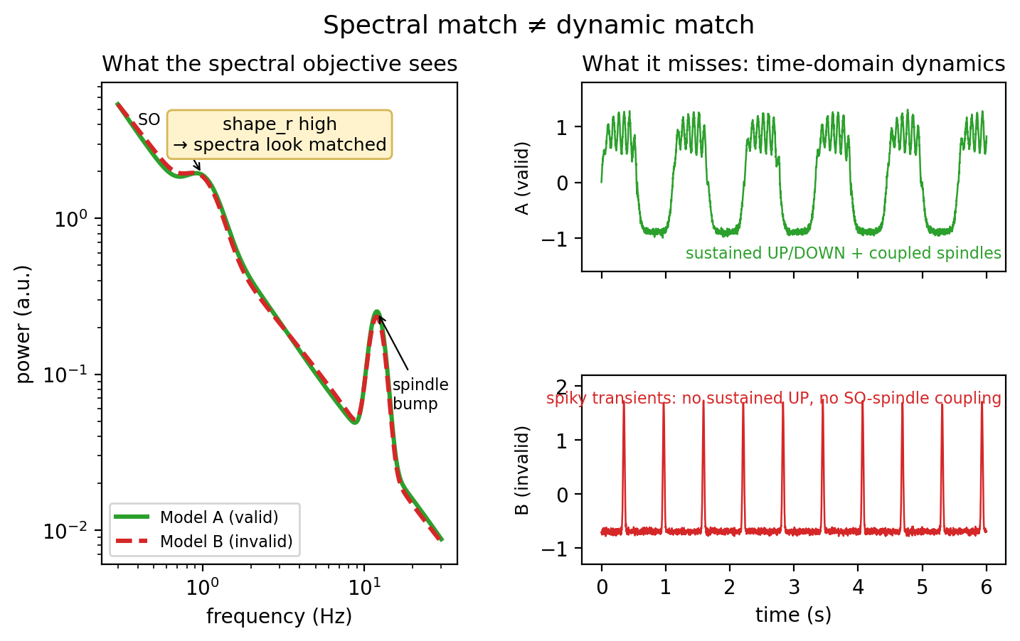
Fig. 1. Schematic of the spectral-fit loophole. Two models can share a nearly identical power spectrum (left; high shape_r) while differing sharply in time-domain dynamics (right): Model A shows sustained UP/DOWN bistability with coupled spindles, whereas Model B produces spiky transients with no sustained UP state and no SO–spindle coupling. The spectral objective cannot separate them (traces are illustrative).
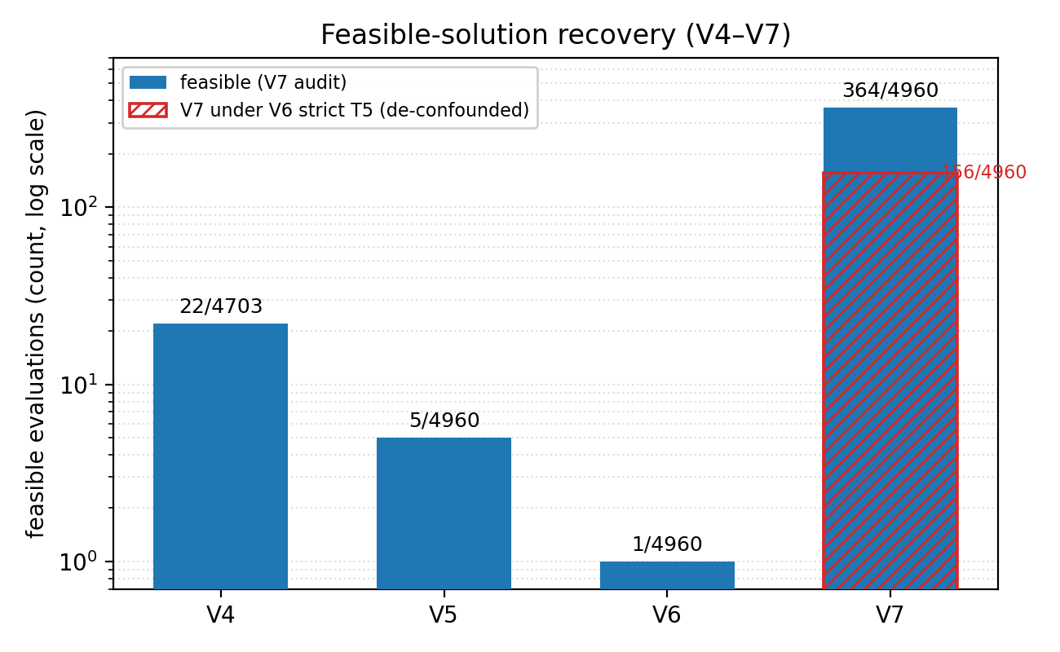
Fig. 2. Feasible-solution recovery (V4–V7), log scale. Feasible counts fall from 22/4703 (V4) to 1/4960 (V6) as constraints tighten, then jump to 364/4960 (V7) after the reward/bound redesign. The hatched overlay marks the 156/4960 V7 points that remain feasible under V6’s strict FWHM > 2.0 Hz rule—i.e. about half the recovery is T5 relaxation rather than loophole closure (Sec. V-B).
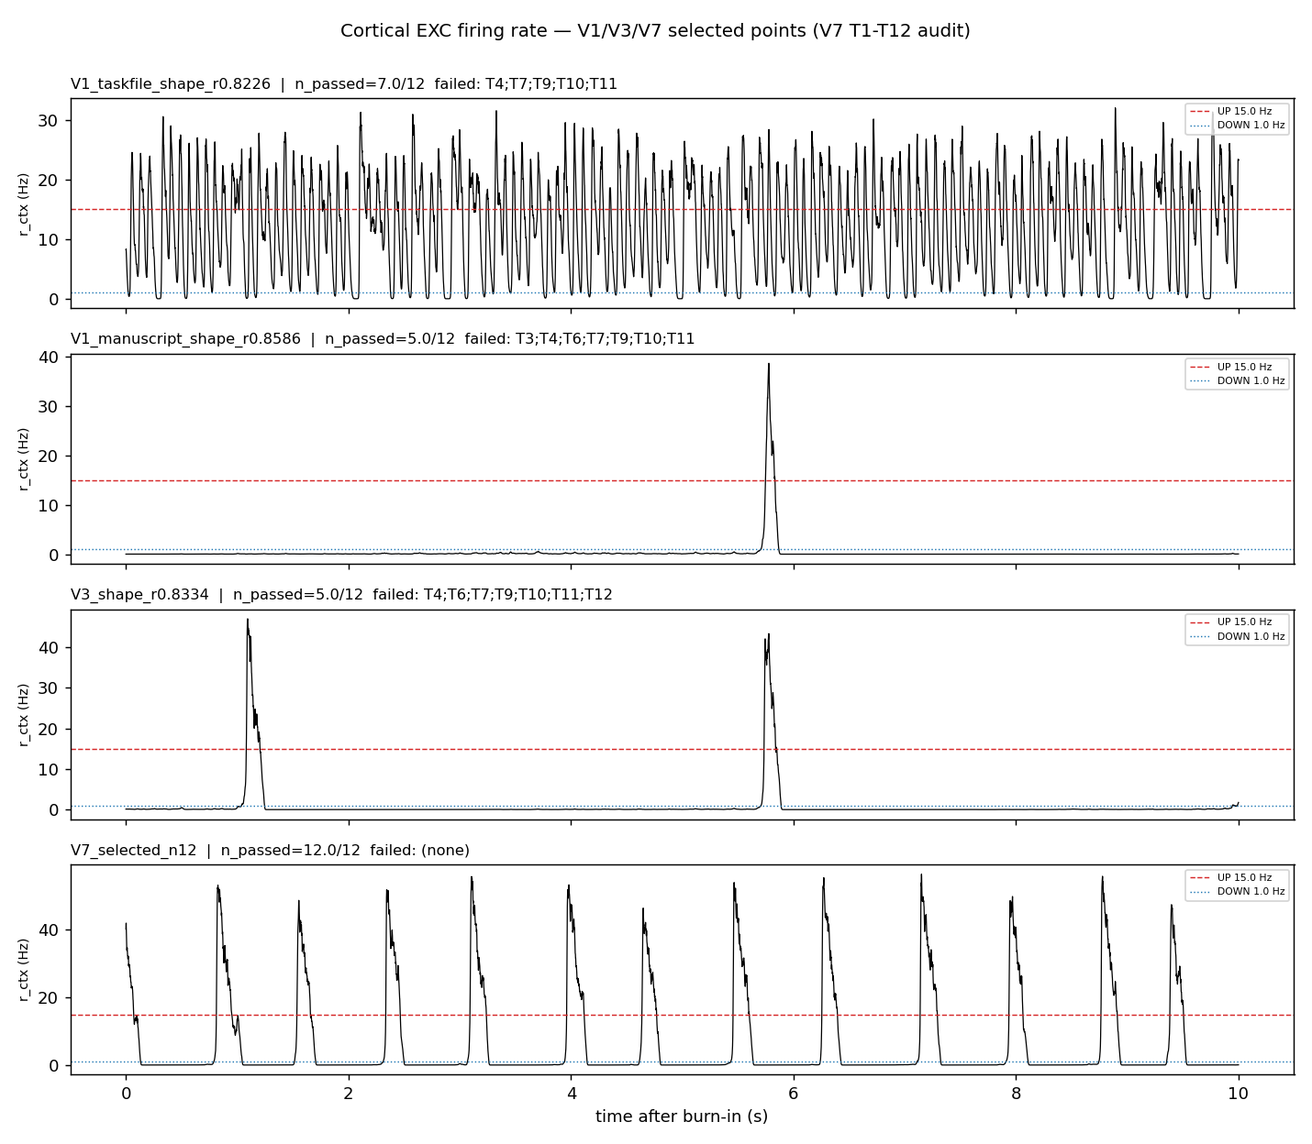
Fig. 3. Existence object—cortical excitatory firing rate of the V1, V3, and V7 selected points under the same T1–T12 audit (60 s sim, 5 s burn-in, seed 42). The canonical V1 point (shape_r = 0.8586) passes only 5/12 and shows spiky UP excursions with no SO–spindle coupling, whereas V7 passes 12/12 with sustained UP/DOWN alternation; each panel annotates the failed checks (Sec. V-A).
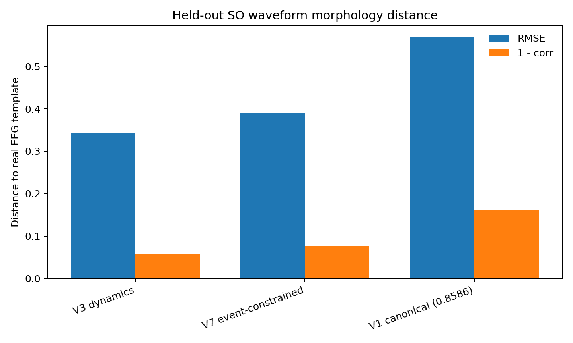
(a)
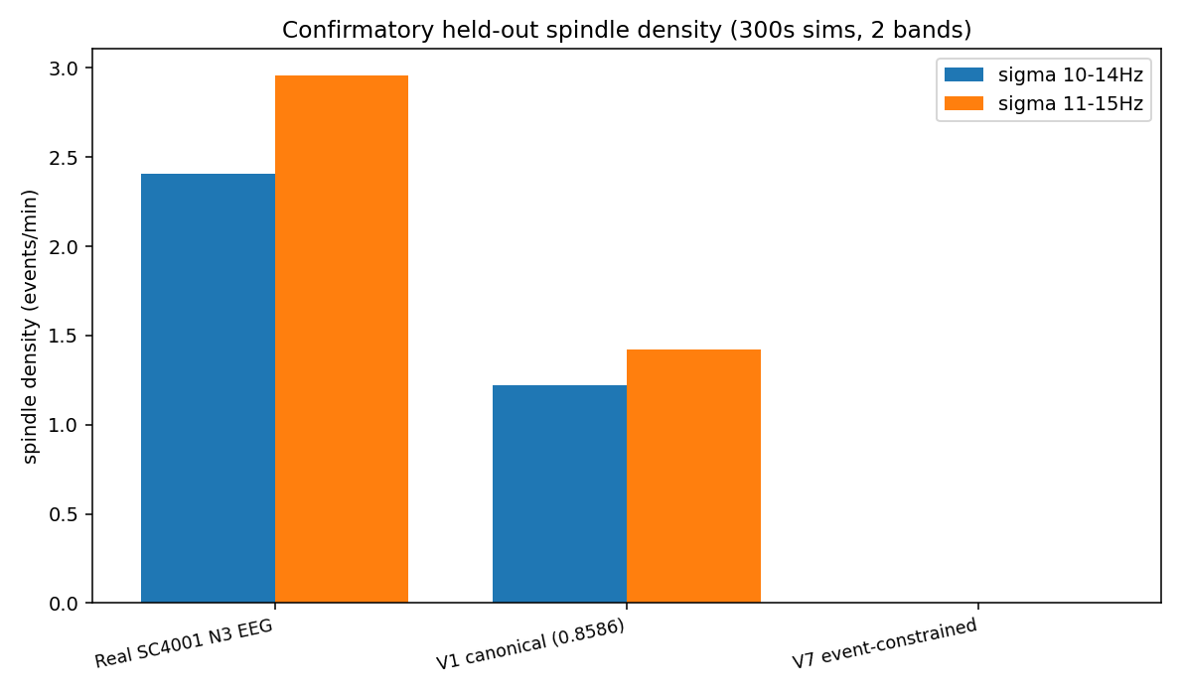
(b)
Fig. 4. Held-out checks giving mixed evidence (canonical V1 throughout). (a) SO average-cycle waveform distance to the real EEG template (RMSE and 1 − corr): V1 is the worst (RMSE 0.57), V7 (0.39) beats V1. (b) Cortical spindle density over 300 s in two sigma bands: real EEG ≈ 2.4–3.0/min, V1 ≈ 1.2–1.4/min, and V7 = 0/min in both 10–14 and 11–15 Hz bands. The two checks disagree, so neither model is ranked best overall.
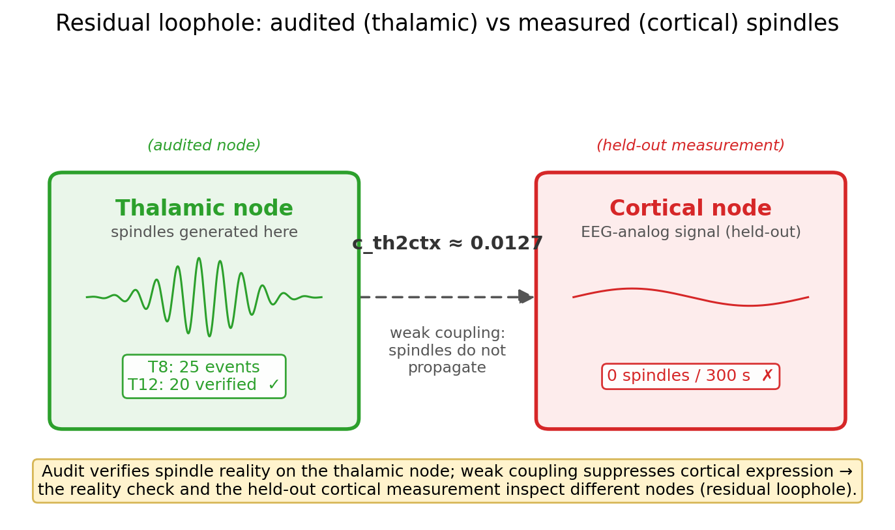
Fig. 5. Residual-loophole schematic. V7’s audit (T8/T12) verifies spindle events on the thalamic node, but the EEG-analog signal is the cortical node. At V7’s small coupling (c_th2ctx ≈ 0.0127) thalamic spindles do not propagate, so cortical spindle density is ≈ 0 even though the audit passes—the reality check and the held-out measurement inspect different nodes.

References
[1] C. Cakan, N. Jajcay, and K. Obermayer, “neurolib: A Simulation Framework for Whole-Brain Neural Mass Modeling,” Cognitive Computation, vol. 15, pp. 1132–1152, 2023, doi:10.1007/s12559-021-09931-9.
[2] N. Jajcay, C. Cakan, and K. Obermayer, “Cross-Frequency Slow Oscillation–Spindle Coupling in a Biophysically Realistic Thalamocortical Neural Mass Model,” Front. Comput. Neurosci., vol. 16, art. 769860, 2022, doi:10.3389/fncom.2022.769860.
[3] B. Kemp, A. H. Zwinderman, B. Tuk, H. A. C. Kamphuisen, and J. J. L. Oberye, “Analysis of a sleep-dependent neuronal feedback loop: the slow-wave microcontinuity of the EEG,” IEEE Trans. Biomed. Eng., vol. 47, no. 9, pp. 1185–1194, 2000, doi:10.1109/10.867928. Database: A. L. Goldberger et al., “PhysioBank, PhysioToolkit, and PhysioNet,” Circulation, vol. 101, no. 23, pp. e215–e220, 2000, doi:10.1161/01.cir.101.23.e215.
[4] P. A. Robinson, C. J. Rennie, and D. L. Rowe, “Dynamics of large-scale brain activity in normal arousal states and epileptic seizures,” Phys. Rev. E, vol. 65, no. 4, art. 041924, 2002, doi:10.1103/PhysRevE.65.041924.
[5] M. Steriade, A. Nuñez, and F. Amzica, “A novel slow (<1 Hz) oscillation of neocortical neurons in vivo: depolarizing and hyperpolarizing components,” J. Neurosci., vol. 13, no. 8, pp. 3252–3265, 1993, doi:10.1523/JNEUROSCI.13-08-03252.1993.
[6] M. Massimini, R. Huber, F. Ferrarelli, S. Hill, and G. Tononi, “The sleep slow oscillation as a traveling wave,” J. Neurosci., vol. 24, no. 31, pp. 6862–6870, 2004, doi:10.1523/JNEUROSCI.1318-04.2004.
[7] M. Mölle, T. O. Bergmann, L. Marshall, and J. Born, “Fast and slow spindles during the sleep slow oscillation: disparate coalescence and engagement in memory processing,” Sleep, vol. 34, no. 10, pp. 1411–1421, 2011, doi:10.5665/SLEEP.1290.
[8] R. F. Helfrich, B. A. Mander, W. J. Jagust, R. T. Knight, and M. P. Walker, “Old brains come uncoupled in sleep: slow wave–spindle synchrony, brain atrophy, and forgetting,” Neuron, vol. 97, no. 1, pp. 221–230.e4, 2018, doi:10.1016/j.neuron.2017.11.020.
[9] A. B. L. Tort, R. Komorowski, H. Eichenbaum, and N. Kopell, “Measuring phase-amplitude coupling between neuronal oscillations of different frequencies,” J. Neurophysiol., vol. 104, no. 2, pp. 1195–1210, 2010, doi:10.1152/jn.00106.2010.
[10] R. T. Canolty et al., “High gamma power is phase-locked to theta oscillations in human neocortex,” Science, vol. 313, no. 5793, pp. 1626–1628, 2006, doi:10.1126/science.1128115.
[11] B. A. Mander et al., “β-amyloid disrupts human NREM slow waves and related hippocampus-dependent memory consolidation,” Nat. Neurosci., vol. 18, no. 7, pp. 1051–1057, 2015, doi:10.1038/nn.4035.
[12] F. Ferrarelli, R. Huber, M. J. Peterson, M. Massimini, M. Murphy, B. A. Riedner, A. Watson, P. Bria, and G. Tononi, “Reduced sleep spindle activity in schizophrenia patients,” Am. J. Psychiatry, vol. 164, no. 3, pp. 483–492, 2007, doi:10.1176/ajp.2007.164.3.483.
[13] R. Vallat and M. P. Walker, “An open-source, high-performance tool for automated sleep staging,” eLife, vol. 10, art. e70092, 2021, doi:10.7554/eLife.70092.
[14] V. Krakovna, J. Uesato, V. Mikulik, M. Rahtz, T. Everitt, R. Kumar, Z. Kenton, J. Leike, and S. Legg, “Specification gaming: the flip side of AI ingenuity,” DeepMind Safety Research, 2020.
[15] D. Amodei, C. Olah, J. Steinhardt, P. Christiano, J. Schulman, and D. Mané, “Concrete Problems in AI Safety,” arXiv:1606.06565, 2016; J. Skalse, N. H. R. Howe, D. Krasheninnikov, and D. Krueger, “Defining and Characterizing Reward Hacking,” in Adv. Neural Inf. Process. Syst. (NeurIPS), 2022, arXiv:2209.13085.
[16] T. Donoghue, M. Haller, E. J. Peterson, P. Varma, P. Sebastian, R. Gao, T. Noto, A. H. Lara, J. D. Wallis, R. T. Knight, A. Shestyuk, and B. Voytek, “Parameterizing neural power spectra into periodic and aperiodic components,” Nat. Neurosci., vol. 23, pp. 1655–1665, 2020, doi:10.1038/s41593-020-00744-x.

