**Name:- Bambhaniya Jaydev Lakhamana Bhai**

**ID:- 19CEUOF027**

**Roll No:- CE008**

**LAB-1**

1. **Create a resume using HTML.**

**Ans:-**

**<!docktype html>**

**<head>**

**<title>RESUME</title>**

**</head>**

**<body>**

**<style>**

**table,th,td,tr{**

**border:1px solid black;**

**border-collapse:collapse;**

**}**

**tr{**

**text-align:center;**

**}**

**id="a"{**

**width:500px;**

**}**

**</style>**

**<table>**

**<tr id="a">**

**<th colspan="4">RESUME</tr>**

**</tr>**

**<tr>**

**<th colspan="2">Professional Details</th>**

**<th>About Me</th>**

**<th>WXYZ<br>ABCD<br><a href="#">Home Page</a></th>**

**</tr>**

**<tr>**

**<th colspan="2">Image</th>**

**<th colspan="2">Key Projects</th>**

**</tr>**

**<tr>**

**<th>Name</th>**

**<td>XYZ</td>**

**<td>I.</td>**

**<td>XYZ</td>**

**</tr>**

**<tr>**

**<th>Date Of Birth</th>**

**<td>MM-DD-YYYY</td>**

**<td>II.</td>**

**<td>ABC</td>**

**</tr>**

**<tr>**

**<th>Highest Qualification</th>**

**<td>ABC</td>**

**<th>Technologies</th>**

**<td>**

**<ul>**

**<li>PQR</li>**

**<li>UVW</li>**

**<li>HIJ</li>**

**</ul>**

**</td>**

**</tr>**

**</table>**

**</body>**

**</html>**

**OUTPUT:**

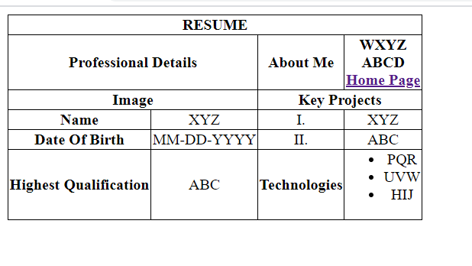

1. **Create pages using HTML.**

**Home Page:-**

**Ans:-**

|  |
| --- |
| **<!Docktype html>** |
| **<head>** |
| **<title>Book World</title>** |
| **</head>** |
| **<body>** |
| **<style>** |
| **h1{** |
| **border:1px black;** |
| **background-color:red;** |
| **text-align:center;** |
| **}** |
| **img{** |
| **margin:10px;** |
| **}** |
| **</style>** |
| **<h1>My Books,My World</h1>** |
| **<h2>Select Book</h2>** |
| **<ul>** |
| **<li>Wings Of Fire</li>** |
| **<a href="**[**#**](file:///C:\Users\Admin\Desktop\page.html)**"><img src="[wings.jfif](file:///C:\\Users\\Admin\\Desktop\\wings.jfif" \t "_blank)" height="85" width="85" alt="poster"></a>** |
| **<li>To sir With Love</li>** |
| **<a href="**[**#**](file:///C:\Users\Admin\Desktop\page.html)**"><img src="[tosirwithlove.jfif](file:///C:\\Users\\Admin\\Desktop\\tosirwithlove.jfif" \t "_blank)" height="85" width="85" alt="poster"></a>** |
| **<li>Into The Wild</li>** |
| **<a href="**[**#**](file:///C:\Users\Admin\Desktop\page.html)**"><img src="[wild.jfif](file:///C:\\Users\\Admin\\Desktop\\wild.jfif" \t "_blank)" height="85" width="85" alt="poster"></a>** |
| **</ul><br>** |
| **<p><I>Thank you for visiting page!</I> <b>Please clear <a href="**[**feedback.html**](file:///C:\Users\Admin\Desktop\feedback.html)**" title="feedback Page">here</a> to submit your feedback</p>** |
| **</body>** |
| **</html>**  **OUTPUT:**  **C:\Users\Admin\Pictures\Screenshots\Screenshot (468).png**  **Feedback Form:**  **<!docktype html>**  **<head>**  **<title>Feedback</title>**  **</head>**  **<body>**  **<h2>Fill the below Form</h2>**  **<fieldset>**  **<legend><h2>Feedback:</h2></legend>**  **Name:<br>**  **<input type="text" placeholder="Enter Your Name" required><br>**  **Gender:<br>**  **<input type="radio" value="Male" name="Gender" id="MaleRadio"><label for="MaleRadio">Male</label><br>**  **<input type="radio" value="Female" name="Gender" id="FemaleRadio"><label for="FemaleRadio">Female</label><br>**  **Language You Prefer:<br>**  **<input type="checkbox" value="English">English<br>**  **<input type="checkbox" value="Hindi">Hindi<br>**  **<input type="checkbox" value="Gujrati">Gujarati<br>**  **Rate Out Efforts:<br>**  **<select>**  **<option>None</option>**  **<option value="Bad">Bad</option>**  **<option value="Moderate">Moderate</option>**  **<option value="Good">Good</option>**  **<option value="Excellent">Excellent</option>**  **</select>**  **<input type="submit" value="Sumbit">**  **</fieldset>**  **</body>**  **</html>**  **OUTPUT:**  **C:\Users\Admin\Pictures\Screenshots\Screenshot (470).png** |