**Name:- Bambhaniya Jaydev Lakhaman Bhai**

**ID:- 19CEUOF027**

**Roll No:- CE008**

**Lab:-03**

1. **To study about the LDAX,STAX,LHLD and SHLD instructions. Study about the jump instructions.**

**Ans:-**

1. **LDAX :**

* **Load accumulator indirect.**
* **The content of the designated register pair point to a memory location, this instruction copies that contents into accumulator.**
* **LDAX B**

1. **STAX :**

* **Store the accumulator indirect.**
* **The content of the accumulator are copied into the memory location specified by the contents of the register pair.**
* **STAX B**

1. **LHLD :**

* **Load H-L register direct.**
* **The content of the specified address is copied into L register and the content of the H register is store by its next memory location.**
* **LHLD 2040H**

1. **SHLD :**

* **Store H-L register direct.**
* **The content of the L register is copied into specified address and content of the H register is copied into the next memory location.**
* **SHLD 2550H**
* **Jump Instructions**
* **It alters the normal sequential flow; this is conditionally or unconditionally.**
* **E.g JMP 2034H**
* **The program sequence is transferred to the memory location specified by the 16-bit address given in the operand.**
* **JZ, JNZ, JNC, JC, JPE, JPO,JM etc…**
* **JZ – Jump if zero, JNZ -- Jump if not zero.**
* **JC – Jump if carry, JNC – Jump if no carry.**
* **JPE – Jump if even parity, JPO – Jump if odd parity.**
* **JM – Jump if Minus, JP – Jump if positive.**

**2.** **Identify the contents of the accumulator/registers and the flag status as the following instructions are executed.**

**a) MVI A,7F**

* **As you can see value 7F is stored in the accumulator and no any flag or other register is changed.**

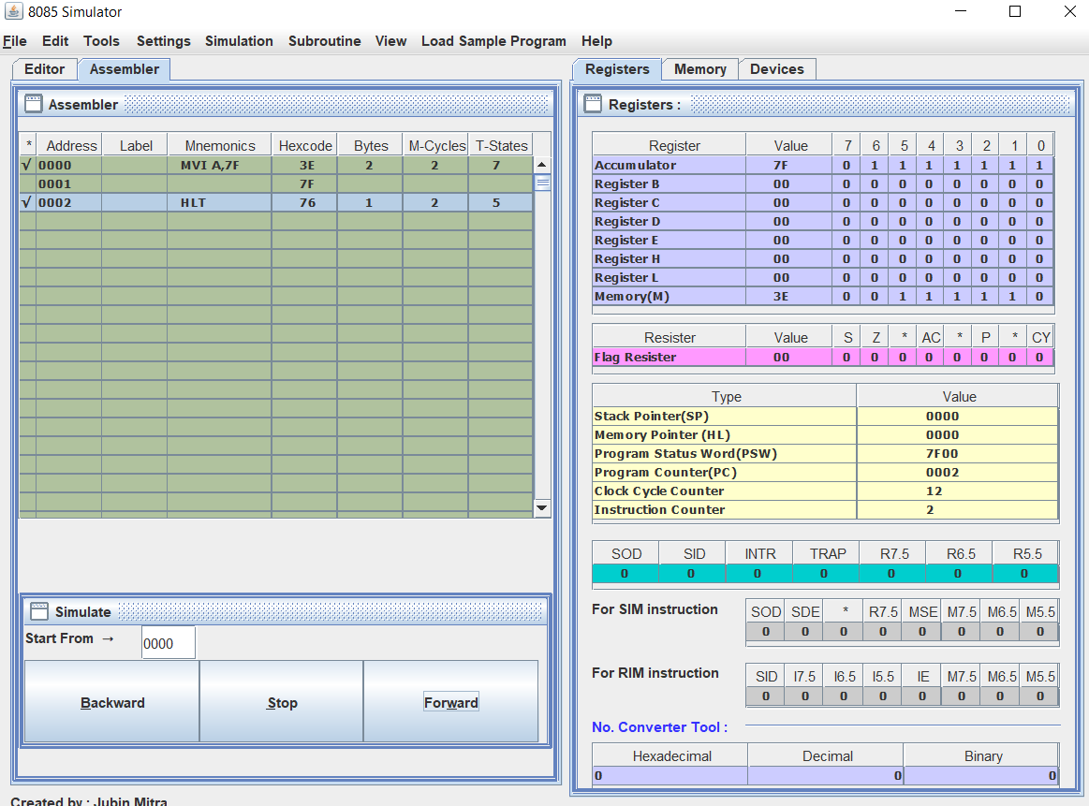

**b) ORA A**

* **ORA function is do the ORing with the accumulator, here operand is also accumulator and the value of accumulator is 00 so no change in accumulator, but as you can see the Zero flag is set and also the parity flag is also set.**

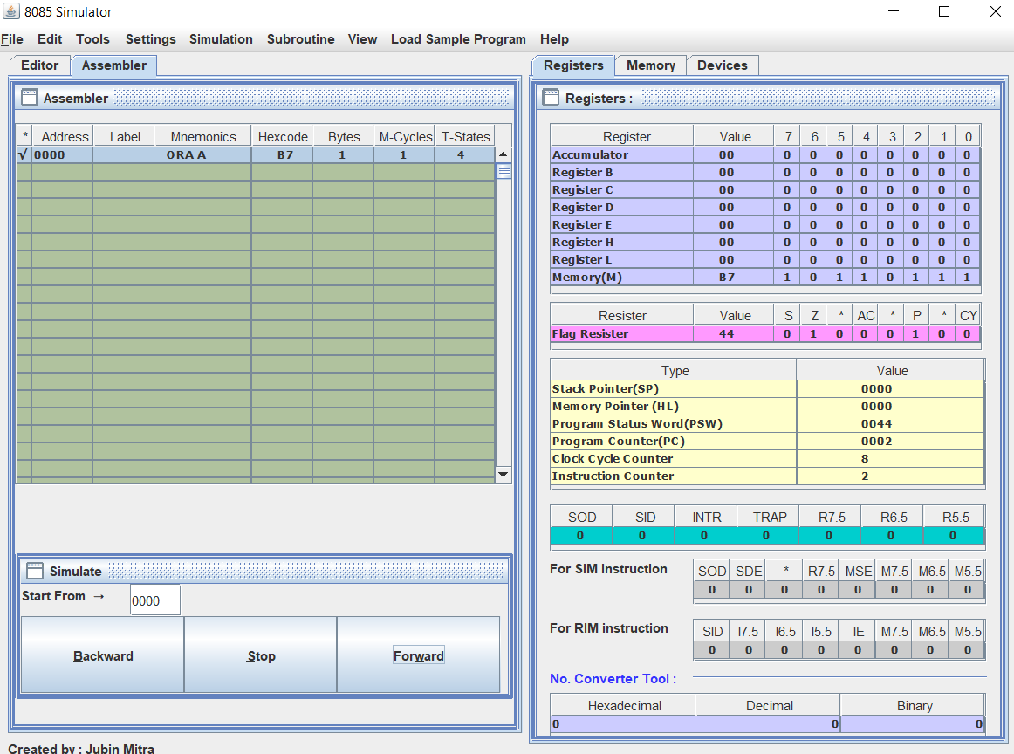

**c) CPI A2H**

* **CPI instruction is doing the comparison between current value of accumulator and the operand passed, here the value of accumulator value is zero, so the A2 is higher than 00 so the Carry flag is set.**

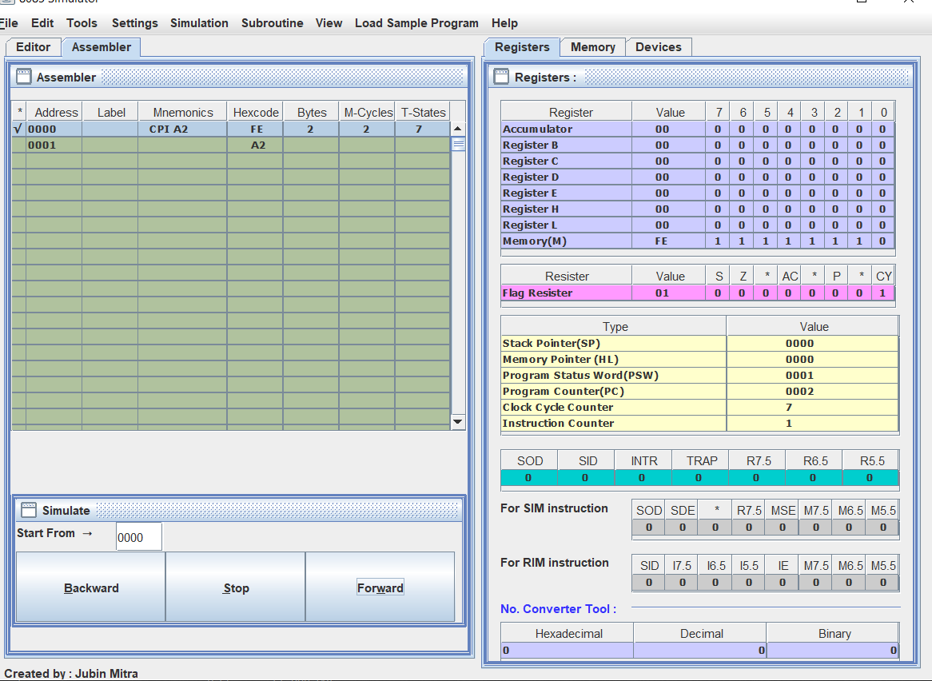

**d) LXI H,2070H**

* **LXI is do nothing just value is set in the H-L register so as you can see the H is 20 and the L is 70 and no any flag is set.**

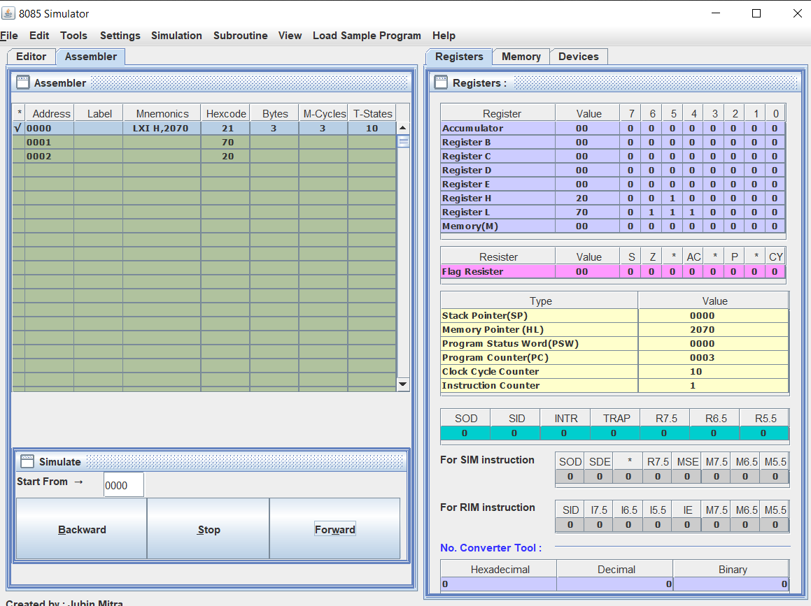

**e) MVI M,64H**

* **MVI instruction set the value of register of Memory whichever passed, here M is passed means the current H-L register at the memory location the value 64 is stored. So no any change is flags.**

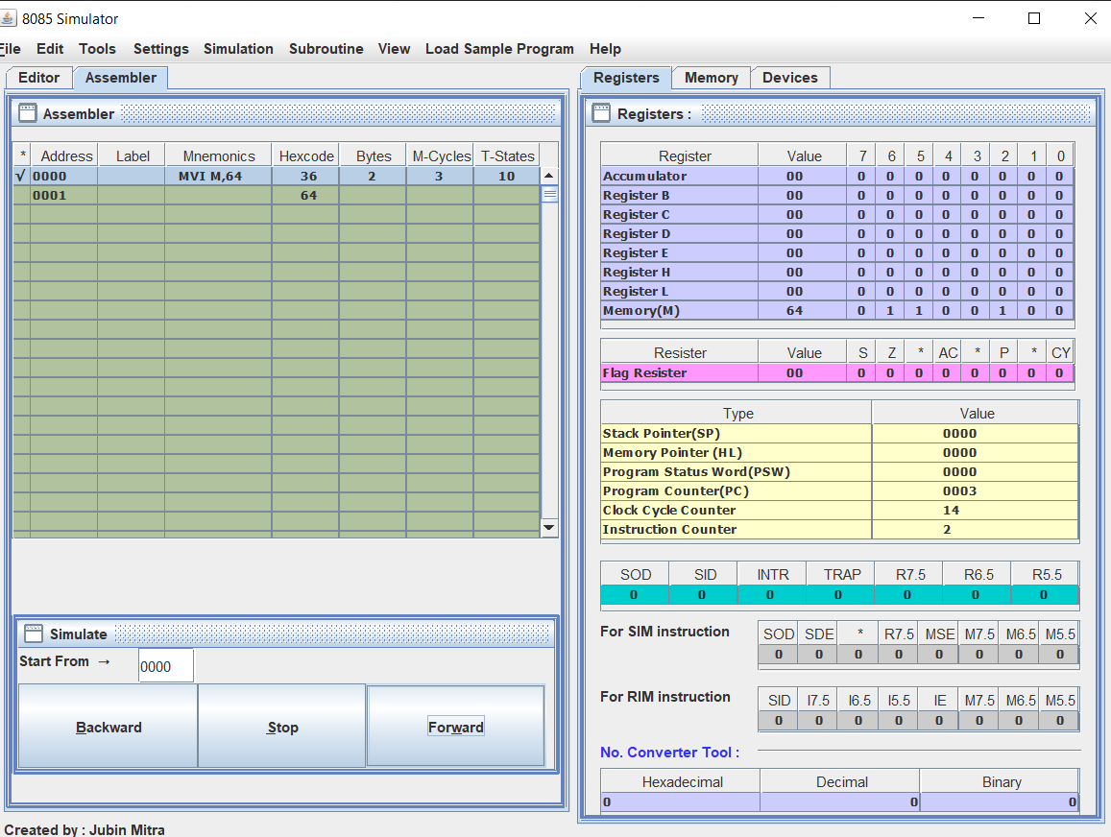

**f) MVI A,8FH**

* **As I tell you in above example MVI change the value of register(Accumulator) to 8F, so any changes in the flag.**

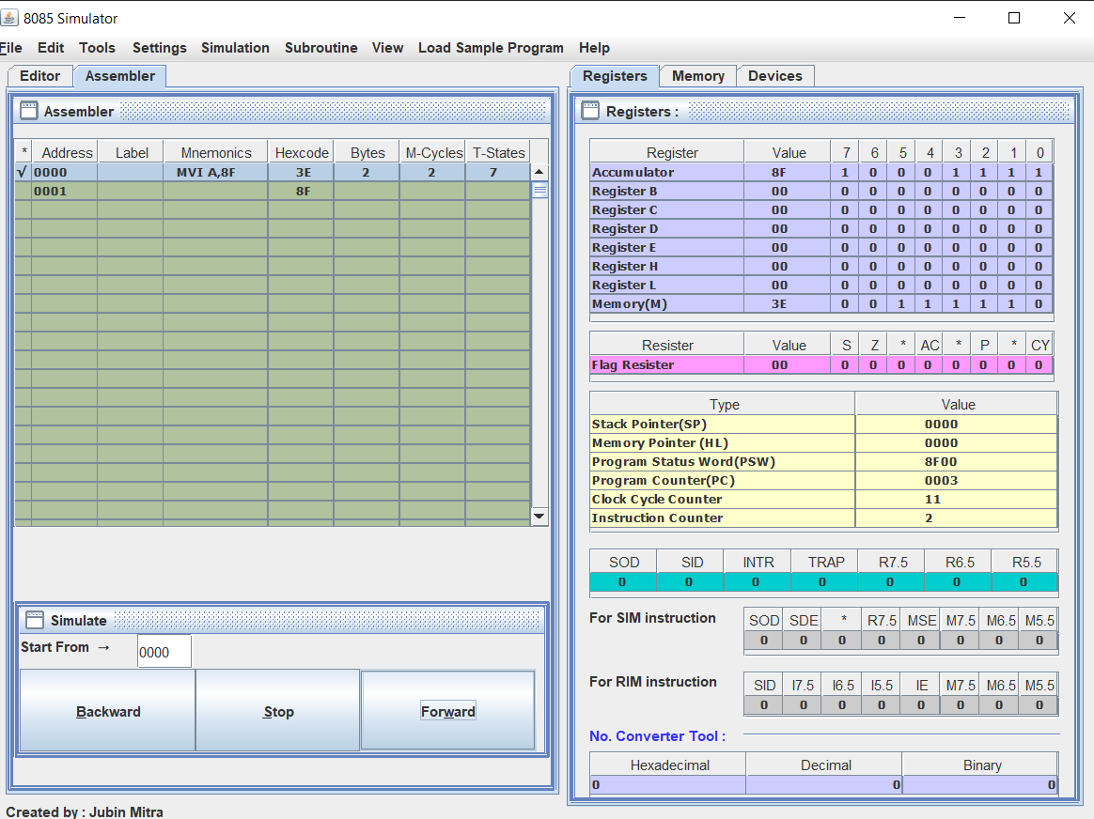

**g) CMP M**

* **CMP instruction is used to compare the value of accumulator and the register or value of memory which is passed, here the value of accumulator is 00 and the currently the value of memory is considered as higher than the accumulator so the carry flag is set, and as well as the parity flag is also set.**

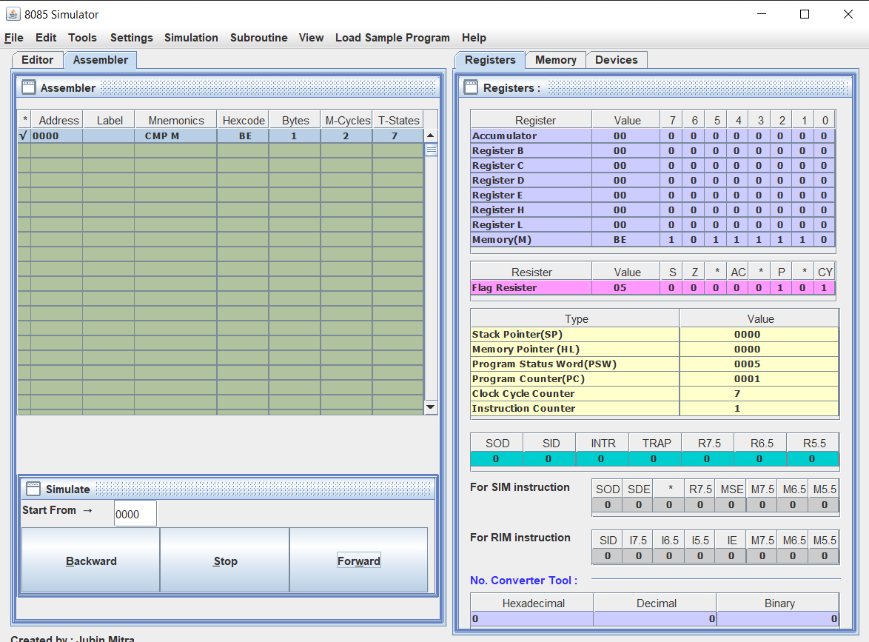

**3. Multiply two numbers given at address 2050H and 2051H respectively.**

**Ans:-**

**LXI H,2050H**

**MOV B,M**

**INX H**

**LOOP:**

**ADD M**

**JNC SKIP**

**INR C**

**SKIP:**

**DCR B**

**JNZ LOOP**

**MOV H,A**

**MOV L,C**

**SHLD 2055H**

**HLT**

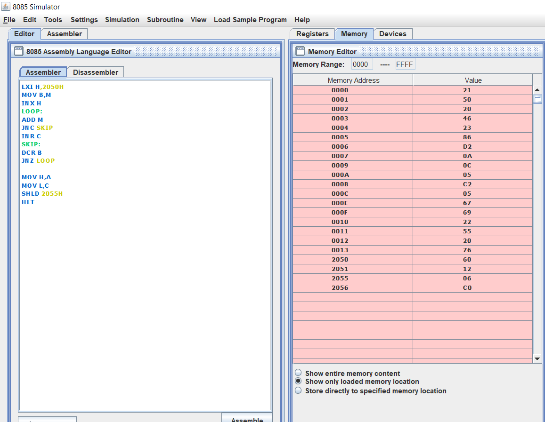

**4.Write a program to add the 5 bytes of data starting at address 2050H and store the result at DE pair.**

**Ans:-**

**LXI H,2050H**

**MVI D,05**

**LOOP:**

**ADD M**

**JNC SKIP**

**INR C**

**SKIP:**

**INX H**

**DCR D**

**JNZ LOOP**

**MOV L,A**

**MOV H,C**

**XCHG**

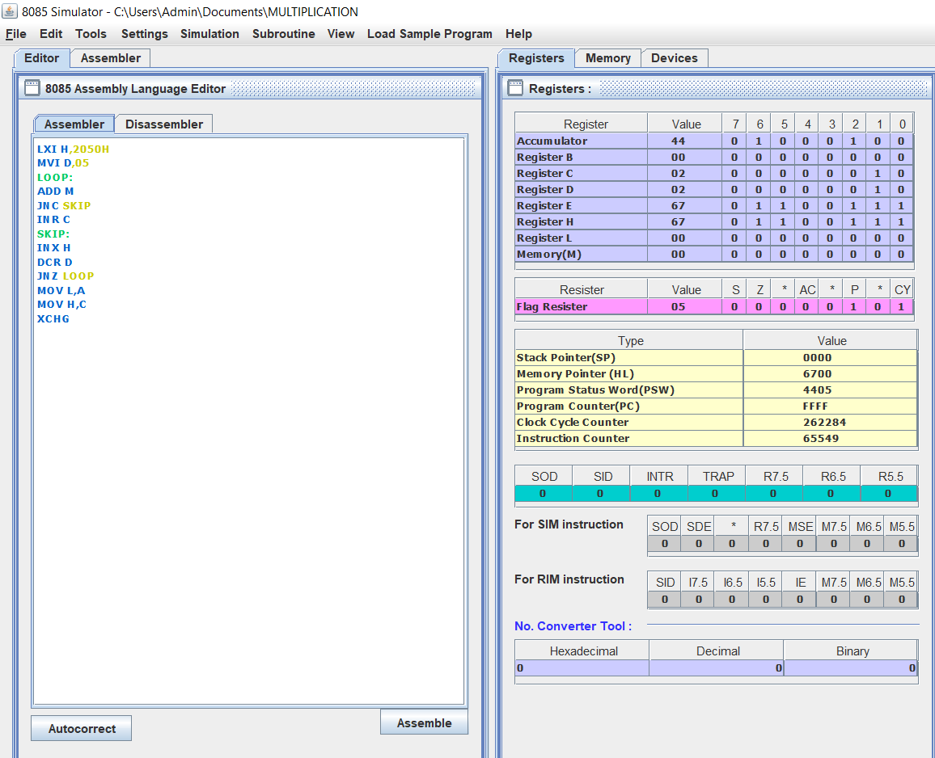

**5. Using the jump instruction transfer block of 8 bytes of data starting from 2055H to 3055H in reverse order.**

**Ans:-**

**LXI B,205C**

**LXI H,3055**

**MVI D,08**

**LOOP:**

**LDAX B**

**MOV M,A**

**DCR D**

**INX H**

**DCX B**

**JNZ LOOP**

