**Name: Bambhaniya Jaydev Lakhaman Bhai**

**Roll No: CE008**

**ID: 19CEUOF027**

**LAB-6**

1. **Write an assembly program to find the GCD and LCM of two numbers.**

**Ans:--**

**//GCD**

**LDA 2050H**

**MOV B,A**

**LDA 2051H**

**MOV C,A**

**MOV A,B**

**GCD:**

**CMP C**

**JZ RESULT**

**CMP C**

**JNC SKIP**

**MOV D,C**

**MOV C,A**

**MOV A,D**

**SKIP:**

**SUB C**

**DCR E**

**JNZ GCD**

**RESULT:**

**STA 3000**

**//LCM**

**LDA 2050H**

**MOV B,A**

**LDA 2051H**

**MOV C,A**

**LDA 3000H**

**MOV D,A**

**MVI A,00**

**MULTIPLY:**

**ADD B**

**DCR C**

**JNZ MULTIPLY**

**MVI E,00H**

**DIVISON:**

**SUB D**

**INR E**

**JNC DIVISON**

**DCR E**

**MOV A,E**

**STA 3050**

**HLT**

**Output:--**

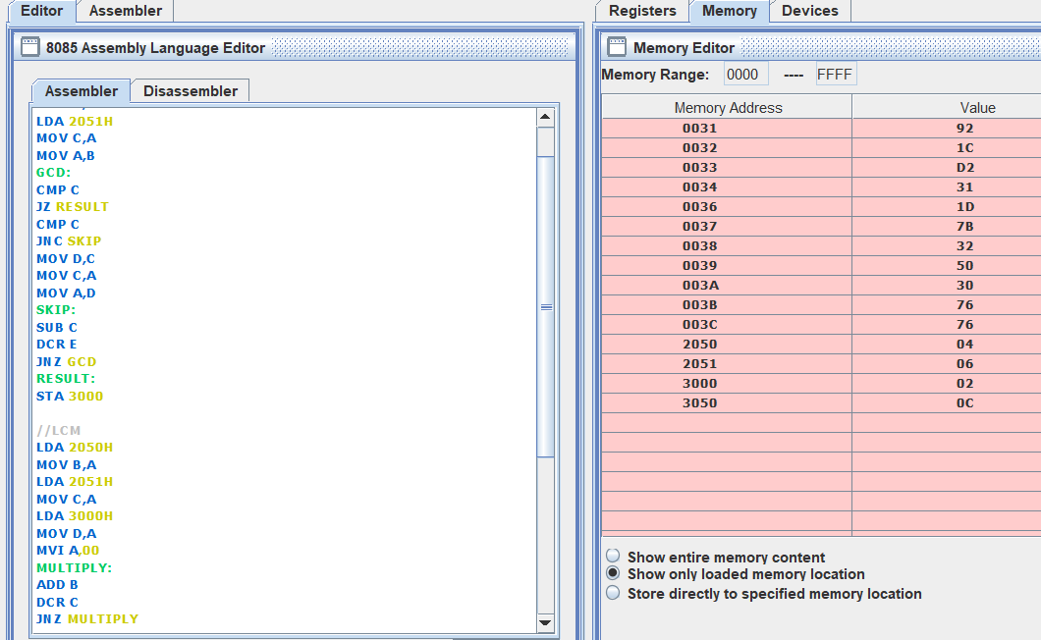

1. **Write an assembly language program to Sort an array of 10 numbers.**

**Ans:--**

**MVI C,0AH**

**LOOP:**

**LXI H,2050H**

**MVI B,0AH**

**INNER:**

**MOV A,M**

**INX H**

**CMP M**

**JC SKIP**

**MOV D,M**

**MOV M,A**

**DCX H**

**MOV M,D**

**INX H**

**SKIP:**

**DCR B**

**JNZ INNER**

**DCR C**

**JNZ LOOP**

**HLT**

**Output:-**

