**Name: Bambhaniya Jaydev Lakhaman Bhai**

**Id: 19CEUOF027**

**Roll No: CE008**

**LAB – 05**

1. **A set of ten readings is stored in memory location starting at 2070H. Write a program to check whether a byte 40H exists in the set. If it does, stop checking, and save its memory location at address 1000H or else save FFFFH.**

**Ans:-**

**LXI H,2070H**

**MVI C,AH**

**LXI D,1000H**

**LOOP:**

**MOV A,M**

**CPI 40**

**JZ FOUND**

**INX H**

**DCR C**

**JNZ LOOP**

**JZ NOTFOUND**

**FOUND:**

**MOV A,H**

**STA 1000H**

**MOV A,L**

**STA 1001H**

**HLT**

**NOTFOUND:**

**MVI A,FFH**

**STA 1000H**

**STA 1001H**

**HLT**

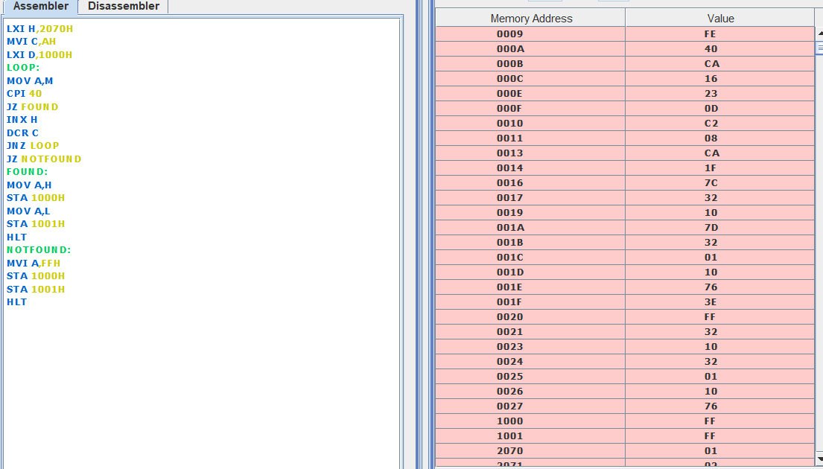

1. **Write a program to check whether a given number is prime or not. If it is a prime store 10H at the address 1000H or else store FFH.**

**Ans:-**

**LXI H,2050H**

**MOV A,M**

**MOV B,M**

**MOV D,M**

**MOV E,M**

**MVI C,00H**

**LOOP:**

**MOV B,E**

**REMINDER:**

**CMP B**

**JC CHECK**

**SUB B**

**JNZ REMINDER**

**CHECK:**

**CPI 00**

**JNZ PM**

**INR C**

**PM:**

**MOV A,D**

**DCR E**

**JNZ LOOP**

**MVI A,02H**

**CMP C**

**MVI A,FFH**

**JNZ ITISPM**

**MVI A,10H**

**ITISPM:**

**STA 1000H**

**HLT**

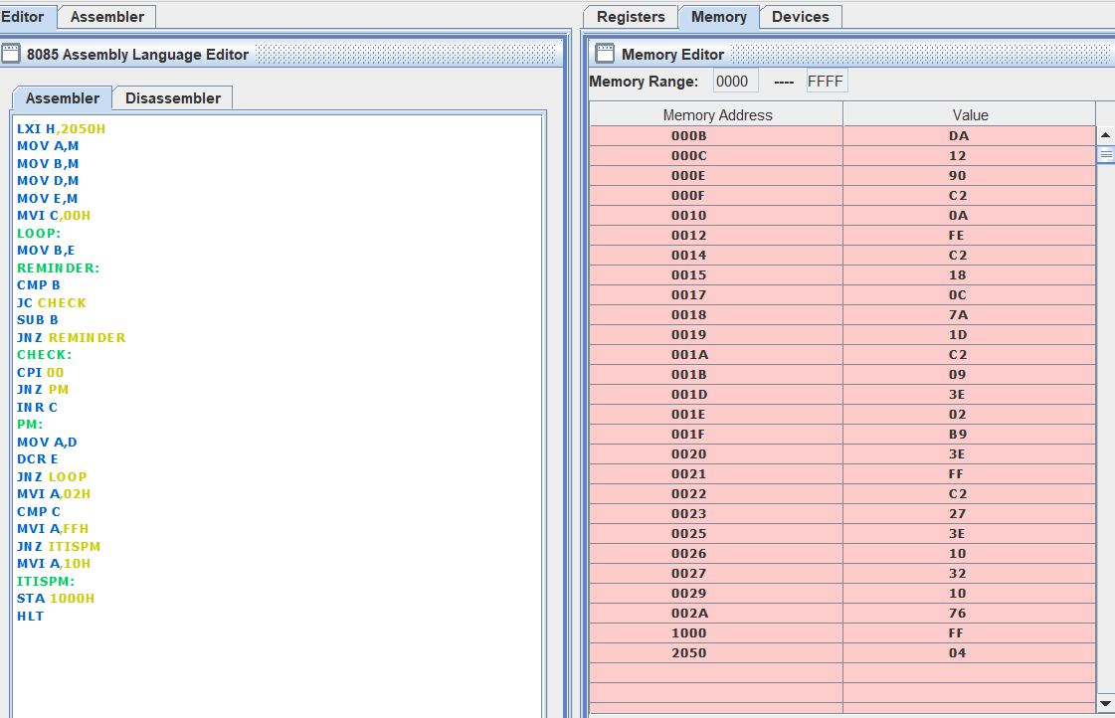

1. **A set of ten bytes are stored at address 2050H. Check each data byte whether it is a positive or negative number. Reject all the negative readings and sum all the positive readings. (Refer the RAL/RAR/RLC and RRC instructions)**

**Ans:-**

**LXI H,2050H**

**MVI C,0A**

**MVI D,00**

**LOOP:**

**MOV A,M**

**RLC**

**JNC SUM**

**INX H**

**DCR C**

**JNZ LOOP**

**MOV A,D**

**STA 3000h**

**HLT**

**SUM:**

**MOV A,D**

**ADD M**

**MOV D,A**

**INX H**

**DCR C**

**JNZ LOOP**

**MOV A,D**

**STA 3000H**

