* **Debugging using GDB of erroneous merge sort.**

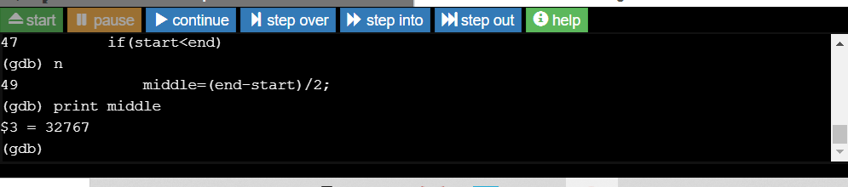

* **As you can see in above screen shot of GDB while running the program merge sort, when the merge sort function is called with argument 0 and 1 means the start=0 and end=1 then the value of middle is some garbage so the thing is clear that the program showing segmentation fault because the value of middle is something not desirable and when the function is called with argument with start=1 and and end 3, then value of middle is 1 which is not expected because actually the value of middle is 2, so the o/p is not correct.**
* **Solution is that we have to modify the right side of middle by adding start to it ,so now value of middle is correct and program run exectly fine.**

**Middle = start + (end-start)/2 -------🡪This the change required in the program.**