**UNIT 1: THE MAN-MADE ENVIRONMENT**

01.

|  |  |  |  |  |  |
| --- | --- | --- | --- | --- | --- |
| **Location** | **Building Type** | **Style** | **Rooms** | **Parts of room** | **Materials** |
| Beach  Remote island  City centre  Countryside  Mountains | Bungalow  Castle  Mansion  Garage  Skyscraper | Glamorous  Modern  Simple  Spacious  Traditional | Dining room  Cellar  Gym | Ceiling  Floor  Staircase  Window | Stone  Leather  Marble  Wood |

02.

When I started to be fallen in love with my wife, we were often imaging about our dream house. That house would be near the mountain in the countryside. It just should be simple with a bungalow made from wood and the basic equipments like bed, floor, ..We very loved the simple style with mimimum things that needed for life. We also thought that we needed to build a out-side gym with a sand area for jumping, we built some weights from stone and wood. We would decorated our windows with some flower and green plant. Ahh, we would make a beautiful room with pink color and funny pictures that painted by ourself for our lovely daughter, too.

LEAD-IN

01

|  |  |  |  |  |  |
| --- | --- | --- | --- | --- | --- |
|  | Line graph |  | line |  | Horizontal axis |
|  | Vertical axis |  | Bar chart |  | bar |
|  | key |  | Title |  | Pie chart |
|  | Segment |  | Table |  | Column |
| 1. Row |  |  |  |  |  |

02

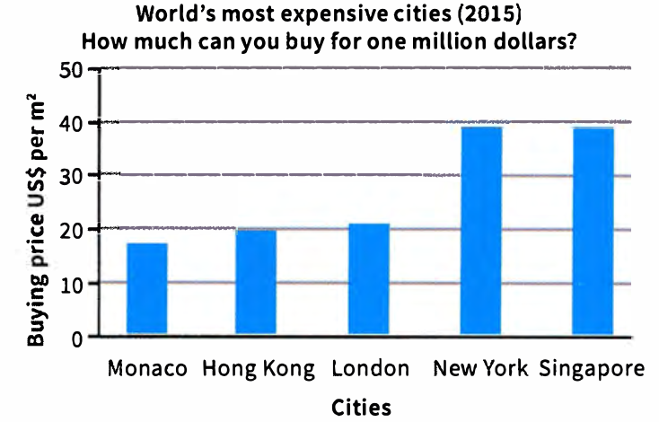

|  |  |  |
| --- | --- | --- |
|  | What does the title say the graph is about? | The world’s most expensive cities in 2015 |
|  | What does the vertical axis describe? | The cost of buying price in US$ per m2 |
|  | What does the horizontal axis describe? | The list of city |
|  | What does the columns/bars represent? | The price of buying in US$ per m2 for specific city |
|  | Which is the tallest and shortest bar? | The tallest is Singapore, the shortest is Monaco |

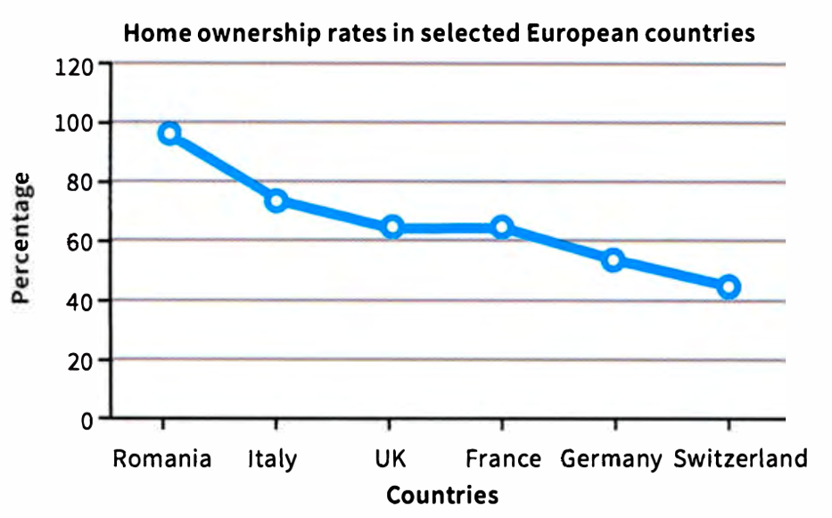

|  |  |  |
| --- | --- | --- |
|  | What does the title say the graph is about? | The rates of home ownership in selected European countries |
|  | What does the vertical axis describe? | The percentage of home ownership rate |
|  | What does the horizontal axis describe? | The list of selected European countries |
|  | What do the highest/lowest points of the line show? | The highest point is Romania about 95%; the lowest one is Switzerland about 45% |
|  | What is the general trend of the line? | It is falling down line chart |
|  | Are ther any sharp decrease or increase? | They are not |

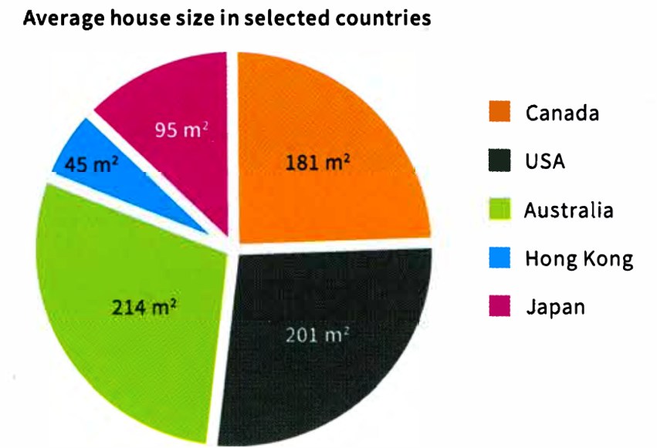

|  |  |  |
| --- | --- | --- |
|  | What does the title say the graph is about? | The average house size in selected countries |
|  | What do the segments represent? | They represent the different countries |
|  | Which is the largerst/smallest segment? | The largest is Autralia and smallest is Hong Kong |
|  | Are some segments similar in size? | There are USA and Autralia similar in size |

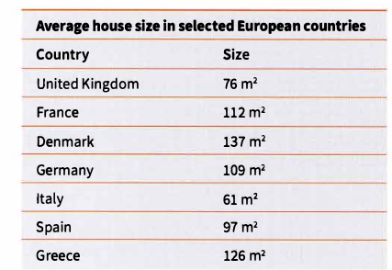

|  |  |  |
| --- | --- | --- |
|  | What does the title say the table is about? | It says the average of house size in selected Ẻuopean countries |
|  | How many columns are there?What do they represent? | There are two columns: Country and average house size |
|  | Which country has the biggest average house size? | It is Denmark |
|  | Which country has the smallest average house size? | It is Italy |
|  | Which countries have a similar average house size? | They are France and Greece |

USING ACCURATE DATA

03

1 = The pie chart provides the average house size in selected countries and the table provides the average house size in selected European.

2 = USA

3 = ???

4 = selected

5 = most houses in European countries are much smaller than in the selected non-European countries

6 = Hong Kong

04

The writer mde some errors and some of them relating to data such as Canada, Italy,…

DESCRIBING TRENDS

05

1 Rise

2 Include

3 Click

4 Goat

5 Row

6 Solid

7 Fall

8 Decrease

9 December

10 Go down

11 Plummet (day roi, lao xuong doc theo duong thang)

12 Plunge (lao xuong nhan manh vao su nhanh chong)

13 Dream

14 Maintain

15 Remain

16 Stay

06

1 Rise

2 Fall

07

1 Last year house prices rose by 5%

2 Monaco’s property market remains stable

3 The line graph illustrates that since 2010 home ownership has decreased

4 House prices are going to go up next year

5 In Ireland, property prices have rocketed substantinally this year

USEFUL ADJECTIVES (demonstrate the range of vocabulary, that describes noun)

Adj as also Noun

To rise/ A rise

To increase or decrease/ An increase or A decrease

To decline/ A decline

To fall/ A fall

To drop/ A drop

To peak/A peak

To dip/ A dip

08

Big change: dramatic, substantial, significant,

Small change: slight, modest

Gradual or no change: stable, steady, unchanged

09

1 Over the last year, Hong Kong has experienced a significant rise in house prices

2 There has been a steady increase in the number of young people buying houses

3 The rental market has seen a slight decrease over the last six months

4 The graph illustrates that the rental market is unchanged at the moment

USEFUL ADVERBS (how something happens and usually follow the verb)

10

A-2 B-3 C-1

11

Big change: significantly, considerablely, substantialy, dramatically

Small change: moderately, slightly

Gradual change: gradually, steadily, slowly, consitently

Quick change: sharply, rapidly, quickly

12

1 Home ownership has decreased dramatically over the last five years

2 Property prices have increased slightly over the last six months

3 The property market is growing gradually/slowly in this area

4 Interest rates have increased sharply recently

PART 1: DESCRIBING TRENDS

13

A The line graph shows increase gradually

B The bar chart shows change quickly from 2008 – 2009, 2014-2015; change slowly from 2009 – 2014

C The bar chart shows fall slowly from 2008 – 2015; fall quickly from 2008 – 2009 with above 10% down to nearly 0%

14 + 15

1 Since 2008, house prices in Dubai have fluctuated heavily. In 2008, prices have remained by just over 40% and then decrease to -40%

2 Since 2008, house price increases in Hong Kong have fluctuated heavily/dramatically under 11% each year. In 2008, prices peaked/rised/reached a top/went up, with a percent of just over 10%

3 Since 2010, house prices in London have grown gradually. In 2009, prices decreased substaintially, by almost L100.000, but the house prices increased again rapidly/steadily in 2010 to approximately L600.000

16 **Later**