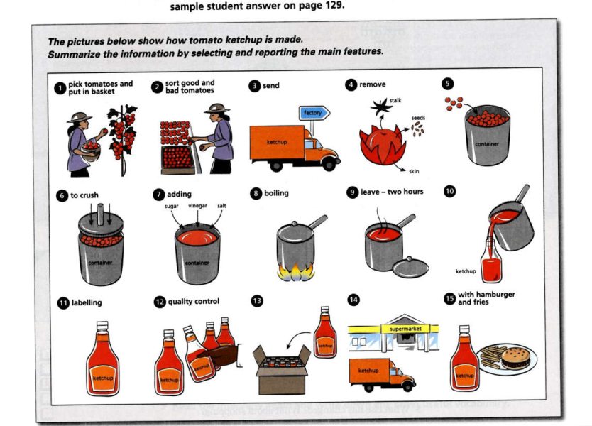

The given image demonstrates the process of making tomato ketchup.

Overall, there are 15 steps starting with picking fresh tomatoes and finishing with commercial ketchup bottles.

Let’s take a closer look for more details. Initially, the starting stage is harvesting ripe tomatoes and putting them in baskets done by agricultural workers. Then they classify those tomatoes in terms of quality, which good ones could be loaded onto lorries and transported to processing plants. At this point, raw tomatoes are peeled and removed from stalks and seeds, which the remaining flesh is put into containers and crushed. After adding some spices like sugar, vinegar, or salt for making more flavors, tomato liquid is evenly stirred and boiled for two hours, which results in the tomato sauce we see everyday. Subsequently, this sauce is separated into small bottles which are labeled and take some quality tests. The accepted ketchups are packed in boxes and delivered to supermarkets or agencies. Finally, these bottles are purchased by customers and then mixed with ordinary dishes for more tastes.