CONFIDENTIAL. Limited circulation. For review only



**Cullen College of Engineering**

Department of Electrical and Computer Engineering

Aaron T Becker

Department of Electrical Engineering

University of Houston

Houston, TX 77004, USA

Email: atbecker@central.uh.edu

Web: youTube.com/aabecker5

June 4, 2017

Magnetic Hammer Actuation for Tissue Penetration using a Millirobot

Dear members of the Editorial team and Reviewers,

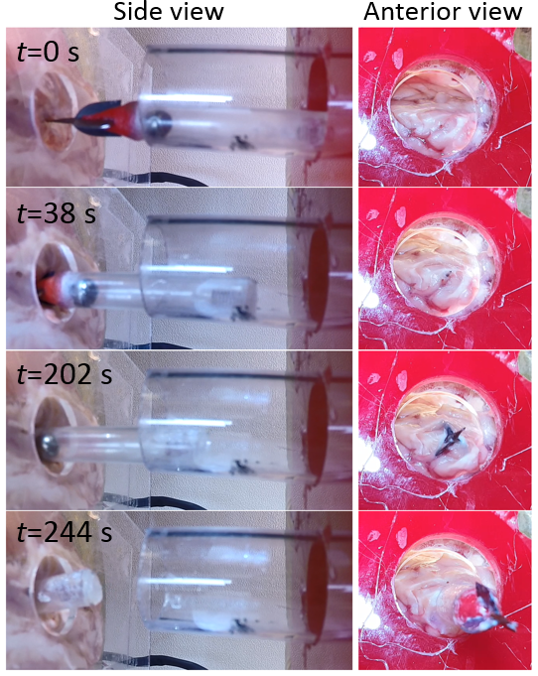

Figure 1, new experimental results include tissue penetration tests through lamb brain.

Please find attached the revised paper, **Magnetic Hammer Actuation for Tissue Penetration using a Millirobot** (RA-L and IROS 17-0241) along with the document containing response to the reviewers. We are grateful to the reviewers for helping us in improving our manuscript through their comments and questions, which lead to major revisions of the paper. Please let us know if further information is required.

Sincerely,



Aaron T Becker (on behalf of all the authors)

**Response to Reviewers**

In the following document, we’ve provided detailed responses to the comments and questions of the reviewers. Comments and questions by reviewers are in blue, our responses are in black.

**Comments by Reviewer 1**

*[R1 C1] [major comment : clarity of presentation] The introduction of the each equation is not clear. Especially, equation (3)-(8), (10)-(13).*

Text was added to introduce equations (3)-(8) more clearly.

“*tres* is calculated by adding up the time taken for the sphere to travel through each of the four phases of motion: *xs* = (i) L to 0, (ii) 0 to -*xcs*, (iii) -*xcs* to 0, and (iv) 0 to L. The durations of motion for each of these individual phases are calculated by solving the equations of motion with the forces acting as shown in Figure 2. Friction has been assumed to be negligible for these calculations.”

Text was added to introduce equation (10)-(13):

“The authors obtained these results by calculating the curl of the magnetic vector potential using the software Mathematica.”

*[R1 C2] The method of the simulation or the experiment are not clearly described in chapter II –V, respectively.*

The text describing the simulation chapter II and the experiment chapter V was modified. We believe that these descriptions are now clearer.

For chapter II: “An analytical model was developed by solving the system of differential equations. This model allows predicting the impact velocity for each impact, given a set of input parameters. The sphere-impact plate system is assumed to have a coefficient of restitution, e. This model assumes that the robot capsule does not move. As seen in fig. 4, the impact velocity initially increases and ultimately saturates for all values of e greater than 0 and less than or equal to 1. The system reaches a resonant state when the impact velocity saturates. This happens when the energy lost by the sphere during impact equals the energy gained by it during the rest of the cycle. A higher e results in a higher impact velocity. For e = 1, the impact velocity indefinitely increases since there is no energy loss during impact. An analytical formula was derived to predict the resonant impact velocity for a given set of input parameters and provided e is between 0 and 1. This was done by solving for the impact velocity at

resonance, under the condition that the velocities at impacts *i* and *i + 1* are the same. The resonant velocity is given by eq. (2) and was also verified by numerical simulations in MATLAB.”

For Section V: “The sphere has a diameter of 5mm and is made of stainless steel. No spring was use in this millirobot. A plastic container was placed inside the MRI scanner, simply sitting on the patient table. The millirobot was positioned inside this container, with its length oriented along the x axis. A lamb brain hemisphere was placed in the container, in front of the millirobot tip. A 2Hz square gradient along the x axis with an amplitude of 23 mT/m was applied to it.”

*[R1 C3] What is the difference about perfectly closed loop, open loop and partially closed loop?*

The following text was added in the introduction: “Different control strategies are studied. The open loop control switches the magnetic gradient direction at constant frequency. It is completely independent of the sphere position and uses no feedback. The partially closed loop control detects the impact of the sphere and switch the magnetic gradient direction as soon as the impact is detected. The original gradient direction is reapplied after a constant time *ts*. The perfectly closed loop control assumes a theoretical sensor able to measure the position of the sphere at any time. It is capable to detect the impact of the sphere as well as the change of direction on the posterior side. The controller is therefore able to change the direction of the gradient when the impact is detected and when the change of direction on the posterior side is detected.”

*[R1 C4] What is the meaning of the following sentences “This is equivalent to a perfectly closed-loop system where the gradient signal switches direction when the sphere switches direction.”. Why?*

The text, with the previous sentence was: “To maximize the average impact velocity over an arbitrary *n* number of contacts, the input magnetic gradient should always be in the same direction as the motion of the sphere. This is equivalent to a perfectly closed-loop system where the gradient signal switches direction when the sphere switches direction.”

The authors want here to explain that, in the theoretical computation, the perfectly closed loop is simulated by applying a magnetic gradient oriented in the same direction of the sphere velocity.

This text has been reformulated as follow for more clarity:

“In the perfectly closed loop system, the magnetic gradient direction is changed when the sphere hits the impact plate and when the spring reaches full compression. These two moments also corresponds to the two changes in the sphere movement direction. In addition, to maximize the impact velocity, the magnetic force, and therefore, the magnetic gradient, are oriented in the same direction as the sphere velocity vector. In the simulations, the sphere will naturally change direction after impact and after the full compression of the spring. The perfectly closed loop system can, indeed, be easily modeled by applying a magnetic gradient in the same direction as the sphere velocity.”

*[R1 C5] [major comment : thoroughness of results] The method and result (especially, experiment part) does not support your concept enough. The further implementation is needed to demonstrate your idea about magnetic hammer.*

Additional experiments were performed and the robot prototype was able to penetrate a lamb brain sample. A section was added in the paper to describe this experiments and the obtained results.

*[R1 C6] [minor comment : clarity of presentation] There are many abbreviation, which is not introduced (ODE, FEMM, etc).*

The abbreviation ODE was removed as it was only used one time. All the abbreviations (FEMM, MRI) in the paper were defined.

*[R1 C7] What is desktop the experiments?*

The authors made the experiments in a small-scale magnetic setup in order to reduce the costs associated with the use of a medical MRI scanner. The authors agree that “desktop experiment” is not appropriate to describe this experimental setup. The term “desktop experiment” was replaced by “magnetic test bench”.

**Comments by Reviewer 2**

*[R2 C1] Explain the derivation of equation (2)*

The following lines have been added in the paper to explain the derivation.

“An analytical formula was derived to predict the resonant impact velocity for a given set of input parameters and for values of ‘*e’* between 0 and 1. This was done by solving for the impact velocity at resonance, under the condition that the velocities at impacts ‘*i’* and ‘*i+1’* are equal. Using this condition, eq. (2) is derived by solving the differential equations that define the dynamics of sphere motion between impacts. The magnetic gradient is always in the same direction as the sphere velocity vector. The results given by eq. (2) were also verified by numerical simulations in MATLAB.”

*[R2 C2] Clarify whether the rotation of the sphere is modeled in the dynamic simulation*

The rotation of the sphere is now completely removed from the paper. Our latest experiments now use magnets to produce more force. The sphere cannot rotate because the magnet is oriented along the magnetic field. Permanent magnets used in our magnetic test bench have similar behavior as a ferromagnetic sphere placed inside an MRI machine. The strong magnetic field of MRI scanner will saturate the ferromagnetic material and produce a constant magnetization. In addition, we observed that the ferromagnetic spheres have a preferred orientation inside the MRI machine. This is probably due to the distribution of the magnetic domains, which tends to move the sphere in an orientation that minimizes the magnetostatic energy.

*[R2 C3] State how the simulation was implemented, whether in a simulation software such as Simulink/Simscape, or coded by the authors, or otherwise.*

More details were added about the implementation of the simulations. The theoretical analytical calculations were performed with the software Mathematica. The numerical computations were performed using the software Matlab.

*[R2 C4] Fix P.5 right side "show that and that" error*

This was corrected.

*[R2 C5] Give the supplier and specifications of the "Syren 25" power supply.*

These data were added: “Each coil is powered by a Syren 25 regenerative switching power supply. The Syren 25 are manufactured by Dimension Engineering. They can provide continuously a current of 25 A with a maximum voltage of 24 V.”

*[R2 C6] Section V: Explain why MRI gradient frequencies other that 2 Hz were not applied as in simulation*

The use of clinical MRI scanner is costly and the authors preferred to perform more experiments on the magnetic test bench. The text of Section V was modified:

_“Preliminary tests of magnetic hammers were performed in a clinical 3T Siemens MRI scanner to demonstrate the ability of MRI scanners to produce a force able to dive the device.”

_“This experiment demonstrate the suitability of MRI scanner to drive magnetic hammers. No further measurements were made as this demonstration was the sole purpose of the experiment and the magnetic test bench allows us to perform extensive testing at reduced cost.”

*[R2 C7] Add discussion and modeling of the effects of air resistance on the motion of the sphere in the tube.*

A discussion about the modeling of the air friction was added in the conclusion: “The friction between the air and the sphere was not taken into account as the final millirobot will be under vacuum to prevent any air release within the body.”

*[R2 C8]* *What is the diameter, mass, and magnetization of the magnet used?*

For the experiments with the magnetic test bench the sphere is a NdFeB magnet with a magnetization of 883,000 A/m. The diameter is 6.35 mm and its mass is 1.05g. This information was added in the paper.

For the experiment in the MRI scanner the sphere is made of stainless steel, has a diameter of 5 mm and weight 0.53 g.

*[R2 C9] How were the dimensions and other parameters of the device selected?*

*Was any optimization procedure used in the design?*

The dimensions were selected in order to make the prototyping easy and possible with commercially available materials (standard tube, standard sphere, and standard spring size). No optimization was made. This is a relevant line of research for future work.

**Comments by Reviewer 3**

*[R3 C1] [Minor points] The clear purpose of this study should be described in Abstract and Introduction.*

The purpose of this study was added in the Abstract and in the Introduction.

In the abstract: “The purpose of this study is to understand the functioning of magnetic hammer actuation and control, as well as demonstration the viability of this mechanism for tissue penetration.”

In the introduction, the text was modified:” The purpose of this paper is to present and study a method, denoted *magnetic hammer actuation*, that can generate large pulsed forces for tissue penetration. The paper demonstrates the capability of the device to penetrate tissue and show that an MRI scanner is suitable to produce the external magnetic field and gradient necessary for the actuation.”

**Other modifications:**

[M1]Section IV.C “Effect of friction” was removed. This section considered that the sphere was rolling inside the tube. Our latest experiments use a permanent magnet sphere. The sphere can therefore no longer roll. In addition, our observations during tests performed inside an MRI scanner concluded that a ferromagnetic sphere has a preferred orientation when placed into the scanner which will reduce or prevent the sphere from rolling. This effect is probably due to the presence of magnetic domains inside ferromagnetic objects.

[M2] Section IV.b was modified. The presented experiment has been improved and now includes a laser and a light sensor to measure the velocity of the sphere.