**HW2 : Kevin Lopez Sepulveda ____________________________________________________________**

* **Submission date: 02/07/2025 (11:59 PM)**
* Read your class notes *thoroughly* before attempting the assignment.
* Also refer to Sec. 1.3 in the Scientific Python lectures ([link)](https://lectures.scientific-python.org/)
* You can submit ***well-commented*** code in either .py or .ipynb formats.
* Submitting a PDF explaining your code is *highly* encouraged.

1. **NumPy practice.** 
   * 1. Create a NumPy array np_array1 of integers from 0 to 25 and reshape it into a (5,5) matrix.
     2. Create a NumPy array np_array2 of size 25 of equally spaced numbers from 5.0 to 10.0 (both endpoints inclusive) and print the array.

This clearly shows too many digits after the decimal point. Write a function called matrix_round() that takes in a NumPy array and a desired precision, and returns another array of the same shape with all entries rounded to the desired precision.

E.g. If the input is a (4, 2) matrix of the form

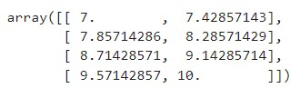

The output of passing this matrix and a precision of 3 must return (you don’t have to print the precision)

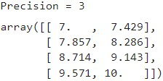

Remember, the only two inputs to the function should be the NumPy array and desired precision.

c. Read the properties of matrix inversion in the class notes. Compute the inverse of the matrix V with the following entries (the linalg package might help here)

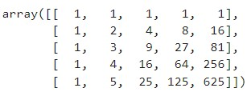

Print 𝑉−1 to 3 decimal places. Compute 𝑉−1𝑉 and 𝑉 𝑉−1 and print them to 3 decimal places. What is the name given to the matrices 𝑉−1𝑉 and 𝑉 𝑉−1? What NumPy command is used to generate such matrices?

1. **Speeding up Matrix Multiplication Using NumPy.**
   * 1. Write a program to multiply two 700 × 700 matrices using nested for loops. Using the tqdm() function from the tqdm package, display a progress bar showing the progress of your program [(short tutorial](https://www.datacamp.com/tutorial/tqdm-python) on using the tqdm package).
     2. Import the time module and use the time() method within to measure the time taken to multiply the two matrices [(documentation](https://docs.python.org/3/library/time.html) on the time module).
     3. Report the average time taken to multiply two 700 × 700 matrices using nested for loops (compute the average over 30 randomly generated pairs of matrices).
     4. Repeat the above procedure, but use the NumPy method numpy.dot()instead of the two for loops.
     5. What speedup do you observe with NumPy?

1. **MatplotLib.** (Review the MatplotLib tutorial thoroughly before answering. Additionally, refer to Sec. 1.4 in the Scientific Python lectures ([link)](https://lectures.scientific-python.org/)) solve the problems related to the MatplotLib library in the Jupyter

Notebooks named matplotlib_questions_Part1.ipynb and matplotlib_questions_Part2.ipynb.