Kevin Lopez Sepulveda

METCS550

Final Report

John Nash and the Nash Equilibrium
John Forbes Nash Jr. (1928–2015) was an American mathematician who made fundamental contributions to game theory, economics, and differential geometry[1][2]. He earned the 1994 Nobel Memorial Prize in Economic Sciences for his analysis of equilibria in non-cooperative games[1][2]. Nash was born in Bluefield, West Virginia, educated at Carnegie Tech and Princeton, and later joined the MIT faculty[1][3]. In 1959 he was diagnosed with schizophrenia but eventually returned to academic work, ultimately also winning the Abel Prize in Mathematics (2015) for separate contributions. His game-theoretic work, especially the concept of the “Nash equilibrium”, revolutionized how economists and scientists model strategic interaction[4][2].

Nash’s Equilibrium Concept
Nash extended game theory beyond the classical zero-sum case (studied by von Neumann) to general games with any number of players and mixtures of cooperation and conflict[4]. He formalized the idea of a Nash equilibrium: a strategy profile from which no player can gain by unilaterally deviating. Formally, in an n-player game with payoff functions u_i and strategy profile a^=(a^_1,\dots,a^_n), a^ is a Nash equilibrium if for every player i and every alternative strategy
$$u_{i}\left(a_{1}^{*},…,a_{n}^{*}\right) ≥ u_{i}\left(a_{1}^{*},…,a_{i-1}^{*},{\hat{a}}_{i},a_{i+1}^{*},…,a_{n}^{*}\right) .$$
In words, no player can improve their payoff by changing only their own strategy[5][6]. In Nash’s words, the equilibrium is a “mutually consistent” choice of strategies: each player’s strategy is a best response to the others[5][6].
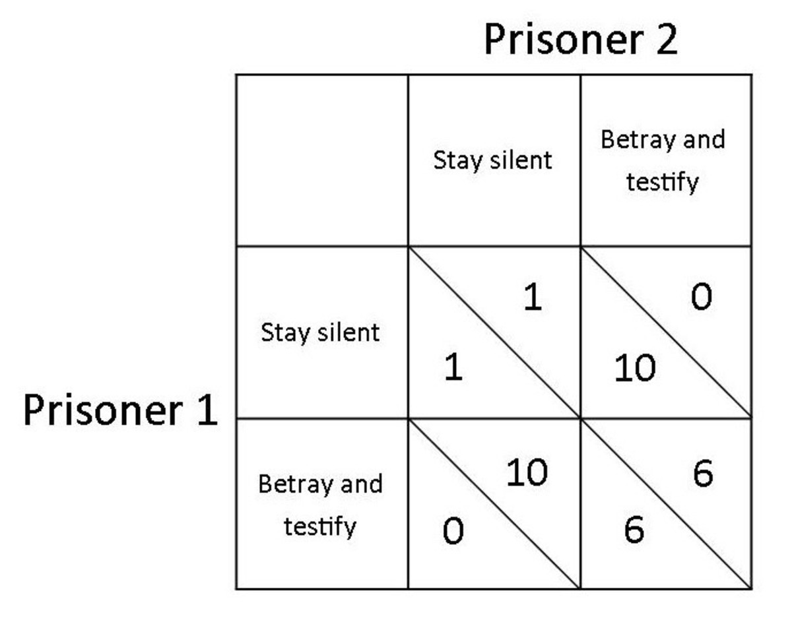
Figure: Payoff matrix for the Prisoner’s Dilemma (player A’s payoffs first, player B’s second). The unique Nash equilibrium is (Betray, Betray) even though both players would be better off with (Silent, Silent)[6].
For example, in the classic Prisoner’s Dilemma each of two players can either Cooperate (stay silent) or Defect (betray). The payoff matrix (shown above) illustrates that (Defect,Defect) is the only Nash equilibrium: given the other’s choice, each prisoner’s dominant strategy is to betray[6]. Although both would earn higher payoffs if both cooperated, rational self-interest drives them to the worse mutual-defection outcome. This simple example highlights the power of the equilibrium concept: it predicts the stable outcome of a strategic interaction even when it is suboptimal.
Another illustration is the Cournot duopoly (two firms competing in quantity). Each firm chooses an output level; the best-response curves (profit-maximizing output for each firm given the other’s output) intersect at the Nash equilibrium production levels[7]. In the figure below, Firm 1’s and Firm 2’s reaction functions meet at (q_1^,q_2^), the unique Nash equilibrium of that game. No firm can unilaterally change its output to improve profit once at this point[7].
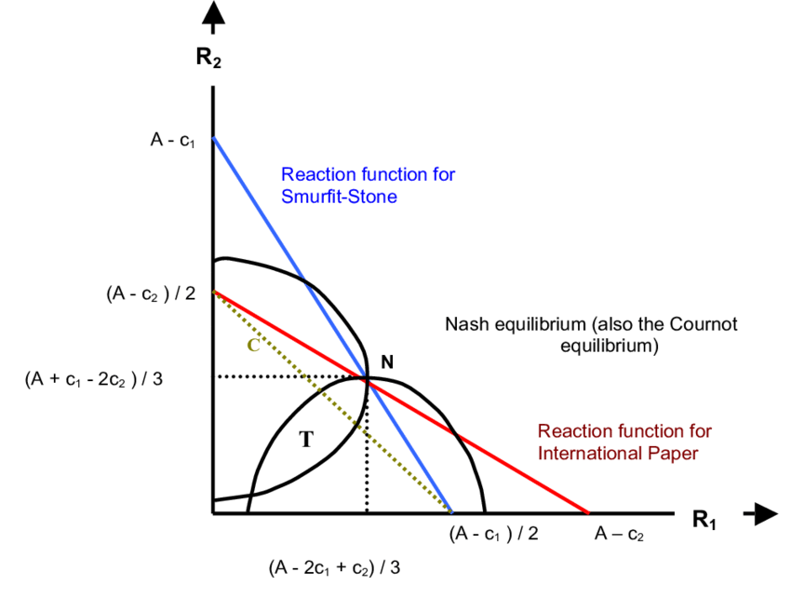
Figure: Cournot duopoly best‐response diagram. Firm 1’s and Firm 2’s best-response curves intersect at the Nash equilibrium quantities (q_1^,q_2^)[7].

Existence of Equilibrium (Mathematical Foundations)
Nash’s key mathematical achievement was proving that every finite game has at least one equilibrium in mixed strategies. In his 1950 dissertation he showed that by allowing players to randomize, an equilibrium is guaranteed to exist for any number of players and any finite set of pure strategies[8][9]. Nash’s original proof used Kakutani’s fixed-point theorem; later expositions often use Brouwer’s fixed-point theorem. The idea is to define a “best-response” correspondence that maps each strategy profile to the set of best responses by each player. Under mild continuity and compactness assumptions (satisfied in finite games), this correspondence has a fixed point – a profile a^ such that a^is in the best-response set for itself. By definition such a fixed point is a Nash equilibrium[8][10]. In effect, Nash converted the equilibrium problem into a fixed-point problem on a high-dimensional simplex. His theorem thus generalized von Neumann’s minimax result (which is a two-player zero-sum equilibrium) to the much broader class of n-player non-cooperative games[8][4].
The formal existence theorem underpins modern applications: because an equilibrium is known to exist, analysts can seek to characterize or compute it without worrying that none exists. Nash’s proof was nonconstructive (it did not give a way to find the equilibrium), but it opened the door to many applications in economics, politics, and even biology (e.g. evolutionary stability) by assuring a solution concept always exists[8][11].

Computational Aspects and Algorithmic Game Theory
Nash’s work also inspired a new branch of theoretical computer science known as algorithmic game theory[12][13]. A central question is: how hard is it to compute a Nash equilibrium? For two-player games (bimatrix games), the classic Lemke–Howson algorithm (1964) can find one equilibrium in finite time[14]. However, in 2005–2009 researchers showed that for general n-player games (with n\ge3 or even 2 with general payoffs), finding a Nash equilibrium is PPAD-complete[13]. PPAD is a complexity class for problems guaranteed to have solutions by parity/fixed-point arguments. Thus computing a Nash equilibrium is believed to be intractable (no efficient polynomial-time algorithm is known) even though we know one exists[13].
These computational results have profound implications: in many strategic settings (auctions, networks, market design), predicting equilibrium behavior may be computationally difficult. Algorithmic game theorists now study how equilibria can be approximated or found under special conditions[13][12]. The Nash concept itself remains central: much of modern research (auction design, network routing, machine learning in multiagent systems) revolves around finding and interpreting Nash equilibria or equilibrium concepts (for example, measuring the Price of Anarchy – the loss due to selfish behavior – relies on Nash equilibria)[15][13].

Influence on Modern Perspectives
John Nash’s equilibrium concept has deeply influenced both economics and computer science. In economics, it provides the standard prediction of outcomes in oligopolies, bargaining, and many other strategic situations[2][4]. In computer science, Nash’s ideas underpin the analysis of strategic algorithms and systems. Algorithmic Game Theory explicitly blends Nash equilibria with algorithmic analysis: it studies how to design systems (like auctions or networks) that are robust to strategic agents[12][15]. Today, Nash equilibrium is taught in all game theory courses and is used to model everything from traffic routing to distributed AI. Nash himself encapsulated its pervasiveness when Princeton economist Avinash Dixit quipped that “if Nash got a dollar for every time someone said ‘Nash equilibrium,’ he would be rich”[16].
In summary, Nash’s work provided a rigorous mathematical framework for equilibrium in non-cooperative games[8][5]. This achievement not only earned him a Nobel Prize but also established a foundation that reshaped economics, computer science, and beyond. His deep theorems – though sometimes abstract – continue to guide how we analyze multi-agent interactions in a wide array of fields, and they remain a cornerstone of modern strategic theory[8][12].

[1] [2] [3] [17] John F. Nash Jr. – Facts - NobelPrize.org
https://www.nobelprize.org/prizes/economic-sciences/1994/nash/facts/
[4] [6] [11] [16] Game Theory Explained | American Experience | Official Site | PBS
https://www.pbs.org/wgbh/americanexperience/features/nash-game/
[5] [10] math.uchicago.edu
https://math.uchicago.edu/~may/REU2017/REUPapers/Karsten.pdf
[7] File:Cournot Duopoly Nash equilibrium.png - Wikimedia Commons
https://commons.wikimedia.org/wiki/File:Cournot_Duopoly_Nash_equilibrium.png
[8] [9] A HISTORY OF THE NASH EQUILIBRIUM THEOREM IN THE FIXED POINT THEORY (Nonlinear Analysis and Convex Analysis)
https://www.kurims.kyoto-u.ac.jp/~kyodo/kokyuroku/contents/pdf/1755-11.pdf
[12] [15] Algorithmic game theory - Wikipedia
https://en.wikipedia.org/wiki/Algorithmic_game_theory
[13] PPAD (complexity) - Wikipedia
https://en.wikipedia.org/wiki/PPAD_(complexity)
[14] Lemke–Howson algorithm - Wikipedia
https://en.wikipedia.org/wiki/Lemke%E2%80%93Howson_algorithm

