Homework

Kevin Lopez Sepulveda
Problem 1. Plot both the function f (·), its derivative f′(·), and the values of both at point x = 1 on the same plot for each of the following functions (take −4 ≤ x ≤ 4):
- f (x) = 2 −→ f′(x) = 0
- f (x) = x + 1 −→ f′(x) = 1
- f (x) = 2x² + x −→ f′(x) = 4x + 1
- f (x) = x^{n} + n −→ f′(x) = nx^{n−1}, for n = 3
- f (x) = 2√x −→ f′(x) = 1/√x
- f (x) = e^{x+1} −→ f′(x) = e^{x}
- f (x) = 3^{x} −→ f′(x) = (log 3)3^{x}
- f (x) = log x + 1 −→ f′(x) = 1/x
- f (x) = sin (x + π/6) −→ f′(x) = cos(x)
- f (x) = cos (x + π/6) −→ f′(x) = − sin(x)
Color curves for f in green and curves for f′ in red, values for f (x = 1) and f′(x = 1) in black.

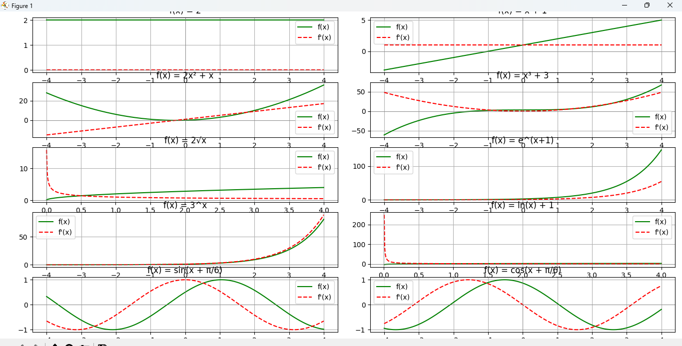

The Python Script in the answer creates the list of all the functions with the help of numpy and after we iterate through them plotting them using matplot.lib

Table 1: A Comparison of Derivatives

function  f(x) | forward  f (x+△x)−f (x)  △x | backward  f (x)−f (x−△x)  △x | central  f (x+△x)−f (x−△x)  2△x | exact  f′(x = 1)
1
x x2
· · ·
· · ·
cos(x)
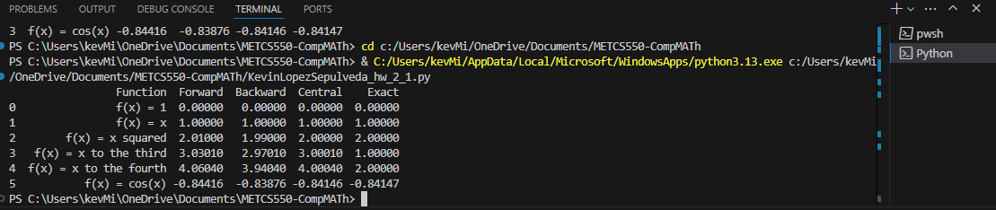
Read script
Problem 2. read and install the ”sympy” Python package
https://scipy-lectures.org/packages/sympy.html

Read the section on calculus (differentiation) and use the ”sympy” Python package to compute derivatives for each function in Problem 1.
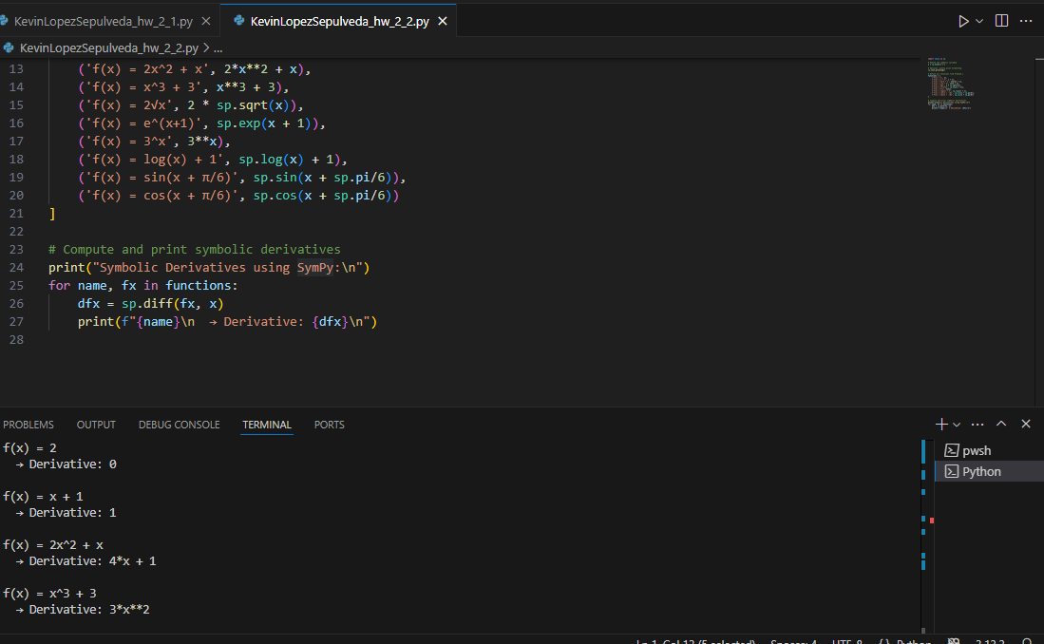

Problem 3. For each of the 10 functions in problem 1, write a script to compute f′(x = 1) using numerical differentiation with forward, backward and central differences for △x = 0.2.
Summarize your results (rounded to 4 decimal digits) in the table as shown. For each row, color the closest value to exact in green and the furthest value in red. Discuss your findings.

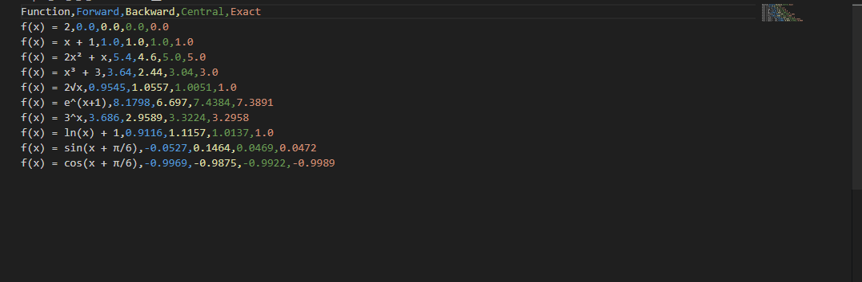
As we can see, The central differences are the closest to for all functions of x that are not a wave of any kind. The central difference is the closest for all values of x being raised to or raised to x. It gets complicated for wave functions because the forward or backward values can sometimes provide a more accurate scope to the area of the function.
Problem 4. Plot both the function f (·), and its integral
J
f (x) dx (as area under the curve) on the same plot for each of the following functions (take 1 ≤ x ≤ 5):
- f (x) = 2
- f (x) = x + 1
- f (x) = 2x² + x
- f (x) = x^{n} + n for n = 3
- f (x) = 2√x
- f (x) = e^{x+1}
- f (x) = 3^{x}
- f (x) = log x + 1
- f (x) = sin(x + π/6)
- f (x) = cos(x + π/6)
Color curves for f in green and ”rectangles” in red, values for f (x = 1) and f′(x = 1) in black.

Problem 5. write a function for each integral and compute each integral as definite integral using sympy (x from 1 to 5)

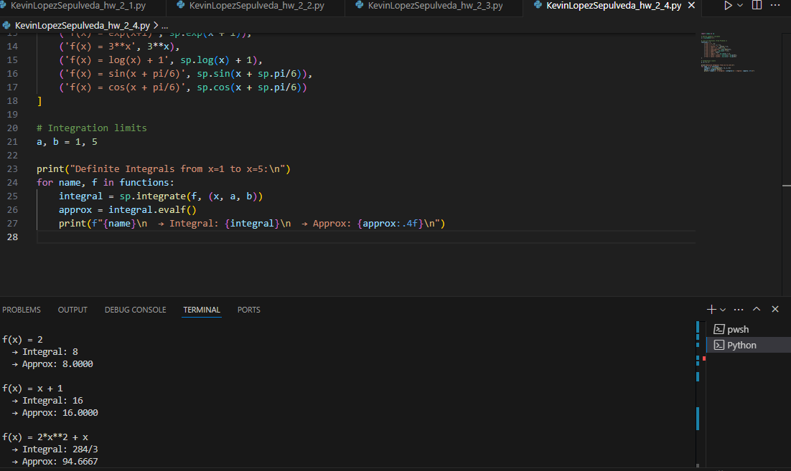

The function is sympy.integrate.

Problem 6. write Python scripts to compute each integral (definite integral with x ∈ [1, 5]) using the scipy package for 3 methods:
- fixed quadrature
- trapezoid
- Simpson
