Homework 4
- Consider a unit circle C centered at the origin. Write the corresponding matrix and show the result of applying this matrix to the original C and compute the corresponding area of the new figure. Use the subplots in Python/R
  - M₁ - expand x by a factor of 1.5
  - M₂ - contract y by a factor of 0.75
  - M₃ - shear along x by a factor of 2
  - M₄ - shear along y by a factor of 1.25
  - M₅ - counterclockwise rotation by π/4
  - M₆ - clockwise rotation by π/6
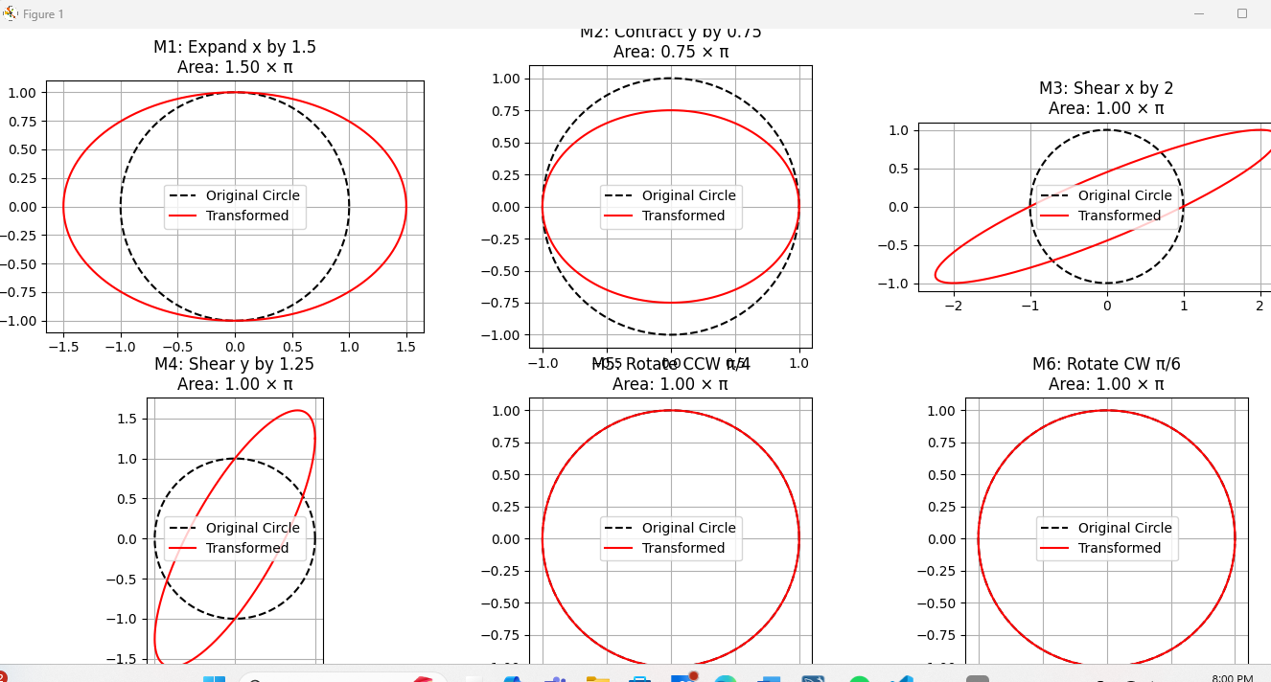
- Recall that the eigenvalues are computed by solving det(M− λI) = 0 inverse M⁻¹. For each matrix M₁, . . . , M₆ above write down the characteristic polynomial, compute the cor- responding eigenvalues λ₁ and λ₂ and plot the correspond- ing eigenvectors.
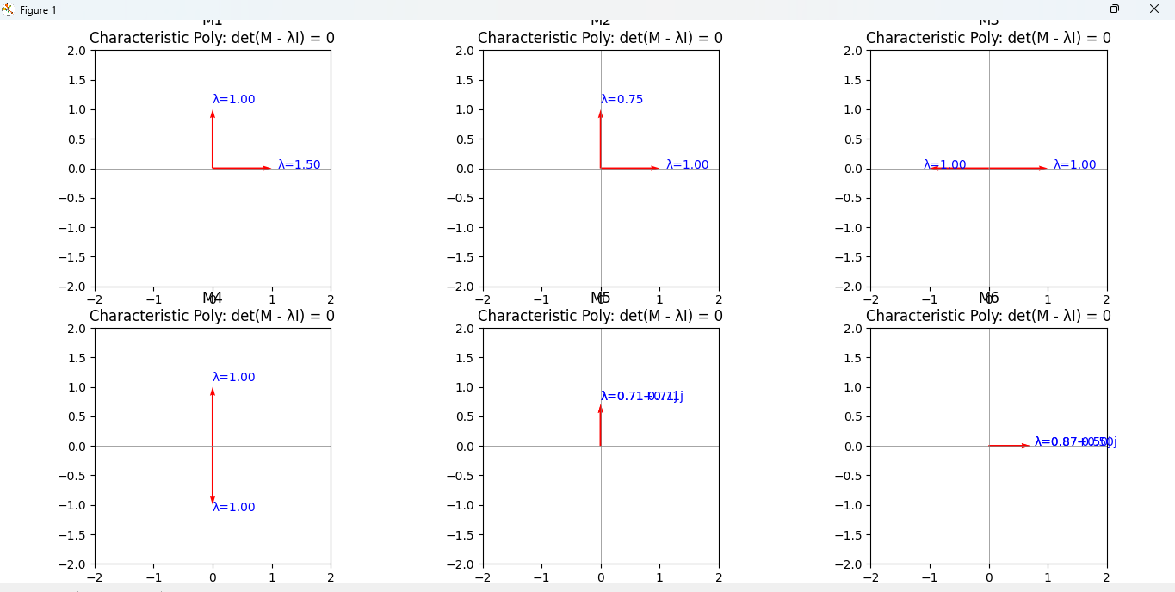
- Consider the same unit circle C. Plot the resulting figure and compute its area after applying the following transfor- mations:

  - (M₁²)(M₃³)M₅
  - (M₂⁻¹)(M₄⁻²)M₆
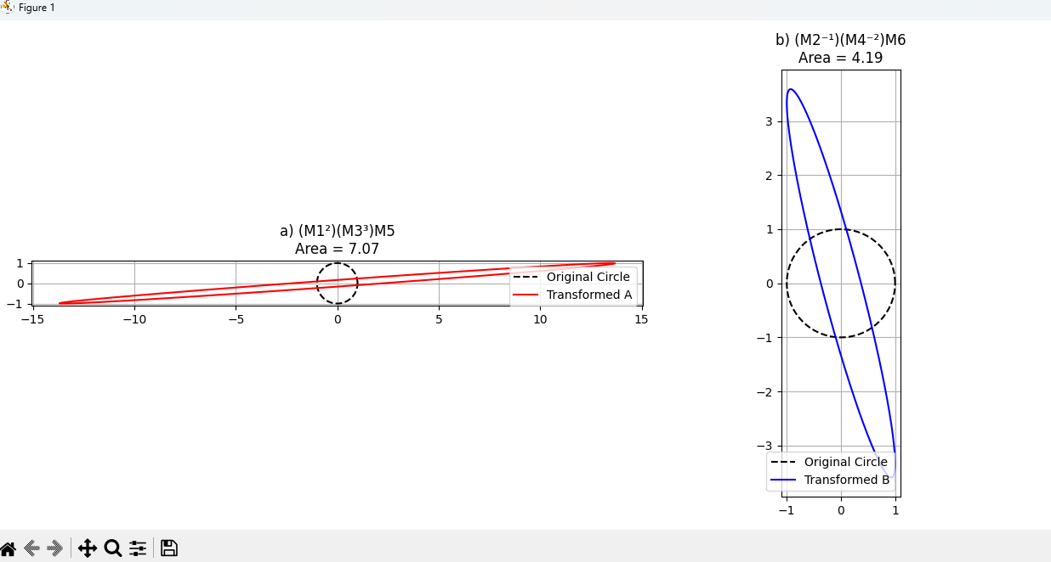
- Compute (by hand and by Python/R) the determinants and L₁ norms of the following matrices
 

A = 1 4

2 3

, B =
5 19
−2 5
2 1 9
, C = 5 7 1

 
4 7 1

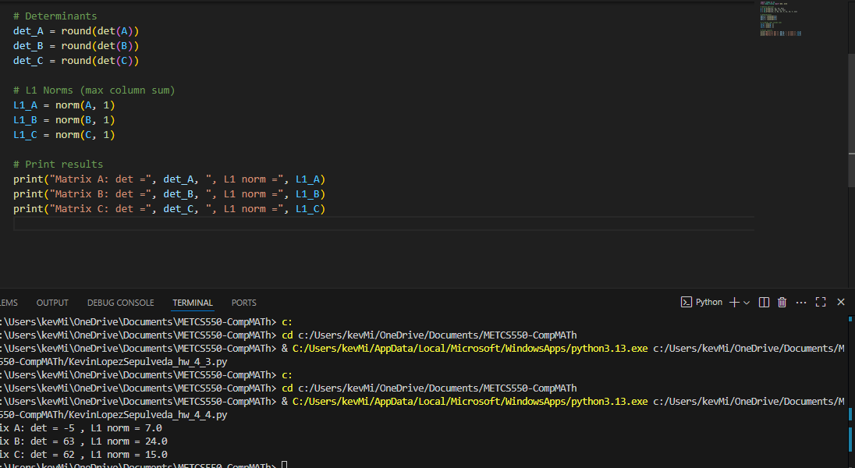
- Consider the following matrix:
 
−3 4 0
A = −2 7 6
 
5 −8 0
Calculate det(A) by
  - expanding along the second row
  - expanding across the third row
  - expanding across the first column
  - expanding across the second column
  - using Python/R
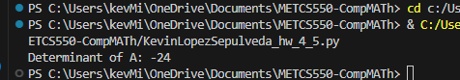
- Consider the matrix

A = 1 2
3 4

Except for (a) do computations by hand and by Python/R
  - write down the characteristic polynomial P (λ)
  - compute the eigenvalues of A
  - compute the eigenvectors of A
  - compute P (A) and verify the Cayley-Hamilton theorem: every square matrix (real or complex elements) satisfies its own characteristic equation
